**Class:** Final Year (Computer Science and Engineering)

**Year:** 2021-22 **Semester:** 1 **Course:** High Performance Computing Lab

**PRN:** 2018BTECS00049

**Practical No. 8**

**Problem Statement 1: Write a CUDA C program to perform the simple matrix-matrix multiplication. Perform code optimization and profiling of existing CUDA C program. (Attach Snapshot of execution before optimization and after optimization)**

**Ans:**

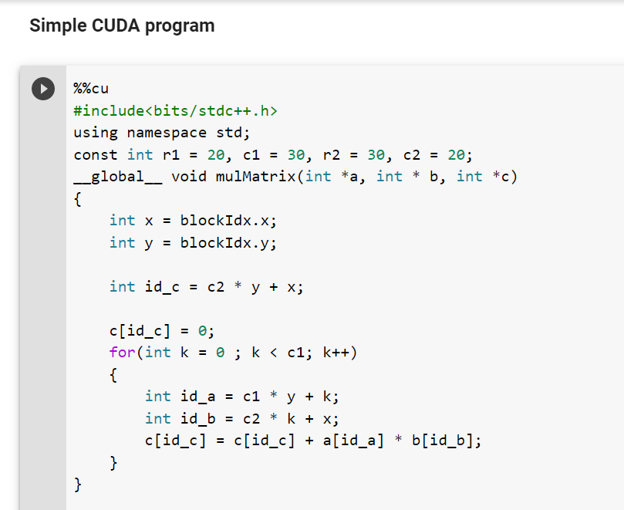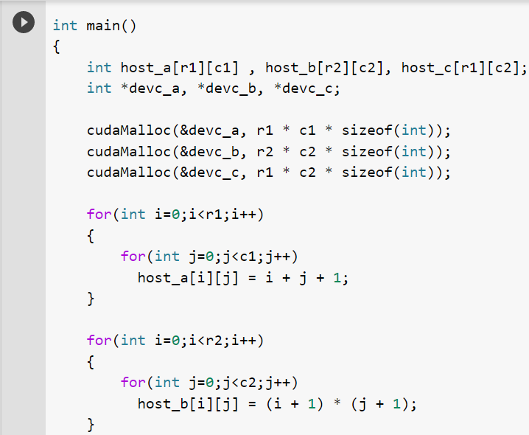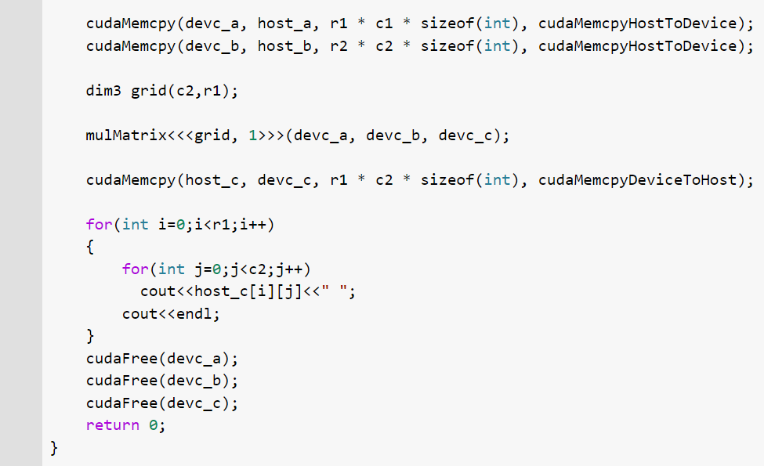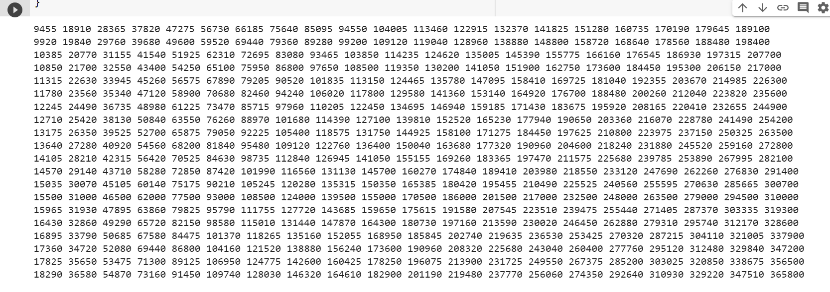

**Problem Statement 2:** **Write a CUDA C program to demonstrate the use of different GPU memories.**

**• Use of private memory.**

**• Use of shared memory.**

**• Use of global memory**



