Name : Kornule Manmath Maroti
Prn : 202401110045
Batch : A3

Problem Statement: Fractional Knapsack Using Greedy Approach

Code :
C++
#include <iostream>
#include <algorithm>
using namespace std;

int main() {
int n, capacity;

cout << "Enter number of items: ";
cin >> n;

int value[n], weight[n];
double ratio[n];

for (int i = 0; i < n; i++) {
cout << "Enter value and weight of item " << i + 1 << ": ";
cin >> value[i] >> weight[i];

ratio[i] = (double)value[i] / weight[i];
}

cout << "Enter capacity: ";
cin >> capacity;

cout << "\nValue-to-Weight Ratio:\n";

for (int i = 0; i < n; i++) {
cout << "Item " << i + 1 << " : "
<< ratio[i] << endl;
}

// Sort according to ratio
for (int i = 0; i < n - 1; i++) {
for (int j = i + 1; j < n; j++) {
if (ratio[i] < ratio[j]) {
swap(ratio[i], ratio[j]);
swap(value[i], value[j]);
swap(weight[i], weight[j]);
}
}
}

cout << "\nItems after sorting by ratio:\n";

for (int i = 0; i < n; i++) {
cout << "Item " << i + 1
<< " -> Value = " << value[i]
<< ", Weight = " << weight[i]
<< ", Ratio = " << ratio[i] << endl;
}

double ans = 0;

for (int i = 0; i < n; i++) {

if (capacity >= weight[i]) {
capacity -= weight[i];
ans += value[i];
}
else {
ans += ratio[i] * capacity;
break;
}
}

cout << "\nMaximum Value = " << ans << endl;

cout << "Time Complexity = O(n^2)" << endl;

return 0;
}

INPUT
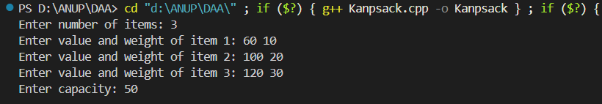
OUTPUT
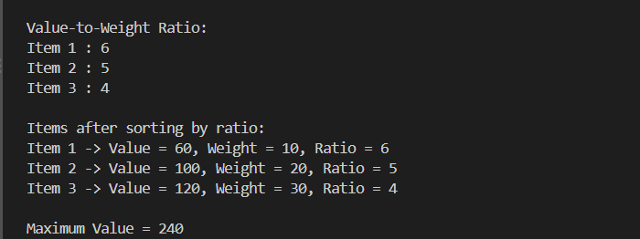

TIME COMPLEXITY ANALYSIS
