MIT ACADEMY OF ENGINEERING, ALANDI, PUNE
Department of Computer Science and Engineering
THEORY OF COMPUTATION
Regular Expression Application Activity
Log File Analysis Using Regular Expressions
Activity Report
Name | Manmath Maroti Kornule
PRN / Roll No. | 202401110045
Application Area | Log File Analysis (PRN mod 8 = 5)
Batch | A3

1. Aim and Objectives
Aim: To study how regular expressions are used in log file analysis and to build a simple Python program that identifies timestamps, IP addresses, log levels and status codes in log entries.
Objectives
- Understand the role of regular expressions in log file analysis.
- Design five regular expressions for timestamps, IPv4 addresses, log levels, status codes and error entries.
- Test every regular expression with five valid and five invalid inputs.
- Represent one regular expression as a Thompson NFA and an equivalent DFA, and relate it to a regex engine.
- Implement a Python program that extracts fields and reports error entries from sample log lines.

2. Understanding the Application

2.1 Log Files and Log File Analysis

A log file is a record of events produced by an application, a server or an operating system. Each line usually stores the time of the event, a severity level, a status or error code and the IP address of the client or host involved. Log file analysis means reading these records to find errors, spot unusual activity and understand how a system behaves.
Busy systems write thousands of lines every minute, so the lines are filtered and parsed automatically. Regular expressions are the standard way to describe the text formats to look for, such as a timestamp, an IP address, a level like ERROR or a three-digit status code. A pattern is written once and applied identically to every line.

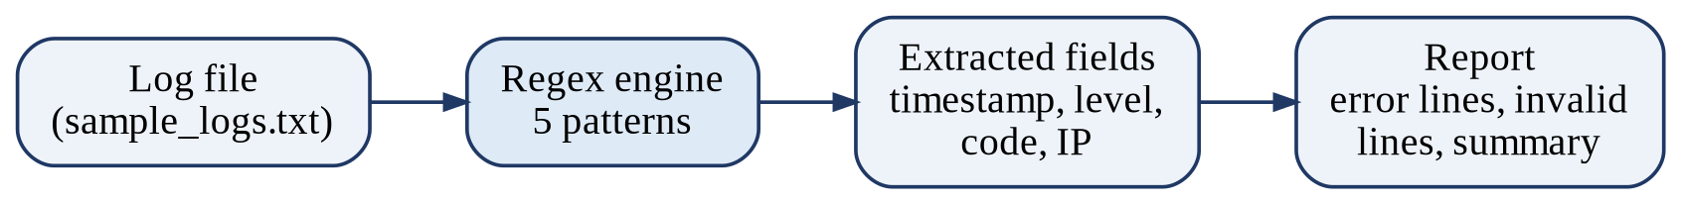
Figure 1: Workflow of the log analyzer

2.2 Real-World Examples
System | Typical log content | How regular expressions help
Web server logs (Apache, Nginx) | Client IP, time, request, HTTP status code | Extract IP addresses and status codes such as 404 and 500 to count failed requests.
Application logs (Python logging, Log4j) | Timestamp, level (INFO, WARNING, ERROR), message | Find ERROR and WARNING lines and group them by time.
System and security logs (Linux syslog, auth.log) | Timestamp, service, event text, source IP | Spot repeated failed-login messages and the IP addresses behind them.

Command-line and enterprise tools such as grep, Logstash (grok patterns) and Splunk (field extraction) also depend on regular expressions.

3. Design and Testing of Regular Expressions

3.1 Log Format Used
Every pattern, test and program run uses one line format: YYYY-MM-DD HH:MM:SS LEVEL STATUS_CODE IP_ADDRESS, for example 2026-10-28 10:16:05 ERROR 404 192.168.1.15. Figure 2 shows which regex handles which field. Python syntax (re module) is used for all patterns.
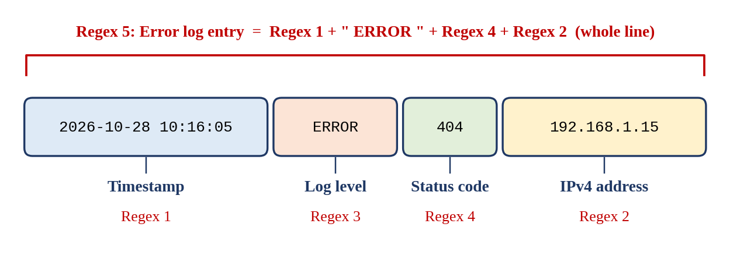
Figure 2: Fields of a log line and the regex used for each

3.2 Summary of the Five Regular Expressions

No. | Regex | Purpose | Tests passed
1 | Timestamp | Match YYYY-MM-DD HH:MM:SS with valid ranges | 5/5 valid, 5/5 invalid
2 | IPv4 address | Match four dot-separated numbers, each 0 to 255 | 5/5 valid, 5/5 invalid
3 | Log level | Match DEBUG, INFO, WARNING, ERROR, CRITICAL | 5/5 valid, 5/5 invalid
4 | HTTP status code | Match a three-digit code from 100 to 599 | 5/5 valid, 5/5 invalid
5 | Error log entry | Match a complete line whose level is ERROR | 5/5 valid, 5/5 invalid

The full test tables (50 cases) are in Appendix A. Each pattern is tested with re.fullmatch, so the whole input string must match.

3.3 Regex 1: Timestamp
Purpose: identify timestamps in the format YYYY-MM-DD HH:MM:SS.
\d{4}-(0[1-9]|1[0-2])-(0[1-9]|[12]\d|3[01]) ([01]\d|2[0-3]):[0-5]\d:[0-5]\d
Component | Meaning
\d{4} | Year: exactly four digits
- | Literal hyphen between date parts
(0[1-9]|1[0-2]) | Month: 01 to 09, or 10 to 12
(0[1-9]|[12]\d|3[01]) | Day: 01 to 09, 10 to 29, or 30 to 31
(space) | Literal space between date and time
([01]\d|2[0-3]) | Hour: 00 to 19, or 20 to 23
: | Literal colon
[0-5]\d | Minutes, and again for seconds: 00 to 59

Limitation: ranges are checked but month lengths are not, so 2026-02-30 is accepted.

3.4 Regex 2: IPv4 Address

Purpose: identify IPv4 addresses written as four dot-separated numbers from 0 to 255.
((25[0-5]|2[0-4]\d|1\d\d|[1-9]?\d)\.){3}(25[0-5]|2[0-4]\d|1\d\d|[1-9]?\d)
Component | Meaning
25[0-5] | Numbers 250 to 255
2[0-4]\d | Numbers 200 to 249
1\d\d | Numbers 100 to 199
[1-9]?\d | Numbers 0 to 99 (optional non-zero first digit; rejects leading zeros like 01)
| | Alternation: one octet is any of the four ranges above
\. | Literal dot (escaped, because a bare . means any character)
( ... ){3} | Three octets, each followed by a dot
last octet group | Fourth octet, with no trailing dot

3.5 Regex 3: Log Level

Purpose: find the log severity labels.
\b(DEBUG|INFO|WARNING|ERROR|CRITICAL)\b
Component | Meaning
\b | Word boundary: the label must start at a word start, so xERROR is rejected
( ... ) | Group containing the alternatives
DEBUG|INFO|WARNING|ERROR|CRITICAL | The five accepted labels (case-sensitive)
\b | Word boundary at the end: ERRORS is rejected

3.6 Regex 4: HTTP Status Code
Purpose: find a three-digit HTTP status code in the chosen log format.
[1-5]\d{2}
Component | Meaning
[1-5] | First digit 1 to 5, covering code classes 1xx to 5xx
\d | Any digit
{2} | Exactly two such digits, so the code has three digits in total

The program applies this pattern only at the status-code position of the line, so it cannot match years or parts of an IP address.

3.7 Regex 5: Error Log Entry

Purpose: find a complete log line whose level is ERROR. It is built from Regex 1, 4 and 2.
^\d{4}-(0[1-9]|1[0-2])-(0[1-9]|[12]\d|3[01]) ([01]\d|2[0-3]):[0-5]\d:[0-5]\d ERROR [1-5]\d{2} ((25[0-5]|2[0-4]\d|1\d\d|[1-9]?\d)\.){3}(25[0-5]|2[0-4]\d|1\d\d|[1-9]?\d)$
Component | Meaning
^ | Start of the line
Regex 1 | Timestamp
ERROR | Literal label with spaces on both sides, so only the exact word ERROR matches
Regex 4 | Status code
Regex 2 | IPv4 address
$ | End of the line: nothing may follow the IP address

4. Connection with TOC Theory

4.1 Selected Regular Expression
or the Theory of Computation part, the regular expression selected is:
Regular Expression: ERROR
This expression represents the exact sequence of five characters: E, R, R, O and R. It is useful in the log file analysis project because ERROR is a common label used to identify error-level log entries.
For automata construction, the complete input is considered to match only when it is exactly ERROR. Any additional or incorrect character makes the input invalid.
The language represented by this expression is:
L = {ERROR}
The input alphabet is Σ = {E, R, O, Other}, where Other represents any character other than uppercase E, R and O.

4.2 NFA using Thompson's Construction
Each symbol becomes a two-state NFA, and the five pieces are joined in sequence with ε-transitions. Five symbols give ten states, q0 to q9, with start state q0 and accepting state q9.
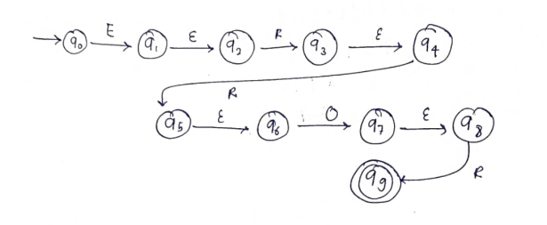
Figure 3: NFA for ERROR using Thompson's construction (ε shown in red)

4.3 Equivalent DFA (Subset Construction)

Taking the ε-closure of each reachable set of NFA states gives six DFA states. The empty set is the dead (trap) state, which every wrong character leads to and which it never leaves.
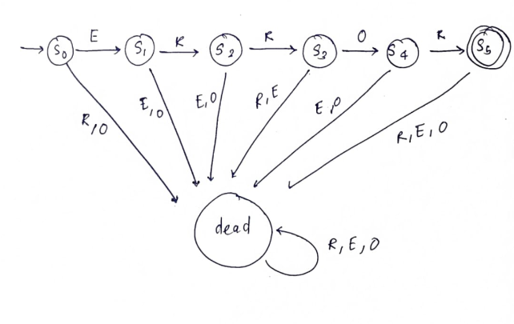
Figure 4: DFA for ERROR including the dead state (dashed grey arrows)
DFA state | NFA states | E | R | O | other
→ s0 (start) | {q0} | s1 | dead | dead | dead
s1 | {q1, q2} | dead | s2 | dead | dead
s2 | {q3, q4} | dead | s3 | dead | dead
s3 | {q5, q6} | dead | dead | s4 | dead
s4 | {q7, q8} | dead | s5 | dead | dead
s5 (accepting) | {q9} | dead | dead | dead | dead
dead (trap) | ∅ | dead | dead | dead | dead

4.4 Minimization
Partition refinement starts by separating the accepting state from all others, then splits any states that move into different groups on the same symbol.
Step | Partition | Reason for the split
0 | {s5} {s0, s1, s2, s3, s4, dead} | Accepting and non-accepting states
1 | {s5} {s4} {s0, s1, s2, s3, dead} | s4 reaches s5 on R
2 | {s5} {s4} {s3} {s0, s1, s2, dead} | s3 reaches s4 on O
3 | {s5} {s4} {s3} {s2} {s0, s1, dead} | s2 reaches s3 on R
4 | {s5} {s4} {s3} {s2} {s1} {s0, dead} | s1 reaches s2 on R
5 | {s5} {s4} {s3} {s2} {s1} {s0} {dead} | s0 reaches s1 on E, dead stays in dead

Every group now holds one state, so no states can be merged. The DFA in Figure 4 is already minimal: 7 states including the dead state (6 if the dead state is left implicit).

4.5 Regex Engine and Finite Automaton
A regular expression and a finite automaton describe exactly the same class of languages (Kleene's theorem). A regex engine first compiles the pattern into an NFA using Thompson's construction, as in Figure 3. It then either follows the NFA paths during matching or converts the NFA into a DFA by subset construction (Figure 4), so that each input character costs one table lookup. Tools such as grep and Lex build DFAs, while Python's re module follows NFA paths with backtracking. In every case the line is read left to right and accepted when an accepting state is reached.
Figure 5: From a regular expression to a matcher

4.6 Is the Language Regular?
Yes. L = {ERROR} is a finite language, and every finite language is regular. It is generated by the regular expression ERROR and accepted by the DFA in Figure 4. The other four regexes are also regular, because they use only concatenation, alternation and bounded repetition ({2}, {3}, ?) and no back-references.

5. Python Implementation

5.1 Program Description
log_analyzer.py uses only Python's built-in re module. Regex 1 to 4 are combined into one line pattern with named groups (ts, level, code, ip), so a valid line yields all four fields at once. Regex 5 marks the ERROR entries. When a line is invalid, each field is re-checked with its own regex to report the reason. The full source is in Appendix B.1.
Mode | Command | Output
Check one line | python log_analyzer.py --check "<line>" | VALID with fields, or INVALID with reason
Analyse a file | python log_analyzer.py sample_logs.txt | Records, ERROR entries, invalid lines, summary
Interactive | python log_analyzer.py --interactive | Checks each line the user types

5.2 Demonstration Runs
Six runs on single lines (three valid, three invalid) and one run on the whole sample file. The complete outputs are in Appendix C.
Run | Type | Input line | Result
1 | Valid | 2026-10-28 10:15:20 INFO 200 192.168.1.10 | VALID, not an error entry
2 | Valid | 2026-10-28 10:16:31 WARNING 301 10.0.0.5 | VALID, not an error entry
3 | Valid | 2026-10-28 10:17:42 ERROR 500 10.0.0.8 | VALID, error entry
4 | Invalid | 2026-10-28 10:15:20 INFO 200 192.168.1.300 | INVALID: invalid IPv4 address
5 | Invalid | 2026-13-28 10:15:20 ERROR 404 192.168.1.15 | INVALID: invalid timestamp
6 | Invalid | 2026-10-28 10:15:20 FATAL 200 192.168.1.10 | INVALID: unknown log level
7 | File | sample_logs.txt (16 lines) | 14 valid, 2 invalid, 5 ERROR entries

5.3 Optional: Browser Version
The same analysis is also available as log_analyzer.html (HTML, CSS and JavaScript, no server). It pastes the same five regexes into JavaScript and gives the same counts on sample_logs.txt. The required demonstration remains the Python program.

6. Results, Observations and Limitations

6.1 Results
Measure | Result
Regular expressions designed and tested | 5
Test cases executed (5 valid + 5 invalid per regex) | 50
Test cases that behaved as expected | 50 / 50
Log lines processed from sample_logs.txt | 16
Valid lines / invalid lines | 14 / 2
ERROR entries identified | 5
Entries with status code 404 | 3
Unique IP addresses found | 8

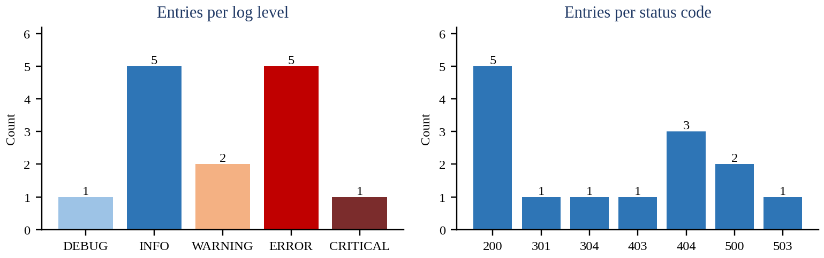
Figure 6: Entries per log level and per status code in sample_logs.txt

6.2 Observations
All 50 test cases gave the expected result. The program extracted all four fields from the 14 well-formed lines and rejected the two malformed ones with the correct reason (invalid IPv4 address and invalid timestamp). Checking the numeric ranges inside the patterns caught values such as 192.168.1.300 and hour 25 that a simple digit pattern would have accepted.

6.3 Limitations
- The patterns check format only. A date such as 2026-02-30 passes the timestamp regex, although it does not exist.
- A well-formed IP address does not prove that the address belongs to a real or reachable host.
- Regex 4 accepts any number from 100 to 599, including numbers that are not assigned HTTP status codes.
- The patterns assume one fixed log format. Other formats, such as lines with free-text messages, need different patterns.

7. Conclusion
This activity showed that regular expressions let a small program recognise and extract timestamps, IP addresses, levels and status codes reliably from log lines. Writing the patterns with explicit ranges and word boundaries made them stricter than a simple digit match, and testing five valid and five invalid inputs for each exposed the edge cases early. Converting the ERROR pattern to an NFA and a DFA made the link with automata theory concrete: the regex engine follows the same states and transitions that were drawn, and the dead state corresponds to the point where matching fails. The work also showed the limits of the approach, since a pattern checks format, not meaning.

8. References
- Python Software Foundation, "re: Regular expression operations," Python 3 Documentation. https://docs.python.org/3/library/re.html
- M. Sipser, Introduction to the Theory of Computation, 3rd ed., Cengage Learning, 2012.
- J. E. Hopcroft, R. Motwani and J. D. Ullman, Introduction to Automata Theory, Languages, and Computation, 3rd ed., Pearson, 2006.
- K. Thompson, "Programming Techniques: Regular expression search algorithm," Communications of the ACM, vol. 11, no. 6, pp. 419-422, 1968.
- regex101, online regular expression tester. https://regex101.com

Appendix A: Regex Test Cases
Each case was run with re.fullmatch using python test_regexes.py <n>. Expected and Actual show whether the whole string should match (Valid) or not (Invalid).

A.1 Regex 1: Timestamp
No. | Input string | Expected | Actual | Result
1 | 2026-10-28 10:15:20 | Valid | Valid | PASS
2 | 2026-01-01 00:00:00 | Valid | Valid | PASS
3 | 2025-12-31 23:59:59 | Valid | Valid | PASS
4 | 2026-02-14 09:05:45 | Valid | Valid | PASS
5 | 2024-07-15 18:30:00 | Valid | Valid | PASS
6 | 2026-13-28 10:15:20 | Invalid | Invalid | PASS
7 | 2026-10-32 10:15:20 | Invalid | Invalid | PASS
8 | 2026-10-28 24:15:20 | Invalid | Invalid | PASS
9 | 2026/10/28 10:15:20 | Invalid | Invalid | PASS
10 | 2026-10-28 10:15 | Invalid | Invalid | PASS

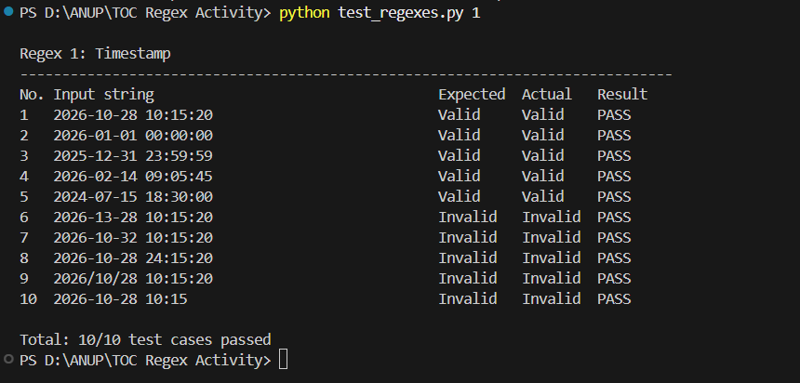
Figure A.1: Test run for Regex 1 (Timestamp)

A.2 Regex 2: IPv4 address
No. | Input string | Expected | Actual | Result
1 | 192.168.1.10 | Valid | Valid | PASS
2 | 10.0.0.8 | Valid | Valid | PASS
3 | 255.255.255.255 | Valid | Valid | PASS
4 | 0.0.0.0 | Valid | Valid | PASS
5 | 172.16.254.1 | Valid | Valid | PASS
6 | 256.1.1.1 | Invalid | Invalid | PASS
7 | 192.168.1 | Invalid | Invalid | PASS
8 | 192.168.1.10.5 | Invalid | Invalid | PASS
9 | 192.168.01.1 | Invalid | Invalid | PASS
10 | 192.168.1.abc | Invalid | Invalid | PASS

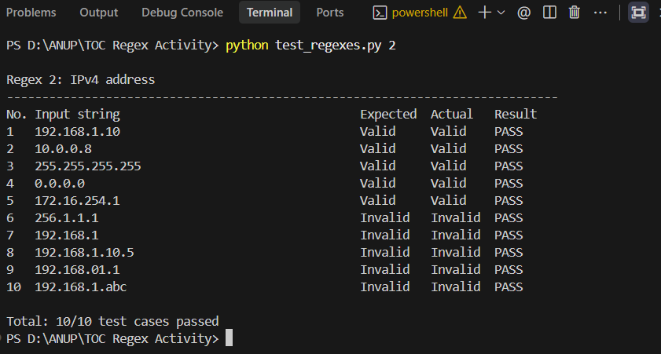
Figure A.2: Test run for Regex 2 (IPv4 address)

A.3 Regex 3: Log level
No. | Input string | Expected | Actual | Result
1 | INFO | Valid | Valid | PASS
2 | WARNING | Valid | Valid | PASS
3 | ERROR | Valid | Valid | PASS
4 | DEBUG | Valid | Valid | PASS
5 | CRITICAL | Valid | Valid | PASS
6 | error | Invalid | Invalid | PASS
7 | ERRORS | Invalid | Invalid | PASS
8 | WARN | Invalid | Invalid | PASS
9 | FATAL | Invalid | Invalid | PASS
10 | ERR0R | Invalid | Invalid | PASS

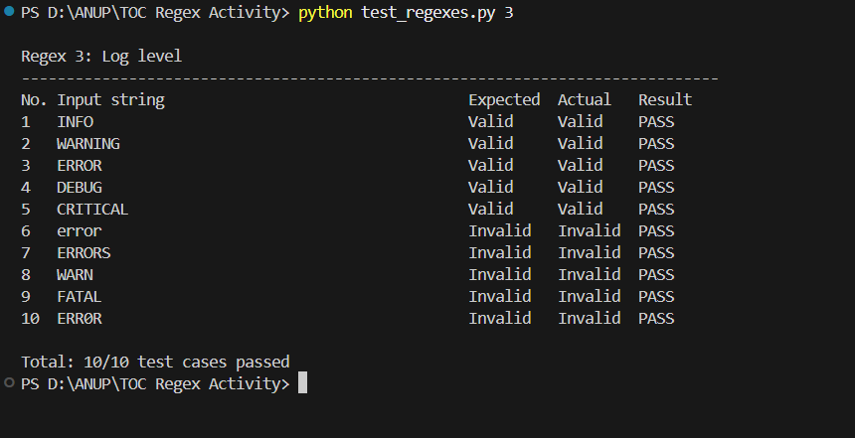
Figure A.3: Test run for Regex 3 (Log level)

A.4 Regex 4: HTTP status code
No. | Input string | Expected | Actual | Result
1 | 200 | Valid | Valid | PASS
2 | 404 | Valid | Valid | PASS
3 | 500 | Valid | Valid | PASS
4 | 301 | Valid | Valid | PASS
5 | 503 | Valid | Valid | PASS
6 | 99 | Invalid | Invalid | PASS
7 | 600 | Invalid | Invalid | PASS
8 | 2000 | Invalid | Invalid | PASS
9 | 4O4 | Invalid | Invalid | PASS
10 | 000 | Invalid | Invalid | PASS

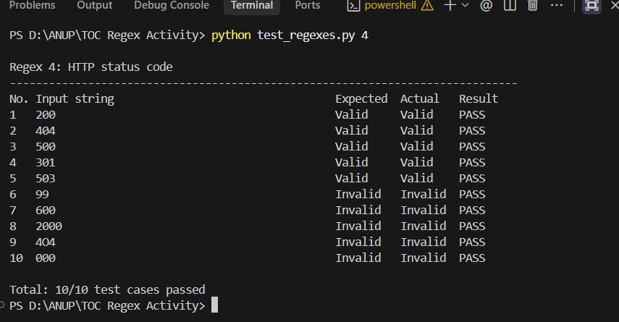
Figure A.4: Test run for Regex 4 (HTTP status code)

A.5 Regex 5: Error log entry
No. | Input string | Expected | Actual | Result
1 | 2026-10-28 10:16:05 ERROR 404 192.168.1.15 | Valid | Valid | PASS
2 | 2026-10-28 10:17:42 ERROR 500 10.0.0.8 | Valid | Valid | PASS
3 | 2026-10-28 11:02:19 ERROR 503 172.16.0.4 | Valid | Valid | PASS
4 | 2026-10-29 00:00:01 ERROR 403 203.0.113.77 | Valid | Valid | PASS
5 | 2026-11-02 23:59:59 ERROR 502 192.168.10.200 | Valid | Valid | PASS
6 | 2026-10-28 10:15:20 INFO 200 192.168.1.10 | Invalid | Invalid | PASS
7 | 2026-10-28 10:16:05 error 404 192.168.1.15 | Invalid | Invalid | PASS
8 | 2026-10-28 10:16:05 ERRORS 404 192.168.1.15 | Invalid | Invalid | PASS
9 | 2026-10-28 10:16:05 ERROR 404 192.168.1.256 | Invalid | Invalid | PASS
10 | ERROR 404 192.168.1.15 | Invalid | Invalid | PASS

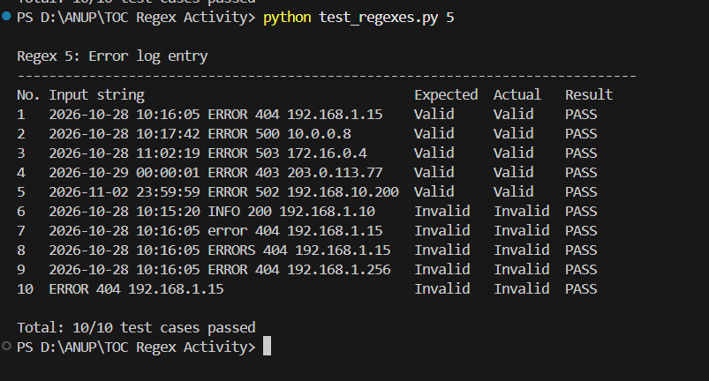
Figure A.5: Test run for Regex 5 (Error log entry)

Appendix B: Source Code

B.1 log_analyzer.py

import re
import sys
import argparse

# ---------- The five regular expressions ----------
# Regex 1: timestamp YYYY-MM-DD HH:MM:SS
TIMESTAMP = r"\d{4}-(0[1-9]|1[0-2])-(0[1-9]|[12]\d|3[01]) ([01]\d|2[0-3]):[0-5]\d:[0-5]\d"
# Regex 2: IPv4 address (each part 0-255, no leading zeros)
OCTET = r"(25[0-5]|2[0-4]\d|1\d\d|[1-9]?\d)"
IPV4 = "(" + OCTET + r"\.){3}" + OCTET
# Regex 3: log level
LEVEL = r"\b(DEBUG|INFO|WARNING|ERROR|CRITICAL)\b"
# Regex 4: HTTP status code (100-599)
STATUS = r"[1-5]\d{2}"
# Regex 5: a complete ERROR log entry
ERROR_ENTRY = "^" + TIMESTAMP + " ERROR " + STATUS + " " + IPV4 + "$"

# Full log line, with named groups to extract each field
LINE = re.compile(
"^(?P<ts>" + TIMESTAMP + ") (?P<level>" + LEVEL + ") (?P<code>" + STATUS + ") (?P<ip>" + IPV4 + ")$"
)
ERROR_RE = re.compile(ERROR_ENTRY)

def diagnose(line):
"""Return the reason why a line is invalid (checks each field with its own regex)."""
parts = line.split(" ")
if len(parts) != 5:
return "expected 5 fields: date time level code ip"
if not re.fullmatch(TIMESTAMP, parts[0] + " " + parts[1]):
return "invalid timestamp"
if not re.fullmatch(LEVEL, parts[2]):
return "unknown log level"
if not re.fullmatch(STATUS, parts[3]):
return "invalid status code"
if not re.fullmatch(IPV4, parts[4]):
return "invalid IPv4 address"
return "does not match the log format"

def check_line(line):
"""Print Valid / Invalid for one log line, with the extracted fields."""
line = line.strip()
m = LINE.match(line)
print("Input :", line)
if m:
print("Result : VALID")
print(" Timestamp :", m.group("ts"))
print(" Level :", m.group("level"))
print(" Status code :", m.group("code"))
print(" IP address :", m.group("ip"))
print(" Error entry :", "YES" if ERROR_RE.match(line) else "NO")
else:
print("Result : INVALID")
print(" Reason :", diagnose(line))

def analyse_file(path, wanted_code):
with open(path, encoding="utf-8") as f:
lines = [l.rstrip("\n") for l in f if l.strip()]

records, invalid, errors = [], [], []
for number, line in enumerate(lines, start=1):
m = LINE.match(line)
if m:
records.append(m.groupdict())
if ERROR_RE.match(line):
errors.append((number, line))
else:
invalid.append((number, line, diagnose(line)))

print("EXTRACTED RECORDS")
print("-" * 66)
print(f"{'Timestamp':<21}{'Level':<10}{'Code':<6}{'IP address'}")
print("-" * 66)
for r in records:
print(f"{r['ts']:<21}{r['level']:<10}{r['code']:<6}{r['ip']}")

print("\nERROR ENTRIES")
print("-" * 66)
for number, line in errors:
print(f"line {number:<3} {line}")

print("\nINVALID LINES")
print("-" * 66)
for number, line, reason in invalid:
print(f"line {number:<3} {line} -> {reason}")

levels = {}
for r in records:
levels[r["level"]] = levels.get(r["level"], 0) + 1
with_code = sum(1 for r in records if r["code"] == wanted_code)

print("\nSUMMARY")
print("-" * 66)
print("Total lines processed :", len(lines))
print("Valid lines :", len(records))
print("Invalid lines :", len(invalid))
print("ERROR entries :", len(errors))
print(f"{'Entries with code ' + wanted_code:<24}:", with_code)
print("Unique IP addresses :", len({r['ip'] for r in records}))
print("Entries per level :", ", ".join(f"{k}={v}" for k, v in sorted(levels.items())))

def main():
ap = argparse.ArgumentParser(description="Log analyser using regular expressions")
ap.add_argument("logfile", nargs="?", help="log file to analyse")
ap.add_argument("--check", metavar="LINE", help="check a single log line")
ap.add_argument("--interactive", action="store_true", help="type log lines one by one")
ap.add_argument("--code", default="404", help="status code to count (default 404)")
args = ap.parse_args()

if args.check:
check_line(args.check)
elif args.interactive:
print("Enter a log line (empty line to quit):")
while True:
line = input("> ")
if not line.strip():
break
check_line(line)
print()
elif args.logfile:
analyse_file(args.logfile, args.code)
else:
ap.print_help()
sys.exit(1)

if __name__ == "__main__":
main()

B.2 test_regexes.py
"""
Regex test runner - 5 regexes x (5 valid + 5 invalid) = 50 test cases.
Run: python test_regexes.py (all regexes)
python test_regexes.py 2 (only Regex 2)
"""
import re
import sys
from log_analyzer import TIMESTAMP, IPV4, LEVEL, STATUS, ERROR_ENTRY

TESTS = {
1: ("Timestamp", TIMESTAMP, [
("2026-10-28 10:15:20", True),
("2026-01-01 00:00:00", True),
("2025-12-31 23:59:59", True),
("2026-02-14 09:05:45", True),
("2024-07-15 18:30:00", True),
("2026-13-28 10:15:20", False),
("2026-10-32 10:15:20", False),
("2026-10-28 24:15:20", False),
("2026/10/28 10:15:20", False),
("2026-10-28 10:15", False),
]),
2: ("IPv4 address", IPV4, [
("192.168.1.10", True),
("10.0.0.8", True),
("255.255.255.255", True),
("0.0.0.0", True),
("172.16.254.1", True),
("256.1.1.1", False),
("192.168.1", False),
("192.168.1.10.5", False),
("192.168.01.1", False),
("192.168.1.abc", False),
]),
3: ("Log level", LEVEL, [
("INFO", True),
("WARNING", True),
("ERROR", True),
("DEBUG", True),
("CRITICAL", True),
("error", False),
("ERRORS", False),
("WARN", False),
("FATAL", False),
("ERR0R", False),
]),
4: ("HTTP status code", STATUS, [
("200", True),
("404", True),
("500", True),
("301", True),
("503", True),
("99", False),
("600", False),
("2000", False),
("4O4", False),
("000", False),
]),
5: ("Error log entry", ERROR_ENTRY, [
("2026-10-28 10:16:05 ERROR 404 192.168.1.15", True),
("2026-10-28 10:17:42 ERROR 500 10.0.0.8", True),
("2026-10-28 11:02:19 ERROR 503 172.16.0.4", True),
("2026-10-29 00:00:01 ERROR 403 203.0.113.77", True),
("2026-11-02 23:59:59 ERROR 502 192.168.10.200", True),
("2026-10-28 10:15:20 INFO 200 192.168.1.10", False),
("2026-10-28 10:16:05 error 404 192.168.1.15", False),
("2026-10-28 10:16:05 ERRORS 404 192.168.1.15", False),
("2026-10-28 10:16:05 ERROR 404 192.168.1.256", False),
("ERROR 404 192.168.1.15", False),
]),
}

def run(selected=None):
total = passed = 0
for n, (name, pattern, cases) in TESTS.items():
if selected and n != selected:
continue
print(f"\nRegex {n}: {name}")
print("-" * 78)
print(f"{'No.':<4}{'Input string':<46}{'Expected':<10}{'Actual':<9}{'Result'}")
for i, (text, expected) in enumerate(cases, start=1):
actual = re.fullmatch(pattern, text) is not None
ok = actual == expected
total += 1
passed += ok
print(f"{i:<4}{text:<46}{'Valid' if expected else 'Invalid':<10}"
f"{'Valid' if actual else 'Invalid':<9}{'PASS' if ok else 'FAIL'}")
print(f"\nTotal: {passed}/{total} test cases passed")

if __name__ == "__main__":
run(int(sys.argv[1]) if len(sys.argv) > 1 else None)

B.3 sample_logs.txt
2026-10-28 10:15:20 INFO 200 192.168.1.10
2026-10-28 10:15:48 INFO 200 192.168.1.12
2026-10-28 10:16:05 ERROR 404 192.168.1.15
2026-10-28 10:16:31 WARNING 301 10.0.0.5
2026-10-28 10:17:42 ERROR 500 10.0.0.8
2026-10-28 10:18:09 INFO 200 172.16.0.21
2026-10-28 10:19:27 DEBUG 200 192.168.1.10
2026-10-28 10:20:03 ERROR 404 203.0.113.45
2026-10-28 10:21:15 WARNING 403 10.0.0.8
2026-10-28 10:22:50 INFO 200 192.168.1.12
2026-10-28 10:23:36 CRITICAL 503 172.16.0.4
2026-10-28 10:24:12 ERROR 404 192.168.1.15
2026-10-28 10:25:44 INFO 304 10.0.0.5
2026-10-28 10:26:58 ERROR 500 172.16.0.21
2026-10-28 10:27:30 INFO 200 192.168.1.300
2026-10-28 25:10:00 ERROR 404 192.168.1.15

Appendix C: Demonstration Runs
C.1 Run 1 (valid)
$ python log_analyzer.py --check "2026-10-28 10:15:20 INFO 200 192.168.1.10"
Input : 2026-10-28 10:15:20 INFO 200 192.168.1.10
Result : VALID
Timestamp : 2026-10-28 10:15:20
Level : INFO
Status code : 200
IP address : 192.168.1.10
Error entry : NO
Figure C.1: Run 1 (valid)
C.2 Run 2 (valid)
$ python log_analyzer.py --check "2026-10-28 10:16:31 WARNING 301 10.0.0.5"
Input : 2026-10-28 10:16:31 WARNING 301 10.0.0.5
Result : VALID
Timestamp : 2026-10-28 10:16:31
Level : WARNING
Status code : 301
IP address : 10.0.0.5
Error entry : NO
Figure C.2: Run 2 (valid)
C.3 Run 3 (valid)
$ python log_analyzer.py --check "2026-10-28 10:17:42 ERROR 500 10.0.0.8"
Input : 2026-10-28 10:17:42 ERROR 500 10.0.0.8
Result : VALID
Timestamp : 2026-10-28 10:17:42
Level : ERROR
Status code : 500
IP address : 10.0.0.8
Error entry : YES
Figure C.3: Run 3 (valid)
C.4 Run 4 (invalid)
$ python log_analyzer.py --check "2026-10-28 10:15:20 INFO 200 192.168.1.300"
Input : 2026-10-28 10:15:20 INFO 200 192.168.1.300
Result : INVALID
Reason : invalid IPv4 address
Figure C.4: Run 4 (invalid)
C.5 Run 5 (invalid)
$ python log_analyzer.py --check "2026-13-28 10:15:20 ERROR 404 192.168.1.15"
Input : 2026-13-28 10:15:20 ERROR 404 192.168.1.15
Result : INVALID
Reason : invalid timestamp
Figure C.5: Run 5 (invalid)
C.6 Run 6 (invalid)
$ python log_analyzer.py --check "2026-10-28 10:15:20 FATAL 200 192.168.1.10"
Input : 2026-10-28 10:15:20 FATAL 200 192.168.1.10
Result : INVALID
Reason : unknown log level
Figure C.6: Run 6 (invalid)
C.7 Run 7 (whole file)
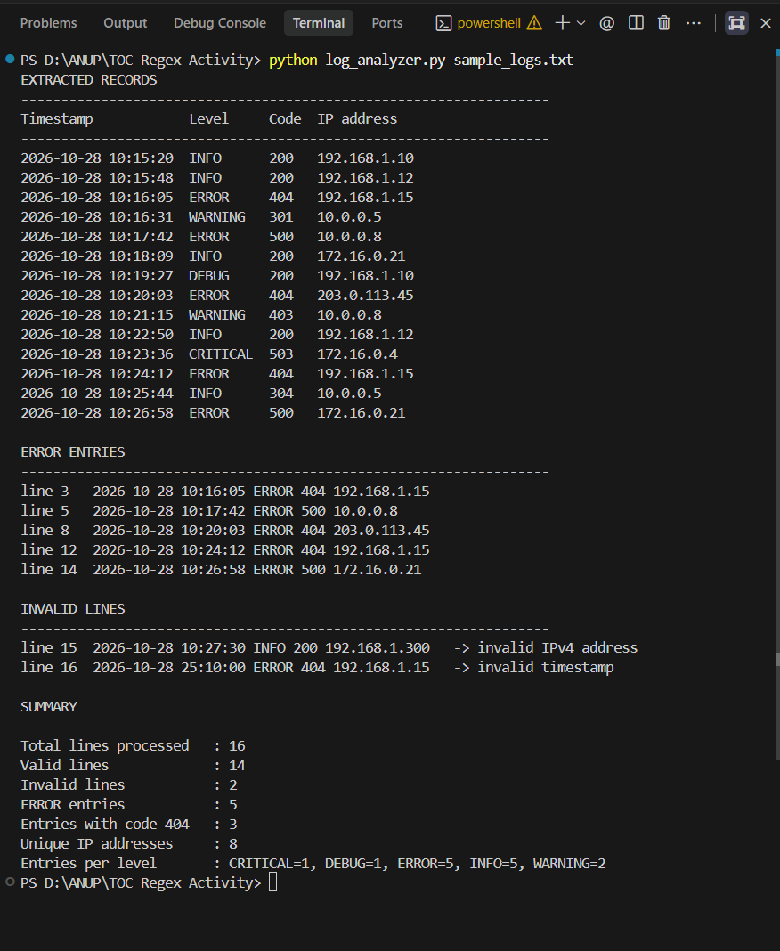 Figure C.7: Run 7 (whole file)
C.8 Optional: browser version
[Paste screenshot of log_analyzer.html after clicking Analyze]
Figure C.8: Browser version of the log analyzer

