Hey guys! As you all are new to the open source. So, let me guide you with some of the commands to follow make your process of making your own repositories a bit easier.... Hope so everyone has made your accounts on GitHub. Then go to your profile and make new repository…

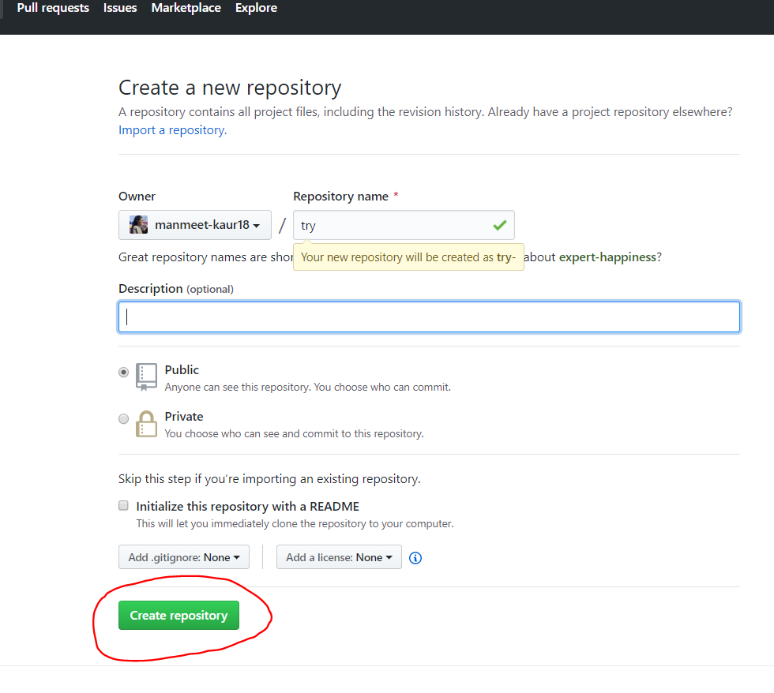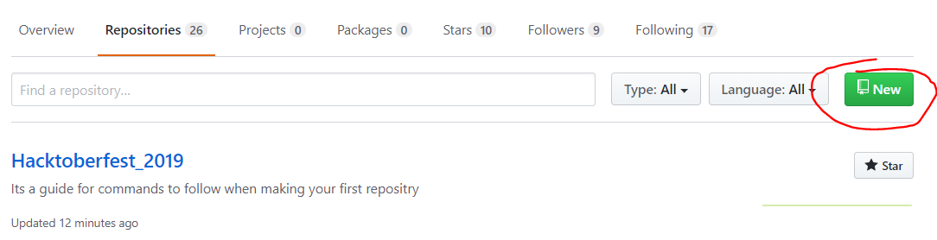

1.Firstly if you don’t have a git bash install it as per your requirements whether it is Macbook or windows. Now, in git bash move to the folder where your file exists.

2.Now write the command git init

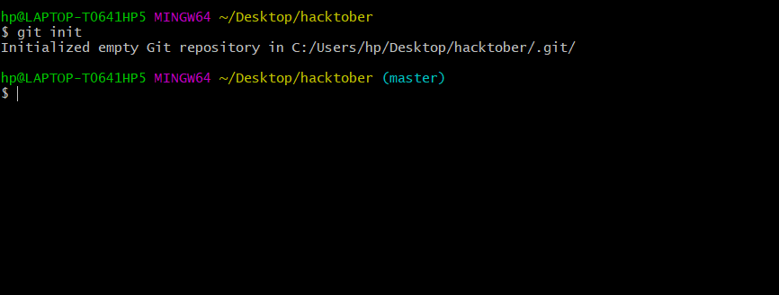

3.git remote add origin "link of your repository in GitHub"

4.Now to check whether the above command has set your pointer to your repository or not write command, git remote -v

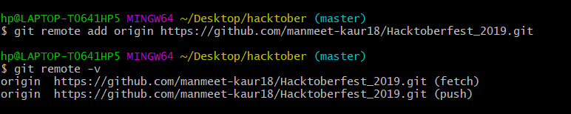

5.git add .

6.Now write git commit -m "new repository"

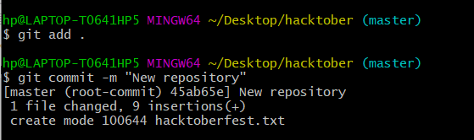

7.git push origin master