Deployment link: <http://ec2-13-57-250-97.us-west-1.compute.amazonaws.com>

Github link: <https://github.com/manmeet3/Cmpe272_Asg1_Ansible.git>

Files included:

*hosts*: Target hosts to run the playbooks on

*index.html.j2*: Custom nginx landing homepage

*server-install.yaml*: Deploy nginx, copy over our index.html, restart nginx

*server-undeploy.yaml*: Stop nginx, uninstall nginx

The below screenshot shows the deployment aspect of setting up a nginx server on Ubuntu instance on AWS. It follows the following steps:

1. Install nginx using apt-get.
2. Copy our custom index.html file to nginx’s root html directory.
3. Restart nginx server.

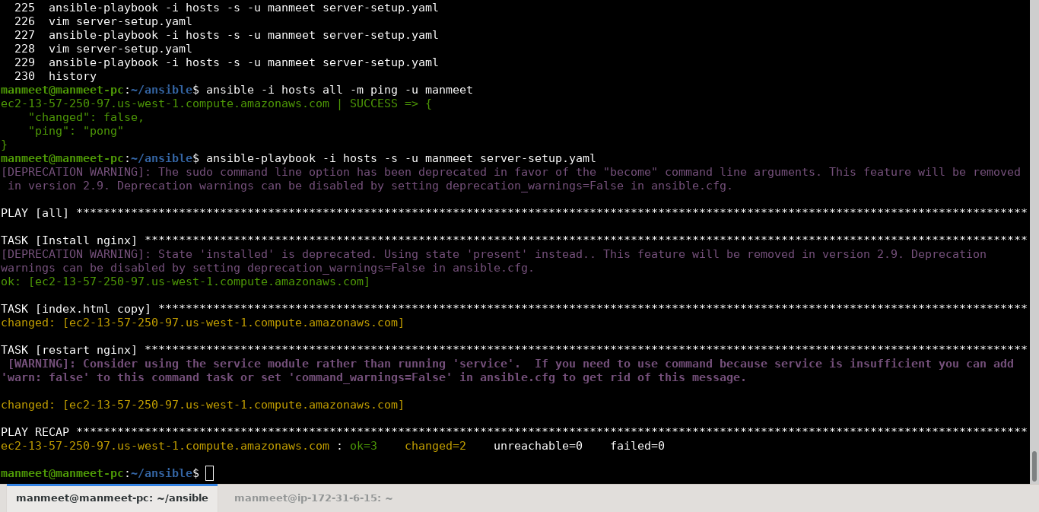

The undeployment aspect of removing nginx from Ubuntu is included in the playbook, but was not executed since that would have meant repeating the deployment step again.