Sinusoidal Grid Vortex Advection Results

In the following cases, Riemann boundary conditions were imposed on the boundary nodes.

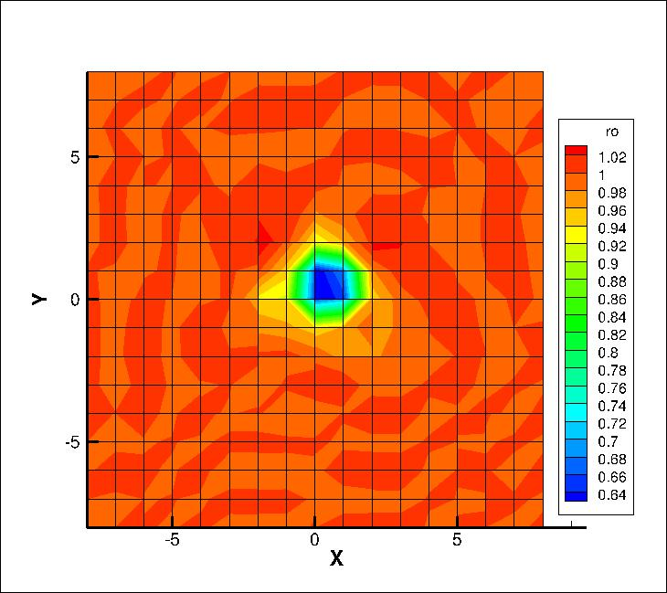

Figure 1. Vortex advection case results for an 8x8 mesh with p = 2 after 500 iterations

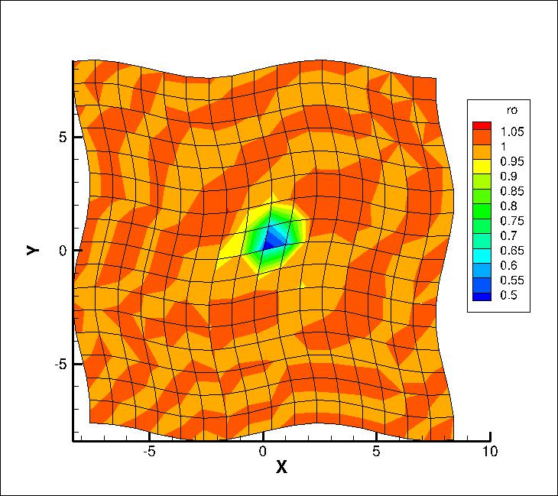

Figure 2. Vortex advection case results for a sinusoidal 8x8 mesh with p=2 after 500 iterations.