Name: Manmeet Kaur

SMTP Server Setup Using Postfix on Ubuntu

Objective
The objective of this exercise was to understand how a basic SMTP (Simple Mail Transfer Protocol) mail server works by setting up and configuring Postfix on an Ubuntu machine. This was done purely for learning and cybersecurity fundamentals, not for real-world email hosting.

System Environment
- Operating System: Ubuntu Linux
- Mail Transfer Agent (MTA): Postfix
- Mail Client: mail (mailutils)
- Network Scope: Local system / local network only

What is SMTP? (Simple Explanation)
SMTP is like a postman:
- It takes a message from a sender
- Delivers it to the receiver’s mailbox
Postfix is the software that plays the role of the postman.

Steps Performed

1. Installing Postfix
Postfix was installed using the package manager:
- During installation, the Internet Site option was selected
- A system mail name such as mymail.local was used
This created a basic working SMTP server on the Ubuntu machine.

3. Sending a Test Email (Local Mail)
A test email was sent using the command:
echo "hi" | mail -s "hello" jude

Explanation:
- echo "hi" → creates the message body
- mail -s "hello" → sends mail with subject "hello"
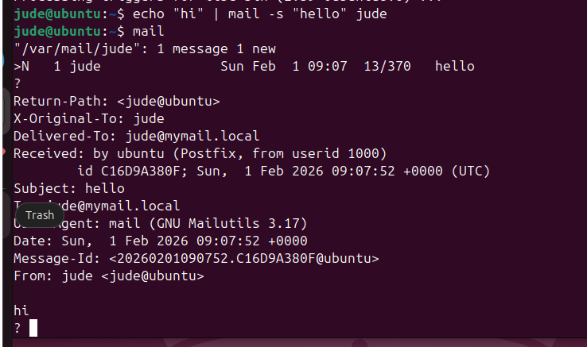
- jude → local Linux user (receiver)

4. Reading the Mail
The mailbox was opened using:
mail

The received message showed:
- Subject: hello
- Message body: hi
- Delivered locally by Postfix
This confirmed that the SMTP server was working correctly.

What I Learned
- What SMTP is and how it works at a basic level
- How Postfix acts as an SMTP server
- How local mail delivery works in Linux
- How to send emails from the command line
- How to read and understand mail headers
- How background system processes (like unattended upgrades) can affect installations

Understanding the Lock Issue (dpkg lock)
While installing Postfix, the system showed a message about:
- Could not get lock /var/lib/dpkg/lock-frontend
This happened because automatic updates (unattended-upgrades) were running in the background. After waiting, the installation continued normally.
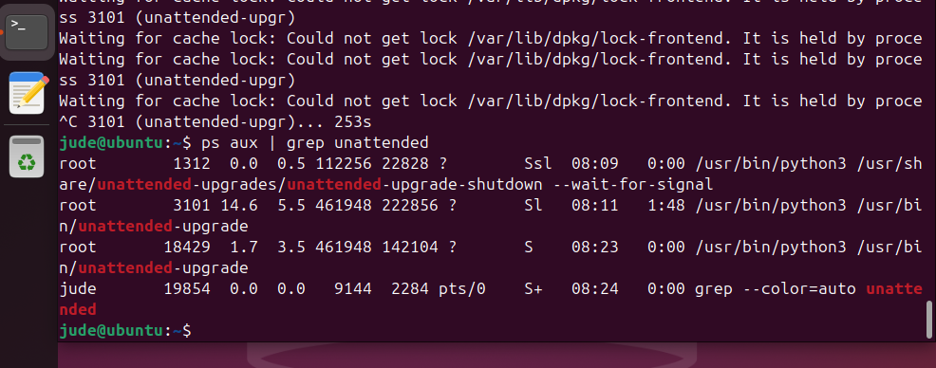

Cybersecurity Relevance
This exercise is important for cybersecurity because:
- Email servers are common attack targets
- Understanding SMTP helps in:
  - Email spoofing analysis
  - Phishing investigation
  - Mail server hardening
  - Incident response
Knowing how a mail server works makes it easier to secure it later.

Limitations of This Setup
- No encryption (no TLS)
- No authentication
- Not safe for internet use
- Only suitable for learning and lab environments

Conclusion
In this lab, I successfully set up a basic SMTP server using Postfix on Ubuntu and verified its functionality by sending and reading local emails. This hands-on practice improved my understanding of Linux mail systems and provided foundational knowledge useful for cybersecurity studies. This setup serves as a strong starting point for learning advanced topics such as mail server security, spam protection, and secure email communication.

