Overview
A next-generation Social Super App where users can connect, create, and engage — all in one platform.
Features include:
- Professional & social networking
- Photo sharing
- Video streaming
- Music listening
- Short-form video content (Vines/Reels)
- Digital payments
- Communities, messaging, and much more
Designed to bring social interaction, entertainment, and digital services together into one seamless ecosystem.

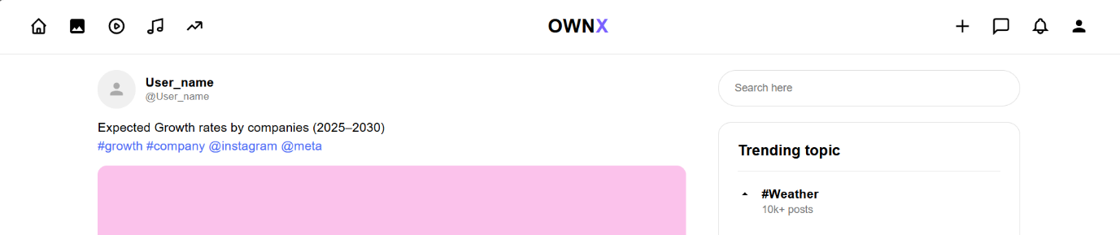

Approach
This platform is being designed as a privacy-focused, interest-driven Social Super App that combines networking, entertainment, communication, and digital services into one ecosystem.
Unlike traditional social media platforms that rely heavily on personal data and identity-based interactions, this platform follows a minimal-data onboarding approach by collecting only:
- Username
- Location
Additionally, user authentication includes a CAPTCHA verification system to reduce bots, fake accounts, and automated abuse during signup and login processes.
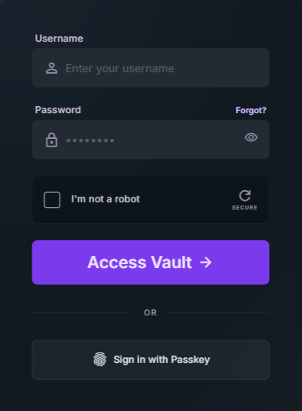

Major Concerns & Solutions
1. Fake Accounts, Spam & Harmful Content
Concern:
Minimal user information can increase:
- fake accounts
- spam
- trolling
- abusive behavior
- bot activity
Solution:
The platform plans to use:
- CAPTCHA-based authentication
- AI-assisted moderation systems
- behavior analysis
- reporting systems
- trust/reputation scoring
- automated content filtering
The goal is to maintain a safer and healthier community environment without excessive user surveillance.
2. Privacy & Security
Concern:
Users are increasingly concerned about:
- excessive tracking
- personal data misuse
- privacy violations
Solution:
The platform follows a privacy-first architecture using:
- minimal data collection
- secure infrastructure
- protected APIs
- authentication systems
- firewall protection
- encrypted systems
This reduces unnecessary exposure of sensitive user information.
3. Advertisement Targeting
Concern:
Traditional social media platforms rely heavily on invasive tracking for advertisements.
Solution:
Instead of aggressive tracking, the platform plans to use:
- user interests
- followed communities
- watched content
- engagement behavior
to provide relevant and less intrusive advertisements.
This creates a balance between:
- personalization
- monetization
- user privacy

What Are The Difference Between Old Social Media Platform And This Super Social Platform?

OLD SOCIAL MEDIA PLATFORMS | YOUR SUPER SOCIAL PLATFORM
Require large amounts of personal data | Collects only username and location
Identity-focused profiles | Interest-focused ecosystem
Separate apps for networking, music, streaming, messaging | All services integrated into one platform
Heavy tracking for ad targeting | Interest-based recommendations without aggressive tracking
Signup often requires email, phone, personal details | Minimal and faster onboarding
High dependency on followers and social status | Community and engagement focused
Bots and spam handled mostly after account creation | CAPTCHA authentication helps reduce bot activity during signup
Privacy concerns due to data collection | Privacy-first architecture with minimal data exposure
Users constantly switch between multiple platforms | Unified digital experience in one ecosystem
Algorithms mainly optimized for engagement time | Planned balance between engagement, privacy, and community quality
Content separated by platform type | Photos, videos, music, streaming, networking together
Many platforms expose too much user identity | Semi-anonymous and safer interaction model
Ads often feel invasive | Ads based on interests and engagement behavior
Communication sometimes secondary | Messaging and communities built-in
Platforms optimized for platform growth | Platform designed around user control and simplicity

