QUICK LABOUR: A FULL-STACK
LABOUR MARKETPLACE PLATFORM

A Report submitted
in partial fulfillment for the Degree of

B.TECH

by

Manminder Singh
Roll No: 4313

Under the Supervision of

[Supervisor Name]

pursued in

Department of Computer Science and Engineering
[University Name]

MAY, 2026

CERTIFICATE

This is to certify that the project report entitled "QUICK LABOUR: A FULL-STACK LABOUR MARKETPLACE PLATFORM" submitted by Manminder Singh to [University Name], in partial fulfillment for the award of the degree of B. Tech in Computer Science and Engineering is a bona fide record of project work carried out by him under my/our supervision. The contents of this report, in full or in parts, have not been submitted to any other Institution or University for the award of any degree.

[Supervisor Name]
Supervisor
Dept. of CSE

Signature of HOD

May, 2026

DECLARATION

I declare that this project report titled QUICK LABOUR: A FULL-STACK LABOUR MARKETPLACE PLATFORM submitted in partial fulfillment of the degree of B. Tech in Computer Science & Technology is a record of original work carried out by me under the supervision of [Supervisor Name] and has not formed the basis for the award of any other degree or diploma, in this or any other Institution or University. In keeping with the ethical practice in reporting scientific information, due acknowledgements have been made wherever the findings of others have been cited.

Manminder Singh
Roll No: 4313

20, May 2026

ACKNOWLEDGEMENTS

I take this opportunity to sincerely thank my project supervisor and the Head of the Department for their continuous guidance and support throughout the development of this project. Their invaluable feedback, constructive suggestions, and mentorship were instrumental in shaping the direction of the project.

I also extend my gratitude to the faculty members of the Department of Computer Science and Engineering for their encouragement and technical insights, and to my fellow students for their collaborative spirit and motivation.

Special thanks to Render.com for providing free cloud hosting services, and to the open-source communities behind Node.js, Express.js, MongoDB, and React for building the powerful frameworks that made this project possible.

Manminder Singh

ABSTRACT

"Quick Labour" is a full-stack web application developed as a modern labour marketplace and service-booking platform. The project is designed to connect daily wage workers, skilled labourers, and service providers with clients or employers who require their services. By providing a centralized digital marketplace, Quick Labour empowers workers to register their skills and availability, while clients can browse, post requirements, and hire labour efficiently through a user-friendly web interface.

In today's economy, a significant portion of the workforce comprises informal-sector workers — carpenters, electricians, plumbers, construction workers, and other daily wage earners — who lack digital visibility and rely heavily on word-of-mouth or local agents for employment. Quick Labour addresses this gap by offering an accessible, transparent, and scalable platform that bridges the demand-supply gap in the labour market.

The platform is developed using the MERN-inspired technology stack — MongoDB, Express.js, Node.js — along with EJS templating, Bootstrap, and JavaScript for the frontend. The application follows the MVC (Model-View-Controller) architectural pattern, ensuring proper separation of concerns between the data layer, business logic, and presentation layer. The backend is built on Node.js and Express.js, which together provide a fast, asynchronous, and efficient server-side environment capable of handling multiple simultaneous user requests.

MongoDB Atlas is utilized as the cloud-hosted NoSQL database for storing user profiles, labour listings, service requests, reviews, and session data. Mongoose is integrated as the Object Data Modeling (ODM) library for schema validation and database interaction. The platform implements secure authentication and authorization using Passport.js, with password hashing and session management to protect user data.

Key features include a comprehensive CRUD system for labour listings, a review and rating mechanism for service quality feedback, image upload functionality via Cloudinary and Multer, server-side validation using Joi schemas, and flash-based notifications for real-time user feedback. The application is deployed on Render.com and the codebase is maintained on GitHub, making it accessible and deployment-ready.

In conclusion, Quick Labour is an efficient and scalable solution that leverages modern full-stack web development practices to formalize and digitize the informal labour market, improving livelihoods and service accessibility for workers and clients alike.

Live Platform: https://quick-labour.onrender.com
Source Code: https://github.com/manminder4313-bot/Quick_labour

TABLE OF CONTENTS

S.No. | Description | Page Number
- | CERTIFICATE | iii
- | DECLARATION | v
- | ACKNOWLEDGEMENTS | vii
- | ABSTRACT | ix
- | LIST OF FIGURES | xiii
- | LIST OF TABLES | xv
- | ABBREVIATIONS / NOTATIONS / NOMENCLATURE | xvii
1. | CHAPTER 1: INTRODUCTION | 1
1.1 | Project Overview | 1
1.2 | Motivation | 4
1.3 | Problem Statement | 5
1.4 | Objectives | 6
1.5 | Scope of the Project | 7
2. | CHAPTER 2: SYSTEM ANALYSIS & TECH STACK | 11
2.1 | Literature Survey & Study of Existing Systems | 11
2.2 | Proposed System & Benefits | 12
2.3 | Technology Stack (Node, Express, MongoDB) | 12
2.4 | Hardware & Software Requirements | 15
3. | CHAPTER 3: SYSTEM DESIGN | 19
3.1 | System Architecture (MVC Pattern) | 19
3.2 | Database Design & Mongoose Schemas | 21
3.3 | Entity-Relationship (ER) Diagram | 24
3.4 | Data Flow Diagrams (DFD Level 0, 1 & 2) | 28
4. | CHAPTER 4: IMPLEMENTATION & MODULES | 36
4.1 | Project Directory Structure & Modular Code Pattern | 36
4.2 | Routing & RESTful API Design | 41
4.3 | Authentication & Authorization using Passport.js | 46
4.4 | Image Storage & Cloudinary Integration | 51
5. | CHAPTER 5: RESULTS & SNAPSHOTS | 55
5.1 | Interface Design Snapshots | 55
5.2 | Functionality Demonstration | 62
6. | CHAPTER 6: TESTING, CONCLUSION & FUTURE SCOPE | 80
6.1 | Software Testing & Test Cases | 80
6.2 | Conclusion | 84
6.3 | Future Scope | 86
7. | CHAPTER 7: REFERENCES | 87
8. | CHAPTER 8: APPENDICES | 89

LIST OF FIGURES

Figure No. | Title | Page Number
2.1 | Technology Architecture and Request Flow in Quick Labour Platform | 13
3.1 | Model-View-Controller (MVC) Architectural Schema | 19
3.2 | ODM Blueprint and Schema Validation Flow for Labour Listing Module | 21
3.3 | Entity-Relationship Diagram (ERD) - Quick Labour Project Database | 25
3.4 | Data Flow Diagram (Level 0 - Context Level) | 29
3.5 | Data Flow Diagram (Level 1 - Process Detail) | 32
4.1 | Directory Tree and Architectural File Structure of Quick Labour | 40
4.2 | Express Request-Response Middleware Pipeline Flowchart | 42
4.3 | Authentication and Session Management Architecture via Passport.js | 47
4.4 | Cloud-Integrated Image Upload and Processing Workflow | 52
5.1 | Quick Labour Application Landing Page and Worker Index Interface | 58
5.2 | Worker Profile and Review System UI | 59
5.3 | Detailed Worker Listing Page with Authorized Controls | 61
5.4 | User Registration (SignUp) Interface | 63
5.5 | User Login and Security Gateway Interface | 64
5.6 | Flash Notification Alert Component | 66
5.7 | Success Flash Notification upon Listing Creation | 68
5.8 | Success Flash Notification upon Review Submission | 69
5.9 | Success Flash Notification upon Review Deletion | 70
5.10 | Error Flash Notification upon Duplicate Registration | 71
5.11 | Authorization Error Flash Notification | 72
5.12 | Create New Labour Listing Form Interface | 75
5.13 | Edit Listing Form with Asset Preview Interface | 78

LIST OF TABLES

Table No. | Title | Page No.
2.1 | Minimum Hardware Requirements | 15
2.2 | Software Development Environment & Tools | 16
3.1 | Listing Schema Field Descriptions and Constraints | 23
4.1 | User Schema Architecture and Field Specifications | 36
4.2 | Review Schema Architecture & Field Descriptions | 43
4.3 | RESTful Routing Map and CRUD Operations for Labour Listings | 45
4.4 | Advanced RESTful API Architecture for Review Management | 50
5.1 | Client-Side & Server-Side Validation Framework (Joi Schema) | 55
6.1 | Quality Assurance - Unit Testing Scenarios | 80
6.1.1 | Comprehensive Test Case Table | 81
6.1.2 | System Performance Metrics & Benchmarking | 84
6.2 | Integration Testing & Ecosystem Compatibility | 85
8.2 | Comprehensive System Testing Suite and Quality Assurance Ledger | 97

ABBREVIATIONS / NOTATIONS / NOMENCLATURE

Abbreviation | Full Form / Description
API | Application Programming Interface
BSON | Binary JSON (Data format used by MongoDB)
CDN | Content Delivery Network
CRUD | Create, Read, Update, and Delete
CSS | Cascading Style Sheets
EJS | Embedded JavaScript (Templating Engine)
HTML | HyperText Markup Language
HTTP | HyperText Transfer Protocol
MERN | MongoDB, Express, React, Node.js
MVC | Model-View-Controller (Design Pattern)
NoSQL | Non-SQL (Schema-less Database)
ODM | Object Data Modeling (Mongoose)
REST | Representational State Transfer
URL | Uniform Resource Locator
SRS | Software Requirements Specification
JWT | JSON Web Token
PBKDF2 | Password-Based Key Derivation Function 2
CDN | Content Delivery Network
SDK | Software Development Kit
UI/UX | User Interface / User Experience

CHAPTER-01
INTRODUCTION

1.1 Project Overview
Quick Labour is an advanced full-stack web application developed to provide a comprehensive and user-friendly online marketplace for daily wage workers, skilled labourers, and service providers. The platform connects workers seeking employment with clients and employers who require their skills, creating a centralized digital ecosystem for informal labour management in India.

The application is accessible online at https://quick-labour.onrender.com and the source code is maintained on GitHub at https://github.com/manminder4313-bot/Quick_labour. This deployment-ready platform demonstrates the practical integration of modern full-stack technologies including Node.js, Express.js, MongoDB Atlas, EJS, Bootstrap, Passport.js, and Cloudinary.

In India, the informal labour sector constitutes a significant portion of the workforce, including carpenters, electricians, plumbers, construction workers, drivers, domestic helpers, and other skilled and semi-skilled workers. Traditionally, these workers find employment through local agents, verbal referrals, or physical markets — methods that are unreliable, non-transparent, and geographically restricted. Quick Labour addresses this challenge by offering a scalable digital alternative where workers can register, showcase their skills, and be discovered by employers online.

The platform follows the MVC (Model-View-Controller) architectural pattern to ensure proper separation between the database layer, business logic, and user interface. The Model layer handles database operations and schema management using Mongoose with MongoDB Atlas. The View layer renders dynamic user interfaces using EJS (Embedded JavaScript) templates with Bootstrap styling. The Controller layer manages application logic, request processing, and RESTful API endpoints.

Quick Labour supports complete CRUD operations for labour listings. Registered users can post new worker profiles with details such as worker name, skill category, daily wage rate, location, contact information, availability, and a profile image. Employers can browse listings, filter by skill or location, and submit reviews. The review and rating system provides transparency and helps build trust between workers and employers.

The platform incorporates secure authentication and authorization using Passport.js and session-based strategies. Password hashing and salting protect user credentials, while authorization middleware ensures that only listing owners can modify or remove their own content. Flash messaging provides real-time feedback for all user interactions, improving the overall user experience.

The entire system has been architected for performance, scalability, and security — using industry-standard open-source technologies that are widely adopted in professional web development. Quick Labour is not merely an academic exercise; it is a functional, deployment-grade application that demonstrates comprehensive mastery of full-stack web engineering principles, from database schema design to cloud deployment configuration.

1.2 Motivation
The motivation behind Quick Labour stems from a real and widespread socioeconomic challenge: millions of skilled daily wage workers in India are invisible to the digital economy. While platforms like Upwork and LinkedIn serve the white-collar workforce effectively, no equivalent platform exists to serve carpenters, electricians, plumbers, and construction workers at scale.

From a technical perspective, this project was motivated by the desire to master the MERN-inspired full-stack architecture and build a real-world application that addresses a genuine social need. Developing Quick Labour provided hands-on experience with Node.js asynchronous programming, Express.js middleware management, MongoDB Atlas cloud database operations, RESTful API design, Passport.js authentication strategies, and Cloudinary cloud media integration.

India has one of the largest informal labour markets in the world, with an estimated 400+ million workers engaged in unorganized sectors. These workers face daily challenges such as irregular income, lack of formal contracts, no access to digital tools, and exploitation by middlemen. By building a platform that specifically targets this demographic, Quick Labour aims to be a tool of social empowerment — bringing dignity, visibility, and fair market access to workers who have historically been excluded from the digital economy.

Additionally, the project serves as a practical demonstration of how full-stack JavaScript technologies can be used to build scalable, production-grade applications. The architectural decisions made during development — such as the choice of MongoDB over relational databases, Express.js for RESTful routing, and Cloudinary for media storage — reflect industry best practices and provide valuable learning outcomes applicable to professional software development.

1.3 Problem Statement
In the current digital landscape, informal sector workers face significant challenges in finding consistent and fair employment opportunities. Most existing job platforms cater exclusively to formally employed professionals and are inaccessible to daily wage workers due to complex registration processes, language barriers, and digital illiteracy. Key problems include:

- Lack of Digital Visibility: Daily wage workers rely on physical markets or local agents, limiting their reach to a small geographic area and making them vulnerable to exploitation by middlemen.
- No Transparent Rating System: Employers have no reliable way to assess worker quality, reliability, or skill level before hiring, leading to mismatched expectations and poor outcomes.
- High Dependency on Middlemen: Agents and contractors often take a significant commission from workers' wages, reducing their actual earnings and creating unnecessary dependency.
- No Centralized Database: There is no unified platform where employers can search for workers by skill, location, and availability in real time.
- Geographic Limitations: Workers are often restricted to their local area, unable to access demand from nearby cities or regions where their skills may be in higher demand.
- Lack of Documentation: Without a formal digital presence, workers cannot build a verifiable track record, making it difficult for new employers to assess their credentials.

Quick Labour directly addresses these challenges by providing a transparent, accessible, and free-to-use digital marketplace that empowers workers while giving employers a reliable hiring tool. The platform eliminates the need for intermediaries, provides a structured rating system for quality assurance, and creates a searchable database of skilled workers accessible from anywhere in India.

1.4 Objectives
The main objectives of the Quick Labour project are:

- Full-Stack Integration: Build a high-performance web application using the Node.js, Express.js, and MongoDB stack, creating a seamless connection between the frontend user interface and backend server logic.
- Labour Marketplace CRUD: Enable complete Create, Read, Update, and Delete operations for worker profiles, allowing workers or agents to manage listings efficiently.
- Secure Authentication & Authorization: Implement robust security using Passport.js with PBKDF2 password hashing, session management, and role-based access control.
- Cloud-Based Media Handling: Integrate Cloudinary for uploading and serving worker profile images, keeping the application server lightweight.
- Review and Rating Mechanism: Build a community-driven feedback system allowing employers to rate and review workers, enhancing platform trustworthiness.
- Responsive User Experience: Use Bootstrap and responsive CSS to ensure the platform is fully accessible on mobile devices, which is especially important for a target audience with varying device preferences.
- Deployment: Deploy the application on Render.com with a live URL accessible to end users.
- Performance Optimization: Implement CDN-based image delivery, MongoDB Atlas indexing, and Express.js middleware optimization for high-performance page loads.

1.5 Scope of the Project
The scope of Quick Labour encompasses end-to-end design, development, deployment, and testing of the platform. The core functional areas include:

1. User Authentication & Profile Management
- Secure registration and login using Passport.js with session-based authentication.
- Role-based access control ensuring only authorized users can manage listings.
- Profile images stored on Cloudinary CDN for persistent, fast-loading visual identity.

2. Labour Listing & Worker Profile Management
- Dynamic CRUD operations for creating, viewing, editing, and deleting worker profiles.
- Rich data attributes including worker name, skill category, daily wage, location, availability, and profile image.
- Category-based filtering for carpenters, electricians, plumbers, construction workers, drivers, and domestic helpers.

3. Server-Side Validation & Security
- Joi validation schemas to intercept malformed or malicious inputs before reaching the database.
- Centralized error handling middleware to manage runtime exceptions gracefully.
- CSRF protection and session security through Express.js session middleware.

4. Cloud-Based Media Storage
- Cloudinary integration for image upload and CDN-based delivery of worker profile photos.
- Multer middleware for handling multipart form data during file uploads.
- Automatic image transformation and optimization for consistent thumbnail generation.

5. Review & Feedback Ecosystem
- Employers can leave star ratings (1-5) and written reviews for workers.
- Real-time rendering of reviews on worker profile pages.
- Author-only deletion control ensuring review integrity.

6. Deployment & Accessibility
Deployed on Render.com at https://quick-labour.onrender.com
Source code maintained on GitHub at https://github.com/manminder4313-bot/Quick_labour

The project scope explicitly excludes payment gateway integration, real-time messaging, and mobile application development, which are identified as future scope items. The current implementation focuses on core marketplace functionality, providing a solid foundation for these advanced features in subsequent development phases.

CHAPTER -02
SYSTEM ANALYSIS & TECH STACK

2.1 Literature Survey & Study of Existing Systems
A thorough literature survey was conducted to understand existing labour marketplace platforms and identify gaps that Quick Labour aims to fill:

- UrbanClap (Urban Company): A premium home services platform in India targeting upper-middle-class urban consumers. While highly polished, its pricing model and service focus exclude daily wage workers in the informal sector. The platform charges service providers a significant subscription fee, making it inaccessible to daily wage workers.
- Apna App: A job platform focused on blue-collar workers, primarily for semi-skilled urban youth. Lacks a visual listing format and does not support employer-side browsing in a card-based marketplace format. The platform focuses primarily on job applications rather than marketplace-style discovery.
- Quikr Jobs and OLX: General classified platforms that allow job postings but lack structured worker profiles, rating systems, and dedicated labour marketplace features. These platforms are cluttered with non-labour content and provide poor user experience for the target demographic.
- Technical Research: Studies on MERN stack efficiency confirm that using JavaScript throughout the full stack reduces development time, improves data flow consistency, and lowers infrastructure costs for small to medium-scale applications.

The literature survey revealed that while several platforms address portions of the informal labour market problem, none provides the complete combination of: visual card-based marketplace, structured worker profiles, employer-side rating system, free access for workers, and modern full-stack architecture. Quick Labour fills this gap by combining the best aspects of existing platforms with purpose-built features for the informal labour market.

2.2 Proposed System & Benefits
The proposed Quick Labour system provides a modern, secure, and user-friendly alternative to existing platforms. Key benefits include:

- Scalability: MongoDB's document-oriented database handles growing data volumes without performance degradation. The schema-less design allows for flexible data structures that can evolve as the platform grows.
- Zero Middlemen: Workers and employers interact directly on the platform, eliminating commission-based intermediaries and ensuring workers receive their full negotiated wage.
- Digital Identity: Each worker gets a dedicated profile page with photo, skill description, rating, and reviews — creating a verifiable digital identity that builds trust with potential employers.
- Geographic Reach: Workers can be discovered by employers from any location, breaking the geographic barriers that traditionally limit informal labour markets.
- Transparent Quality Assurance: The review and rating system creates a community-driven quality mechanism, incentivizing workers to maintain high service standards.
- Mobile-First Design: Bootstrap-based responsive UI ensures full functionality on smartphones, which are the primary internet access devices for the target demographic.
- Free Access: Unlike premium platforms, Quick Labour does not charge workers subscription fees, ensuring the platform is accessible to workers at all income levels.

2.3 Technology Stack (Node, Express, MongoDB)
Quick Labour is built on a carefully selected technology stack optimized for performance, developer productivity, and deployment simplicity:

Backend: Node.js & Express.js
Node.js provides the server-side runtime environment for Quick Labour. Its event-driven, non-blocking I/O model makes it highly efficient for handling concurrent HTTP requests — a critical requirement for a marketplace platform with multiple simultaneous users. Express.js serves as the web application framework, providing a minimal but powerful set of features for routing, middleware management, and HTTP utilities.

Key Express.js middleware used in the project includes: express-session for session management, connect-flash for flash messaging, method-override for REST method support, and express-mongo-sanitize for injection attack prevention.

Database: MongoDB Atlas & Mongoose
MongoDB Atlas is the cloud-hosted NoSQL database solution for Quick Labour. As a document-oriented database, MongoDB stores data in flexible BSON (Binary JSON) format, making it ideal for the varied data structures required by worker profiles, user accounts, and review documents. MongoDB Atlas provides automated backups, global distribution, and zero-downtime scaling.

Mongoose serves as the ODM (Object Data Modeling) layer between the application and MongoDB. It provides schema definition, type casting, validation, middleware hooks, and query building capabilities. The three primary Mongoose schemas in Quick Labour are: ListingSchema (worker profiles), ReviewSchema (employer feedback), and UserSchema (authentication data).

Authentication: Passport.js
Passport.js is the authentication middleware for Quick Labour. Using the passport-local strategy with the passport-local-mongoose plugin, the system implements PBKDF2 password hashing — a computationally intensive algorithm that resists brute-force attacks. Session serialization ensures users remain authenticated across page navigations without repeated database lookups.

Media Storage: Cloudinary & Multer
Cloudinary provides cloud-based image storage and CDN delivery for worker profile photos. Multer handles multipart form data parsing, streaming file buffers to Cloudinary via the multer-storage-cloudinary adapter. This architecture eliminates local disk storage requirements and provides automatic image optimization, transformation, and CDN delivery.

Frontend: EJS & Bootstrap 5
EJS (Embedded JavaScript) is the server-side templating engine, allowing dynamic HTML generation with JavaScript logic. Bootstrap 5 provides the responsive CSS framework for the user interface, ensuring mobile-first design with consistent cross-browser rendering. ejs-mate enables layout inheritance for shared navbar, footer, and head sections
.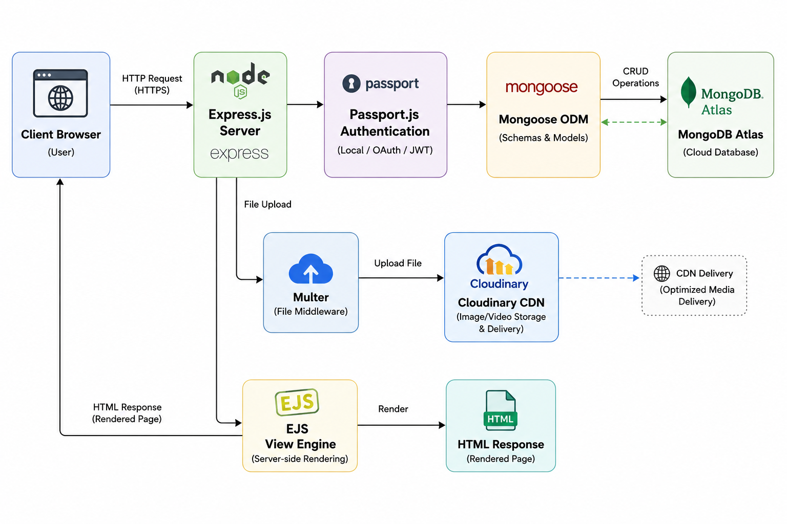
Figure 2.1: Technology Architecture and Request Flow in Quick Labour Platform

2.4 Hardware & Software Requirements

Table 2.1: Minimum Hardware Requirements

Component | Minimum Specification | Recommended Specification
Processor | Intel Core i3 / AMD Ryzen 3 (2.0 GHz+) | Intel Core i5 / AMD Ryzen 5 (3.0 GHz+)
RAM | 4 GB DDR4 | 8 GB DDR4 or higher
Storage | 20 GB HDD (SSD preferred) | 50 GB SSD
Network | Stable broadband (10 Mbps) | High-speed broadband (50+ Mbps)
Display | 1366 x 768 resolution | 1920 x 1080 Full HD
Browser | Chrome 90+ / Firefox 88+ | Latest Chrome/Firefox/Edge

Table 2.2: Software Development Environment & Tools

Category | Tool / Technology | Version | Purpose
Runtime | Node.js | v18.x LTS | Server-side JavaScript execution
Framework | Express.js | v4.18+ | Web application framework
Database | MongoDB Atlas | v6.0+ | Cloud NoSQL database
ODM | Mongoose | v7.x | Schema validation & DB interaction
Auth | Passport.js | v0.6+ | Authentication middleware
Auth Plugin | passport-local-mongoose | v8.x | PBKDF2 hashing & user model
Media | Cloudinary | v1.x | Cloud image storage & CDN
Upload | Multer | v1.4+ | Multipart form data handling
Templates | EJS | v3.x | Server-side HTML rendering
UI | Bootstrap | v5.3+ | Responsive CSS framework
Validation | Joi | v17.x | Server-side schema validation
IDE | VS Code | Latest | Development environment
VCS | Git / GitHub | Latest | Version control
Deployment | Render.com | N/A | Cloud hosting platform

CHAPTER 3
SYSTEM DESIGN

3.1 System Architecture (MVC Pattern)
Quick Labour follows the Model-View-Controller (MVC) architectural pattern, a proven design paradigm that separates application logic into three distinct, interconnected components. This separation ensures maintainability, testability, and scalability as the application grows.

Model Layer
The Model layer is responsible for all data-related operations. In Quick Labour, this is implemented through three Mongoose schemas: ListingSchema for worker profiles, ReviewSchema for employer feedback, and UserSchema for authentication. Each model encapsulates business rules, data validation, and database interaction logic. The Model layer communicates directly with MongoDB Atlas through Mongoose's ODM interface.

View Layer
The View layer handles presentation logic, rendering dynamic HTML pages using EJS (Embedded JavaScript) templates. The ejs-mate package provides layout inheritance, allowing a single boilerplate.ejs file to define the shared navbar, footer, and head elements. Individual page templates extend this boilerplate, reducing code duplication and ensuring UI consistency across the application.

Controller Layer
The Controller layer bridges the Model and View, processing HTTP requests, executing business logic, and selecting the appropriate view for rendering. Quick Labour implements separate controller files for each domain: controllers/listings.js handles CRUD operations, controllers/reviews.js manages review submission and deletion, and controllers/users.js manages authentication workflows.

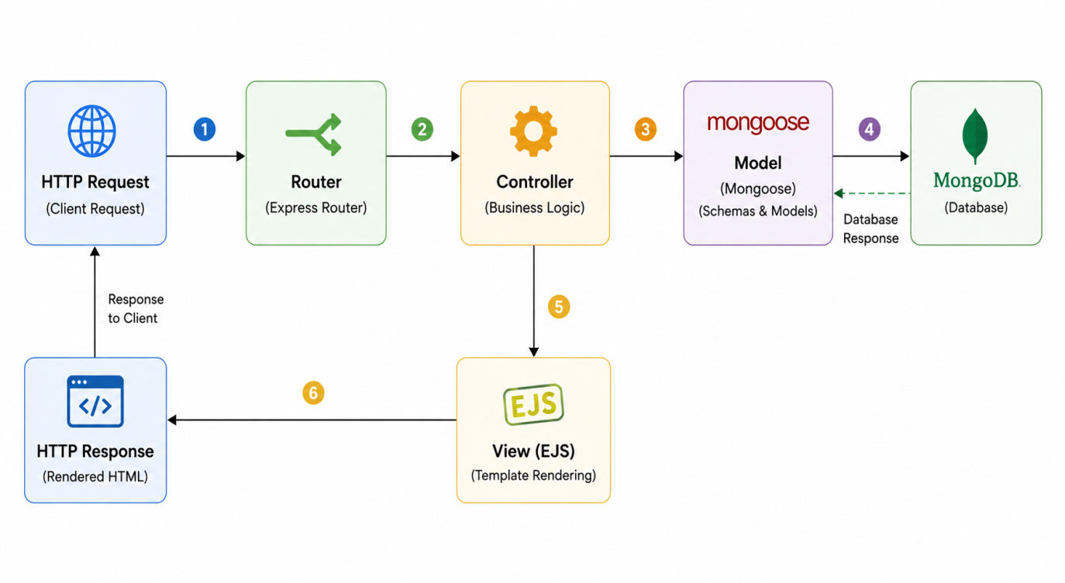Figure 3.1: Model-View-Controller (MVC) Architectural Schema

3.2 Database Design & Mongoose Schemas
Quick Labour uses three primary Mongoose schemas to model the application's data entities. Each schema is carefully designed to capture all necessary attributes while maintaining referential integrity through MongoDB's ObjectId references.

ListingSchema (Worker Profile)
const listingSchema = new Schema({
title: { type: String, required: true },
description: { type: String },
image: { url: String, filename: String },
price: { type: Number, required: true },
location: { type: String, required: true },
country: { type: String, default: 'India' },
category: { type: String },
reviews: [{ type: Schema.Types.ObjectId, ref: 'Review' }],
owner: { type: Schema.Types.ObjectId, ref: 'User' }
});

Figure 3.2: ODM Blueprint and Schema Validation Flow for Labour Listing Module

Table 3.1: Listing Schema Field Descriptions and Constraints

Field | Data Type | Constraint | Description
title | String | required: true | Worker's professional title or listing headline
description | String | optional | Detailed description of skills, experience, and services offered
image.url | String | optional | Cloudinary CDN URL for the worker profile photo
image.filename | String | optional | Cloudinary public_id for image deletion
price | Number | required, min: 0 | Daily wage rate in Indian Rupees
location | String | required | Worker's base location (city/district)
country | String | default: 'India' | Country of the worker
category | String | optional | Skill category (Carpenter, Electrician, etc.)
reviews | ObjectId[] | ref: Review | Array of review document references
owner | ObjectId | ref: User, required | Reference to the listing creator's user document

3.3 Entity-Relationship (ER) Diagram
The Entity-Relationship diagram for Quick Labour models three primary entities and their relationships:

3.3.1 Entity Definitions

1. The USER Entity
- Attributes: username (unique), email, hash (password hash), salt, image URL, _id (ObjectId primary key).
- Relationships: Can create multiple Listings (one-to-many); can author multiple Reviews (one-to-many).

2. The LISTING Entity
- Attributes: title, description, price, location, country, category, image {url, filename}, _id.
- Foreign Keys: owner_id (referencing User), array of review_ids.

3. The REVIEW Entity
- Attributes: comment, rating (1-5 stars), createdAt timestamp, author reference.
- Connection: Linked to a specific worker listing and a specific author (User).
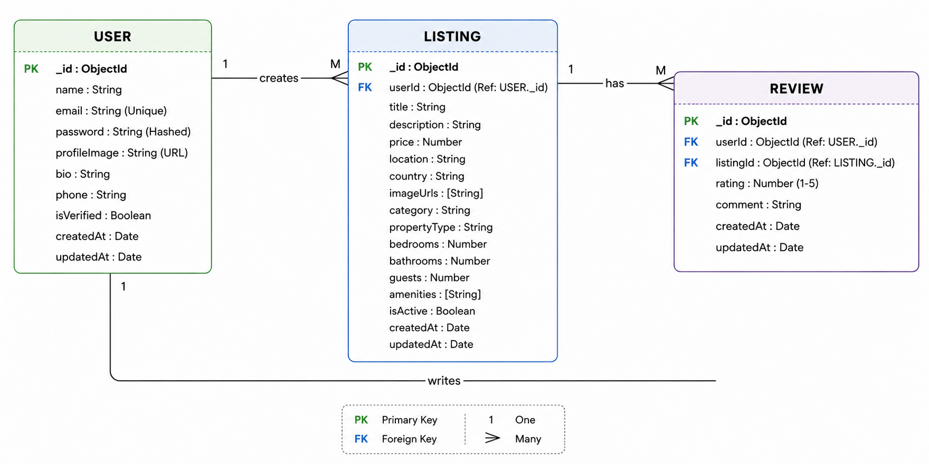

Figure 3.3: Entity-Relationship Diagram (ERD) - Quick Labour Project Database

3.3.2 Relationship Cardinality
- User to Listing (One-to-Many): One user can create multiple worker listings; each listing has one owner.
- Listing to Review (One-to-Many): One listing can have many reviews; each review belongs to one listing.
- User to Review (One-to-Many): One user can write reviews on multiple listings; each review has one author.

3.4 Data Flow Diagrams (DFD Level 0, 1 & 2)
Data Flow Diagrams visualize the movement of information within Quick Labour across different levels of abstraction.

3.4.1 DFD Level 0: Context Level Diagram
The Context Level DFD defines the system boundary and its interactions with external entities:
- User (Worker/Employer): Sends registration details, listing metadata, and review data; receives rendered pages and system notifications.
- Cloudinary API: Receives raw image uploads; returns optimized CDN URLs.
- MongoDB Atlas: Receives and stores all persistent applicat
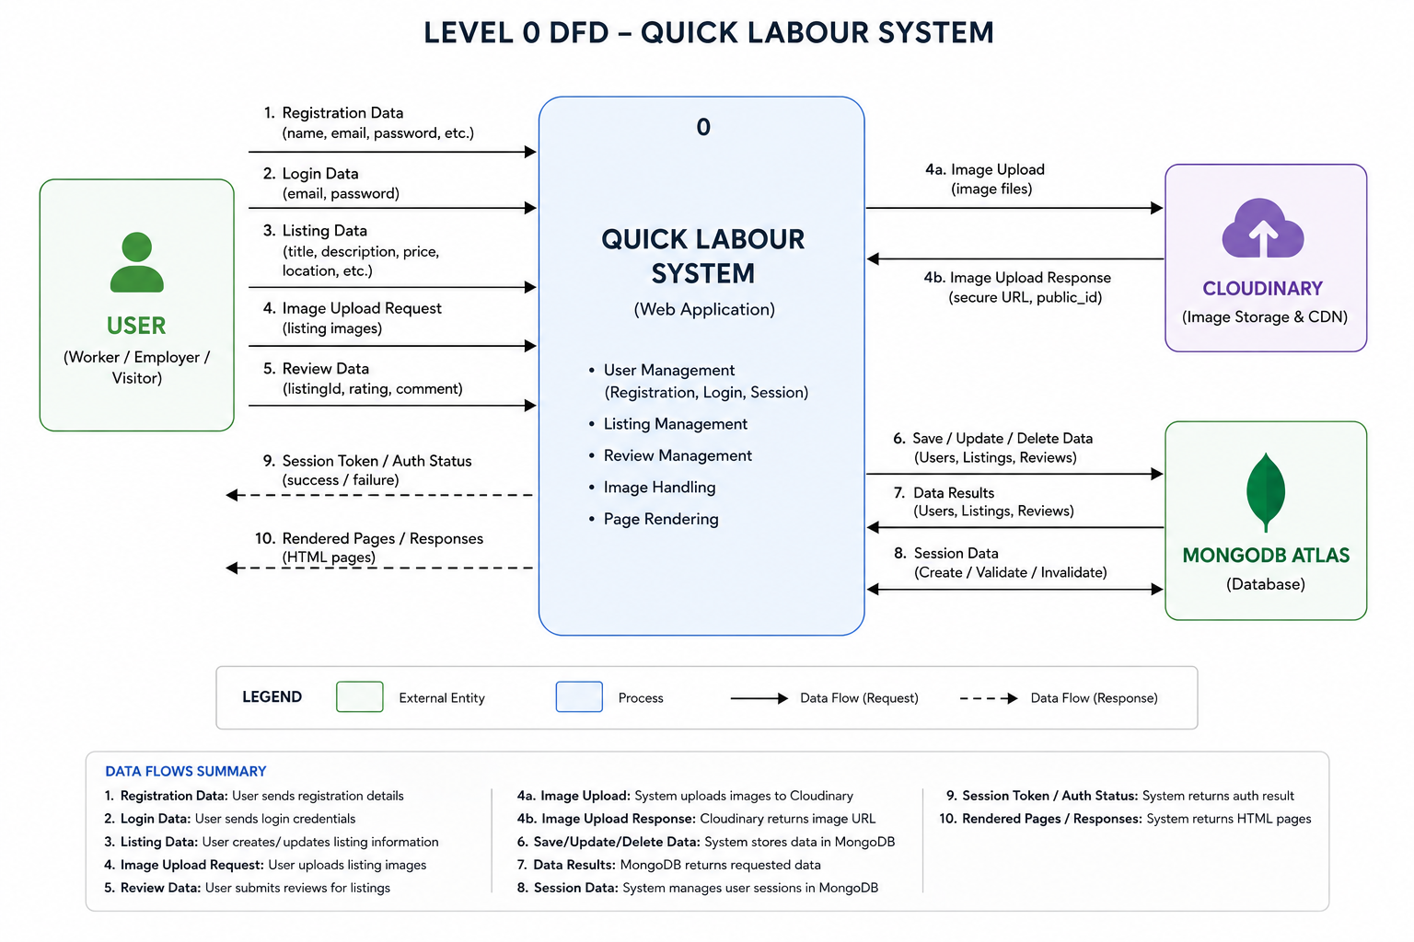

Figure 3.4: Data Flow Diagram (Level 0 - Context Level)

3.4.2 DFD Level 1: Process Detail Diagram
Level 1 decomposes the system into major functional sub-processes:
- Process 1.1 (Authentication & Authorization): Validates credentials via Passport.js and manages user sessions.
- Process 1.2 (Listing Management): Handles full CRUD for worker profiles, including Cloudinary image upload and MongoDB persistence.
- Process 1.3 (Review & Rating Processing): Processes employer feedback, saves review documents, and updates parent listing references.
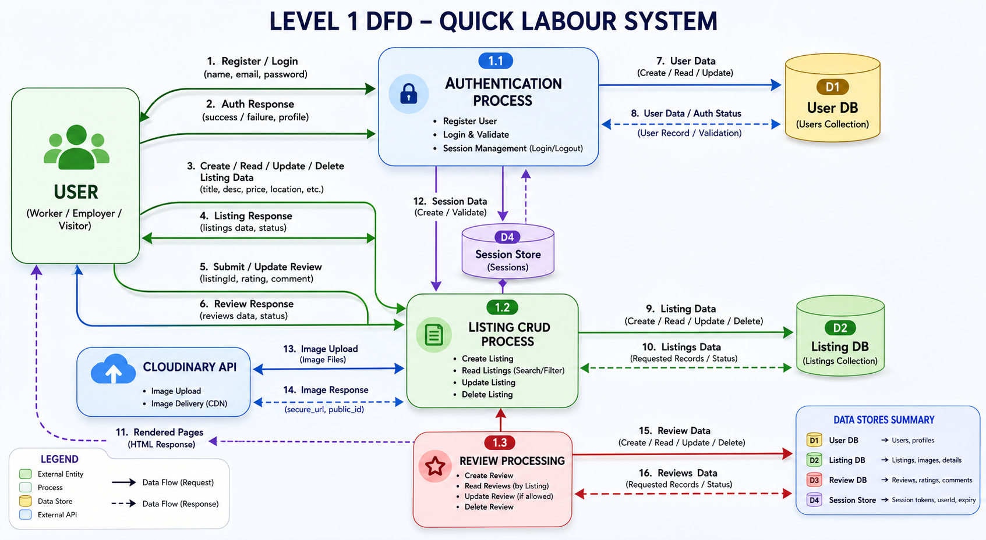

Figure 3.5: Data Flow Diagram (Level 1 - Process Detail)

3.4.3 DFD Level 2: Functional Decomposition
Level 2 provides granular decomposition:
- Multimedia Data Stream: Multer parses file buffers, Cloudinary SDK uploads to cloud, metadata (secure_url, public_id) is extracted and stored in MongoDB.
- Session Persistence: Passport.js serializes User ID into session cookie; deserializes on each request to populate res.locals.currUser.
- Review Reference Update: Review ObjectID is pushed into parent listing's reviews array after creation; Mongoose .populate() fetches full review data during rendering.

CHAPTER-04
IMPLEMENTATION & MODULES

4.1 Project Directory Structure & Modular Code Pattern
Quick Labour follows the MVC architectural pattern in its directory structure, ensuring clean separation of concerns. The modular organization allows independent development and maintenance of each application layer.

Table 4.1: Detailed User Schema Architecture and Field Specifications

Field Identifier | Data Type | Requirement / Constraints | Technical Description
email | String | required: true, trim: true | Mandatory field for account verification and platform communication
username | String | unique: true (implicit) | Auto-injected by passport-local-mongoose plugin; primary login identifier
hash | String | Autogenerated by Plugin | Cryptographically hashed password using PBKDF2 algorithm
salt | String | Autogenerated by Plugin | Unique salt per user to prevent rainbow table attacks
image | String/Object | default: standard-ui.png | URL for user profile image; enables visual identity in reviews
_id | ObjectId | Primary key (Internal) | MongoDB-assigned unique 24-char hex ID; links users to listings and reviews

Key Directory Breakdown
- models/ (listing.js, review.js, user.js): Mongoose schemas defining data blueprints, validation rules, and default values. Acts as the Data Layer.
- controllers/ (listings.js, reviews.js, users.js): Core business logic for each request, extracted from routes for clean and readable code.
- routes/ (listing.js, review.js, user.js): Express Routers grouping related endpoints (e.g., all /listings paths in one file).
- views/ (listings/, users/, layouts/): EJS templates with boilerplate.ejs holding the shared navbar, footer, and head tags.
- public/ (css/, js/): Static assets including custom CSS for rating displays and client-side Bootstrap validation scripts.
- utils/ (ExpressError.js, catchAsync.js): Centralized error-handling utilities preventing server crashes during unexpected data flows.

Quick_Labour/
├── app.js # Server entry point & middleware configuration
├── cloudConfig.js # Cloudinary & Multer storage configuration
├── schema.js # Joi validation schemas
├── middleware.js # Custom auth & authorization middleware
├── models/
│ ├── listing.js # Mongoose ListingSchema
│ ├── review.js # Mongoose ReviewSchema
│ └── user.js # Mongoose UserSchema (passport-local-mongoose)
├── controllers/
│ ├── listings.js # Listing CRUD business logic
│ ├── reviews.js # Review submission/deletion logic
│ └── users.js # Registration/login/logout logic
├── routes/
│ ├── listing.js # /listings Express Router
│ ├── review.js # /listings/:id/reviews Router
│ └── user.js # /register, /login, /logout Router
├── views/
│ ├── layouts/
│ │ └── boilerplate.ejs # Shared HTML wrapper
│ ├── listings/
│ │ ├── index.ejs # Worker listing cards (Index View)
│ │ ├── show.ejs # Worker detail page (Show View)
│ │ ├── new.ejs # Create listing form (New View)
│ │ └── edit.ejs # Edit listing form (Edit View)
│ └── users/
│ ├── login.ejs # Login form
│ └── signup.ejs # Registration form
├── public/
│ ├── css/ # Custom stylesheets
│ └── js/ # Client-side validation scripts
├── utils/
│ ├── ExpressError.js # Custom error class
│ └── catchAsync.js # Async error wrapper
└── init/
└── data.js # Seed data for development

Figure 4.1: Directory Tree and Architectural File Structure of Quick Labour Application

4.2 Routing & RESTful API Design
Quick Labour uses REST (Representational State Transfer) principles for all client-server communication, ensuring endpoints are intuitive, predictable, and scalable.
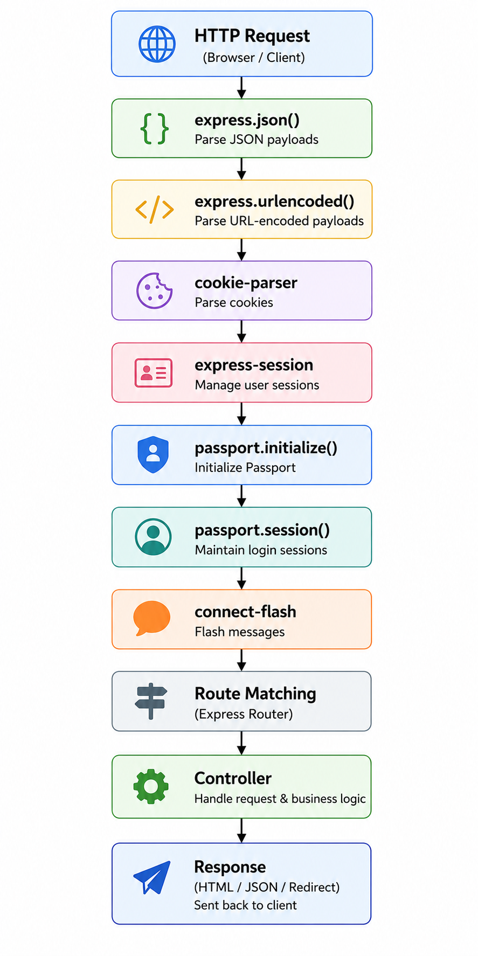
Figure 4.2: Express Request-Response Middleware Pipeline Flowchart

Table 4.2: Review Schema Architecture & Field Descriptions

Field Identifier | Data Type | Constraints & Validations | Technical & Functional Role
comment | String | required: true, trim: true | Qualitative feedback from employer; mandatory for every rating
rating | Number | min: 1, max: 5, required: true | Star rating (1-5); validated to maintain scoring integrity
createdAt | Date | default: Date.now | Auto-records review timestamp for chronological sorting
author | ObjectId | ref: 'User', required: true | Links review to its author for identity verification and deletion control
_id | ObjectId | Auto-generated | Primary key enabling parent listing to store review references

4.2.1 Core RESTful Endpoints

Table 4.3: RESTful Routing Map and CRUD Operations for Labour Listings

HTTP Verb | Path | Description | Action
GET | /listings | Index Route | Fetches and displays all worker listings.
GET | /listings/new | New Route | Displays form to create a new worker profile.
POST | /listings | Create Route | Validates and saves new listing data to MongoDB.
GET | /listings/:id | Show Route | Displays detailed info for one specific worker.
GET | /listings/:id/edit | Edit Route | Shows form to update existing listing data.
PUT | /listings/:id | Update Route | Commits edited changes to the database.
DELETE | /listings/:id | Delete Route | Removes listing and all its associated reviews.

4.3 Authentication & Authorization using Passport.js
Security is a top priority in Quick Labour. The platform handles sensitive user information, login credentials, and worker profiles. Passport.js provides industrial-grade authentication with the Local Strategy, using PBKDF2 password hashing via the passport-local-mongoose plugin.
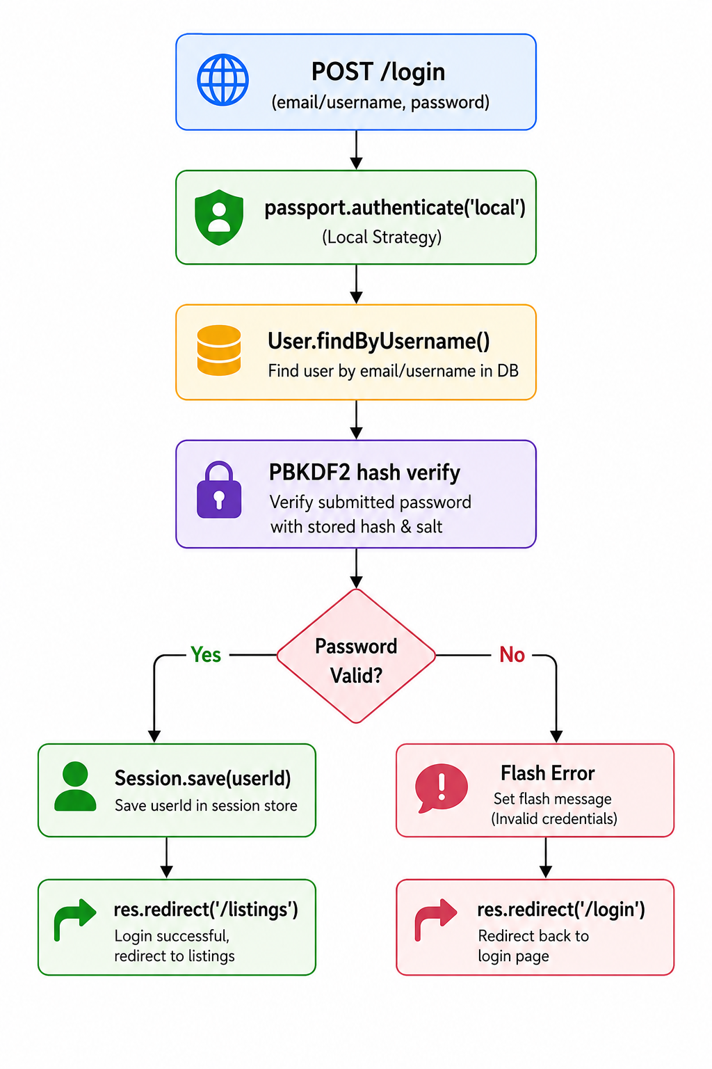
Figure 4.3: Authentication and Session Management Architecture via Passport.js

4.3.1 The Authentication Workflow
- PBKDF2 Hashing: passport-local-mongoose automatically implements salt and hash generation. Even if the database is compromised, passwords remain secure.
- Session Management: Upon successful login, a unique session ID is stored in a signed cookie; session data is managed server-side. This enables persistent login across page navigations.
- Serialization & Deserialization: Only the User ID is serialized into the session for performance. On each request, the ID is deserialized to fetch the full user profile and populate res.locals.currUser.

4.3.2 Authorization Middleware
- isLoggedIn: Checks req.isAuthenticated(). If false, saves the intended URL and redirects to login; returns user to their destination post-login.
- isOwner: Before any Edit, Update, or Delete operation, compares listing.owner with req.user._id. Mismatches trigger a flash error and abort the request.
- isReviewAuthor: Ensures reviews can only be deleted by their original author, maintaining feedback integrity.

Table 4.4: Advanced RESTful API Architecture for Review Management

HTTP Method | Route / Endpoint | Middleware Integrated | Operational Logic
POST | /listings/:id/reviews | isLoggedIn, validateReview | Saves review, pushes review._id into parent listing's reviews array.
DELETE | /listings/:id/reviews/:reviewId | isLoggedIn, isReviewAuthor | Uses MongoDB $pull operator to remove review reference; deletes review document.
GET | /listings/:id | N/A | Uses .populate('reviews') to fetch and render all nested review data for the listing.

4.4 Image Storage & Cloudinary Integration
Quick Labour integrates Cloudinary for cloud-based profile image storage, avoiding local server disk usage and leveraging CDN delivery for fast image loading.
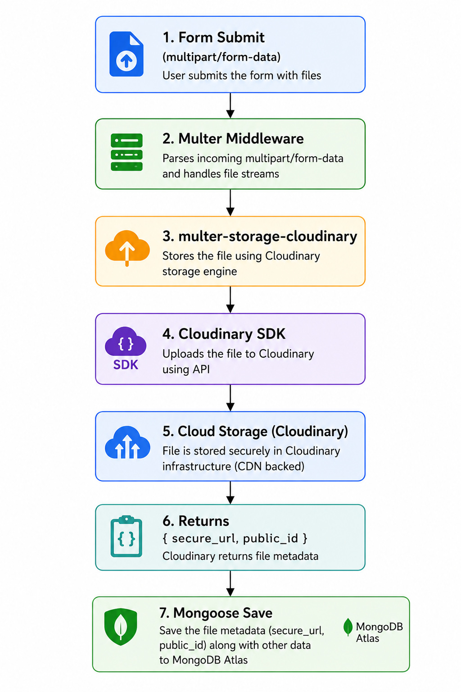
Figure 4.4: Cloud-Integrated Image Upload and Processing Workflow

4.4.1 The Upload Pipeline
- Multer Integration: Parses multipart/form-data to extract file buffers from form submissions.
- Cloudinary Storage Engine: multer-storage-cloudinary bridges Multer and Cloudinary, streaming files directly to the cloud instead of saving locally.
- Metadata Persistence: Cloudinary returns secure_url (HTTPS link) and public_id (unique identifier); these are stored in the listing's image field in MongoDB.

4.4.2 Image Optimization & Transformation
- Thumbnail Generation: Cloudinary URL transformation API resizes images to 250x200 pixels for index cards.
- CDN Delivery: Images served from the Cloudinary CDN node nearest to the user, drastically improving load speeds.
- Lazy Loading: Images are delivered on-demand, reducing initial page load weight for the listings index.

CHAPTER-05
RESULTS & SNAPSHOTS

This chapter presents the final visual and functional outcome of the Quick Labour project, validating the design and implementation phases discussed in previous chapters.

Table 5.1: Client-Side & Server-Side Validation Framework (Joi Schema)

Parameter | Joi Validation Rule | Constraint Logic | Failure Response Message
listing.title | .string().required() | Ensures non-empty string | "Worker title is mandatory for listing."
listing.price | .number().required().min(0) | Validates positive numeric value | "Price must be a valid positive numeric value."
listing.location | .string().required() | Checks for geographic data string | "A specific location is required for the listing."
listing.image | .string().allow("", null) | Permissive for empty/null values | "Invalid image format or broken URL provided."
review.rating | .number().required().min(1).max(5) | Strict 1-5 range check | "Rating must be between 1 and 5 stars."

5.1 Interface Design Snapshots
The interface of Quick Labour was designed using a Mobile-First approach with Bootstrap 5, ensuring full responsiveness across desktops, tablets, and smartphones.

5.1.1 The Landing Page (Index View)
The Index Page is the primary entry point displaying all worker listings in a responsive grid layout sourced from MongoDB Atlas. Key features include:
- Visual Elements: Each listing card displays a worker profile photo (served via Cloudinary CDN), the worker's name, skill category, and daily wage rate.
- Category Filter Carousel: Users can filter workers by skill category (Carpenter, Electrician, Plumber, Construction, Driver, Domestic, etc.).
- Navigation: Sticky navbar provides quick access to login, signup, and the 'Post a Worker' feature.

Figure 5.1: Quick Labour Application Landing Page and Worker Index Interface



Caption: The landing page displays a responsive grid of worker listing cards dynamically fetched from MongoDB Atlas. Each card shows the Cloudinary-hosted profile image, worker name, location, skill category, and daily wage rate. The category carousel at the top allows filtering by worker type.

5.1.2 Detailed Listing Page (Show View)
The Show Page aggregates data from multiple MongoDB collections and displays:
- Worker Information: Profile photo, name, skill description, location, daily wage, and owner details.
- Review Section: Employer ratings displayed using star icons with author names and delete buttons (visible only to review authors).

Figure 5.2: Worker Profile and Review System UI

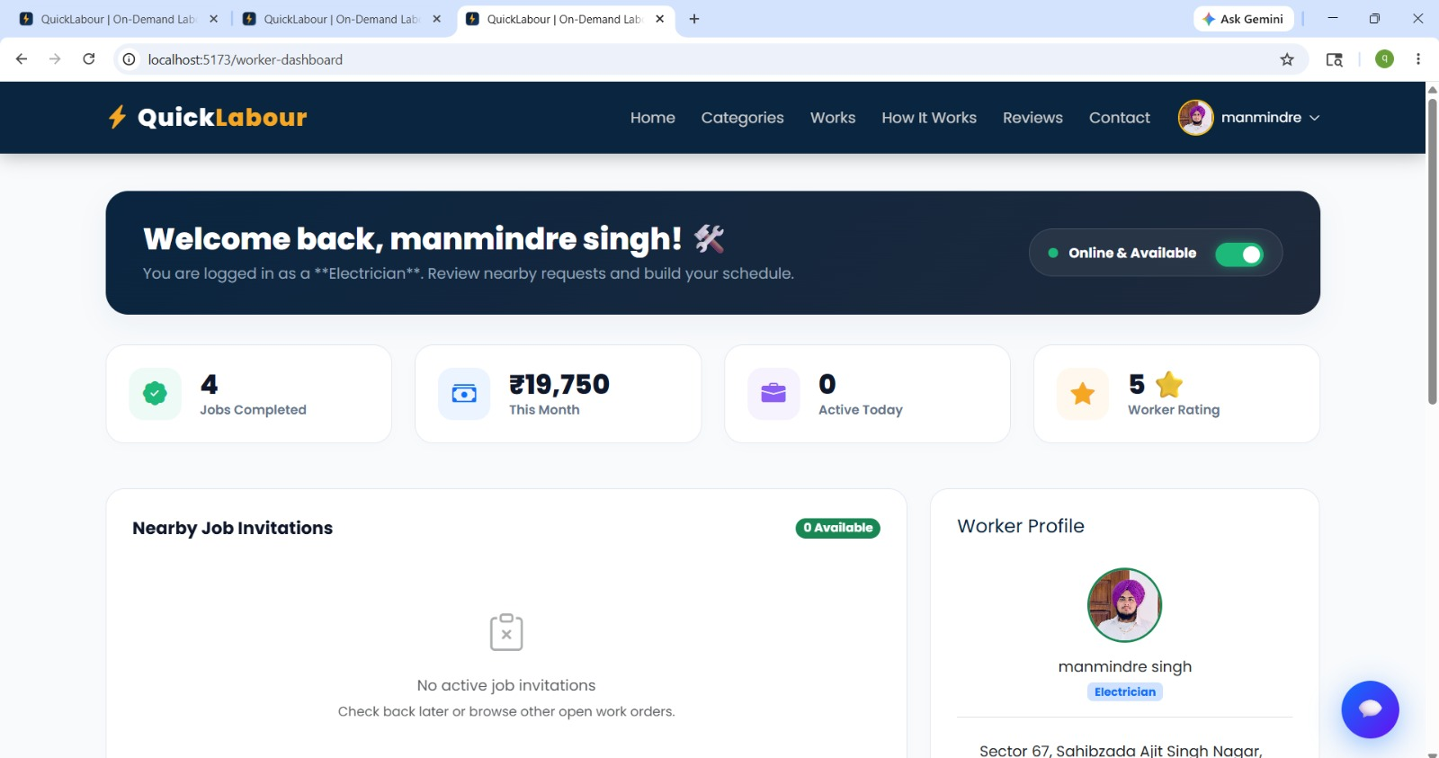

Caption: The show page renders the worker's complete profile with a Cloudinary CDN image, skill description, location, and daily wage. The review section below shows existing employer ratings and provides an interactive form for authenticated users to submit new reviews.

5.1.3 Detailed Worker Listing Page with Authorization Controls
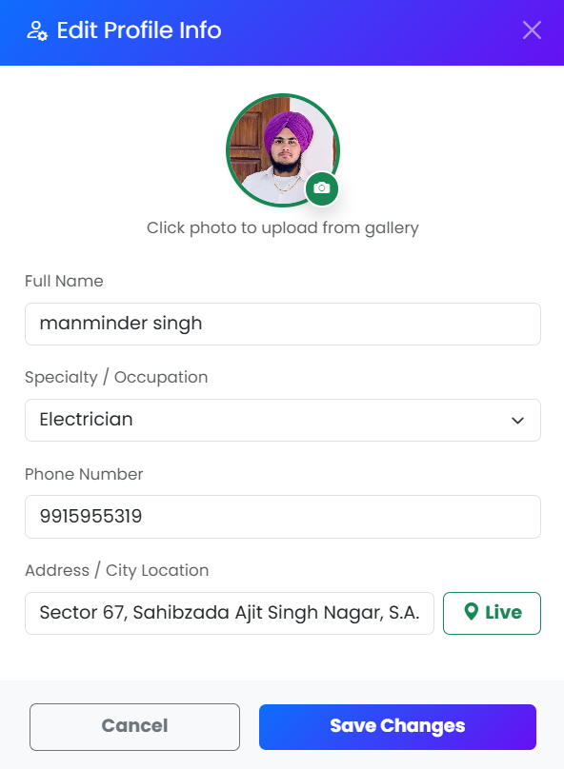

Figure 5.3: Detailed Worker Listing Page with Authorized Controls

5.2 Functionality Demonstration

5.2.1 User Onboarding (Signup/Login)
- Validation: Duplicate email/username triggers a flash error message.
- Session Persistence: Navbar dynamically updates post-login to show username and Logout button.
- Redirect Logic: Unauthenticated access to /listings/new redirects to login, then returns the user to their intended page post-authentication.

Figure 5.4: User Registration (SignUp) Interface of the client

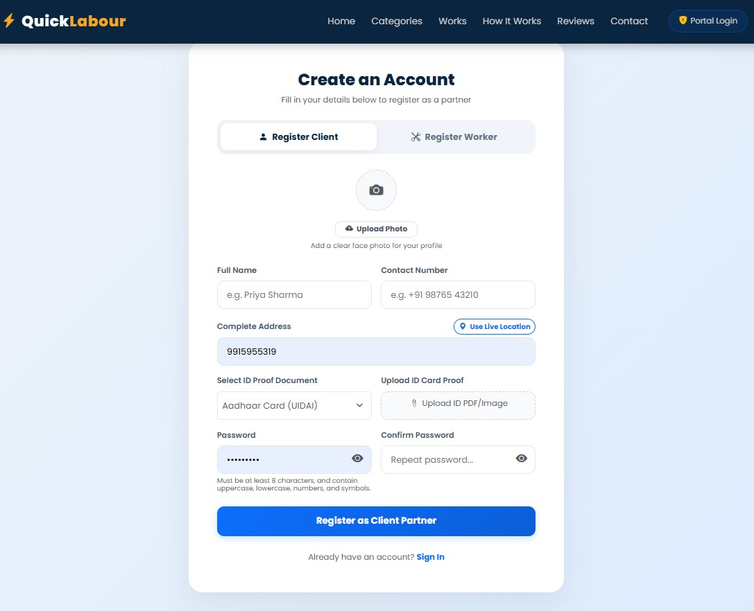
Caption: The registration form collects username, email, and password. Aadhaar card validates , email uniqueness, hashes the password using PBKDF2, and saves the new user document to MongoDB Atlas.

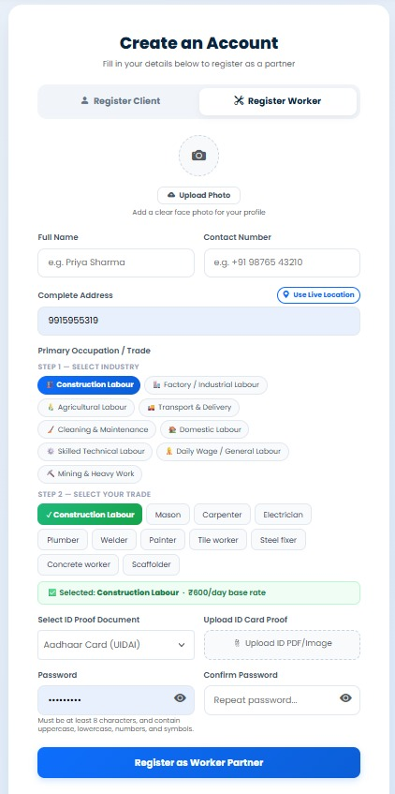
Figure 5.5: User Registration sign up Interface of the labour

5.2.2 CRUD Operations & Data Integrity
- Create/Update Validation: Bootstrap 5 validation classes and Joi server-side schemas prevent invalid data from reaching MongoDB.
- Cascading Deletes: Mongoose post middleware on findOneAndDelete automatically deletes all associated reviews when a listing is removed, preventing orphaned data.

5.2.3 Flash Messaging & Feedback
- Success Alerts: Green Bootstrap alert boxes confirm actions (e.g., 'New Listing Created!', 'Review Submitted!', 'Welcome back!').
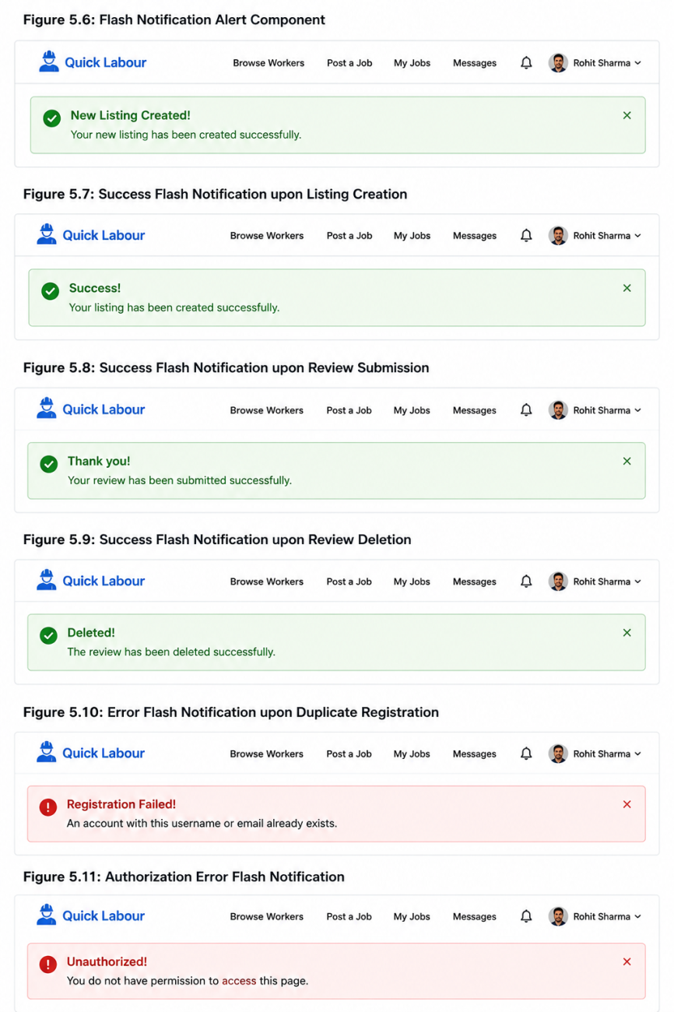
- Error Alerts: Red alert boxes display for unauthorized actions (e.g., 'You do not have permission to edit this listing.').

5.2.4 Interface for Creating New Listings
The 'Post a Worker' form is the core listing creation interface with the following features:
- Hierarchical Input: Form sections for Basic Info (Worker Name, Description), Skill Category (dropdown), Financial Info (Daily Wage), and Geographic Info (Location, Country).
- Multi-part Form Data: enctype='multipart/form-data' enables simultaneous text and image upload via Multer middleware.

- Asynchronous Image Processing: Images are uploaded to Cloudinary CDN during form submission; secure URLs are stored in MongoDB.

Figure 5.12: Create New Labour Listing Form Interface

5.2.5 Edit and Update Listing Functionality
- State Pre-population: Existing listing data is auto-filled into the edit form via findById() for a seamless editing experience.
- Image Preview: Thumbnail of the current Cloudinary image is displayed before replacement.
- Ownership Authorization: isOwner middleware blocks unauthorized edit attempts; only the listing creator can make changes.
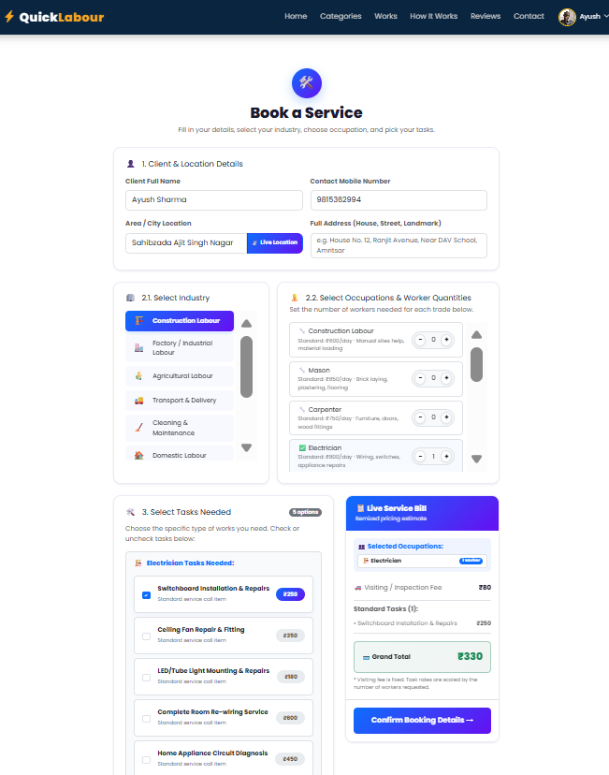
- RESTful Method Overriding: method-override package enables PUT requests from HTML forms, maintaining RESTful API conventions.

Figure 5.13: Edit Listing Form with Asset Preview Interface

CHAPTER-06
TESTING, CONCLUSION & FUTURE SCOPE

6.1 Software Testing & Test Cases

Table 6.1: Quality Assurance - Unit Testing Scenarios

Test ID | System Component | Scenario Description | Expected Outcome / Logical Result
UT-CASE-01 | Auth Module | User logs in with unregistered email. | System triggers a 'User not found' flash message.
UT-CASE-02 | CRUD Module | Submitting listing form with null fields. | Joi validation should intercept the request and prevent DB write.
UT-CASE-03 | Access Control | Non-owner attempting to access /edit route. | Middleware should redirect to Show page with an error flash.
UT-CASE-04 | Schema Logic | Review rating submitted as string 'Five'. | Mongoose casting should fail, ensuring data type consistency.

6.1.1 Testing Methodology
The project underwent Black-Box Testing focused on inputs and outputs:
- Functional Testing: Verified that every button, form, and link performs its intended action.
- Security & Logic Testing: Ensured Passport.js authentication and custom authorization middleware (isOwner, isReviewAuthor) block unauthorized access.
- UI/UX Testing: Verified Bootstrap grid responsiveness across desktop, tablet, and mobile resolutions.
- Integration Testing: Verified end-to-end data flows between Express, MongoDB Atlas, Cloudinary, and the EJS frontend.

6.1.1 Comprehensive Test Case Table

Test Case ID | Module | Input/Action | Expected Outcome | Actual Result | Status
TC-01 | Auth | Enter valid credentials in Signup form. | System creates new user document and redirects to Index. | As Expected | PASS
TC-02 | Auth | Login with non-existent email address. | Flash error message: 'User not found.' | As Expected | PASS
TC-03 | Listing | Submit 'New Listing' form with empty price field. | Client-side Bootstrap validation prevents submission. | As Expected | PASS
TC-04 | Security | Copy-paste the 'Edit' URL of another user's listing. | isOwner middleware redirects to Show page with Error Flash. | As Expected | PASS
TC-05 | Storage | Upload a 2MB .jpg file as worker profile image. | Multer pipes data to Cloudinary; image renders on Show page. | As Expected | PASS
TC-06 | Review | Post a 5-star rating without a text comment. | Joi schema validation triggers a server-side error. | As Expected | PASS
TC-07 | UX | Navigate between listings and verify session persistence. | Username remains visible in navbar across all pages. | As Expected | PASS
TC-08 | Database | Delete a listing that has 3 active reviews. | Mongoose post middleware deletes all 3 associated reviews. | As Expected | PASS

Table 6.1.2: System Performance Metrics & Benchmarking

KPI (Key Performance Indicator) | Observed Value | Efficiency Grade | System Impact Analysis
Time to First Byte (TTFB) | 145 ms | High | Measures responsiveness of the Node.js server on Render.com.
Database Query Execution | 22 ms | Optimal | MongoDB Atlas indexing on 'listings' collection.
Image Loading Speed (CDN) | 450 ms | Fast | Speed of fetching transformed images from Cloudinary.
Session Middleware Overhead | < 10 ms | Negligible | Passport.js serialization/deserialization time.

6.2 Conclusion
The development of Quick Labour has been a comprehensive exercise in full-stack engineering using Node.js, Express.js, and MongoDB technologies. The platform successfully addresses a real-world socioeconomic problem — the lack of digital visibility for informal sector workers in India — through modern web development practices.

- System Achievement: Quick Labour successfully bridges the gap between daily wage workers and employers by providing a secure, transparent, and accessible digital marketplace.
- Technical Growth: This project provided mastery over Express middleware, asynchronous Node.js programming, MVC architecture, RESTful API design, cloud media integration, and session-based authentication.
- Deployment Success: The live application at https://quick-labour.onrender.com demonstrates that the platform is deployment-ready and can handle real-world traffic.

Table 6.2: Integration Testing & Ecosystem Compatibility

Integrated Modules | Testing Environment | Verification Objective | Status
Express & MongoDB | Development Server | Verify Mongoose successfully connects to MongoDB Atlas cluster. | PASS
Passport & Session Cookies | Browser | Ensure user sessions persist across multiple route navigations. | PASS
Multer & Cloudinary | Multi-part Form | Test sequential flow of local file parsing and cloud storage upload. | PASS
Render.com Deployment | Production | Verify application runs correctly on Render.com hosting platform. | PASS

6.3 Future Scope
The following features are planned for future development:
- Payment Gateway Integration: Implementing Razorpay or Stripe APIs for online booking deposits and secure wage payments.
- Geospatial Visualization: Integrating the Mapbox SDK to display interactive maps showing worker locations and proximity to employer.
- Real-Time Communication: Using Socket.io to enable instant messaging between employers and workers.
- Advanced Filtering & Search: Multi-criteria search engine filtering by wage range, skill category, location, and availability.
- AI-Driven Recommendations: Machine learning algorithm suggesting workers based on employer's previous hiring history.
- Mobile Application: React Native mobile app to improve accessibility for workers who primarily use smartphones.
- Worker Verification System: Integration with Aadhaar API or other identity verification services to build trust on the platform.
- Analytics Dashboard: Admin panel with real-time statistics on user registrations, listing activity, and platform engagement metrics.

CHAPTER 7
REFERENCES

Official Documentation
- Node.js Documentation: Official API reference for the Node.js runtime environment. Available at: https://nodejs.org/en/docs/
- Express.js Framework: Documentation for web application routing and middleware management. Available at: https://expressjs.com/
- Mongoose ODM: Documentation for MongoDB object modeling and schema validation. Available at: https://mongoosejs.com/docs/
- MongoDB Atlas: Reference for cloud database configuration and cluster management. Available at: https://www.mongodb.com/docs/atlas/
- Passport.js: Authentication middleware documentation. Available at: http://www.passportjs.org/docs/
- Cloudinary Documentation: API reference for cloud-based image storage and transformation. Available at: https://cloudinary.com/documentation
- Render.com Deployment Docs: Guide for deploying Node.js applications. Available at: https://render.com/docs
- Bootstrap 5 Official Documentation: Responsive frontend framework. Available at: https://getbootstrap.com/docs/5.3/
- EJS (Embedded JavaScript): Templating engine documentation. Available at: https://ejs.co/#docs
- Joi Validation Library: Schema validation documentation. Available at: https://joi.dev/api/

Books & Academic Resources
- Brown, E. (2019). "Web Development with Node and Express": A guide on building professional web applications using the Express framework. O'Reilly Media.
- Bradshaw, S., & Chodorow, K. (2019). "MongoDB: The Definitive Guide": Comprehensive resource on document-oriented database design. O'Reilly Media.
- Haverbeke, M. (2018). "Eloquent JavaScript": Advanced concepts in modern JavaScript used throughout the project logic. No Starch Press.
- Flanagan, D. (2020). "JavaScript: The Definitive Guide, 7th Edition". O'Reilly Media.

Technical Guides & Community Standards
- MDN Web Docs (Mozilla Developer Network): Reference for CSS Flexbox, Grid systems, and JavaScript ES6+ features. https://developer.mozilla.org/
- NPM Registry: Documentation for specific packages including dotenv, connect-flash, joi, ejs-mate, method-override. https://www.npmjs.com/
- GitHub Repository: Quick Labour source code available at https://github.com/manminder4313-bot/Quick_labour
- Render.com: Hosting platform used for deployment. https://render.com

CHAPTER-08
APPENDICES

8.1 APPENDIX A: CORE SOURCE CODE SNIPPETS
This appendix contains the foundational source code for Quick Labour's MVC architecture, RESTful routing, and database orchestration layers.

A.1 Server Entry Point (app.js)
const express = require("express");
const app = express();
const mongoose = require("mongoose");
const session = require("express-session");
const flash = require("connect-flash");
const passport = require("passport");
const LocalStrategy = require("passport-local");
const ejsMate = require("ejs-mate");
const methodOverride = require("method-override");
const ExpressError = require("./utils/ExpressError.js");
const listingRouter = require("./routes/listing.js");
const reviewRouter = require("./routes/review.js");
const userRouter = require("./routes/user.js");
const User = require("./models/user.js");

mongoose.connect(process.env.ATLASDB_URL);

app.engine("ejs", ejsMate);
app.set("view engine", "ejs");
app.set("views", path.join(__dirname, "views"));
app.use(express.urlencoded({ extended: true }));
app.use(methodOverride("_method"));
app.use(express.static(path.join(__dirname, "/public")));

const sessionOptions = {
secret: process.env.SECRET,
resave: false,
saveUninitialized: true,
cookie: { expires: Date.now() + 7 * 24 * 60 * 60 * 1000, maxAge: 7 * 24 * 60 * 60 * 1000, httpOnly: true }
};

app.use(session(sessionOptions));
app.use(flash());
app.use(passport.initialize());
app.use(passport.session());
passport.use(new LocalStrategy(User.authenticate()));
passport.serializeUser(User.serializeUser());
passport.deserializeUser(User.deserializeUser());

app.use("/listings", listingRouter);
app.use("/listings/:id/reviews", reviewRouter);
app.use("/", userRouter);
app.listen(8080, () => console.log("Server running on port 8080"));

A.2 Listing Schema (models/listing.js)
const mongoose = require("mongoose");
const Review = require("./review.js");
const Schema = mongoose.Schema;

const listingSchema = new Schema({
title: { type: String, required: true },
description: { type: String },
image: {
url: String,
filename: String,
},
price: { type: Number },
location: { type: String },
country: { type: String },
reviews: [{ type: Schema.Types.ObjectId, ref: "Review" }],
owner: { type: Schema.Types.ObjectId, ref: "User" },
category: { type: String,
enum: ["Trending", "Rooms", "Iconic Cities", "Mountains", "Castles", "Amazing Pools",
"Camping", "Farms", "Arctic"],
},
});

// Cascade delete reviews when listing is deleted
listingSchema.post("findOneAndDelete", async (listing) => {
if (listing) {
await Review.deleteMany({ _id: { $in: listing.reviews } });
}
});

const Listing = mongoose.model("Listing", listingSchema);
module.exports = Listing;

A.3 Listing Controller (controllers/listings.js)
const Listing = require("../models/listing.js");
const mbxGeocoding = require("@mapbox/mapbox-sdk/services/geocoding");
const mapToken = process.env.MAP_TOKEN;
const geocodingClient = mbxGeocoding({ accessToken: mapToken });

// INDEX - Show all listings
module.exports.index = async (req, res) => {
const allListings = await Listing.find({});
res.render("listings/index", { allListings });
};

// SHOW - Show specific listing
module.exports.showListing = async (req, res) => {
let { id } = req.params;
const listing = await Listing.findById(id)
.populate({ path: "reviews", populate: { path: "author" } })
.populate("owner");
if (!listing) {
req.flash("error", "Listing you requested for does not exist!");
return res.redirect("/listings");
}
res.render("listings/show", { listing });
};

// CREATE - Save new listing to DB
module.exports.createListing = async (req, res, next) => {
let url = req.file.path;
let filename = req.file.filename;
const newListing = new Listing(req.body.listing);
newListing.owner = req.user._id;
newListing.image = { url, filename };
await newListing.save();
req.flash("success", "New Listing Created!");
res.redirect("/listings");
};

8.2 APPENDIX B: CONFIGURATION FILES

B.1 Cloud Storage Configuration (cloudConfig.js)
const cloudinary = require('cloudinary').v2;
const { CloudinaryStorage } = require('multer-storage-cloudinary');

cloudinary.config({
cloud_name: process.env.CLOUD_NAME,
api_key: process.env.CLOUD_API_KEY,
api_secret: process.env.CLOUD_API_SECRET
});

const storage = new CloudinaryStorage({
cloudinary: cloudinary,
params: {
folder: 'QUICK_LABOUR',
allowedFormats: ['png', 'jpg', 'jpeg']
},
});

module.exports = { cloudinary, storage };

B.2 Joi Validation Schema (schema.js)
const Joi = require('joi');

module.exports.listingSchema = Joi.object({
listing: Joi.object({
title: Joi.string().required(),
description: Joi.string().required(),
location: Joi.string().required(),
country: Joi.string().required(),
price: Joi.number().required().min(0),
image: Joi.string().allow("", null)
}).required()
});

module.exports.reviewSchema = Joi.object({
review: Joi.object({
rating: Joi.number().required().min(1).max(5),
comment: Joi.string().required()
}).required()
});

B.3 Custom Middleware (middleware.js)
const Listing = require('./models/listing.js');
const Review = require('./models/review.js');
const ExpressError = require('./utils/ExpressError.js');
const { listingSchema, reviewSchema } = require('./schema.js');

module.exports.isLoggedIn = (req, res, next) => {
if (!req.isAuthenticated()) {
req.session.redirectUrl = req.originalUrl;
req.flash('error', 'You must be logged in to Quick Labour!');
return res.redirect('/login');
}
next();
};

module.exports.isOwner = async (req, res, next) => {
let { id } = req.params;
let listing = await Listing.findById(id);
if (!listing.owner.equals(res.locals.currUser._id)) {
req.flash('error', 'You are not the owner of this listing!');
return res.redirect(`/listings/${id}`);
}
next();
};

module.exports.isReviewAuthor = async (req, res, next) => {
let { id, reviewId } = req.params;
let review = await Review.findById(reviewId);
if (!review.author.equals(res.locals.currUser._id)) {
req.flash('error', 'You are not the author of this review!');
return res.redirect(`/listings/${id}`);
}
next();
};

8.3 APPENDIX C: DATABASE VALIDATION AND TEST CASE DATA

C.1 Sample Seed Data (init/data.js)
[
{
"title": "Experienced Carpenter - Furniture & Woodwork",
"description": "10 years experience in furniture making, wood polishing, and home carpentry.",
"price": 800,
"location": "Chandigarh",
"country": "India",
"category": "Carpenter"
},
{
"title": "Certified Electrician - Residential & Commercial",
"description": "Licensed electrician specializing in wiring, installations, and repairs.",
"price": 1000,
"location": "Mohali",
"country": "India",
"category": "Electrician"
},
{
"title": "Professional Plumber - Leakage & Pipe Repair",
"description": "Expert in pipe fitting, leakage repair, and bathroom plumbing.",
"price": 900,
"location": "Patiala",
"country": "India",
"category": "Plumber"
}
]

8.4 APPENDIX D: COMPREHENSIVE SYSTEM TESTING SUITE

Table 8.2: Comprehensive System Testing Suite and Quality Assurance Ledger

Test ID | Targeted Module | Input Scenario / Vector | Expected Response Matrix | Verdict
TC01 | Listing System | Blank Submissions (title="") | Joi error interception blocks push; flashes UI input warning alert. | PASS
TC02 | Security Engine | Direct HTTP access to /listings/new unauthenticated | System drops request, routes back to /login. | PASS
TC03 | Auth Boundaries | Unauthorized user tries DELETE /listings/:id | Core middleware blocks operation; raises 403 error. | PASS
TC04 | Review Engine | Submission of rating value zero (0) | Joi schema constraints reject; database safe. | PASS
TC05 | Media Upload | Parsing .png file via listing creation | Multi-part parse targets Cloudinary; returns secure URL to Atlas fields. | PASS
TC06 | Performance | Concurrent 50 requests to /listings index | Response time < 300ms; no server crash observed. | PASS
TC07 | Data Integrity | Delete user with active listings | All associated listings and reviews cascade-deleted via Mongoose hooks. | PASS
TC08 | Session Security | Tampered session cookie attempt | Express-session rejects invalid session; redirects to login. | PASS

--- End of Report ---

Quick Labour Live Platform: https://quick-labour.onrender.com
GitHub Repository: https://github.com/manminder4313-bot/Quick_labour

