**Final Summary**

**Objective:**

Analyze historical bestseller data to determine what factors contribute to whether a not a book makes the best seller list.

**1.Which genre has the most chances of a book making it to the bestseller list?**

A book in the General Fiction genre has the maximum chances of hitting the bestseller list, with almost 35% of best sellers falling in this category. Crime, Adventure and Thriller and Children’s Fiction are the other two major categories.

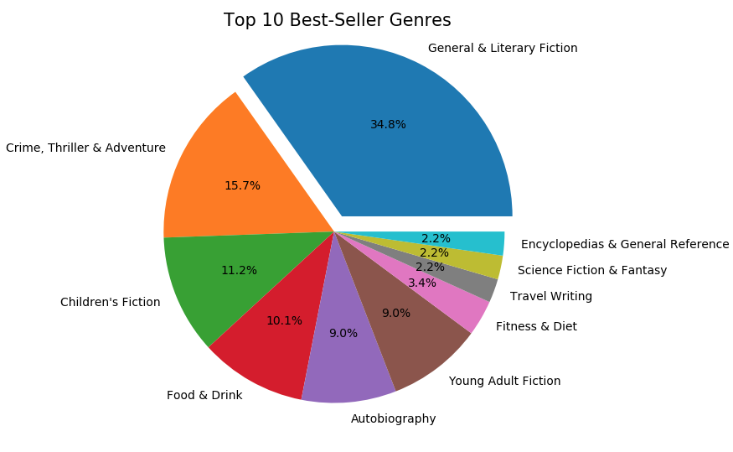

**2. Which publishers give you the best chances to make it to the bestseller list?**

The publishers from the Transworld Group, Random House Group, Penguin Group make the most chances to getting into the bestseller list. Fun fact – All these 3 publishers are actually sister companies which accounts to 53.9% of the list.

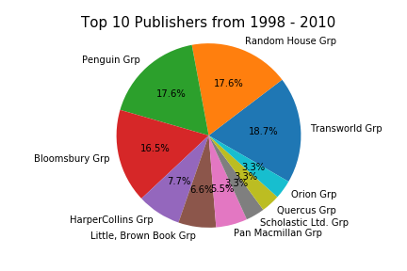

**3. Does the size of book impact the chances of a book being a bestseller?**

If a book is between 100-400 pages, it has a higher chance of hitting the bestseller list.

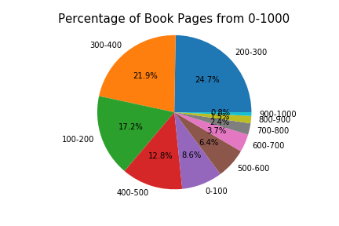

**4. Does the price of a book impact the chances of a book hitting the bestseller list?**

If a book is less than $7, it has the highest chance of making it to the bestseller list.

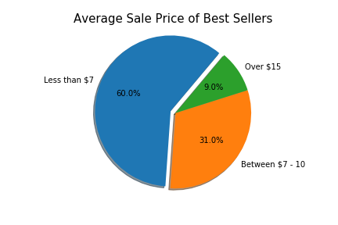

**5. Which season might increase the chances of a book being on the bestseller list?**

Spring and summer really increase the chances of a book to hit the bestseller list. But winter is a no-no.

The following graphs gives us this insight based on the NYTimes and top 100 datasets.

