**Introduction**

There is a huge impact on the society due to traffic accidents where there is a great costs of fatalities and injuries. In recent years, there is a increase in the researches attention to determine the significantly affect the severity of the drivers injuries which is caused due to the road accidents. Accurate and comprehensive accident records are the basis of accident analysis. the effective use of accident records depends on some factors, like the accuracy of the data, record retention, and data analysis. There is many approaches applied to this scenario to study this problem.

A recent study illustrated that the residential and shopping sites are more hazardous than village areas.as might have been predicted , the frequencies of the casualties were higher near the zones of residence possibly because of the higher exposure.A study revealed that the casualty rates among the residential areas are classified as relatively deprived and significantly higher than those from relatively affluent areas.

**REQUIREMENTS**

**Software:**Anaconda – Jupyter.

**Language:**Python3

**Modules Used:**

* numpy
* pandas
* from pandas.tools.plotting import scatter_matrix
* import matplotlib.pyplot as plt
* sklearn
* seaborn

Number of accident in an hour

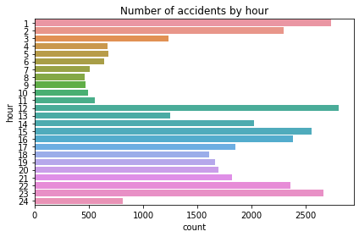

**Number of accident each month**

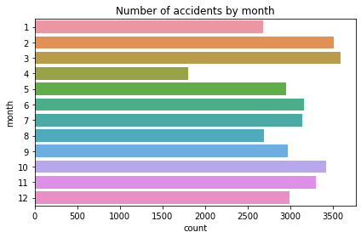

Number of accidents by weekday

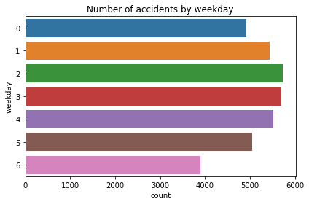

### **Accidents In High-Speed-Limit Areas Have More Casualties**

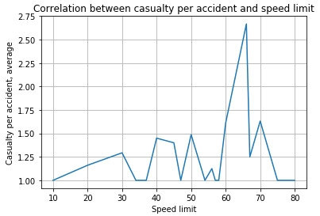

### **The Most Dangerous Time To Drive**

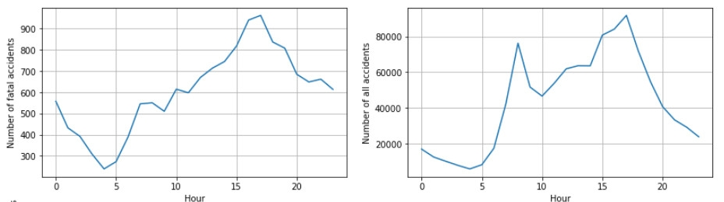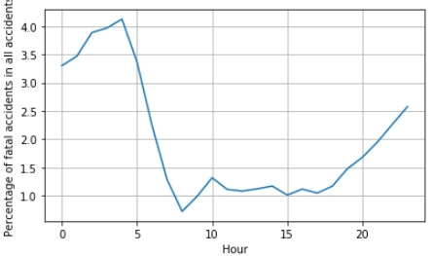

## PROPOSED SYSTEM AND METHODOLOGY

Models are created using accident data records which can help to understand the characteristics of many features like drivers behavior, roadway conditions, light condition, weather conditions and so on. This can help the users to compute the safety measures which is useful to avoid accidents. It can be illustrated how statistical method based on directed graphs, by comparing two scenarios based on out-of-sample forecasts. the model is performed to identify statistically significant factors which can be able to predict the probabilities of crashes and injury that can be used to perform a risk factor and reduce it.

Here the road accident study is done by analyzing some data by giving some queries which is relevant to the study. The queries like what is the most dangerous time to drive , what fractions of accidents occur in rural, urban and other areas. What is the trend in the number of accidents that occur each year,do accidents in high speed limit areas have more casualties and so on … These data can be accessed using Microsoft excel sheet and the required answer can be obtained. This analysis aims to highlight the data of the most importance in a road traffic accident and allow predictions to be made.