

Assignment: **Minimilitia||**

On

Date: November 26, 2017

Submitted to: Submitted by:

Prof. Przemslaw Pawluk Man Mohan - 101036048

Table of Contents Page no.

Detailed Game Description………………………………………………………………………………………………………..3

Controls Description………………………………………………………………………………………………………………….3

Interface Sketch…………………………………………………………………………………………………………………………4

Screen Descriptions……………………………………………………………………………………………………………………5

Enemies…………………………………………………………………………………………………………………………………….7

Scoring……………………………………………………………………………………………………………………………………….7

Sound Index……………………………………………………………………………………………………………………………….7

Art/Multimedia Index………………………………………………………………………………………………………………..7

**Detailed Game Description**

Mini Militia is a 2D action game where the players take the control of the Mini Militia through various actions including running, jumping over the enemy to avoid collision and getting killed. Their mission is to save the player and scoring more at the same time by avoiding collision with the cactus which acts as an enemy in the game.

|  |  |
| --- | --- |
| Background | The background and the characters of the game are very colorful giving a theme of forest with the wood panels on the floor and cactus plant. |
| Genre | The game is a two-dimensional action game where the Mini Militia player runs towards right direction avoiding a collision by jumping over the cactus plant and getting killed. |
| Platform | The game has been developed in Unity Software in C# programming language. |
| Player | The game has only 1 player named Mini Militia who runs and jumps over the obstacles tend to score the highest every time. |

**Controls Description**

Keyboard controls include Spacebar and double click on the mouse allows the player to perform jump action. Escape redirects to the Start game.

**Interface Sketch**

Start Screen



Game over Screen

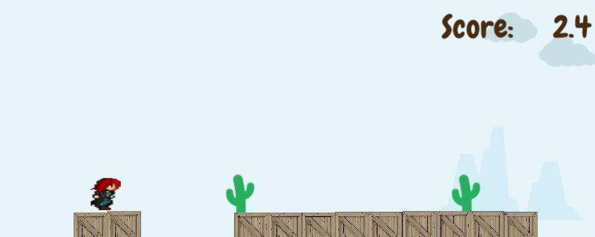

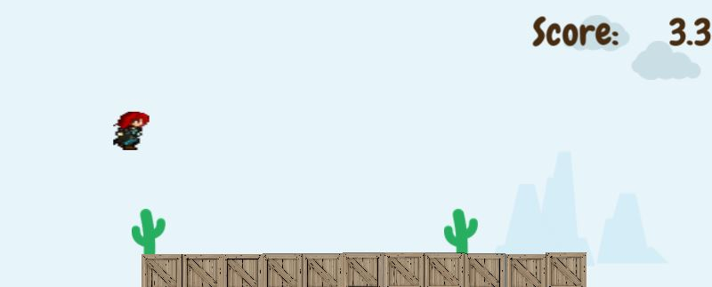

**Screen Descriptions**

|  |
| --- |
| Start State |
| C:\Users\notz\Desktop\game\s1.JPG |
| Gameplay State |
| C:\Users\notz\Desktop\game\s2.JPG |
| Game-End State |
| C:\Users\notz\Desktop\game\s3.JPG |

**Enemies**

Cactus plant acts as an enemy to the player in the Mini Militia game. While the player runs over the wood panels on the floor and comes across its enemy, every now and then, and jumps to avoid any collision with either spacebar on the keyboard or by double clicking on the mouse.

**Scoring**

The score of the player is based upon the velocity

The score of player is calculated according to enemy from which player survive from and space he covered.

**Sound Index**

Sound effects describe the state of the game ()

|  |  |
| --- | --- |
| Background Sound | Retro Comedy.ogg |
| Jump Sound | phaseJump1.ogg |
| Player Dies | jingles_SAX07.ogg |

**Art / Multimedia Index**

|  |  |
| --- | --- |
| C:\Users\notz\Desktop\game\MiniMilitiaII-master\Assets\Sprites\cactus.png | Enemy Image |
| C:\Users\notz\Desktop\game\MiniMilitiaII-master\Assets\Sprites\floor.png | Floor Image |
| C:\Users\notz\Desktop\game\MiniMilitiaII-master\Assets\Sprites\cloud4.png | Cloud 1 Image |
| C:\Users\notz\Desktop\game\MiniMilitiaII-master\Assets\Sprites\cloud5.png | Cloud 2 Image |
| C:\Users\notz\Desktop\game\MiniMilitiaII-master\Assets\Sprites\mountain1.png | Mountain 1 Image |
| C:\Users\notz\Desktop\game\MiniMilitiaII-master\Assets\Sprites\mountain2.png | Mountain 2 Image |
| C:\Users\notz\Desktop\game\MiniMilitiaII-master\Assets\Sprites\mountain3.png | Mountain 3 Image |