Capstone Project:

T20 Cricket Player Performance & Impact Analysis
Name: Anusuri Manmohan Sai | Domain: Sports Analytics & Predictive Modeling

Business Problem & Objective

- The Problem: In T20 cricket, raw volume stats (like total runs or wickets) can be misleading because players have vastly different opportunities based on their team role. Evaluating true player impact requires a balanced, data-driven approach.
- The Objective: To scrape real-world T20I player data, engineer a unified "Impact Score," and build a machine learning model that predicts player value based on their efficiency (strike rate/economy) rather than just volume.
- The Goal: Provide a functional, interactive dashboard that cricket scouts or team managers can use to evaluate global talent.

Data Acquisition, Cleaning & Feature Engineering

- Data Extraction: Scraped multi-page T20I batting and bowling statistics from 2015 to 2025 using Python `requests` and `BeautifulSoup`, handling dynamic pagination, request delays, and error retries. Merged datasets on player identity and year.

- Data Preprocessing: Replaced web artifacts (`-`) with standard nulls, cast numeric metrics into float/int types, and verified zero duplication.

- Handling Missing Values: Systemic missingness analysis proved that unplayed roles (e.g., pure batters having no bowling records) naturally resulted in structural nulls, which were filled with role-specific baseline zeroes.

- Feature Engineering: Developed a custom composite target variable called `impact_score` defined as: runs + (wickets × 20) to quantify multi-dimensional player value.

Exploratory Data Analysis & Key Findings

- Top-Heavy Performance: A small group of elite players generates the vast majority of runs and wickets, creating a highly skewed dataset.
- Feature Redundancy: Volume metrics like "Runs" and "Balls Faced" are nearly identical in behavior (97% correlation). To prevent our AI from getting confused, we isolated rate-metrics (strike rate, economy) for modeling.
- Clear Role Segmentation: Scatter plots cleanly group the dataset into three distinct archetypes: Specialist Batters, Specialist Bowlers, and All-Rounders.
- Global Expansion: T20I match volume exploded post-2021 (surpassing 5,000+ matches) due to the ICC granting global T20I status.

Machine Learning Architecture & Benchmark Results

- Methodology: Built a Random Forest Regressor to predict a player's impact_score.
- Preventing Data Leakage: Strictly excluded runs and wickets from the training features so the model wouldn't "cheat." The model learned entirely from participation volume and efficiency rates.
- Model Results:
  - Mean Absolute Error (MAE): 63.08 points.
  - R-Squared ($R^{2}$): 0.78 (The model successfully explains 78% of player performance variance).
  - Baseline Comparison: The model improved prediction accuracy by 57.4% compared to simply guessing the average player score.

Dashboard Simulation & Strategic Recommendations

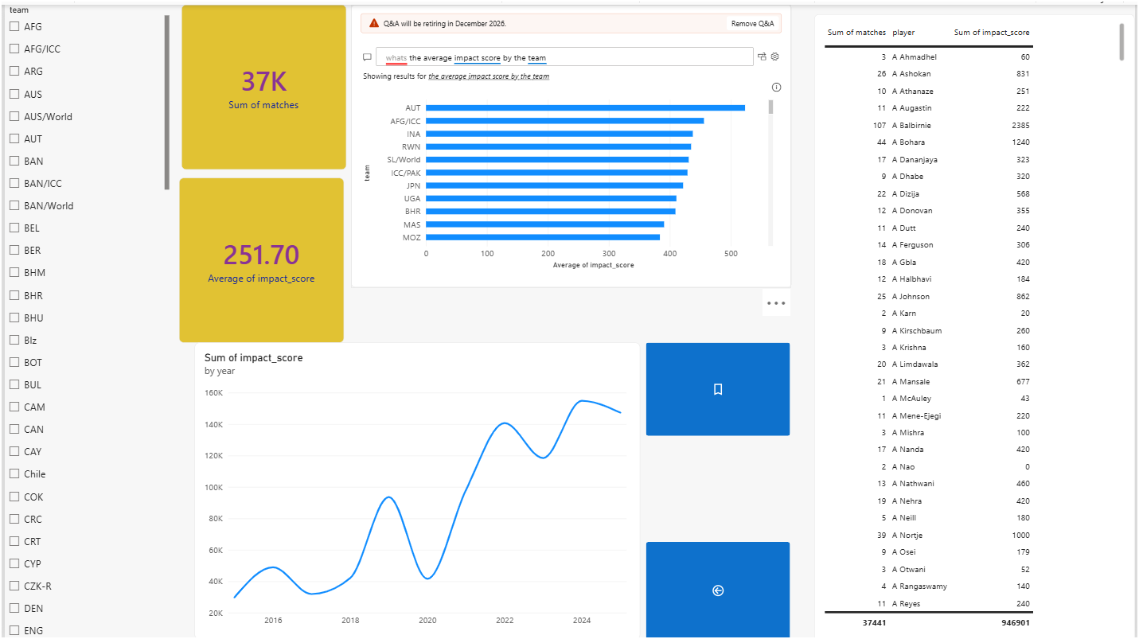
- Dashboard Features Implemented:
  - KPIs: Tracking average impact scores and player volume.
  - Row-Level Security (RLS): Tested a regional manager view restricted to Indian (IND) players.
  - Interactive Filters: Sync slicers to filter data by Team and Year across multiple pages.
  - Advanced Navigation: Built Bookmarks for quick-views and Drill-Through functionality to investigate specific team rosters.

Business Recommendations

- Focus on Efficiency Over Volume: When scouting talent, management should prioritize strike rate and economy. Our model proved these metrics are highly predictive of a player's overall impact score.
- Leverage the Associate Nations: With match volume quadrupling since 2021, the dashboard highlights massive untapped talent in smaller, emerging cricket nations.
- Dashboard Adoption: Team analysts can use the interactive Drill-Through features to instantly identify anomalous performances (players overperforming their expected AI predictions) for targeted scouting.
- Dashboard Features: Simulated an executive dashboard environment containing dynamic KPIs, Row-Level Security (RLS) regional slicing (e.g., isolating team `IND`), drill-through logic for annual deep-dives, and bookmark views for outlier detection (identifying 47 extreme model residual anomalies). Backend optimization pre-aggregated queries, rendering in 0.0048 seconds.

