PHYSICS 1600: Introduction to Modern Technology

Fall 2020

“Project Written Report”

Manmohan Badhesa

Introduction:

To program using MPLAB software in C programming language a PIC18F46K42 Microcontroller a burglar alarm system. Project will need a PIC18F46K42 microcontroller, breadboard, keypad, photo gate, a speaker, and a bicolour LED. You will also need a Computer with MPLAB, software plugins, and PUTTY software. The photo gate is an infrared sensor that can detect human and other solid discrete object motion.

Equipment:

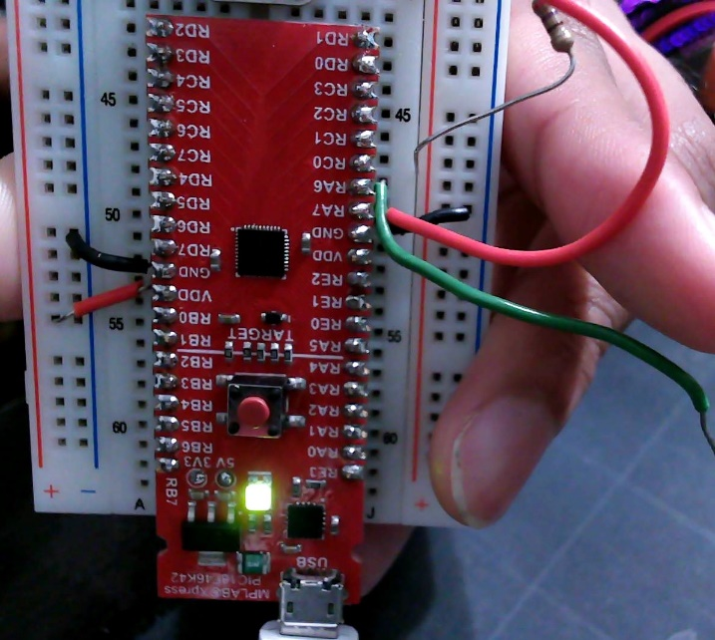

Picture 1. PIC18F46K42 Microcontroller on a breadboardA picture containing person, hand

Description automatically generated

Picture 2. Photo gate used as motion sensor.

Picture 3. Speaker

Picture 4. Speaker from the Side

Picture 5. Keypad with 7 pin connectors.

The code written provides a basic burglar alarm system that notifies when the system is activated, off, or triggered by an intruder. The code has separate functions that read in the input from either a keypad or photo gate. They both are button press inputs at different pins on the Microcontroller. The code then compares an input from the user to predefined passwords to turn on and off the alarm system.

A Pulse Width Modulation (PWM) was used for the speaker to make a sound. The function uses Timer2 to set the duty cycle of a signal. The duty cycle of a signal is the ratio of the signal being at a “on” level to the period of the signal. 50% duty cycle was used in this module, but the duty cycle value needed to be adjusted due to change of one parameter called PWMDC value (PR2) for PWM5. The new duty cycle value could be calculated by Duty Cycle % \* 4.0 \* (PR2+1)/100.0. The percentage of the duty cycle is used at 50% to get the required frequency of the signal which is at half the duty cycle.