ADSBee m1421
Ultra Low-Power Dual Band ADS-B Receiver Module

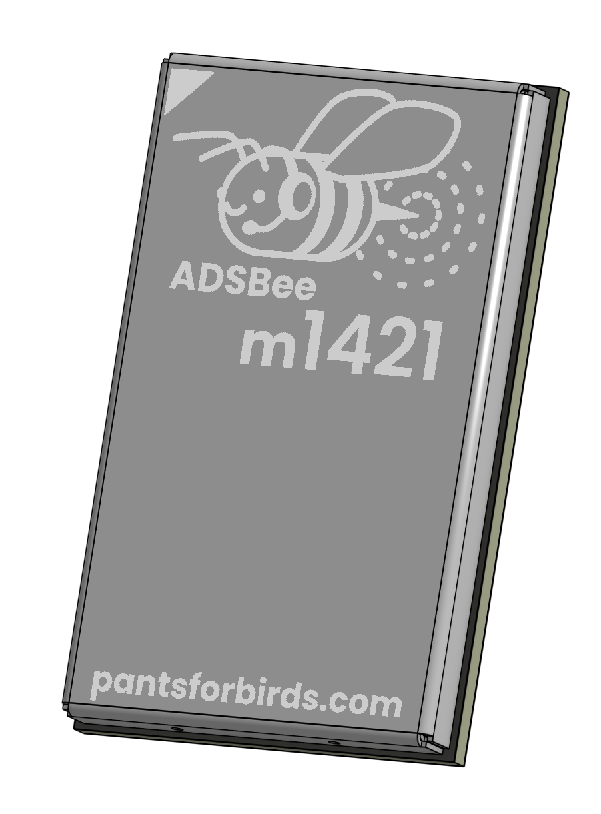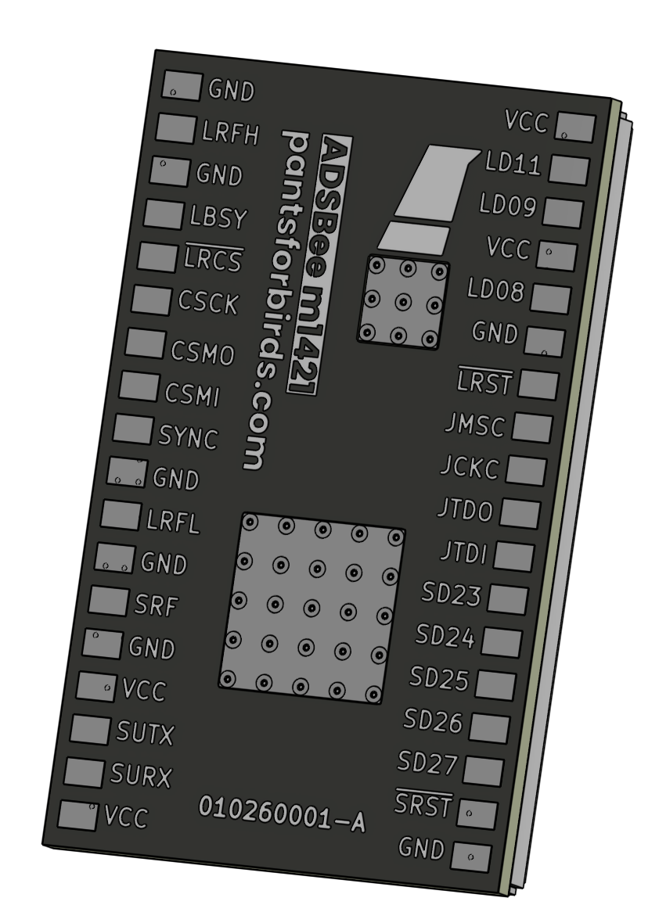

Features
- 1090MHz Mode S and ADS-B packet decoding.
- Tunable sub-GHz transceiver for UAT / additional protocols.
- Multiple output formats over UART: Raw Frames / ADSBee CSV / MAVLINK1 / MAVLINK2 / Mode S Beast / GDL90 / Aircraft JSON.
- Firmware updates over UART or JTAG.

Applications
- Aircraft detect and avoid for UAS
- ADS-B In for low-power systems

Quick Specs
Power Draw | 19mA* @ 1.8-3.3V
Minimum RF Input Power Level | Mode S: -90dBm*  UAT: -87dBm*
Dynamic Range | Mode S: 90dBm*  UAT: 87dBm*
Simultaneous Aircraft Tracks Supported | ≤400
Weight | 1.85g
* = subject to change during validation

Contents
Features 1
Applications 1
Quick Specs 1
Revision History 4
1 Overview 5
2 Pin Functions 6
2.1 SYNC Pin Functionality 7
3 Device Form Factor 8
3.1 Module Dimensions 8
3.2 Recommended Footprint 9
4 AT Commands 10
4.1 AT+BAUD_RATE 10
4.1.1 Set the Console Baud Rate 10
4.1.2 Query the Console Baud Rate 10
4.2 AT+BOOT_UART_BOOTLOADER 11
4.3 AT+DEVICE_INFO 12
4.4 AT+LOG_LEVEL 13
4.4.1 Set the Log Level 13
4.4.2 Query the Log Level 13
4.5 AT+MAVLINK_ID 14
4.5.1 Set the MAVLINK System ID and Component ID 14
4.5.2 Query the MAVLINK System ID and Component ID 14
4.6 AT+PROTOCOL_OUT 15
4.6.1 Set the Reporting Protocol for a Serial Interface 15
4.6.2 Query the Reporting Protocol for All Serial Interfaces 15
4.7 AT+R1090_GAIN 15
4.7.1 Set the 1090 MHz Gain 15
4.7.2 Query the 1090 MHz Gain 15
4.8 AT+R1090_PREAMBLE 16
4.8.1 Set the Preamble Mode 16
4.8.2 Query the Preamble Mode 16
4.9 AT+R1090_RX_BOOST 17
4.9.1 Set the 1090 MHz RX Boost Level 17
4.9.2 Query the 1090 MHz RX Boost Level 17
4.10 AT+REBOOT 18
4.11 AT+RX_ENABLE 19
4.11.1 Enable or Disable the Receiver(s) 19
4.11.2 Query Whether the Receiver(s) Are Enabled 19
4.12 AT+RX_POSITION 20
4.12.1 Query Receiver Position 20
4.12.2 Set Receiver Position 20
4.13 AT+RX_STATS 22
4.14 AT+SETTINGS 23
4.14.1 Query Current Settings 23
4.14.2 Dump Settings in AT Format 23
4.14.3 Load Settings from Nonvolatile Memory 23
4.14.4 Save Settings to Nonvolatile Memory 23
4.14.5 Reset Settings to Factory Defaults 23
4.15 AT+WATCHDOG 24
4.15.1 Configure the Watchdog Timer 24
4.15.2 Query the Watchdog Timer 24
4.15.3 Test the Watchdog Timer 24
5 Reporting Protocols 25
5.1 CSBee 26
5.1.1 CSBee Protocol Version History 26
5.1.2 Mode S Aircraft Message 27
5.1.3 UAT Aircraft Message 34
5.1.4 Statistics Message 36
5.2 GDL90 37
5.3 MAVLINK 38
5.3.1 MAVLINK_HEARTBEAT （Message ID 0） Packet Definition 38
5.3.2 MAVLINK ADSB_VEHICLE (Message ID 246) Packet Definition 38
5.3.3 MAVLINK_REQUEST_DATA_STREAM (Message ID 66) Packet Definition 39
5.3.4 MAVLINK MESSAGE_INTERVAL (Message ID 244) Packet Definition 39
5.4 Mode S Beast 40
5.4.1 Beast: Mode S Frames 40
5.4.2 Beast: UAT Frames 40
5.5 Raw Packets 41
5.5.1 Raw Mode S Frames 41
5.5.2 Raw UAT ADSB Frames 41
5.5.3 Raw UAT Uplink Frames 42
5.6 Aircraft JSON 43
5.6.1 Message Format 43
5.6.2 JSON Fields 44

Revision History
20260606
- Documented the serial command interface and reporting protocols. Renamed the 1090 MHz commands to the R1090_ prefix and added RX_STATS.
20260516
- Initial release.
20260606
- Add detailed protocol descriptions.
- Revise power estimate.

Overview
ADSBee m1421 is the world’s lowest power and most cost-effective dual-band ADS-B receiver. The name comes from what’s under the hood: a TI CC1314 low power RF MCU and a Semtech LR2021 radio. These two ICs combine the best of two worlds: the LR2021’s best in class sensitivity for high baud rate OOK RF protocols, plus the CC1314’s low-power compute and high sensitivity sub-GHz RF reception.
ADSBee m1421 is built with open-source firmware from Pants for Birds LLC’s ADSBee project, and includes onboard demodulation and decoding for Mode S and UAT messages, with ADS-R, TIS-B, and FIS-B (including NOTAMs and weather). An onboard aircraft dictionary contains all relevant information for up to 400 aircraft targets, and reports target information via UART using a wide range of available protocols, including RAW, CSBee, MAVLINK1, MAVLINK2, GDL90, and Mode S Beast.
Customers who want direct control of the onboard LR2021’s 2.4GHz radio (e.g. for LoRa or mesh radio applications) can suspend the CC1314 using the SYNC line and configure the LR2021 directly over SPI. All LR2021 SPI pins, plus three GPIOs, are provided for direct interfacing with the radio (interrupts, etc).

Pin Functions
Pin # | Pin Name | Pin Function | Pin # | Pin Name | Pin Function
1 | VCC | Power supply (1.8V – 3.3V). | 19 | VCC | Power supply (1.8V – 3.3V).
2 | LD11* | LR2021 DIO 11. | 20 | SURX | SubGHz MCU UART RX.
3 | LD09* | LR2021 DIO 12. | 21 | SUTX | SubGHz MCU UART TX.
4 | VCC | Power supply (1.8V – 3.3V). | 22 | VCC | Power supply (1.8V – 3.3V).
5 | LD08* | LR2021 DIO 8. | 23 | GND | Ground.
6 | GND | Ground. | 24 | SRF | SubGHz RF connection.
7 | ~LRST* | LR2021 Reset (active low). | 25 | GND | Ground.
8 | JMSC | SubGHz MCU JTAG TMSC. | 26 | LRFL | Mode S RF connection.
9 | JCKC | SubGHz MCU JTAG TCKC. | 27 | GND | Ground.
10 | JTDO | SubGHz MCU JTAG TDO. | 28 | SYNC* | SubGHz sync (drive high to suspend SubGHz MCU).
11 | JTDI | SubGHz MCU JTAG TDI. | 29 | CSMI* | LR2021 SPI MISO.
12 | SD23 | SubGHz MCU DIO 23. | 30 | CSMO* | LR2021 SPI MOSI.
13 | SD24 | SubGHz MCU DIO 24. | 31 | CSCK* | LR2021 SPI SCK.
14 | SD25 | SubGHz MCU DIO 25. | 32 | ~LRCS* | LR2021 SPI CS.
15 | SD26 | SubGHz MCU DIO 26. | 33 | LBSY* | LR2021 busy.
16 | SD27 | SubGHz MCU DIO 27. | 34 | GND | Ground.
17 | ~SRST | SubGHz MCU Reset (active low). | 35 | LRFH* | LR2021 2.4GHz RF connection.
18 | GND | Ground. | 36 | GND | Ground.
MP |  | Thermal pad for CC1314 and LR2021.
*= Only required for direct control of LR2021. Leave unconnected for normal applications.
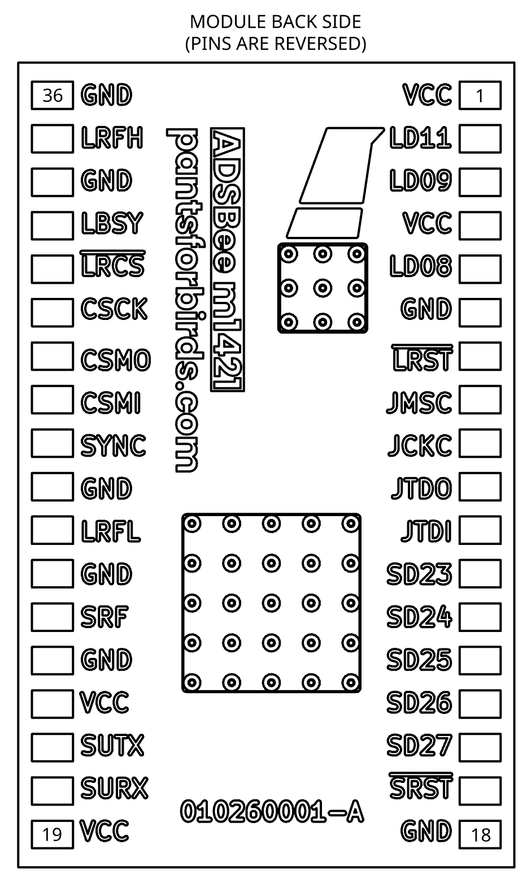

SYNC Pin Functionality
The SYNC pin can be driven high to put the CC1314R10 into a low-power sleep state, with all LR2021 control lines tri-stated in order to allow external control of the LR2021.
The green trace below shows the SYNC line going high, and the yellow trace shows the LRST (LR2021 RESET) net going to tri-state, in a repeated test with trace persistence turned to maximum. To be safe, an external MCU may assume that the LR2021is freed 40us after asserting the SYNC line high, or after the LRST line is tri-stated, whichever occurs first.

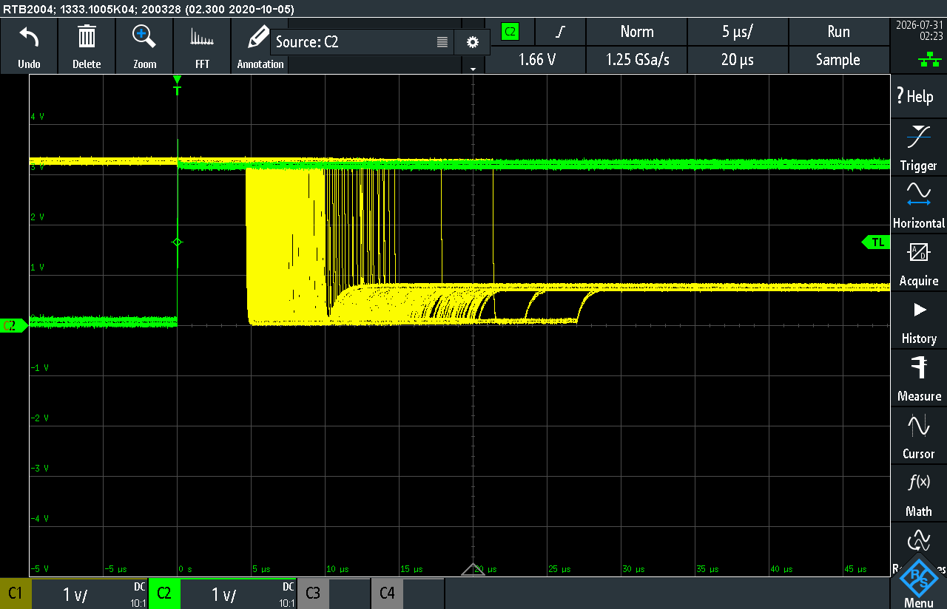

Device Form Factor

Module Dimensions
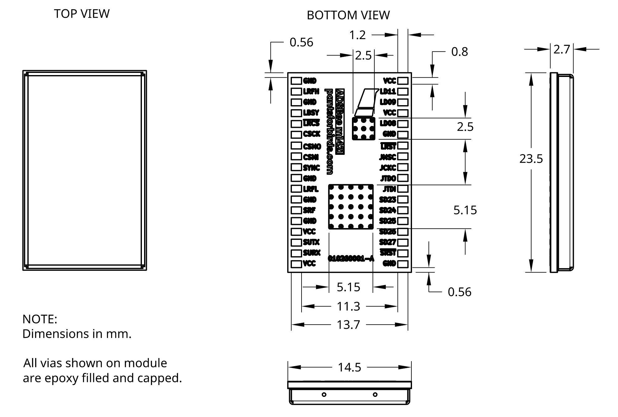

Recommended Footprint
A KiCAD footprint is available at: https://github.com/CoolNamesAllTaken/kicad-libs/blob/main/lib_fp/Custom_Module.pretty/PantsForBirds_ADSBee_m1421_Module.kicad_mod
A screenshot of the footprint is included below. Note the top copper keepouts (hatched red areas) where impedance controlled transmission lines exist on the surface of the module.
LRFH, LRFL, and SRF are coplanar waveguides controlled to 50 Ohms. They can be broken out as microstrip or coplanar waveguide, depending on designer preference. Inserting filled and capped vias directly under the GND pads on the right side of the module is recommended for minimal impedance discontinuity.
LR2021 and CC1314 IC mounting pads are brought through the module using thermal vias. It is recommended to connect both pads labelled “MP” to a ground plane using filled and capped thermal vias.
All exposed copper pads shown in red should have paste.

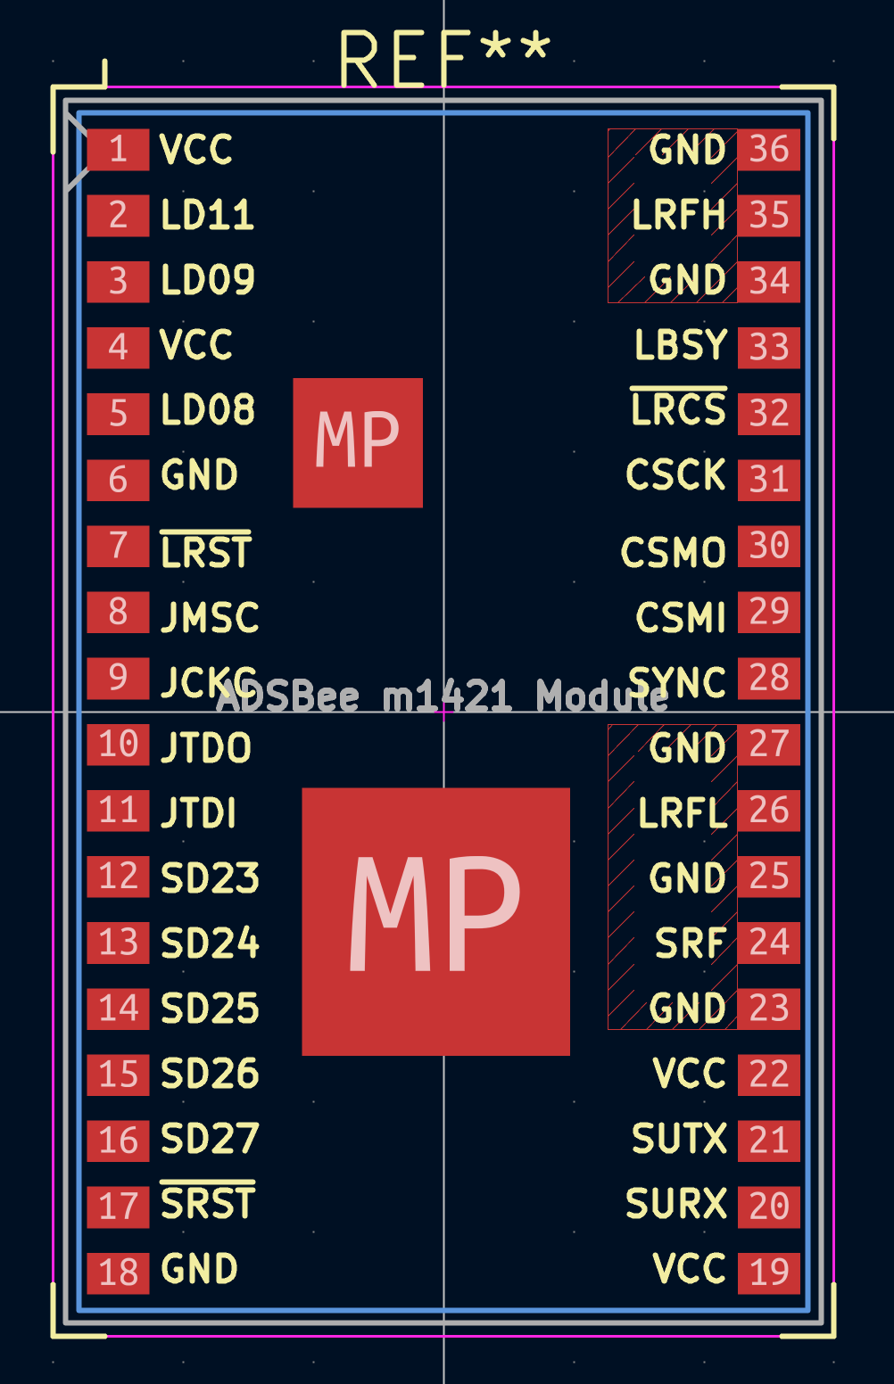

AT Commands
ADSBee m1421 is configured over its Console UART using ASCII AT commands. Each command begins with the prefix AT+ and ends with a carriage return. Most commands provide a query form (AT+COMMAND?) that reports the current value and a set form (AT+COMMAND=<args>) that changes it. Changes take effect immediately; write them to nonvolatile memory with AT+SETTINGS=SAVE so they persist across reboots.

AT+BAUD_RATE
Changes the Console UART baud rate at runtime. The device acknowledges with OK at the old baud rate and then switches, so the host should reopen its serial port at the new rate after receiving the OK. The baud rate is not saved to nonvolatile settings: any reboot or power cycle returns the console to 115200 baud.
A baud rate of 921600 or above is recommended for best performance. Significant bottlenecks can occur if using verbose reporting protocols at the default baud rate of 115200.

Set the Console Baud Rate

AT+BAUD_RATE=CONSOLE,<baud>

OK

Parameter | Description | Acceptable Values
iface | Serial interface to configure. | CONSOLE
baud | New console baud rate. | 115200, 230400, 460800, 921600, 1000000

Query the Console Baud Rate

AT+BAUD_RATE?

BAUD_RATE=CONSOLE,115200

AT+BOOT_UART_BOOTLOADER
Erases the application image and enters the CC1314 ROM UART bootloader (on pins DIO2/DIO3) for serial reflashing. The device remains in the bootloader until it is reflashed. A confirmation word is required to prevent accidental use.

AT+BOOT_UART_BOOTLOADER=1DEADBEE

Parameter | Description | Acceptable Values
confirmation | Confirmation word required to erase the app image and enter the bootloader. | 1DEADBEE

AT+DEVICE_INFO
Reports manufacturing and firmware information about the module.

AT+DEVICE_INFO?

Part Code: ADSBEE-M1421

CC1314R10 Unique ID: 00112233AABBCCDD

CC1314R10 Firmware Version: 0.1.0

OTA Key 0:

OTA Key 1:

AT+LOG_LEVEL
Sets how much diagnostic output the firmware prints to the Console UART.

Set the Log Level

AT+LOG_LEVEL=<log_level>

OK

Parameter | Description | Acceptable Values
log_level | Console logging verbosity. | SILENT, ERRORS, WARNINGS, INFO

Query the Log Level

AT+LOG_LEVEL?

LOG_LEVEL=INFO

AT+MAVLINK_ID
MAVLink components have a system ID and a component ID. For more information about system and component IDs, visit https://mavlink.io/en/services/mavlink_id_assignment.html.

Set the MAVLINK System ID and Component ID

AT+MAVLINK_ID=<system_id>,<component_id>

OK

Parameter | Description | Acceptable Values
system_id | Unique identifier for the MAVLink system (e.g. the aircraft). All components in the system should share the same system_id. | 1-255
component_id | Unique identifier for a component within the MAVLink system (e.g. the ADSBee). Each component should have a unique component_id. | 1-255
Default: 156 (MAV_COMP_ID_ADSB).

Query the MAVLINK System ID and Component ID

AT+MAVLINK_ID?

System ID: 1

Component ID: 156

AT+PROTOCOL_OUT
Selects the reporting protocol used to output decoded data on a serial interface. See the Reporting Protocols section for the format of each protocol.

Set the Reporting Protocol for a Serial Interface

AT+PROTOCOL_OUT=<iface>,<protocol>

OK

Parameter | Description | Acceptable Values
iface | Serial interface to configure. | CONSOLE
protocol | Reporting protocol to use on the interface. | NONE, RAW, BEAST, BEAST_NO_UAT, BEAST_NO_UAT_UPLINK, CSBEE, MAVLINK1, MAVLINK2, GDL90, GDL90_NO_UAT_UPLINK, AIRCRAFT_JSON

Query the Reporting Protocol for All Serial Interfaces

AT+PROTOCOL_OUT?

PROTOCOL_OUT=CONSOLE,MAVLINK2

AT+R1090_GAIN
Sets the gain of the 1090 MHz front-end. Lower gain steps reduce sensitivity but improve dynamic range in high-signal environments. AUTO enables automatic gain control, which improves dynamic range at the cost of mangling the preamble. For best dynamic range, utilize AUTO gain with DF17 preamble. Defaults to AUTO.

Set the 1090 MHz Gain

AT+R1090_GAIN=<gain_step>

OK

Parameter | Description | Acceptable Values
gain_step | 1090 MHz front-end AGC gain step. | 0 or AUTO = automatic; 1-15 = manual (13 = maximum gain)

Query the 1090 MHz Gain

AT+R1090_GAIN?

R1090_GAIN=10

AT+R1090_PREAMBLE
Sets the preamble detection mode used by the 1090 MHz Mode S receiver. The DF17 mode triggers on the second preamble half plus the DF17 header bits, which provides best dynamic range. This comes at the cost of missing non-DF17 messages, including DF 4/5/11 (no squawk codes, pressure altitude from ADSB only, no all-call reply). For aircraft detection and collision avoidance purposes, DF17 preamble mode is recommended. Defaults to DF17. The MODE_S_SW_CRC mode uses the standard Mode S preamble with the hardware CRC filter disabled; the firmware validates the CRC in software, keeping failed-CRC frames available for error correction.

Set the Preamble Mode

AT+R1090_PREAMBLE=<mode>

OK

Parameter | Description | Acceptable Values
mode | 1090 MHz Mode S receiver preamble detection mode. | MODE_S_PREAMBLE, DF17, MODE_S_SW_CRC

Query the Preamble Mode

AT+R1090_PREAMBLE?

R1090_PREAMBLE=MODE_S_PREAMBLE

AT+R1090_RX_BOOST
Sets the receive boost level of the LR2021 1090 MHz receive path. Higher boost levels increase receiver sensitivity at the cost of higher current consumption. Defaults to 0 (boost off).

Set the 1090 MHz RX Boost Level

AT+R1090_RX_BOOST=<boost>

OK

Parameter | Description | Acceptable Values
boost | 1090 MHz RX path boost level. | 0 = off; 1-7 (7 = maximum boost)

Query the 1090 MHz RX Boost Level

AT+R1090_RX_BOOST?

R1090_RX_BOOST=0

AT+REBOOT
Reboots the device.

AT+REBOOT

AT+RX_ENABLE
Enables or disables the onboard receivers. The first argument, if present, overrides the others, allowing all receivers to be enabled or disabled at once.

Enable or Disable the Receiver(s)

AT+RX_ENABLE=<all>,<1090>,<subg>

OK

Parameter | Description | Acceptable Values
all | Enables or disables all receivers. Overrides the other arguments if present. | 0, 1
1090 | Enables or disables the 1090 MHz receiver. | 0, 1
subg | Enables or disables the Sub-GHz receiver. | 0, 1

Query Whether the Receiver(s) Are Enabled

AT+RX_ENABLE?

1090 Receiver: ENABLED

SubG Receiver: ENABLED

AT+RX_POSITION
Sets or queries the receiver position and the source used to determine it. A receiver position is required for some calculations, such as the distance to a tracked aircraft.

Query Receiver Position

AT+RX_POSITION?

Receiver Position:

Source: FIXED [OK]

Latitude: 37.000000 deg

Longitude: -122.000000 deg

GNSS Altitude: 0 ft

Barometric Altitude: 0 ft

Heading: 0.0 deg

Speed: 0 kts

ICAO: 0x000000 [NOT IN USE]

Set Receiver Position

AT+RX_POSITION=<source>,<args>

Parameter | Description | Acceptable Values
source | Source used to determine the receiver position. Each source takes different additional arguments, described below. | NONE, FIXED, GNSS, LOWEST, ICAO

Disable Receiver Position

AT+RX_POSITION=NONE

OK

Set a Fixed Receiver Position

AT+RX_POSITION=FIXED,<lat_deg>,<lon_deg>,<gnss_alt_ft>,<baro_alt_ft>,<heading_deg>,<speed_kts>

OK

Parameter | Description | Acceptable Values
lat_deg | Latitude in degrees. | -90.0 to 90.0
lon_deg | Longitude in degrees. | -180.0 to 180.0
gnss_alt_ft | GNSS altitude in feet. | integer
baro_alt_ft | Barometric altitude in feet. | integer
heading_deg | Heading in degrees (true north). | 0.0 to 360.0
speed_kts | Ground speed in knots. | >= 0

Use the GNSS Receiver Position

AT+RX_POSITION=GNSS

OK

Track the Lowest Aircraft

AT+RX_POSITION=LOWEST

OK

Bootstraps the receiver position from the lowest-altitude aircraft currently being tracked.

Track an Aircraft by ICAO Address

AT+RX_POSITION=ICAO,<icao>

OK

Parameter | Description | Acceptable Values
icao | ICAO address (hex) of the aircraft to use for position bootstrap. | 0x000000 to 0xFFFFFF

AT+RX_STATS
Reports OOK receiver statistics from the LR2021 radio: received packet count (pkt_rx), CRC and length error counts (crc_error, len_error), preamble detector fires (pbl_det), sync word successes and failures (sync_ok, sync_fail), and receive timeouts (timeout). Also reports receiver health counters: LR2021 RX FIFO overflows (fifo_full), raw packet queue overflows (q_ovf), single-bit errors corrected by the decoder (bitflips_fixed), and UAT receiver error restarts (uat_rx_restarts). The counters accumulate until reset.

AT+RX_STATS?

RX_STATS=pkt_rx=1234,crc_error=5,len_error=0,pbl_det=1500,sync_ok=1234,sync_fail=12,timeout=0,fifo_full=0,q_ovf=0,bitflips_fixed=42,uat_rx_restarts=0
Reset all statistics counters, including the health counters:

AT+RX_STATS=RESET

OK

AT+SETTINGS
Loads, saves, resets, or displays the device nonvolatile settings. Settings changed by other AT commands take effect immediately but are not retained across reboots until saved.

Query Current Settings

AT+SETTINGS?
Prints the current settings in a human-readable format.

Dump Settings in AT Format

AT+SETTINGS?DUMP

+PROTOCOL_OUT=CONSOLE,MAVLINK2

+R1090_GAIN=10

+RX_ENABLE=1,1,1

+WATCHDOG=0

...
Prints the current settings as AT commands that can be replayed to restore the configuration.

Load Settings from Nonvolatile Memory

AT+SETTINGS=LOAD

OK

Save Settings to Nonvolatile Memory

AT+SETTINGS=SAVE

OK

Reset Settings to Factory Defaults

AT+SETTINGS=RESET

OK

AT+WATCHDOG
The watchdog timer automatically resets the device if firmware execution stalls and the timer is no longer serviced, providing automatic recovery from a hard fault. It can be disabled (for example, during breakpoint debugging) and can be self-tested via AT command to verify that it is still active.

Configure the Watchdog Timer

AT+WATCHDOG=<timeout_sec>

OK

Parameter | Description | Acceptable Values
timeout_sec | Watchdog timeout in seconds. 0 disables the watchdog; 65535 is approximately 18.2 hours. | 0-65535

Query the Watchdog Timer

AT+WATCHDOG?

WATCHDOG=10

Prints the watchdog timeout in seconds, or 0 if the watchdog is disabled.

Test the Watchdog Timer

AT+WATCHDOG=TEST

Blocking for 11 seconds.

Blocks the processor for the configured timeout plus one second, which should induce a reboot. If no reboot occurs, an error indicates that the watchdog failed to activate.

Reporting Protocols
ADSBee m1421 supports the following reporting protocols on CONSOLE.
- CSBee
- GDL90
- MAVLINK 1
- MAVLINK 2
- Mode S Beast
- Raw Packets
- Aircraft JSON
The CONSOLE interface reports debug messages and AT command responses in addition to the selected reporting protocol. If the CONSOLE interface is being used as a reporting interface, it is recommended to send AT+LOG_LEVEL=SILENT to silence any debug logs that might corrupt the reported data, and to avoid sending additional AT commands while reading reported data in order to avoid the reported data being interspersed with OK and other AT command responses from the ADSBee m1421.

CSBee
Comma Separated Bee protocol containing information about tracked aircraft as plain text.
The CSBee protocol is heavily inspired by the Aerobits Aero CSV protocol.

CSBee Protocol Version History
Consult the table below for a version history of the CSBee protocol. Each version of the ADSBee firmware writes only the most recent version of the CSBee protocol. All versions of the CSBee protocol except for the most recent version are considered deprecated. Whenever possible, efforts are made to reduce breaking changes to the CSBee protocol when incrementing the version number.
Current protocol version: 3
CSBee Protocol Version | Introductory Firmware Revision | Description
1 |  | Initial release.
2 | adsbee_1090-0.9.0-rc1 | - Add UAT contacts.  - Change bit flag positions.  - Add dedicated fields for GNSS / baro vertical rates.  - Add additional aircraft info (e.g. dimensions).
3 | adsbee_1090-0.9.0-rc15 | - Add is_non_transponder flag to Mode S aircraft.  - Prepend address qualifier to UAT ICAO addresses.  - Add is_utc_coupled flag to UAT aircraft.

Mode S Aircraft Message
This message contains information about an aircraft being tracked via ADS-B (1090MHz). Aircraft reports are provided once per second, per aircraft, until contact with the aircraft has been lost for 60 seconds.

#A:ICAO,FLAGS,CALL,SQUAWK,ECAT,LAT,LON,BARO_ALT,GNSS_ALT,DIR,SPEED,BARO_VRATE,GNSS_VRATE,NICNAC,ACDIMS,VERSION,SIGS,SIGQ,SFPS,ESFPS,CRC\r\n

Field | Description | Format | Example value
#A | Mode S aircraft message start indicator.
ICAO | ICAO number of aircraft (3 bytes). | Hex Integer | 3C65AC
FLAGS | Flags bitfield, see table 5.1.2.1. | Hex Integer | 12F356A8
CALL | Callsign of aircraft. | String | N61ZP
SQUAWK | SQUAWK of aircraft. | Octal Integer | 7232
ECAT | Emitter category, see table 5.1.2.2. | Integer | 14
LAT | Latitude, in degrees. | Float | 57.57634
LON | Longitude, in degrees. | Float | 17.59554
BARO_ALT | Barometric altitude, in feet. | Integer | 5000
GNSS_ALT | Geometric altitude, in feet. | Integer | 5000
DIR | Direction of aircraft, in degrees [0,360). Consult bit flags to determine whether this field is true heading, magnetic heading, or track. | Integer | 35
SPEED | Horizontal velocity of aircraft, in knots. | Integer | 464
BARO_VRATE | Barometric vertical velocity of aircraft, in ft/min. | Integer | -1344
GNSS_VRATE | Geometric vertical velocity of the aircraft, in ft/min | Integer | -1344
NICNAC | Aircraft data integrity. See table 5.1.2.4 | Hex Integer
ACDIMS | Aircraft physical dimensions and system design assurance. See table 5.1.2.5. | Hex Integer | 31BE89F2
VERSION | ADS-B protocol version used by the aircraft. | Integer | 2
SIGS | Signal strength, in dBm. | Integer | -92
SIGQ | Signal quality, in dB. | Integer | 2
SFPS | Number of valid 56-bit Squitter Mode S frames received from the aircraft during the last second. | Integer | 2
ESFPS | Number of valid 112-bit Extended Squitter Mode S frames received from the aircraft during the last second. | Integer | 5
CRC | CRC16 (described in 5.1.2.6). | Hex Integer | 2D3E

FLAGS Bitfield
Note: All bits 25-31 are momentary (cleared and updated every reporting interval).
Bit | Bit Name | Meaning if the bit is set (1)
0 | IS_AIRBORNE | Emitter is airborne.
1 | BARO_ALTITUDE_VALID | Emitter has provided a barometer altitude.
2 | GNSS_ALTITUDE_VALID | Emitter has provided a GNSS altitude.
3 | POSITION_VALID | Emitter has provided a pair of even and odd Compact Position Reporting packets that were decoded to a location.
4 | DIRECTION_VALID | Emitter has provided a direction (may be ground track, magnetic compass heading, or true compass heading).
5 | HORIZONTAL_SPEED_VALID | Emitter has provided a horizontal velocity.
6 | BARO_VERTICAL_RATE_VALID | Emitter has provided a barometric vertical velocity.
7 | GNSS_VERTICAL_RATE_VALID | Emitter has provided a GNSS vertical velocity.
8 | IS_MILITARY | Emitter has transmitted at least one packet using a military format, such as Military Extended Squitter (DF=19).
9 | IS_CLASS_B2_GROUND_VEHICLE | Emitter is actually a ground vehicle using a Class B2 transponder with a transmission power < 70W.
10 | HAS_1090_ES_IN | Emitter has receive capability for 1090MHz Extended Squitter transmissions.
11 | HAS_UAT_IN | Emitter has receive capability for UAT (978MHz Universal Access Transceiver) transmissions.
12 | TCAS_OPERATIONAL | Emitter has a functional TCAS (Traffic Collision Avoidance System) onboard.
13 | SINGLE_ANTENNA | Emitter is using a single antenna, instead antennas above and below the fuselage. Transmissions may be weak or irregular during maneuvering.
14 | DIRECTION_IS_HEADING | Surface position messages provided by the aircraft indicate a heading and not a track angle.
15 | HEADING_USES_MAGNETIC_NORTH | Heading reported by the aircraft while on the surface uses magnetic north instead of true north.
16 | IDENT | The aircraft has its SPI (Special Position Identification) bits set in Mode A/C or Mode S messages. This indicates that the pilot has depressed the momentary IDENT switch on their transponder, most likely at the request of air traffic control.
17 | ALERT | The aircraft is issuing either a permanent or momentary alert. This could correspond to an operational mode change or something else.
18 | TCAS_RA | The aircraft has an active TCAS resolution advisory (i.e. the aircraft is warning the pilot to take action in order to avoid colliding with another aircraft).
19 | IS_NON_TRANSPONDER | This aircraft is being rebroadcast (not received from a transponder).
20-22 Reserved
23 | UPDATED_BARO_ALTITUDE | Barometric altitude has been updated within the last reporting interval.
24 | UPDATED_GNSS_ALTITUDE | GNSS altitude has been updated within the last reporting interval.
25 | UPDATED_POSITION | Position (latitude / longitude) has been updated within the last reporting interval.
26 | UPDATED_DIRECTION | Direction has been updated within the last reporting interval.
27 | UPDATED_HORIZONTAL_SPEED | Horizontal velocity has been updated within the last reporting interval.
28 | UPDATED_BARO_VERTICAL_RATE | Barometric vertical velocity has been updated within the last reporting interval.
29 | UPDATED_GNSS_VERTICAL_RATE | GNSS vertical velocity has been updated within the last reporting interval.
30-31 Reserved

ECAT Field
The ECAT field indicates the Emitter Category (i.e. airframe type) for each ADSB emitter that is being tracked. This field contains information about what kind of aircraft, ground vehicle, obstacle, or other airspace user is emitting ADS-B packets, and can be used to understand the emitter’s maneuvering capability and potential for wake vortex impact.
ECAT Value | Emitter Category
-1 | Invalid
0 | No Category Information
1 | Light Aircraft (< 7,000kg)
2 | Medium 1 (7,000kg – 34,000kg)
3 | Medium 2 (34,000kg – 136,000kg)
4 | High Vortex Aircraft
5 | Heavy (> 136,000kg)
6 | High Performance (> 5 G acceleration and > 400 kts speed)
7 | Rotorcraft
8 | Reserved
9 | Glider / Sailplane
10 | Lighter Than Air
11 | Parachutist / Skydiver
12 | Ultralight / Hang Glider / Paraglider
13 | Reserved 1
14 | Unmanned Aerial Vehicle
15 | Space / Transatmospheric Vehicle
16 | Reserved 2
17 | Surface Emergency Vehicle
18 | Surface Service Vehicle
19 | Point Obstacle
20 | Cluster Obstacle
21 | Line Obstacle

NICNAC Bitfield
NICNAC Bitfield
15 | 14 | 13 | 12 | 11 | 10 | 9 | 8 | 7 | 6 | 5 | 4 | 3 | 2 | 1 | 0
Source Integrity Level (SIL) |  | Geometric Vertical Accuracy (GVA) |  | Navigation Accuracy Category: Position (NAC_{p}) |  |  |  | Navigation Accuracy Category: Velocity (NAC_{v}) |  |  | Navigation Integrity Category: Barometer (NIC_{baro}) | Navigation Integrity Category (NIC)

NICNAC[0-3]: Navigation Integrity Category (NIC)
The radius of containment (NIC) indicates how much trust should be placed in an aircraft’s reported location in the horizonal plane. The NIC reports a radius of containment specified by the avionics system of the emitter. The probability that the aircraft is outside of this radius of containment due to its avionics system receiving a faulty signal from one of its inputs (without displaying an error) is provided by another bitfield called the Source Integrity Level (SIL). Combined, the NIC and SIL indicate how likely it is that an aircraft is not actually contained by a bubble of a specified size, centered at the aircraft’s reported location, assuming that the avionics onboard the aircraft are functioning correctly but may be given faulty inputs.
A higher NIC value indicates more trust in an aircraft’s reported latitude / longitude position.
NIC Value | 0 | 1 | 2 | 3 | 4 | 5 | 6 | 7 | 8 | 9 | 10 | 11
Radius of Containment | Unknown | < 20 NM | < 8 NM | < 4 NM | < 2 NM | < 1 NM | < 0.6 NM | < 0.2 NM | < 0.1 NM | < 75 m | < 25 m | < 7.5 m

NICNAC [4]: Navigation Integrity Category: Barometer (NIC_{baro})
The barometric altitude integrity (NIC_{baro}) indicates how much trust should be placed in an aircraft’s reported altitude. The field is a single bit that indicates whether the aircraft uses an altimeter that has been cross-checked against other sources. Old school encoding altimeters have many parallel wires and output an altitude in a format called a Gillham Code, and have no built-in method of error checking. A single faulty wire can result in erroneous readings, so this bit lets air traffic control know whether to take altitude readings from the aircraft with a grain of salt. A 0 indicates that the transponder is outputting altitude from a Gillham coded source (with no way to cross check the value), while a 1 indicates that the transponder is outputting altitude from a Gillham coded source while using another sensor to cross-check it, or is using a more modern barometer that supports a protocol with built-in error checking.
A higher NIC_{baro} value (i.e. 1 instead of 0) indicates more trust in the aircraft’s reported altitude.
NIC_{baro} Value | 0 | 1
Barometric Altitude Integrity | Altitude is from a Gillham-coded input, not cross checked. | Altitude is from a Gillham-coded input that is being cross-checked with another source, or from a non Gillham-coded input with built-in error checking features.

NICNAC [5-7]: Navigation Accuracy Category: Velocity (NAC_{v})
The horizontal velocity error (NAC_{v}) indicates the expected accuracy of the reported velocity of the aircraft when systems are operating nominally. This varies depending on the accuracy capabilities of the measurement equipment onboard the aircraft, and not how often we expect said equipment to fail.
A higher NAC_{v} indicates a more accurate velocity measurement system.
NAC_{v} Value | Horizontal Velocity Error
0b000 | Unknown or ≥ 10 m/s
0b110 | < 10 m/s
0b010 | < 3 m/s
0b011 | < 1 m/s
0b100 | < 0.3 m/s

NICNAC [8-11]: Navigation Accuracy Category: Position (NAC_{p})
The estimated position uncertainty (NAC_{p}) indicates the expected accuracy of the aircraft’s reported location when systems are operating nominally. This varies depending on the capabilities of the aircraft’s positioning system and not on how often we expect said equipment to fail.
A higher NAC_{p} indicates a more accurate positioning system.
NAC_{p} Value | 0 | 1 | 2 | 3 | 4 | 5 | 6 | 7 | 8 | 9 | 10 | 11
Estimated Position Uncertainty | Unknown or ≥ 10NM | < 10 NM | < 4 NM | < 2 NM | < 1 NM | < 0.5 NM | < 0.3 NM | < 0.1 NM | < 0.5 NM | < 30 m | < 10 m | < 3 m

NICNAC[12-13]: Geometric Vertical Accuracy (GVA)
The geometric vertical accuracy indicates the 95% confidence interval (vertical figure of merit) provided by the aircraft’s onboard GNSS system (i.e. assuming some distribution of altitudes, the aircraft’s GNSS system is confident that 95 out of 100 times, the aircraft falls within some height of the reported geometric altitude.
GVA Value | 0 | 1 | 2 | 3
95% Vertical Figure of Merit (VFOM) | Unknown or ≥ 150 m | < 150 m | ≤ 45 m | < 45 m (Was previously “reserved”, the actual value of this field may change but is guaranteed to be < 45 m).

NICNAC[14-15]: Source Integrity Level (SIL)
The source integrity level indicates the probability that the aircraft exceeds the bounds of its horizontal radius of containment (NIC) due to a silent fault in signals received by the aircraft (no avionics failure).
SIL Value | Probability of Exceeding NIC Radius of Containment Due to Silent Fault
0 | Unknown or > 1x10⁻³ per flight hour.
1 | ≤ 1x10⁻³ per flight hour.
2 | ≤ 1x10⁻⁵ per flight hour.
3 | ≤ 1x10⁻⁷ per flight hour.
4 | Unknown or > 1x10⁻³ per sample.
5 | ≤ 1x10⁻³ per sample.
6 | ≤ 1x10⁻⁵ per sample.
7 | ≤ 1x10⁻⁷ per sample.

ACDIMS Bitfield
ACDIMS Bitfield
31 | 30 | 29 | 28 | 27 | 26 | 25 | 24 | 23 | 22 | 21 | 20 | 19 | 18 | 17 | 16
GNSS Offset Forward of Reference Point  (GOF) |  |  |  |  |  |  |  | GNSS Offset Right of Reference Point  (GOR)

15 | 14 | 13 | 12 | 11 | 10 | 9 | 8 | 7 | 6 | 5 | 4 | 3 | 2 | 1 | 0
Aircraft Length  (ACL) |  |  |  |  |  |  | Aircraft Width  (ACW) |  |  |  |  |  |  | System Design Assurance (SDA)

ACDIMS[0-1]: System Design Assurance (SDA)
The system design assurance indicates how robust the aircraft’s position reporting systems are to failures of various severities. For instance, SDA = 1, a low SDA value, corresponds to Software and Hardware Design Assurance Level D, which states that a minor failure could cause the aircraft to transmit misleading position information with a probability of ≤ 1x10⁻³ per flight hour. A more robust system with SDA = 3, corresponding to Software and Hardware Design Assurance Level B, is expected to transmit misleading position information with a probability of 1x10⁻⁷ per flight hour even under a Hazardous failure condition.
Software Design Assurance categories used in this field are classified under RTCA DO-178B, Airborne Electronic Hardware Design Assurance are classified under RTCA DO-254, and failure classification levels are defined in FAA Advisory Circular AC-23.1309-1E.
SDA Value | Supported Failure Condition | Probability of Undetected Fault causing transmission of False or Misleading Information | Software and Hardware Design Assurance Level
0 | Unknown / No Safety Effect | > 1x10⁻³ per flight hour or unknown. | N/A
1 | Minor | ≤ 1x10⁻³ per flight hour. | D
2 | Major | ≤ 1x10⁻⁵ per flight hour. | C
3 | Hazardous | ≤ 1x10⁻⁷ per flight hour. | B

ACDIMS[2-8] Aircraft Width (ACW)
Approximate value for the width of the aircraft bounding box, in meters. Can be interpreted as a 7-bit unsigned integer.
ACDIMS[9-15] Aircraft Length (ACL)
Approximate value for the length of the aircraft bounding box, in meters. Can be interpreted as a 7-bit unsigned integer.
ACDIMS[16-23] GNSS Offset Right of Reference Point (GOR)
Signed 8-bit integer representing the left/right offset of the GNSS antenna from the aircraft’s reference point. A positive value indicates that the GNSS antenna is to the right of the aircraft reference point.
ACDIMS[24-31] GNSS Offset Forward of Reference Point (GOF)
Signed 8-bit integer representing the forward/back offset of the GNSS antenna from the aircraft’s reference point. A positive value indicates that the GNSS antenna is forward of the aircraft’s reference point. Always 0 for Mode S aircraft.

CRC Field

CSBee messages use a 16-bit Cyclical Redundancy Checksum (CRC-16), which can be calculated using the algorithm in the C++ code snippet below. Note the “swap16” helper function which also needs to be included.

uint16_t swap16(uint16_t value) { return (value << 8) | (value >> 8); }

uint16_t CalculateCRC16(const uint8_t *data_p, int32_t length) {

uint8_t x;

uint16_t crc = 0xFFFF;

while (length--) {

x = crc >> 8 ^ *data_p++;

x ^= x >> 4;

crc = (crc << 8) ^ ((uint16_t)(x << 12)) ^ ((uint16_t)(x << 5)) ^ ((uint16_t)x);

}

return swap16(crc);

}

UAT Aircraft Message

#U:ICAO,UAT_FLAGS,CALL,SQUAWK,ECAT,LAT,LON,BARO_ALT,GNSS_ALT,DIR,SPEED,BARO_VRATE,GNSS_VRATE,UAT_EMERG,NICNAC,ACDIMS,VERSION,SIGS,SIGQ,UATFPS,CRC\r\n

Field | Description | Format | Example value
#U | UAT aircraft message start indicator.
ICAO | First Digit (optional): Address Qualifier (1 digit: see table 5.1.3.1)  Last 6 Digits: ICAO address of aircraft (6 hex digits). | Hex Integer | 13C65AC  3C65AC
UAT_FLAGS | Flags bitfield, see table 5.1.3.2. | Hex Integer | 12F356A8
CALL | Callsign of aircraft. | String | N61ZP
SQUAWK | SQUAWK of aircraft. | Octal Integer | 7232
ECAT | Emitter category, see table 5.1.2.2. | Integer | 14
LAT | Latitude, in degrees. | Float | 57.57634
LON | Longitude, in degrees. | Float | 17.59554
BARO_ALT | Barometric altitude, in feet. | Integer | 5000
GNSS_ALT | Geometric altitude, in feet. | Integer | 5000
DIR | Direction of aircraft, in degrees [0,360). Consult bit flags to determine whether this field is true heading, magnetic heading, or track. | Integer | 35
SPEED | Horizontal velocity of aircraft, in knots. | Integer | 464
BARO_VRATE | Barometric vertical velocity of aircraft, in ft/min. | Integer | -1344
GNSS_VRATE | Geometric vertical velocity of the aircraft, in ft/min | Integer | -1344
UAT_EMERG | Aircraft UAT emergency / priority status. See table. | Integer | 0
NICNAC | Aircraft data integrity. See table 5.1.2.4 | Hex Integer
ACDIMS | Aircraft physical dimensions and system design assurance. See table 5.1.2.5. | Hex Integer | 31BE89F2
VERSION | UAT protocol version used by the aircraft. | Integer | 1
SIGS | Signal strength, in dBm. | Integer | -92
SIGQ | Number of bits corrected using UAT forward error correction. 0 (best), 6 (worst). | Integer | 2
UATFPS | Number of valid UAT frames received from the aircraft in the last second. | Integer | 1
CRC | CRC16 (described in 5.1.2.6). | Hex Integer | 2D3E

NOTE: See Mode S Aircraft message decoding reference for any bitfields not prefixed with “UAT_”.

UAT Address Qualifier
Address Qualifier Value | Meaning
0 | Contact is ADSB target (broadcast by transponder) with 24-bit ICAO address.
1 | Contact is ADSB target (broadcast by transponder) with self-assigned temporary address.
2 | Contact is TIS-B target (broadcast by ground station), using a 24-bit ICAO address.
3 | Contact is TIS-B target (broadcast by ground stations) with track file identifier.
4 | Contact is a surface vehicle.
5 | Contact is a fixed ADSB beacon.

UAT_FLAGS Bitfield
Bit | Bit Name | Meaning if the bit is set (1)
0 | IS_AIRBORNE | Emitter is airborne.
1 | BARO_ALTITUDE_VALID | Emitter has provided a barometer altitude.
2 | GNSS_ALTITUDE_VALID | Emitter has provided a GNSS altitude.
3 | POSITION_VALID | Emitter has provided a pair of even and odd Compact Position Reporting packets that were decoded to a location.
4 | DIRECTION_VALID | Emitter has provided a direction (may be ground track, magnetic compass heading, or true compass heading).
5 | HORIZONTAL_SPEED_VALID | Emitter has provided a horizontal velocity.
6 | BARO_VERTICAL_RATE_VALID | Emitter has provided a barometric vertical velocity.
7 | GNSS_VERTICAL_RATE_VALID | Emitter has provided a GNSS vertical velocity.
8 | HAS_CDTI | Aircraft has Cockpit Display of Traffic Information (CDTI) equipped.
9 | TCAS_OPERATIONAL | Aircraft is equipped with an operational TCAS / ACAS system.
10 | DIRECTION_IS_HEADING | Surface position messages provided by the aircraft indicate a heading and not a track angle.
11 | HEADING_USES_MAGNETIC_NORTH | Heading reported by the aircraft while on the surface uses magnetic north instead of true north.
12 | IDENT | The aircraft has its SPI (Special Position Identification) bits set in Mode A/C or Mode S messages. This indicates that the pilot has depressed the momentary IDENT switch on their transponder, most likely at the request of air traffic control.
13 | IS_UTC_COUPLED | The aircraft is transmitting frames precisely aligned to the UTC second.
14 Reserved
15 | TCAS_RA | The aircraft has an active TCAS resolution advisory (i.e. the aircraft is warning the pilot to take action in order to avoid colliding with another aircraft).
16 | RECEIVING_ATC_SERVICES
17-22 Reserved
23 | UPDATED_BARO_ALTITUDE | Barometric altitude has been updated within the last reporting interval.
24 | UPDATED_GNSS_ALTITUDE | GNSS altitude has been updated within the last reporting interval.
25 | UPDATED_POSITION | Position (latitude / longitude) has been updated within the last reporting interval.
26 | UPDATED_DIRECTION | Direction has been updated within the last reporting interval.
27 | UPDATED_HORIZONTAL_SPEED | Horizontal velocity has been updated within the last reporting interval.
28 | UPDATED_BARO_VERTICAL_RATE | Barometric vertical velocity has been updated within the last reporting interval.
29 | UPDATED_GNSS_VERTICAL_RATE | GNSS vertical velocity has been updated within the last reporting interval.
30-31 Reserved

UAT_EMERG Bitfield
Contains the emergency / priority status reported by a UAT emitter.
UAT_EMERG Value | Meaning
0 | No emergency.
1 | General emergency.
2 | Lifeguard / medical emergency.
3 | Minimum fuel.
4 | No communications.
5 | Unlawful interference.
6 | Downed aircraft.
7 | Reserved.

Statistics Message
This message contains some useful statistics about ADSBee’s operational status. Format of that frame is shown below:

#S:VERSION,DPS,RAW_SFPS,SFPS,RAW_ESFPS,ESFPS,RAW_UATFPS,UATFPS,TSCAL,UPTIME,CRC\r\n

Field | Description | Format | Example Value
#S | Statistics message start indicator.
VERSION | Version of the CSBee protocol being used. | Integer | 3
SDPS | Number of attempted Mode S demodulations in the last second. | Integer | 106
RAW_SFPS | Number of squitter (56-bit Mode S) frames received in the last second. | Integer | 150
SFPS | Number of valid squitter (56-bit Mode S) frames received in the last second. | Integer | 20
RAW_ESFPS | Number of extended squitter (112-bit Mode S) frames received in the last second. | Integer | 15
ESFPS | Number of valid Mode S frames received in the last second. | Integer | 3
RAW_UATFPS | Number of UAT frames received in the last second. | Integer | 5
UATFPS | Number of valid UAT frames received in the last second. | Integer | 4
NUM_AIRCRAFT | Number of aircraft tracked in the last second. | Integer | 20
TSCAL | Calibration value for TS field in raw frames | Integer | 13999415
UPTIME | Receiver uptime, in seconds. | Integer | 13456
CRC | CRC16 (described in 5.1.4.1). | Hex Integer | 2D3E

CRC Field
See 5.1.2.6.

GDL90
ADSBee complies with the GDL90 public data interface specification 560-1058-00 Rev A. The GDL90_NO_UAT_UPLINK protocol variant is identical to GDL90, except that UAT uplink messages are not forwarded.

MAVLINK
Tracked aircraft information is sent in MAVLINK ADSB_VEHICLE messages, in a data burst once per second. The data burst consists of 1x MAVLINK Heartbeat message, Nx ADSB_VEHICLE messages, where N is the number of tracked aircraft, and 1x special delimiter message (MAVLINK_REQUEST_DATA_STREAM for MAVLINK1 mode, MAVLINK_MESSAGE_INTERVAL for MAVLINK2 mode) which indicates the end of the list of tracked aircraft. Note that this is a binary protocol which is not human readable.
WARNING: Windows has a bug, which causes some machines to recognize a serial port reporting MAVLINK packets as a mouse, which can result in phantom mouse movements and clicks (ask me how I know). Please use caution while running MAVLINK on a serial port while the computer is unattended.

MAVLINK_HEARTBEAT （Message ID 0） Packet Definition
Field Name | Type | Units | Values | Description
custom_mode | uint32_t |  | 0 | Unused.
type | uint8_t |  | MAV_TYPE_ADSB | Always MAV_TYPE_ADSB (27).
autopilot | uint8_t |  | MAV_AUTOPILOT_INVALID | Always MAV_AUTOPILOT_INVALID (8).
base_mode | uint8_t |  | 0 | Unused.
system_status | uint8_t |  | MAV_STATE_ACTIVE | Always MAV_STATE_ACTIVE (4).
mavlink_version | uint8_t |  | MAVLINK_VERSION | 1 for MAVLINK1 mode, 2 for MAVLINK2 mode.

MAVLINK ADSB_VEHICLE (Message ID 246) Packet Definition
From: https://mavlink.io/en/messages/common.html#ADSB_VEHICLE
Field Name | Type | Units | Values | Description
ICAO_address | uint32_t |  |  | ICAO address
lat | int32_t | degE7 |  | Latitude
lon | int32_t | degE7 |  | Longitude
altitude_type | uint8_t |  | ADSB_ALTITUDE_TYPE | ADSB altitude type.
altitude | int32_t | mm |  | Altitude(ASL)
heading | uint16_t | cdeg |  | Course over ground
hor_velocity | uint16_t | cm/s |  | The horizontal velocity
ver_velocity | int16_t | cm/s |  | The vertical velocity. Positive is up
callsign | char[9] |  |  | The callsign, 8+null
emitter_type | uint8_t |  | ADSB_EMITTER_TYPE | ADSB emitter type.
tslc | uint8_t | s |  | Time since last communication in seconds
flags | uint16_t |  | ADSB_FLAGS | Bitmap to indicate various statuses including valid data fields
squawk | uint16_t |  |  | Squawk code

MAVLINK_REQUEST_DATA_STREAM (Message ID 66) Packet Definition
This message serves as the delimiter which indicates the end of the aircraft list in MAVLINK1 mode.
Field Name | Type | Units | Description
req_message_rate | uint16_t |  | Always 0 (unused).
target_system | uint8_t |  | Always 0 (unused).
target_component | uint8_t |  | Always 0 (unused).
req_stream_id | uint8_t |  | Always 0 (unused).
start_stop | uint8_t |  | Always 0 (unused).

MAVLINK MESSAGE_INTERVAL (Message ID 244) Packet Definition
This message serves as the delimiter which indicates the end of the aircraft list in MAVLINK2 mode.
From: https://mavlink.io/en/messages/common.html#MESSAGE_INTERVAL
Field Name | Type | Units | Description
message_id | uint16_t |  | The ID of the requested MAVLink message. v1.0 is limited to 254 messages.  NOTE: For ADSBee m1421, message_id is always 246, corresponding to the ADSB_VEHICLE message.
interval_us | int32_t | us | The interval between two messages. A value of -1 indicates this stream is disabled, 0 indicates it is not available, > 0 indicates the interval at which it is sent.  NOTE: For ADSBee m1421, message_id is always 1000 us.

Mode S Beast
Mode S Beast is a popular feed protocol used by both open-source and commercial data exchanges to send Mode S data, often over TCP sockets or serial connections.
Mode S Beast sends packets as raw binary, with 0x1a used as an “escape” character indicating the start of a Beast frame. Any non start-of-frame instance of 0x1a is escaped with an additional 0x1a beforehand. Thus, 0x1a can be interpreted as the start of a Beast frame, and 0x1a1a can be interpreted as a 0x1a value within a Beast frame.

Beast: Mode S Frames
Field | Frame Start | Frame Type | Timestamp | RSSI | Payload
Length [Bytes] | 1 | 1 | 6-12 | 1-2 | Mode S Short: 7-14  Mode S Long: 14-28
Example | 0x1a | 0x32 | 0x123456781a1aff | 0x56 | <data>
Definition | 0x1a  Frame start is always an escape char. | 0x32: Mode S Short  0x33: Mode S Long  No escapes. | 6-byte 12MHz MLAT timestamp, MSB first.  May have up to 6 escapes. | RSSI byte is “Beast Power Level”, which is the square root of the un-logged dBFS value.  May have up to 1 escape. | Packet contents.  May theoretically have up to <packet_length> escapes, but this would not correspond to a valid packet and will not be seen in practice.

Beast: UAT Frames
Field | Frame Start | Frame Type | UAT Message Type | Timestamp | RSSI | Payload
Length [Bytes] | 1 | 1 | 1 | 6-12 | 1-2 | UAT Short ADSB:
Example | 0x1a | 0xec | 0x73 | 0x123456781a1aff | 0x56 | <data>
Definition | 0x1a  Frame start is always an escape char. | 0xec  Indicates frame type UAT (both ADSB and uplink).  No escapes. | 0x73 (‘s’): UAT short ADSB (30 byte payload, not including escapes).  0x5c (‘l’): UAT long ADSB (48 byte payload, not including escapes)  0x75 (‘u’): UAT Uplink (552 byte payload, not including escapes)  No escapes. | 6-byte 12MHz MLAT timestamp, MSB first.  May have up to 6 escapes. | RSSI byte is “Beast Power Level”, which is the square root of the un-logged dBFS value.  May have up to 1 escape. | Packet contents, including both payload and FEC parity.  Uplink packets remain interleaved (transmitted byte order retained).  May theoretically have up to <packet_length> escapes, but this would not correspond to a valid packet and will not be seen in practice.

Raw Packets

Raw Mode S Frames
Raw Mode S packets are reported in the format below. Only packets that have passed checksum validation and match a supported Mode S downlink format are reported.

#MDS*RAW_FRAME;(SOURCE,SIGS,SIGQ,TS)\r\n

Field | Description | Format | Example value
#MDS | Indicates the start of a raw Mode S frame.
RAW_FRAME | The packet contents as raw hexadecimal. Varies in length depending on packet length. | Hexadecimal String | 8D48C22D60AB0452BFAD19A695E0
SOURCE | An unsigned integer | int16_t | 2
SIGS | Signal strength of the packet in dBm, printed as a decimal value. | int16_t | -60
SIGQ | Signal quality of the packet in dB, printed as a decimal value. | int16_t | 2
TS | 64-bit 48MHz MLAT counter ticks, printed as a hexadecimal string. | uint64_t | 00000000FB671342

Raw UAT ADSB Frames
Raw UAT frames are reported in the format below. Only packets that have passed checksum validation are reported. Note that UAT uplink frames can be quite long (552 Bytes / 1104 chars), so serial buffers need to be able to handle this!

#UAT*-RAW_FRAME;(SIGS,SIGQ,TS)\r\n

Field | Description | Format | Example value
#UAT | Indicates the start of a raw UAT frame.
RAW_FRAME | The packet contents as raw hexadecimal. Varies in length depending on packet length. | Hexadecimal String
SIGS | Signal strength of the packet in dBm. | int16_t | -60
SIGQ | Signal quality of the packet in dB. | int16_t | 2
TS | 64-bit MLAT counter value in hexadecimal format. | uint64_t | 00000000FB671342

Raw UAT Uplink Frames
Raw UAT uplink frames are reported in the format below. Only packets that have passed checksum validation are reported. Note that UAT uplink frames can be quite long (552 Bytes / 1104 chars), so serial buffers need to be able to handle this!

#UAT*+RAW_FRAME;(SIGS,SIGQ,TS)\r\n

Field | Description | Format | Example value
#UAT | Indicates the start of a raw UAT frame.
RAW_FRAME | The packet contents as raw hexadecimal. Varies in length depending on packet length. | Hexadecimal String
SIGS | Signal strength of the packet in dBm. | int16_t | -60
SIGQ | Signal quality of the packet in dB. | int16_t | 2
TS | 64-bit MLAT counter value in hexadecimal format. | uint64_t | 00000000FB671342

Aircraft JSON
The ADSBee m1421 streams real-time aircraft data over the Console UART when its reporting protocol is set to AIRCRAFT_JSON (AT+PROTOCOL_OUT=CONSOLE,AIRCRAFT_JSON). The full aircraft list is sent once per second as one JSON object per tracked aircraft, with objects separated by newline characters.
The ADSBee Aircraft JSON format is intended to be compatible with the JSON format emitted by readsb (https://github.com/wiedehopf/readsb/blob/dev/README-json.md).

Message Format
The Console UART stream contains one or more newline-terminated JSON objects, one per tracked aircraft. Fields are omitted when their data has not been received or is not applicable to the aircraft type; clients must treat absent fields as unknown rather than zero.

{"hex":"a1b2c3","type":"adsb_icao","flight":"UAL123 ","lat":37.62345,"lon":-122.37812,"alt_baro":37000,"gs":480,"track":270.0,"baro_rate":0,"nic":8,"nic_baro":1,"nac_p":9,"nac_v":2,"sil":3,"gva":2,"sda":2,"version":2,"rssi":-68,"messages":142}

{"hex":"c3d4e5","type":"adsb_icao","on_ground":1,"lat":37.61200,"lon":-122.38500,"alt_baro":0,"gs":12,"track":90.0,"nic":8,"nic_baro":1,"nac_p":9,"nac_v":2,"sil":3,"gva":2,"sda":2,"version":2,"rssi":-71,"messages":23}

JSON Fields
Field | Type | Condition | Mode S | UAT | Units | Description
hex | string | Always | ✓ | ✓ | — | 6-digit ICAO 24-bit address in lowercase hex. UAT non-ICAO addresses (self-assigned or TIS-B track file) are prefixed with ~.
type | string | Always | ✓ | ✓ | — | Aircraft type. Mode S: adsb_icao, adsr_icao (non-transponder), adsb_icao_nt (Class B ground vehicle). UAT: adsb_icao, adsb_other, tisb_icao, tisb_trackfile.
flight | string | If callsign received | ✓ | ✓ | — | 8-character flight identifier / callsign, right-padded with spaces.
squawk | string | If squawk received | ✓ | ✓ | — | 4-digit octal transponder squawk code.
category | string | If category received | ✓ | ✓ | — | Emitter category in readsb A0-D7 format. Letter A-D = set 0-3; digit 0-7 = subcategory.
lat | number | If position valid | ✓ | ✓ | degrees | WGS-84 latitude, 5 decimal places (~1.1 m resolution).
lon | number | If position valid | ✓ | ✓ | degrees | WGS-84 longitude, 5 decimal places (~1.1 m resolution).
alt_baro | integer | If baro altitude valid | ✓ | ✓ | ft | Barometric pressure altitude.
alt_geom | integer | If GNSS altitude valid | ✓ | ✓ | ft | Geometric (GNSS/GPS) altitude.
gs | integer | If speed valid | ✓ | ✓ | kt | Ground speed.
track | number | If direction valid, not heading | ✓ | ✓ | degrees | True track over ground, 1 decimal place.
mag_heading | number | If heading valid, magnetic | ✓ | ✓ | degrees | Magnetic heading, 1 decimal place.
true_heading | number | If heading valid, true north | ✓ | ✓ | degrees | True heading, 1 decimal place.
baro_rate | integer | If baro vertical rate valid | ✓ | ✓ | ft/min | Barometric vertical rate of climb/descent.

geom_rate | integer | If GNSS vertical rate valid | ✓ | ✓ | ft/min | Geometric (GNSS) vertical rate of climb/descent.
nic | integer | Always | ✓ | ✓ | — | Navigation Integrity Category (0-11).
nic_baro | integer | Always | ✓ | ✓ | — | Navigation Integrity Category Barometric (0-4).
nac_p | integer | Always | ✓ | ✓ | — | Navigation Accuracy Category - Position (0-11).
nac_v | integer | Always | ✓ | ✓ | — | Navigation Accuracy Category - Velocity (0-4).
sil | integer | Always | ✓ | ✓ | — | Surveillance Integrity Level (0-3).
gva | integer | Always | ✓ | ✓ | — | Geometric Vertical Accuracy (0-2).
sda | integer | Always | ✓ | ✓ | — | System Design Assurance (0-3).
version | integer | Always (Mode S); if >= 0 (UAT) | ✓ | ✓ | — | ADS-B version number.
rssi | integer | Always | ✓ | ✓ | dBm | Last received signal strength.
messages | integer | Always | ✓ | ✓ | — | Total valid messages received from this aircraft since tracking began.
alert | integer (1) | If alert flag set | ✓ | ✗ | — | Present (value 1) when the Mode S alert flag is active. Mode S only.
spi | integer (1) | If SPI flag set | ✓ | ✗ | — | Present (value 1) when the aircraft is squawking ident (Special Position Identification). Mode S only.
emergency | string | If emergency status set | ✗ | ✓ | — | Emergency/priority status: none, general, lifeguard, minfuel, nordo, unlawful, downed, reserved. UAT only.
on_ground | integer (1) | If NOT airborne | ✓ | ✓ | — | Present (value 1) when aircraft is on the ground. For UAT, also set for surface vehicles.

