CAS-107 HTML & CSS (SEC)

**Assignment 1 :**

Design the following page using HTML:

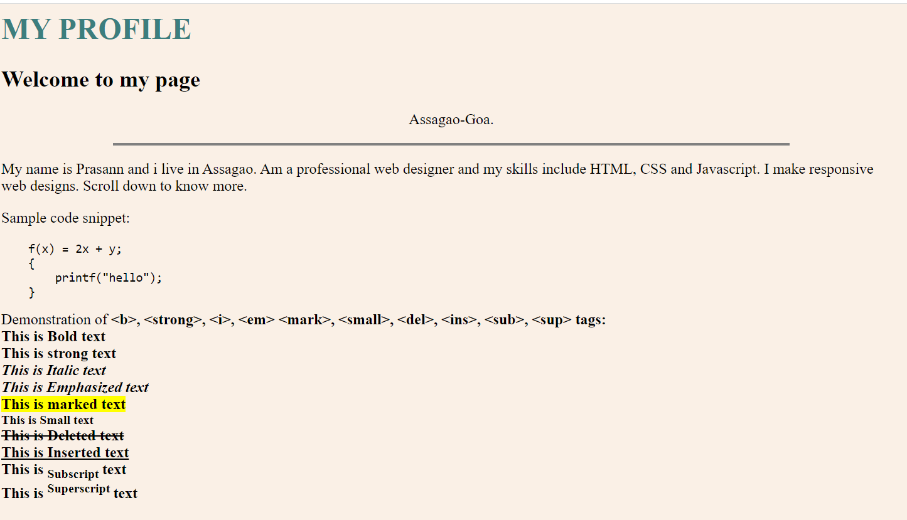

**Code :**

<html>

   <head>

   <title> Assignment 1 </title>

   </head>

   <body bgcolor="linen">

   <h1><p style = "color:darkcyan"> MY PROFILE </p> </h1>

   <p><h3>Welcome to my page</h3></p>

   <h5><center>Assagao-Goa</center></h5>

   <hr width = 60%>

   <p>

    <h4>My name is Amrutha and I live in Assagao. I am a professional web designer and my skills include HTML, CSS and Javascript. I make responsive web designs. Scroll down to know more.</h4>

   </p>

   <p>

    <h4>Sample code snippet:</h4>

   </p>

   <p>

    <pre>

        f(x) = 2x + y;

        {

            printf("Hello");

        }

    </pre>

   </p>

   <p><h4>

        Demonstration of &lt;b&gt; , &lt;strong&gt; , &lt;i&gt; , &lt;em&gt; , &lt;mark&gt; , &lt;small&gt; , &lt;del&gt; , &lt;ins&gt; ,&lt;sub&gt; , &lt;sup&gt; <br>

        <b>This is a bold text</b><br>

        <strong>This is a strong text</strong><br>

        <i>This is Italic text</i><br>

        <em>This is Emphasized text</em><br>

        <mark>This is marked text</mark><br>

        <small>This is small text</small><br>

        <del>This is deleted text</del><br>

        <ins>This is Inserted text</ins><br>

        This is <sub>Subscript</sub>text<br>

        This is <sup>Superscript</sup>text<br>

   </h4>

   </p>

   </body>

</html>