

Faculty of Technology and Engineering
Chandubhai S. Patel Institute of Technology (CSPIT) Department of Computer Science & Engineering
Date:05/11/2026
Practical Submission

Academic Year | : | 2026-27 | Semester | : | 3rd
Course code | : | CEUE203 | Course name | : | JAVA

Practical No: 2

Program Title: Thermostat

Problem Statement: (a) Create class Thermostat with private String location, private int temperature, private static final int MIN=16 and MAX=30, and private static int activeCount=0. (b) Constructor(location, startTemp): store location; set temperature to startTemp if it is within MIN..MAX else 22; increment activeCount. (c) Constructor(location): chain with this(location, 22). (d) raise(): if temperature < MAX add 1, else print “Already at maximum (30)”. (e) lower(): if temperature > MIN subtract 1, else print “Already at minimum (16)”. (f) Add getTemperature() (no setter) and static getActiveCount(). (g) In main: create two thermostats, call raise() 10 times then lower() 20 times in loops (printing the temperature each time), then print getActiveCount(). Expected output: temperature rises to 30 then “Already at maximum”, falls to 16 then “Already at minimum”, count 2.
Formatted Code:

package practical_2;

public class Thermostat {

// Private instance variables to store thermostat details
private String location;
private int temperature;

// Fixed temperature limits for all thermostats
private static final int MIN = 16;
private static final int MAX = 30;

// Shared counter to keep track of created thermostat objects
private static int activeCount = 0;

// Constructor that accepts location and starting temperature
public Thermostat(String location, int startTemp) {

this.location = location;

// Set the given temperature only if it is within the allowed range
// Otherwise, use the default temperature of 22
if (startTemp >= MIN && startTemp <= MAX) {
this.temperature = startTemp;
} else {
this.temperature = 22;
}

// Increment the count whenever a new thermostat is created
activeCount++;
}

// Constructor chaining: use 22 as the default starting temperature
public Thermostat(String location) {
this(location, 22);
}

// Increase the temperature by 1 if it has not reached the maximum
public void raise() {

if (temperature < MAX) {
temperature++;
} else {
System.out.println("Already at maximum (" + MAX + ")");
}
}

// Decrease the temperature by 1 if it has not reached the minimum
public void lower() {

if (temperature > MIN) {
temperature--;
} else {
System.out.println("Already at minimum (" + MIN + ")");
}
}

// Getter method to access the current temperature
// No setter is provided so temperature can only be changed through raise() and lower()
public int getTemperature() {
return temperature;
}

// Static getter to access the total number of created thermostats
public static int getActiveCount() {
return activeCount;
}

public static void main(String[] args) {

// Create two thermostat objects using both constructors
Thermostat t1 = new Thermostat("Living Room", 22);
Thermostat t2 = new Thermostat("Bedroom");

// Increase the temperature 10 times
System.out.println("Raising temperature:");

for (int i = 1; i <= 10; i++) {
t1.raise();
System.out.println("Temperature: " + t1.getTemperature());
}

// Decrease the temperature 20 times
System.out.println("\nLowering temperature:");

for (int i = 1; i <= 20; i++) {
t1.lower();
System.out.println("Temperature: " + t1.getTemperature());
}

// Display the number of thermostat objects created
System.out.println("\nActive Thermostats: " + Thermostat.getActiveCount());
}
}

Screenshots / Output:

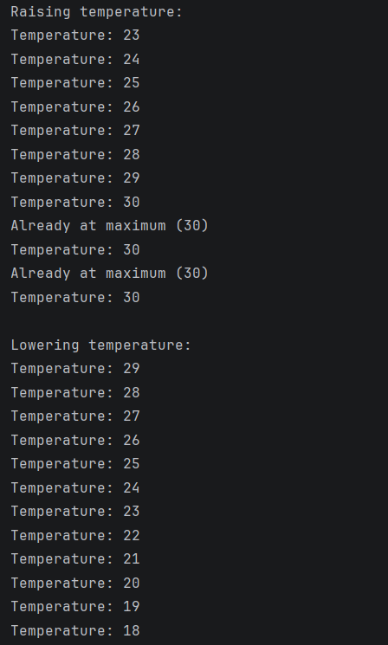
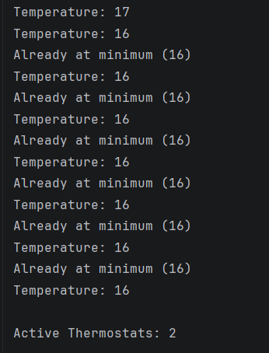

Program Title: Cinema show

Problem Statement: (a) Create class CinemaShow with private String title, private int seatsAvailable, private final int capacity, and private static int totalBooked=0. (b) Constructor(title, capacity): set both and seatsAvailable = capacity. Constructor(title): chain with this(title, 100). (c) book(int n): if n ≤ seatsAvailable, reduce seatsAvailable by n, add n to totalBooked, return true; else return false unchanged. (d) cancel(int n): increase seatsAvailable by n but never above capacity. (e) Add getSeatsAvailable() and static getTotalBooked(). (f) In main: run a sequence of book and cancel calls, printing the result and seats after each, then print getTotalBooked(). Expected output: booking more than available prints false and leaves seats unchanged; totalBooked equals the successful bookings.

Formatted code:

package practical_2;

public class CinemaShow {

// Private variables to store show details
private String title;
private int seatsAvailable;

// Capacity is fixed when the cinema show object is created
private final int capacity;

// Shared counter to track the total number of successfully booked seats
private static int totalBooked = 0;

// Constructor that accepts the movie title and total seat capacity
public CinemaShow(String title, int capacity) {

this.title = title;
this.capacity = capacity;

// Initially, all seats are available
this.seatsAvailable = capacity;
}

// Constructor chaining: use 100 seats as the default capacity
public CinemaShow(String title) {
this(title, 100);
}

// Book the requested number of seats
public boolean book(int n) {

// Booking is allowed only if the requested seats are available
if (n > 0 && n <= seatsAvailable) {

// Reduce the available seats by the booked quantity
seatsAvailable -= n;

// Update the total number of successfully booked seats
totalBooked += n;

return true;
}

// Return false if the requested booking cannot be completed
return false;
}

// Cancel the requested number of seats
public void cancel(int n) {

if (n > 0) {

// Add the cancelled seats but never exceed the original capacity
seatsAvailable = Math.min(capacity, seatsAvailable + n);
}
}

// Getter method to access the number of available seats
public int getSeatsAvailable() {
return seatsAvailable;
}

// Static getter to access the total number of successful bookings
public static int getTotalBooked() {
return totalBooked;
}

public static void main(String[] args) {

// Create two cinema shows using the two constructors
CinemaShow show1 = new CinemaShow("Avengers", 50);
CinemaShow show2 = new CinemaShow("Interstellar");

// Try booking 20 seats for the first show
System.out.println("Booking 20 seats: " + show1.book(20));
System.out.println("Seats available: " + show1.getSeatsAvailable());

// Try booking another 25 seats
System.out.println("\nBooking 25 seats: " + show1.book(25));
System.out.println("Seats available: " + show1.getSeatsAvailable());

// Try booking more seats than are available
System.out.println("\nBooking 10 seats: " + show1.book(10));
System.out.println("Seats available: " + show1.getSeatsAvailable());

// Cancel 10 previously booked seats
show1.cancel(10);
System.out.println("\nAfter cancelling 10 seats:");
System.out.println("Seats available: " + show1.getSeatsAvailable());

// Book 5 seats for the second show
System.out.println("\nBooking 5 seats in second show: " + show2.book(5));
System.out.println("Seats available: " + show2.getSeatsAvailable());

// Display the total number of seats successfully booked across both shows
System.out.println("\nTotal Booked: " + CinemaShow.getTotalBooked());
}
}

Screenshots/Output:

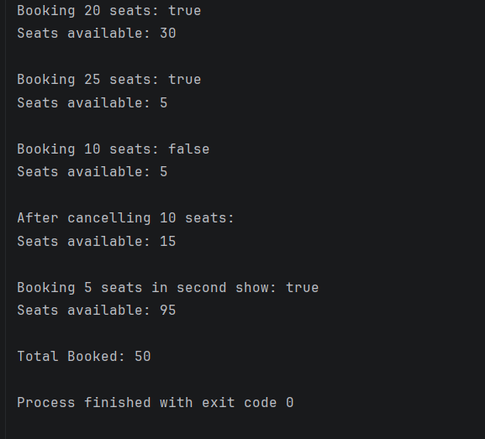

Program Title: Parking Lot

Problem Statement: (a) Create class ParkingLot with private int twoWheelers and fourWheelers, private final int twoCap and fourCap, and private static long revenue=0. (b) park(String type): for “two”, if twoWheelers < twoCap increment and add 20 to revenue; for “four”, if fourWheelers < fourCap increment and add 40; otherwise print “Full” and reject. (c) leave(String type): decrement the matching count but never below 0. (d) In main: simulate a sequence of park/leave events, printing each outcome, then print final occupancy and revenue. Expected output: parking into a full section is refused; revenue = 20×(two parked) + 40×(four parked).

Formatted Code:

package practical_1;

public class ParkingLot {

// Private counters to track the number of parked vehicles
private int twoWheelers;
private int fourWheelers;

// Fixed parking capacity for each type of vehicle
private final int twoCap;
private final int fourCap;

// Shared revenue collected from all parking operations
private static long revenue = 0;

// Constructor to initialize the parking capacities
public ParkingLot(int twoCap, int fourCap) {

this.twoCap = twoCap;
this.fourCap = fourCap;

// Initially, no vehicles are parked
this.twoWheelers = 0;
this.fourWheelers = 0;
}

// Park a vehicle based on its type
public void park(String type) {

// Convert input to lowercase so that TWO and two are treated equally
type = type.toLowerCase();

switch (type) {

case "two" -> {

// Check whether space is available for a two-wheeler
if (twoWheelers < twoCap) {

twoWheelers++;

// Collect 20 as parking fee
revenue += 20;

System.out.println("Two-wheeler parked successfully.");
} else {
System.out.println("Full");
}
}

case "four" -> {

// Check whether space is available for a four-wheeler
if (fourWheelers < fourCap) {

fourWheelers++;

// Collect 40 as parking fee
revenue += 40;

System.out.println("Four-wheeler parked successfully.");
} else {
System.out.println("Full");
}
}

default -> System.out.println("Invalid vehicle type!");
}
}

// Remove a vehicle from the parking lot
public void leave(String type) {

// Convert input to lowercase for case-insensitive comparison
type = type.toLowerCase();

switch (type) {

case "two" -> {

// Decrease the count only if at least one two-wheeler is parked
if (twoWheelers > 0) {
twoWheelers--;
System.out.println("Two-wheeler left.");
} else {
System.out.println("No two-wheelers available.");
}
}

case "four" -> {

// Decrease the count only if at least one four-wheeler is parked
if (fourWheelers > 0) {
fourWheelers--;
System.out.println("Four-wheeler left.");
} else {
System.out.println("No four-wheelers available.");
}
}

default -> System.out.println("Invalid vehicle type!");
}
}

public static void main(String[] args) {

// Create a parking lot with space for 2 two-wheelers and 1 four-wheeler
ParkingLot parking = new ParkingLot(2, 1);

// Park two two-wheelers
System.out.println("Parking vehicles:");

parking.park("two");
parking.park("two");

// Try parking another two-wheeler when the section is full
parking.park("two");

// Park one four-wheeler
parking.park("four");

// Try parking another four-wheeler when the section is full
parking.park("four");

// Display the result after vehicles leave
System.out.println("\nVehicles leaving:");

parking.leave("two");
parking.leave("four");

// Display the final parking occupancy
System.out.println("\nFinal Occupancy:");
System.out.println("Two-wheelers: " + parking.twoWheelers);
System.out.println("Four-wheelers: " + parking.fourWheelers);

// Display the total revenue collected
System.out.println("Total Revenue: " + revenue);
}
}

Screenshots/Output:



