

Faculty of Technology and Engineering
Chandubhai S. Patel Institute of Technology (CSPIT) Department of Computer Science & Engineering
Date:06/11/2026
Practical Submission

Academic Year | : | 2026-27 | Semester | : | 3rd
Course code | : | CEUE203 | Course name | : | JAVA

Practical No: 10

Program Title: Thread pool runner, Produce consumer, Deadlock between two threads.

Problem Statement: 1. Thread-pool runner: with a fixed pool of 3 (ExecutorService), submit about 10 Runnable tasks that print their id and sleep briefly; shut down and await completion, observing the few threads being reused. 2. Producer–consumer: one thread adds numbers to a small shared buffer and another removes them, coordinated with wait()/notify(); produce and consume a fixed number of items in order with none lost. 3. (For Advanced Learners – home) Reproduce a deadlock between two threads that lock two objects in opposite order, then remove it with a consistent lock order. Choose the scenario yourself.
Formatted Code:

ThreadPoolDemo.java

package practical_10;

import java.util.concurrent.ExecutorService;
import java.util.concurrent.Executors;
import java.util.concurrent.TimeUnit;

// Demonstrates how a fixed thread pool executes and reuses threads.

public class ThreadPoolDemo {

public static void main(String[] args) {

// Create a thread pool containing exactly 3 worker threads.
ExecutorService executor = Executors.newFixedThreadPool(3);

// Submit 10 independent tasks to the thread pool.
for (int i = 1; i <= 10; i++) {

// Store the task ID for use inside the Runnable.
final int taskId = i;

// Submit a task to the executor.
executor.submit(() -> {

// Display the task ID and the worker thread executing it.
String threadName = Thread.currentThread().getName();

System.out.println(
"Task " + taskId + " started by " + threadName
);

try {
// Simulate some work by sleeping for a short time.
Thread.sleep(1000);
} catch (InterruptedException e) {

// Restore the interrupted status if the task is interrupted.
Thread.currentThread().interrupt();

System.out.println("Task " + taskId + " was interrupted.");
return;
}

System.out.println(
"Task " + taskId + " completed by " + threadName
);
});
}

// Stop accepting new tasks.
executor.shutdown();

try {
// Wait until all submitted tasks have completed.
if (!executor.awaitTermination(30, TimeUnit.SECONDS)) {

// Forcefully stop remaining tasks if the timeout expires.
executor.shutdownNow();

System.out.println("Some tasks did not finish in time.");
} else {
System.out.println("\nAll tasks completed successfully.");
}

} catch (InterruptedException e) {

// Force shutdown if the main thread is interrupted.
executor.shutdownNow();

Thread.currentThread().interrupt();

System.out.println("Main thread was interrupted.");
}
}
}

Output:

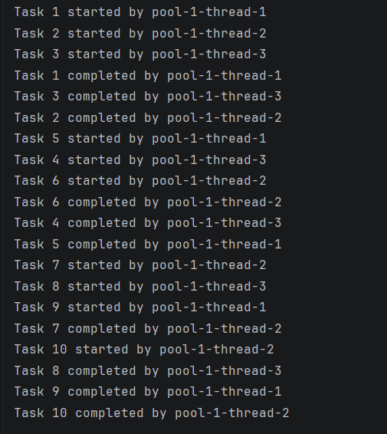

ProducerConsumerDemo.java

package practical_10;

import java.util.ArrayDeque;
import java.util.Queue;

// Shared buffer used by both producer and consumer.
class SharedBuffer {

// Queue stores the produced items.
private final Queue<Integer> buffer = new ArrayDeque<>();

// Maximum number of items the buffer can hold.
private final int capacity = 3;

// Adds an item to the buffer.
public synchronized void produce(int item) throws InterruptedException {

// Wait while the buffer is full.
while (buffer.size() == capacity) {
System.out.println("Buffer full. Producer is waiting...");
wait();
}

// Add the new item to the buffer.
buffer.add(item);

System.out.println("Produced: " + item + " | Buffer: " + buffer);

// Notify waiting threads that the buffer has changed.
notifyAll();
}

// Removes an item from the buffer.
public synchronized int consume() throws InterruptedException {

// Wait while the buffer is empty.
while (buffer.isEmpty()) {
System.out.println("Buffer empty. Consumer is waiting...");
wait();
}

// Remove the oldest item from the queue.
int item = buffer.remove();

System.out.println("Consumed: " + item + " | Buffer: " + buffer);

// Notify waiting threads that space is now available.
notifyAll();

return item;
}
}

// Producer thread creates items and places them in the buffer.
class Producer implements Runnable {

private final SharedBuffer sharedBuffer;
private final int totalItems;

public Producer(SharedBuffer sharedBuffer, int totalItems) {
this.sharedBuffer = sharedBuffer;
this.totalItems = totalItems;
}

@Override
public void run() {

try {
// Produce numbers from 1 to totalItems.
for (int i = 1; i <= totalItems; i++) {
sharedBuffer.produce(i);
}

System.out.println("Producer finished.");

} catch (InterruptedException e) {

// Restore interrupted status if the producer is interrupted.
Thread.currentThread().interrupt();
System.out.println("Producer was interrupted.");
}
}
}

// Consumer thread removes items from the buffer.
class Consumer implements Runnable {

private final SharedBuffer sharedBuffer;
private final int totalItems;

public Consumer(SharedBuffer sharedBuffer, int totalItems) {
this.sharedBuffer = sharedBuffer;
this.totalItems = totalItems;
}

@Override
public void run() {

try {
// Consume exactly totalItems items.
for (int i = 1; i <= totalItems; i++) {
sharedBuffer.consume();
}

System.out.println("Consumer finished.");

} catch (InterruptedException e) {

// Restore interrupted status if the consumer is interrupted.
Thread.currentThread().interrupt();
System.out.println("Consumer was interrupted.");
}
}
}

// Main class starts the producer and consumer threads.
public class ProducerConsumerDemo {

public static void main(String[] args) throws InterruptedException {

// Create one shared buffer with capacity 3.
SharedBuffer sharedBuffer = new SharedBuffer();

// Both threads will process exactly 10 items.
int totalItems = 10;

// Create producer and consumer threads.
Thread producer = new Thread(
new Producer(sharedBuffer, totalItems),
"Producer"
);

Thread consumer = new Thread(
new Consumer(sharedBuffer, totalItems),
"Consumer"
);

System.out.println("Producer-Consumer problem started.\n");

// Start both threads.
producer.start();
consumer.start();

// Wait for both threads to complete.
producer.join();
consumer.join();

System.out.println("\nAll 10 items produced and consumed successfully.");
}
}

Output:

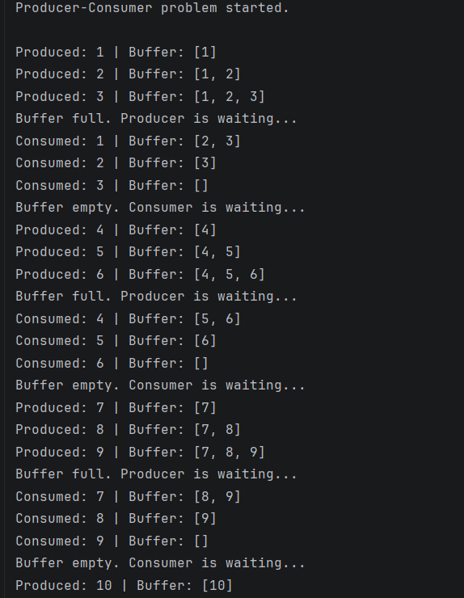
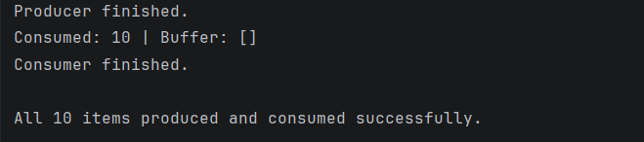

DeadlockDemo.java

package practical_10;

import java.util.concurrent.CountDownLatch;

// Demonstrates deadlock and its prevention using a consistent lock order.

public class DeadlockDemo {

// Two shared bank account objects act as locks.
private static final Object accountA = new Object();
private static final Object accountB = new Object();

// ------------------------------------------------
// METHOD 1: CREATE A DEADLOCK
// ------------------------------------------------

public static void demonstrateDeadlock() throws InterruptedException {

System.out.println("METHOD 1: DEADLOCK DEMONSTRATION");

// Both threads must acquire their first lock before proceeding.
// This makes the deadlock demonstration predictable.
CountDownLatch bothFirstLocksAcquired = new CountDownLatch(2);

Thread employee1 = new Thread(() -> {

try {
// Employee 1 locks Account A first.
synchronized (accountA) {

System.out.println("Employee 1 locked Account A.");

bothFirstLocksAcquired.countDown();

// Wait until Employee 2 has locked Account B.
bothFirstLocksAcquired.await();

System.out.println("Employee 1 is waiting for Account B...");

// Employee 1 now tries to lock Account B.
synchronized (accountB) {
System.out.println("Employee 1 accessed both accounts.");
}
}

} catch (InterruptedException e) {
Thread.currentThread().interrupt();
}

}, "Employee-1");

Thread employee2 = new Thread(() -> {

try {
// Employee 2 locks Account B first.
synchronized (accountB) {

System.out.println("Employee 2 locked Account B.");

bothFirstLocksAcquired.countDown();

// Wait until Employee 1 has locked Account A.
bothFirstLocksAcquired.await();

System.out.println("Employee 2 is waiting for Account A...");

// Employee 2 now tries to lock Account A.
synchronized (accountA) {
System.out.println("Employee 2 accessed both accounts.");
}
}

} catch (InterruptedException e) {
Thread.currentThread().interrupt();
}

}, "Employee-2");

// Daemon threads allow the JVM to exit even if they remain deadlocked.
employee1.setDaemon(true);
employee2.setDaemon(true);

employee1.start();
employee2.start();

// Wait for a limited time to check whether the threads finish.
employee1.join(1000);
employee2.join(1000);

// If both threads are still alive, they are stuck in the deadlock.
if (employee1.isAlive() && employee2.isAlive()) {
System.out.println("\nDEADLOCK DETECTED!");
System.out.println("Employee 1 is waiting for Account B.");
System.out.println("Employee 2 is waiting for Account A.");
} else {
System.out.println("No deadlock detected in this run.");
}
}

// ------------------------------------------------
// METHOD 2: PREVENT DEADLOCK
// ------------------------------------------------

public static void demonstrateDeadlockPrevention()
throws InterruptedException {

System.out.println("\nMETHOD 2: DEADLOCK PREVENTION");

Thread employee1 = new Thread(() -> transferSafely("Employee 1"));

Thread employee2 = new Thread(() -> transferSafely("Employee 2"));

// Start both employees.
employee1.start();
employee2.start();

// Wait for both employees to finish.
employee1.join();
employee2.join();

System.out.println("Both employees completed successfully.");
System.out.println("No deadlock occurred.");
}

// Both employees always acquire Account A first and Account B second.
// A consistent lock order prevents circular waiting.
private static void transferSafely(String employeeName) {

synchronized (accountA) {

System.out.println(employeeName + " locked Account A.");

synchronized (accountB) {

System.out.println(employeeName + " locked Account B.");

// Simulate a short bank transfer operation.
System.out.println(employeeName + " transferred money safely.");
}
}
}

public static void main(String[] args) throws InterruptedException {

// First demonstrate the deadlock.
demonstrateDeadlock();

// Then demonstrate the corrected approach.
demonstrateDeadlockPrevention();
}
}
Output:



