

Faculty of Technology and Engineering
Chandubhai S. Patel Institute of Technology (CSPIT) Department of Computer Science & Engineering
Date:06/11/2026
Practical Submission

Academic Year | : | 2026-27 | Semester | : | 3rd
Course code | : | CEUE203 | Course name | : | JAVA

Practical No: 11

Program Title: Serializable, Log analyzer, Folder tree implementation

Problem Statement: 1. Save/load: make a small class Serializable, save an array of its objects to a file with ObjectOutputStream, then read it back into fresh objects and confirm the values survived. Mark one field transient and show it is not saved. 2. Log analyzer: create a few text files, then use Path/Files to read each line by line and count the total lines and how many contain a keyword across all files; also print each file’s size from its attributes. 3. (For Advanced Learners – home) Walk a folder tree with NIO and produce a report of the files it contains (name, size, modified time), writing the summary to a file; decide what to include.
Formatted Code:

SerializationDemo.java

package practical_11;

import java.io.FileOutputStream;
import java.io.FileInputStream;
import java.io.ObjectOutputStream;
import java.io.ObjectInputStream;
import java.io.Serializable;
import java.io.IOException;
import java.util.Arrays;

// Student class implements Serializable so its objects can be saved.
class Student implements Serializable {

// Used to identify the class version during deserialization.
private static final long serialVersionUID = 1L;

private int rollNo;
private String name;
private double marks;

// transient fields are not saved during serialization.
private transient String password;

// Constructor to initialize student details.
public Student(int rollNo, String name, double marks, String password) {
this.rollNo = rollNo;
this.name = name;
this.marks = marks;
this.password = password;
}

// Displays all student details.
public void display() {
System.out.println("Roll Number : " + rollNo);
System.out.println("Name : " + name);
System.out.println("Marks : " + marks);
System.out.println("Password : " + password);
System.out.println("----------------------------");
}
}

public class SerializationDemo {

public static void main(String[] args) {

// Name of the file in which objects will be stored.
String fileName = "students.ser";

// Create an array containing three Student objects.
Student[] students = {
new Student(101, "Amit", 85.5, "amit123"),
new Student(102, "Neha", 92.0, "neha456"),
new Student(103, "Rahul", 78.5, "rahul789")
};

// ---------------- SERIALIZATION ----------------

try (ObjectOutputStream output =
new ObjectOutputStream(new FileOutputStream(fileName))) {

// Write the complete Student array into the file.
output.writeObject(students);

System.out.println("Student objects saved successfully.");

} catch (IOException e) {
System.out.println("Error while saving objects: " + e.getMessage());
return;
}

// ---------------- DESERIALIZATION ----------------

try (ObjectInputStream input =
new ObjectInputStream(new FileInputStream(fileName))) {

// Read the saved array and convert it back into Student objects.
Student[] loadedStudents = (Student[]) input.readObject();

System.out.println("\nStudent objects loaded successfully.");
System.out.println("\nDetails after loading:");

// Display the loaded objects.
for (Student student : loadedStudents) {
student.display();
}

} catch (IOException | ClassNotFoundException e) {
System.out.println("Error while loading objects: " + e.getMessage());
}
}
}

Output:

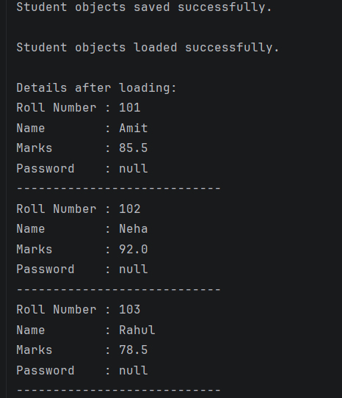

LogAnalyzerDemo.java

package practical_11;

import java.io.IOException;
import java.nio.file.Path;
import java.nio.file.Files;
import java.nio.file.attribute.BasicFileAttributes;
import java.util.List;
import java.util.Locale;

// Demonstrates reading multiple log files using Java NIO.

public class LogAnalyzerDemo {

public static void main(String[] args) {

// Create a folder to store our sample log files.
Path folder = Path.of("logs");

// Define paths for three log files.
Path file1 = folder.resolve("application1.txt");
Path file2 = folder.resolve("application2.txt");
Path file3 = folder.resolve("application3.txt");

// Keyword that we want to search for in the log files.
String keyword = "ERROR";

try {

// Create the logs folder if it does not already exist.
Files.createDirectories(folder);

// Sample log entries for the first file.
List<String> logs1 = List.of(
"Application started successfully",
"User logged in",
"ERROR: Database connection failed",
"User logged out"
);

// Sample log entries for the second file.
List<String> logs2 = List.of(
"Server started",
"ERROR: Invalid request",
"Request processed successfully"
);

// Sample log entries for the third file.
List<String> logs3 = List.of(
"Backup started",
"Backup completed",
"WARNING: Low disk space",
"ERROR: Backup verification failed"
);

// Write the sample log entries into their respective files.
Files.write(file1, logs1);
Files.write(file2, logs2);
Files.write(file3, logs3);

// Store all file paths in an array for easy processing.
Path[] files = {file1, file2, file3};

// Variables to store totals across all files.
int totalLines = 0;
int totalKeywordMatches = 0;

System.out.println("LOG FILE ANALYSIS");
System.out.println("=================");

// Process each log file one by one.
for (Path file : files) {

System.out.println("\nFile: " + file.getFileName());

// Read basic attributes such as file size.
BasicFileAttributes attributes =
Files.readAttributes(file, BasicFileAttributes.class);

System.out.println(
"File size: " + attributes.size() + " bytes"
);

// Read the file line by line.
int fileLines = 0;
int fileMatches = 0;

try (var reader = Files.newBufferedReader(file)) {

String line;

while ((line = reader.readLine()) != null) {

// Count every line.
fileLines++;

// Check whether the line contains the keyword.
if (line.toLowerCase(Locale.ROOT)
.contains(keyword.toLowerCase(Locale.ROOT))) {
fileMatches++;
}
}
}

// Add this file's counts to the overall totals.
totalLines += fileLines;
totalKeywordMatches += fileMatches;

System.out.println("Total lines: " + fileLines);
System.out.println(keyword + " lines: " + fileMatches);
}

// Display the final totals across all log files.
System.out.println("\nOVERALL SUMMARY");
System.out.println("================");
System.out.println("Total lines across all files: " + totalLines);
System.out.println(
"Total " + keyword + " occurrences by line: "
+ totalKeywordMatches
);

} catch (IOException e) {

// Display an error if file creation, reading, or writing fails.
System.out.println("File operation failed: " + e.getMessage());
}
}
}

Output:

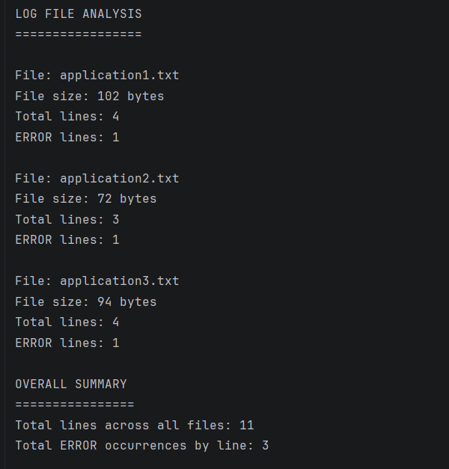

FolderTreeReport.java

package practical_11;

import java.io.IOException;
import java.nio.file.Files;
import java.nio.file.Path;
import java.nio.file.attribute.BasicFileAttributes;
import java.time.format.DateTimeFormatter;
import java.util.ArrayList;
import java.util.Comparator;
import java.util.List;
import java.util.stream.Stream;

// Walks through a folder tree and writes a report of all regular files.

public class FolderTreeReport {

public static void main(String[] args) {

// Root folder that will be scanned.
Path rootFolder = Path.of("sample_tree");

// Report is saved outside the scanned folder.
Path reportFile = Path.of("folder_report.txt");

// Format used to display the last modified date and time.
DateTimeFormatter formatter =
DateTimeFormatter.ofPattern("dd-MM-yyyy HH:mm:ss");

try {

// Create a sample folder structure for testing.
createSampleFolders(rootFolder);

// Store report lines before writing them to the output file.
List<String> report = new ArrayList<>();

report.add("FOLDER TREE REPORT");
report.add("==================");
report.add("Scanned folder: " + rootFolder.toAbsolutePath());
report.add("");

int fileCount = 0;
long totalSize = 0;

// Files.walk() visits the root folder and all its subfolders.
// try-with-resources closes the stream after processing.
try (Stream<Path> paths = Files.walk(rootFolder)) {

// Sort paths so the report is easier to read.
List<Path> allPaths = paths
.filter(Files::isRegularFile)
.sorted(Comparator.naturalOrder())
.toList();

// Read information about every regular file.
for (Path file : allPaths) {

// Read file attributes such as size and modified time.
BasicFileAttributes attributes =
Files.readAttributes(
file,
BasicFileAttributes.class
);

String fileName = file.getFileName().toString();

// Show the path relative to the scanned root folder.
String relativePath = rootFolder.relativize(file).toString();

// Convert the last modified time into a readable format.
String modifiedTime = attributes.lastModifiedTime()
.toInstant()
.atZone(java.time.ZoneId.systemDefault())
.format(formatter);

long fileSize = attributes.size();

// Add the file information to the report.
report.add("File name : " + fileName);
report.add("Relative path : " + relativePath);
report.add("File size : " + fileSize + " bytes");
report.add("Modified time : " + modifiedTime);
report.add("----------------------------------------");

fileCount++;
totalSize += fileSize;
}
}

// Add summary information at the end of the report.
report.add("");
report.add("SUMMARY");
report.add("==================");
report.add("Total files : " + fileCount);
report.add("Total size : " + totalSize + " bytes");

// Write the complete report to a text file.
Files.write(reportFile, report);

System.out.println("Folder scan completed successfully.");
System.out.println("Total files found: " + fileCount);
System.out.println("Total size: " + totalSize + " bytes");
System.out.println(
"Report saved to: " + reportFile.toAbsolutePath()
);

} catch (IOException e) {

// Handle errors while creating folders, scanning, or writing.
System.out.println("Folder operation failed: " + e.getMessage());
}
}

// Creates sample folders and text files for demonstration.
private static void createSampleFolders(Path root) throws IOException {

Path documents = root.resolve("Documents");
Path images = root.resolve("Images");
Path projects = documents.resolve("Projects");

// Create the folder structure, including missing parent folders.
Files.createDirectories(projects);
Files.createDirectories(images);

// Create sample files only if they do not already exist.
createFileIfMissing(
documents.resolve("notes.txt"),
"These are sample notes."
);

createFileIfMissing(
projects.resolve("java.txt"),
"Java folder traversal practical."
);

createFileIfMissing(
images.resolve("image-info.txt"),
"Sample image information."
);
}

// Creates a file only if it is not already present.
private static void createFileIfMissing(Path file, String content)
throws IOException {

if (Files.notExists(file)) {
Files.writeString(file, content);
}
}
}

Output:

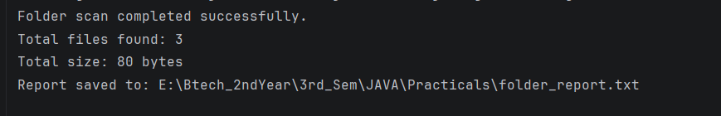

f

