

Faculty of Technology and Engineering
Chandubhai S. Patel Institute of Technology (CSPIT) Department of Computer Science & Engineering
Date:06/11/2026
Practical Submission

Academic Year | : | 2026-27 | Semester | : | 3rd
Course code | : | CEUE203 | Course name | : | JAVA

Practical No: 12

Program Title: Word frequency check, Unique visitors check, Leaderboard implementation.

Problem Statement: 1. Word frequency: split a paragraph into words, count each in a HashMap, and print the words sorted by frequency (highest first) using a Comparator. 2. Unique visitors: from a list of login names with repeats, use a HashSet to count unique users and a LinkedHashSet to keep first-seen order; print the unique count and the first three distinct names. 3. (For Advanced Learners – home) Build a leaderboard from player scores held in a Map and print the top-N sorted by score (ties broken by name); choose the data and sorting details.
Formatted Code:

WordFrequencyDemo.java

package practical_12;

import java.util.HashMap;
import java.util.Map;
import java.util.List;
import java.util.ArrayList;
import java.util.Comparator;

// Demonstrates word counting using HashMap and sorting using Comparator.

public class WordFrequencyDemo {

public static void main(String[] args) {

// Sample paragraph containing repeated words.
String paragraph =
"Java is simple and Java is powerful. "
+ "Java is popular because Java is easy to learn.";

// Convert the complete paragraph to lowercase.
// This makes the counting case-insensitive.
paragraph = paragraph.toLowerCase();

// Remove punctuation and split the paragraph into words.
String[] words = paragraph.replaceAll("[^a-z0-9\\s]", "")
.trim()
.split("\\s+");

// HashMap stores each word as a key and its frequency as a value.
Map<String, Integer> frequencyMap = new HashMap<>();

// Count how many times each word occurs.
for (String word : words) {

// If the word exists, increase its count by 1.
// Otherwise, start its count at 1.
frequencyMap.put(
word,
frequencyMap.getOrDefault(word, 0) + 1
);
}

// Convert the map entries into a list so they can be sorted.
List<Map.Entry<String, Integer>> sortedWords =
new ArrayList<>(frequencyMap.entrySet());

// Sort by frequency in descending order.
// If frequencies are equal, sort alphabetically by word.
sortedWords.sort(
Comparator
.comparing(
(Map.Entry<String, Integer> entry) ->
entry.getValue()
)
.reversed()
.thenComparing(Map.Entry::getKey)
);

// Display the final word frequency list.
System.out.println("WORD FREQUENCY");
System.out.println("==============");

for (Map.Entry<String, Integer> entry : sortedWords) {

System.out.println(
entry.getKey() + " : " + entry.getValue()
);
}
}
}

Output:

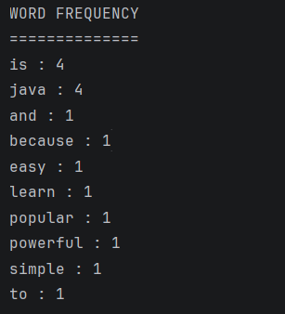

UniqueVisitorsDemo.java

package practical_12;

import java.util.Arrays;
import java.util.HashSet;
import java.util.LinkedHashSet;
import java.util.List;
import java.util.Set;

// Demonstrates unique visitor counting using HashSet and LinkedHashSet.

public class UniqueVisitorsDemo {

public static void main(String[] args) {

// Login history containing repeated usernames.
List<String> loginNames = Arrays.asList(
"Amit",
"Neha",
"Rahul",
"Amit",
"Priya",
"Neha",
"Karan",
"Rahul",
"Sneha"
);

// ---------------- USING HASHSET ----------------

// HashSet automatically removes duplicate usernames.
Set<String> uniqueUsers = new HashSet<>(loginNames);

// Display the total number of unique visitors.
System.out.println("UNIQUE VISITOR COUNT");
System.out.println("====================");
System.out.println("Total unique visitors: " + uniqueUsers.size());

// ---------------- USING LINKEDHASHSET ----------------

// LinkedHashSet removes duplicates but preserves first-seen order.
Set<String> orderedUniqueUsers =
new LinkedHashSet<>(loginNames);

System.out.println("\nFIRST THREE DISTINCT VISITORS");
System.out.println("=============================");

int count = 0;

// Print only the first three distinct usernames.
for (String user : orderedUniqueUsers) {

if (count == 3) {
break;
}

System.out.println((count + 1) + ". " + user);

count++;
}

// Display all unique visitors in their original first-seen order.
System.out.println("\nALL UNIQUE VISITORS");
System.out.println("===================");

for (String user : orderedUniqueUsers) {
System.out.println(user);
}
}
}

Output:

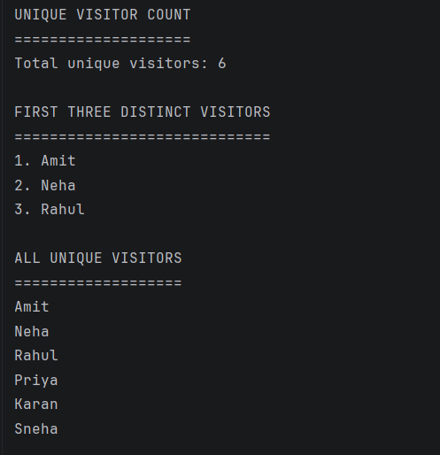

LeaderboardDemo.java

package practical_12;

import java.util.HashMap;
import java.util.Map;
import java.util.List;
import java.util.ArrayList;
import java.util.Comparator;

// Demonstrates creating a sorted leaderboard using Map and Comparator.

public class LeaderboardDemo {

public static void main(String[] args) {

// Store player names as keys and their scores as values.
Map<String, Integer> playerScores = new HashMap<>();

// Add player names and scores.
playerScores.put("Amit", 850);
playerScores.put("Neha", 950);
playerScores.put("Rahul", 900);
playerScores.put("Priya", 950);
playerScores.put("Karan", 780);
playerScores.put("Sneha", 880);
playerScores.put("Rohan", 900);
playerScores.put("Anjali", 820);

// Number of top players to display.
int topN = 5;

// Convert the map entries into a list for sorting.
List<Map.Entry<String, Integer>> leaderboard =
new ArrayList<>(playerScores.entrySet());

// Sort players by:
// 1. Score in descending order.
// 2. Player name in alphabetical order when scores are equal.
leaderboard.sort(
Comparator
.comparing(
(Map.Entry<String, Integer> entry) ->
entry.getValue()
)
.reversed()
.thenComparing(Map.Entry::getKey)
);

// Display the top-N leaderboard.
System.out.println("PLAYER LEADERBOARD");
System.out.println("==================");

System.out.println(
String.format("%-8s %-15s %s", "Rank", "Player", "Score")
);

System.out.println("--------------------------------");

// Display only the requested number of top players.
int rank = 1;

for (Map.Entry<String, Integer> entry : leaderboard) {

// Stop after printing topN players.
if (rank > topN) {
break;
}

System.out.println(
String.format(
"%-8d %-15s %d",
rank,
entry.getKey(),
entry.getValue()
)
);

rank++;
}

System.out.println("\nTop " + topN + " players displayed.");
}
}

Output:



