

Faculty of Technology and Engineering
Chandubhai S. Patel Institute of Technology (CSPIT) Department of Computer Science & Engineering
Date:05 /11/2026
Practical Submission

Academic Year | : | 2026-27 | Semester | : | 3rd
Course code | : | CEUE203 | Course name | : | JAVA

Practical No: 05

Program Title: Shape areas, Payroll system, Media late fees.

Problem Statement: 1. Shape areas: an abstract Shape with abstract area(); subclasses Circle, Rectangle, Triangle. Put a mix in a Shape[] and loop once to print each area and the running total, tracking the largest — one loop handling every shape through polymorphism. 2. Payroll: an abstract Employee with abstract monthlySalary(); FullTime (fixed), PartTime (hours × rate) and Intern (stipend), each calling super for the shared name/id. Loop a mixed array to print each salary and the total; use instanceof to add a note only for interns. 3. (For Advanced Learners – home) Model a few media types that each compute a late fee differently and total the fees for a returned batch. Design the hierarchy and rules yourself.
Formatted Code:

ShapeAreaDemo.java

package practical_5;

// Abstract parent class representing a general shape.
abstract class Shape {

// Every child class must provide its own area calculation.
abstract double area();
}

// Circle class inherits from Shape.
class Circle extends Shape {

private double radius;

// Constructor to initialize the radius.
Circle(double radius) {
this.radius = radius;
}

// Overriding area() to calculate the area of a circle.
@Override
double area() {
return Math.PI * radius * radius;
}
}

// Rectangle class inherits from Shape.
class Rectangle extends Shape {

private double length;
private double width;

// Constructor to initialize length and width.
Rectangle(double length, double width) {
this.length = length;
this.width = width;
}

// Overriding area() to calculate rectangle area.
@Override
double area() {
return length * width;
}
}

// Triangle class inherits from Shape.
class Triangle extends Shape {

private double base;
private double height;

// Constructor to initialize base and height.
Triangle(double base, double height) {
this.base = base;
this.height = height;
}

// Overriding area() to calculate triangle area.
@Override
double area() {
return 0.5 * base * height;
}
}

// Main class to demonstrate runtime polymorphism.
public class ShapeAreaDemo {

public static void main(String[] args) {

// Creating an array of parent type Shape.
// It can store objects of Circle, Rectangle and Triangle.
Shape[] shapes = {
new Circle(5),
new Rectangle(10, 4),
new Triangle(6, 8),
new Circle(3),
new Rectangle(7, 5)
};

double total = 0;
double largest = 0;

System.out.println("===== SHAPE AREAS =====");

// One loop handles every shape using polymorphism.
for (Shape s : shapes) {

// Java automatically calls the correct overridden area().
double currentArea = s.area();

System.out.printf("Area: %.2f%n", currentArea);

// Add the current area to the running total.
total += currentArea;

// Track the largest area found so far.
if (currentArea > largest) {
largest = currentArea;
}
}

// Display the final results.
System.out.println("------------------------");
System.out.printf("Total Area: %.2f%n", total);
System.out.printf("Largest Area: %.2f%n", largest);
}
}

Output:

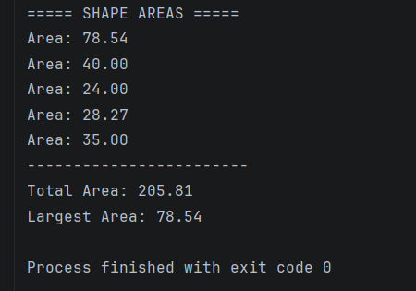
PayrollDemo.java

package practical_5;

// Abstract parent class representing a general employee.
abstract class Employee {

protected String name;
protected int id;

// Constructor to initialize common employee information.
Employee(String name, int id) {
this.name = name;
this.id = id;
}

// Abstract method: each employee type calculates salary differently.
abstract double monthlySalary();
}

// FullTime employee receives a fixed monthly salary.
class FullTime extends Employee {

private double fixedSalary;

// super() calls the parent constructor to initialize name and ID.
FullTime(String name, int id, double fixedSalary) {
super(name, id);
this.fixedSalary = fixedSalary;
}

// Returns the fixed monthly salary.
@Override
double monthlySalary() {
return fixedSalary;
}
}

// PartTime employee is paid according to working hours.
class PartTime extends Employee {

private double hours;
private double rate;

// Initialize employee details and hourly payment information.
PartTime(String name, int id, double hours, double rate) {
super(name, id);
this.hours = hours;
this.rate = rate;
}

// Salary = total working hours multiplied by hourly rate.
@Override
double monthlySalary() {
return hours * rate;
}
}

// Intern receives a fixed monthly stipend.
class Intern extends Employee {

private double stipend;

// Initialize common employee details using super().
Intern(String name, int id, double stipend) {
super(name, id);
this.stipend = stipend;
}

// Returns the intern's monthly stipend.
@Override
double monthlySalary() {
return stipend;
}
}

// Main class to demonstrate employee payroll.
public class PayrollDemo {

public static void main(String[] args) {

// Creating a mixed array of different employee types.
Employee[] employees = {
new FullTime("Rahul", 101, 50000),
new PartTime("Priya", 102, 80, 200),
new Intern("Amit", 103, 10000),
new FullTime("Neha", 104, 60000),
new Intern("Karan", 105, 8000)
};

double totalSalary = 0;

System.out.println("===== EMPLOYEE PAYROLL =====");

// One loop processes all employee types.
for (Employee e : employees) {

// Polymorphism calls the correct salary method.
double salary = e.monthlySalary();

System.out.println("\nEmployee Name: " + e.name);
System.out.println("Employee ID: " + e.id);
System.out.printf("Monthly Salary: Rs. %.2f%n", salary);

// Add the current salary to the total payroll.
totalSalary += salary;

// instanceof checks whether the employee is an Intern.
if (e instanceof Intern) {
System.out.println("Note: This employee is an intern.");
}
}

// Display the total monthly payroll.
System.out.println("\n----------------------------");
System.out.printf("Total Payroll: Rs. %.2f%n", totalSalary);
}
}

Output:

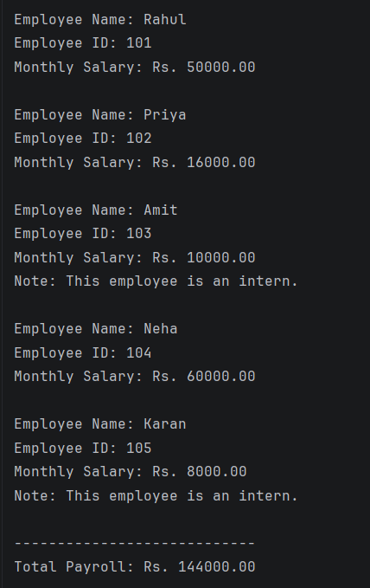

MediaLateFeeDemo.java

package practical_5;

// Abstract parent class representing library media.
abstract class Media {

protected String title;
protected int lateDays;

// Constructor initializes the media title and late days.
Media(String title, int lateDays) {
this.title = title;
this.lateDays = lateDays;
}

// Each media type must define its own late-fee calculation.
abstract double calculateLateFee();
}

// Book class has a late fee of Rs. 5 per day.
class Book extends Media {

Book(String title, int lateDays) {
super(title, lateDays);
}

// Calculate the book's late fee.
@Override
double calculateLateFee() {
return lateDays * 5;
}
}

// DVD class has a late fee of Rs. 10 per day.
class DVD extends Media {

DVD(String title, int lateDays) {
super(title, lateDays);
}

// Calculate the DVD's late fee.
@Override
double calculateLateFee() {
return lateDays * 10;
}
}

// Magazine class has a late fee of Rs. 3 per day.
class Magazine extends Media {

Magazine(String title, int lateDays) {
super(title, lateDays);
}

// Calculate the magazine's late fee.
@Override
double calculateLateFee() {
return lateDays * 3;
}
}

// Main class to demonstrate media late-fee calculation.
public class MediaLateFeeDemo {

public static void main(String[] args) {

// Creating a mixed array containing different media types.
Media[] mediaItems = {
new Book("Java Programming", 4),
new DVD("Java Tutorial DVD", 3),
new Magazine("Science Monthly", 5),
new Book("Data Structures", 2),
new DVD("Computer Basics", 6)
};

double totalFees = 0;

System.out.println("===== MEDIA LATE FEE REPORT =====");

// One loop processes every media object polymorphically.
for (Media m : mediaItems) {

// Calls the correct overridden method for each media type.
double fee = m.calculateLateFee();

System.out.println("\nMedia Title: " + m.title);
System.out.println("Late Days: " + m.lateDays);
System.out.printf("Late Fee: Rs. %.2f%n", fee);

// Add the individual fee to the total.
totalFees += fee;
}

// Display the total late fees for all returned media.
System.out.println("\n--------------------------------");
System.out.printf("Total Late Fees: Rs. %.2f%n", totalFees);
}
}

Output:



