

Faculty of Technology and Engineering
Chandubhai S. Patel Institute of Technology (CSPIT) Department of Computer Science & Engineering
Date:05/11/2026
Practical Submission

Academic Year | : | 2026-27 | Semester | : | 3rd
Course code | : | CEUE203 | Course name | : | JAVA

Practical No: 01

Program Title: Implement demo of working Vending machine.

Problem Statement: (a) Define an enum Coin with constants ONE, TWO, FIVE, TEN. (b) In main, set a snack price of 15 and a running total of 0; create a Scanner. (c) Loop: read a coin name, use a switch expression to convert the Coin to its value (ONE→1, TWO→2, FIVE→5, TEN→10), add it to the total, and print the total so far. (d) Stop the loop once the total reaches 15 or more. (e) Print the change to return (total − 15). Expected output: TEN then FIVE prints “Paid. Change: 0”; TEN then TEN prints “Paid. Change: 5”.

Formatted Code:

package practical_1;

import java.util.Scanner;

public class VendingMachine {

// Enum defining all the valid coin denominations accepted by the machine
enum Coins {
ONE, TWO, FIVE, TEN
}

public static void main(String[] args) {

// Automatically closes the Scanner when the program finishes
try (Scanner sc = new Scanner(System.in)) {

// Fixed price of the item in cents
final int itemPrice = 15;

// Keeps track of the total amount inserted by the user
int receivedAmount = 0;

// Continue accepting coins until the received amount reaches the item price
while (receivedAmount < itemPrice) {

// Ask the user to enter a valid coin denomination
System.out.println("Enter coin (ONE, TWO, FIVE, TEN):");

// Read the user's input and convert it to uppercase
// This allows inputs like "one" and "ONE" to be treated equally
String input = sc.nextLine().toUpperCase();

try {
// Convert the input String into its corresponding enum constant
// Example: "FIVE" becomes Coins.FIVE
Coins coin = Coins.valueOf(input);

// Update the received amount based on the selected coin
receivedAmount = switch (coin) {
case ONE -> receivedAmount + 1;
case TWO -> receivedAmount + 2;
case FIVE -> receivedAmount + 5;
case TEN -> receivedAmount + 10;
};

} catch (IllegalArgumentException e) {

// Handle invalid input if it does not match any enum constant
System.out.println("Invalid coin!");
}

// Display the item's price and the amount received so far
System.out.println("Item Price: " + itemPrice + " cents");
System.out.println("Received Amount: " + receivedAmount + " cents");
}

// Dispense the item once the received amount reaches or exceeds its price
System.out.println("Item dispensed!");

// Calculate and display the remaining change, if any
System.out.println("Change: " + (receivedAmount - itemPrice));
}
}
}
Screenshots / Output :

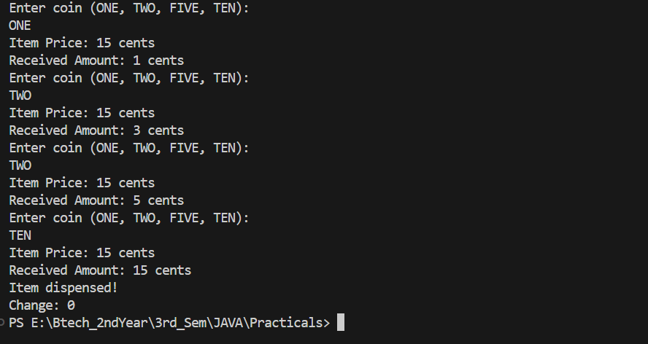

Program Title: Implement demo of working Toll Booth.

Problem Statement: (a) Define a record Vehicle (String number, String type). (b) In main, keep a running toll total and three counters (bike, car, truck). (c) Loop until the user types “done” for the number: build a Vehicle, use a switch expression on its type for the toll (bike→20, car→50, truck→150), add to the total, and increment that type’s counter. (d) After the loop, print the total toll and the type with the highest count. Expected output: two cars + one bike → “Total toll: 120”, “Most frequent: car”.
Formatted Code:

package practical_1;

import java.util.Scanner;

// Record to store the number of vehicles and their type
record Vehicle(String number, String type) {}

public class TollBooth {

static Scanner sc = new Scanner(System.in);

// Enum representing the number of vehicles entered by the user
// Each enum constant stores its corresponding numeric value
enum Numbers {
ONE(1), TWO(2), THREE(3), FOUR(4), FIVE(5),
SIX(6), SEVEN(7), EIGHT(8), NINE(9), TEN(10);

final int value;

// Constructor to initialize the numeric value of each enum constant
Numbers(int value) {
this.value = value;
}
}

public static void main(String[] args) {

// Counters to keep track of the total number of each vehicle type
int bikeCount = 0;
int carCount = 0;
int truckCount = 0;

// Stores the total toll collected from all vehicles
int total = 0;

// Continuously accept vehicle entries until the user enters "done"
while (true) {

// Read the number of vehicles entered by the user
String input = sc.next().toLowerCase();

// Stop accepting input when the user enters "done"
if (input.equals("done")) {
break;
}

// Convert the input String into its corresponding enum constant
// Example: "two" becomes Numbers.TWO
Numbers no = Numbers.valueOf(input.toUpperCase());

// Read the type of vehicle (bike, car, or truck)
String type = sc.next().toLowerCase();

// Create a Vehicle record containing the entered quantity and vehicle type
Vehicle v = new Vehicle(no.name(), type);

// Calculate the toll based on the vehicle type
int toll = switch (v.type()) {

case "bike" -> {
// Increase bike count by the entered quantity
bikeCount += no.value;

// Each bike pays 20, so calculate the total bike toll
yield 20 * no.value;
}

case "car" -> {
// Increase car count by the entered quantity
carCount += no.value;

// Each car pays 50, so calculate the total car toll
yield 50 * no.value;
}

case "truck" -> {
// Increase truck count by the entered quantity
truckCount += no.value;

// Each truck pays 150, so calculate the total truck toll
yield 150 * no.value;
}

default -> {
// Handle an invalid vehicle type without adding any toll
System.out.println("Invalid vehicle type!");
yield 0;
}
};

// Add the calculated toll to the overall toll collection
total += toll;
}

// Display the total toll collected after all entries are completed
System.out.println("Total toll: " + total);

// Assume bikes are the most frequent initially
String frequent = "bike";
int max = bikeCount;

// Check whether cars have a higher count than bikes
if (carCount > max) {
max = carCount;
frequent = "car";
}

// Check whether trucks have a higher count than the current maximum
if (truckCount > max) {
frequent = "truck";
}

// Display the vehicle type with the highest count
System.out.println("Most frequent: " + frequent);

// Close the Scanner after all input operations are completed
sc.close();
}
}

Screenshots:

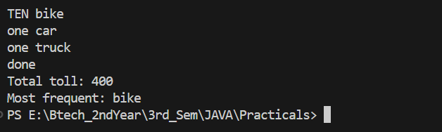

Practical Title: Rock-Paper-Scissors-Lizard-Spock

Problem Statement: (a) Define an enum Move with ROCK, PAPER, SCISSORS, LIZARD, SPOCK. (b) Write winner (Move a, Move b) returning 1 if a beats b, -1 if b beats a, 0 for a tie — use a switch expression listing what each move beats (Scissors cut Paper, Paper covers Rock, Rock crushes Lizard, Lizard poisons Spock, Spock smashes Scissors, and the five mirror cases). (c) In main, play 5 rounds: pick a random computer Move, read the player’s Move, call winner(), print the round result and keep score. (d) After 5 rounds, print the overall winner. Expected output: each round prints both moves and the round winner; ends with a “You win 3–2” summary.

Formatted Code:

package practical_1;

import java.util.Scanner;
import java.util.Random;

public class RockPaperScissors {

// All possible moves that can be selected in the game
enum Move {
ROCK, PAPER, SCISSORS, LIZARD, SPOCK
}

// Returns 1 if player A wins, -1 if player B wins, and 0 for a tie
static int winner(Move a, Move b) {

// Check which moves can be defeated by move A
boolean aWins = switch (a) {

case ROCK -> b == Move.SCISSORS || b == Move.LIZARD;

case PAPER -> b == Move.ROCK || b == Move.SPOCK;

case SCISSORS -> b == Move.PAPER || b == Move.LIZARD;

case LIZARD -> b == Move.PAPER || b == Move.SPOCK;

case SPOCK -> b == Move.ROCK || b == Move.SCISSORS;
};

// Check for a tie first
if (a == b) {
return 0;
}

// Return the result based on which move wins
return aWins ? 1 : -1;
}

public static void main(String[] args) {

Scanner sc = new Scanner(System.in);
Random random = new Random();

// Keep track of the player's and computer's scores
int playerScore = 0;
int computerScore = 0;

// Play a total of 5 rounds
for (int i = 1; i <= 5; i++) {

System.out.println("\n----- Round " + i + " -----");

// Computer randomly selects one of the five moves
Move computerMove = Move.values()[random.nextInt(Move.values().length)];

// Read the player's move
System.out.println("Enter your move (ROCK, PAPER, SCISSORS, LIZARD, SPOCK):");

Move playerMove;

// Keep asking until the player enters a valid move
while (true) {
try {
playerMove = Move.valueOf(sc.nextLine().trim().toUpperCase());
break;
} catch (IllegalArgumentException e) {
System.out.println("Invalid move! Please try again:");
}
}

// Display both the player's and computer's moves
System.out.println("Your move: " + playerMove);
System.out.println("Computer's move: " + computerMove);

// Compare both moves and decide the round winner
int result = winner(playerMove, computerMove);

if (result == 1) {
System.out.println("You win this round!");
playerScore++;
}
else if (result == -1) {
System.out.println("Computer wins this round!");
computerScore++;
}
else {
System.out.println("It's a tie!");
}

// Display the current score after every round
System.out.println("Score: You " + playerScore + " - " + computerScore + " Computer");
}

// Display the final result after all five rounds
System.out.println("\n===== FINAL RESULT =====");

if (playerScore > computerScore) {
System.out.println("You win " + playerScore + "–" + computerScore);
}
else if (computerScore > playerScore) {
System.out.println("Computer wins " + computerScore + "–" + playerScore);
}
else {
System.out.println("The game is a tie! " + playerScore + "–" + computerScore);
}

sc.close();
}
}

Screenshots/Output:



