

Faculty of Technology and Engineering
Chandubhai S. Patel Institute of Technology (CSPIT) Department of Computer Science & Engineering
Date:05 /11/2026
Practical Submission

Academic Year | : | 2026-27 | Semester | : | 3rd
Course code | : | CEUE203 | Course name | : | JAVA

Practical No: 04

Program Title: Password strength checker

Problem Statement: (a) In PasswordChecker, check four rules — length ≥ 8, contains an uppercase letter, contains a digit, contains a special character — using regex (e.g. “.*[A-Z].*”) or String methods. (b) Write strength(String pw) that counts how many rules pass and returns “Weak” (0–1), “Medium” (2–3) or “Strong” (4). (c) In Driver.main: test several passwords; for each, print which rules passed and the final label. Expected output: “abc” → Weak; “Abcd1234!” → Strong.
Formatted Code:

PasswordDriver.java

package practical_4;

public class PasswordDriver {

public static void main(String[] args) {

String[] passwords = {
"abc",
"Abcd1234!",
"abcdefgh",
"Abcdefgh",
"Abcdef12"
};

for (String pw : passwords) {

boolean[] rules = PasswordChecker.checkRules(pw);

System.out.println("\nPassword: " + pw);

System.out.println("Length >= 8: " + rules[0]);
System.out.println("Uppercase: " + rules[1]);
System.out.println("Digit: " + rules[2]);
System.out.println("Special Character: " + rules[3]);

System.out.println("Strength: " + PasswordChecker.strength(pw));
}
}
}

PasswordChecker.java

package practical_4;

public class PasswordChecker {

public static boolean[] checkRules(String pw) {

boolean[] rules = new boolean[4];

// Rule 1: Length should be at least 8
rules[0] = pw.length() >= 8;

// Rule 2: Contains an uppercase letter
rules[1] = pw.matches(".*[A-Z].*");

// Rule 3: Contains a digit
rules[2] = pw.matches(".*[0-9].*");

// Rule 4: Contains a special character
rules[3] = pw.matches(".*[^a-zA-Z0-9].*");

return rules;
}

public static String strength(String pw) {

boolean[] rules = checkRules(pw);

int count = 0;

for (boolean rule : rules) {
if (rule) {
count++;
}
}

if (count <= 1) {
return "Weak";
} else if (count <= 3) {
return "Medium";
} else {
return "Strong";
}
}
}

Screenshots/Output:

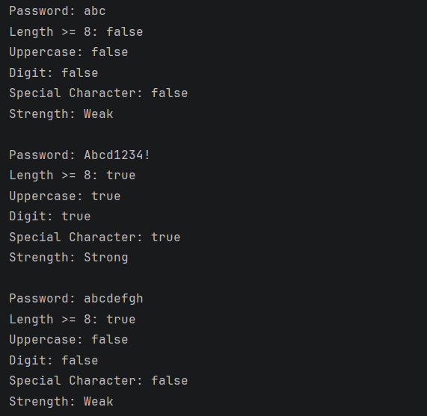
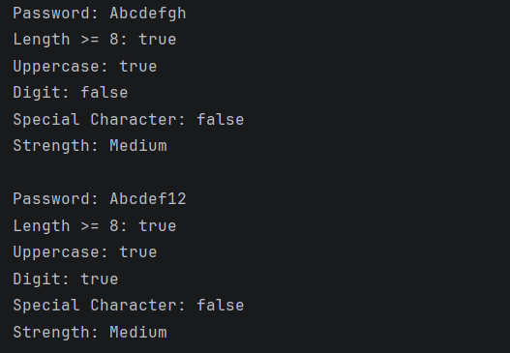

Program Title: Chatlog filter

Problem Statement: (a) In Driver.main, define a String[] of log lines like “10:05 alice Hello there” (include one malformed line with fewer than 3 parts). (b) Read a keyword from the user. (c) For each line, split into time/user/message with split(“ ”, 3); skip lines that do not have 3 parts. (d) If the message contains the keyword (case-insensitive), increment a counter and append “time user: message” to a StringBuilder. (e) Print “Matches: N” and the built report. Expected output: keyword “hello” over 3 lines (1 malformed) → “Matches: 1” and the matching line.

Formatted Code:

Chatfilter.java

package practical_4;
public class ChatFilter {
public static String filterLogs(String[] logs, String keyword) {
StringBuilder report = new StringBuilder();
int count = 0;
for (String line : logs) {
String[] parts = line.split(":", 3);
// Skip malformed lines
if (parts.length != 3) {
continue;
}
String time = parts[0];
String user = parts[1];
String message = parts[2];
// Check keyword ignoring case
if (message.toLowerCase().contains(keyword.toLowerCase())) {
count++;
report.append(time)
.append(" ")
.append(user)
.append(": ")
.append(message)
.append("\n");
}
}
System.out.println("Matches: " + count);
return report.toString();
}
}

ChatfilterDriver.java

package practical_4;
import java.util.Scanner;
public class ChatfilterDriver {
public static void main(String[] args) {
Scanner sc = new Scanner(System.in);
String[] logs = {
"10:05:alice:Hello there",
"10:06:bob:How are you?",
"10:07:riya:Hello everyone",
"10:08:john:Good morning",
"10:09:aman"
};
System.out.print("Enter keyword: ");
String keyword = sc.nextLine();
String report = ChatFilter.filterLogs(logs, keyword);
System.out.println(report);
sc.close();
}
}

Output:

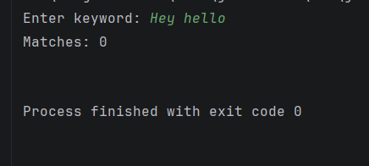

Program Title: Template filler

Problem Statement: (a) In Driver.main, define a template like “Dear {name}, order {id} ships {date}.” and two parallel arrays: names {“name”, “id”} and values {“Riya”, “A07”} (note {date} is not supplied). (b) Compile a Pattern for \{(\w+)\} and get a Matcher on the template. (c) Walk the matches with a StringBuilder: for each {placeholder}, look up its value in the names array and replace with the value, or with “[?]” if not found. (d) Print the filled template. Expected output: the unsupplied {date} becomes [?].

Formatted Code:

TemplateFiller.java

package practical_4;
import java.util.regex.Pattern;
import java.util.regex.Matcher;
public class TemplateFiller {
public static String fillTemplate(String template, String[] names, String[] values) {
Pattern pattern = Pattern.compile("\\{(\\w+)\\}");
Matcher matcher = pattern.matcher(template);
StringBuilder result = new StringBuilder();
while (matcher.find()) {
String placeholder = matcher.group(1);
String replacement = "[?]";
for (int i = 0; i < names.length; i++) {
if (names[i].equals(placeholder)) {
replacement = values[i];
break;
}
}
matcher.appendReplacement(result, Matcher.quoteReplacement(replacement));
}
matcher.appendTail(result);
return result.toString();
}
}

TemplateFillterDriver.java

package practical_4;
public class TemplateFillerDriver {
public static void main(String[] args) {
String template = "Dear {name}, order {id} ships {date}.";
String[] names = {"name", "id"};
String[] values = {"Riya", "A07"};
String result = TemplateFiller.fillTemplate(template, names, values);
System.out.println("Original Template:");
System.out.println(template);
System.out.println("\nFilled Template:");
System.out.println(result);
}
}

Screenshots/Output:



