

Faculty of Technology and Engineering
Chandubhai S. Patel Institute of Technology (CSPIT) Department of Computer Science & Engineering
Date:05/11/2026
Practical Submission

Academic Year | : | 2026-27 | Semester | : | 3rd
Course code | : | CEUE203 | Course name | : | JAVA

Practical No: 08

Program Title: Guarded calculator, Stock issue, AutoCloseable resource.

Problem Statement: 1. Guarded calculator: read two numbers and an operator; throw a custom DivideByZeroException and catch invalid-number input separately, printing a clear message each time; loop until a valid calculation succeeds and use finally to log each attempt. 2. Stock issue: a Warehouse where issue(item, qty) throws a custom checked OutOfStockException carrying the shortfall, and InvalidQuantityException for qty ≤ 0. Process a list of requests, catching and reporting each failure without stopping the run. 3. (For Advanced Learners – home) Create an AutoCloseable resource and use try-with-resources to prove it always closes — even when an exception is thrown inside the block — and that the original error is the one reported. Decide what to model as the resource.
Formatted Code:

GaurdedCalculatorDemo.java

package practical_8;

import java.util.InputMismatchException;
import java.util.Scanner;

// Custom exception for division by zero.
class DivideByZeroException extends Exception {

// Constructor passes the error message to the parent Exception class.
DivideByZeroException(String message) {
super(message);
}
}

// Main class containing the guarded calculator.
public class GuardedCalculatorDemo {

// Method to perform the requested arithmetic operation.
static double calculate(double num1, double num2, char operator)
throws DivideByZeroException {

switch (operator) {

case '+':
return num1 + num2;

case '-':
return num1 - num2;

case '*':
return num1 * num2;

case '/':

// Check for division by zero before performing division.
if (num2 == 0) {
throw new DivideByZeroException(
"Cannot divide a number by zero!"
);
}

return num1 / num2;

default:
throw new IllegalArgumentException(
"Invalid operator! Use +, -, * or /."
);
}
}

public static void main(String[] args) {

Scanner sc = new Scanner(System.in);

// The calculator keeps running until a valid calculation succeeds.
boolean success = false;

int attempt = 0;

System.out.println("===== GUARDED CALCULATOR =====");

while (!success) {

attempt++;

System.out.println("\nAttempt Number: " + attempt);

try {

// Read the first number.
System.out.print("Enter first number: ");
double num1 = sc.nextDouble();

// Read the arithmetic operator.
System.out.print("Enter operator (+, -, *, /): ");
char operator = sc.next().charAt(0);

// Read the second number.
System.out.print("Enter second number: ");
double num2 = sc.nextDouble();

// Perform the calculation.
double result = calculate(num1, num2, operator);

// Display the result if the calculation succeeds.
System.out.println("\nResult: " + result);

success = true;

} catch (DivideByZeroException e) {

// Handle the custom division-by-zero exception.
System.out.println("Calculation Error: " + e.getMessage());

} catch (InputMismatchException e) {

// Handle non-numeric input separately.
System.out.println(
"Input Error: Please enter valid numeric values."
);

// Remove the invalid token so the next attempt can continue.
sc.nextLine();

} catch (IllegalArgumentException e) {

// Handle unsupported arithmetic operators.
System.out.println("Operator Error: " + e.getMessage());

} finally {

// This block executes after every attempt,
// regardless of success or failure.
System.out.println(
"Log: Attempt " + attempt + " completed."
);
}
}

System.out.println("\nCalculator completed successfully!");

sc.close();
}
}

Output:

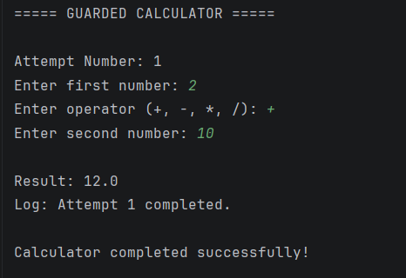

StockIssueDemo.java

package practical_8;

import java.util.HashMap;
import java.util.Map;
import java.util.Arrays;
import java.util.List;

// Custom checked exception for insufficient stock.
class OutOfStockException extends Exception {

// Stores the number of additional items required.
private int shortfall;

// Constructor initializes the shortfall and error message.
OutOfStockException(String item, int shortfall) {
super("Insufficient stock for " + item
+ ". Shortfall: " + shortfall);
this.shortfall = shortfall;
}

// Returns the number of additional items needed.
public int getShortfall() {
return shortfall;
}
}

// Custom checked exception for invalid requested quantities.
class InvalidQuantityException extends Exception {

InvalidQuantityException(String message) {
super(message);
}
}

// Warehouse class manages inventory and stock issues.
class Warehouse {

// HashMap stores item names and their available quantities.
private Map<String, Integer> inventory = new HashMap<>();

// Constructor initializes the warehouse inventory.
Warehouse() {

inventory.put("Laptop", 10);
inventory.put("Mouse", 20);
inventory.put("Keyboard", 5);
}

// Method to issue stock for a requested item.
// It may throw either of our custom checked exceptions.
public void issue(String item, int qty)
throws OutOfStockException, InvalidQuantityException {

// Quantity must always be greater than zero.
if (qty <= 0) {
throw new InvalidQuantityException(
"Quantity must be greater than zero."
);
}

// Get the currently available stock of the requested item.
// If the item does not exist, treat its available stock as zero.
int available = inventory.getOrDefault(item, 0);

// Check whether the requested quantity is available.
if (qty > available) {

// Calculate how many more items are required.
int shortfall = qty - available;

throw new OutOfStockException(item, shortfall);
}

// Reduce inventory only after all validations succeed.
inventory.put(item, available - qty);

System.out.println("SUCCESS: " + qty
+ " units of " + item + " issued.");
}

// Displays the current inventory after processing requests.
public void displayStock() {

System.out.println("\n--- Remaining Warehouse Stock ---");

for (Map.Entry<String, Integer> entry : inventory.entrySet()) {

System.out.println(entry.getKey()
+ ": " + entry.getValue());
}
}
}

// Class representing an individual stock request.
class StockRequest {

String item;
int quantity;

StockRequest(String item, int quantity) {
this.item = item;
this.quantity = quantity;
}
}

// Main class to demonstrate stock issue operations.
public class StockIssueDemo {

public static void main(String[] args) {

// Create a warehouse object with initial inventory.
Warehouse warehouse = new Warehouse();

// Create a list of different stock requests.
List<StockRequest> requests = Arrays.asList(

new StockRequest("Laptop", 3),
new StockRequest("Mouse", 25),
new StockRequest("Keyboard", -2),
new StockRequest("Keyboard", 4),
new StockRequest("Monitor", 5),
new StockRequest("Mouse", 5)
);

System.out.println("===== WAREHOUSE STOCK ISSUE =====");

// Process each request independently.
for (StockRequest request : requests) {

System.out.println("\nRequest: "
+ request.item + ", Quantity: "
+ request.quantity);

try {

// Attempt to issue the requested stock.
warehouse.issue(request.item, request.quantity);

} catch (OutOfStockException e) {

// Handle insufficient stock without stopping the loop.
System.out.println("STOCK ERROR: " + e.getMessage());

// Display the exact shortfall carried by the exception.
System.out.println("Additional units needed: "
+ e.getShortfall());

} catch (InvalidQuantityException e) {

// Handle zero or negative quantities separately.
System.out.println("QUANTITY ERROR: " + e.getMessage());
}
}

// Display inventory after all requests have been processed.
warehouse.displayStock();

System.out.println("\nAll stock requests processed.");
}
}

Output:

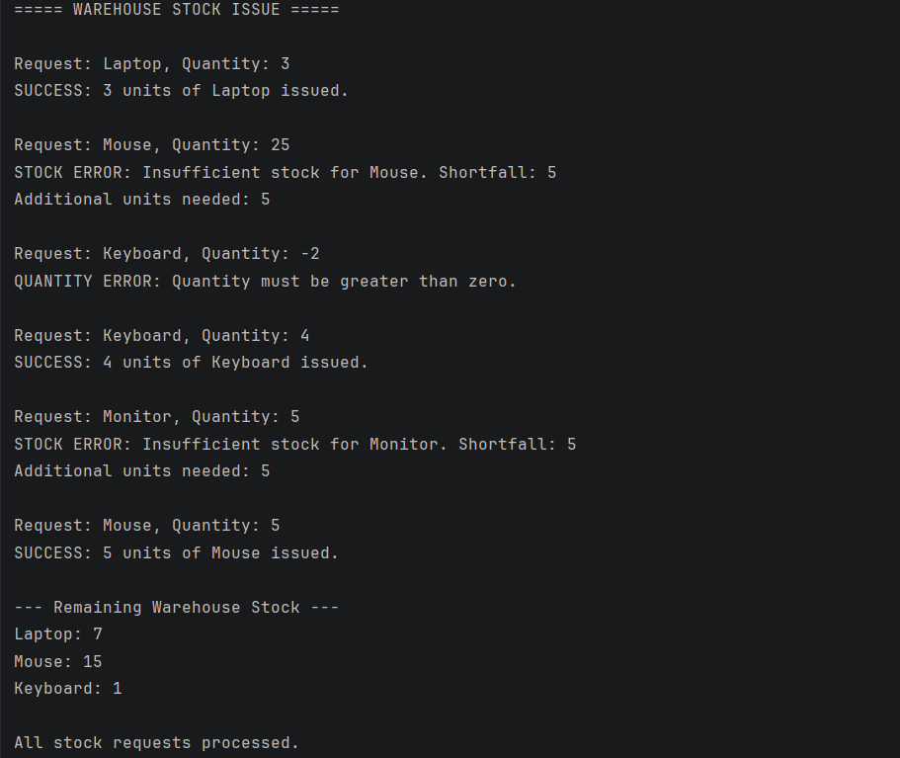

AutoCloseableDemo.java

package practical_8;

import java.io.IOException;

// Custom resource class that implements AutoCloseable.
// This allows Java to close the resource automatically
// when used inside a try-with-resources statement.
class FileResource implements AutoCloseable {

// Constructor simulates opening a file resource.
FileResource() {
System.out.println("Resource opened successfully.");
}

// Method that simulates processing the resource.
public void process() throws IOException {

System.out.println("Processing resource...");

// Simulate an error while processing the resource.
throw new IOException(
"Original Error: Failed to process the file."
);
}

// close() is automatically called when the try block ends.
@Override
public void close() throws IOException {

System.out.println("Closing resource automatically...");

// Simulate another error while closing the resource.
throw new IOException(
"Closing Error: Problem while closing the file."
);
}
}

// Main class to demonstrate try-with-resources.
public class AutoCloseableDemo {

public static void main(String[] args) {

System.out.println("===== AUTO CLOSEABLE DEMO =====");

// Try-with-resources automatically manages the resource.
// The close() method runs when the try block finishes,
// even if an exception occurs inside it.
try (FileResource resource = new FileResource()) {

// Process the resource.
resource.process();

} catch (IOException e) {

// The original processing exception is reported first.
System.out.println("\nCaught Exception: " + e.getMessage());

// If close() also throws an exception,
// Java attaches it to the original exception.
// These additional errors are called suppressed exceptions.
Throwable[] suppressed = e.getSuppressed();

for (Throwable error : suppressed) {

System.out.println(
"Suppressed Exception: " + error.getMessage()
);
}
}

System.out.println("\nProgram continues normally.");
}
}

Output:



