

Faculty of Technology and Engineering
Chandubhai S. Patel Institute of Technology (CSPIT) Department of Computer Science & Engineering
Date:05/11/2026
Practical Submission

Academic Year | : | 2026-27 | Semester | : | 3rd
Course code | : | CEUE203 | Course name | : | JAVA

Practical No: 06

Program Title: Remote control, Notification senders, Discount Engine

Problem Statement: 1. Remote control: an interface Switchable with on()/off() and a default toggle(); Fan and Light implement it. Loop over a Switchable[] toggling each. Then add a functional interface that decides, given a device and an hour, whether it may switch on, and supply it once as an anonymous class and once as a lambda. 2. Notification senders: a functional interface Notifier with send(String); make email and SMS senders as lambdas, hold them in an array, and broadcast one message through all. Add a marker interface Urgent and send twice for senders marked urgent. 3. (For Advanced Learners – home) Build a small discount engine where each rule is a lambda the user picks at runtime
Formatted Code:

Remote ControlDemo.java

package practical_6;

// Interface representing any device that can be switched ON or OFF.
interface Switchable {

// Abstract methods that implementing classes must define.
void on();
void off();

// Extra methods to check the device's current state and name.
boolean isOn();
String getName();

// Default method to toggle the device's state.
// If ON, turn it OFF; otherwise, turn it ON.
default void toggle() {

if (isOn()) {
off();
} else {
on();
}
}
}

// Fan class implements the Switchable interface.
class Fan implements Switchable {

private boolean status = false;

@Override
public void on() {
status = true;
System.out.println("Fan is switched ON.");
}

@Override
public void off() {
status = false;
System.out.println("Fan is switched OFF.");
}

@Override
public boolean isOn() {
return status;
}

@Override
public String getName() {
return "Fan";
}
}

// Light class implements the Switchable interface.
class Light implements Switchable {

private boolean status = false;

@Override
public void on() {
status = true;
System.out.println("Light is switched ON.");
}

@Override
public void off() {
status = false;
System.out.println("Light is switched OFF.");
}

@Override
public boolean isOn() {
return status;
}

@Override
public String getName() {
return "Light";
}
}

// Functional interface containing exactly one abstract method.
// It decides whether a particular device can be switched ON
// at a given hour.
@FunctionalInterface
interface SwitchPolicy {

boolean maySwitchOn(Switchable device, int hour);
}

// Main class to demonstrate interfaces and lambda expressions.
public class RemoteControlDemo {

public static void main(String[] args) {

// Creating objects of Fan and Light.
Fan fan = new Fan();
Light light = new Light();

// Storing different devices in one interface-type array.
Switchable[] devices = {fan, light};

System.out.println("===== REMOTE CONTROL =====");

// Loop through all devices and toggle their states.
System.out.println("\n--- Toggling Devices ---");

for (Switchable device : devices) {
device.toggle();
}

// Current hour for checking the switching policy.
int hour = 21;

System.out.println("\nCurrent Hour: " + hour);

// Implementation 1: Using an anonymous class.
// This policy allows devices to switch ON between 6 AM and 10 PM.
SwitchPolicy dayPolicy = new SwitchPolicy() {

@Override
public boolean maySwitchOn(Switchable device, int hour) {

return hour >= 6 && hour <= 22;
}
};

System.out.println("\n--- Anonymous Class Policy ---");

for (Switchable device : devices) {

if (dayPolicy.maySwitchOn(device, hour)) {
System.out.println(device.getName()
+ " is allowed to switch ON.");
} else {
System.out.println(device.getName()
+ " is NOT allowed to switch ON.");
}
}

// Implementation 2: Using a lambda expression.
// This policy allows the Fan to operate at any hour,
// but the Light only between 6 AM and 10 PM.
SwitchPolicy smartPolicy = (device, time) -> {

if (device instanceof Fan) {
return true;
}

return time >= 6 && time <= 22;
};

System.out.println("\n--- Lambda Expression Policy ---");

int nightHour = 23;

for (Switchable device : devices) {

if (smartPolicy.maySwitchOn(device, nightHour)) {
System.out.println(device.getName()
+ " is allowed to switch ON.");
} else {
System.out.println(device.getName()
+ " is NOT allowed to switch ON.");
}
}
}
}

Output:

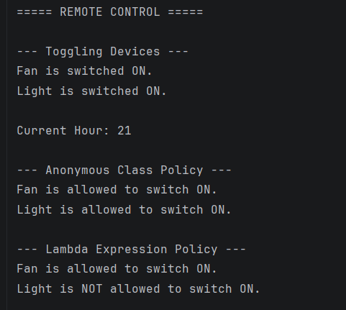

NotificationDemo.java

package practical_6;

// Functional interface for sending notifications.
@FunctionalInterface
interface Notifier {

// Single abstract method to send a message.
void send(String message);
}

// Marker interface used to identify urgent notification senders.
// It does not contain any methods.
interface Urgent {
}

// Main class to demonstrate notification broadcasting.
public class NotificationDemo {

public static void main(String[] args) {

// Lambda expression for a normal email sender.
Notifier emailSender = (message) -> {
System.out.println("Email Notification: " + message);
};

// Lambda expression for an urgent SMS sender.
// The intersection cast makes this object implement
// both Notifier and Urgent.
Notifier smsSender = (Notifier & Urgent) (message) -> {
System.out.println("SMS Notification: " + message);
};

// Lambda expression for an urgent backup email sender.
Notifier backupEmailSender = (Notifier & Urgent) (message) -> {
System.out.println("Backup Email Notification: " + message);
};

// Store all notification senders in one array.
Notifier[] senders = {
emailSender,
smsSender,
backupEmailSender
};

// Message to be broadcast to all notification senders.
String message = "Important: Practical exam is tomorrow!";

System.out.println("===== NOTIFICATION SYSTEM =====");

// First broadcast: Send the message once to every sender.
System.out.println("\n--- Broadcasting Message ---");

for (Notifier sender : senders) {

// Calls the send() method of each lambda.
sender.send(message);
}

// Second broadcast: Send the message again only
// to notification senders implementing Urgent.
System.out.println("\n--- Sending Again to Urgent Senders ---");

for (Notifier sender : senders) {

// instanceof checks whether the sender is marked Urgent.
if (sender instanceof Urgent) {

System.out.println("Urgent sender detected!");

// Urgent senders receive the message a second time.
sender.send(message);
}
}

System.out.println("\nNotification broadcasting completed.");
}
}

Output:

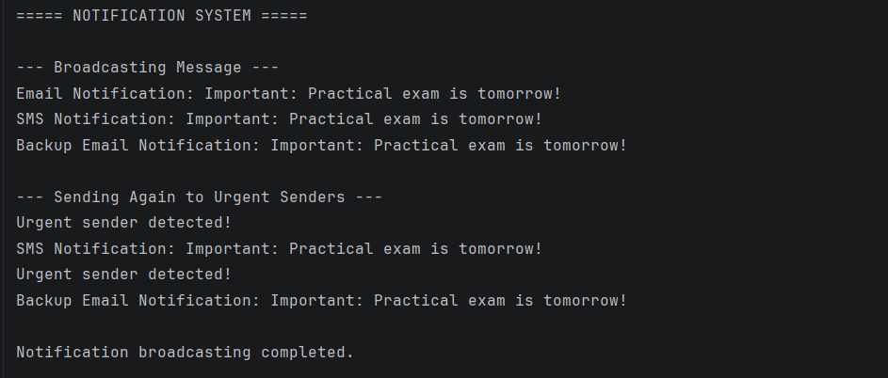

DiscountEngineDemo.java

package practical_6;

import java.util.Scanner;

// Functional interface for applying a discount rule.
@FunctionalInterface
interface DiscountRule {

// Returns the discount amount for the given original price.
double calculateDiscount(double price);
}

// Main class to demonstrate the discount engine.
public class DiscountEngineDemo {

public static void main(String[] args) {

Scanner sc = new Scanner(System.in);

System.out.println("===== DISCOUNT ENGINE =====");

// Ask the user to enter the original product price.
System.out.print("Enter original price: Rs. ");
double price = sc.nextDouble();

// Check whether the entered price is valid.
if (price < 0) {
System.out.println("Invalid price! Price cannot be negative.");
sc.close();
return;
}

// Display the available discount rules.
System.out.println("\nSelect a Discount Rule:");
System.out.println("1. Student Discount (10%)");
System.out.println("2. Festival Discount (20%)");
System.out.println("3. Membership Discount (15%)");
System.out.println("4. No Discount (0%)");

// Ask the user to select a discount.
System.out.print("\nEnter your choice: ");
int choice = sc.nextInt();

// Reference of the functional interface.
DiscountRule selectedRule;

// Select the appropriate lambda expression at runtime.
switch (choice) {

case 1:
// Student discount: 10% of the original price.
selectedRule = (amount) -> amount * 0.10;
System.out.println("\nStudent discount selected.");
break;

case 2:
// Festival discount: 20% of the original price.
selectedRule = (amount) -> amount * 0.20;
System.out.println("\nFestival discount selected.");
break;

case 3:
// Membership discount: 15% of the original price.
selectedRule = (amount) -> amount * 0.15;
System.out.println("\nMembership discount selected.");
break;

case 4:
// No discount is applied.
selectedRule = (amount) -> 0;
System.out.println("\nNo discount selected.");
break;

default:
// Handle invalid menu choices.
System.out.println("Invalid choice! Please select 1 to 4.");
sc.close();
return;
}

// Apply the selected lambda rule to calculate the discount.
double discount = selectedRule.calculateDiscount(price);

// Calculate the final price after subtracting the discount.
double finalPrice = price - discount;

// Display the complete bill.
System.out.println("\n===== DISCOUNT BILL =====");

System.out.printf("Original Price : Rs. %.2f%n", price);
System.out.printf("Discount Amount: Rs. %.2f%n", discount);
System.out.printf("Final Price : Rs. %.2f%n", finalPrice);

System.out.println("-------------------------");
System.out.println("Thank you for shopping!");

sc.close();
}
}

Output:



