action.php:
<?php
$errors = [];
$storage_mode = 'csv';

if ($_SERVER['REQUEST_METHOD'] === 'POST') {

$name = trim($_POST['name'] ?? '');
$email = trim($_POST['email'] ?? '');
$message = trim($_POST['message'] ?? '');
$mobile = trim($_POST['mobile'] ?? '');
$pincode = trim($_POST['pincode'] ?? '');
$gender = trim($_POST['gender'] ?? '');
$address = trim($_POST['Address'] ?? '');

if (empty($name)) {
$errors[] = "Name is required.";
} else {
$name;
}

if (empty($email)) {
$errors[] = "Email is required.";
} elseif (!filter_var($email, FILTER_VALIDATE_EMAIL)) {
$errors[] = "Invalid email address format.";
}

if (empty($message)) {
$errors[] = "Message is required.";
} else {
$message = htmlspecialchars($message, ENT_QUOTES, 'UTF-8');
}

if(empty($mobile)){
$errors[] = "Mobile is required.";
} elseif (!preg_match('/^\d{10}$/', $mobile)) {
$errors[] = "Invalid mobile number format.";
} else {
$mobile = htmlspecialchars($mobile, ENT_QUOTES, 'UTF-8');
}

if(empty($pincode)){
$errors[] = "Pincode is required.";
} elseif(!preg_match('/^\d{6}$/', $pincode)) {
$errors[] = "Invalid pincode format.";}

else {
$pincode = htmlspecialchars($pincode, ENT_QUOTES, 'UTF-8');
}

if(empty($gender)){
$errors[] = "Gender is required.";
} else {
$gender;
}
if(empty($address)){
$errors[] = "Address is required.";
} else {
$address = htmlspecialchars($address, ENT_QUOTES, 'UTF-8');
}

if (empty($errors)) {
$entry = [
'timestamp' => date('Y-m-d H:i:s'),
'name' => $name,
'email' => $email,
'message' => $message,
'mobile' => $mobile,
'pincode' => $pincode,
'gender' => $gender,
'address' => $address
];

if ($storage_mode === 'csv') {
saveToCSV('data.csv', $entry);
} else {
saveToJSON('data.json', $entry);
}

echo "Form submitted successfully!";
} else {
foreach ($errors as $error) {
echo "<p style='color:red;'>$error</p>";
}
}
}

function saveToCSV($filename, $data) {
$file_exists = file_exists($filename);
$handle = fopen($filename, 'a');

if (!$file_exists) {
fputcsv($handle, array_keys($data));
}

fputcsv($handle, $data);
fclose($handle);
}

function saveToJSON($filename, $data) {
$existing = file_exists($filename) ? json_decode(file_get_contents($filename), true) : [];
if (!is_array($existing)) {
$existing = [];
}

$existing[] = $data;
file_put_contents($filename, json_encode($existing, JSON_PRETTY_PRINT | JSON_UNESCAPED_UNICODE));
}
?>

Index.html:
<form action="action.php" method="POST">
<label for="name">Name:</label>
<input type="text" id="name" name="name">
<br/><br/>
<label for="email">Email:</label>
<input type="email" id="email" name="email">
<br/><br/>

<label for="mobile">Mobile:</label>
<input type="text" id="mobile" name="mobile">
<br/><br/>

<label for="pincode">Pincode:</label>
<input type="text" id="pincode" name="pincode">
<br/><br/>
<label for="pincode">Gender:</label>
<input type="radio" id="male" name="gender" value="male">
<label for="male">Male</label>
<input type="radio" id="female" name="gender" value="female">
<label for="female">Female</label>
<br/><br/>
<label for="Address">Address:</label>
<input type="text" id="Address" name="Address">
<br/><br/>
<label for="message">Message:</label>
<textarea id="message" name="message"></textarea>

<br/><br/>
<button type="submit">Submit</button>
</form>
Form UI:
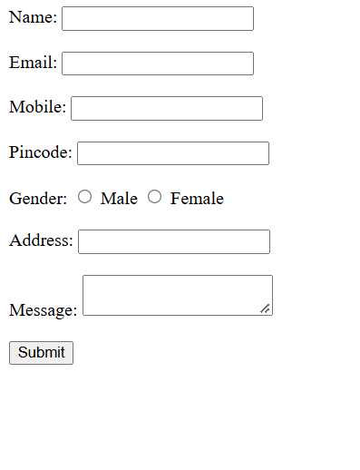
Error Messages:
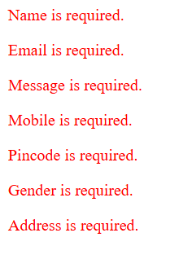

Submitting Data:
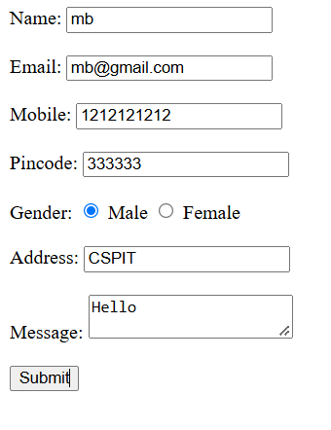

Output after submitting data:
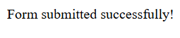

Data Entry in CSV:

Data Entry in JSON:
