

Faculty of Technology and Engineering
Chandubhai S. Patel Institute of Technology (CSPIT) Department of Computer Science & Engineering
Date:26/10/2026
Laboratory Manual

Academic Year | : | 2026-27 | Semester | : | 3rd
Course code | : | ITUE203 | Course name | : | WEB DEVELOPMENT FRAMEWORKS

Practical No: 11

Problem Statement: Create a student management module to add, view, edit, delete, search and filter student records. All database operations must use MYSQLI
statements and clear success/failure messages.

Objective: N/A

GitHub Repository Link:
https://github.com/mann-bhalodiya/WDF_Practicals.git

Screenshots:

Db.php
<?php
mysqli_report(MYSQLI_REPORT_ERROR | MYSQLI_REPORT_STRICT);
try {
$conn = new mysqli("localhost", "root", "", "practical11_db");
$conn->set_charset("utf8mb4");
} catch (mysqli_sql_exception $e) {
error_log("Database connection error: ".$e->getMessage());
http_response_code(500);
exit("Database connection failed. Check XAMPP and db.php credentials.");
}

Index.php

<?php
require_once __DIR__ . "/db.php";

function h($v)
{
return htmlspecialchars((string)$v, ENT_QUOTES, "UTF-8");
}

function go($m, $type = "success")
{
header(
"Location: index.php?message=" .
urlencode($m) .
"&type=" . $type
);
exit;
}

if ($_SERVER["REQUEST_METHOD"] === "POST") {
$action = $_POST["action"] ?? "";

try {
if ($action === "save") {
$id = (int)($_POST["id"] ?? 0);
$name = trim($_POST["student_name"] ?? "");
$email = trim($_POST["email"] ?? "");
$course = trim($_POST["course"] ?? "");
$year = (int)($_POST["year_of_study"] ?? 0);
$mobile = trim($_POST["mobile"] ?? "");

// Validate student details
if ($name === "" || mb_strlen($name) > 100) {
throw new RuntimeException(
"Enter a student name (maximum 100 characters)."
);
}

if (!filter_var($email, FILTER_VALIDATE_EMAIL)) {
throw new RuntimeException("Enter a valid email.");
}

if ($course === "" || mb_strlen($course) > 80) {
throw new RuntimeException("Enter a course.");
}

if ($year < 1 || $year > 6) {
throw new RuntimeException(
"Year must be between 1 and 6."
);
}

if (
$mobile !== "" &&
!preg_match('/^[0-9+\-\s()]{7,20}$/', $mobile)
) {
throw new RuntimeException(
"Enter a valid mobile number."
);
}

// Update an existing student
if ($id) {
$s = $conn->prepare(
"UPDATE students
SET student_name = ?,
email = ?,
course = ?,
year_of_study = ?,
mobile = ?
WHERE id = ? AND status = 'active'"
);

$s->bind_param(
"sssisi",
$name,
$email,
$course,
$year,
$mobile,
$id
);

$s->execute();
$s->close();

go("Student updated successfully.");
} else {
// Insert a new student
$s = $conn->prepare(
"INSERT INTO students
(student_name, email, course,
year_of_study, mobile)
VALUES (?, ?, ?, ?, ?)"
);

$s->bind_param(
"sssis",
$name,
$email,
$course,
$year,
$mobile
);

$s->execute();
$s->close();

go("Student added successfully.");
}
}

// Soft delete or restore a student
if ($action === "delete" || $action === "restore") {
$id = (int)($_POST["id"] ?? 0);

if (!$id) {
throw new RuntimeException("Invalid student ID.");
}

if ($action === "delete") {
$s = $conn->prepare(
"UPDATE students
SET status = 'deleted'
WHERE id = ? AND status = 'active'"
);
} else {
$s = $conn->prepare(
"UPDATE students
SET status = 'active'
WHERE id = ? AND status = 'deleted'"
);
}

$s->bind_param("i", $id);
$s->execute();

$n = $s->affected_rows;
$s->close();

$message = $n
? (
$action === "delete"
? "Student moved to deleted records."
: "Student restored."
)
: "No record changed.";

go($message, $n ? "success" : "error");
}
} catch (mysqli_sql_exception $e) {
error_log("CRUD error: " . $e->getMessage());

go(
$e->getCode() === 1062
? "Email already exists. Use a different email."
: "Database operation failed. Check the input and try again.",
"error"
);
} catch (RuntimeException $e) {
go($e->getMessage(), "error");
}
}

// Search, filter and record status
$search = trim($_GET["search"] ?? "");
$course = trim($_GET["course"] ?? "");

$deleted = (($_GET["deleted"] ?? "") === "1");
$status = $deleted ? "deleted" : "active";

// Export records to CSV
if (($_GET["export"] ?? "") === "csv") {
$s = $conn->prepare(
"SELECT id, student_name, email, course,
year_of_study, mobile, created_at
FROM students
WHERE status = ?
AND (
? = ''
OR student_name LIKE CONCAT('%', ?, '%')
OR email LIKE CONCAT('%', ?, '%')
OR course LIKE CONCAT('%', ?, '%')
)
AND (? = '' OR course = ?)
ORDER BY student_name"
);

$s->bind_param(
"sssssss",
$status,
$search,
$search,
$search,
$search,
$course,
$course
);

$s->execute();
$r = $s->get_result();

header("Content-Type: text/csv; charset=utf-8");
header('Content-Disposition: attachment; filename="students.csv"');

$out = fopen("php://output", "w");

fputcsv(
$out,
[
"ID",
"Name",
"Email",
"Course",
"Year",
"Mobile",
"Created"
]
);

while ($row = $r->fetch_assoc()) {
fputcsv($out, $row);
}

fclose($out);
$s->close();
$conn->close();
exit;
}

// Pagination
$page = max(1, (int)($_GET["page"] ?? 1));
$per = 8;

// Count matching records
$count = $conn->prepare(
"SELECT COUNT(*) AS total
FROM students
WHERE status = ?
AND (
? = ''
OR student_name LIKE CONCAT('%', ?, '%')
OR email LIKE CONCAT('%', ?, '%')
OR course LIKE CONCAT('%', ?, '%')
)
AND (? = '' OR course = ?)"
);

$count->bind_param(
"sssssss",
$status,
$search,
$search,
$search,
$search,
$course,
$course
);

$count->execute();

$total = (int)$count->get_result()->fetch_assoc()["total"];
$count->close();

$pages = max(1, (int)ceil($total / $per));
$page = min($page, $pages);
$offset = ($page - 1) * $per;

// Fetch records for the current page
$s = $conn->prepare(
"SELECT id, student_name, email, course,
year_of_study, mobile, created_at
FROM students
WHERE status = ?
AND (
? = ''
OR student_name LIKE CONCAT('%', ?, '%')
OR email LIKE CONCAT('%', ?, '%')
OR course LIKE CONCAT('%', ?, '%')
)
AND (? = '' OR course = ?)
ORDER BY id DESC
LIMIT ? OFFSET ?"
);

$s->bind_param(
"sssssssii",
$status,
$search,
$search,
$search,
$search,
$course,
$course,
$per,
$offset
);

$s->execute();
$result = $s->get_result();

// Fetch available courses for the filter
$courseRows = $conn->query(
"SELECT DISTINCT course
FROM students
WHERE status = 'active'
ORDER BY course"
);

$courses = [];

while ($x = $courseRows->fetch_assoc()) {
$courses[] = $x["course"];
}

// Fetch student details for editing
$edit = null;

if (
isset($_GET["edit"]) &&
ctype_digit((string)$_GET["edit"])
) {
$id = (int)$_GET["edit"];

$e = $conn->prepare(
"SELECT *
FROM students
WHERE id = ? AND status = 'active'"
);

$e->bind_param("i", $id);
$e->execute();

$edit = $e->get_result()->fetch_assoc();
$e->close();
}

// Display status messages
$msg = $_GET["message"] ?? "";
$err = (($_GET["type"] ?? "") === "error");
?>

<!DOCTYPE html>
<html lang="en">

<head>
<meta charset="utf-8">
<meta
name="viewport"
content="width=device-width, initial-scale=1"
>

<title>Practical 11 - Student CRUD</title>

<style>
* {
box-sizing: border-box;
}

body {
margin: 0;
padding: 24px;
background: #f1f5f9;
color: #172033;
font: 15px Arial, sans-serif;
}

.wrap {
max-width: 1200px;
margin: auto;
}

.top {
display: flex;
justify-content: space-between;
gap: 12px;
align-items: center;
flex-wrap: wrap;
}

h1 {
color: #1e3a8a;
}

h2 {
margin-top: 0;
}

.card {
background: white;
padding: 20px;
margin: 18px 0;
border: 1px solid #dbe3ef;
border-radius: 12px;
}

.grid {
display: grid;
grid-template-columns: repeat(2, minmax(0, 1fr));
gap: 14px;
}

label {
display: block;
font-weight: bold;
margin-bottom: 6px;
}

input,
select {
width: 100%;
padding: 10px;
border: 1px solid #cbd5e1;
border-radius: 6px;
}

button,
.btn {
display: inline-block;
padding: 10px 13px;
border: 0;
border-radius: 6px;
background: #1d4ed8;
color: white;
text-decoration: none;
cursor: pointer;
font-weight: bold;
}

.green {
background: #15803d;
}

.red {
background: #b91c1c;
}

.gray {
background: #475569;
}

.light {
background: #e2e8f0;
color: #172033;
}

.toolbar {
display: grid;
grid-template-columns: 2fr 1fr auto auto;
gap: 10px;
align-items: end;
}

.actions {
display: flex;
gap: 6px;
flex-wrap: wrap;
margin-top: 14px;
}

.alert {
padding: 12px;
border-radius: 7px;
background: #dcfce7;
color: #166534;
}

.alert.error {
background: #fee2e2;
color: #991b1b;
}

.tablewrap {
overflow-x: auto;
}

table {
width: 100%;
min-width: 900px;
border-collapse: collapse;
}

th,
td {
text-align: left;
padding: 10px;
border-bottom: 1px solid #e2e8f0;
}

th {
background: #eff6ff;
color: #1e3a8a;
}

td form {
display: inline;
}

.muted {
color: #64748b;
font-size: 13px;
}

.pager {
display: flex;
justify-content: space-between;
align-items: center;
gap: 10px;
flex-wrap: wrap;
margin-top: 16px;
}

@media (max-width: 720px) {
body {
padding: 10px;
}

.grid,
.toolbar {
grid-template-columns: 1fr;
}
}
</style>
</head>

<body>

<main class="wrap">

<div class="top">
<div>
<h1>Student Management CRUD</h1>
<p class="muted">
Practical 11 · MySQLi · Search, filter, pagination, CSV export
</p>
</div>

<a
class="btn green"
href="?export=csv&amp;search=<?= urlencode($search) ?>&amp;course=<?= urlencode($course) ?>&amp;deleted=<?= $deleted ? 1 : 0 ?>"
>
Export CSV
</a>
</div>

<?php if ($msg !== ""): ?>
<p
class="alert <?= $err ? "error" : "" ?>"
role="status"
>
<?= h($msg) ?>
</p>
<?php endif; ?>

<!-- Add or Edit Student -->
<section class="card">

<h2><?= $edit ? "Edit Student" : "Add Student" ?></h2>

<form method="post">

<input type="hidden" name="action" value="save">

<input
type="hidden"
name="id"
value="<?= h($edit["id"] ?? "") ?>"
>

<div class="grid">

<div>
<label for="student_name">Student name *</label>
<input
id="student_name"
name="student_name"
required
maxlength="100"
value="<?= h($edit["student_name"] ?? "") ?>"
>
</div>

<div>
<label for="email">Email *</label>
<input
id="email"
name="email"
type="email"
required
maxlength="150"
value="<?= h($edit["email"] ?? "") ?>"
>
</div>

<div>
<label for="course_input">Course *</label>
<input
id="course_input"
name="course"
required
maxlength="80"
placeholder="e.g. BCA"
value="<?= h($edit["course"] ?? "") ?>"
>
</div>

<div>
<label for="year">Year (1–6) *</label>
<input
id="year"
name="year_of_study"
type="number"
min="1"
max="6"
required
value="<?= h($edit["year_of_study"] ?? 1) ?>"
>
</div>

<div>
<label for="mobile">Mobile (optional)</label>
<input
id="mobile"
name="mobile"
maxlength="20"
value="<?= h($edit["mobile"] ?? "") ?>"
>
</div>

</div>

<div class="actions">

<button>
<?= $edit ? "Update student" : "Add student" ?>
</button>

<?php if ($edit): ?>
<a class="btn light" href="index.php">
Cancel
</a>
<?php endif; ?>

</div>

</form>
</section>

<!-- Search and Filter -->
<section class="card">

<h2>Search and Filter</h2>

<form class="toolbar" method="get">

<div>
<label for="search">Search name, email or course</label>
<input
id="search"
name="search"
value="<?= h($search) ?>"
placeholder="Type to search"
>
</div>

<div>
<label for="course">Course</label>

<select id="course" name="course">

<option value="">All courses</option>

<?php foreach ($courses as $c): ?>
<option
value="<?= h($c) ?>"
<?= $course === $c ? "selected" : "" ?>
>
<?= h($c) ?>
</option>
<?php endforeach; ?>

</select>
</div>

<button>Apply</button>

<a class="btn light" href="index.php">
Reset
</a>

</form>

<div class="actions">

<a
class="btn gray"
href="?deleted=<?= $deleted ? 0 : 1 ?>"
>
<?= $deleted ? "View active students" : "View deleted records" ?>
</a>

</div>
</section>

<!-- Student Records -->
<section class="card">

<h2>
<?= $deleted ? "Deleted records" : "Student records" ?>
<span class="muted">(<?= $total ?> records)</span>
</h2>

<div class="tablewrap">

<table>

<thead>
<tr>
<th>ID</th>
<th>Name</th>
<th>Email</th>
<th>Course</th>
<th>Year</th>
<th>Mobile</th>
<th>Created</th>
<th>Actions</th>
</tr>
</thead>

<tbody>

<?php if ($result->num_rows === 0): ?>

<tr>
<td colspan="8">No records found.</td>
</tr>

<?php else: ?>

<?php while ($row = $result->fetch_assoc()): ?>

<tr>

<td><?= h($row["id"]) ?></td>
<td><?= h($row["student_name"]) ?></td>
<td><?= h($row["email"]) ?></td>
<td><?= h($row["course"]) ?></td>
<td><?= h($row["year_of_study"]) ?></td>
<td><?= h($row["mobile"]) ?></td>
<td><?= h($row["created_at"]) ?></td>

<td>

<?php if (!$deleted): ?>

<a
class="btn gray"
href="?edit=<?= $row["id"] ?>"
>
Edit
</a>

<form
method="post"
onsubmit="return confirm('Move this student to deleted records?')"
>
<input
type="hidden"
name="action"
value="delete"
>

<input
type="hidden"
name="id"
value="<?= $row["id"] ?>"
>

<button class="red">
Delete
</button>
</form>

<?php else: ?>

<form
method="post"
onsubmit="return confirm('Restore this student?')"
>
<input
type="hidden"
name="action"
value="restore"
>

<input
type="hidden"
name="id"
value="<?= $row["id"] ?>"
>

<button class="green">
Restore
</button>
</form>

<?php endif; ?>

</td>

</tr>

<?php endwhile; ?>

<?php endif; ?>

</tbody>

</table>

</div>

<!-- Pagination -->
<div class="pager">

<span class="muted">
Page <?= $page ?> of <?= $pages ?> · 8 records per page
</span>

<div class="actions">

<?php
$p = [
"search" => $search,
"course" => $course,
"deleted" => $deleted ? 1 : 0
];

if ($page > 1):
$p["page"] = $page - 1;
?>

<a
class="btn light"
href="?<?= h(http_build_query($p)) ?>"
>
Previous
</a>

<?php endif; ?>

<?php if ($page < $pages): ?>

<?php $p["page"] = $page + 1; ?>

<a
class="btn light"
href="?<?= h(http_build_query($p)) ?>"
>
Next
</a>

<?php endif; ?>

</div>

</div>

</section>

<p class="muted">
Delete is implemented as soft delete.
Records can be restored from “View deleted records”.
</p>

</main>

</body>
</html>

<?php
$s->close();
$conn->close();
?>

Screenshots of output:

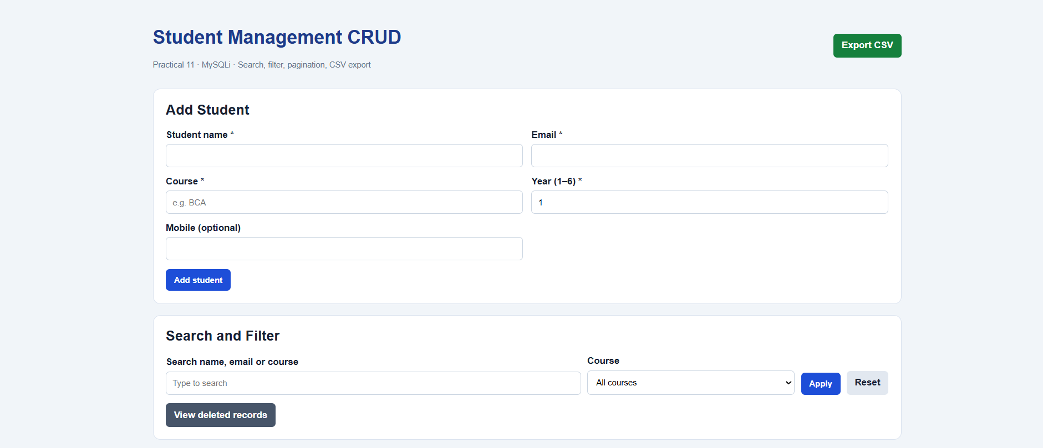
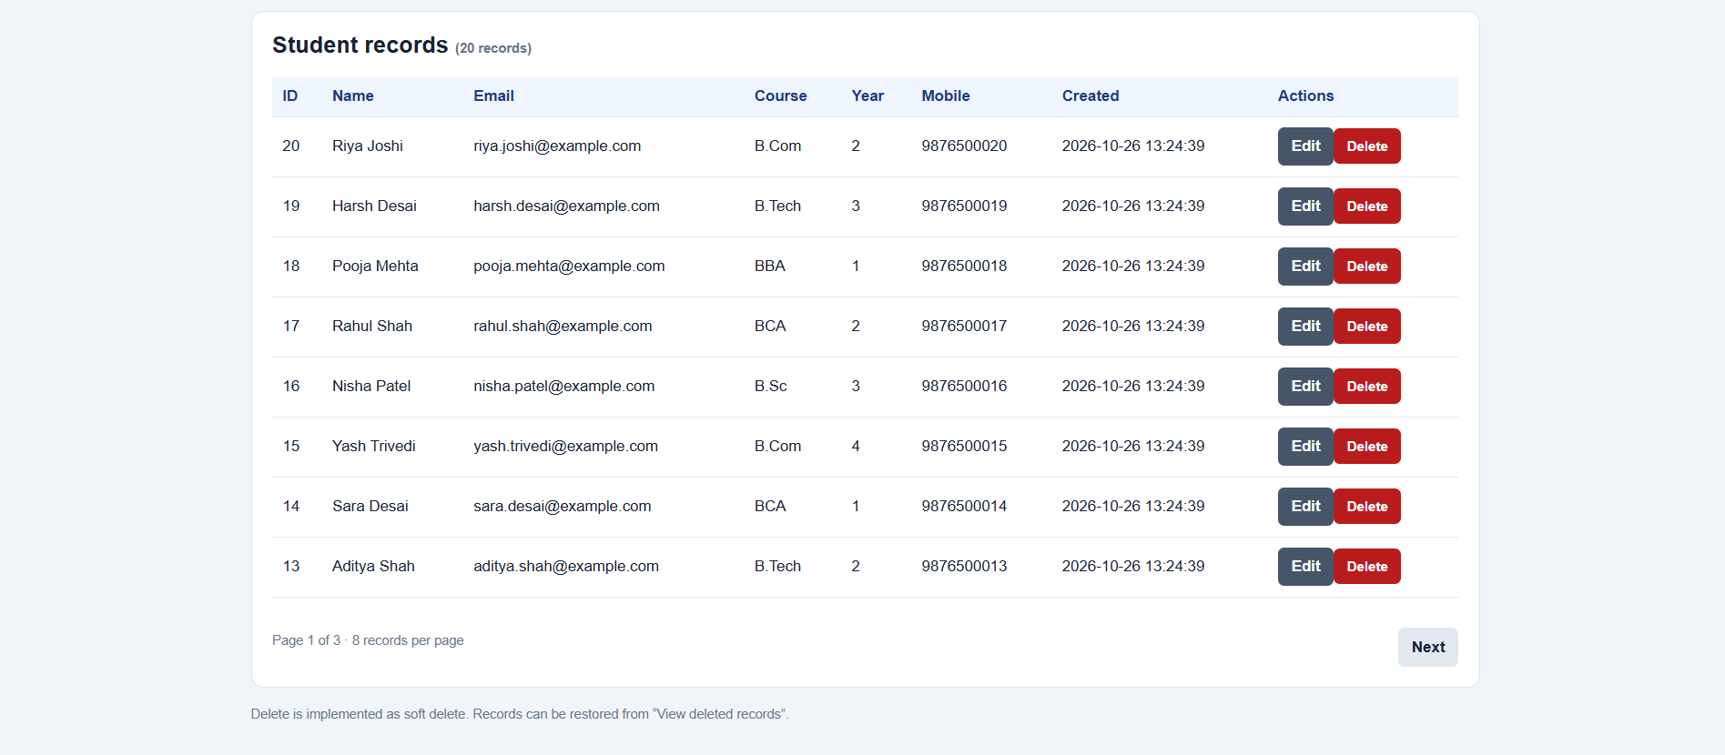

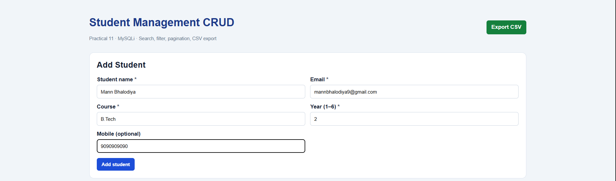

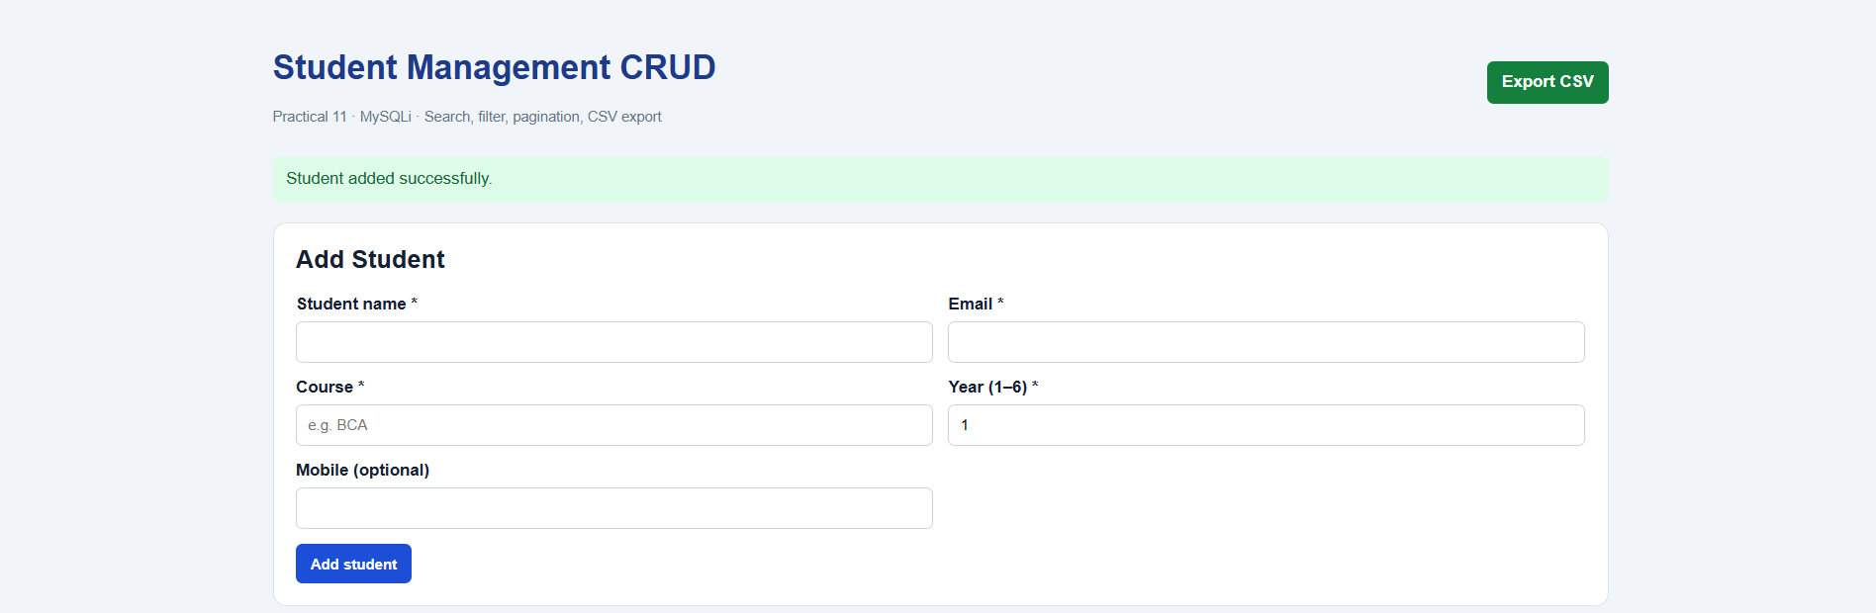

Updating course

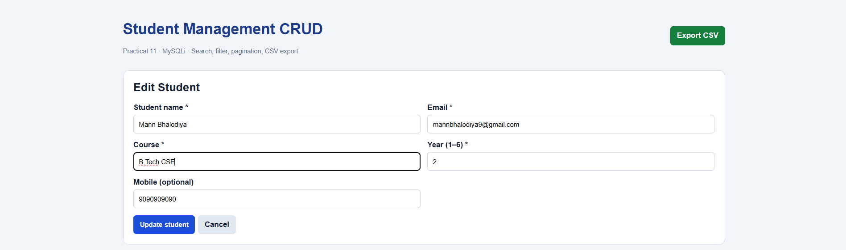

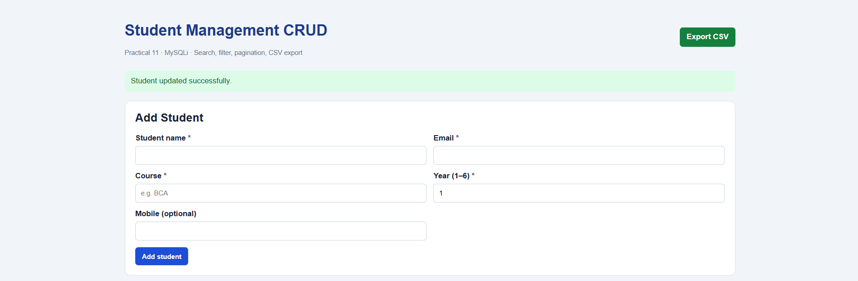

Searching using Name

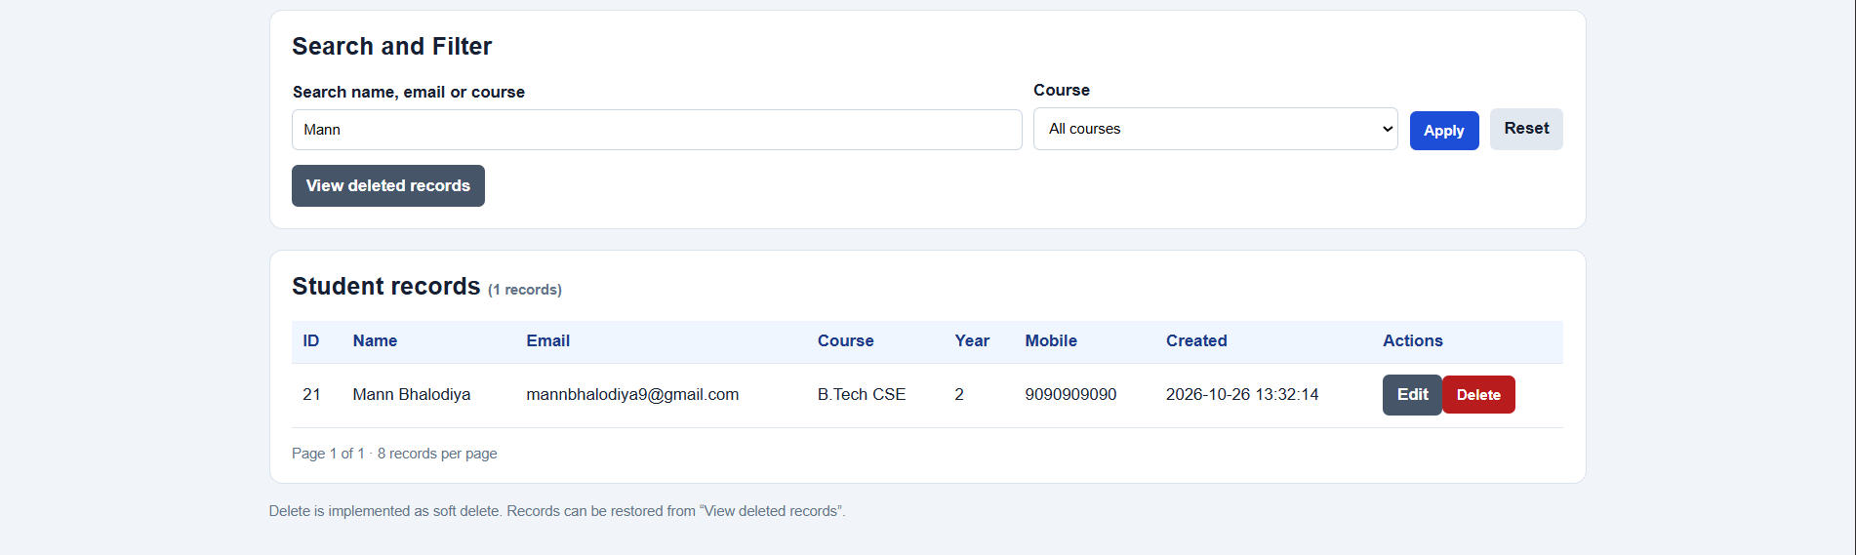

Course Filter

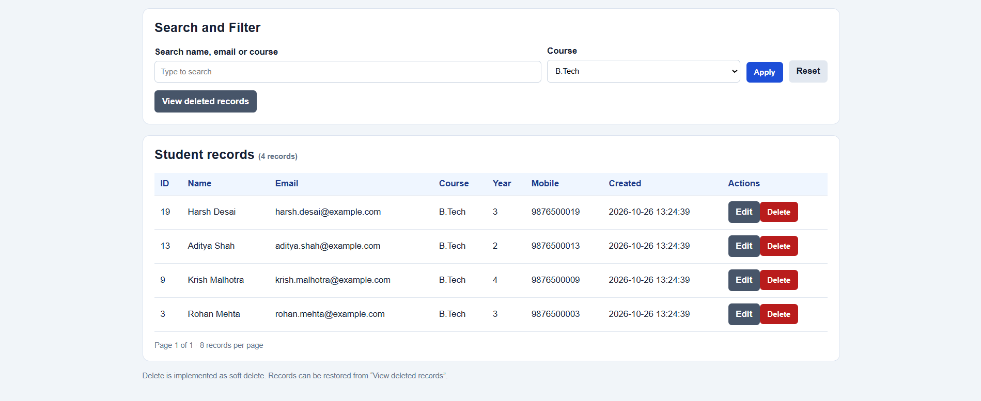
Delete confirmation message

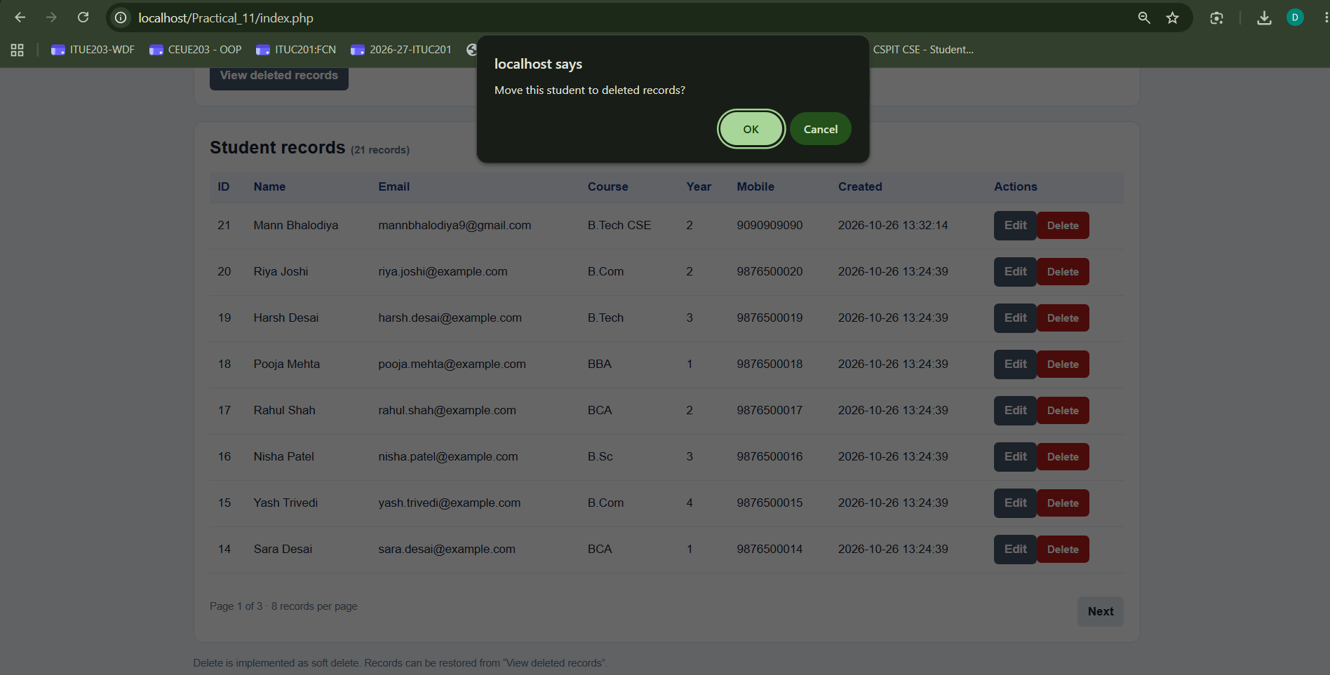

Soft Delete

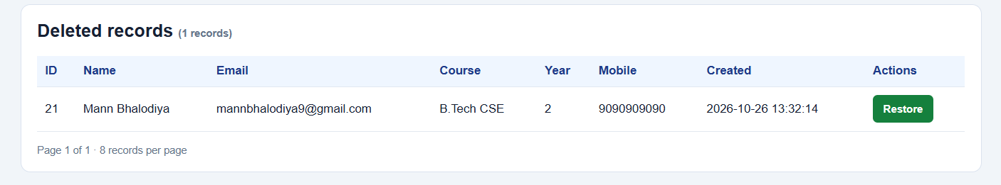

Error messages

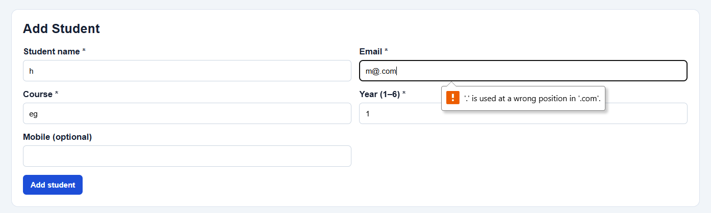

CSV Download

