

Faculty of Technology and Engineering
Chandubhai S. Patel Institute of Technology (CSPIT) Department of Computer Science & Engineering
Date:25/09/2026
Laboratory Manual

Academic Year | : | 2026-27 | Semester | : | 3rd
Course code | : | ITUE203 | Course name | : | WEB DEVELOPMENT FRAMEWORKS

Practical No: 6

Problem Statement: JSON Files, Fetch API, Dynamic Rendering, Search & Filter, Sorting, Pagination, Loading/Error, Modular JS.

Objective: JSON Files – Create/use events. json, students. json, FAQs. json with at least 15 records each.
Fetch API – Fetch JSON data using JavaScript.
Dynamic Rendering – Display JSON data dynamically on webpage.
Search & Filter – Add search and filter functionality.
Sorting – Sort records using JavaScript.
Pagination – Display records page by page.
Loading/Error – Show loading message and handle errors.
Modular JS – Keep JavaScript code properly organized.

GitHub Repository Link:
https://github.com/mann-bhalodiya/WDF_Practicals/tree/main/Practical_Six
Screenshots:

JSON Data Displayed:

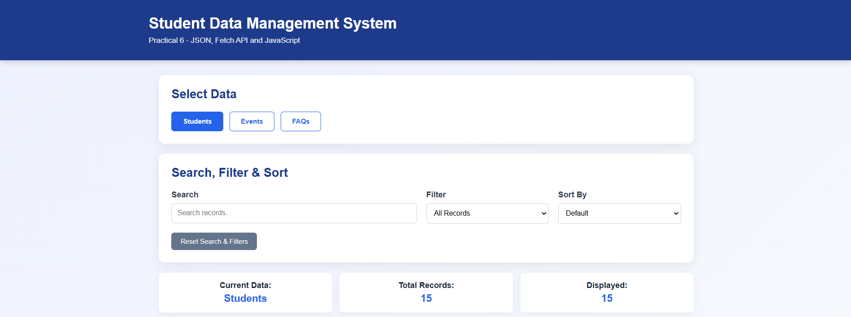
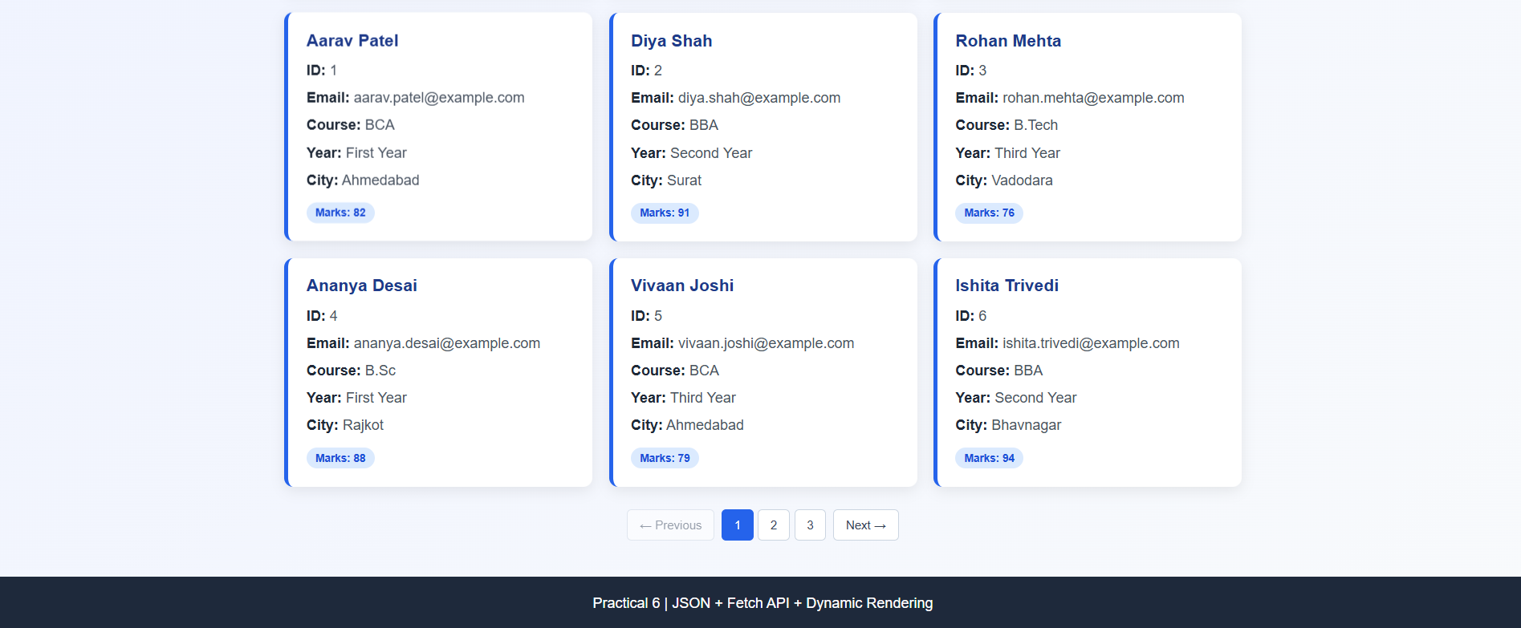

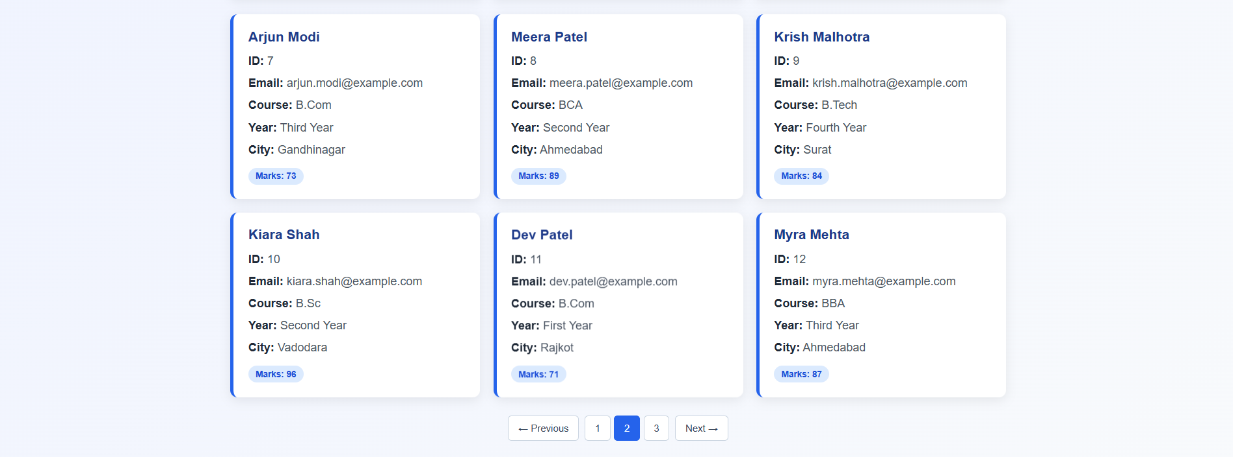

Search Result:

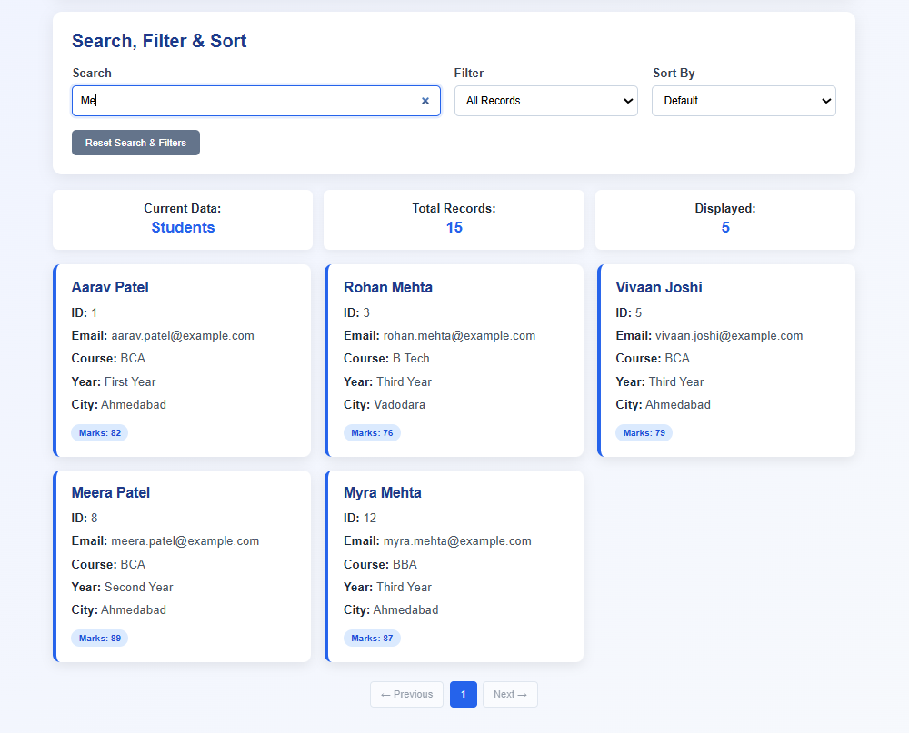

Filter Result:

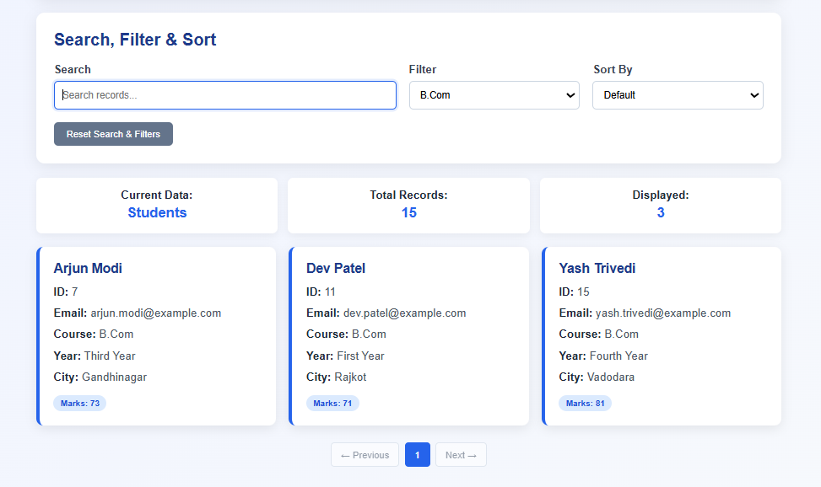

Sorting Result:

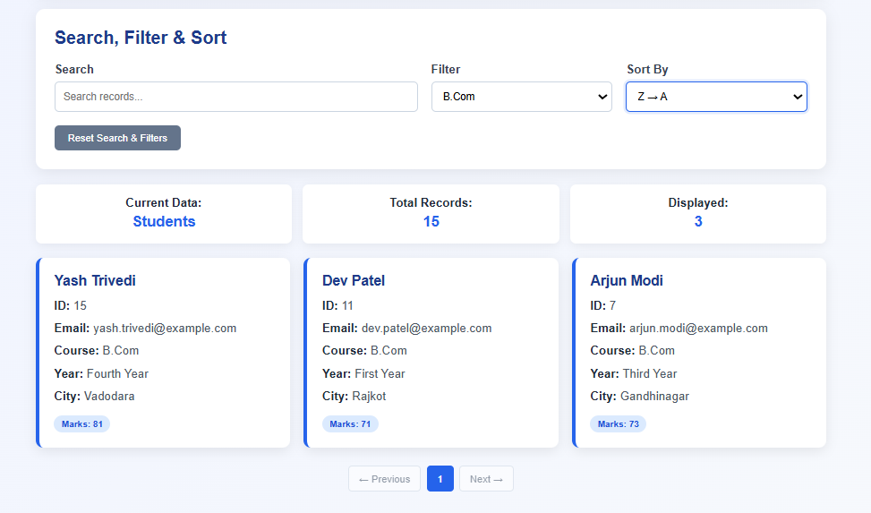

Pagination:

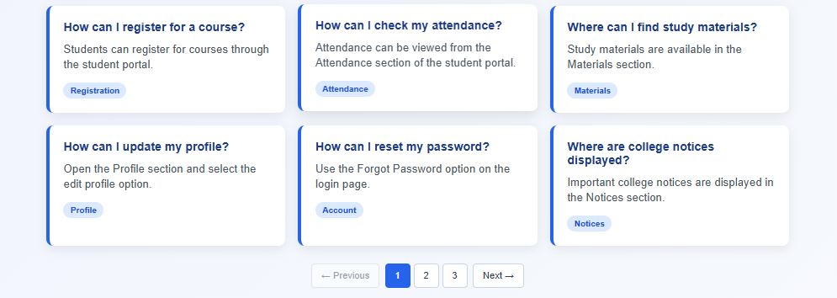
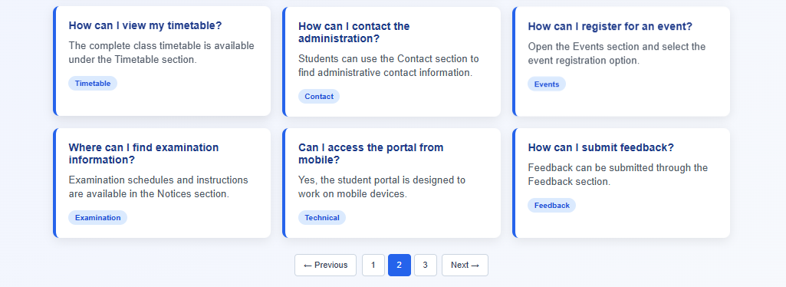
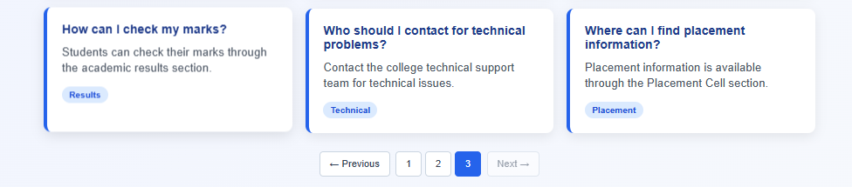

Data Fetched Successfully:

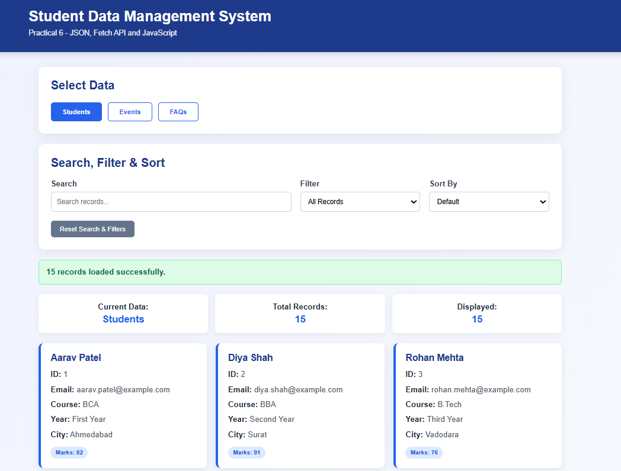

Error Message:

