

Faculty of Technology and Engineering
Chandubhai S. Patel Institute of Technology (CSPIT) Department of Computer Science & Engineering
Date:24/09/2026
Laboratory Manual

Academic Year | : | 2026-27 | Semester | : | 3rd
Course code | : | ITUE203 | Course name | : | WEB DEVELOPMENT FRAMEWORKS

Practical No: 1

Problem Statement: Initiate the semester-long StudentHub portal by identifying the problem scope, user roles, key modules, navigation flow, and minimum 10 pages. Create a sitemap, low-fidelity wireframe, project folder structure, README file, and GitHub repository.
Objective: Project Folder – Complete StudentHub project folder created in VS Code.
GitHub Repository Screenshot – Screenshot showing the created GitHub repository and uploaded project.
GitHub Repository Link – Submit the link to your GitHub repository.
Sitemap PDF – Submit the sitemap created in Figma as a PDF file.
Low-Fidelity Wireframe PDF – Submit the low-fidelity wireframe created in Figma as a PDF file.

GitHub Repository Link:
https://github.com/mann-bhalodiya/WDF_Practicals.git
Screenshots:
- Sitemap:
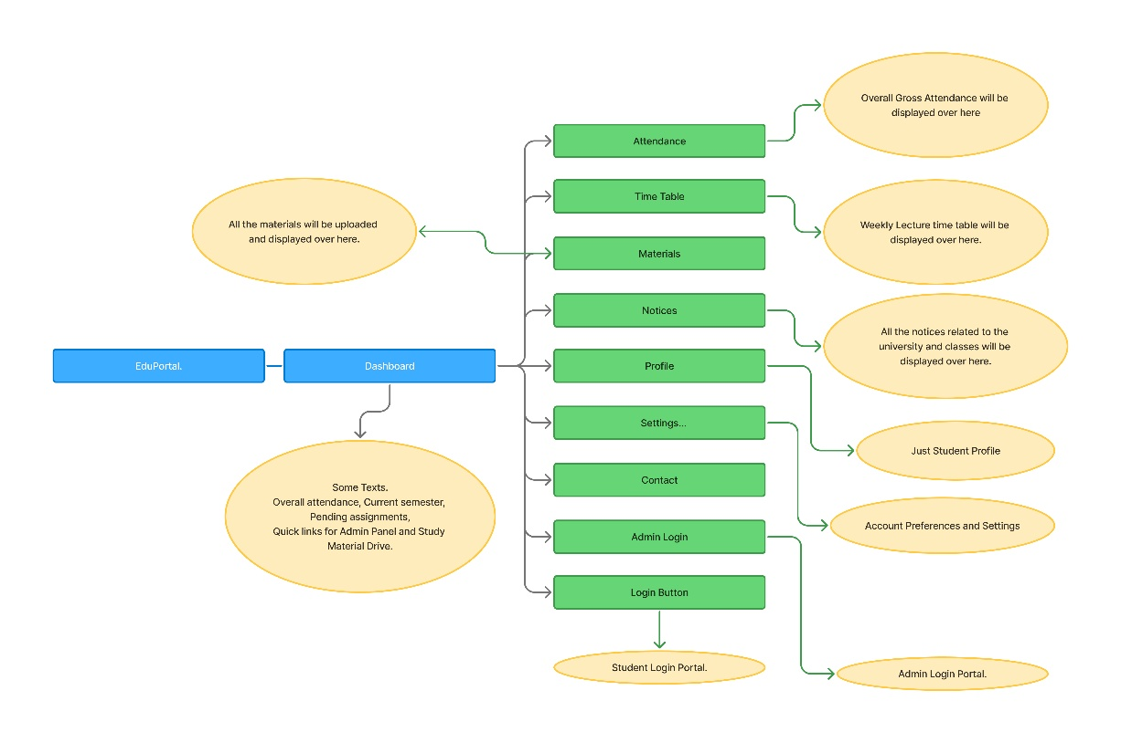
- Wireframes:
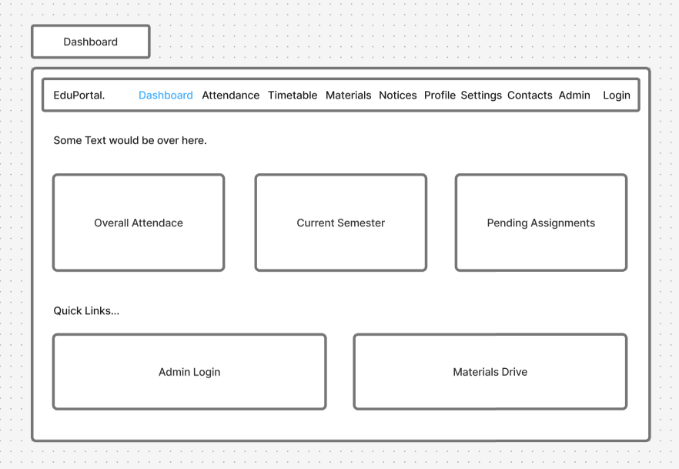
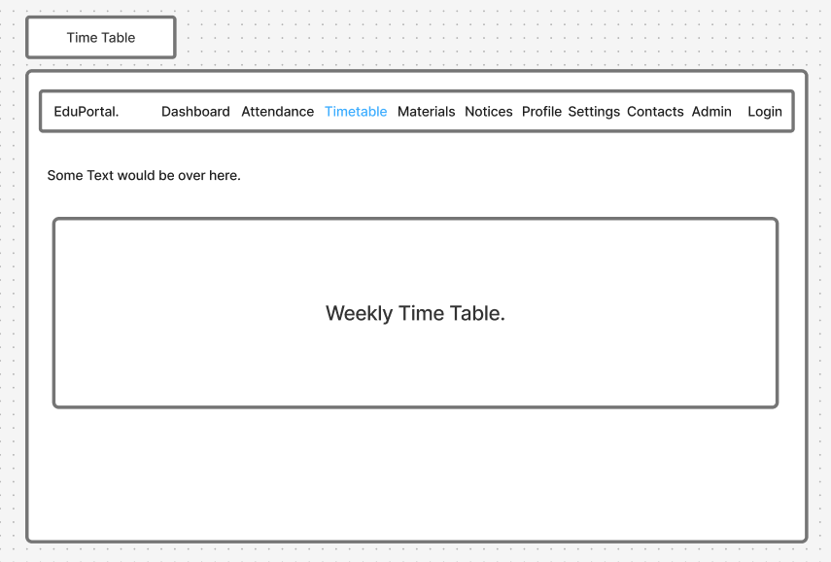
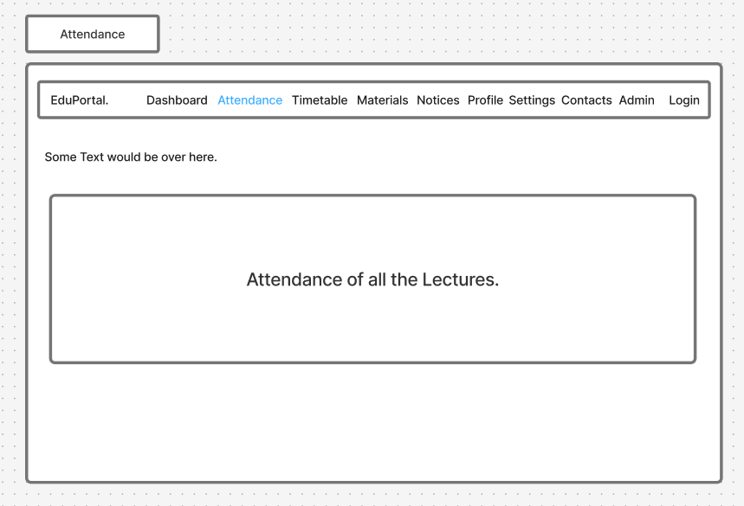
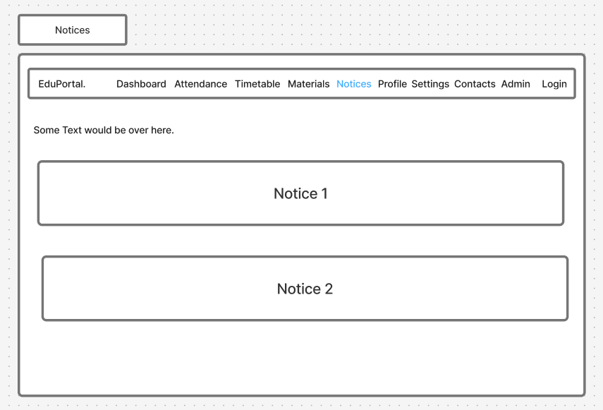
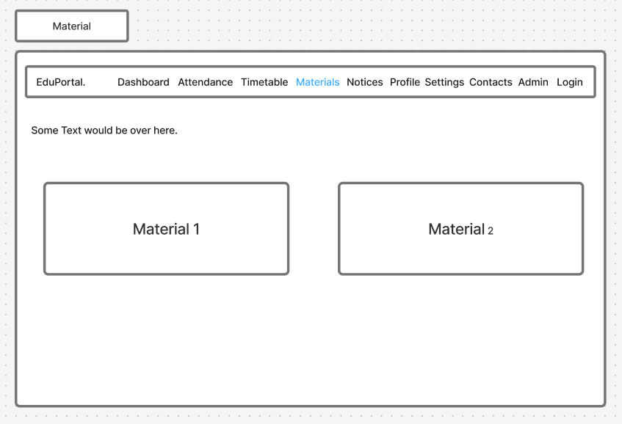
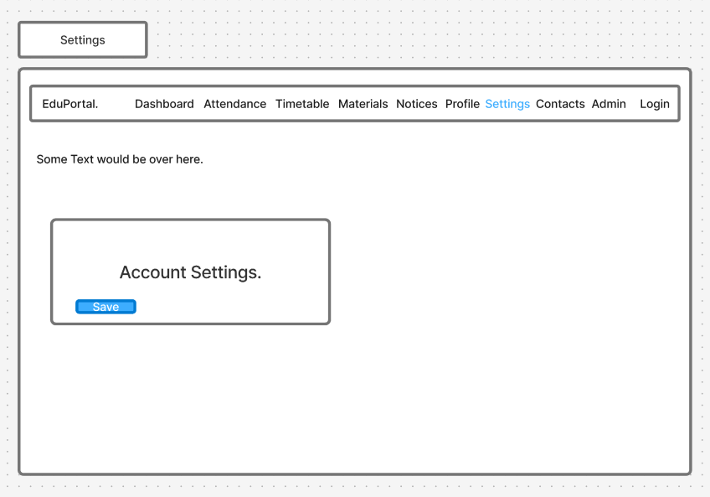
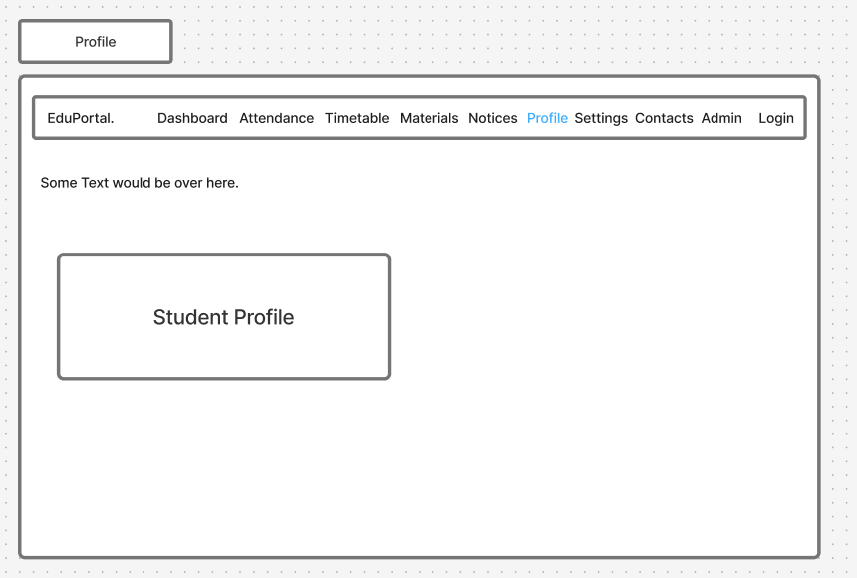
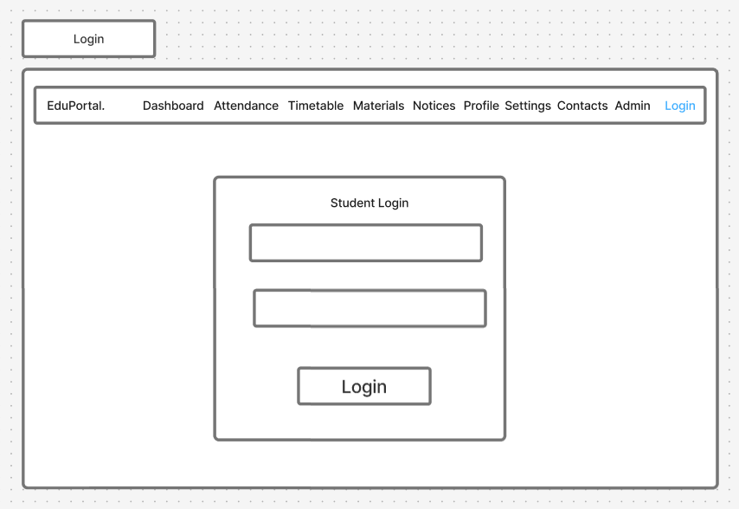
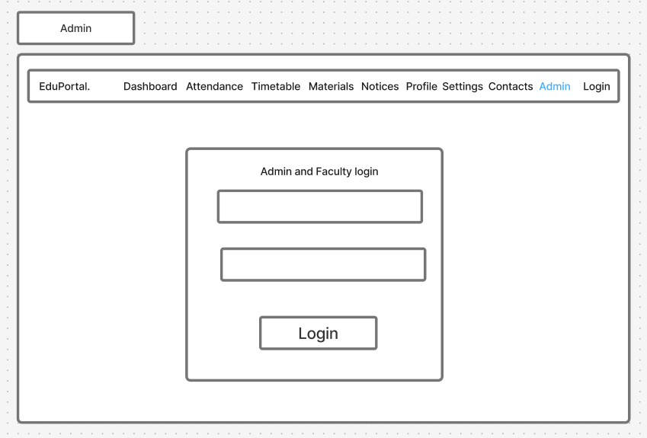
- Folder Structure:

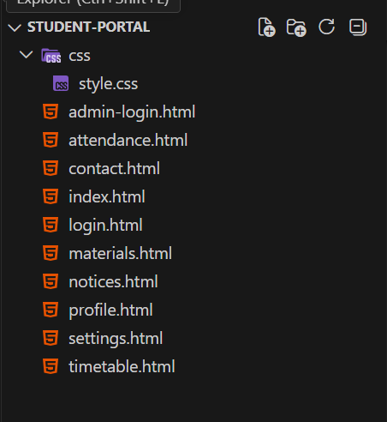

- GitHub Repository:

