 | 
Faculty of Technology and Engineering
Chandubhai S. Patel Institute of Technology (CSPIT)
Department of Computer Science & Engineering
Date: 22/07/2026
Laboratory Manul
Academic Year | : | 2026-27 | Semester | : | 3rd
Course code | : | ITUE203 | Course name | : | WEB DEVELOPMENT FRAMEWORKS

Practical – 14:-
Admin Dashboard with Role-Based Access Control and Dynamic Menu

Problem Statement:- Develop an admin dashboard that displays user statistics, student count, event count and latest registrations. Restrict access to admin users only and show dynamic menu options based on role.

Objective:- To design and implement a role-based access-controlled admin dashboard that restricts access exclusively to authorized administrators, displays real-time system metrics (such as user, student, and event counts) along with recent registration records, and dynamically renders navigation menus based on user roles.

Dynamic stats (user/student/event count):-

Admin side:-

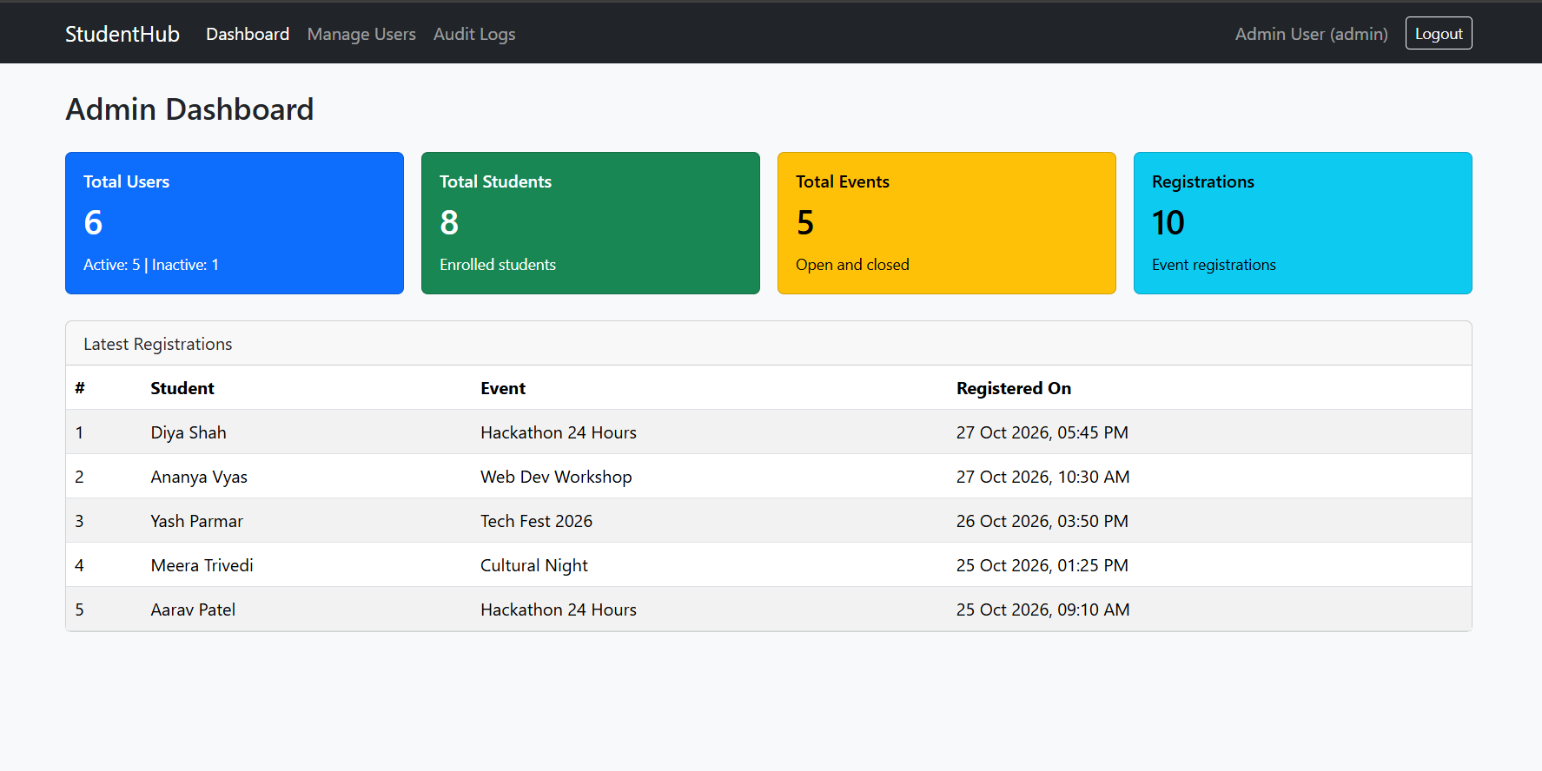

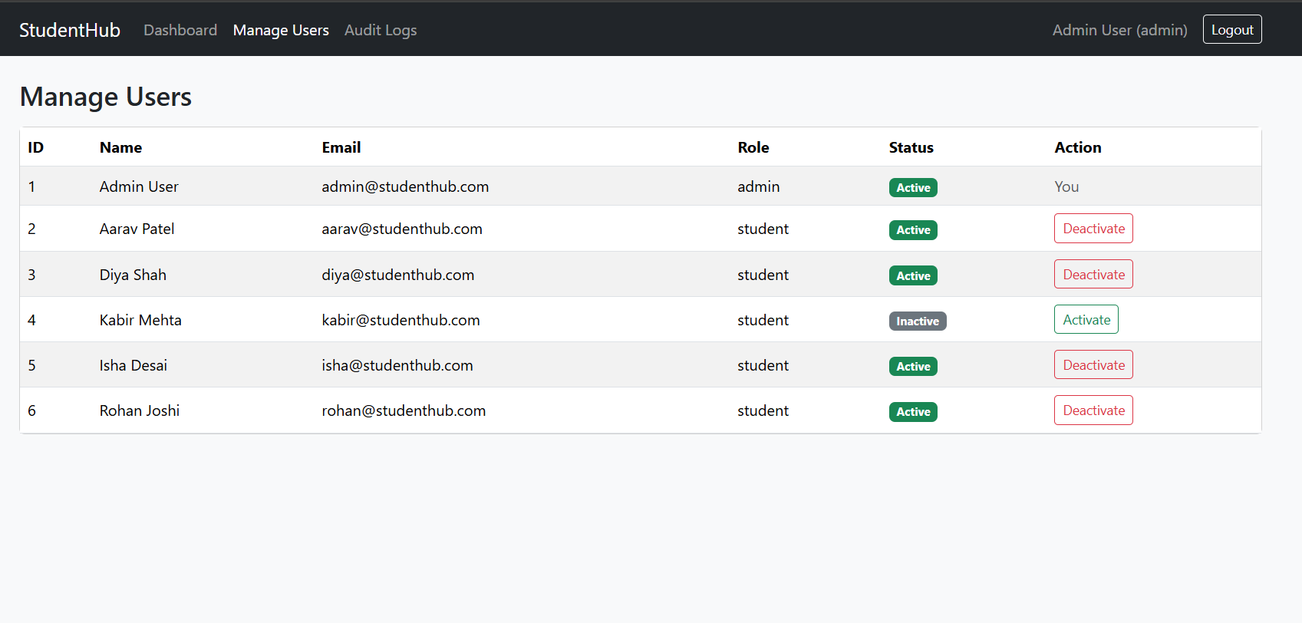

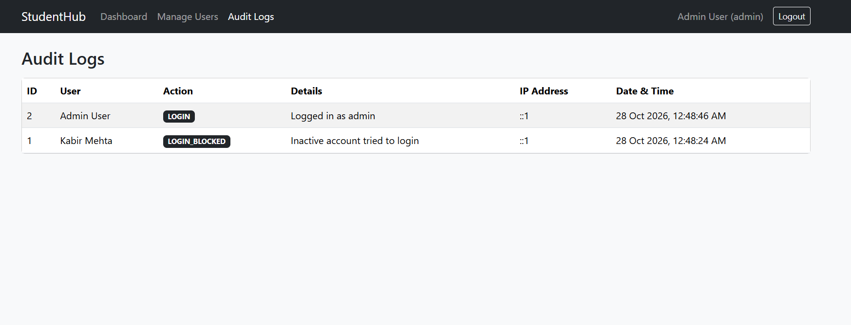

Student side:-

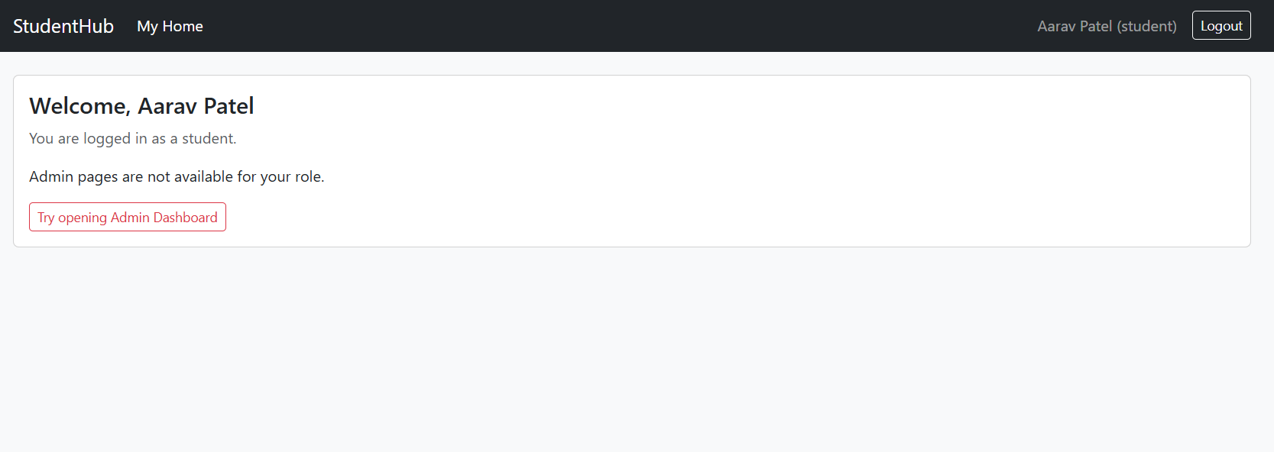

RBAC & Security Screenshots: Dynamic menu according to role ane Non-admin access restricted (403 error) page screenshot:-

Diya is deactivated by Admin:-

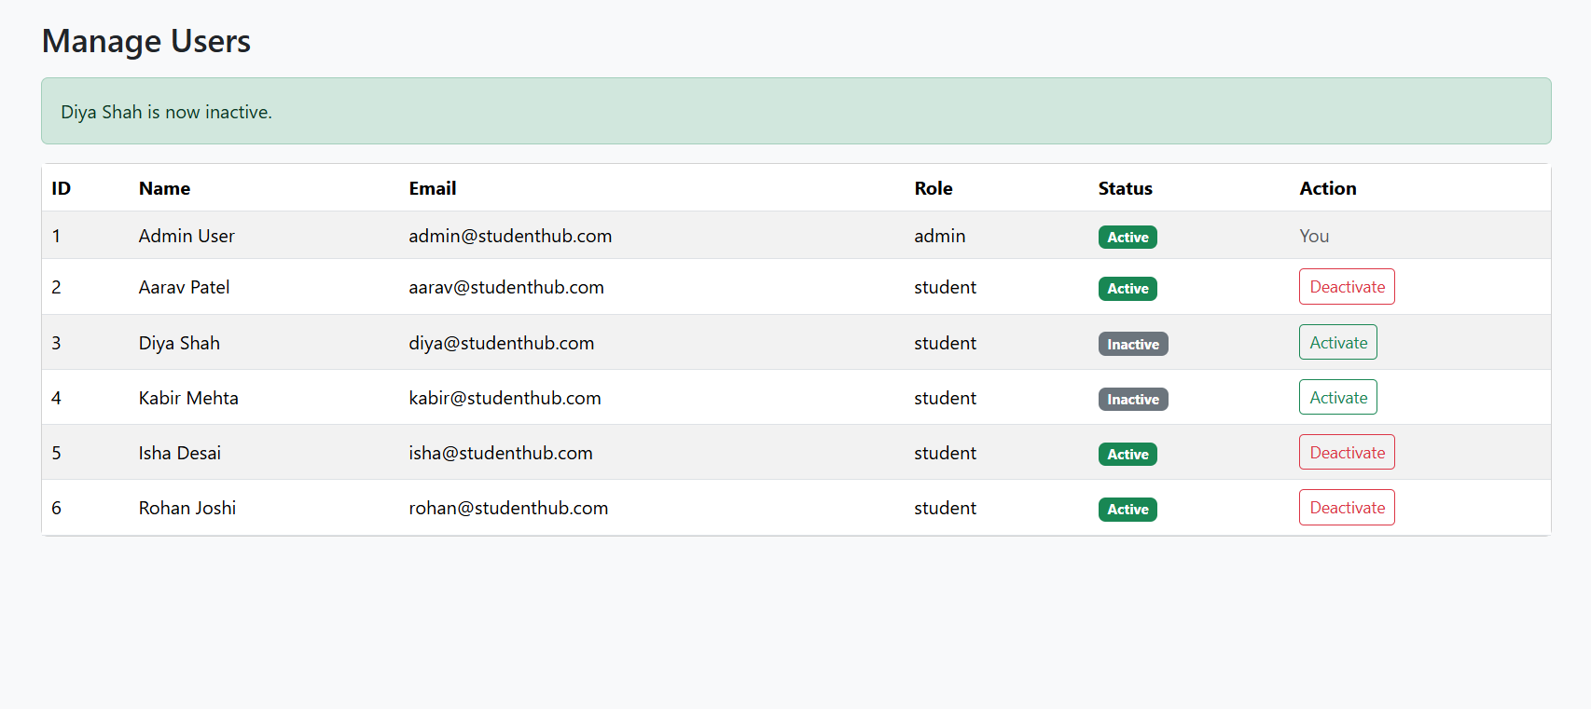

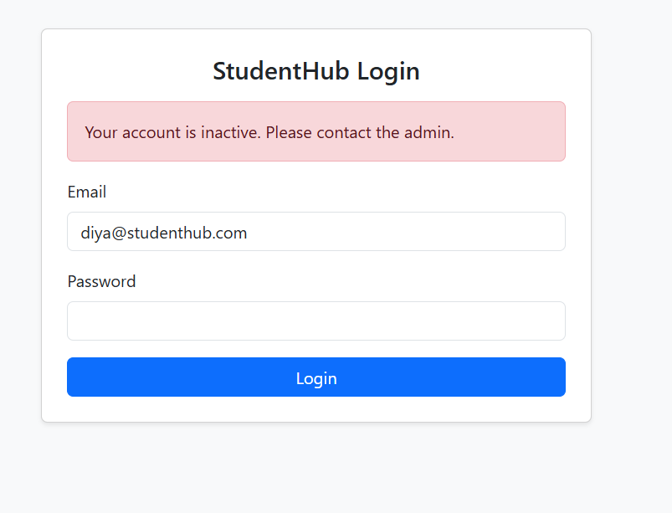

Aarav is trying to access admin dashboard:-

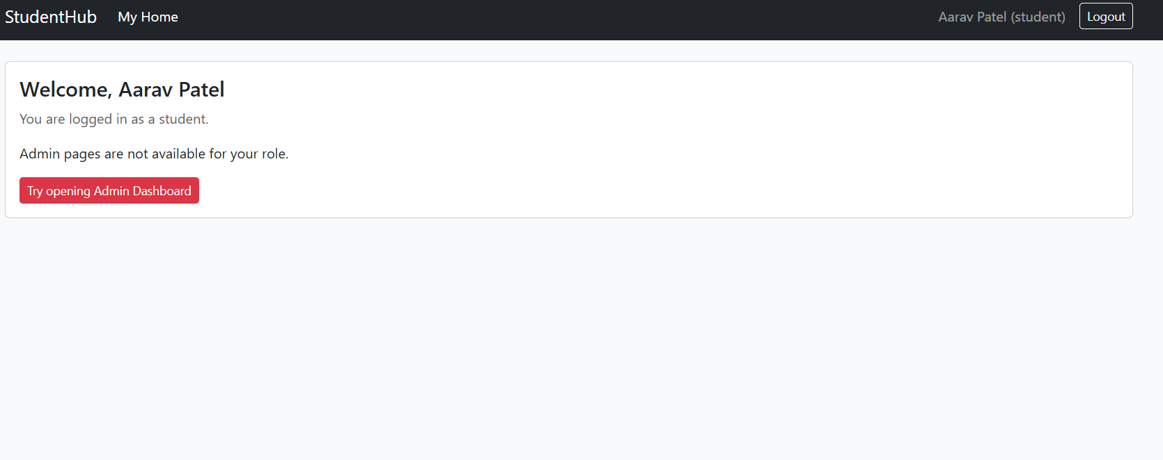

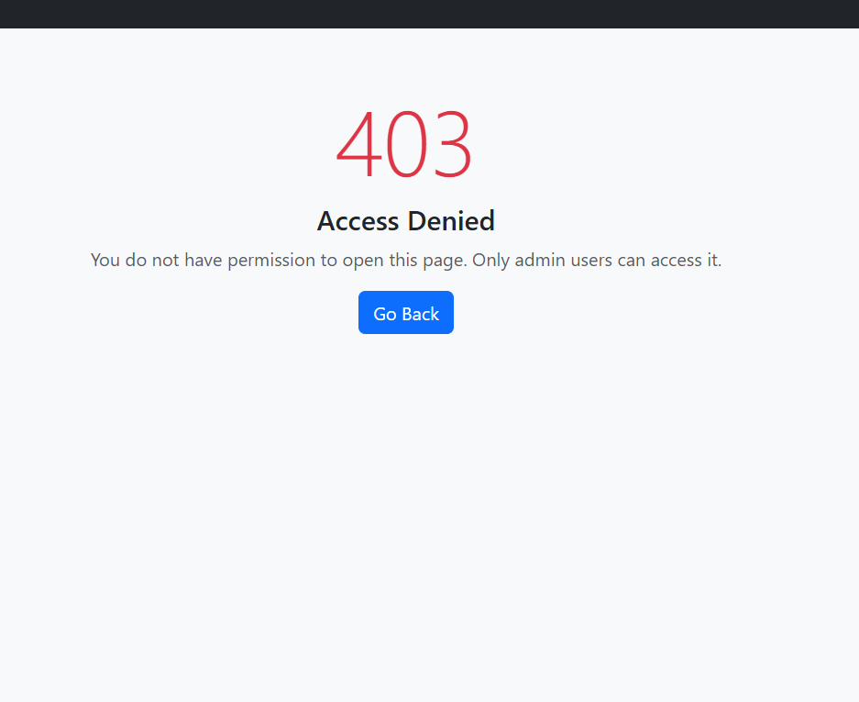

Audit log:-

