

Faculty of Technology and Engineering
Chandubhai S. Patel Institute of Technology (CSPIT) Department of Computer Science & Engineering
Date:26/10/2026
Laboratory Manual

Academic Year | : | 2026-27 | Semester | : | 3rd
Course code | : | ITUE203 | Course name | : | WEB DEVELOPMENT FRAMEWORKS

Practical No: 13

Problem Statement: To develop a web application using PHP and MySQL that provides JSON API endpoints for managing student records. The application should use JavaScript Fetch API to perform asynchronous Create, Read, Update, and Delete (CRUD) operations without reloading the webpage. It should also implement input validation and display appropriate loading, success, and error messages.

Objective: To create PHP API endpoints that return valid JSON responses. To connect a PHP backend with a MySQL database. To use JavaScript Fetch API for asynchronous communication between the frontend and backend. To implement CRUD operations for student records without a full page reload. To validate user inputs before performing database operations. To handle HTTP methods such as GET, POST, PUT, and DELETE correctly. To display success messages, loading indicators, and error messages on the frontend. To understand frontend-backend integration and API response handling.

GitHub Repository Link:
https://github.com/mann-bhalodiya/WDF_Practicals.git
Screenshots:

List

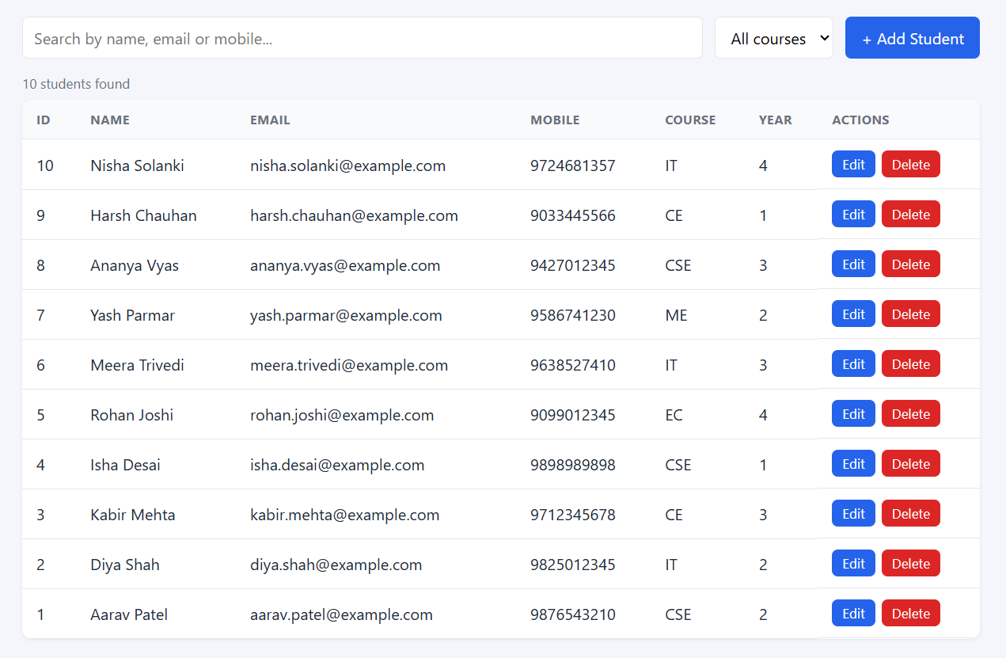

Add

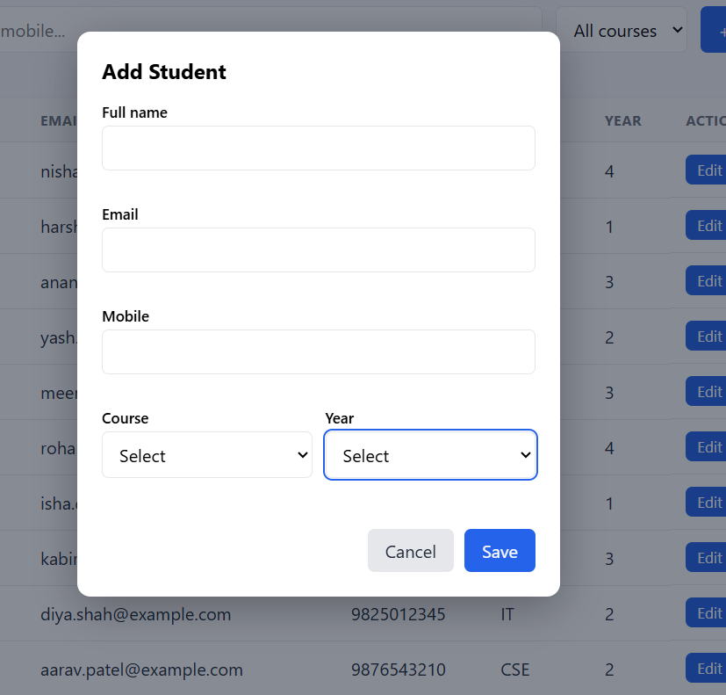

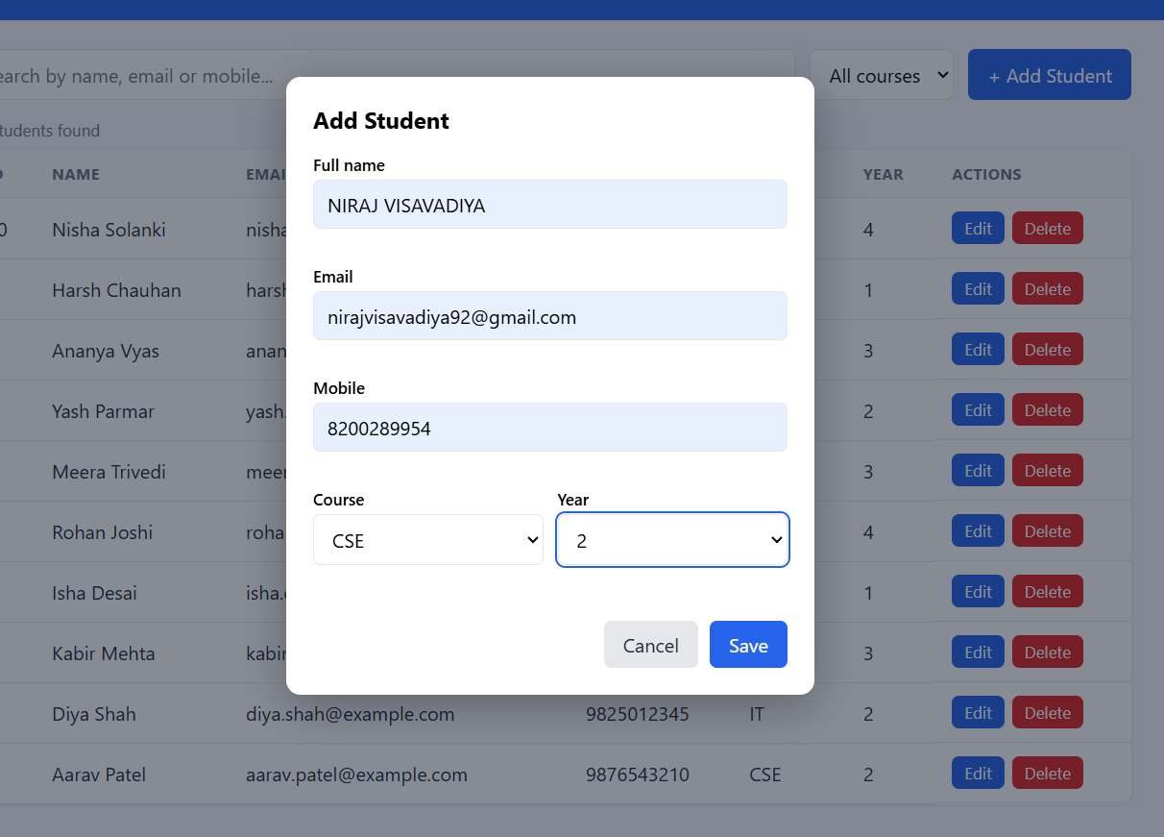

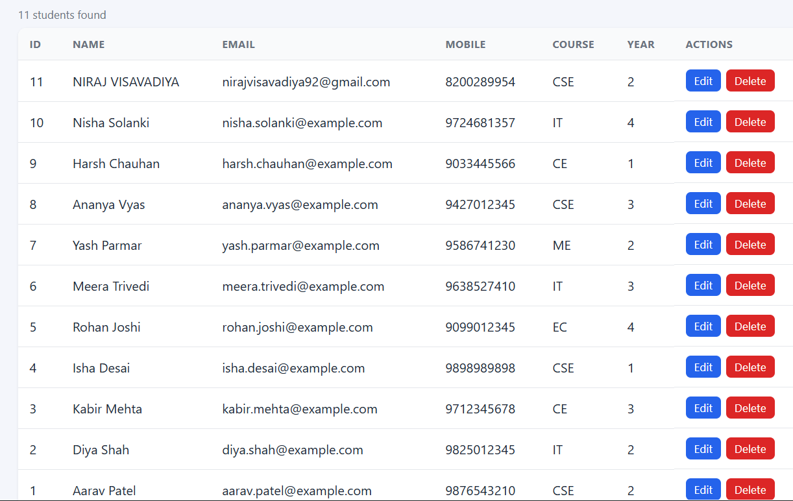

Edit

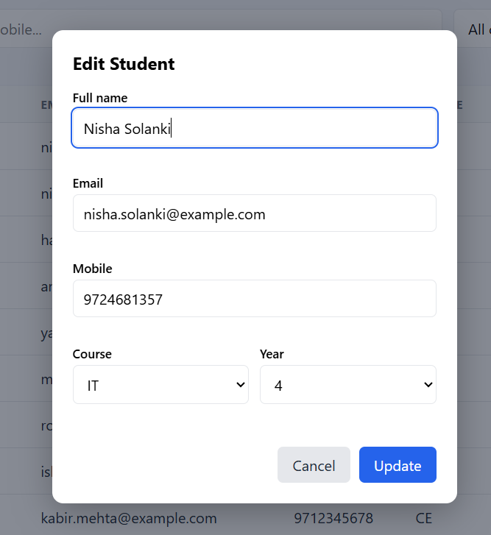

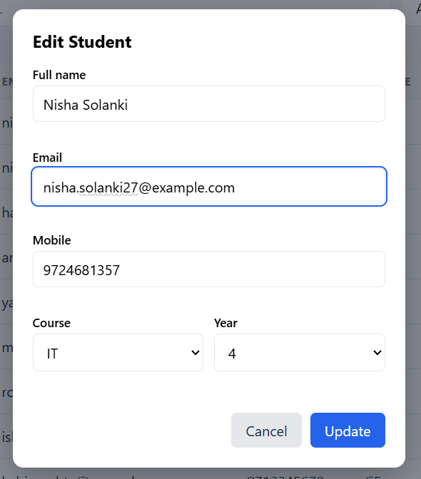

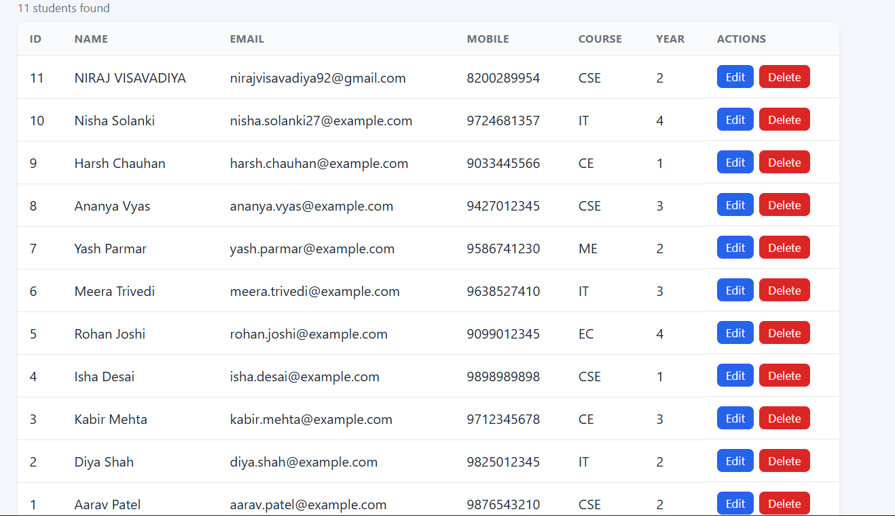

Delete

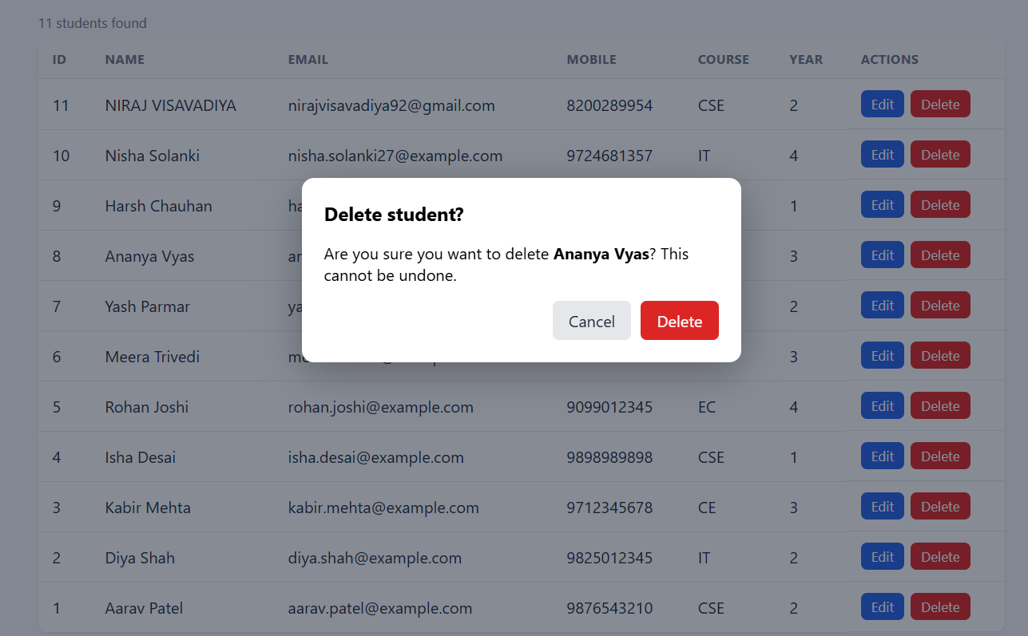

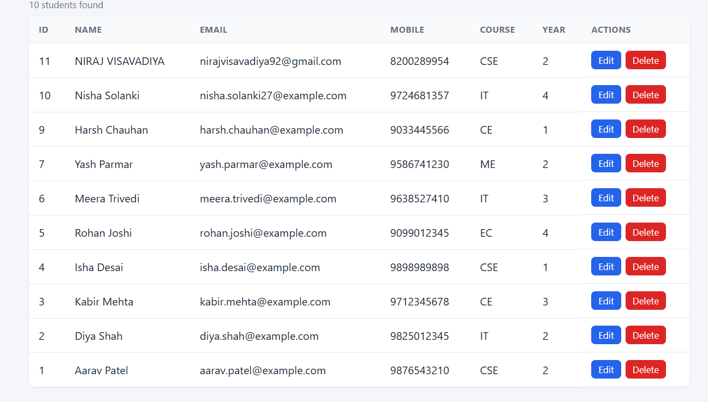

Loading state

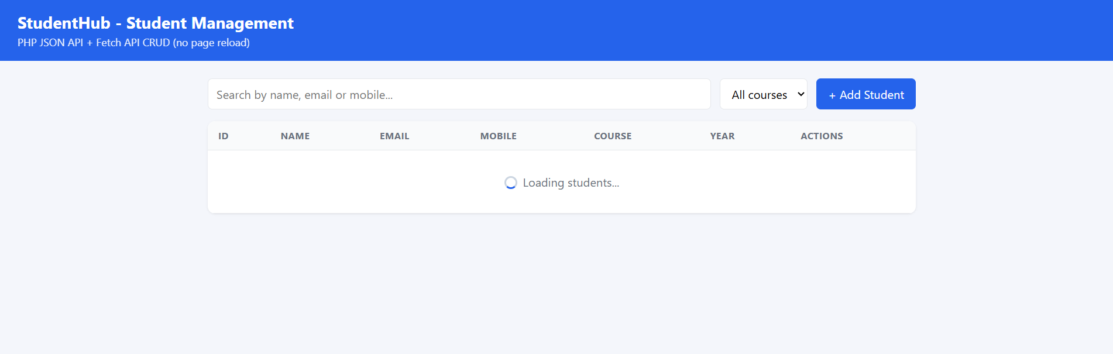

Error state

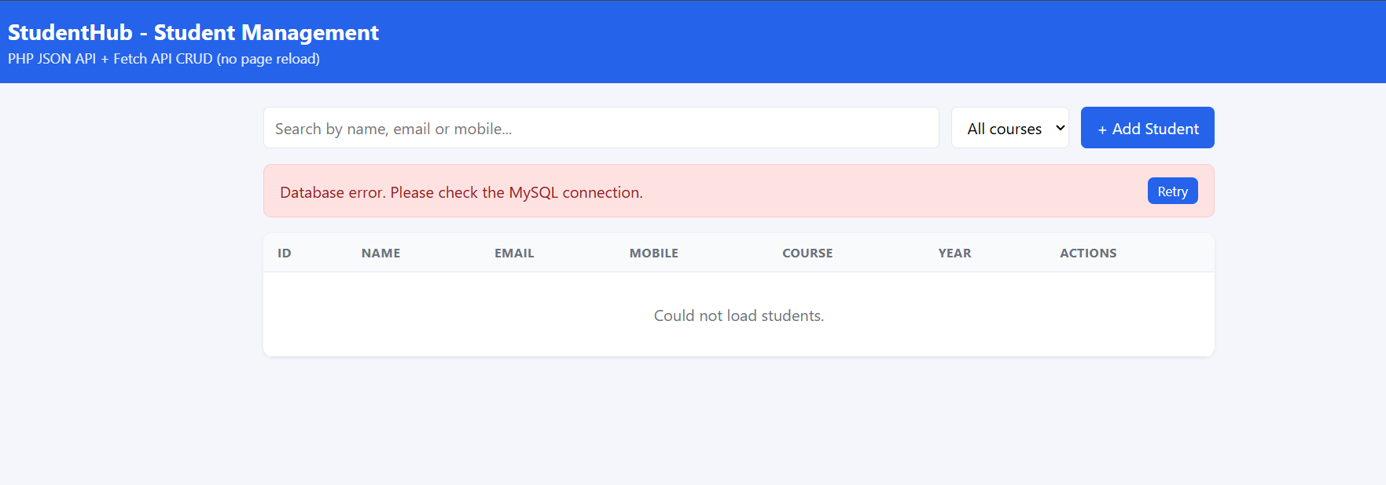
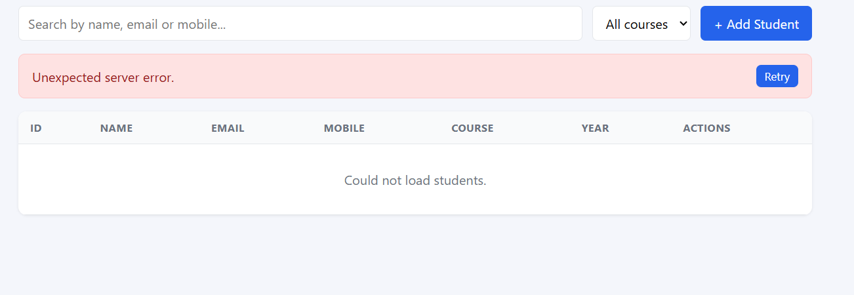

Form state

