

**Assignment-7**

**Name: - Mann Kothari**

**Reg. No.: - 22BCB7064**

**Course Title: - Design and Analysis of Algorithm (Embedded Lab)**

**Course Code: - CSE3023**

**Slot: - L21+L22**

**Submitted to: - Prof. Tanikella Divya Naga Pavani**

* **INDEX**
* Prim's algorithm for the construction of a minimum cost-spanning tree using

the greedy methodology

* Algorithm
* Code
* Output
* Complexity
* Kruskal's algorithm for the construction of a minimum cost spanning tree using the greedy methodology
* Algorithm
* Code
* Output
* Complexity
* Complexity Chart

1. Write a C/C++ program to Implement Prim's algorithm for the construction of a minimum cost-spanning tree using the greedy methodology

Algorithm: -

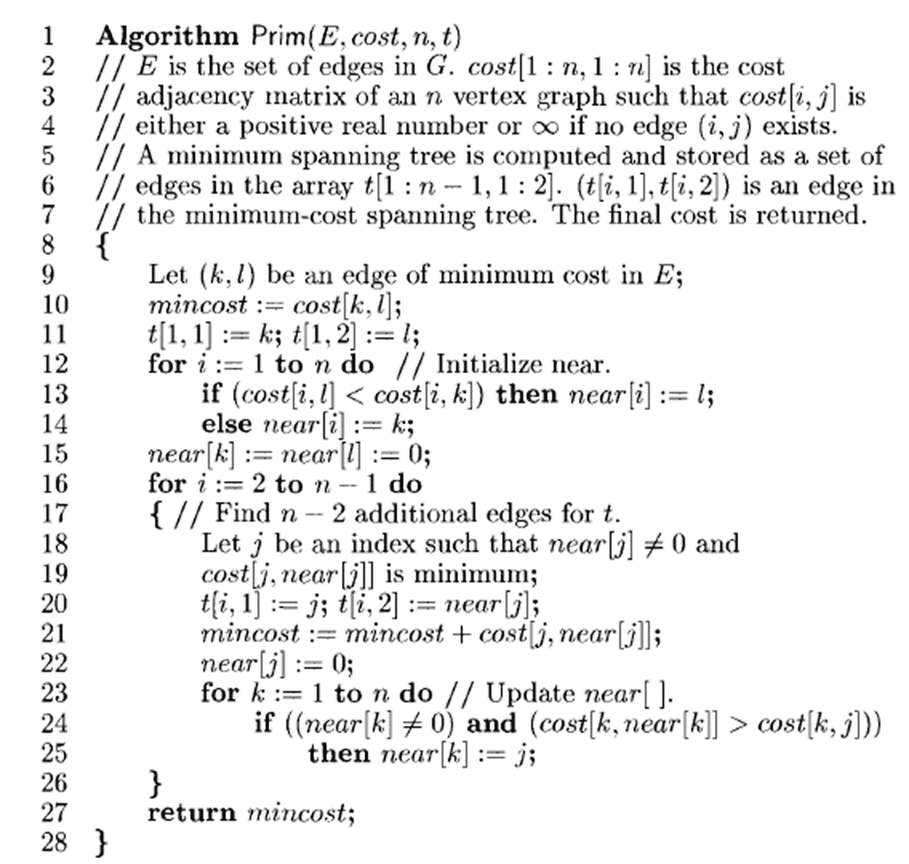

Time Complexity: -

O(n2)

Code: -

#include <limits.h>

#include <stdbool.h>

#include <stdio.h>

#define V 5

int minKey(int key[], bool mstSet[])

{

    int min = INT_MAX, min_index;

    for (int v = 0; v < V; v++)

        if (mstSet[v] == false && key[v] < min)

            min = key[v], min_index = v;

    return min_index;

}

int printMST(int parent[], int graph[V][V])

{

    printf("Edge \tWeight\n");

    for (int i = 1; i < V; i++)

        printf("%d - %d \t%d \n", parent[i], i,

               graph[i][parent[i]]);

}

void primMST(int graph[V][V])

{

    int parent[V];

    int key[V];

    bool mstSet[V];

    for (int i = 0; i < V; i++)

        key[i] = INT_MAX, mstSet[i] = false;

    key[0] = 0;

    parent[0] = -1;

    for (int count = 0; count < V - 1; count++)

    {

        int u = minKey(key, mstSet);

        mstSet[u] = true;

        for (int v = 0; v < V; v++)

            if (graph[u][v] && mstSet[v] == false && graph[u][v] < key[v])

                parent[v] = u, key[v] = graph[u][v];

    }

    printMST(parent, graph);

}

int main()

{

    int graph[V][V] = {{0, 2, 0, 6, 0},

                       {2, 0, 3, 8, 5},

                       {0, 3, 0, 0, 7},

                       {6, 8, 0, 0, 9},

                       {0, 5, 7, 9, 0}};

    primMST(graph);

    return 0;

}

Output: -

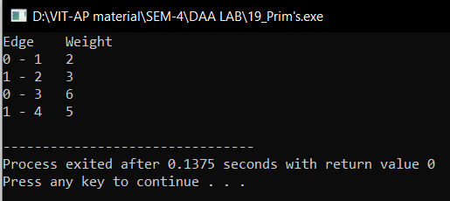

1. Write a C/C++ program to Implement Kruskal’s algorithm for the construction of a minimum cost spanning tree using the greedy methodology

Algorithm: -

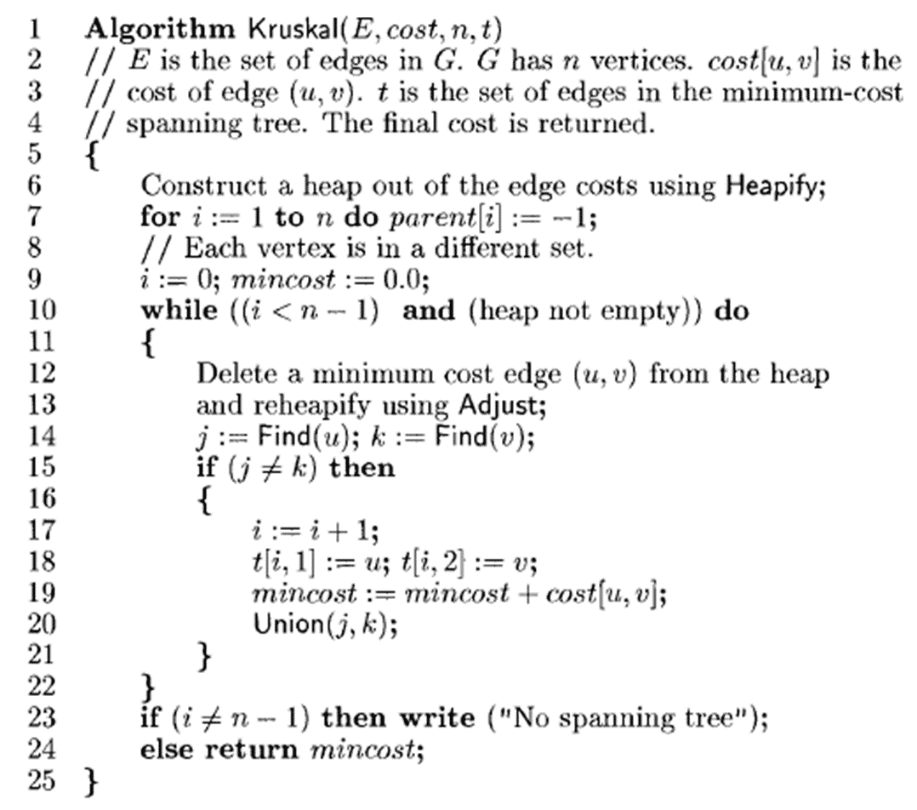

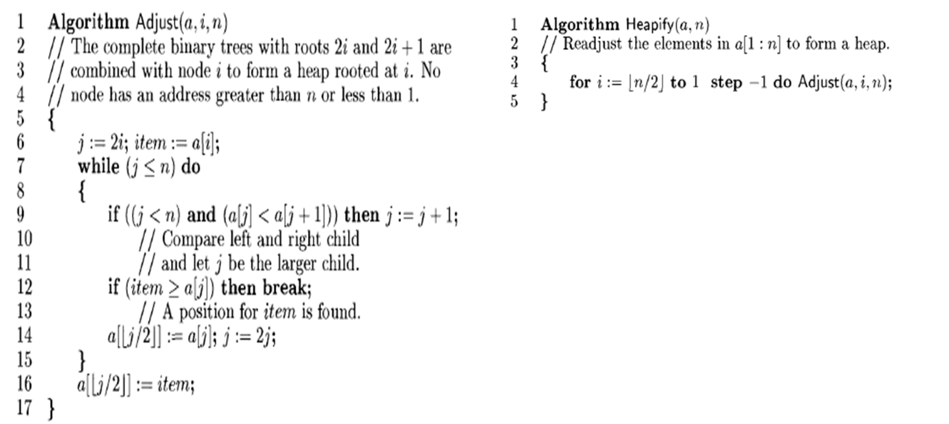

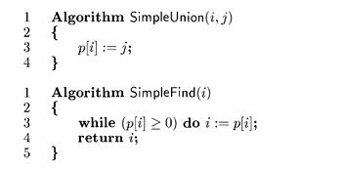

Time Complexity: -

O(E*logE)

Code: -

#include <stdio.h>

#include <stdlib.h>

int comparator(const void *p1, const void *p2)

{

    const int(*x)[3] = p1;

    const int(*y)[3] = p2;

    return (*x)[2] - (*y)[2];

}

void makeSet(int parent[], int rank[], int n)

{

    for (int i = 0; i < n; i++)

    {

        parent[i] = i;

        rank[i] = 0;

    }

}

int findParent(int parent[], int component)

{

    if (parent[component] == component)

        return component;

    return parent[component] = findParent(parent, parent[component]);

}

void unionSet(int u, int v, int parent[], int rank[], int n)

{

    u = findParent(parent, u);

    v = findParent(parent, v);

    if (rank[u] < rank[v])

    {

        parent[u] = v;

    }

    else if (rank[u] > rank[v])

    {

        parent[v] = u;

    }

    else

    {

        parent[v] = u;

        rank[u]++;

    }

}

void kruskalAlgo(int n, int edge[n][3])

{

    qsort(edge, n, sizeof(edge[0]), comparator);

    int parent[n];

    int rank[n];

    makeSet(parent, rank, n);

    int minCost = 0;

    printf(

        "Following are the edges in the constructed MST\n");

    for (int i = 0; i < n; i++)

    {

        int v1 = findParent(parent, edge[i][0]);

        int v2 = findParent(parent, edge[i][1]);

        int wt = edge[i][2];

        if (v1 != v2)

        {

            unionSet(v1, v2, parent, rank, n);

            minCost += wt;

            printf("%d -- %d == %d\n", edge[i][0],

                   edge[i][1], wt);

        }

    }

    printf("Minimum Cost Spanning Tree: %d\n", minCost);

}

int main()

{

    int edge[5][3] = {{0, 1, 10},

                      {0, 2, 6},

                      {0, 3, 5},

                      {1, 3, 15},

                      {2, 3, 4}};

    kruskalAlgo(5, edge);

    return 0;

}

Output: -

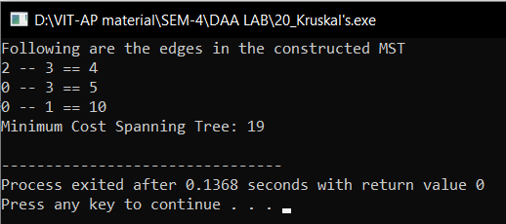

|  |  |  |
| --- | --- | --- |
| Algorithm | Time Complexity | Space Complexity |
| Prim's algorithm for the construction of a minimum cost-spanning tree using the greedy methodology | O(n2) | O(2n) |
| Kruskal's algorithm for the construction of a minimum cost spanning tree using the greedy methodology | O(E*logE) | O(E+V) |