**PRACTICAL: 1**

**AIM:**

Understanding and Analyzing Your Costs with Google Cloud Billing Reports. Google Cloud cost management tools provide greater visibility, accountability, control, and intelligence so that you can scale your business in the cloud with confidence. Tailored to meet the needs of organizations of all sizes, these tools help reduce complexity and increase the predictability of your cloud costs. Google Cloud Billing reports is a cost management tool that provides built-in reporting within the Google Cloud Console. In this lab, you familiarize yourself with Billing reports and understand how to answer fundamental cost management questions, such as: How much am I spending? What are my cost trends? What are my cost drivers?

**THEORY:**

Google Cloud cost management tools provide greater visibility, accountability, control, and intelligence so that you can scale your business in the cloud with confidence. Tailored to meet the needs of organizations of all sizes, these tools help reduce complexity and increase the predictability of your cloud costs.

Google Cloud Billing reports is a cost management tool that provides built-in reporting within the Google Cloud Console. In this lab, you familiarize yourself with Billing reports and understand how to answer fundamental cost management questions, such as: How much am I spending? What are my cost trends? What are my cost drivers?

**OUTPUT:**

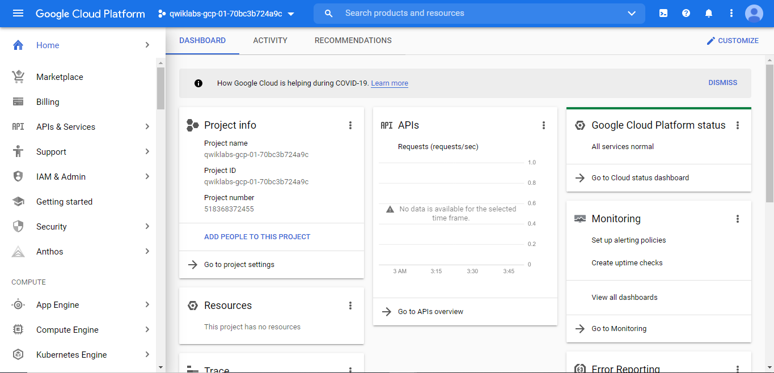

* 1. **– GCP Dashboard**

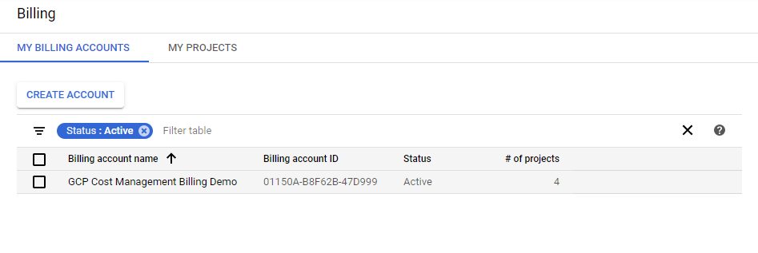

* 1. **– Billing account already registered by GCP for learning purpose.**

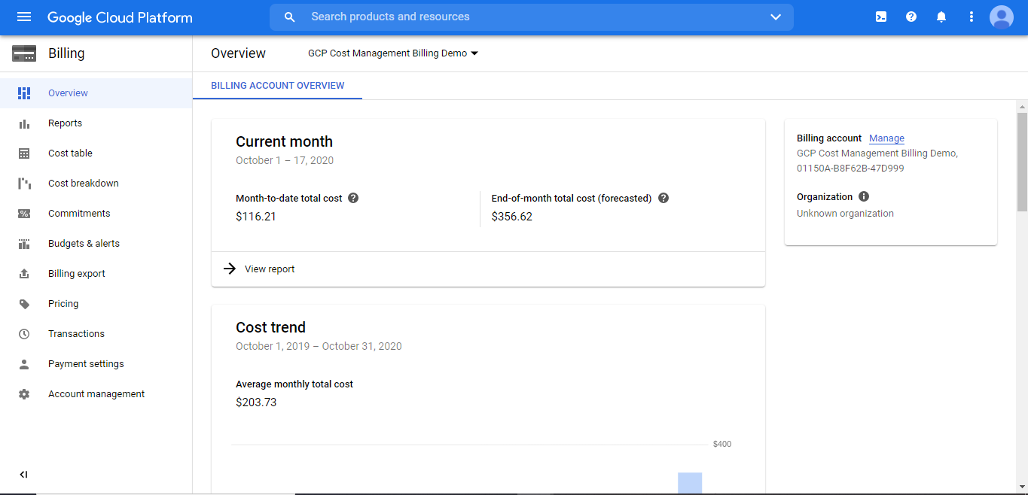

* 1. **Billing account overview**

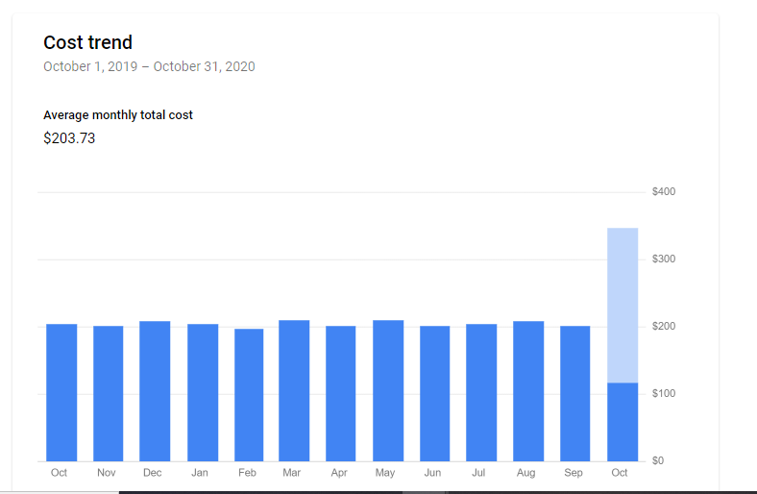

* 1. **Cost Trend**

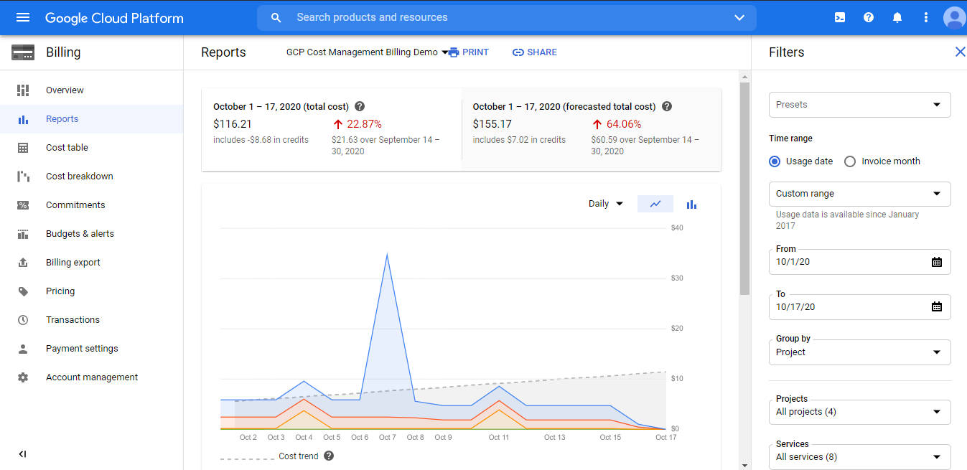

* 1. **Reports which filtered on the basis of date when enrolled**

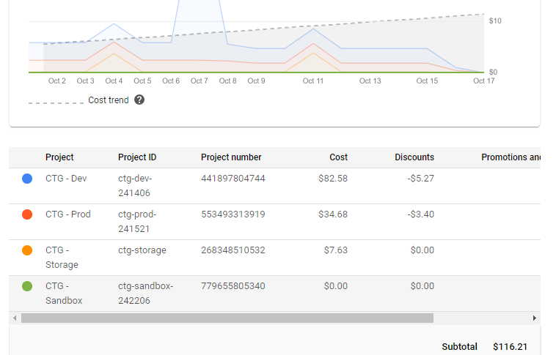

* 1. **List of all project ID associated with the billing account**

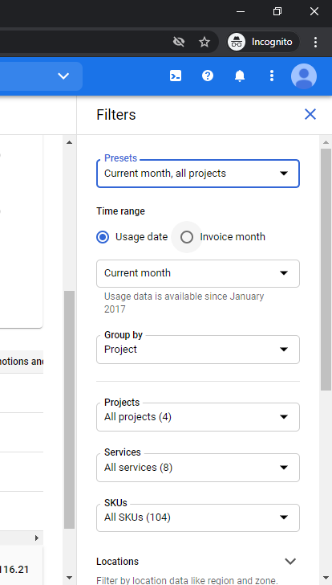

* 1. **Filter queries.**

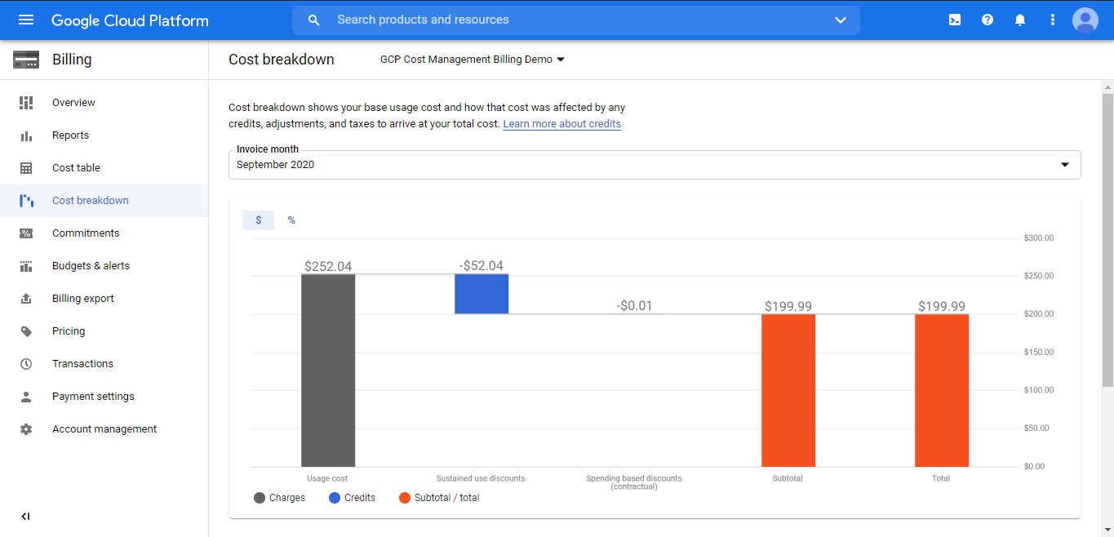

* 1. **Cost Breakdown Charts**

**LATEST APPLICATIONS:**

The google cloud platform works on the simple rule pay as you use. GCP provide a very user-friendly billing dashboard along with multiple filters features.

**LEARNING OUTCOME:**

View billing reports in the google cloud platform using a sample billing account. View your current and forecasted Google Cloud costs at project and product. Analyze costs using report filters to identify cost drivers and trends. Examples of report filters include **Projects**, **Products**, **Locations**, and **Credits.**

**REFERENCE:**

1. <https://google.qwiklabs.com/focuses/6268?parent=catalog>