**PRACTICAL: 4**

**AIM:**

Baseline: Infrastructure in Google Cloud. If you are a novice cloud developer looking for hands-on practice beyond Google Cloud Essentials, this quest is for you. You will get practical experience through labs that dive into Cloud Storage and other key application services like Stack driver and Cloud Functions. By taking this quest, you will develop valuable skills that are applicable to any Google Cloud initiative.

**THEORY:**

Cloud Storage allows world-wide storage and retrieval of any amount of data at any time. You can use Cloud Storage for a range of scenarios including serving website content, storing data for archival and disaster recovery, or distributing large data objects to users via direct download. In this hands-on lab you will learn how to use the Cloud Console to create a storage bucket, then upload objects, create folders and subfolders, and make those objects publicly accessible.

Google Cloud's Identity and Access Management (IAM) service lets you create and manage permissions for Google Cloud resources. Cloud IAM unifies access control for Google Cloud services into a single system and provides a consistent set of operations.

Cloud Monitoring provides visibility into the performance, uptime, and overall health of cloud-powered applications. Cloud Monitoring collects metrics, events, and metadata from Google Cloud, Amazon Web Services, hosted uptime probes, application instrumentation, and a variety of common application components including Cassandra, Nginx, Apache Web Server, Elasticsearch, and many others. Cloud Monitoring ingests that data and generates insights via dashboards, charts, and alerts. Cloud Monitoring alerting helps you collaborate by integrating with Slack, PagerDuty, HipChat, Campfire, and more.

Google Cloud Functions is a serverless execution environment for building and connecting cloud services. With Cloud Functions you write simple, single-purpose functions that are attached to events emitted from your cloud infrastructure and services. Your Cloud Function is triggered when an event being watched is fired. Your code executes in a fully managed environment. There is no need to provision any infrastructure or worry about managing any servers.

Cloud Functions are written in Javascript and execute in a Node.js environment on Google Cloud Platform. You can take your Cloud Function and run it in any standard Node.js runtime which makes both portability and local testing a breeze.

Google Cloud Pub/Sub is a messaging service for exchanging event data among applications and services. A producer of data publishes messages to a Cloud Pub/Sub topic. A consumer creates a subscription to that topic. Subscribers either pull messages from a subscription or are configured as webhooks for push subscriptions. Every subscriber must acknowledge each message within a configurable window of time.

**OUTPUT:**

**4.1 - Cloud Storage: Qwik Start - Cloud Console**

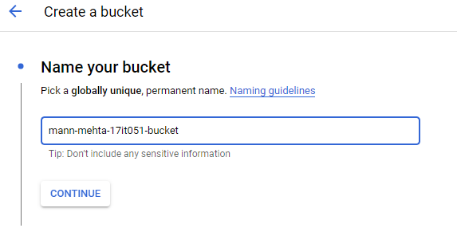

**Creating new bucket**

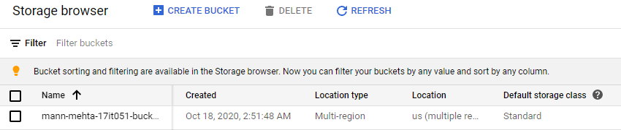

**Bucket created successfully**

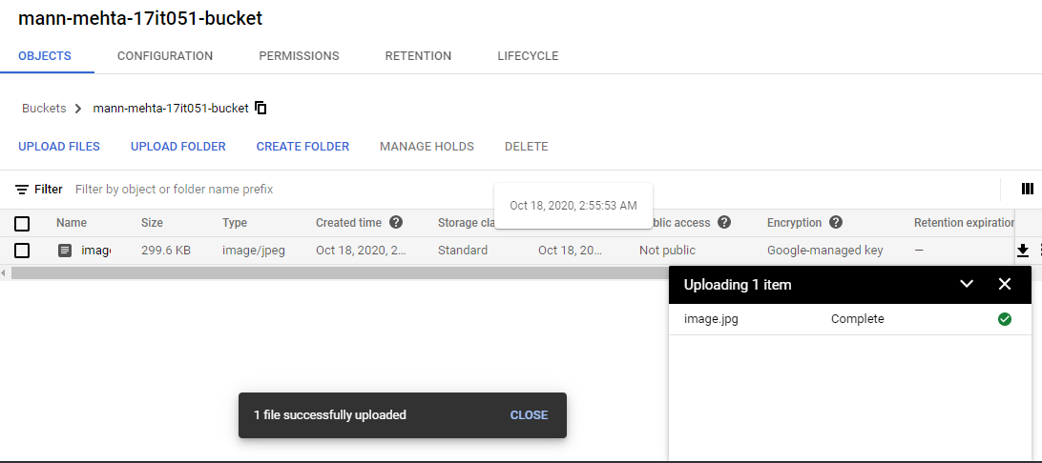

**Uploading a local image on the bucket**

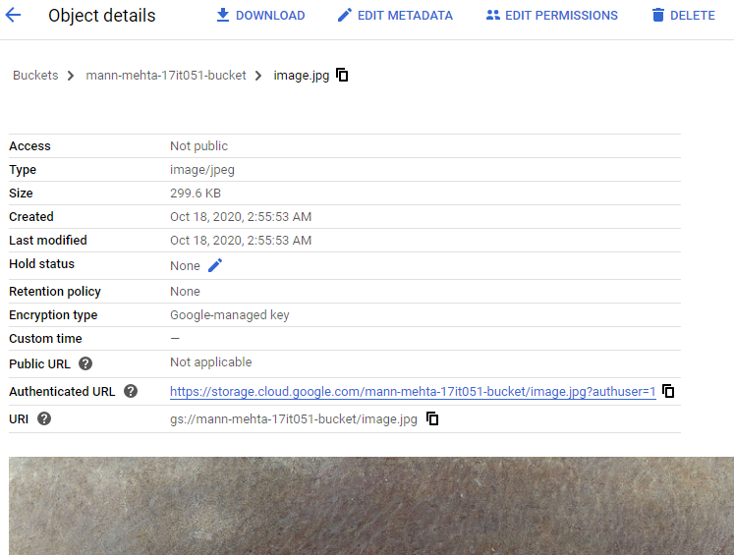

**Analyzing object details just uploaded**

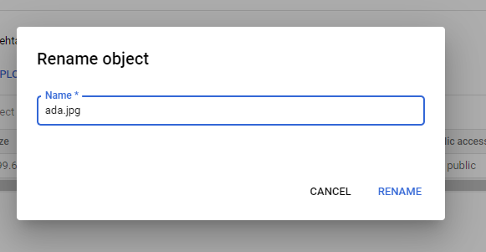

**Renaming an object**

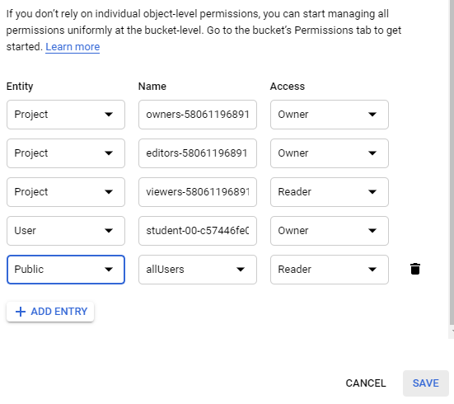

**Providing access to all users for selected object**

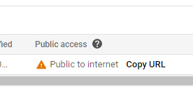

**Hence its now public to internet**

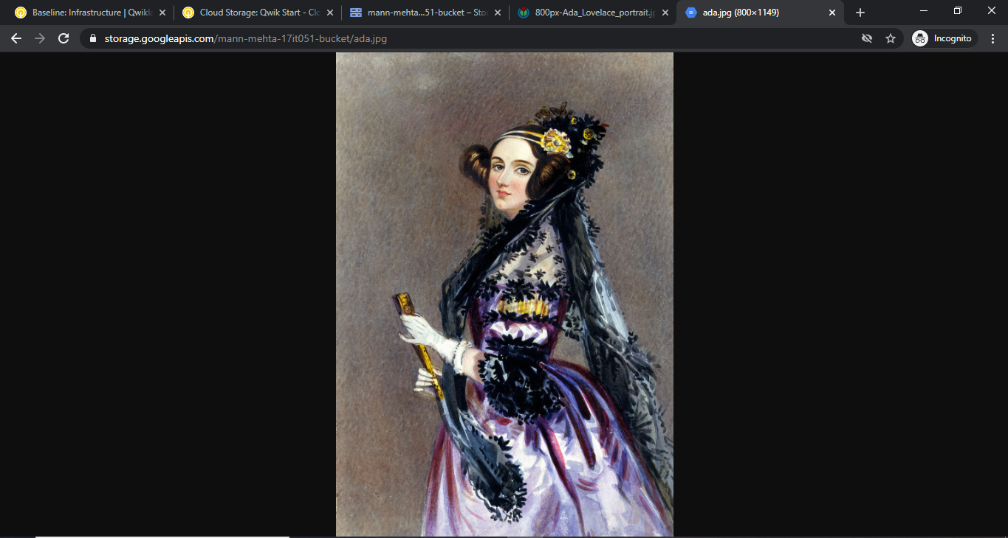

**Verifying with using public URL**

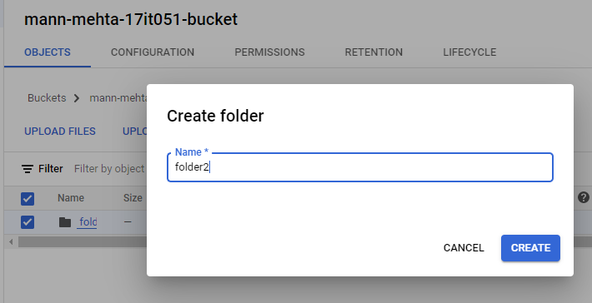

**We can also create folders and subfolders too.**

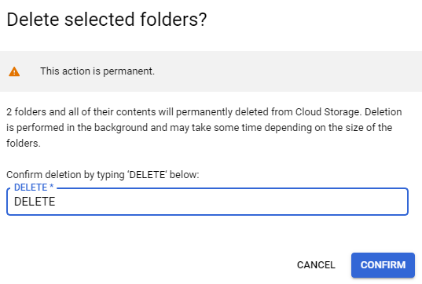

**DELETE folders**

**4.2 - Cloud IAM: Qwik Start**

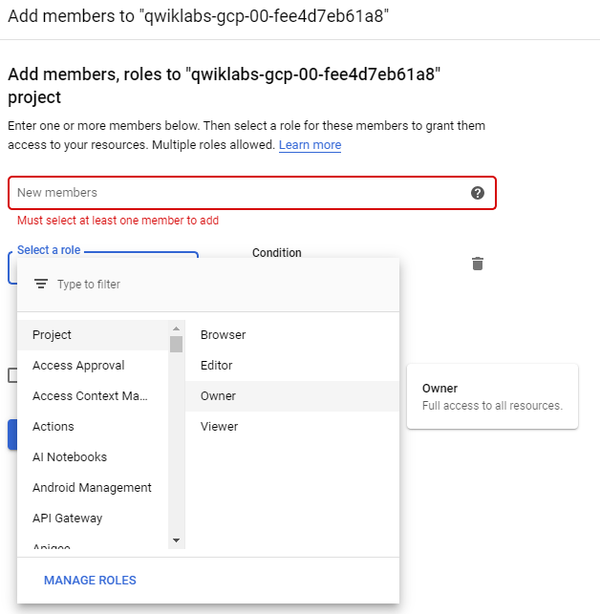

**Adding new IAM role**

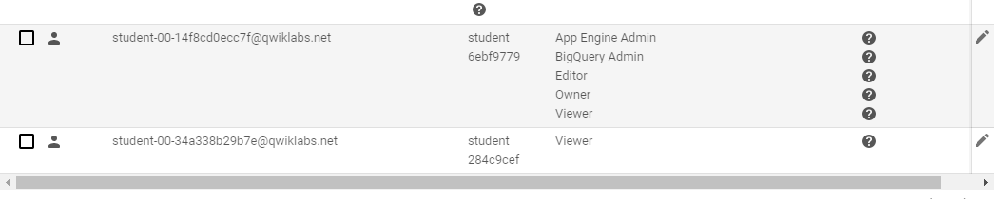

**There are two IAM roles**

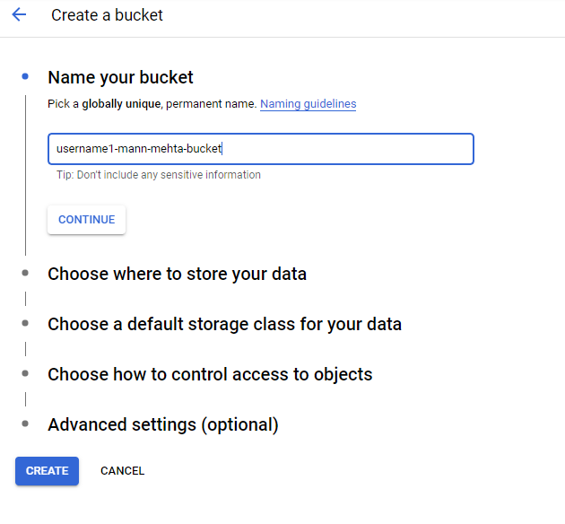

**Creating bucket**

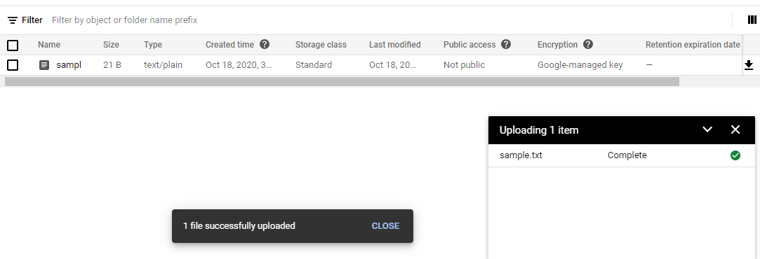

**Uploading a local file**

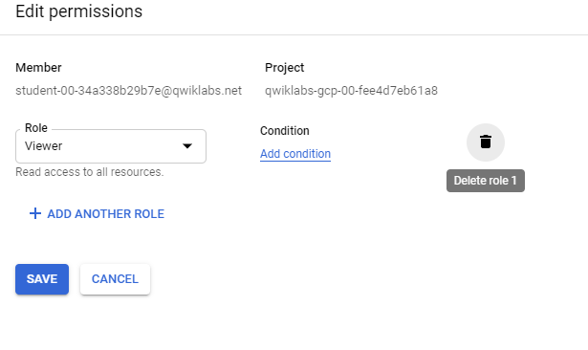

**Deleting the viewer roles**

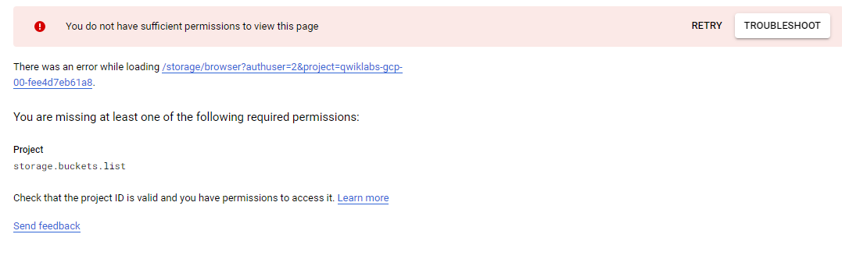

**Hence from another we can’t access the bucket details**

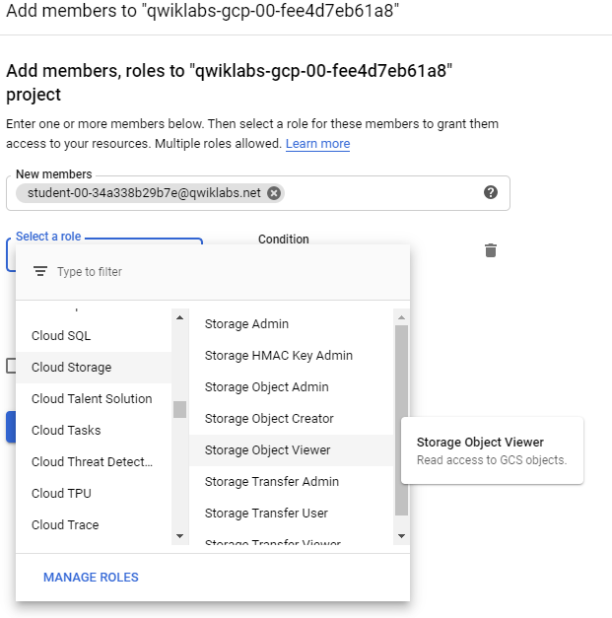

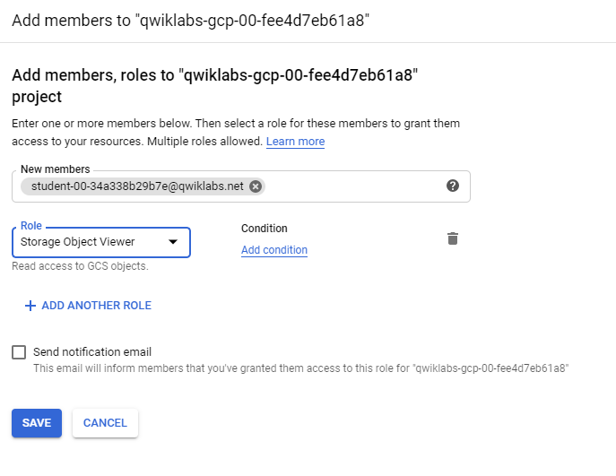

**Adding member access to the bucket**

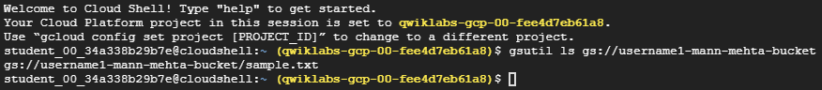

**Hence, other user can access the bucket data successfully**

**4.3 - Cloud Monitoring: Qwik Start**

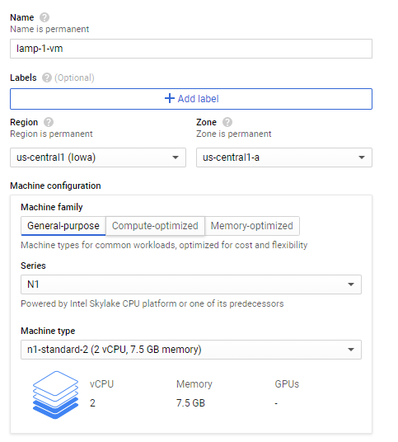

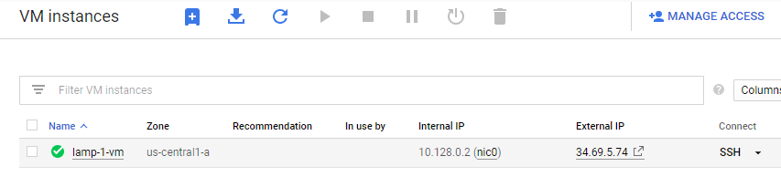

**Creating a virtual instance with name lamp-1-vm**

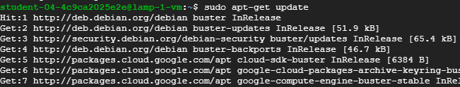

**SSH to newly created instance and updates with sudo access**

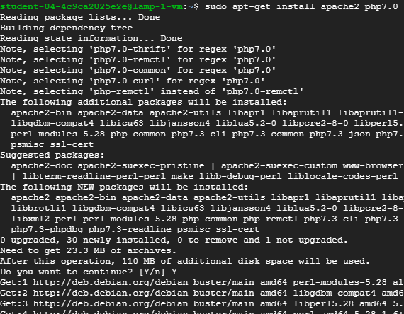

**Installing apache server**



**Restarting the server**

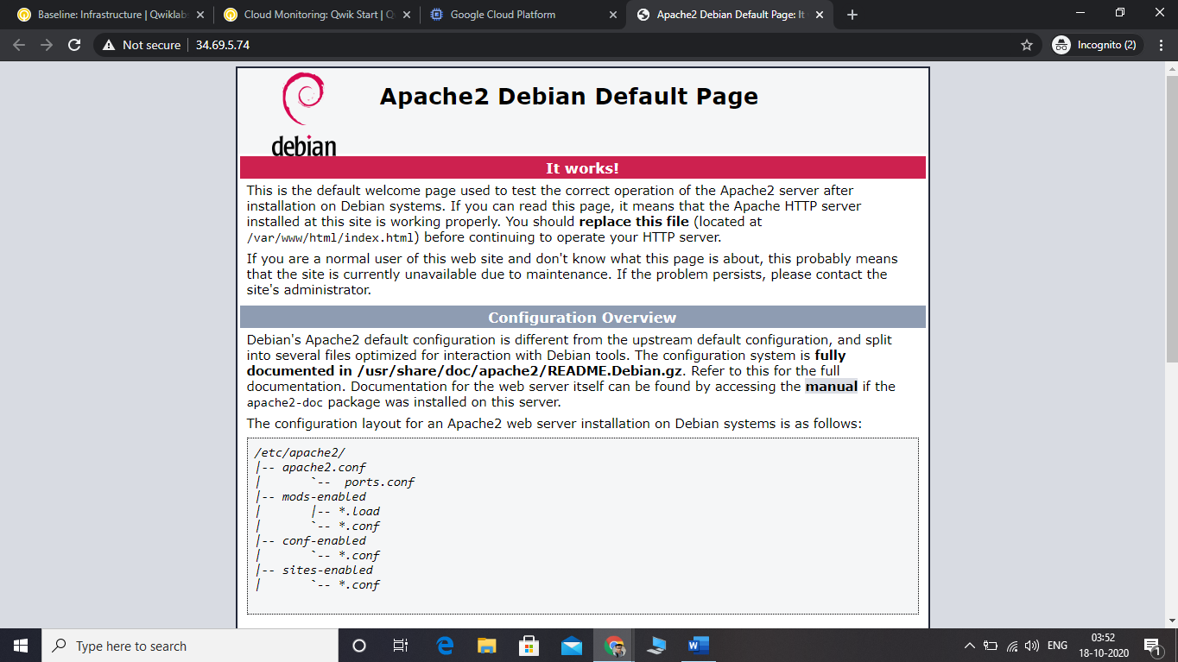

**Hence server can now access from external IP**

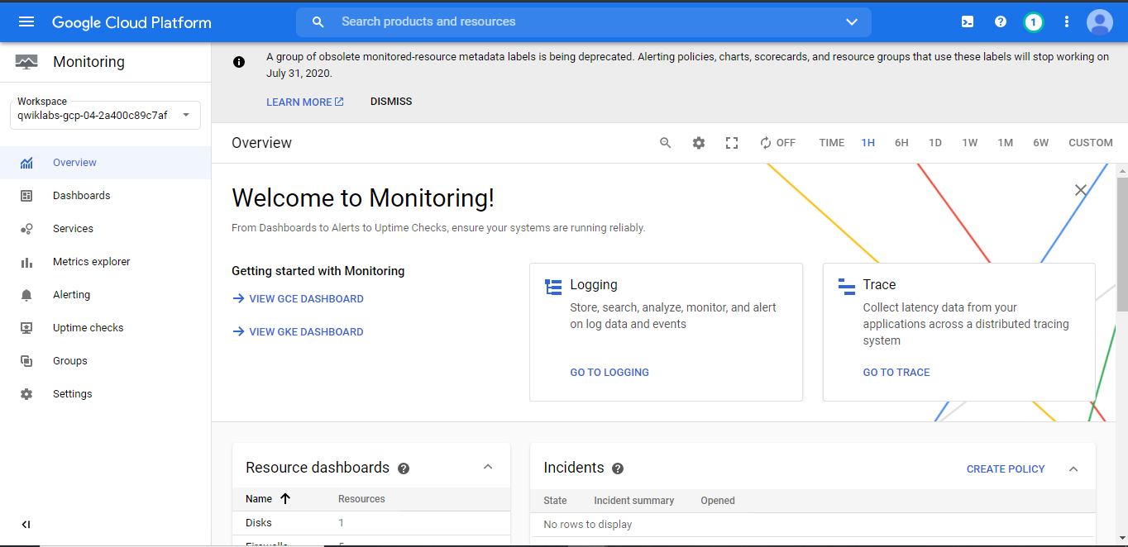

**Monitoring Dashboard**

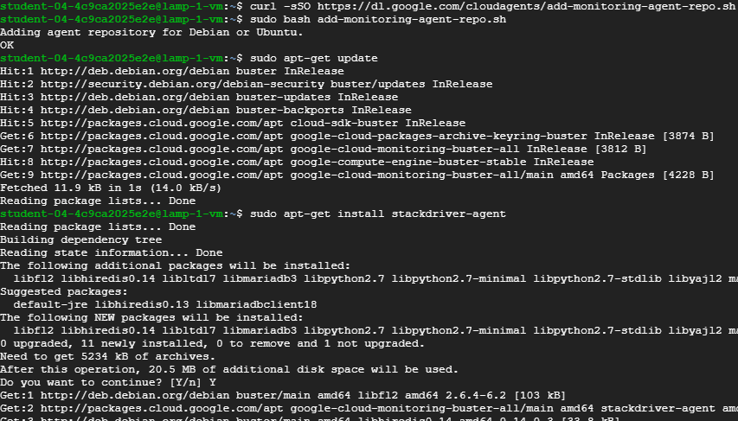

**Adding monitoring agent and install stackdriver-agent**

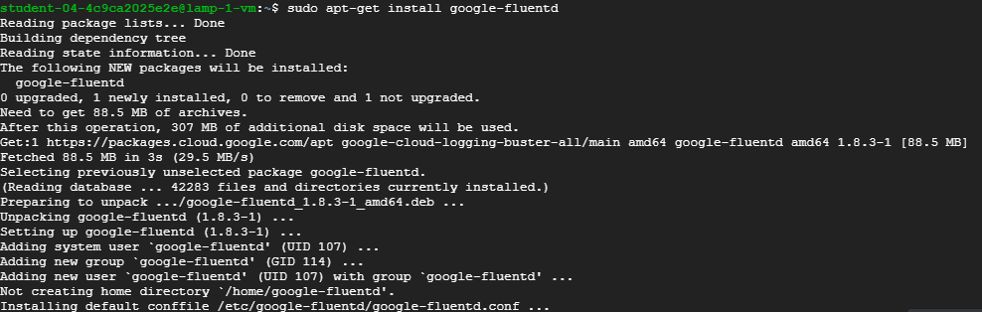

**Installing google-fluentd**

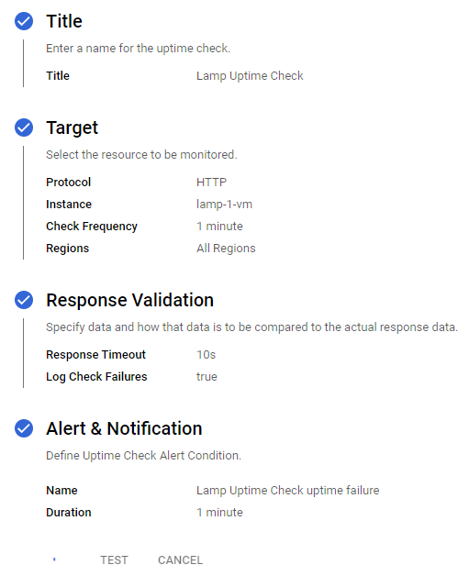

**Creating Uptime checks**

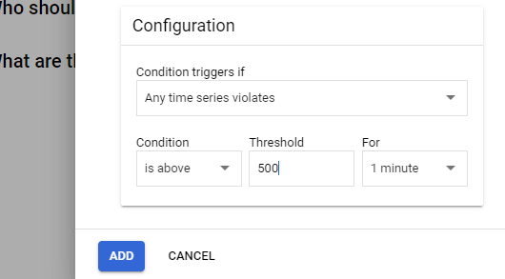

**Configure triggers**

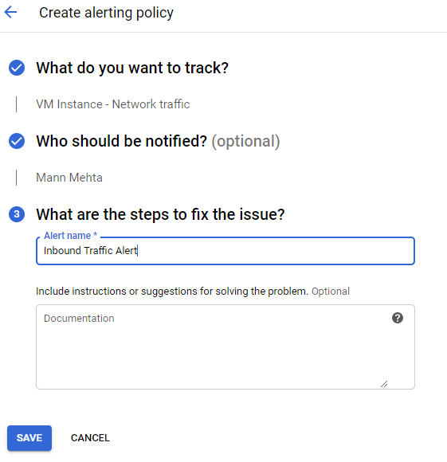

**Creating alerting channels**

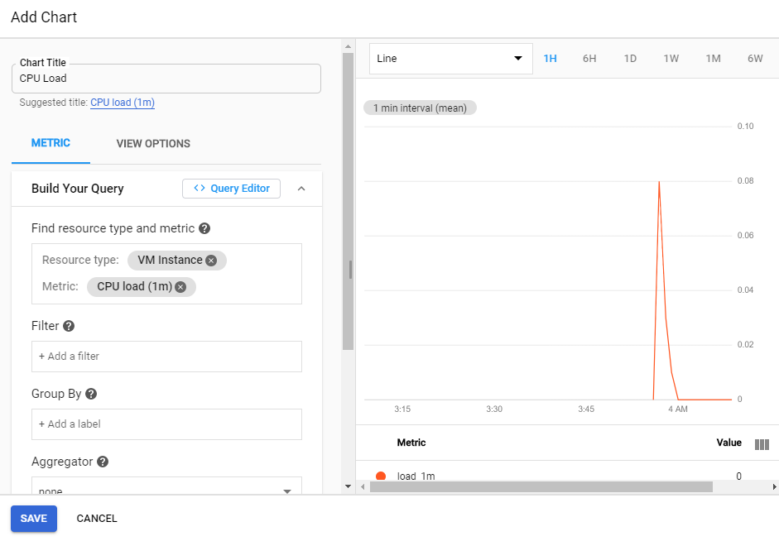

**Creating customize dashboard for monitoring tasks**

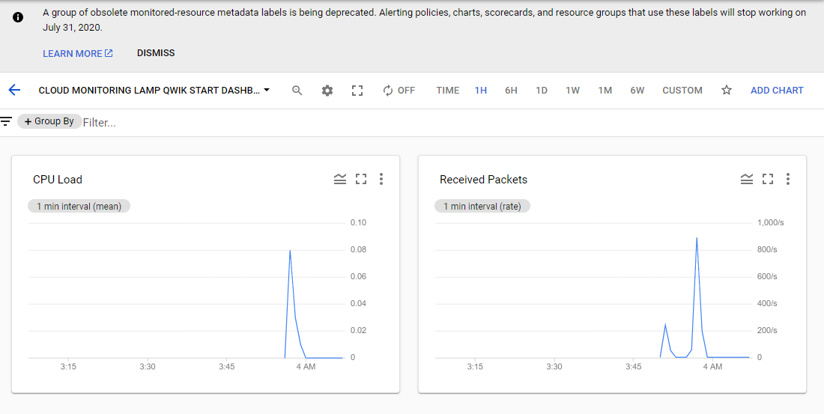

**CPU load and packets tracking**

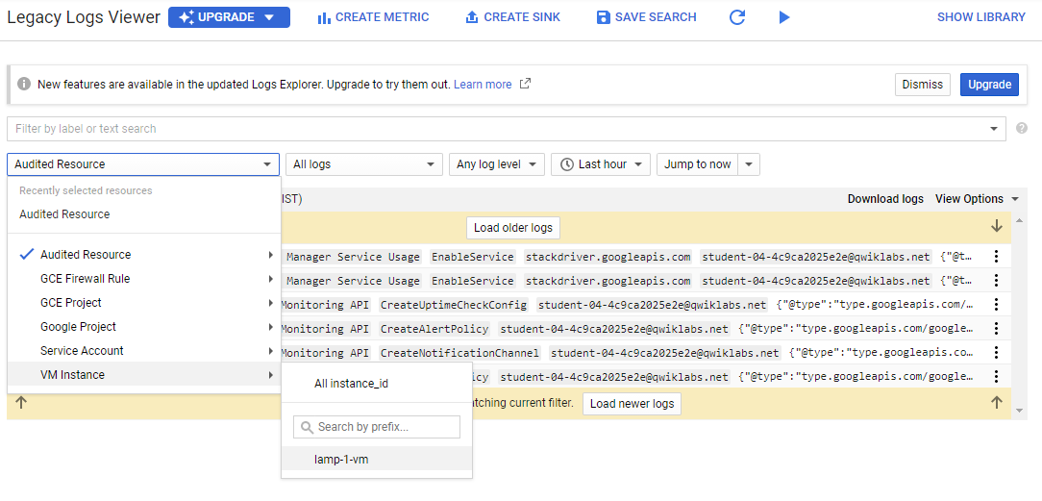

**Legacy logs viewer**

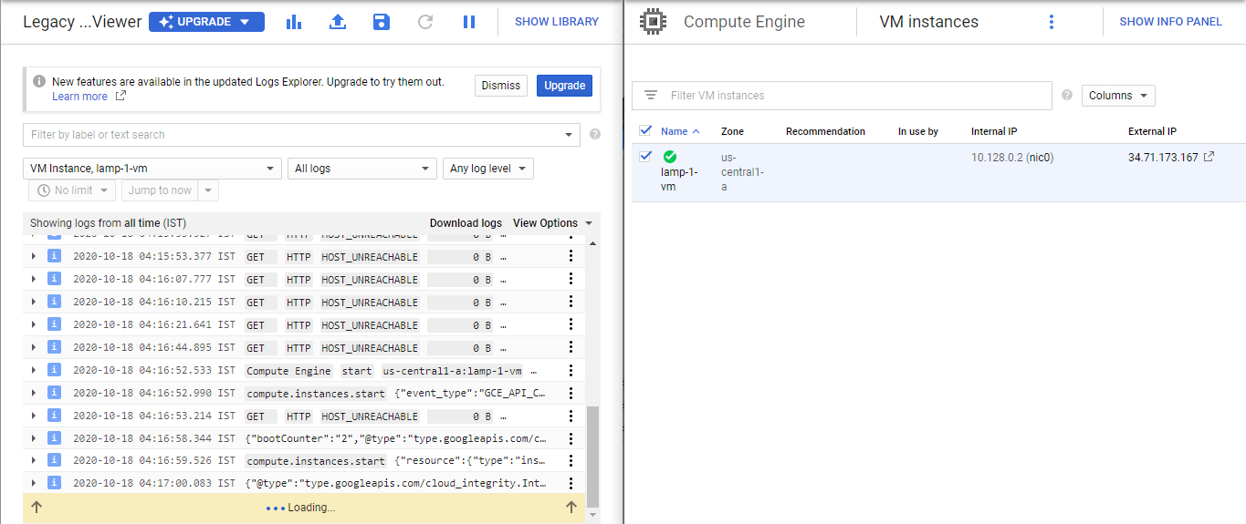

**Analyzing changes when instance stop and restarted**

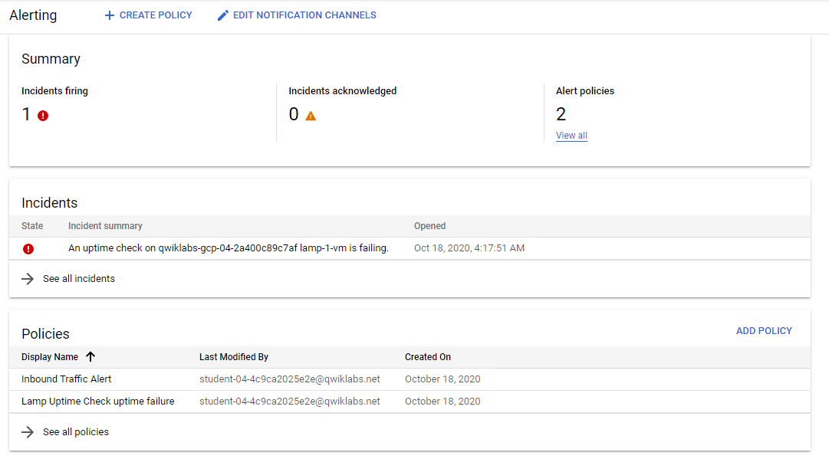

**Alerting if some error or warning occurs**

**4.4 - Cloud Functions: Qwik Start – Console**

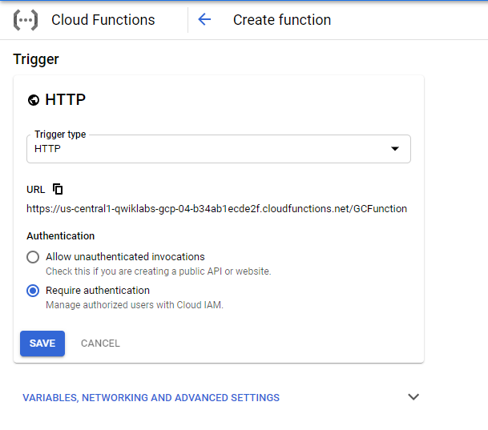

**Creating cloud function**

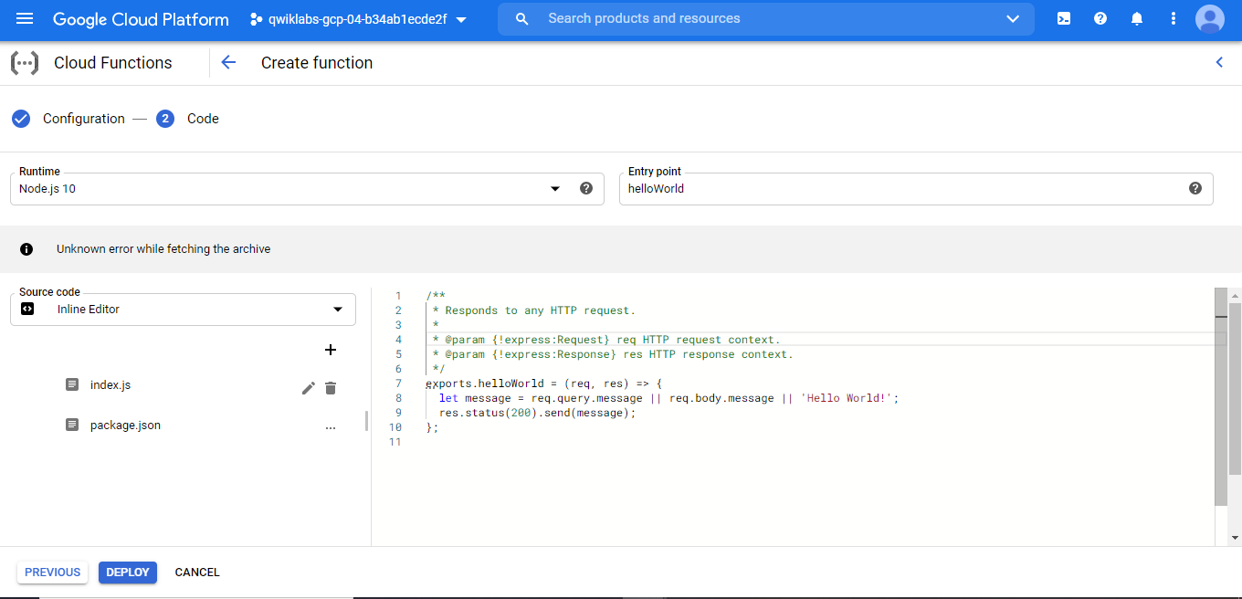

**Nodejs Hello World Program**

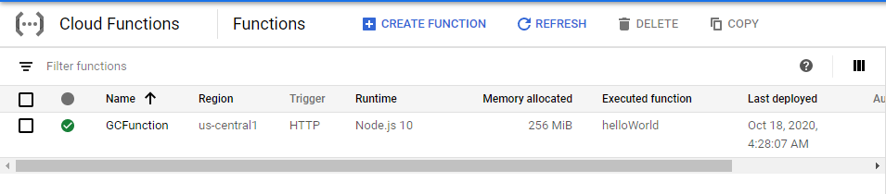

**Cloud Function is now up and running**

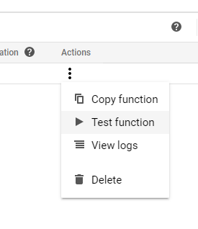

**Test Function**

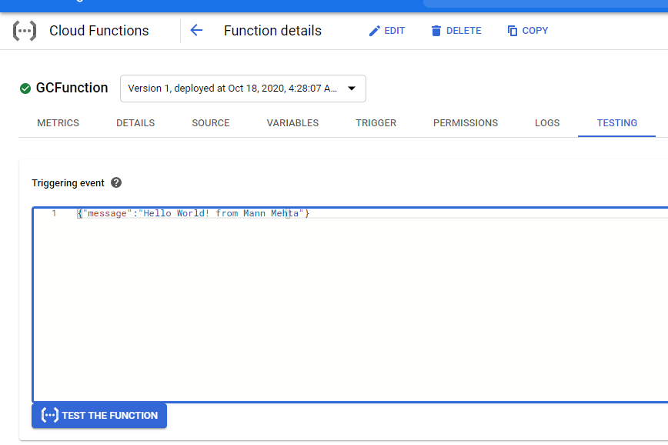

**Testing function my passing message**

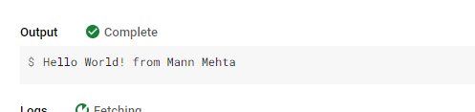

**Able to receive response successfully**

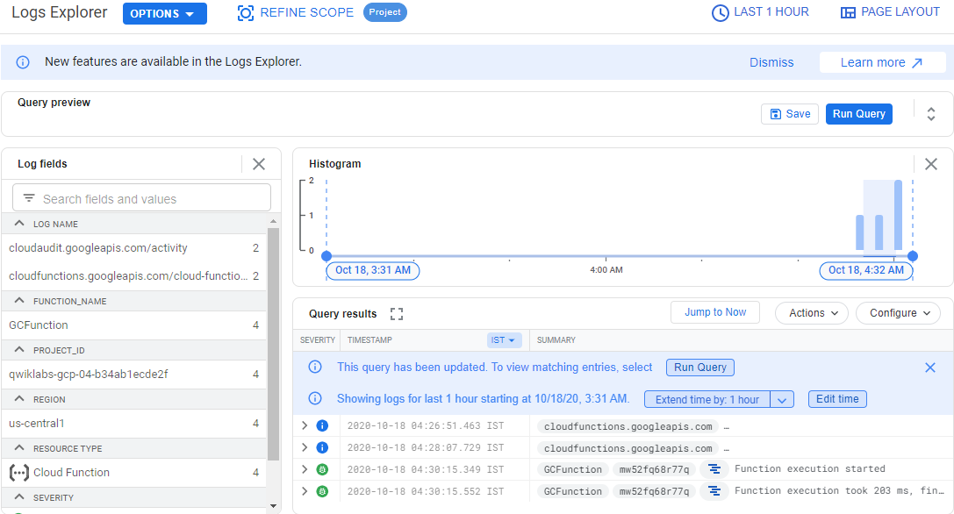

**Logs explorer**

**4.5 - Google Cloud Pub/Sub: Qwik Start – Console**

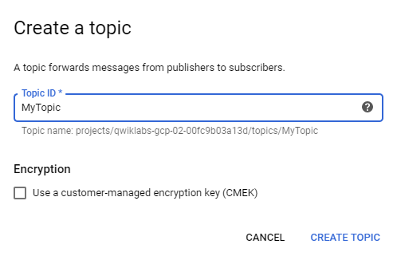

**Creating topi with name MyTopic**

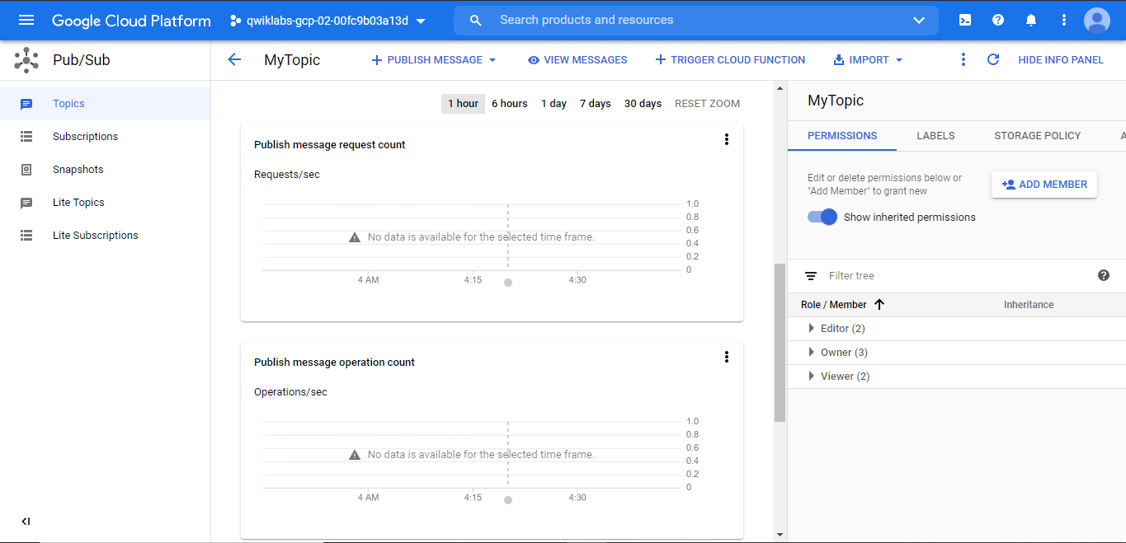

**MyTopic Dashboard**

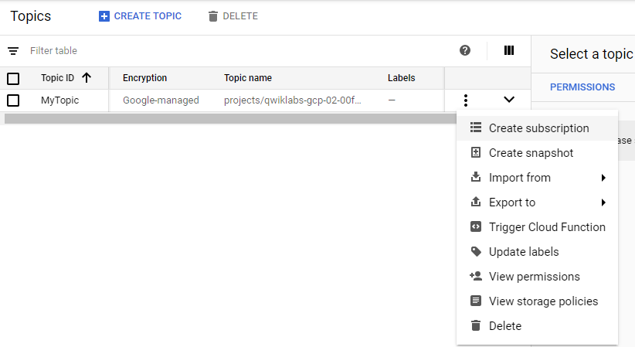

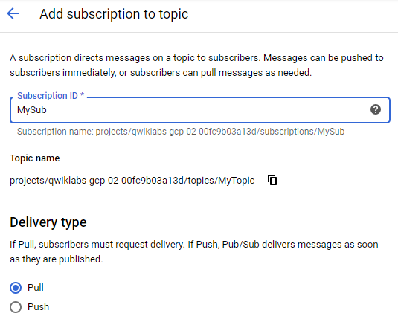

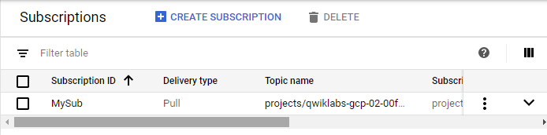

**Creating subscription**

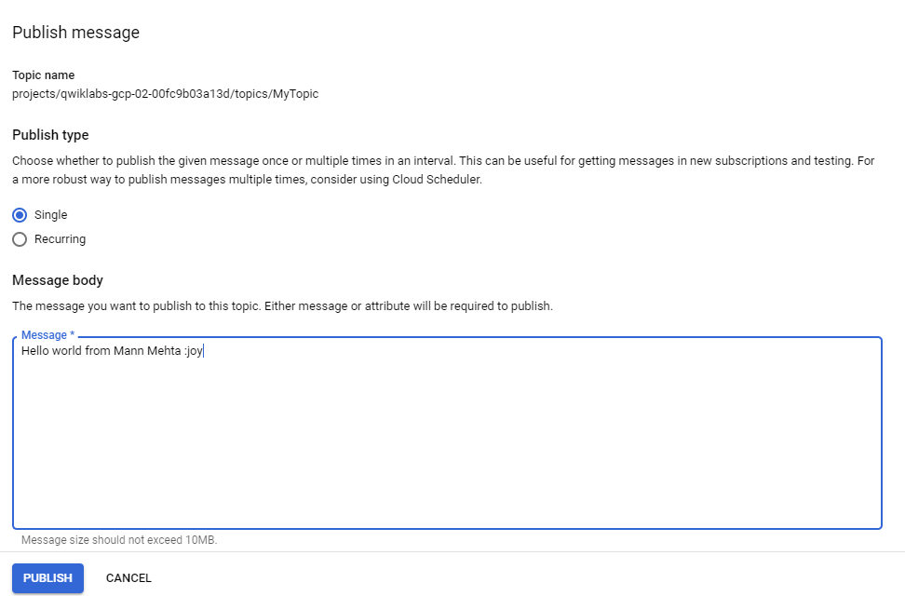

**Publishing message**



**Able to access message from cloud shell**

**LATEST APPLICATIONS and Learning Outcomes:**

4.1 - The data stored in the cloud is safeguarded against any type of hardware failure. Cloud servers also provide automated backups and snapshots in order to make sure that your data is safe.

4.2 - Cloud IAM enables you to grant access to cloud resources at fine-grained levels, well beyond project-level access. These policies help ensure that the appropriate security controls are in place when granting access to cloud resources.

4.3 - Eliminating potential breaches by providing visibility into files, applications, and users. Continually monitoring the cloud to ensure real-time file scans. Regular auditing and reporting to ensure security standards. Merging monitoring tools with different cloud providers.

4.4 - Functions automatically scale and are highly available and fault-tolerant. Cloud Functions are great for building serverless backends, doing real-time data processing, and creating intelligent apps.

4.5 - Pub/Sub offers durable message storage and real-time message delivery with high availability and consistent performance at scale. Pub/Sub servers run in all Google Cloud regions around the world

**REFERENCE:**

1. <https://google.qwiklabs.com/quests/33>