**PRACTICAL: 6**

**AIM:**

Web-application deployment on EC2 using AWS CodeDeploy & S3 services. (with CI/CD )

**THEORY:**

AWS CodeDeploy is a fully managed deployment service that automates software deployments to a variety of compute services such as Amazon EC2, AWS Fargate, AWS Lambda, and your on-premises servers. ... You can use AWS CodeDeploy to automate software deployments, eliminating the need for error-prone manual operations.

Amazon Simple Storage Service (Amazon S3) is an object storage service that offers industry-leading scalability, data availability, security, and performance. This means customers of all sizes and industries can use it to store and protect any amount of data for a range of use cases, such as data lakes, websites, mobile applications, backup and restore, archive, enterprise applications, IoT devices, and big data analytics. Amazon S3 provides easy-to-use management features so you can organize your data and configure finely-tuned access controls to meet your specific business, organizational, and compliance requirements. Amazon S3 is designed for 99.999999999% (11 9's) of durability, and stores data for millions of applications for companies all around the world.

An EC2 instance is a virtual server in Amazon's Elastic Compute Cloud (EC2) for running applications on the Amazon Web Services (AWS) infrastructure. AWS is a comprehensive, evolving cloud computing platform; EC2 is a service that allows business subscribers to run application programs in the computing environment.

A CI/CD pipeline automates your software delivery process. The pipeline builds code, runs tests (CI), and safely deploys a new version of the application (CD).

Automated pipelines remove manual errors, provide standardized feedback loops to developers, and enable fast product iterations.

**OUTPUT:**

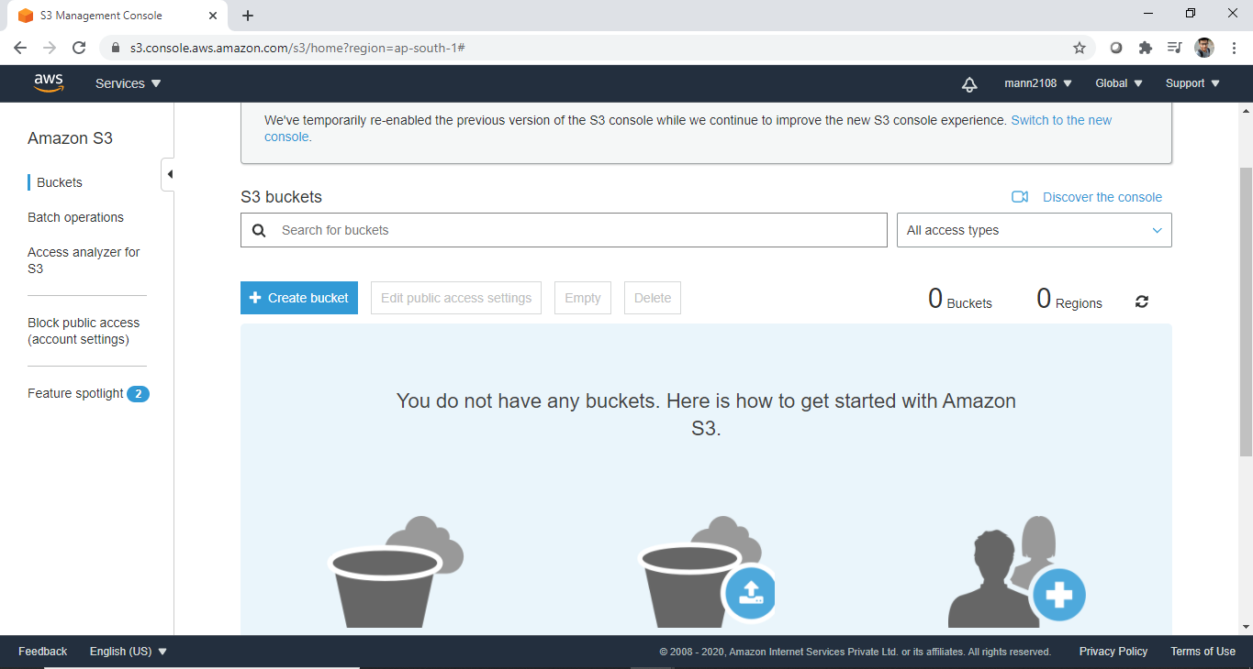

**S3 Bucket Dashboard**

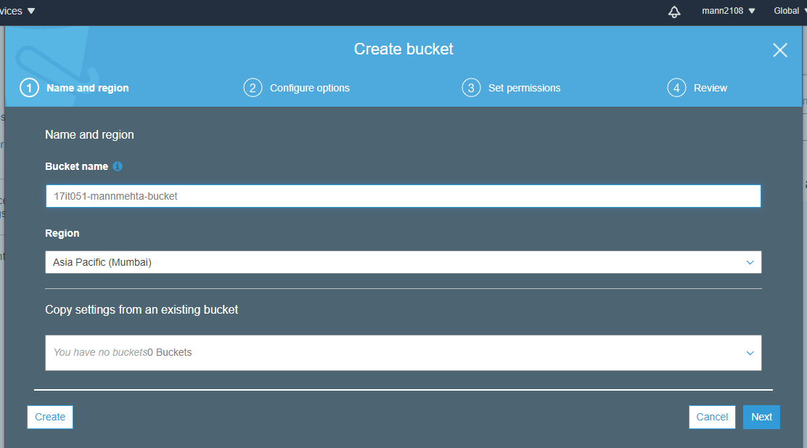

**Create a new bucket**

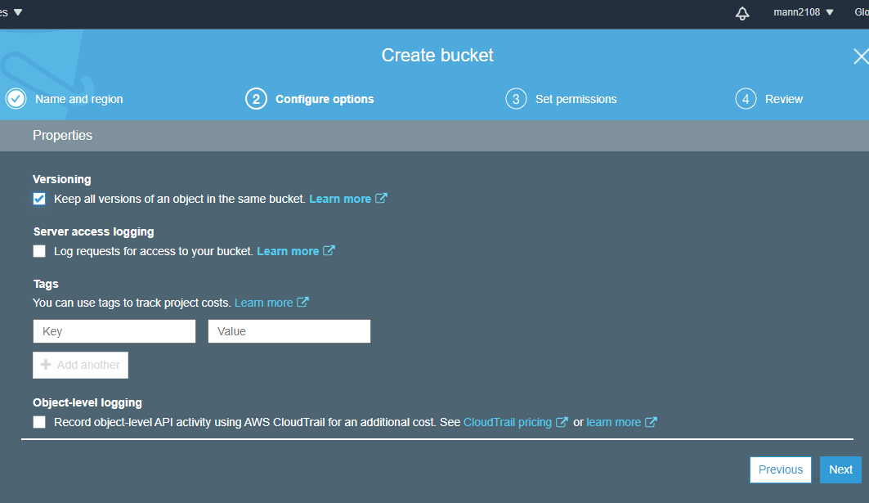

**Checking kepp versions**

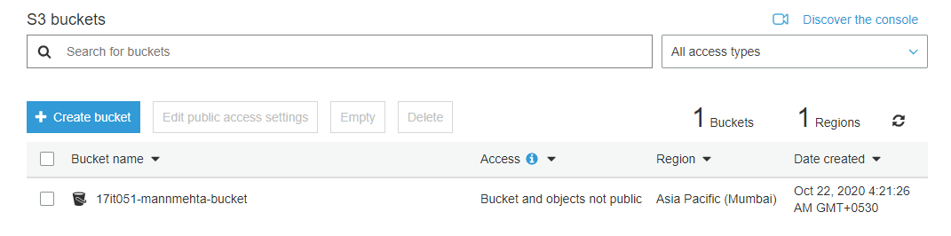

**Bucket Create Successfully**

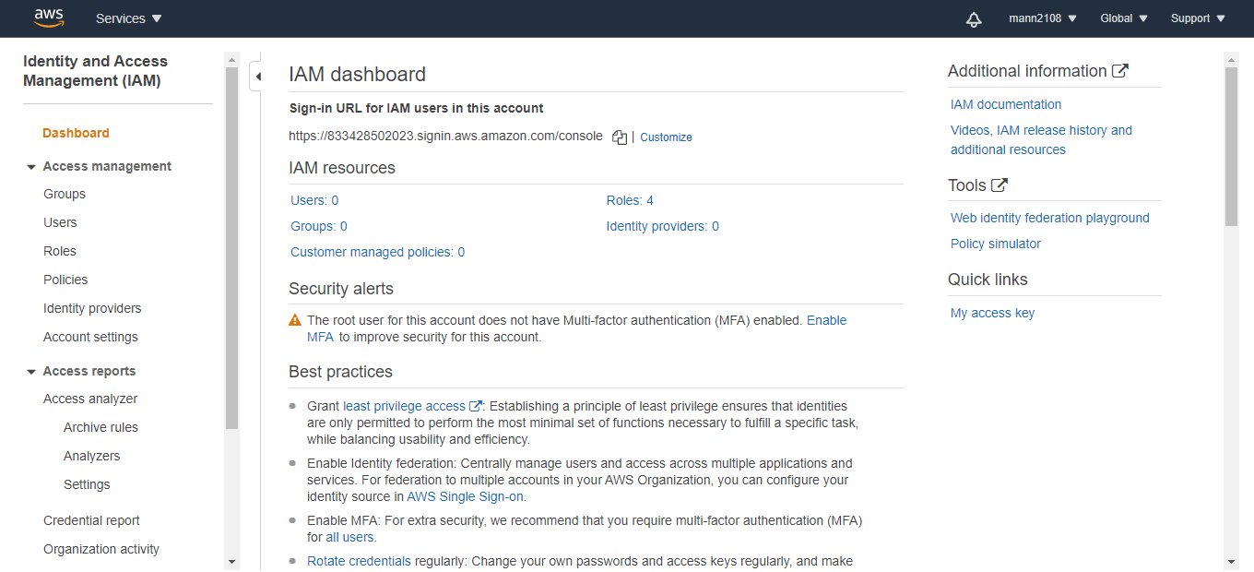

**IAM Dashboard**

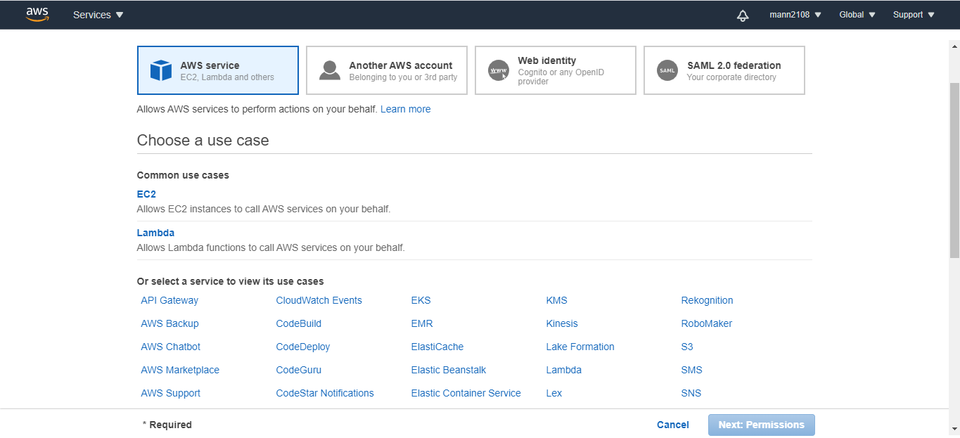

**Selecting AWS Services**

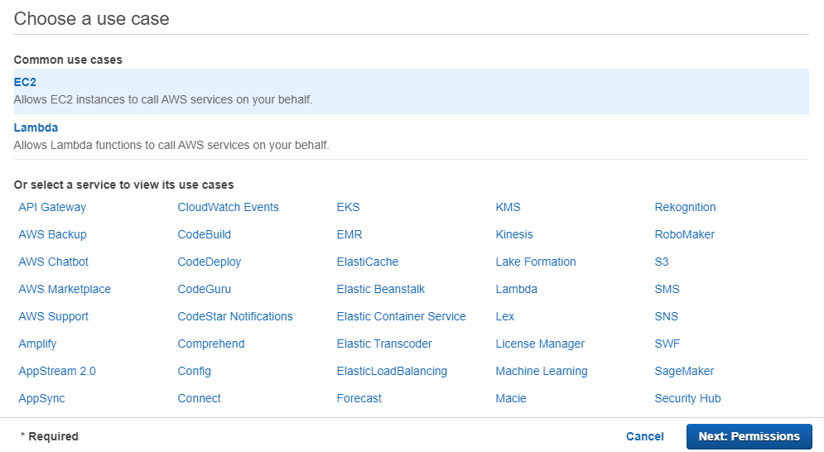

**Seleting EC2 Instance**

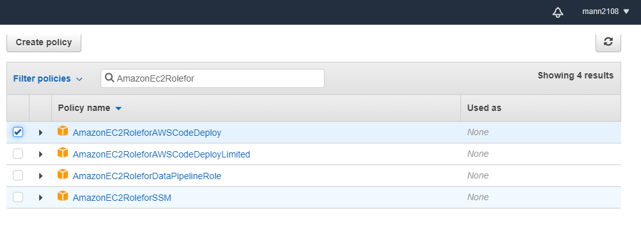

**Selecting AmazonEC2RoleforAWSCodeDeploy**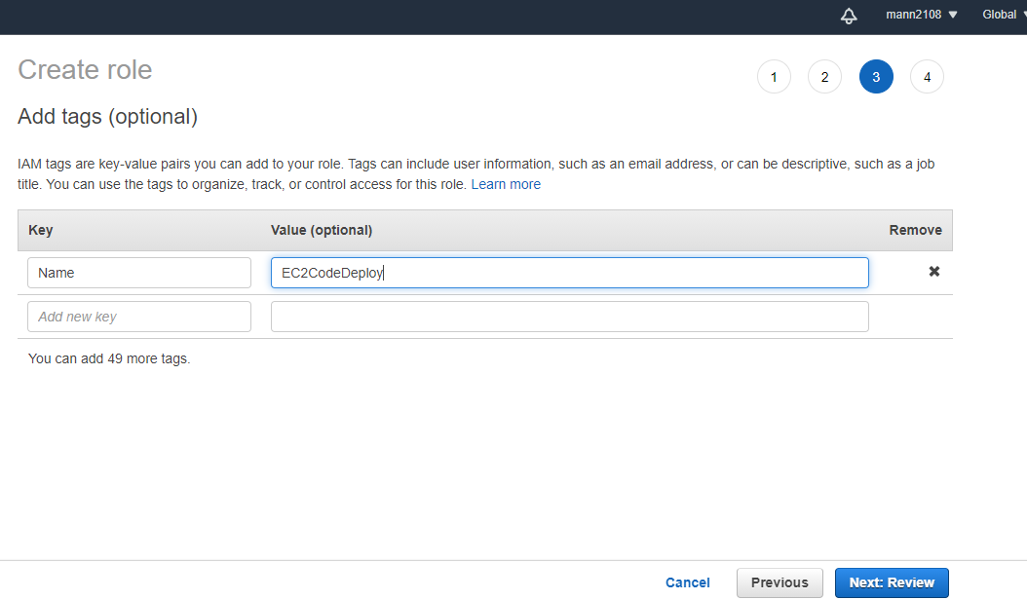

**Providing tags**

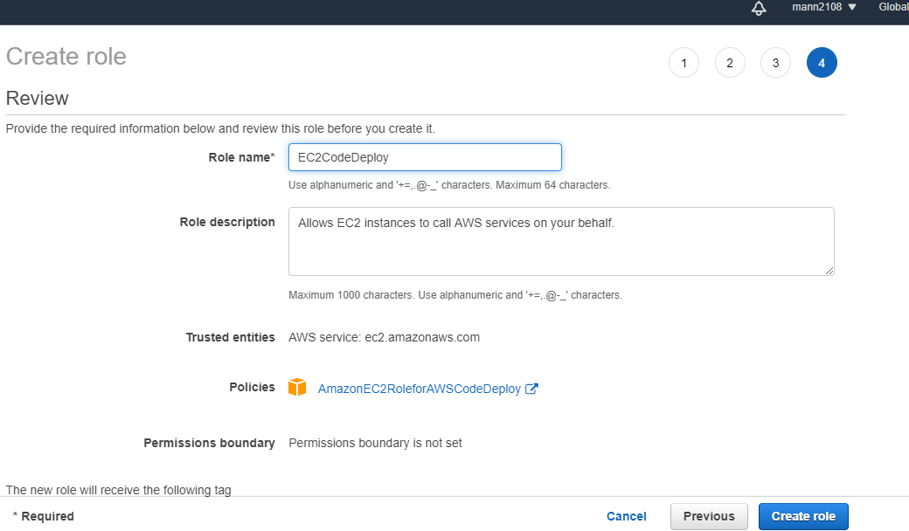

**Giving role name EC2CodeDeploy**

 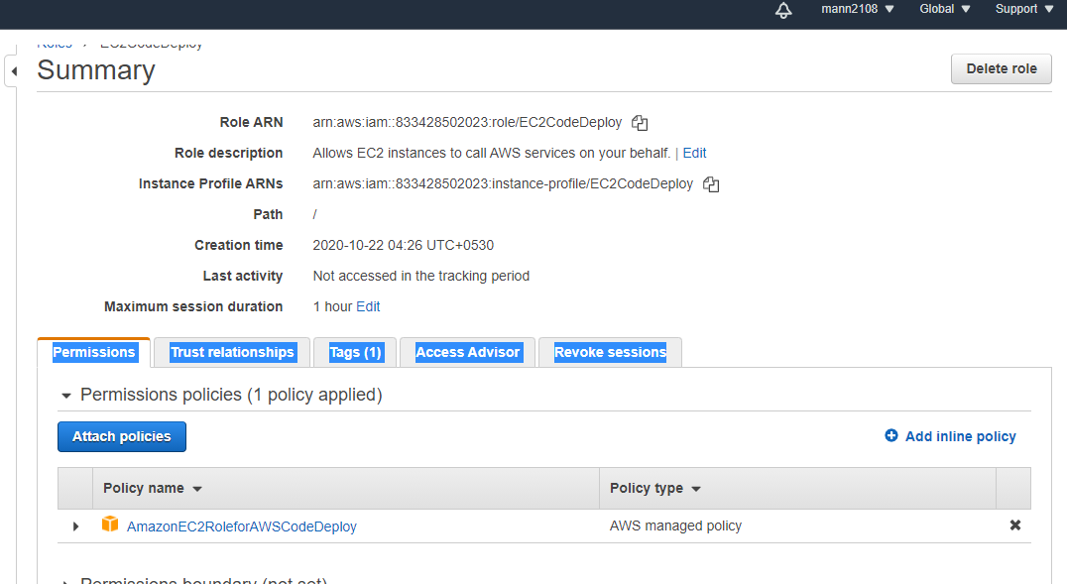   
**Summary and Review before final action**

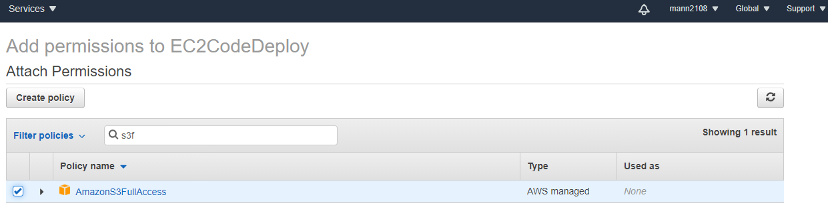

**Adding permission of S3 full access**

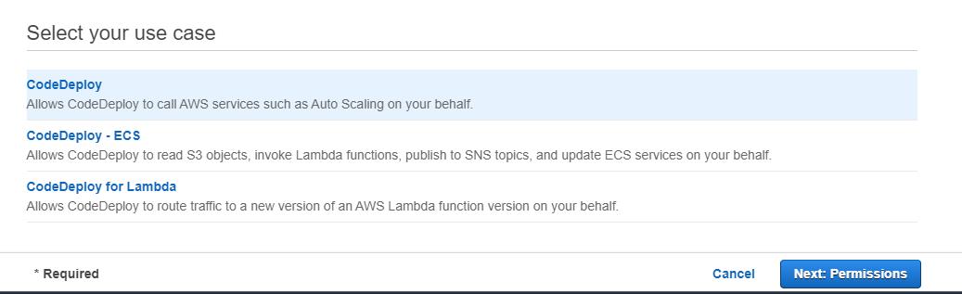

**Creating another role for codedeploy**

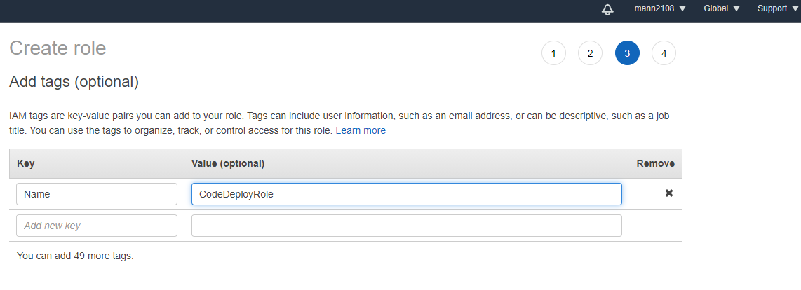

**Similarly providing tags**

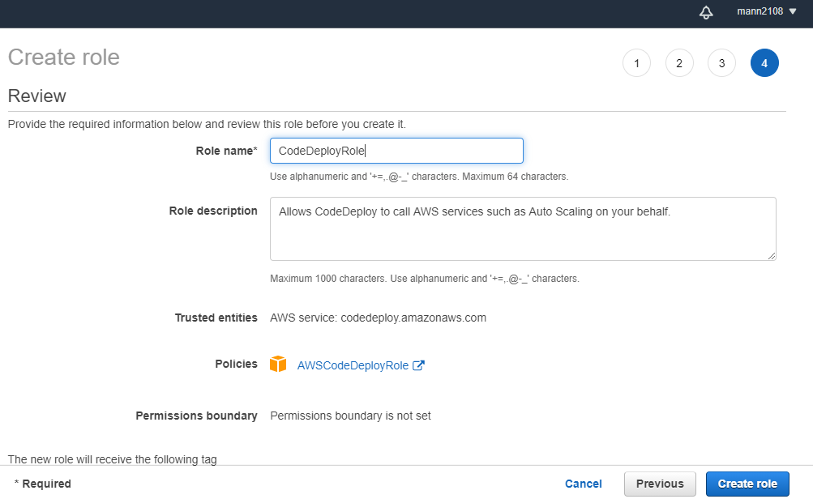

**Giving 2nd role name associate with codedeploy**

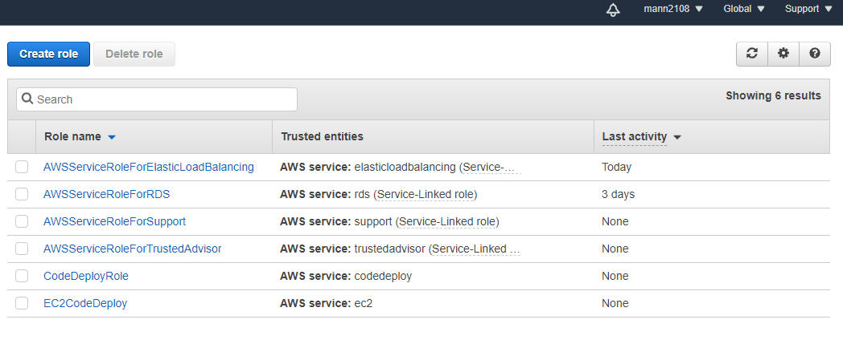

**Last two rows contain newly created roles**

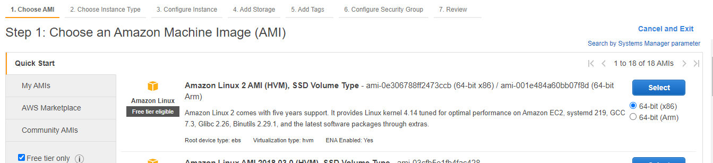

**Creating EC2 Instance**

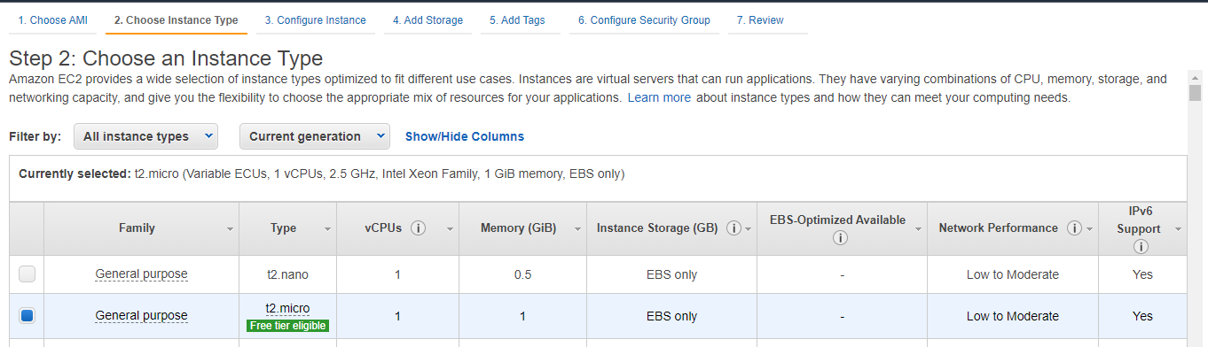

**Type – t2_micro under free tier**

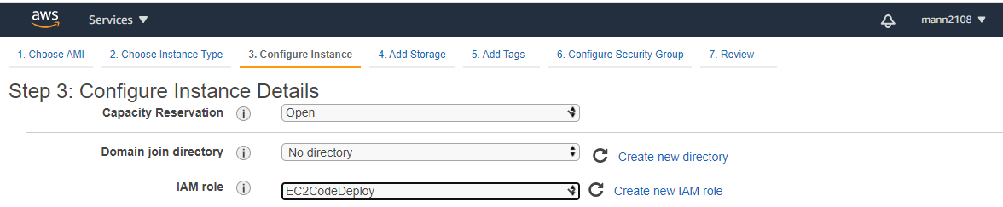

**Giving IAM role we just created for EC2 Instance**

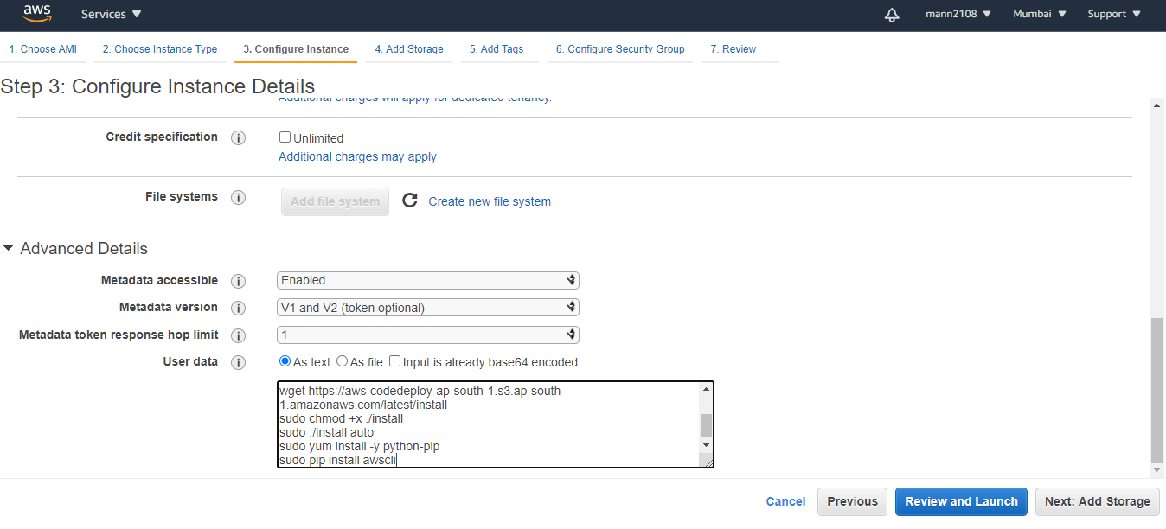

**Giving user data or start up meta data/scripts for ec2 instance**

**Startup Scripts**

#!/bin/bash  
sudo yum -y update  
sudo yum -y install ruby  
sudo yum -y install wget  
cd /home/ec2-user  
wget <https://aws-codedeploy-ap-south-1.s3.ap-south-1.amazonaws.com/latest/install>  
sudo chmod +x ./install  
sudo ./install auto  
sudo yum install -y python-pip  
sudo pip install awscli

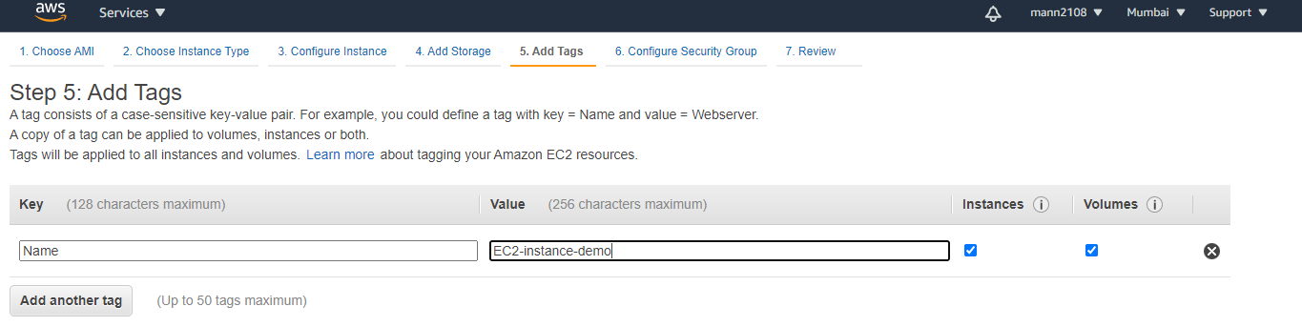

**Adding tags**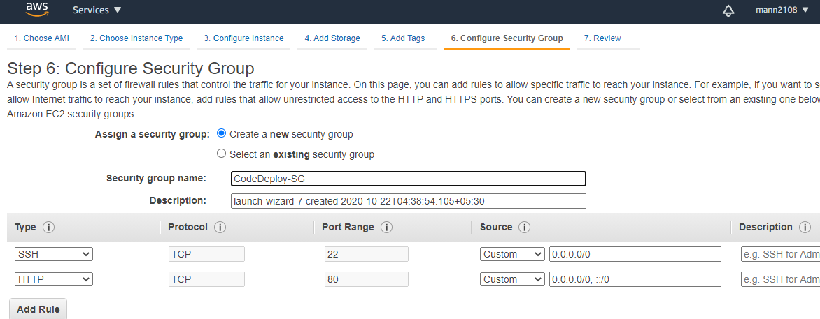

**Adding http security group and give custome name**

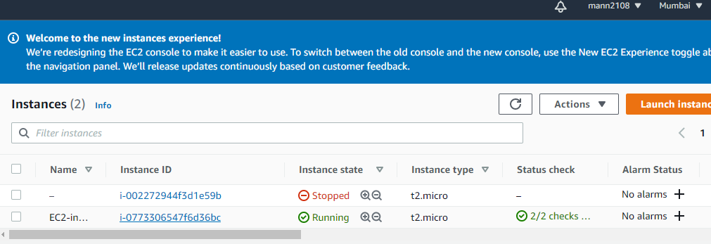

**EC2 Instance is now up and running**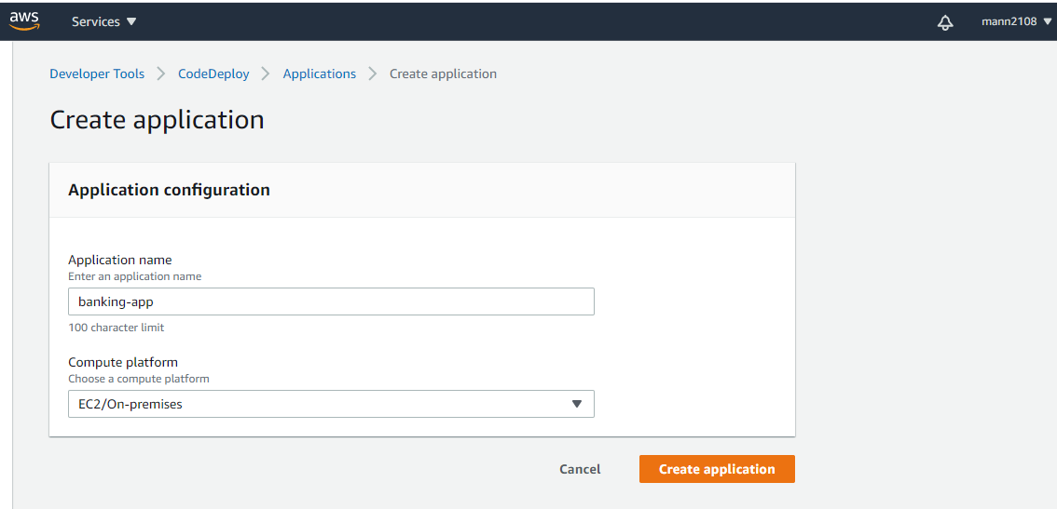

**Creating application under codedeploy**

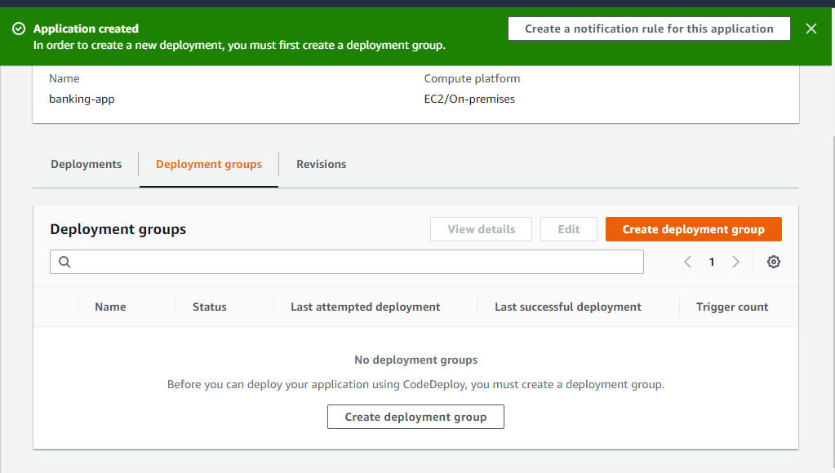

**After that creat deployment group**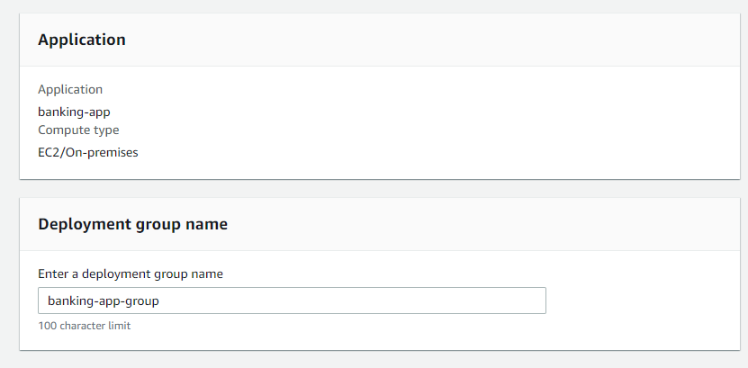

**Adding group name**

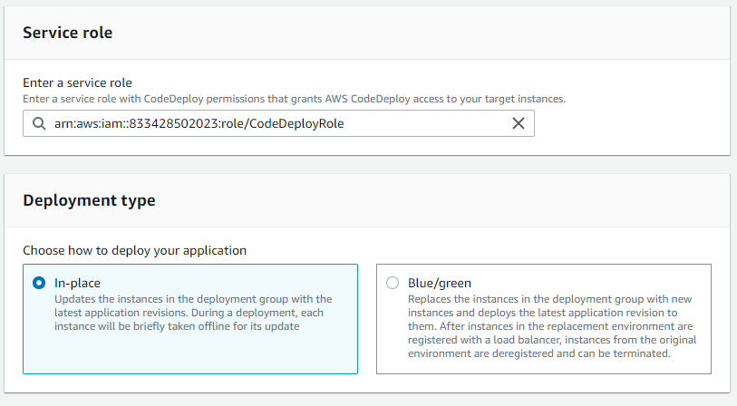

**Chosing service role of codedeploy we created in our earlier steps**

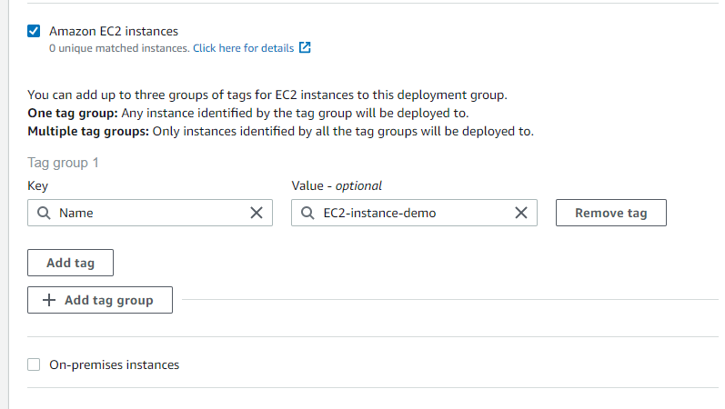

**Adding tags**

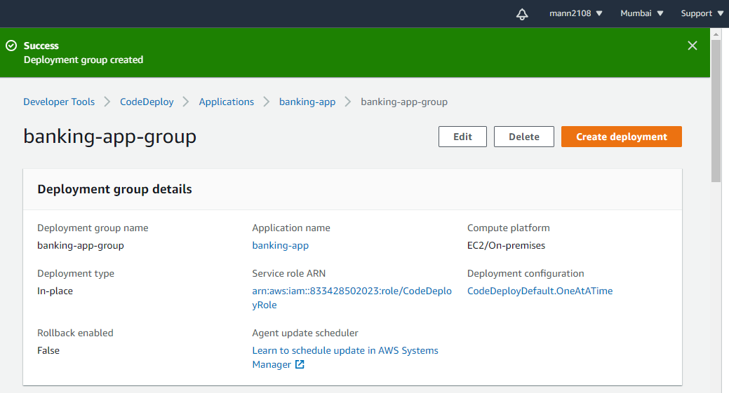

**Sucessfully application created**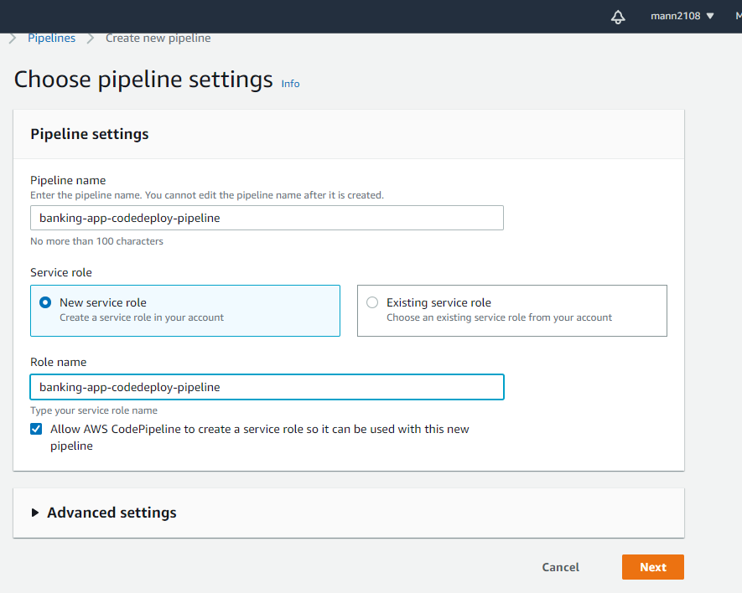

**Creating pipeline**

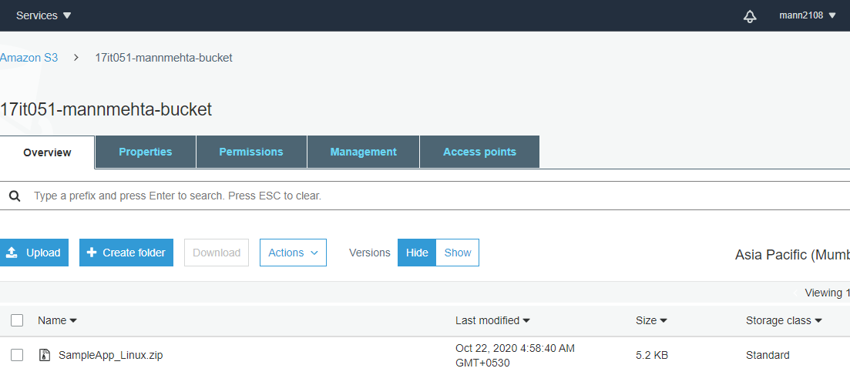

**Uploading the sample Application to s3 bucket**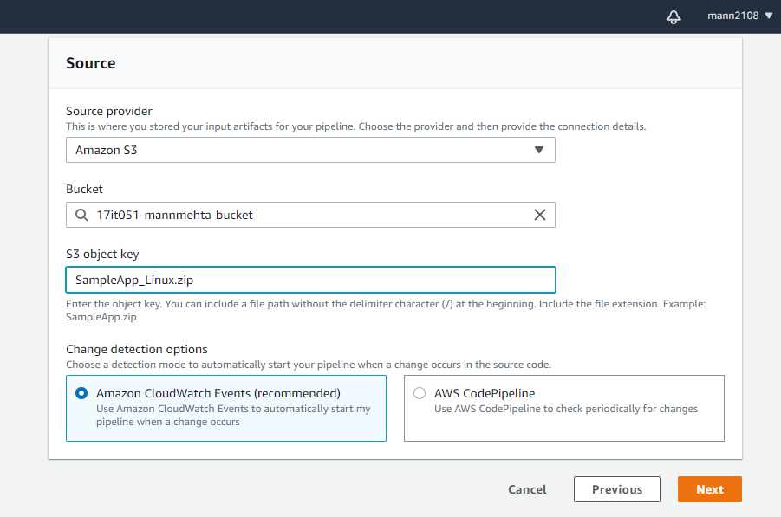

**Providing name of zip file as object key**

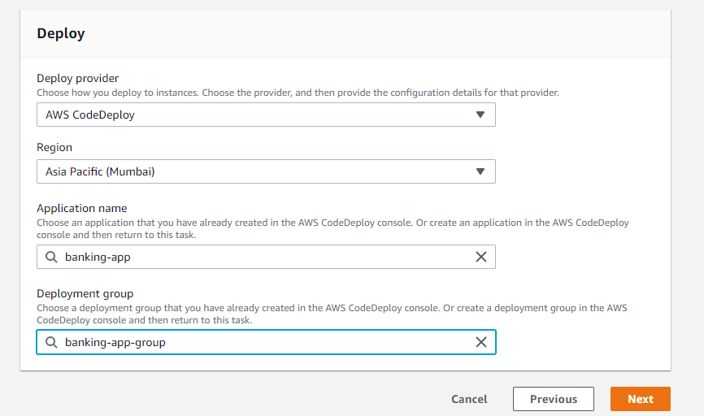

**Selecting application name and deployment group** 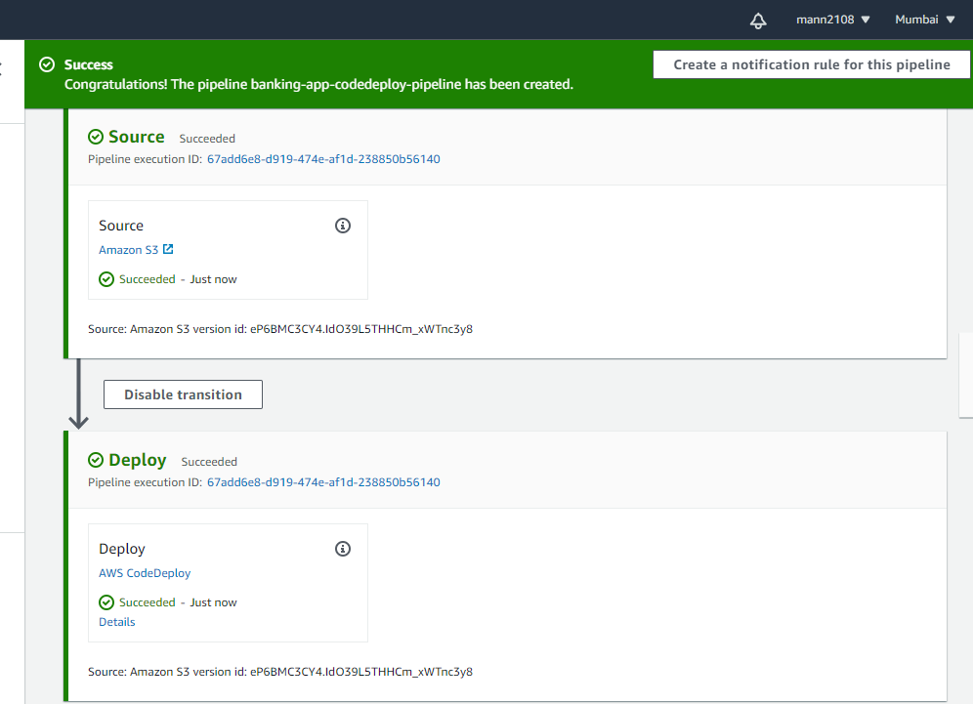

**Appication deployed sucessfully**

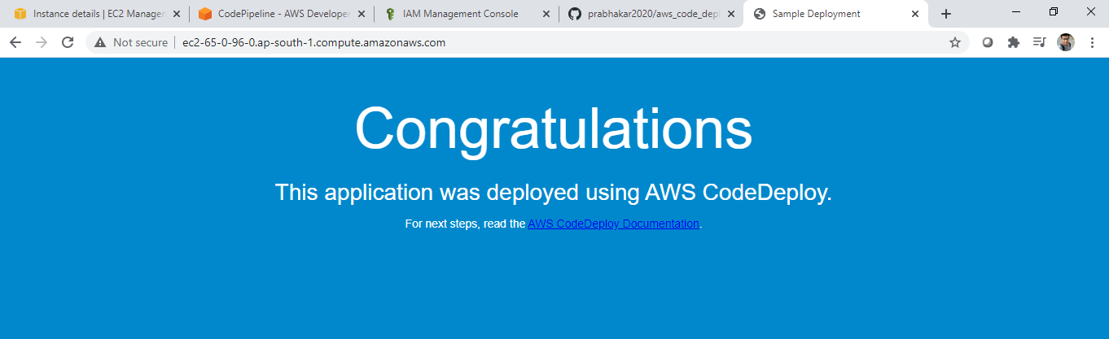

**Able to access application from the public DNS of ec2 instance**

**LATEST APPLICATIONS:**

AWS Codedeploy provides modern software engineering and application deployment ways, with automates deployment, enable high availability, deeply integrated with AWS services and also its avaible with gitlab and github means whenever the new changes pushes on the repo it will automatically detect the changes and deploy the new version. It supports hybrid infrastructure, can be integrated with other tools its power option for devops and most important thing its free.

**LEARNING OUTCOME:**

Creating aws s3 bucket then added a sample aws application on that bucket, create ec2 instance, created two different roles for ec2 instance and codeploy, use codedeploy to create an application then create pipline for continuos integration (CI/CD) and finally deploy the application.

**REFERENCE:**

1. <http://snpatel.in/2019/03/24/php-application-deployment-on-ec2-using-aws-codedeploy-s3/>