**PRACTICAL: 9**

**AIM:**

Case study of “***Product Sample Approval Workflow”*** TCS live projects.

**TEAM MEMBERS:**

|  |  |
| --- | --- |
| **Student ID No.: 17IT051** | **Student Name: Mann** |

**DESCRIPTION OF THE SCENARIO:**

For marketing of product, sales representative to raise a request to seek approval before providing sample product to their customers. System should provide features wherein sales representatives can raise a request and it is approved or rejected by the approver based on the details mentioned in the request.

**PROBLEM:**

Product sample approval workflow is an application which should be available for any location throughout any location in India and having 24/7 usage along with maintaining a relational database which supports PostgreSQL with high scalability & maintainability.

**SOLUTION USING AWS:**

AWS cloud provides an EC2 and RDS (Relational Database System) in this application we use PostgreSQL, using these two services we will deploy the application.

So here we will discuss all the steps for deployment of application on the EC2 Instance.

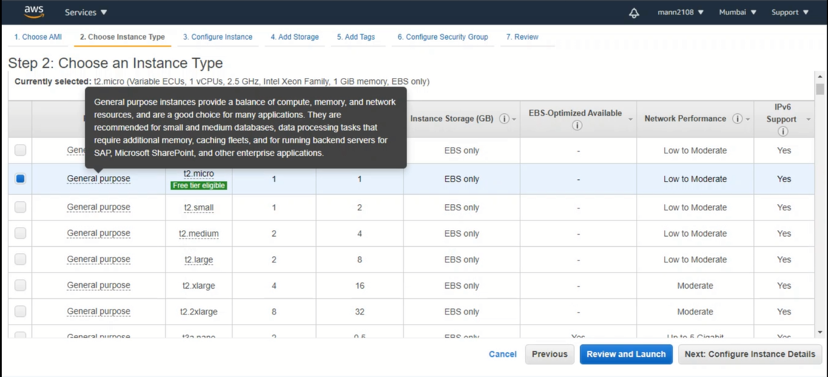

**Creating EC2 Instance with free tier access.**

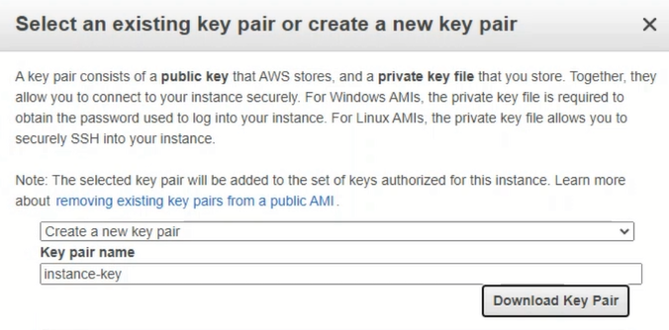

**Save the private key later we will need this to connect windows to EC2 instance**

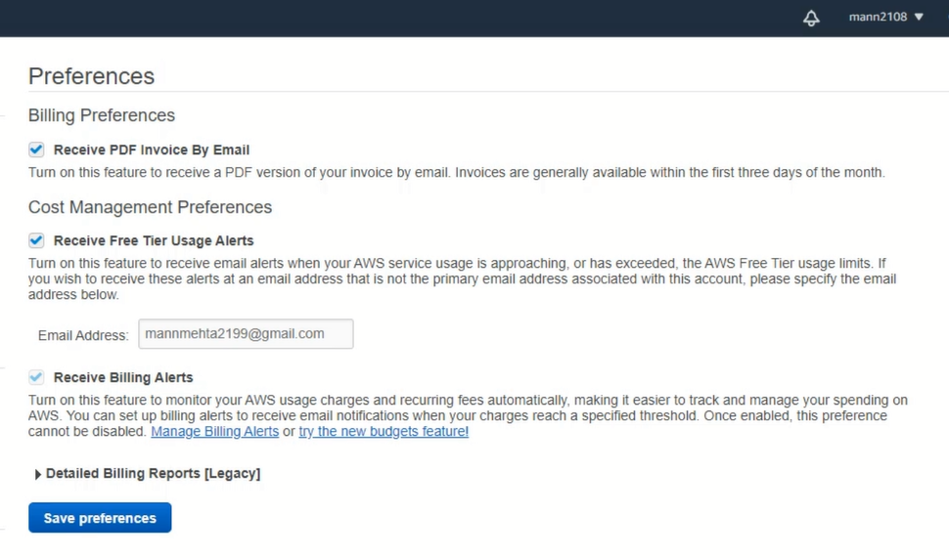

**It is good to set up billing notifications to notified whenever we exceeded the free tier usage**

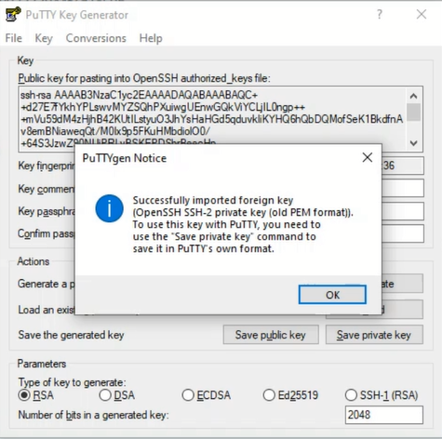

**We will be using PUTTY to connect with our EC2 instance before that PUTTY need an key to access the root directory of EC2 instance, but PUTTY not support (.pem) file because of that we need to use putty key generator to convert the key into readable format (.ppk).**

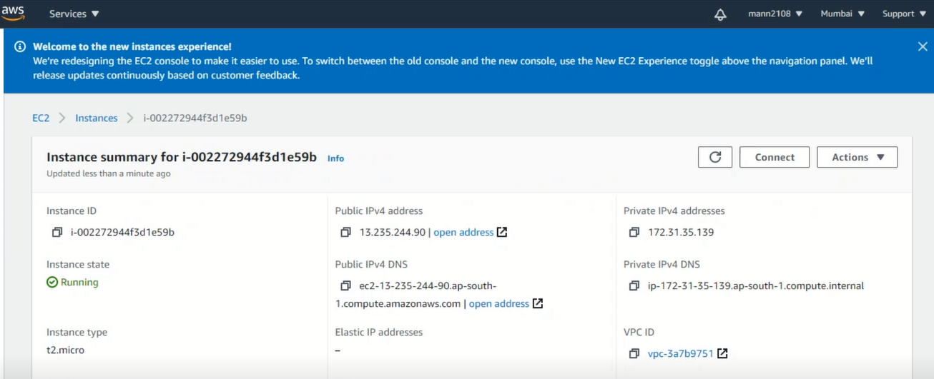

**EC2 Instance is now up and running. (We will use public IP address to connect with putty locally from the windows machine)**

**LIST OF CLOUD SERVICES USED:**

1. EC2 Instance
2. RDS (Relational Database System) (PostgreSQL)

1.1

**BLOCK DIAGRAM: (Optional) /**/ Times New Roman 12

|  |
| --- |
|  |

**LEARNING OUTCOME:**

// Times New Roman 12

// Contribution of Student 1: **17IT001**

// Contribution of Student 2: **17IT002**

**REFERENCE:**