CS501E_18791gm HW#7 GAJJAR MANTHAN

Q1.

Arraysort.java

/*

* To change this license header, choose License Headers in Project Properties.

* To change this template file, choose Tools | Templates

* and open the template in the editor.

*/

/**

*

* @author manthan

*/

abstract class ArraySort{

protected int[] a ; //array to be sorted

protected long numCompare ;

protected long numSwap ;

protected int numRecursion ;

protected boolean display;

protected static final IntUtil u = new IntUtil();

private void sort1(int [] a, boolean ascend) {

System.out.println("---------SORT1 Start------------");

this.a = a ;

numCompare = 0 ;

numSwap = 0 ;

numRecursion = 0 ;

display = false ;

if (a.length > 0 && a.length < 20) {

display = true ;

}

sort(ascend); //THIS CODE IS WRITTEN BY USER

if (ascend) {

u.assertAscending(a) ;

}else {

u.reverse(a) ;

u.assertDescending(a) ;

}

if (display) {

int n = a.length ;

u.pLn(n) ;

u.pLn(a,0,n);

}

u.printStatistics(a.length,numCompare,numSwap,0);

System.out.println("---------SORT1 End---------------");

}

//I don't know how to write it

//Override by the concrete class

abstract protected void sort(boolean ascend) ;

private void testSort(int N, boolean ascend) {

int [] a = u.generateRandomNumber(N,false);//Generates random pos and neg numbers

sort1(a,ascend) ;

}

private void basicTests() {

int b[][] = u.testArray();

int l = b.length ;

for (int i = 0; i < l; ++i) {

int [] a = b[i] ;

sort1(a,true);

}

}

protected void testBench() {

System.out.println("------------START---------------------");

basicTests() ;

for (int n = 10000; n < 50000; n = n + 10000) {

testSort(n,true); //ascending order

}

for (int n = 10001; n < 50001; n = n + 10000) {

testSort(n,false); //descending order

}

int h = 1 ;

for (int i = 5000 + h; i < 25001 + h; i = i + 5000) {

System.out.println("------------testing " + i + " SORTED ASCENDING numbers----------");

int [] b = u.generateNumberInIncreasingOrder(i,1) ;

sort1(a,true) ;

}

System.out.println("------------DONE!--------");

}

public static void main(String[] args) {

System.out.println("ArraySort.java");

//You cannot instantiate an object from abstract class

//ArraySort a = new ArraySort() ;

//a.testBench();

}

}

Bubblesort.java

/*

* To change this license header, choose License Headers in Project Properties.

* To change this template file, choose Tools | Templates

* and open the template in the editor.

*/

/**

*

* @author manthan

*/

public class BubbleSort extends ArraySort{

protected void sort(boolean ascend) {

if(display) ArraySort.u.pLn(a.length);

boolean flag = true; // set flag to true to begin first pass

int temp; // holding variable

while (flag) {

flag = false; // set flag to false awaiting a possible swap

if(display) ArraySort.u.pLn(a);

for (int j = 0; j < a.length - 1; j++) {

if (a[j] > a[j + 1]) // change to > for ascending sort

{

temp = a[j]; // swap elements

a[j] = a[j + 1];

a[j + 1] = temp;

flag = true; // shows a swap occurred

numSwap++;

}

numCompare++;

}

}

}

public static void main(String[] args) {

System.out.println("ArraySort.java");

BubbleSort a = new BubbleSort();

a.testBench();

}

}

SS:

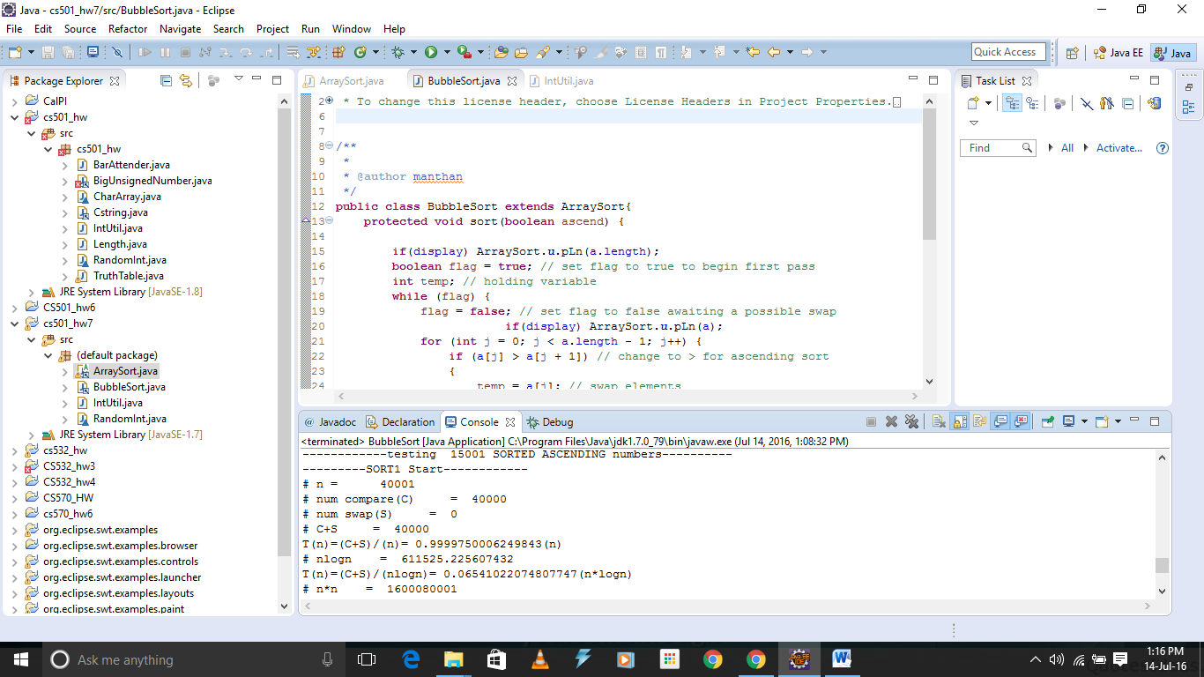

Output:

ArraySort.java

------------START---------------------

---------SORT1 Start------------

# n = 0

# num compare(C) = 0

# num swap(S) = 0

# C+S = 0

Zero elements in array

---------SORT1 End---------------

---------SORT1 Start------------

0

15

0

15

# n = 1

# num compare(C) = 0

# num swap(S) = 0

# C+S = 0

T(n)=(C+S)/(n)= 0.0(n)

# nlogn = 0.0

# n*n = 1

T(n)=(C+S)/(n^2)= 0.0(n^2)

---------SORT1 End---------------

---------SORT1 Start------------

0 1

15 5

5 15

0 1

5 15

# n = 2

# num compare(C) = 2

# num swap(S) = 1

# C+S = 3

T(n)=(C+S)/(n)= 1.5(n)

# nlogn = 2.0

T(n)=(C+S)/(nlogn)= 1.5(n*logn)

# n*n = 4

T(n)=(C+S)/(n^2)= 0.75(n^2)

---------SORT1 End---------------

---------SORT1 Start------------

0 1 2 3 4 5 6 7

15 5 64 8 12 11 4 35

5 15 8 12 11 4 35 64

5 8 12 11 4 15 35 64

5 8 11 4 12 15 35 64

5 8 4 11 12 15 35 64

5 4 8 11 12 15 35 64

4 5 8 11 12 15 35 64

0 1 2 3 4 5 6 7

4 5 8 11 12 15 35 64

# n = 8

# num compare(C) = 49

# num swap(S) = 15

# C+S = 64

T(n)=(C+S)/(n)= 8.0(n)

# nlogn = 24.0

T(n)=(C+S)/(nlogn)= 2.6666666666666665(n*logn)

# n*n = 64

T(n)=(C+S)/(n^2)= 1.0(n^2)

---------SORT1 End---------------

---------SORT1 Start------------

0 1 2 3 4 5

6 5 4 3 2 1

5 4 3 2 1 6

4 3 2 1 5 6

3 2 1 4 5 6

2 1 3 4 5 6

1 2 3 4 5 6

0 1 2 3 4 5

1 2 3 4 5 6

# n = 6

# num compare(C) = 30

# num swap(S) = 15

# C+S = 45

T(n)=(C+S)/(n)= 7.5(n)

# nlogn = 15.509775004326936

T(n)=(C+S)/(nlogn)= 2.901396054259062(n*logn)

# n*n = 36

T(n)=(C+S)/(n^2)= 1.25(n^2)

---------SORT1 End---------------

---------SORT1 Start------------

0 1 2 3 4 5

1 2 3 4 5 6

0 1 2 3 4 5

1 2 3 4 5 6

# n = 6

# num compare(C) = 5

# num swap(S) = 0

# C+S = 5

T(n)=(C+S)/(n)= 0.8333333333333334(n)

# nlogn = 15.509775004326936

T(n)=(C+S)/(nlogn)= 0.322377339362118(n*logn)

# n*n = 36

T(n)=(C+S)/(n^2)= 0.1388888888888889(n^2)

---------SORT1 End---------------

---------SORT1 Start------------

0 1 2 3 4 5

1 1 1 1 1 1

0 1 2 3 4 5

1 1 1 1 1 1

# n = 6

# num compare(C) = 5

# num swap(S) = 0

# C+S = 5

T(n)=(C+S)/(n)= 0.8333333333333334(n)

# nlogn = 15.509775004326936

T(n)=(C+S)/(nlogn)= 0.322377339362118(n*logn)

# n*n = 36

T(n)=(C+S)/(n^2)= 0.1388888888888889(n^2)

---------SORT1 End---------------

---------SORT1 Start------------

0 1 2 3 4 5 6 7 8 9 10 11 12 13 14 15

3 1 4 1 5 9 2 6 5 3 5 8 9 7 9 3

1 3 1 4 5 2 6 5 3 5 8 9 7 9 3 9

1 1 3 4 2 5 5 3 5 6 8 7 9 3 9 9

1 1 3 2 4 5 3 5 5 6 7 8 3 9 9 9

1 1 2 3 4 3 5 5 5 6 7 3 8 9 9 9

1 1 2 3 3 4 5 5 5 6 3 7 8 9 9 9

1 1 2 3 3 4 5 5 5 3 6 7 8 9 9 9

1 1 2 3 3 4 5 5 3 5 6 7 8 9 9 9

1 1 2 3 3 4 5 3 5 5 6 7 8 9 9 9

1 1 2 3 3 4 3 5 5 5 6 7 8 9 9 9

1 1 2 3 3 3 4 5 5 5 6 7 8 9 9 9

0 1 2 3 4 5 6 7 8 9 10 11 12 13 14 15

1 1 2 3 3 3 4 5 5 5 6 7 8 9 9 9

# n = 16

# num compare(C) = 165

# num swap(S) = 31

# C+S = 196

T(n)=(C+S)/(n)= 12.25(n)

# nlogn = 64.0

T(n)=(C+S)/(nlogn)= 3.0625(n*logn)

# n*n = 256

T(n)=(C+S)/(n^2)= 0.765625(n^2)

---------SORT1 End---------------

---------SORT1 Start------------

# n = 10000

# num compare(C) = 97590240

# num swap(S) = 25235068

# C+S = 122825308

T(n)=(C+S)/(n)= 12282.5308(n)

# nlogn = 132877.1237954945

T(n)=(C+S)/(nlogn)= 924.3525483666789(n*logn)

# n*n = 100000000

T(n)=(C+S)/(n^2)= 1.22825308(n^2)

---------SORT1 End---------------

---------SORT1 Start------------

# n = 20000

# num compare(C) = 398280085

# num swap(S) = 101113653

# C+S = 499393738

T(n)=(C+S)/(n)= 24969.6869(n)

# nlogn = 285754.247590989

T(n)=(C+S)/(nlogn)= 1747.6336474787993(n*logn)

# n*n = 400000000

T(n)=(C+S)/(n^2)= 1.248484345(n^2)

---------SORT1 End---------------

---------SORT1 Start------------

# n = 30000

# num compare(C) = 895320155

# num swap(S) = 225193077

# C+S = 1120513232

T(n)=(C+S)/(n)= 37350.441066666666(n)

# nlogn = 446180.2464081182

T(n)=(C+S)/(nlogn)= 2511.3465713026517(n*logn)

# n*n = 900000000

T(n)=(C+S)/(n^2)= 1.2450147022222222(n^2)

---------SORT1 End---------------

---------SORT1 Start------------

# n = 40000

# num compare(C) = 1569560760

# num swap(S) = 400292933

# C+S = 1969853693

T(n)=(C+S)/(n)= 49246.342325(n)

# nlogn = 611508.495181978

T(n)=(C+S)/(nlogn)= 3221.3022525775277(n*logn)

# n*n = 1600000000

T(n)=(C+S)/(n^2)= 1.231158558125(n^2)

---------SORT1 End---------------

---------SORT1 Start------------

# n = 10001

# num compare(C) = 99420000

# num swap(S) = 25008949

# C+S = 124428949

T(n)=(C+S)/(n)= 12441.650734926507(n)

# nlogn = 132891.85427504728

T(n)=(C+S)/(nlogn)= 936.3173512687125(n*logn)

# n*n = 100020001

T(n)=(C+S)/(n^2)= 1.2440406694257082(n^2)

---------SORT1 End---------------

---------SORT1 Start------------

# n = 20001

# num compare(C) = 394400000

# num swap(S) = 100312700

# C+S = 494712700

T(n)=(C+S)/(n)= 24734.398280085996(n)

# nlogn = 285769.9780344762

T(n)=(C+S)/(nlogn)= 1731.157007473739(n*logn)

# n*n = 400040001

T(n)=(C+S)/(n^2)= 1.2366580811002448(n^2)

---------SORT1 End---------------

---------SORT1 Start------------

# n = 30001

# num compare(C) = 885570000

# num swap(S) = 225636260

# C+S = 1111206260

T(n)=(C+S)/(n)= 37038.97403419886(n)

# nlogn = 446196.561802084

T(n)=(C+S)/(nlogn)= 2490.3962852427567(n*logn)

# n*n = 900060001

T(n)=(C+S)/(n^2)= 1.2345913147628031(n^2)

---------SORT1 End---------------

---------SORT1 Start------------

# n = 40001

# num compare(C) = 1595000000

# num swap(S) = 399640052

# C+S = 1994640052

T(n)=(C+S)/(n)= 49864.754681132974(n)

# nlogn = 611525.225607432

T(n)=(C+S)/(nlogn)= 3261.746152856918(n*logn)

# n*n = 1600080001

T(n)=(C+S)/(n^2)= 1.2465877023357659(n^2)

---------SORT1 End---------------

------------testing 5001 SORTED ASCENDING numbers----------

---------SORT1 Start------------

# n = 40001

# num compare(C) = 1600040000

# num swap(S) = 800019916

# C+S = 2400059916

T(n)=(C+S)/(n)= 59999.9979000525(n)

# nlogn = 611525.225607432

T(n)=(C+S)/(nlogn)= 3924.7112228543065(n*logn)

# n*n = 1600080001

T(n)=(C+S)/(n^2)= 1.4999624484401015(n^2)

---------SORT1 End---------------

------------testing 10001 SORTED ASCENDING numbers----------

---------SORT1 Start------------

# n = 40001

# num compare(C) = 40000

# num swap(S) = 0

# C+S = 40000

T(n)=(C+S)/(n)= 0.9999750006249843(n)

# nlogn = 611525.225607432

T(n)=(C+S)/(nlogn)= 0.06541022074807747(n*logn)

# n*n = 1600080001

T(n)=(C+S)/(n^2)= 2.4998750046873436E-5(n^2)

---------SORT1 End---------------

------------testing 15001 SORTED ASCENDING numbers----------

---------SORT1 Start------------

# n = 40001

# num compare(C) = 40000

# num swap(S) = 0

# C+S = 40000

T(n)=(C+S)/(n)= 0.9999750006249843(n)

# nlogn = 611525.225607432

T(n)=(C+S)/(nlogn)= 0.06541022074807747(n*logn)

# n*n = 1600080001

T(n)=(C+S)/(n^2)= 2.4998750046873436E-5(n^2)

---------SORT1 End---------------

------------testing 20001 SORTED ASCENDING numbers----------

---------SORT1 Start------------

# n = 40001

# num compare(C) = 40000

# num swap(S) = 0

# C+S = 40000

T(n)=(C+S)/(n)= 0.9999750006249843(n)

# nlogn = 611525.225607432

T(n)=(C+S)/(nlogn)= 0.06541022074807747(n*logn)

# n*n = 1600080001

T(n)=(C+S)/(n^2)= 2.4998750046873436E-5(n^2)

---------SORT1 End---------------

------------testing 25001 SORTED ASCENDING numbers----------

---------SORT1 Start------------

# n = 40001

# num compare(C) = 40000

# num swap(S) = 0

# C+S = 40000

T(n)=(C+S)/(n)= 0.9999750006249843(n)

# nlogn = 611525.225607432

T(n)=(C+S)/(nlogn)= 0.06541022074807747(n*logn)

# n*n = 1600080001

T(n)=(C+S)/(n^2)= 2.4998750046873436E-5(n^2)

---------SORT1 End---------------

------------DONE!--------