DATABASE:

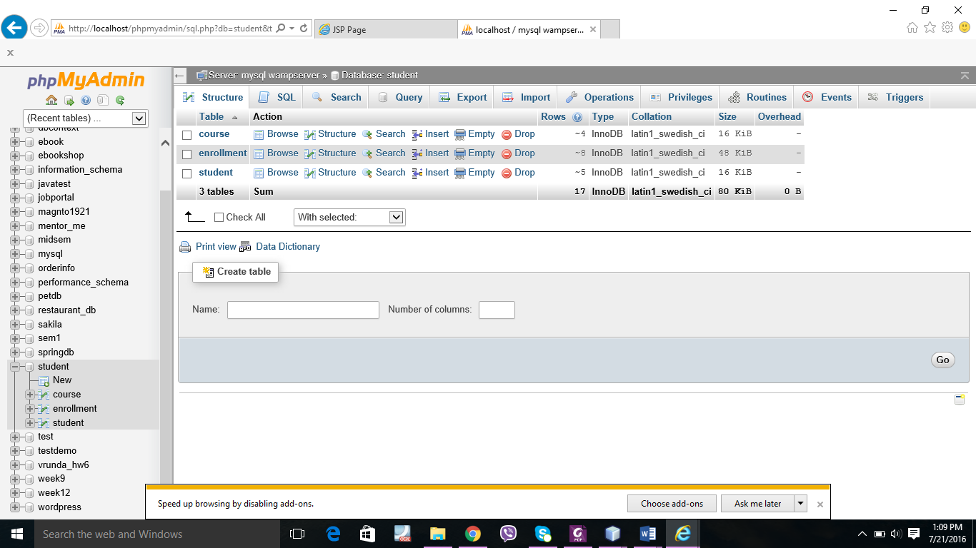

Table data of Course

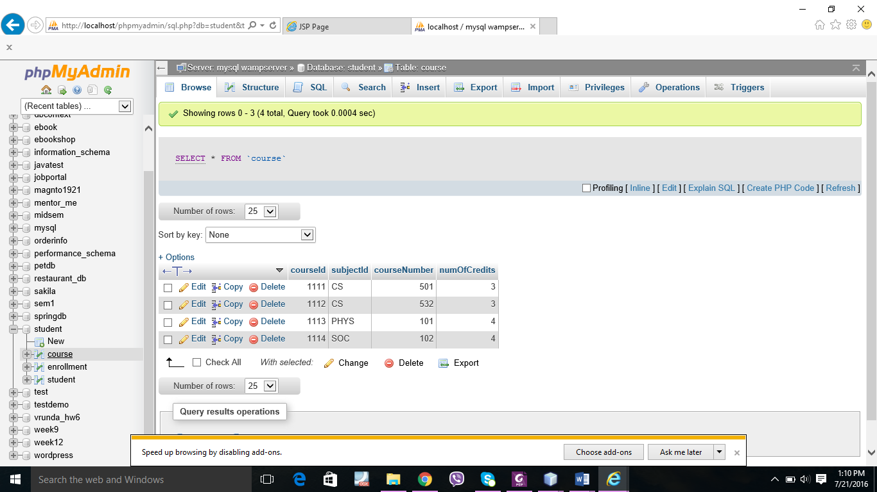

Data of enrollment table

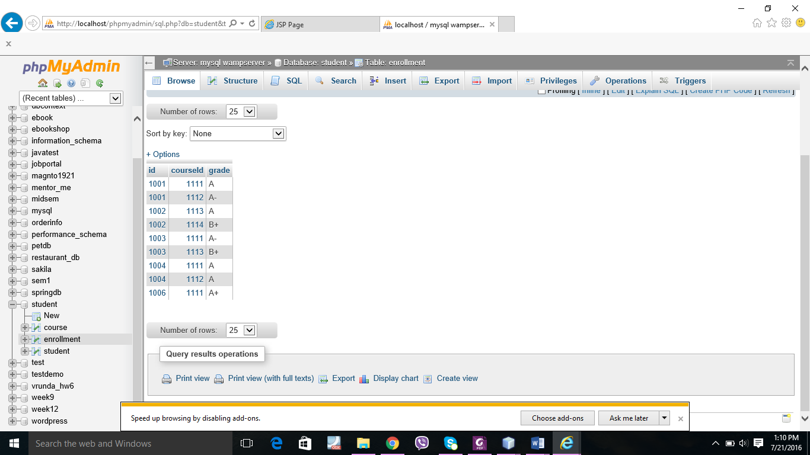

Data of student table

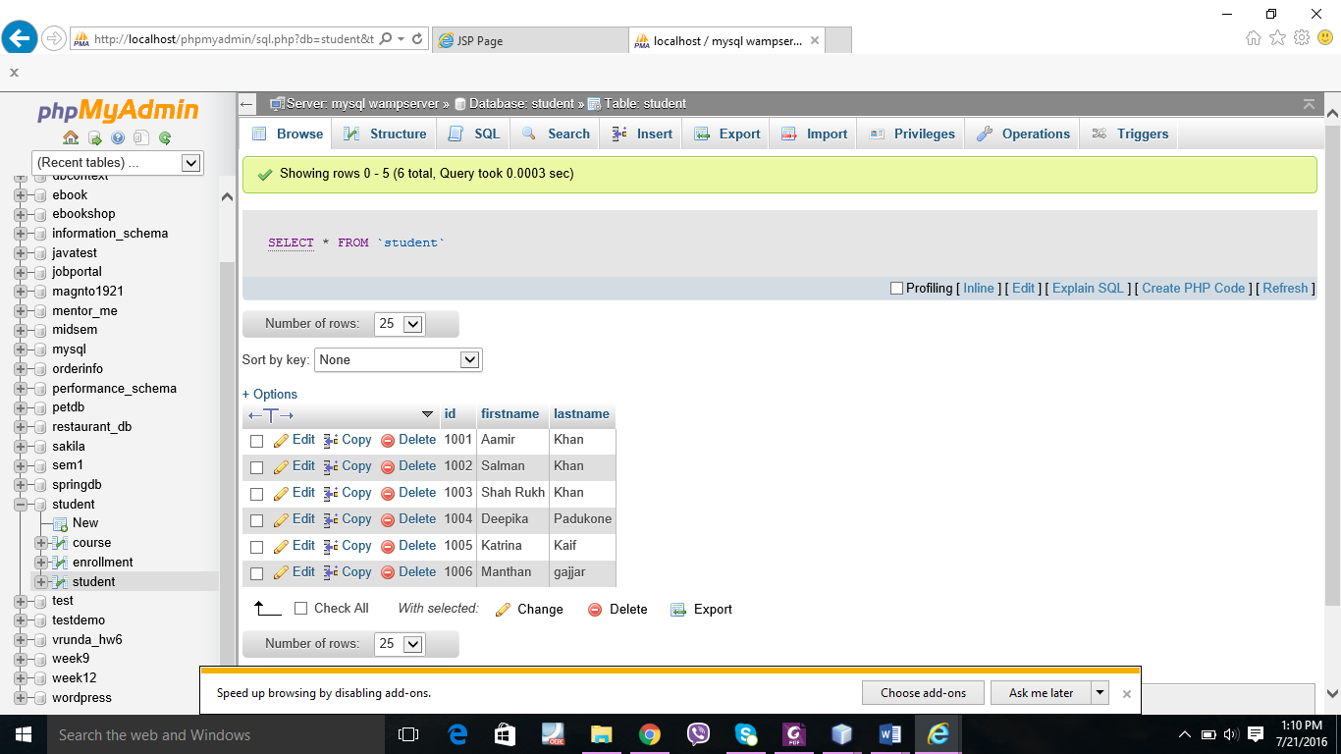

Q.1

/\*

\* To change this license header, choose License Headers in Project Properties.

\* To change this template file, choose Tools | Templates

\* and open the template in the editor.

\*/

package cs532;

/\*\*

\*

\* @author manthan

\*/

public class CalculteFee {

private String subject1;

private String subject2;

private String subject3;

private String subject4;

private int total = 0;

public CalculteFee() {

}

public void setSubject1(String subject1) {

this.subject1 = subject1;

}

public void setSubject2(String subject2) {

this.subject2 = subject2;

System.out.println(subject2);

}

public void setSubject3(String subject3) {

this.subject3 = subject3;

System.out.println(subject3);

}

public void setSubject4(String subject4) {

this.subject4 = subject4;

System.out.println(subject4);

}

public String getSubject1() {

return subject1;

}

public String getSubject2() {

return subject2;

}

public String getSubject3() {

return subject3;

}

public String getSubject4() {

return subject4;

}

public int CalculteTutionFee() {

if ((subject1.matches("Chemistry")) || (subject2.matches("Chemistry")) || (subject3.matches("Chemistry")) || (subject4.matches("Chemistry"))) {

//selectedsub += "Chemistry +";

total += 900;

}

if ((subject1.matches("Physics")) || (subject2.matches("Physics")) || (subject3.matches("Physics")) || (subject4.matches("Physics"))) {

//selectedsub += "Physics +";

total += 900;

}

if ((subject1.matches("Java")) || (subject2.matches("Java")) || (subject3.matches("Java")) || (subject4.matches("Java"))) {

//selectedsub += "Java +";

total += 1000;

}

if ((subject1.matches("Algorithm")) || (subject2.matches("Algorithm")) || (subject3.matches("Algorithm")) || (subject4.matches("Algorithm"))) {

//selectedsub += "Algorithm +";

total += 1000;

}

if ((subject1.matches("Capstone")) || (subject2.matches("Capstone")) || (subject3.matches("Capstone")) || (subject4.matches("Capstone"))) {

//selectedsub += "Capstone";

total += 1000;

}

return total;

}

}

Multiplication Table

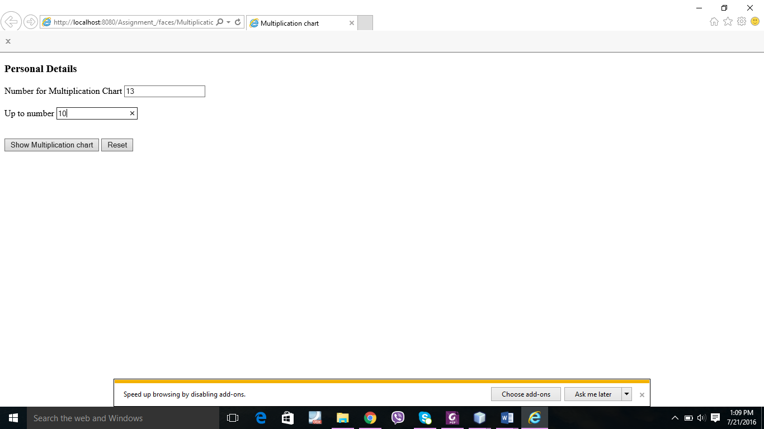

Multiplication:

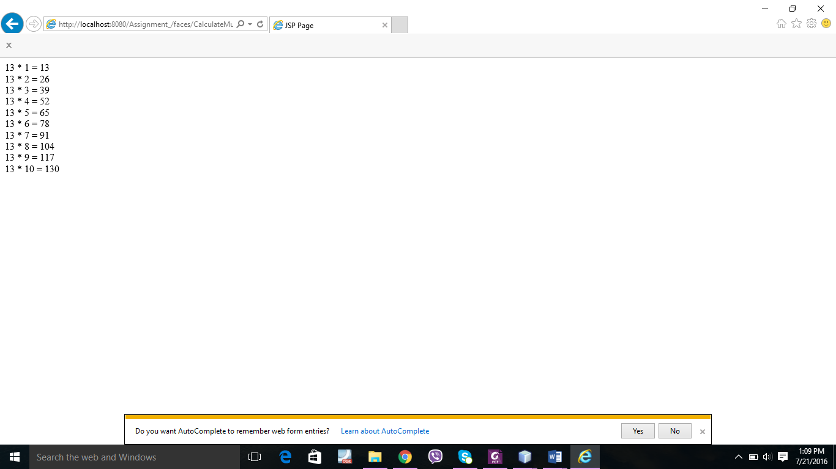

Q.2: question calculate tuition fees

/\*

\* To change this license header, choose License Headers in Project Properties.

\* To change this template file, choose Tools | Templates

\* and open the template in the editor.

\*/

/\*\*

\*

\* @author manthan

\*/

public class Demo {

public static void main(String[] args) {

/\*

if ((sub1 == "Chemistry") || (sub2 == "Chemistry") || (sub3 == "Chemistry") || (sub4 == "Chemistry")){

selectedsub = "Chemistry +";

total +=900;

}

if ((sub1 == "Physics") || (sub2 == "Physics") || (sub3 == "Physics") || (sub4 == "Physics")){

selectedsub = "Physics +";

total +=900;

}

if ((sub1 == "Java") || (sub2 == "Java") || (sub3 == "Java") || (sub4 == "java")){

selectedsub = "Java +";

total +=1000;

}

if ((sub1 == "Algorithm") || (sub2 == "Algorithm") || (sub3 == "Algorithm") || (sub4 == "Algorithm")){

selectedsub = "Algorithm +";

total +=1000;

}

if ((sub1 == "Capstone") || (sub2 == "Capstone") || (sub3 == "Capstone") || (sub4 == "Capstone")){

selectedsub = "Capstone +";

total +=1000;

}

}

You Selected : <%= selectedsub %> Courses

Your Tuition Fees would be <%= total %> . Thank You\*/

}

}

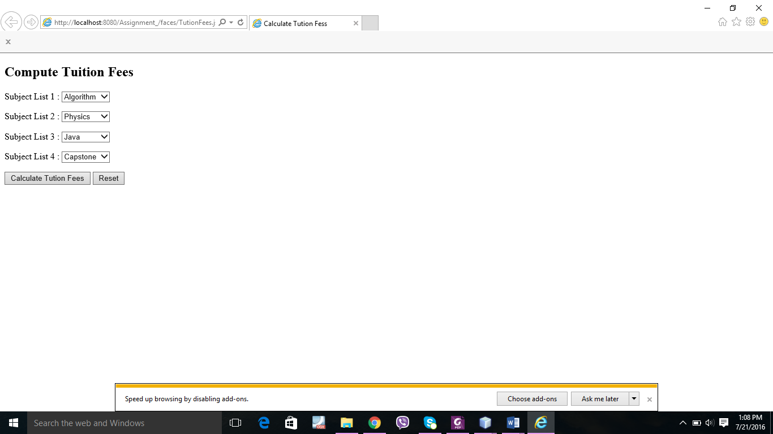

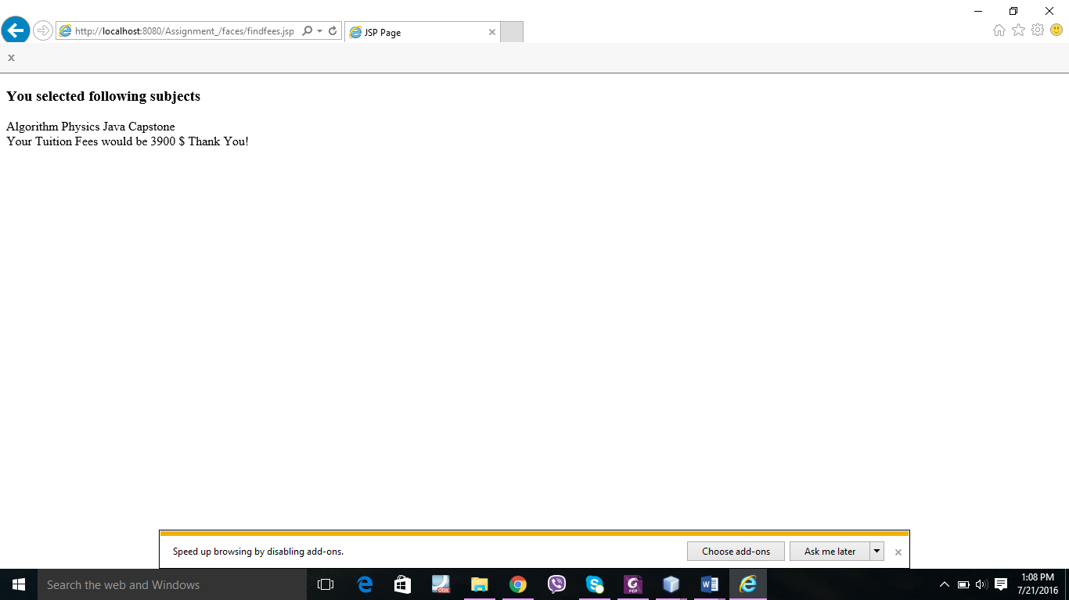

Q.3

