CS532H_HW#3_18791gm Manthan gajjar

1. [20 Pts] Use the file called Input.txt that is given along with this homework assignment file in the portal as input text file for this problem. Write a program that: • Prompts the user to enter a text file name • Count and display the number of vowels in the file • Use the Java HashSet to store the vowels A, E, I, O, and U • The output on the console screen should be as follows:

Enter a filename: Input.txt The number of vowels is [vowels count from the program]

OUTPUT:

**package** cs532_hw;

/**

*

* **@author** manthan gajjar(18791)

*/

**import** java.io.File;

**import** java.util.HashSet;

**import** java.util.Map;

**import** java.util.Scanner;

**import** java.util.Set;

**import** java.util.TreeMap;

**public** **class** CountVowels {

**public** **static** **void** main(String[] args) **throws** Exception {

Scanner scanner = **new** Scanner(System.***in***);

StringBuilder sb = **new** StringBuilder(

"C:\\Users\\manthan\\Desktop\\CS532 ajava\\");

System.***out***.println("Enter input file name from \n at path "

+ " C:\\Users\\manthan\\Desktop\\CS532 ajava\\ \n");

String inputFileName = scanner.nextLine();

String filename = sb.append(inputFileName).toString().trim();

File file = **new** File(filename);

Map<Character, Integer> map = **new** TreeMap<Character, Integer>();

System.***out***.println("List of Vowels");

**char**[] vowels = { 'a', 'e', 'i', 'o', 'u' };

**int** total = 0;

Set<Character> vowelsSet = **new** HashSet<Character>();

**for** (**int** i = 0; i < vowels.length; i++) {

vowelsSet.add(vowels[i]);

}

System.***out***.println(vowelsSet);

Scanner input = **new** Scanner(file);

**if** (file.exists()) {

**int** count = 0;

**while** (input.hasNext()) {

String word = input.next();

**char**[] w = word.toLowerCase().toCharArray();

**for** (**int** i = 0; i < w.length; i++) {

**if** (vowelsSet.contains(w[i])) {

**if** (!map.containsKey(w[i])) {

map.put(w[i], 1);

count++;

} **else** {

**int** value = map.get(w[i]);

value++;

count++;

map.put(w[i], value);

}

}

}

}

System.***out***.println("Total number of vowels" + count);

Set<Map.Entry<Character, Integer>> entrySet = map.entrySet();

**for** (Map.Entry<Character, Integer> entry : entrySet)

System.***out***.println(entry.getKey() + "\t" + entry.getValue());

} **else** {

System.***out***.println("File NPU.txt is does not exist");

}

}

}

OUTPUT:

Enter input file name from

at path C:\Users\manthan\Desktop\CS532 ajava\

Input.txt

List of Vowels

[a, e, u, i, o]

Total number of vowels154

a 33

e 47

i 34

o 33

u 7

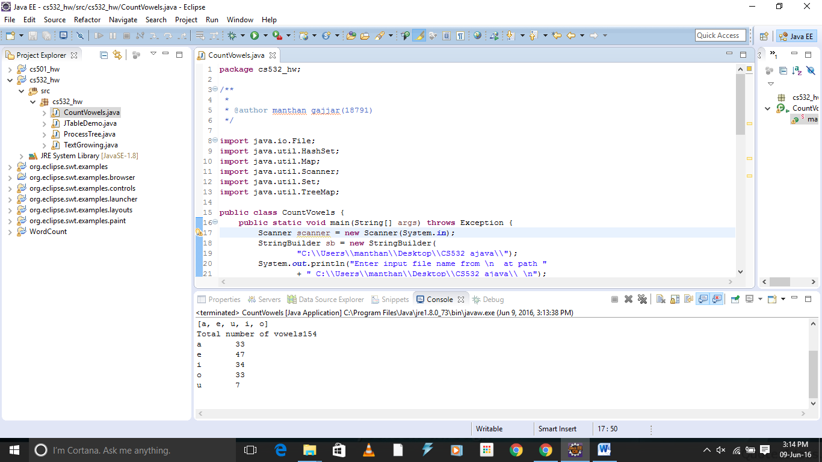

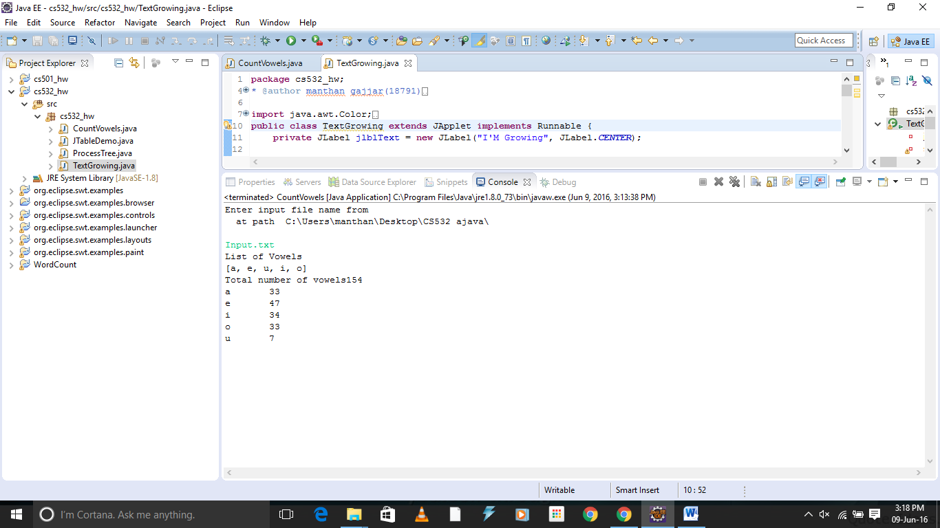

2. [30 Pts] Modify the program FlashingText.java (given as a sample program for the Java Threading

lecture) :

• Rename the program to GrowingText, instead of FlashingText

• The text “I’M GROWING” starts with font size = 10

• Every 1/2 second (500 milliseconds) the font size increases by 5

• When the font size increases up to 50, the size is reset back to 10

• The GUI application displays the text as shown below:

At the start of the program, font size is 10

After 2 seconds, font size is increased to 30

After 4 seconds, font size is increased to 50

After the size reaches 50, font size goes back to 10 and increase by 5 every 1/2 second again

OUTPUT:

**package** cs532_hw;

/**

*

* **@author** manthan gajjar(18791)

*/

**import** java.awt.Color;

**import** java.awt.Font;

**import** javax.swing.*;

**public** **class** TextGrowing **extends** JApplet **implements** Runnable {

**private** JLabel jlblText = **new** JLabel("I'M Growing", JLabel.***CENTER***);

**private** **int** size = 0;

**private** String color;

**public** TextGrowing() {

add(jlblText);

jlblText.setFont(**new** Font("Serif",Font.***BOLD***, 10));

**new** Thread(**this**).start();

}

@Override /** Set the text on/off every 1000 milliseconds */

**public** **void** run() {

**try** {

**while** (**true**) {

**for**(**int** i=10;i<=50;i+=5)

{

Thread.*sleep*(1000);

jlblText.setFont(**new** Font("Serif",Font.***BOLD***,i));

Color color = **new** Color((**int**)(Math.*random*() * 256),(**int**)(Math.*random*() * 256), (**int**)(Math.*random*() * 256));

jlblText.setForeground(color);

}

}

}

**catch** (InterruptedException ex) {

}

}

/** Main method */

**public** **static** **void** main(String[] args) {

SwingUtilities.*invokeLater*(**new** Runnable() {

**public** **void** run() {

JFrame frame = **new** JFrame("Growing Text With different color");

frame.add(**new** TextGrowing());

frame.setLocationRelativeTo(**null**); // Center the frame

frame.setDefaultCloseOperation(JFrame.***EXIT_ON_CLOSE***);

frame.setSize(350,350);

frame.setVisible(**true**);

}

});

}



