**First Demo of simple helloworld.java using servlet:**

**Practical -1**

/*

* To change this license header, choose License Headers in Project Properties.

* To change this template file, choose Tools | Templates

* and open the template in the editor.

*/

import java.io.IOException;

import java.io.PrintWriter;

import javax.servlet.ServletException;

import javax.servlet.annotation.WebServlet;

import javax.servlet.http.HttpServlet;

import javax.servlet.http.HttpServletRequest;

import javax.servlet.http.HttpServletResponse;

/**

*

* @author manthan

*/

@WebServlet(urlPatterns = {"/SayHello"})

public class HelloWorldServlt extends HttpServlet {

@Override

public void doGet(HttpServletRequest request, HttpServletResponse response)

throws IOException, ServletException {

// Set the response MIME type of the response message

response.setContentType("text/html");

// Allocate a output writer to write the response message into the network socket

PrintWriter out = response.getWriter();

// Write the response message, in an HTML page

try {

out.println("<html>");

out.println("<head><title>Hello, World</title></head>");

out.println("<body>");

out.println("<h1>Hello, world!</h1>"); // says Hello

// Echo client's request information

out.println("<p>Request URI: " + request.getRequestURI() + "</p>");

out.println("<p>Protocol: " + request.getProtocol() + "</p>");

out.println("<p>PathInfo: " + request.getPathInfo() + "</p>");

out.println("<p>Remote Address: " + request.getRemoteAddr() + "</p>");

// Generate a random number upon each request

out.println("<p>A Random Number: <strong>" + Math.random() + "</strong></p>");

out.println("</body></html>");

} finally {

out.close(); // Always close the output writer

}

}

}

**Output:**

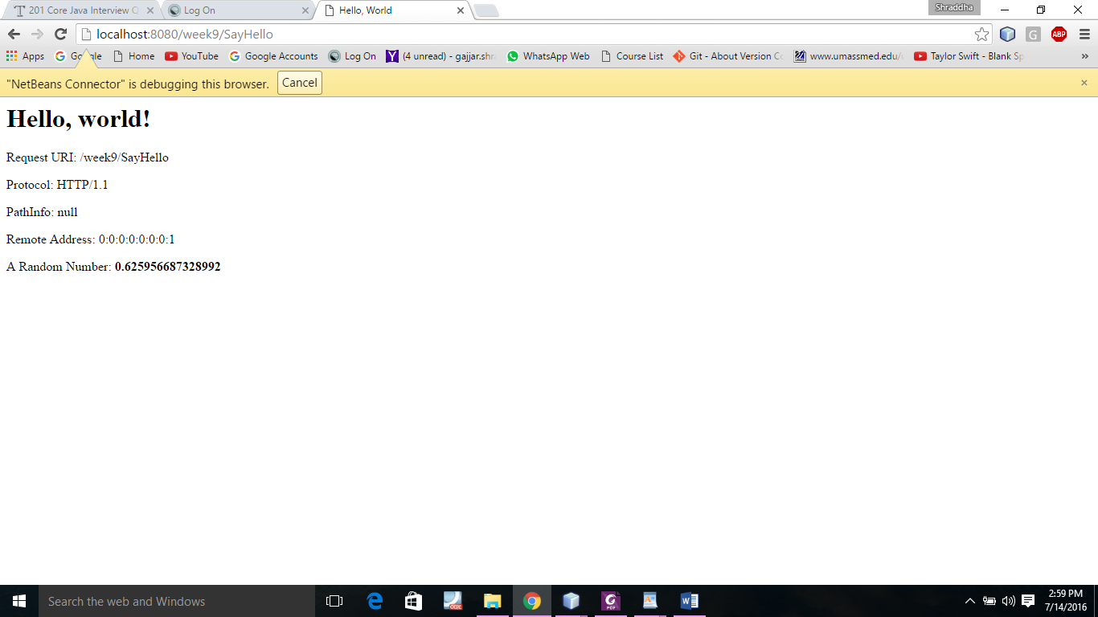

**Practical -2**

**That shows Date and Time of the selected country in selected language.**

/*

* To change this license header, choose License Headers in Project Properties.

* To change this template file, choose Tools | Templates

* and open the template in the editor.

*/

import javax.servlet.annotation.WebServlet;

import javax.servlet.*;

import javax.servlet.http.*;

import java.io.*;

import java.util.*;

import java.text.*;

/**

*

* @author manthan

*/

@WebServlet(name = "Time", urlPatterns = {"/Time"})

public class TimeForm extends HttpServlet {

private static final String CONTENT_TYPE = "text/html";

private Locale[] allLocale = Locale.getAvailableLocales();

private String[] allTimeZone = TimeZone.getAvailableIDs();

/** Process the HTTP Get request */

public void doGet(HttpServletRequest request, HttpServletResponse

response) throws ServletException, IOException {

response.setContentType(CONTENT_TYPE);

PrintWriter out = response.getWriter();

out.println("<h3>Choose locale and time zone</h3>");

out.println("<form method=\"post\" action=" +

"Time>");

out.println("Locale <select size=\"1\" name=\"locale\">");

// Fill in all locales

for (int i = 0; i < allLocale.length; i++) {

out.println("<option value=\"" + i +"\">" +

allLocale[i].getDisplayName() + "</option>");

}

out.println("</select>");

// Fill in all time zones

out.println("<p>Time Zone<select size=\"1\" name=\"timezone\">");

for (int i = 0; i < allTimeZone.length; i++) {

out.println("<option value=\"" + allTimeZone[i] +"\">" +

allTimeZone[i] + "</option>");

}

out.println("</select>");

out.println("<p><input type=\"submit\" value=\"Submit\" >");

out.println("<input type=\"reset\" value=\"Reset\"></p>");

out.println("</form>");

out.close(); // Close stream

}

/** Process the HTTP Post request */

public void doPost(HttpServletRequest request, HttpServletResponse

response) throws ServletException, IOException {

response.setContentType(CONTENT_TYPE);

PrintWriter out = response.getWriter();

out.println("<html>");

int localeIndex = Integer.parseInt(

request.getParameter("locale"));

String timeZoneID = request.getParameter("timezone");

out.println("<head><title>Current Time</title></head>");

out.println("<body>");

Calendar calendar =

new GregorianCalendar(allLocale[localeIndex]);

TimeZone timeZone = TimeZone.getTimeZone(timeZoneID);

DateFormat dateFormat = DateFormat.getDateTimeInstance(

DateFormat.FULL, DateFormat.FULL, allLocale[localeIndex]);

dateFormat.setTimeZone(timeZone);

out.println("Current time is " +

dateFormat.format(calendar.getTime()) + "</p>");

out.println("</body></html>");

out.close(); // Close stream

}

}

**Output:**

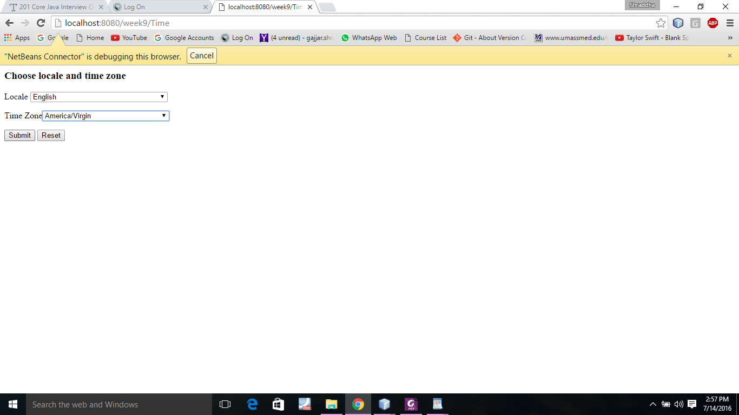

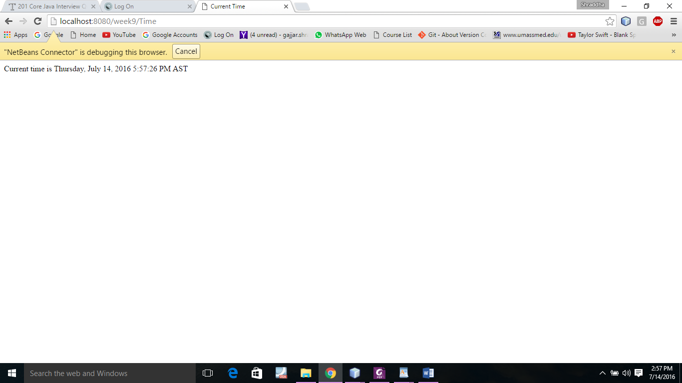

**Practical -3**

**Registration class:**

/*

* To change this license header, choose License Headers in Project Properties.

* To change this template file, choose Tools | Templates

* and open the template in the editor.

*/

import java.io.IOException;

import java.io.PrintWriter;

import javax.servlet.ServletException;

import javax.servlet.annotation.WebServlet;

import javax.servlet.http.HttpServlet;

import javax.servlet.http.HttpServletRequest;

import javax.servlet.http.HttpServletResponse;

/**

*

* @author manthan

*/

@WebServlet(urlPatterns = {"/Regiclass"})

public class Regiclass extends HttpServlet {

private String lastname;

private String firstname;

private String gender;

private String telephone;

private String eamil;

public Regiclass(String lastname, String firstname, String gender, String telephone, String eamil) {

this.lastname = lastname;

this.firstname = firstname;

this.gender = gender;

this.telephone = telephone;

this.eamil = eamil;

}

public String getFirstname() {

return firstname;

}

public String getLastname() {

return lastname;

}

public String getGender() {

return gender;

}

public String getTelephone() {

return telephone;

}

public String getEamil() {

return eamil;

}

public void setLastname(String lastname) {

this.lastname = lastname;

}

public void setFirstname(String firstname) {

this.firstname = firstname;

}

public void setGender(String gender) {

this.gender = gender;

}

public void setTelephone(String telephone) {

this.telephone = telephone;

}

public void setEamil(String eamil) {

this.eamil = eamil;

}

}

**Regiservelt java class that take value from user write in dat file then read from it and display what you entered:**

/*

* To change this license header, choose License Headers in Project Properties.

* To change this template file, choose Tools | Templates

* and open the template in the editor.

*/

import java.io.IOException;

import java.io.PrintWriter;

import javax.servlet.ServletException;

import javax.servlet.annotation.WebServlet;

import javax.servlet.http.HttpServlet;

import javax.servlet.http.HttpServletRequest;

import javax.servlet.http.HttpServletResponse;

import java.io.*;

import javax.servlet.*;

import javax.servlet.http.*;

/**

*

* @author manthan

*/

@WebServlet(urlPatterns = {"/Regi"})

public class Regi extends HttpServlet {

private String message;

public void init() throws ServletException

{

// Do required initialization

message = "Shraddha Gajjar";

}

public void doGet(HttpServletRequest request,HttpServletResponse response)throws ServletException, IOException

{

response.setContentType("text/html");

PrintWriter out = response.getWriter();

out.println("<h3>Choose locale and time zone</h3>");

out.println("<form method=\"post\" action=" +

"Regi>");

out.println("<p>First Name : <input type=\"text\" name=\"FirstName\"> </p>");

out.println("<p>Last Name : <input type=\"text\" name=\"LastName\"> </p>");

out.println("<p> Gender: <select size=\"1\" name=\"Gender\"> </p>");

out.println("<option value=\"Female\">Female</option>");

out.println("<option value=\"Male\">Male</option>");

out.println("</select>");

out.println("<p>Telephone : <input type=\"text\" name=\"Teleno\">");

out.println("<p>Email ID : <input type=\"text\" name=\"Email\">");

out.println("<p><input type=\"submit\" value=\"Submit\" >");

out.println("<input type=\"reset\" value=\"Reset\"></p>");

out.println("</form>");

out.close(); // Close stream

}

public void doPost(HttpServletRequest request, HttpServletResponse

response) throws ServletException, IOException {

response.setContentType("text/html");

PrintWriter out = response.getWriter();

String lastName = request.getParameter("LastName");

String firstName = request.getParameter("FirstName");

String gender = request.getParameter("Gender");

String telephone = request.getParameter("Teleno");

String email = request.getParameter("Email");

if (lastName.length() == 0 || firstName.length() == 0) {

out.println("Last Name and First Name are required");

return; // End the method

}

Regiclass r = new Regiclass(lastName, firstName, gender, telephone, email);

try{

ObjectOutputStream outFile = new ObjectOutputStream(new FileOutputStream("Regidata.dat"));

outFile.writeObject(r);

outFile.close();

} catch(Exception e){

System.out.println(e);

}

try{

ObjectInputStream inFile = new ObjectInputStream(new FileInputStream("Regidata.dat"));

Regiclass regiin = (Regiclass)inFile.readObject();

out.println("You entered the following data");

out.println("<p>Last name: " + regiin.getLastname());

out.println("<br>First name: " + regiin.getFirstname());

out.println("<br>Gender: " + regiin.getGender());

out.println("<br>Telephone: " + regiin.getTelephone());

out.println("<br>Email: " + regiin.getEamil());

} catch(Exception e){

System.out.println(e);

}

}

public void destroy()

{

// do nothing.

}

}

**Output:**

