NATIONAL UNIVERSITY OF COMPUTING AND EMERGING SCIENCES



COLORIZING OLD BLACK & WHITE PHOTOS & VIDEOS

SUBMITTED BY:

SYED MOHAMMAD FAHAD ZAHID (20K-1637)

LOHIT ASHWA (20K-0299)

ALISHBA SUBHANI (20K-0351)

MANNAHIL MIFTAH (20K-0234)

SECTION: BAI-4A

SUBMITTED TO:

Dr. MUHAMMAD FARRUKH SHAHID

MUHAMMAD DANISH WASEEM

PROJECT OVERVIEW:
Image colorization is the process of taking a grayscale (black and white) image as input and producing a colorized image that accurately depicts the input's semantic colors and tones (for example, an ocean on a clear sunny day must be convincingly "blue" – the model cannot color it "pink").

DESCRIPTION:

As indicated in the original paper, the authors welcomed the problem's underlying ambiguity by organizing it as a classification job with class-rebalancing during training time to increase the diversity of colors in the output. The AI approach is trained on over a million color photos and used as a feed-forward pass in a CNN (Convolutional Neural Network).

Previous image colorization methods either:

- Relied on significant human interaction and annotation

- Produced desaturated colorization

METHODOLOGY:

The system is implemented as a feed-forward pass in a CNN at test time and is trained on over a million color images. We evaluate our algorithm using a “colorization Turing test, ” asking human participants to choose between a generated and ground truth color image. Our method successfully fools humans on 32% of the trials, significantly higher than previous methods. Moreover, we show that colorization can be a powerful pretext task for self supervised feature learning, acting as a cross-channel encoder. This approach results in state-of-the-art performance on several feature learning benchmarks.

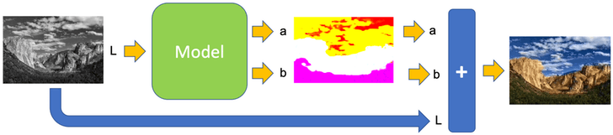

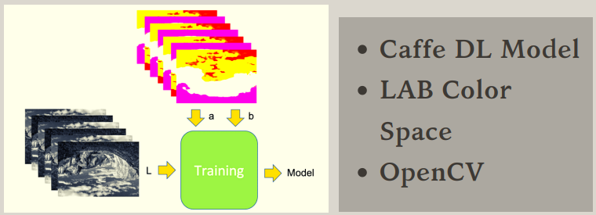

RESULTS:

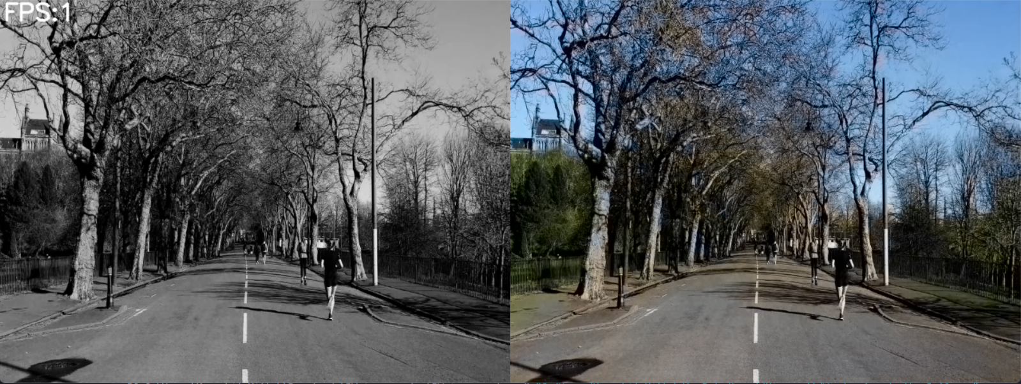

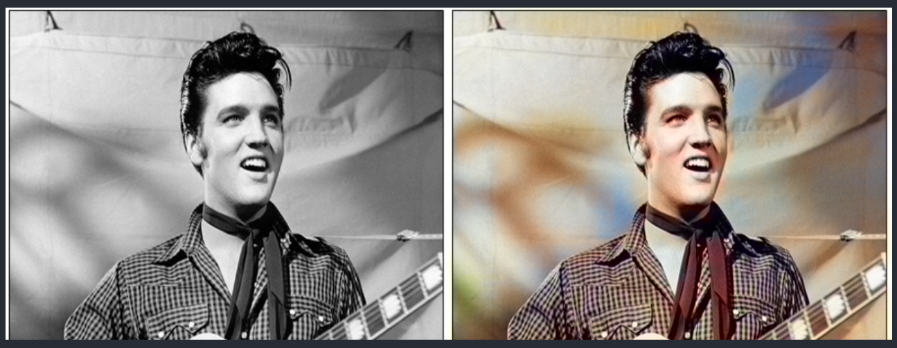

REFERENCES:
This project is based on Richard Zhang, Phillip Isola, and Alexei A. Efros' research at the University of California, Berkeley. Colorful Image Colorization. (https://arxiv.org/pdf/1603.08511.pdf).

CONCLUSION:
While colorizing images and videos is a specialized form of graphics work, it is also a difficult problem in computer vision. Here we have shown that using a deep neural network (DNN) can produce results that are indistinguishable from real color photos and videos.

xxxxxxxxxxxxxxxxxxxxxxxxxxxxxxxxxxxxxxxxxxxxxxxxxxxxxxxxxxxxxxxxxxxxxxxxxxxxxxxxxxxxxxxxxx

