Training Models in Jupyter Notebooks on CSCS

See this tutorial:
https://www.cscs.ch/publications/tutorials/2021/video-of-the-tutorial-interactive-computing-with-jupyter-on-piz-daint-using-python-paraview-and-julia/

(1) Spawn Notebook Lab

Go to Jupyter Hub on CSCS.

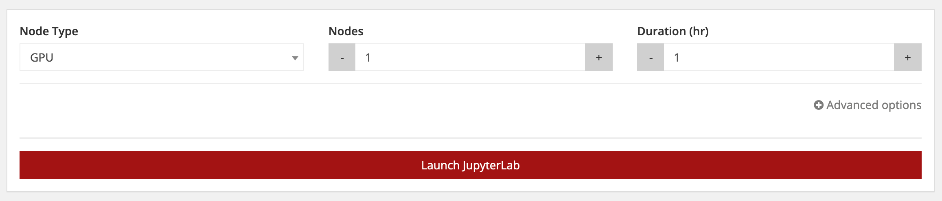

Specify type of node, number of nodes (typically 1) and duration and push the button.
This should spawn a process on a compute node with a Jupyter lab running and redirect the current page to its web interface.

(2) Configure Kernel

In order to launch a notebook with the proper libraries available (such as pytorch) you either need
- to pip install the libraries from within the notebook or
- create a kernel that you then can select in Jupyter lab to launch your notebook with.

The basic steps to achieve this can be found in this notebook. For the second option, you have different ways to proceed:
- use virtual envs: define a virtual env and a kernel
- use conda: define a conda environment and a kernel
- specify module load commands in .jupyterhub.env (in your $HOME)

All require you to ssh in a shell to Piz Daint:
First ssh to the login node: ssh <username>@ela.cscs.ch
Then ssh to Piz Daint: ssh daint.cscs.ch

Then you can follow one of the options in the notebook (Option 2/3/4)

(3) Using GPUs

For using GPUs, you need to
- select a node of type GPU
- make sure that in your environment the module daint-gpu is loaded, i.e. $ module load daint-gpu
- Finally, make sure that your code uses the GPU, e.g., when using pytorch, a GPU device is selected: device = torch.device("cuda:0")

You can find a good demo in this notebook. You can also check whether the GPU is used by using the GPU Dashboards. Siehe das dritte Icon von links oben im Jupyter Lab - oder auch im Tutorial etwa um 1:06:15.

(4) Data

The data used for training can be put either in the
- $HOME: Quote 50GB in total and 5TB shared in the group.
- $SCRATCH: No limit but from time to time automatically cleaned by the system.

Specify a symbolic link to $SCRATCH in your notebook so that the environment in the notebook can find it: !ln -s $SCRATCH $HOME/scratch

