# Documentation

Challenge: Terse set of requirements

The requirements for the problem are vague, which was the challenge I faced. I first thought to have a multi-layered model. The top layer was *log*, which had a list of *actions*, which had *properties*. Since the logs are coming from the front-end, it is fair to assume that multiple logs can have same *userId* and *sessionId.* Because of this, I changed my design choice to have just one layered model.

Model Design:

The incoming data is coming in a format that has a *userId* and a *sessionId* linked to multiple actions. The actions are split up given a *userId* and *sessionId* and made into a *Logs*.

The properties are saved into a Map of String, String since querying over properties is not required.

Model: Logs

* String userId
* String sessoinId
* String time
* String type
* Map<String, String> properties

Database: H2 database

Link: [http://localhost:8080/h2-console](http://localhost:8080/h2-console/login.jsp?jsessionid=4b61352781bef66d7f9b1bf54e4a78bc)

JDBC URL: jdbc:h2:mem:testdb

User Name: sa

Password:

Rest API: Swagger is used to generate OpenApi Definiton

For full documentation: <http://localhost:8080/swagger-ui/index.html?configUrl=/api-docs/swagger-config>

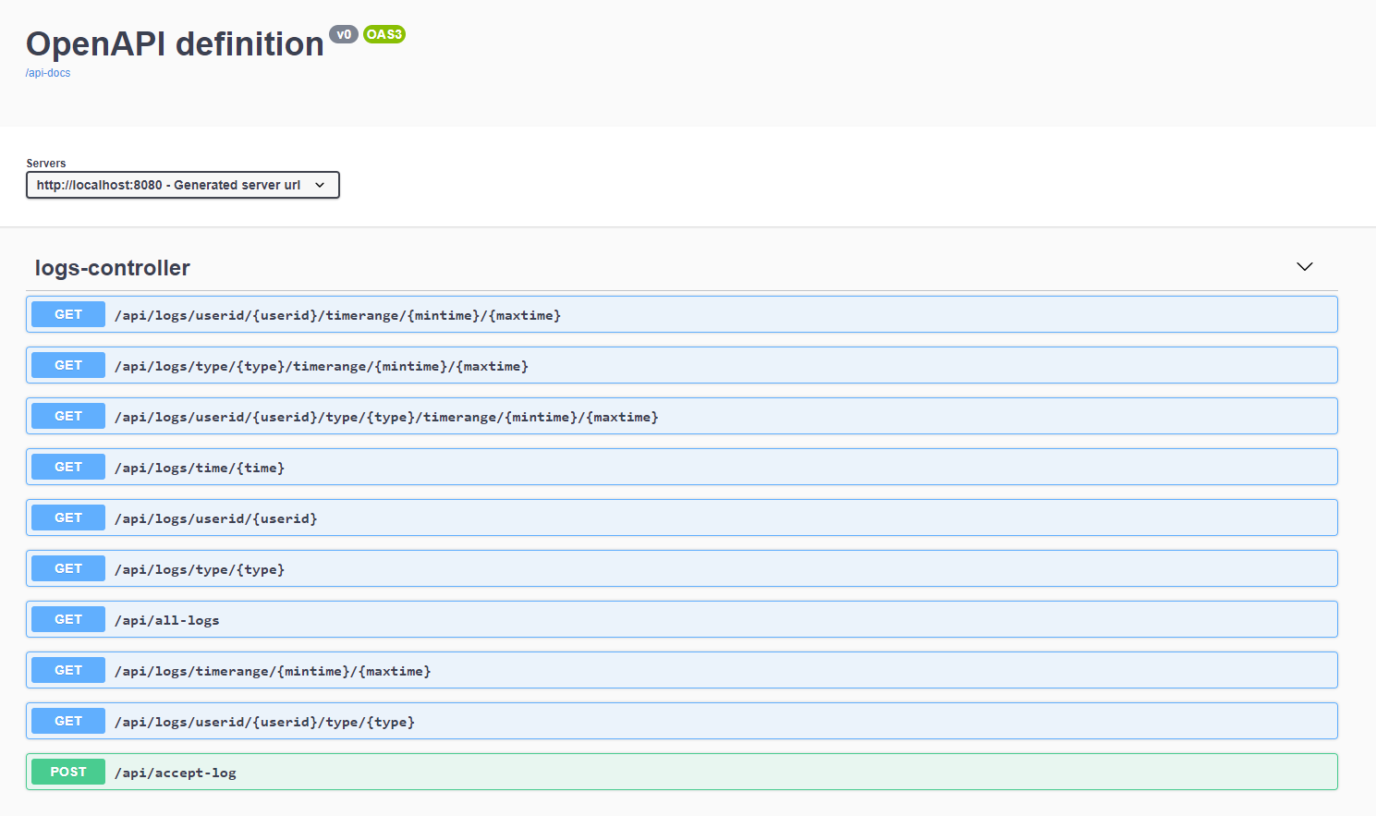Testing:

PostMan Collection with Various Test Cases is provided under the postmanSet Directory