DATA SCIENCE WITH PYTHON
WEEK 6 – INTEGRATIVE CAPSTONE PROJECT AND EVALUATION
PROJECT REPORT
CUSTOMER CHURN PREDICTION AND ANALYSIS USING PYTHON
Submitted By
Nandita Manna
Internship Programme
YuvaIntern – Data Science with Python
Project Type
Integrative Capstone Project
Tools and Technologies
Python | Google Colab | Pandas | NumPy | Matplotlib | Seaborn | Scikit-learn
Submission
Week 6 – Final Project Report
TABLE OF CONTENTS
- Abstract
- Introduction
- Problem Statement
- Project Objectives
- Methodology
- Data Collection and Dataset Description
- Data Cleaning
- Exploratory Data Analysis (EDA)
- Feature Selection and Data Preprocessing
- Model Building
- Model Evaluation and Results
- Business Insights
- Recommendations
- Challenges and Learning Outcomes
- Conclusion and Future Scope
- Python Code Examples
- References

1. ABSTRACT
Customer churn means when customers stop using a company's products or services. It is an important problem for companies because losing customers can reduce business revenue.
This project focuses on customer churn prediction and analysis using Python. The main aim is to analyse customer information, identify patterns and predict whether a customer is likely to leave the company.
The Telco Customer Churn dataset was collected from Kaggle. It contains information about 7,043 customers. The project includes data collection, data cleaning, exploratory data analysis (EDA), data preprocessing, model building and model evaluation.
Two machine learning techniques were used in this project. Logistic Regression was used for supervised learning, and K-Means Clustering was used for unsupervised learning.
The Logistic Regression model achieved 79.70% accuracy, 63.75% precision, 54.55% recall, 58.79% F1-score and 0.84 ROC-AUC score. The overall customer churn rate was 26.54%.
The project helps understand customer behaviour and identify factors related to customer churn. It also provides recommendations that may help businesses improve customer retention.
2. INTRODUCTION
Data Science is an important field that uses data, statistics and programming to find useful information and solve real-world problems.
In business, understanding customer behaviour is very important. Companies want to know why customers stop using their services and what can be done to keep them.
Customer churn is one of the major challenges faced by companies, especially in the telecommunications industry. When customers leave a company, it can affect its revenue and growth.
In this project, Python is used to analyse customer churn. The project uses a real-world Telco Customer Churn dataset. Different Python libraries are used for data cleaning, visualisation and machine learning.
The project follows a complete Data Science process, starting from data collection and ending with model evaluation and business recommendations.
3. PROBLEM STATEMENT
Customer churn is a common business problem. When customers stop using a company's services, the company may lose revenue and business opportunities.
The main problem addressed in this project is to understand customer churn and predict whether a customer is likely to leave the company.
The project aims to identify customer patterns and important factors related to churn by analysing customer information such as contract type, tenure, monthly charges and payment method.
Machine learning techniques are used to support the analysis and provide useful insights.
4. PROJECT OBJECTIVES
The main objectives of this project are:
- To understand customer churn using a real-world dataset.
- To collect and load publicly available data using Python.
- To clean and preprocess the dataset.
- To perform Exploratory Data Analysis (EDA).
- To identify important features related to customer churn.
- To build a supervised machine learning model using Logistic Regression.
- To perform unsupervised learning using K-Means Clustering.
- To evaluate model performance using suitable metrics.
- To identify useful business insights.
- To provide recommendations for improving customer retention.
5. METHODOLOGY
The project follows a step-by-step Data Science pipeline.
The main steps are:
- Problem Identification
- Data Collection
- Data Cleaning
- Exploratory Data Analysis
- Feature Selection
- Data Preprocessing
- Model Building
- Model Evaluation
- Business Insights
- Recommendations
Each step helps transform raw customer data into useful information.
The project started with identifying the customer churn problem and collecting the dataset from Kaggle. The dataset was then checked and cleaned using Pandas. Exploratory Data Analysis was performed using Matplotlib and Seaborn to understand customer behaviour. After selecting the required features, the data was preprocessed for machine learning. Logistic Regression was applied for churn prediction, and K-Means Clustering was used for customer grouping. Finally, the models were evaluated and business recommendations were prepared based on the analysis.

6. DATA COLLECTION AND DATASET DESCRIPTION
6.1 Data Collection
The dataset used in this project is the Telco Customer Churn dataset. It was collected from the publicly available Kaggle platform.
The dataset contains customer information from a telecommunications company. It includes details about customer services, account information, payment methods and churn status.
The dataset was downloaded in Excel format and loaded into Google Colab using Python.
Dataset Name: Telco Customer Churn
Source: Kaggle
File Name: Telco_customer_churn.xlsx
Sheet Name: Telco_Churn
Total Records: 7,043
Total Columns: 33
6.2 Dataset Description
The dataset contains different types of customer information.
Some important columns are:
- CustomerID: Unique identification number of each customer.
- Gender: Gender of the customer.
- Senior Citizen: Indicates whether the customer is a senior citizen.
- Partner: Indicates whether the customer has a partner.
- Dependents: Indicates whether the customer has dependents.
- Tenure Months: Number of months the customer has stayed with the company.
- Phone Service: Indicates whether phone service is used.
- Internet Service: Type of internet service.
- Contract: Type of customer contract.
- Payment Method: Method used for payment.
- Monthly Charges: Monthly amount paid by the customer.
- Total Charges: Total amount charged to the customer.
- Churn Label: Indicates whether the customer left the company.
The target variable used in this project is Churn Label.
7. DATA CLEANING
Data cleaning is an important step in Data Science. It helps improve data quality before performing analysis and building machine learning models.
The following data cleaning steps were performed:
7.1 Loading the Dataset
The Excel dataset was loaded into Google Colab using the Pandas library.
7.2 Checking Dataset Information
The shape, column names and data types were checked to understand the dataset.
7.3 Checking Missing Values
Missing values were checked in all columns. The Total Charges column contained missing or blank values. These values were handled during preprocessing using median imputation.
7.4 Handling Missing Values
Missing values in the Total Charges feature were handled using a median imputer in the numerical preprocessing pipeline.
Missing values in Churn Reason were filled with the value "Not Applicable".
7.5 Checking Duplicate Records
Duplicate records were checked. No duplicate rows were reported in the dataset.
7.6 Removing Unnecessary Columns
CustomerID was excluded because it is an identification column and does not provide useful predictive information.
Churn Score, Churn Value, Churn Reason and Churn Category were also excluded from model input to avoid target leakage.
After cleaning, the dataset was prepared for further analysis and model building.
8. EXPLORATORY DATA ANALYSIS (EDA)
Exploratory Data Analysis is used to understand the dataset and discover patterns, relationships and trends.
Python libraries such as Pandas, Matplotlib and Seaborn were used for data analysis and visualisation.
8.1 Customer Churn Distribution
The churn distribution was analysed to understand how many customers stayed and how many customers left the company.
The dataset contains 7,043 customers, of which 1,869 customers churned.
The overall churn rate was 26.54%.
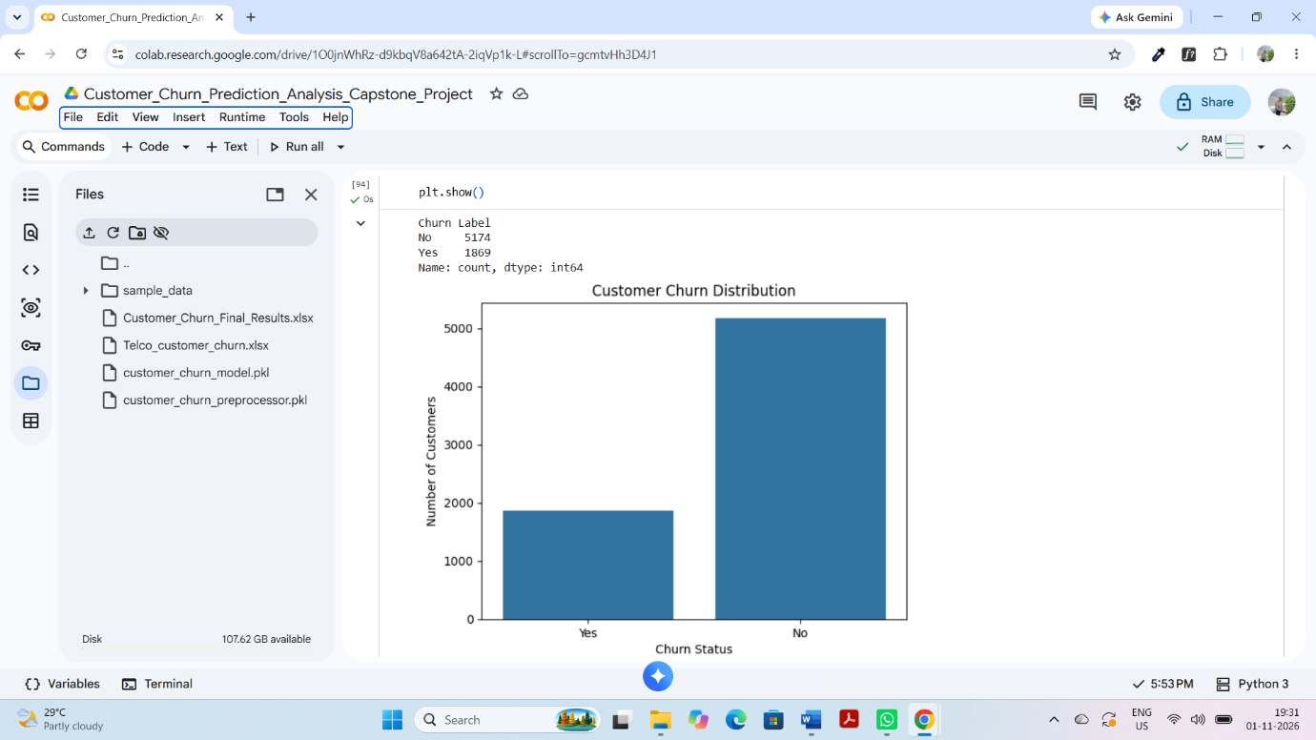
[Insert Figure 1: Customer Churn Distribution]
8.2 Gender and Customer Churn
Customer churn was analysed based on gender to understand whether there was a major difference between male and female customers.
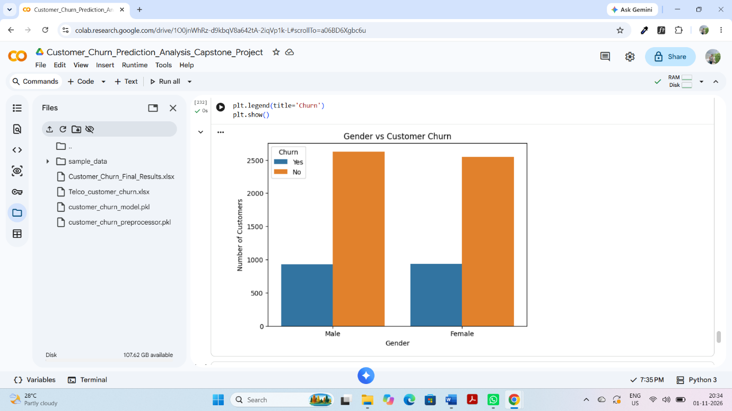
[Insert Figure 2: Gender vs Churn]
8.3 Contract Type and Customer Churn
The relationship between contract type and churn was analysed. This helps understand whether customers with different contract types show different churn patterns.
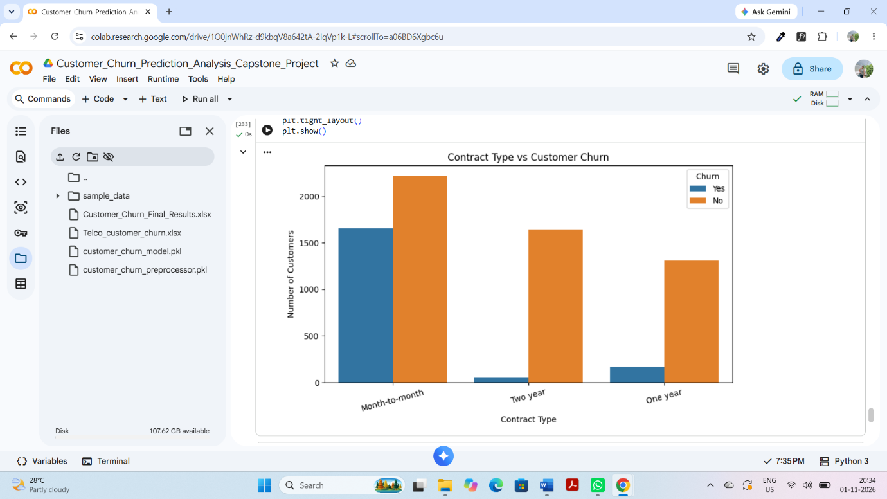
[Insert Figure 3: Contract Type vs Churn]
8.4 Monthly Charges Analysis
A boxplot was used to analyse monthly charges and understand the distribution of charges among customers.
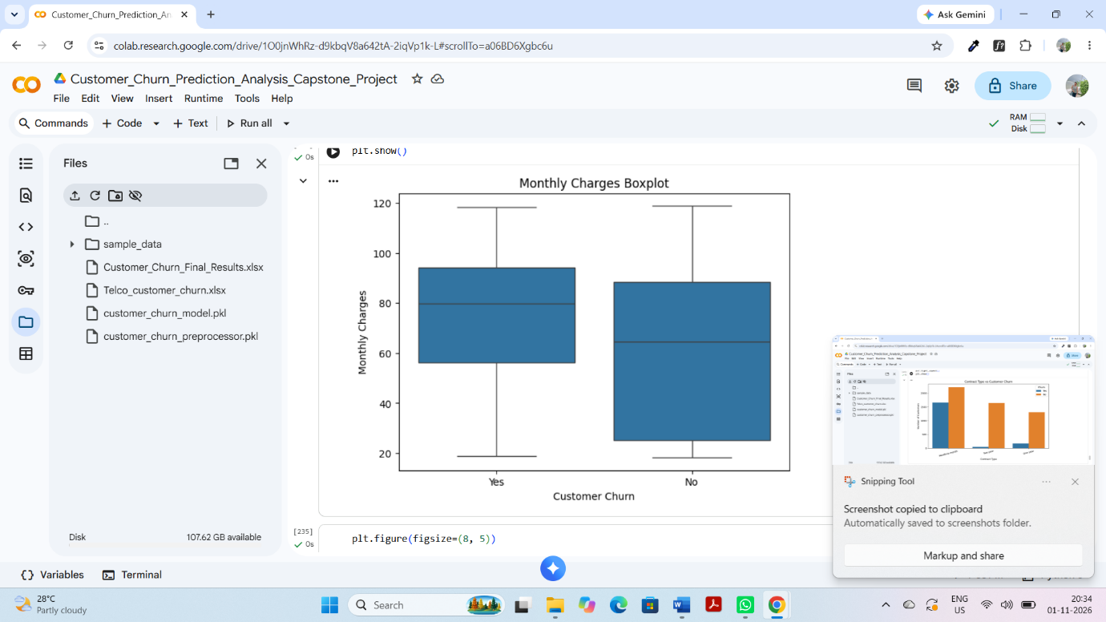
[Insert Figure 4: Monthly Charges Boxplot]
8.5 Tenure Analysis
A histogram was used to understand the distribution of customer tenure in months.
This analysis helps examine how long customers have stayed with the company.
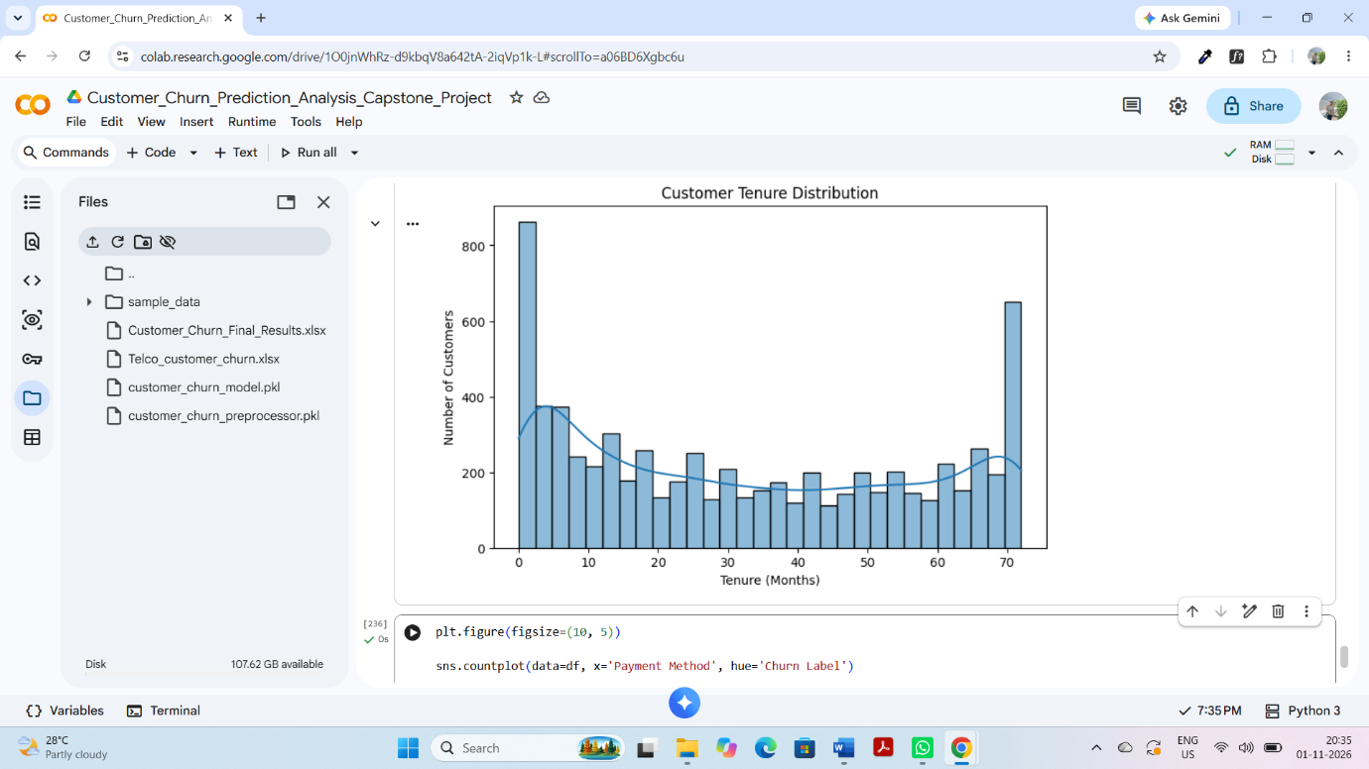
[Insert Figure 5: Customer Tenure Histogram]
8.6 Payment Method Analysis
Payment methods were analysed to understand customer churn patterns across different payment methods.
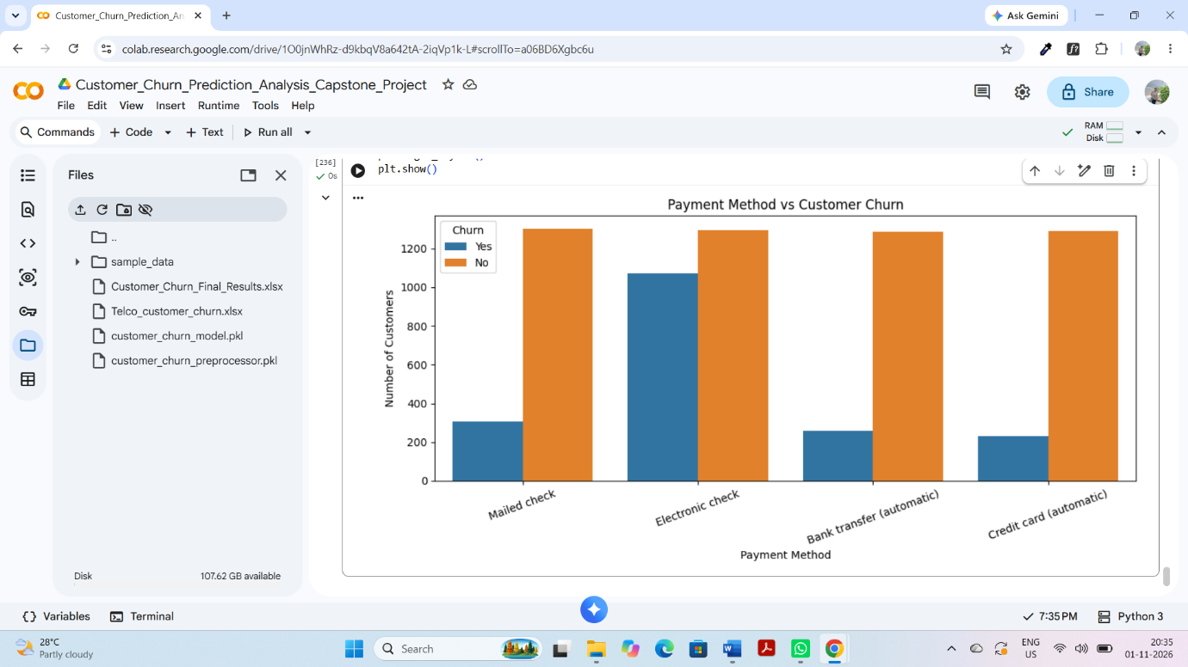
[Insert Figure 6: Payment Method vs Churn]
8.7 EDA Summary
EDA helped identify important customer patterns and understand the relationship between different customer features and churn.
The analysis showed that customer churn is an important issue, with 26.54% of customers leaving the company.
9. FEATURE SELECTION AND DATA PREPROCESSING
Feature selection and preprocessing are important steps before building a machine learning model.
9.1 Target Variable
The target variable selected for this project was Churn Label.
The values were converted into numerical form:
- Yes = 1
- No = 0
9.2 Feature Selection
CustomerID and leakage-related columns were excluded from the model input.
The remaining customer information was used as input features.
9.3 Train-Test Split
The dataset was divided into training and testing sets.
- Training Data: 80%
- Testing Data: 20%
Stratified splitting was used to maintain the proportion of churn and non-churn customers in both sets.
9.4 Numerical Preprocessing
Numerical features were processed using:
- Median Imputation
- Standard Scaling
9.5 Categorical Preprocessing
Categorical features were processed using:
- Most Frequent Imputation
- One-Hot Encoding
A preprocessing pipeline was created using Scikit-learn.
10. MODEL BUILDING
Machine learning models were used to analyse and understand customer churn.
Two different learning techniques were applied.
10.1 Logistic Regression (Supervised Learning)
Logistic Regression is a supervised machine learning algorithm used for classification problems.
In this project, Logistic Regression was used to predict whether a customer would leave the company or stay.
The model was trained using the training dataset and evaluated using the testing dataset.
The target variable was Churn Label.
10.2 K-Means Clustering (Unsupervised Learning)
K-Means is an unsupervised machine learning algorithm used to group similar data points into clusters.
In this project, K-Means Clustering was used to identify groups of customers with similar characteristics.
Unlike Logistic Regression, K-Means does not require a target label to create clusters.
The Silhouette Score was used to evaluate the quality of clustering.
The obtained Silhouette Score was 0.2666.
11. MODEL EVALUATION AND RESULTS
Model evaluation helps measure how well a machine learning model performs.
11.1 Logistic Regression Evaluation
The Logistic Regression model achieved the following results:
Evaluation Metric | Result
Accuracy | 79.70%
Precision | 63.75%
Recall | 54.55%
F1-score | 58.79%
ROC-AUC | 0.84
11.2 Understanding the Metrics
Accuracy: Measures the overall percentage of correct predictions.
Precision: Measures how many customers predicted as churned actually churned.
Recall: Measures how many actual churned customers were correctly identified by the model.
F1-score: Combines precision and recall into one score.
ROC-AUC: Measures how well the model can distinguish between churned and non-churned customers.
11.3 Interpretation of Results
The model achieved 79.70% accuracy, which shows that it correctly classified a large proportion of the test records.
The precision score of 63.75% indicates that some predicted churn cases were incorrect.
The recall score of 54.55% means that the model identified around 54.55% of the actual churned customers.
The F1-score of 58.79% shows that there is scope to improve the balance between precision and recall.
The ROC-AUC score of 0.84 indicates good ability to distinguish between the two classes.
11.4 K-Means Evaluation
The K-Means model achieved a Silhouette Score of 0.2666.
The Silhouette Score measures how well data points fit within their own clusters compared with other clusters.
The score suggests that the clusters have some structure, but there is also room for improvement.
12. BUSINESS INSIGHTS
The analysis of the Telco Customer Churn dataset provided useful information about customer behaviour.
The major business insights from the project are:
- The overall customer churn rate was 26.54%, which means that around one-fourth of the customers left the company.
- The customer churn distribution graph helped compare the number of customers who stayed with the company and those who left.
- The Gender vs Churn graph helped examine whether churn patterns differed between male and female customers.
- The Contract Type vs Churn graph helped study the relationship between contract type and customer churn.
- The Monthly Charges boxplot helped compare the monthly charges of customers who stayed and customers who left.
- The Customer Tenure histogram helped understand how long customers had stayed with the company.
- The Payment Method vs Churn graph helped compare churn patterns across different payment methods.
- The Logistic Regression model achieved 79.70% accuracy and a ROC-AUC score of 0.84. These results show that the model can help identify customers who may be likely to leave.
Overall, the analysis shows how customer data and machine learning can support business decisions and customer retention strategies.

13. RECOMMENDATIONS
Based on the analysis, the following recommendations can be considered:
- Companies should identify customers who may be likely to leave.
- Special offers and discounts can be provided to customers at risk of leaving.
- Companies should focus on improving customer satisfaction.
- Flexible contract options can be considered.
- Customer feedback should be collected regularly.
- Companies should monitor customer payment patterns.
- Machine learning models can be improved to identify more churned customers.
These recommendations may help companies improve customer retention.
14. CHALLENGES AND LEARNING OUTCOMES
14.1 Challenges
During the project, some challenges were faced:
- Understanding the dataset and its different columns.
- Handling missing values in the dataset.
- Selecting useful features for model building.
- Converting categorical data into numerical form.
- Applying preprocessing techniques correctly.
- Understanding different machine learning evaluation metrics.
- Interpreting the results of Logistic Regression and K-Means.
14.2 Learning Outcomes
This project helped improve practical knowledge of Data Science with Python.
The main learning outcomes were:
- Learned how to collect and load a real-world dataset.
- Understood data cleaning and preprocessing.
- Learned how to perform Exploratory Data Analysis.
- Practised data visualisation using Matplotlib and Seaborn.
- Understood supervised machine learning.
- Learned how to apply Logistic Regression.
- Understood unsupervised learning using K-Means.
- Learned how to evaluate machine learning models.
- Improved understanding of how data analysis can support business decisions.
14.3 Project Successes
- The project successfully completed the main stages of the Data Science pipeline.
- The major successes of this project are:
- Successfully collected and analysed a real-world customer churn dataset.
- Completed data cleaning and preprocessing using Python.
- Created different visualisations to understand customer behaviour.
- Applied Logistic Regression for customer churn prediction.
- Applied K-Means Clustering for customer segmentation.
- Evaluated the models using suitable performance metrics.
- Developed useful business insights and recommendations.
- This project improved my practical knowledge of Python, data analysis, data visualisation and machine learning. It also helped me understand how Data Science can solve real-world business problems.

15. CONCLUSION AND FUTURE SCOPE
This project successfully demonstrates a complete Data Science workflow using Python.
The Telco Customer Churn dataset was analysed through data cleaning, preprocessing, exploratory analysis, machine learning and model evaluation.
Logistic Regression was used to predict customer churn, while K-Means Clustering was used to group similar customers.
The Logistic Regression model achieved 79.70% accuracy and a ROC-AUC score of 0.84. The overall customer churn rate was 26.54%.
The project helped develop practical knowledge of Python, data analysis, data visualisation and machine learning.
Future Scope
The project can be improved in several ways:
- More machine learning algorithms such as Random Forest and Decision Tree can be tested.
- Hyperparameter tuning can be performed to improve model performance.
- More customer data can be collected for further analysis.
- Additional customer behaviour features can be studied.
- A dashboard can be developed using Power BI to display churn insights.
- The model can be deployed as a simple application for practical use.
16. PYTHON CODE EXAMPLES
The following are selected examples of Python code used in the project. They represent important stages of the Data Science pipeline. The code should match the final executed Google Colab notebook.
16.1 Importing Libraries
import pandas as pd
import numpy as np
import matplotlib.pyplot as plt
import seaborn as sns

from sklearn.model_selection import train_test_split
from sklearn.linear_model import LogisticRegression
from sklearn.cluster import KMeans
from sklearn.metrics import accuracy_score
from sklearn.metrics import precision_score
from sklearn.metrics import recall_score
from sklearn.metrics import f1_score
from sklearn.metrics import roc_auc_score
from sklearn.metrics import silhouette_score
16.2 Loading the Dataset
df = pd.read_excel("Telco_customer_churn.xlsx",
sheet_name="Telco_Churn")

print(df.shape)
print(df.head())
16.3 Checking Missing Values
print(df.isnull().sum())
16.4 Churn Distribution
sns.countplot(data=df, x="Churn Label")
plt.title("Customer Churn Distribution")
plt.show()
16.5 Train-Test Split
X_train, X_test, y_train, y_test = train_test_split(
X, y,
test_size=0.20,
random_state=42,
stratify=y
)
16.6 Model Evaluation
y_pred = model.predict(X_test)

print("Accuracy:", accuracy_score(y_test, y_pred))
print("Precision:", precision_score(y_test, y_pred))
print("Recall:", recall_score(y_test, y_pred))
print("F1 Score:", f1_score(y_test, y_pred))
Note: These are selected illustrative examples. Use the exact variable names and final code from your executed notebook when preparing the submitted report.
from sklearn.compose import ColumnTransformer
from sklearn.pipeline import Pipeline
from sklearn.impute import SimpleImputer
from sklearn.preprocessing import StandardScaler, OneHotEncoder

numeric_transformer = Pipeline(steps=[
("imputer", SimpleImputer(strategy="median")),
("scaler", StandardScaler())
])

categorical_transformer = Pipeline(steps=[
("imputer", SimpleImputer(strategy="most_frequent")),
("encoder", OneHotEncoder(handle_unknown="ignore"))
])

preprocessor = ColumnTransformer(transformers=[
("num", numeric_transformer, numeric_features),
("cat", categorical_transformer, categorical_features)
])
from sklearn.linear_model import LogisticRegression

model = Pipeline(steps=[
("preprocessor", preprocessor),
("classifier", LogisticRegression(max_iter=1000))
])

model.fit(X_train, y_train)

y_pred = model.predict(X_test)
from sklearn.metrics import roc_auc_score

y_probability = model.predict_proba(X_test)[:, 1]

roc_auc = roc_auc_score(y_test, y_probability)

print("ROC-AUC Score:", roc_auc)
from sklearn.cluster import KMeans
from sklearn.metrics import silhouette_score

kmeans = KMeans(
n_clusters=3,
random_state=42,
n_init=10
)

cluster_labels = kmeans.fit_predict(X_scaled)

score = silhouette_score(X_scaled, cluster_labels)

print("Silhouette Score:", score)
17. REFERENCES
- Kaggle – Telco Customer Churn Dataset.
Dataset source: [https://www.kaggle.com/datasets/yeanzc/telco-customer-churn-ibm-dataset]
- Pandas Documentation – https://pandas.pydata.org/docs/
- NumPy Documentation – https://numpy.org/doc/
- Matplotlib Documentation – https://matplotlib.org/stable/
- Seaborn Documentation – https://seaborn.pydata.org/
- Scikit-learn Documentation – https://scikit-learn.org/stable/
- Google Colab – https://colab.research.google.com/

