Exploratory Data Analysis and Visualization
Supermarket Sales Dataset
Submitted By: Nandita Manna
Course: B.Sc. Data Science
University: Techno India University
Task: Week 2 – Exploratory Data Analysis and Visualization
Dataset: Supermarket Sales Dataset

1. Introduction
This project presents an Exploratory Data Analysis (EDA) of a Supermarket Sales dataset. The main objective is to understand sales performance, customer behaviour, product performance, payment methods, ratings, and relationships between numerical variables.
Python libraries including Pandas, Matplotlib, and Seaborn were used for data analysis and visualization.

2. Objectives of the Analysis
- Understand the structure and characteristics of the dataset.
- Check missing values and duplicate records.
- Calculate descriptive statistics.
- Analyze sales across product lines, cities, customer types, genders, and payment methods.
- Study distributions and identify possible outliers.
- Analyze correlations between numerical variables.
- Identify important trends and patterns using visualizations.
- Summarize the major findings from the dataset.

3. Dataset Description
The dataset contains 1000 rows and 18 columns.
The dataset contains information related to supermarket transactions, including invoice details, branch/city, customer type, gender, product line, unit price, quantity, tax, total sales, payment method, gross income, and customer rating.

4. Python Libraries Used
- Pandas – Data loading, cleaning, transformation, and aggregation.
- Matplotlib – Basic plotting and visualization.
- Seaborn – Statistical visualization and advanced charts.

5. Data Loading
The CSV dataset was loaded into a Pandas DataFrame using the read_csv() function.
import pandas as pd
import matplotlib.pyplot as plt
import seaborn as sns
df = pd.read_csv('/content/supermarket_sales.csv')

6. Data Quality and Initial Inspection
The dataset was inspected using shape, columns, info, missing-value checking, duplicate checking, and descriptive statistics.
Total number of records: 1000
Total number of variables: 18
Total missing values: 0
Total duplicate records: 0

7. Descriptive Statistics
Descriptive statistics were calculated for the numerical variables to understand their central tendency, spread, minimum, and maximum values.
Statistic | Unit price | Quantity | Tax 5% | Total | cogs | gross margin percentage | gross income | Rating
mean | 55.67 | 5.51 | 15.38 | 322.97 | 307.59 | 4.76 | 15.38 | 6.97
median | 55.23 | 5.0 | 12.09 | 253.85 | 241.76 | 4.76 | 12.09 | 7.0
min | 10.08 | 1.0 | 0.51 | 10.68 | 10.17 | 4.76 | 0.51 | 4.0
max | 99.96 | 10.0 | 49.65 | 1042.65 | 993.0 | 4.76 | 49.65 | 10.0
std | 26.49 | 2.92 | 11.71 | 245.89 | 234.18 | 0.0 | 11.71 | 1.72

8. Categorical Analysis
Categorical variables were examined to understand customer composition and transaction characteristics.

9. Product Line Analysis
Product-level aggregation was performed using total sales, total quantity sold, and average customer rating.
Product Line | Total Sales | Quantity | Average Rating
Electronic accessories | 54337.53 | 971.0 | 6.92
Fashion accessories | 54305.9 | 902.0 | 7.03
Food and beverages | 56144.84 | 952.0 | 7.11
Health and beauty | 49193.74 | 854.0 | 7.0
Home and lifestyle | 53861.91 | 911.0 | 6.84
Sports and travel | 55122.83 | 920.0 | 6.92

10. City-wise Analysis
City-wise aggregation was used to compare total sales, quantity sold, and average customer rating across the cities.
City | Total Sales | Quantity | Average Rating
Mandalay | 106197.67 | 1820.0 | 6.82
Naypyitaw | 110568.71 | 1831.0 | 7.07
Yangon | 106200.37 | 1859.0 | 7.03

11. Customer Type Analysis
Customer type analysis compares Member and Normal customers based on sales, quantity, and average rating.
Customer Type | Total Sales | Quantity | Average Rating
Member | 164223.44 | 2785.0 | 6.94
Normal | 158743.3 | 2725.0 | 7.01

12. Payment Method Analysis
Payment methods were compared based on total sales, quantity, and average rating.
Payment Method | Total Sales | Quantity | Average Rating
Cash | 112206.57 | 1896.0 | 6.97
Credit card | 100767.07 | 1722.0 | 7.0
Ewallet | 109993.11 | 1892.0 | 6.95

13. Outlier Analysis
Using the Interquartile Range (IQR) method, the lower limit was -395.97 and the upper limit was 991.74. There were 9 potential outlier transactions in Total Sales.
Outliers may represent unusually large or small transactions and should be considered when interpreting the sales distribution.

14. Correlation Analysis
A correlation matrix was calculated for numerical variables to identify relationships between sales, quantity, unit price, gross income, tax, and other numerical features.
Correlation values range from -1 to +1. Values closer to +1 indicate a positive relationship, while values closer to -1 indicate a negative relationship. Values near zero indicate a weak linear relationship.

15. Data Visualizations and Interpretation

Customer Count by Gender
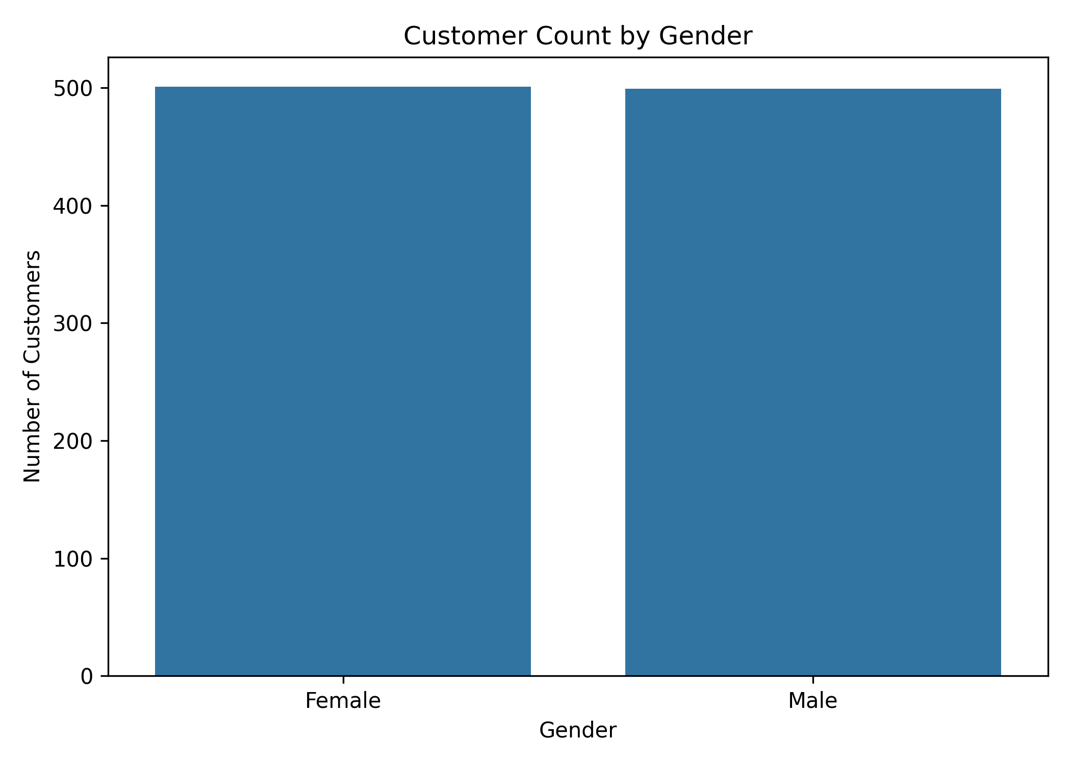
Interpretation: This chart compares the number of customers across genders.

Total Sales by Product Line
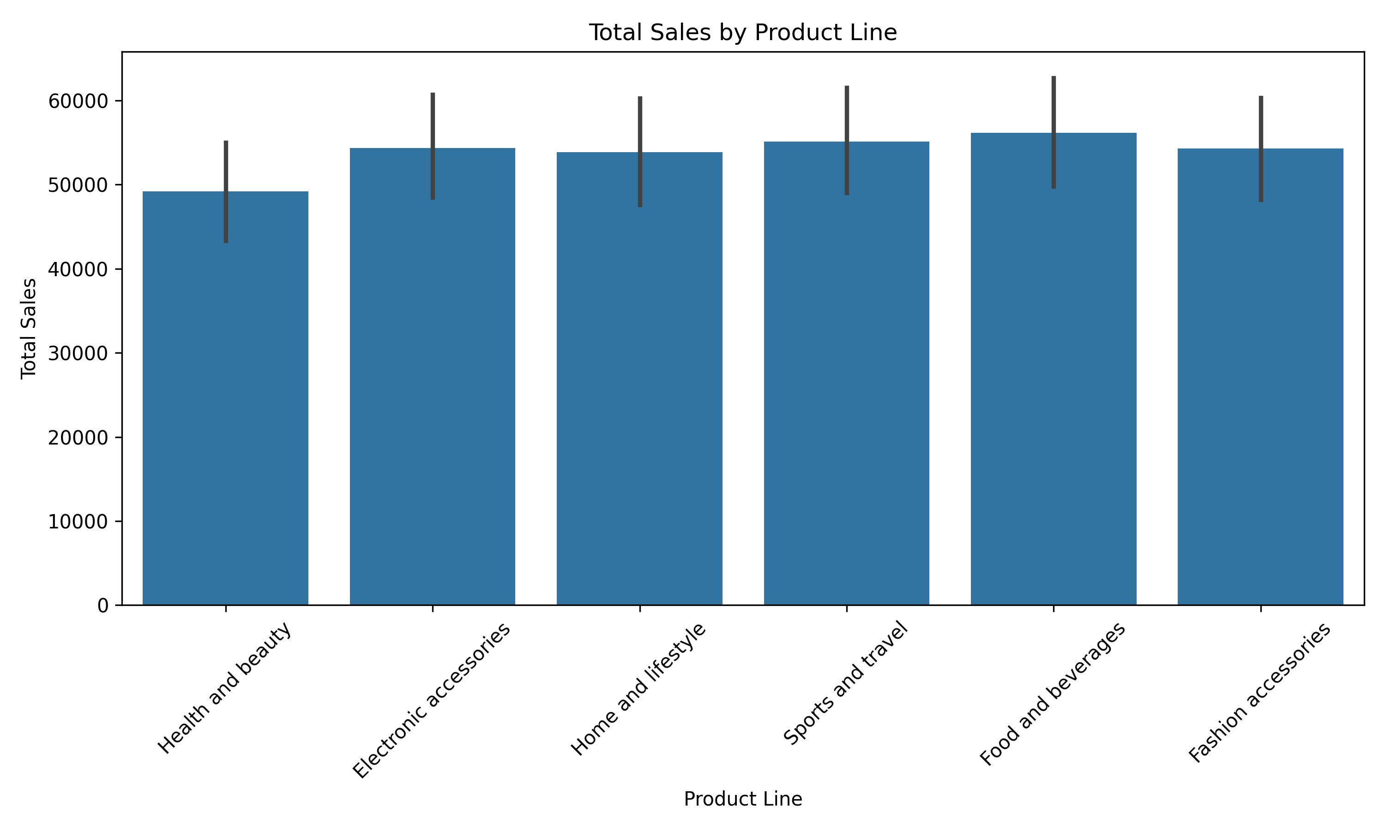
Interpretation: This visualization compares total sales generated by different product lines.

Total Sales by Payment Method
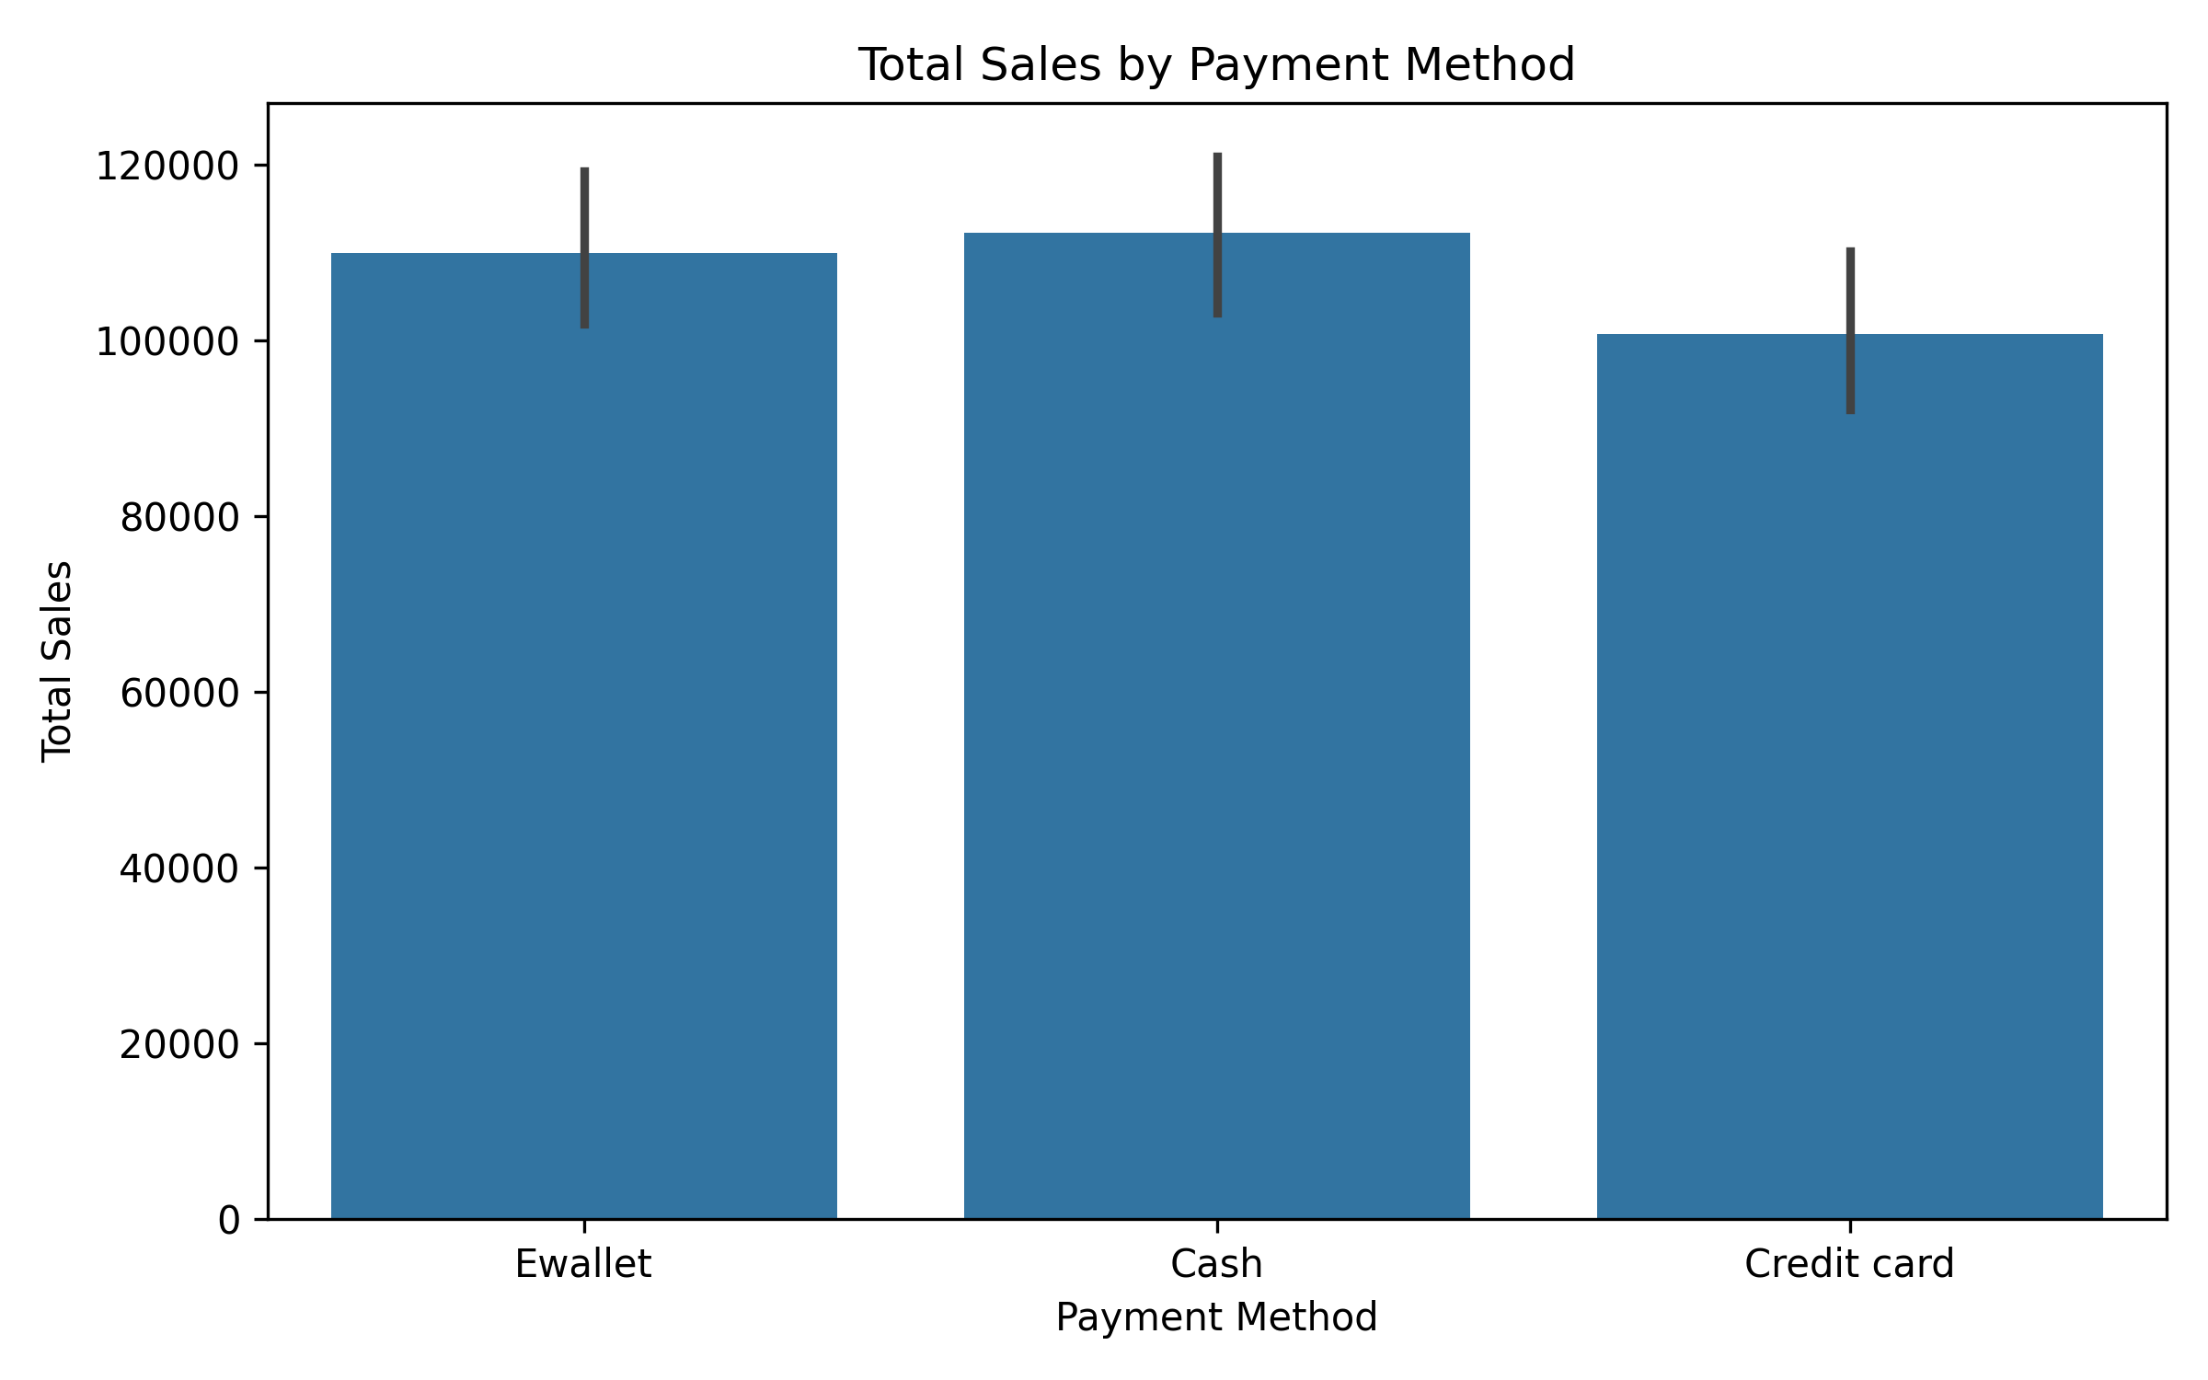
Interpretation: This chart compares total sales across different payment methods.

Total Sales by Customer Type
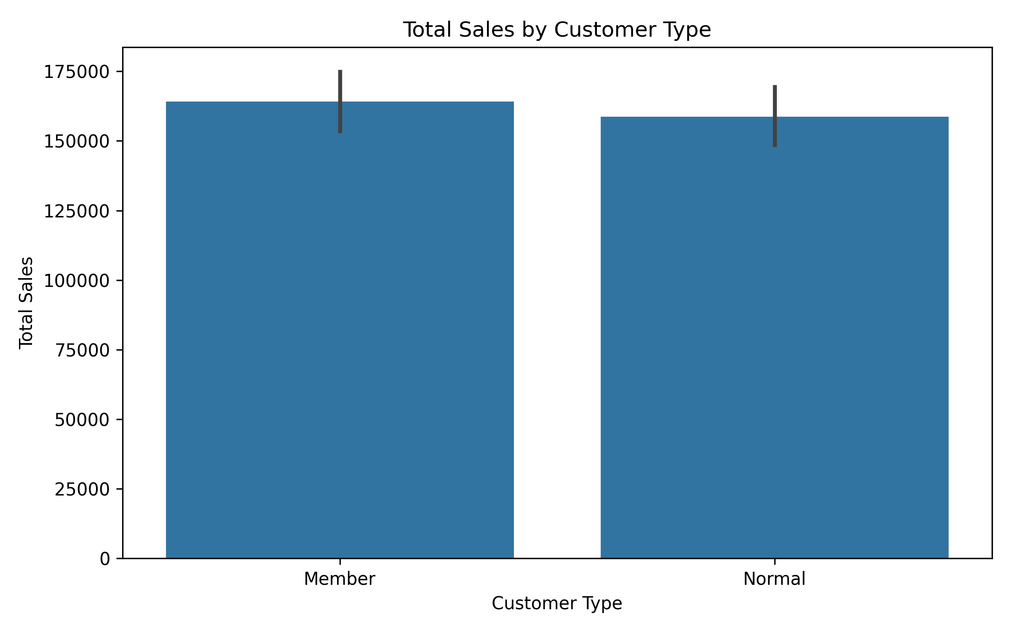
Interpretation: This visualization compares sales generated by Member and Normal customers.

Total Sales by City
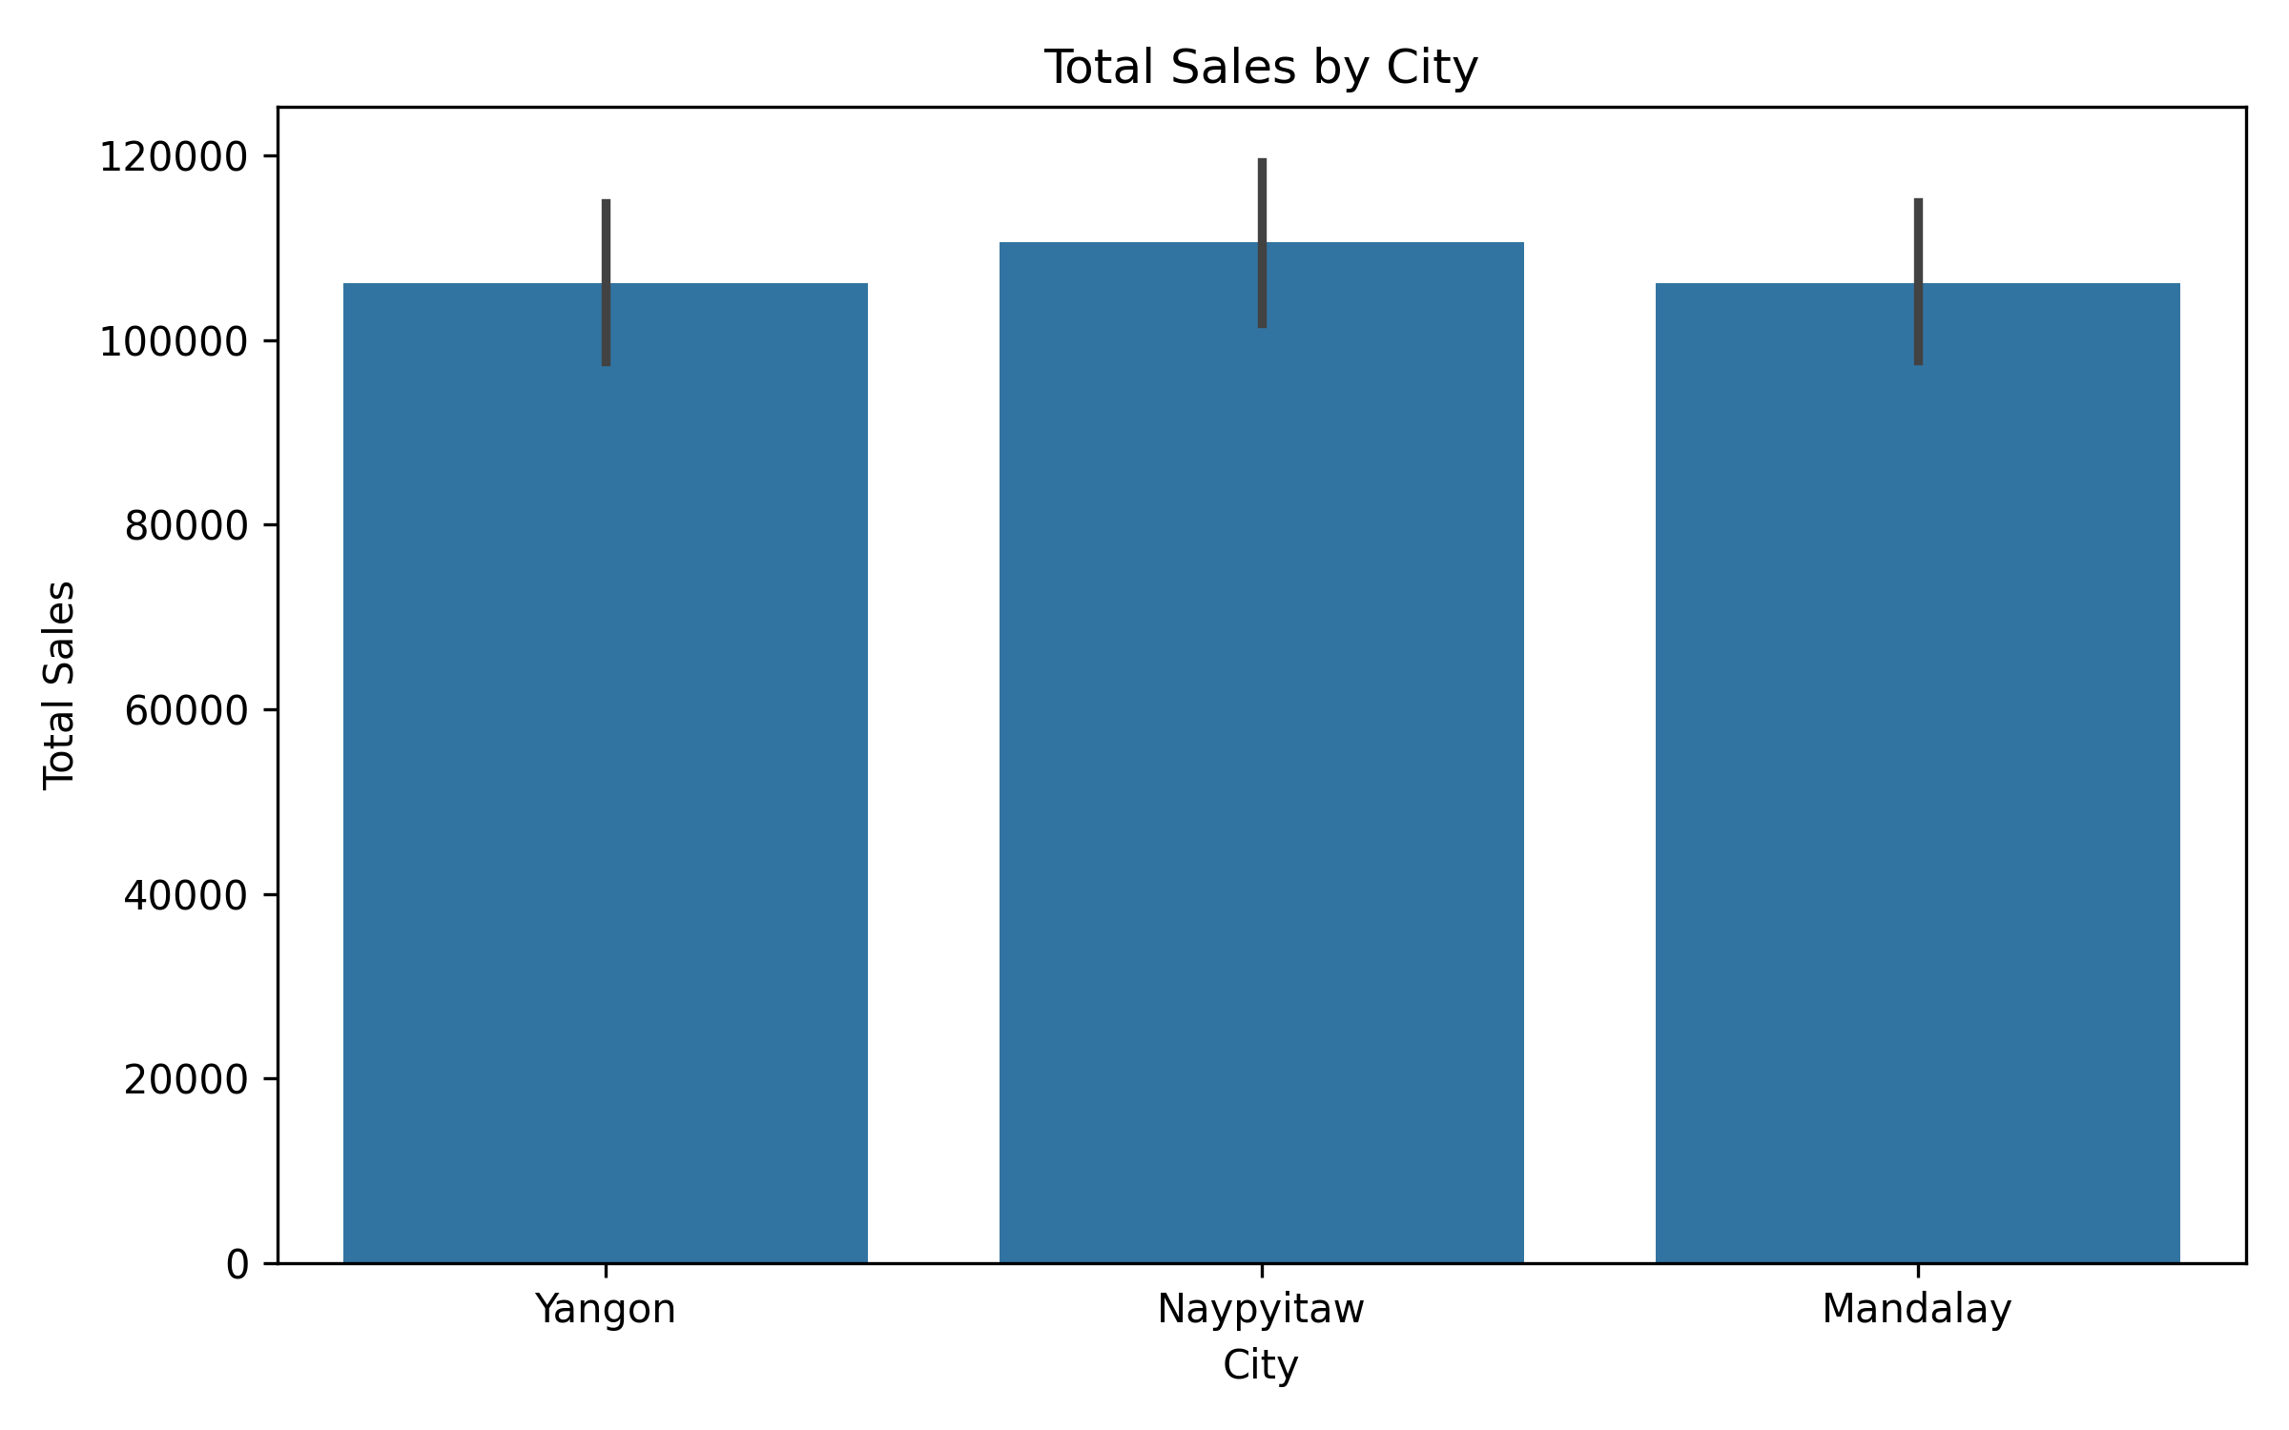
Interpretation: This chart compares total sales across the cities in the dataset.

Correlation Heatmap
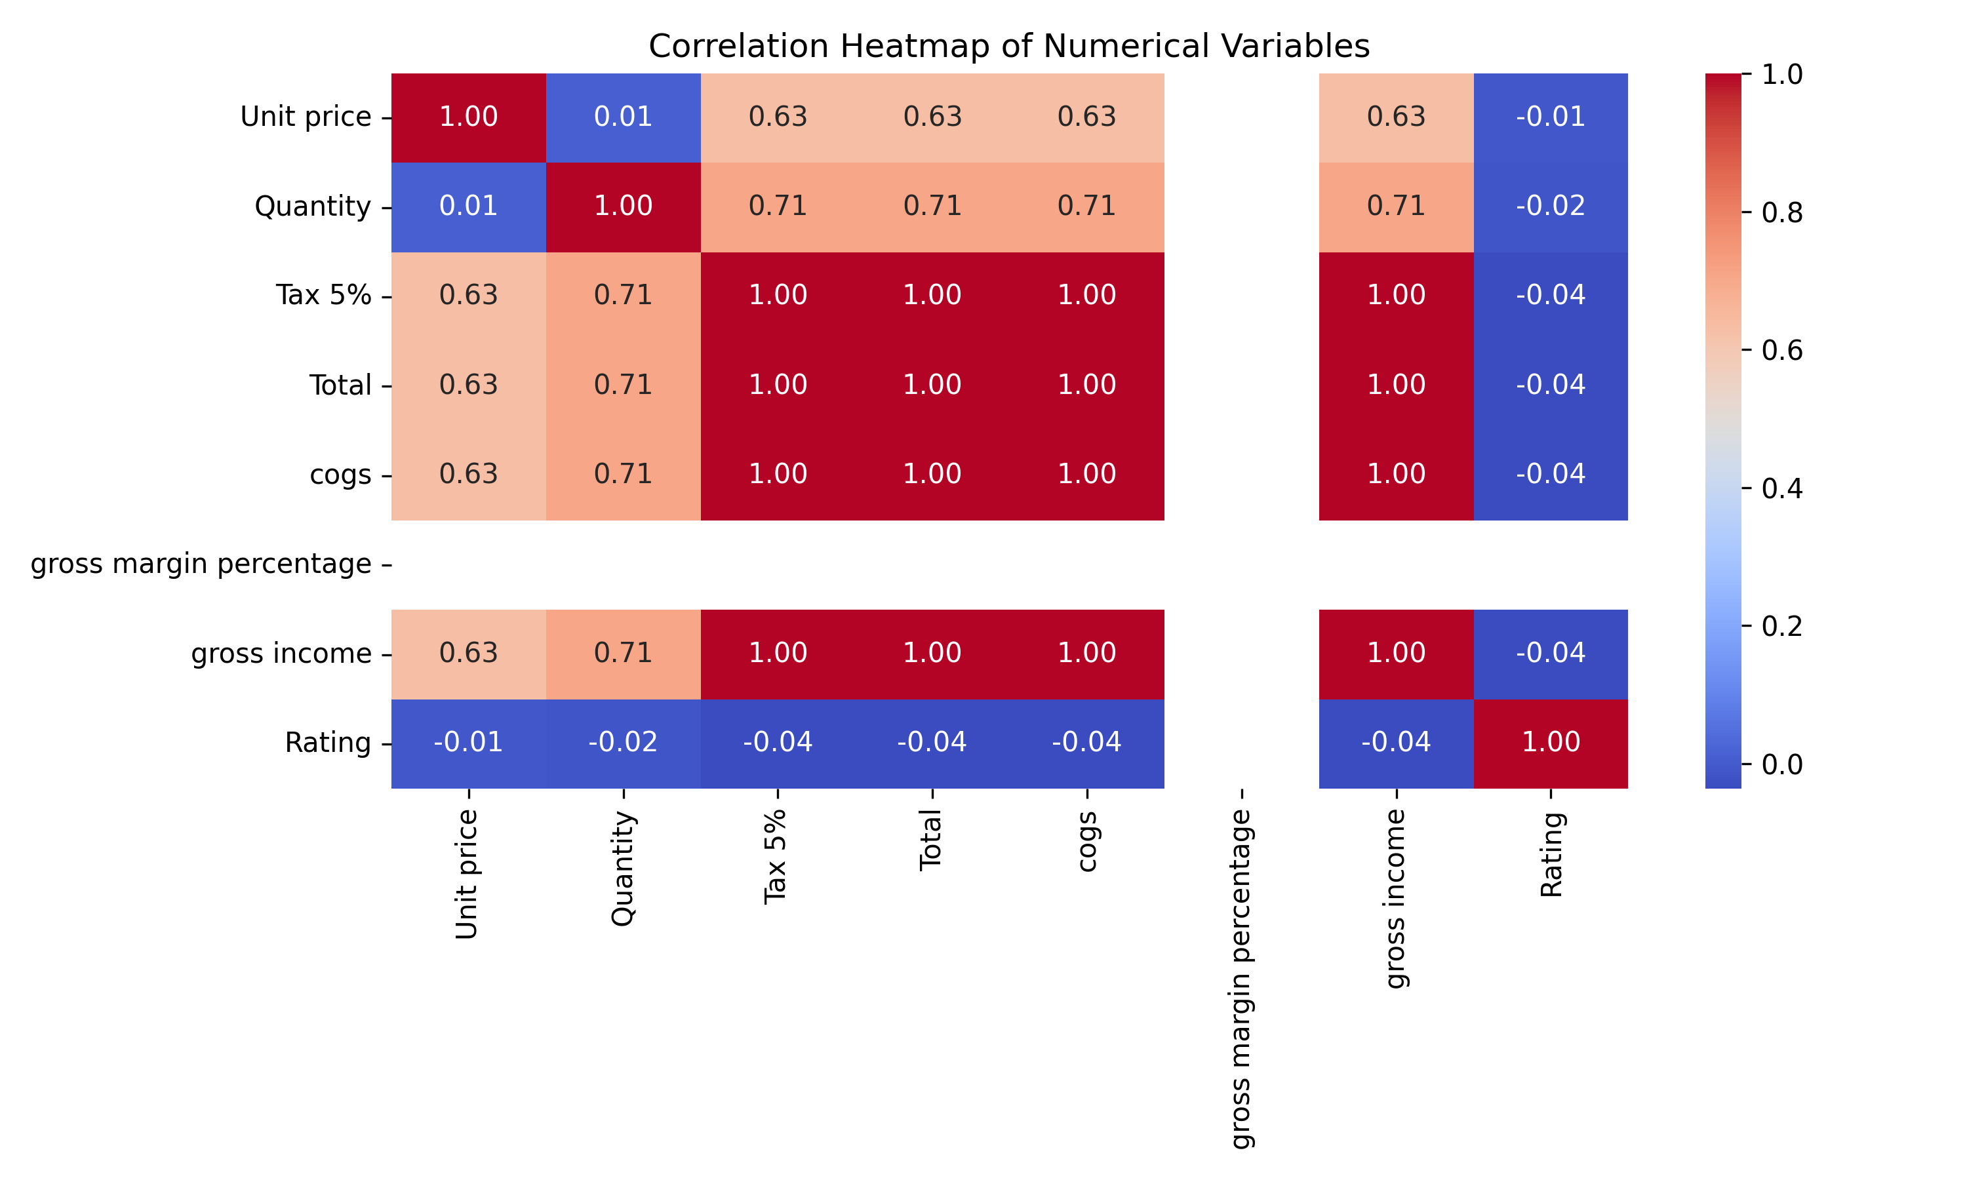
Interpretation: The heatmap shows the strength and direction of relationships among numerical variables.

Distribution of Total Sales
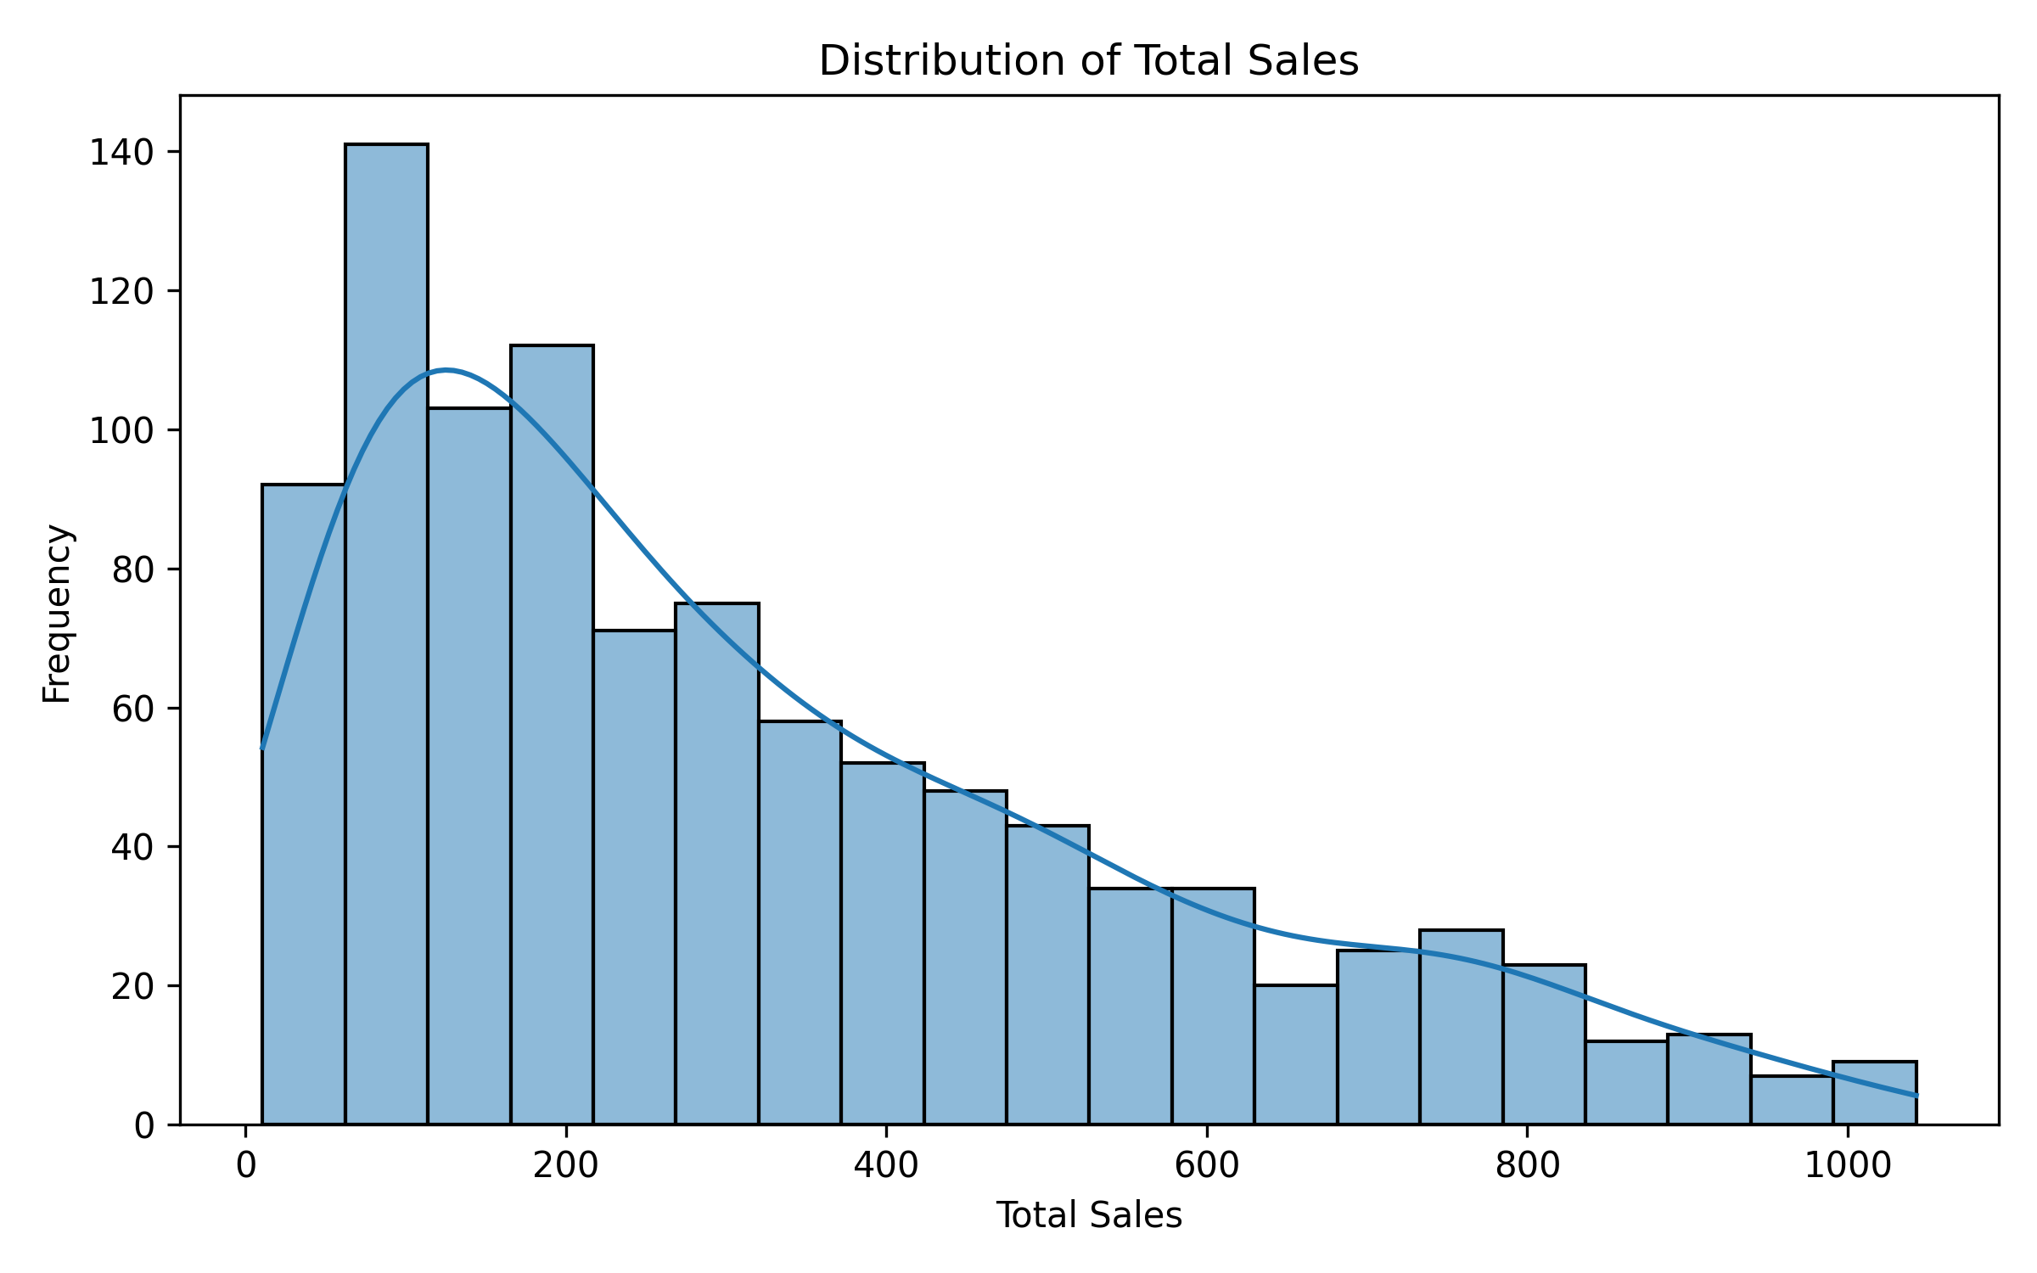
Interpretation: The histogram shows the distribution and concentration of transaction-level sales values.

Quantity vs Total Sales
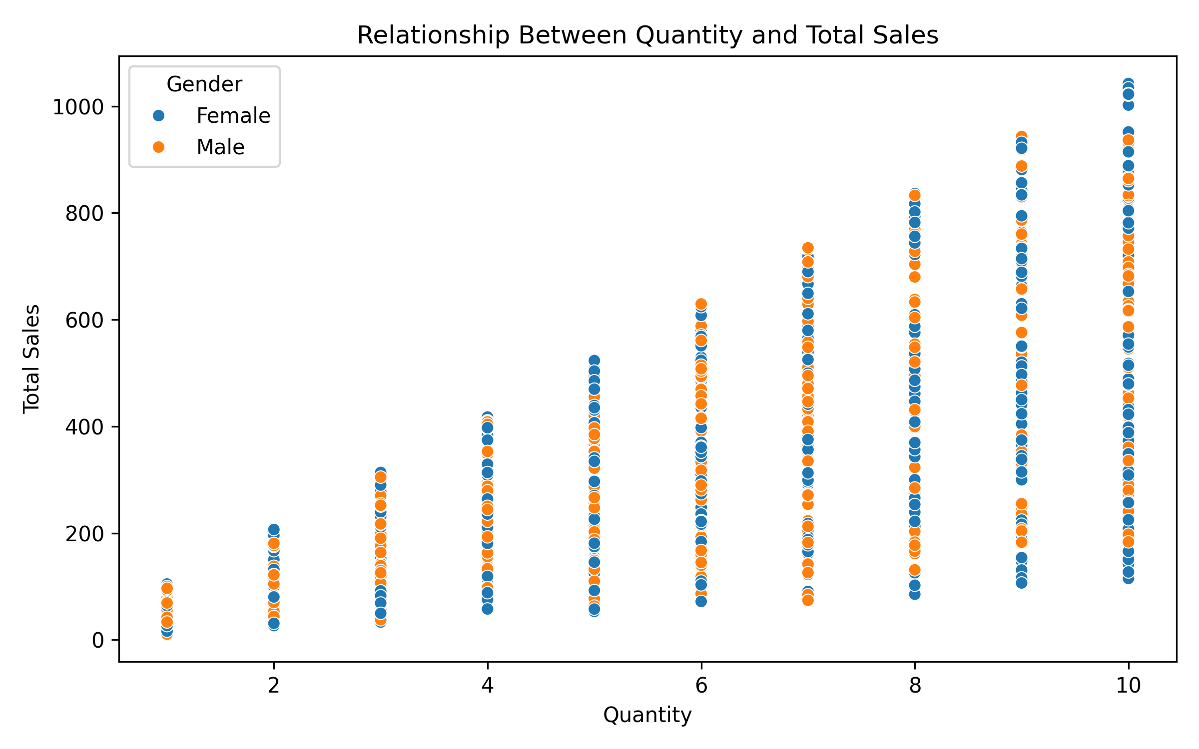
Interpretation: The scatter plot helps examine the relationship between quantity purchased and total sales.

Average Rating by Product Line
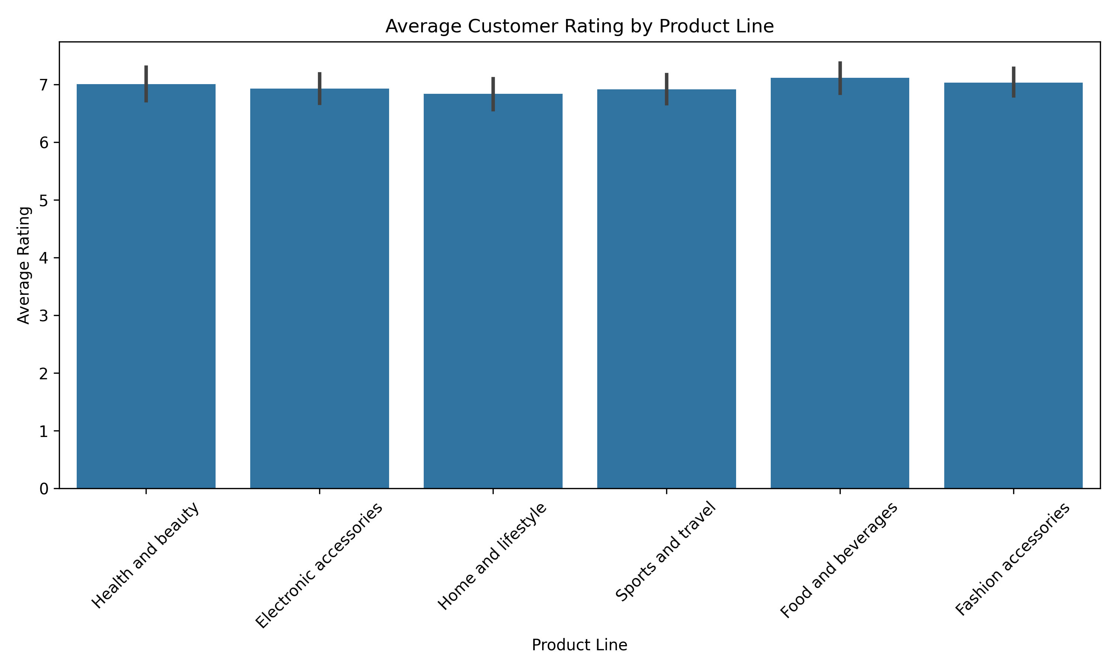
Interpretation: This chart compares average customer ratings across product lines.

Monthly Sales Trend
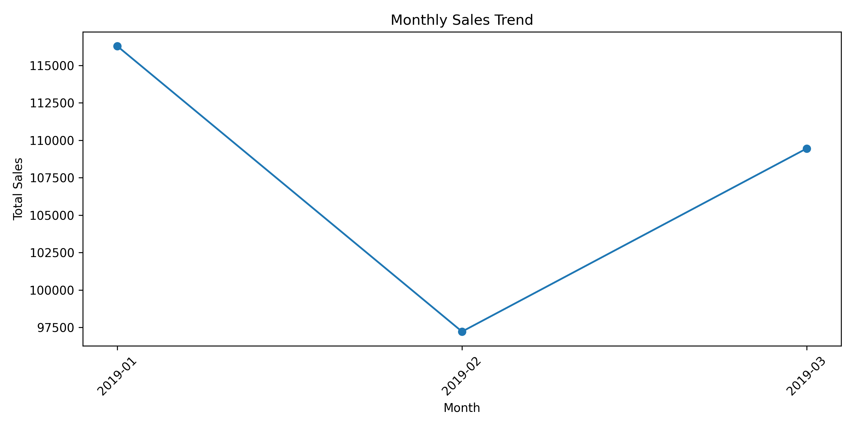
Interpretation: The line chart shows how total sales change across the available months.

Total Sales by Day of the Week
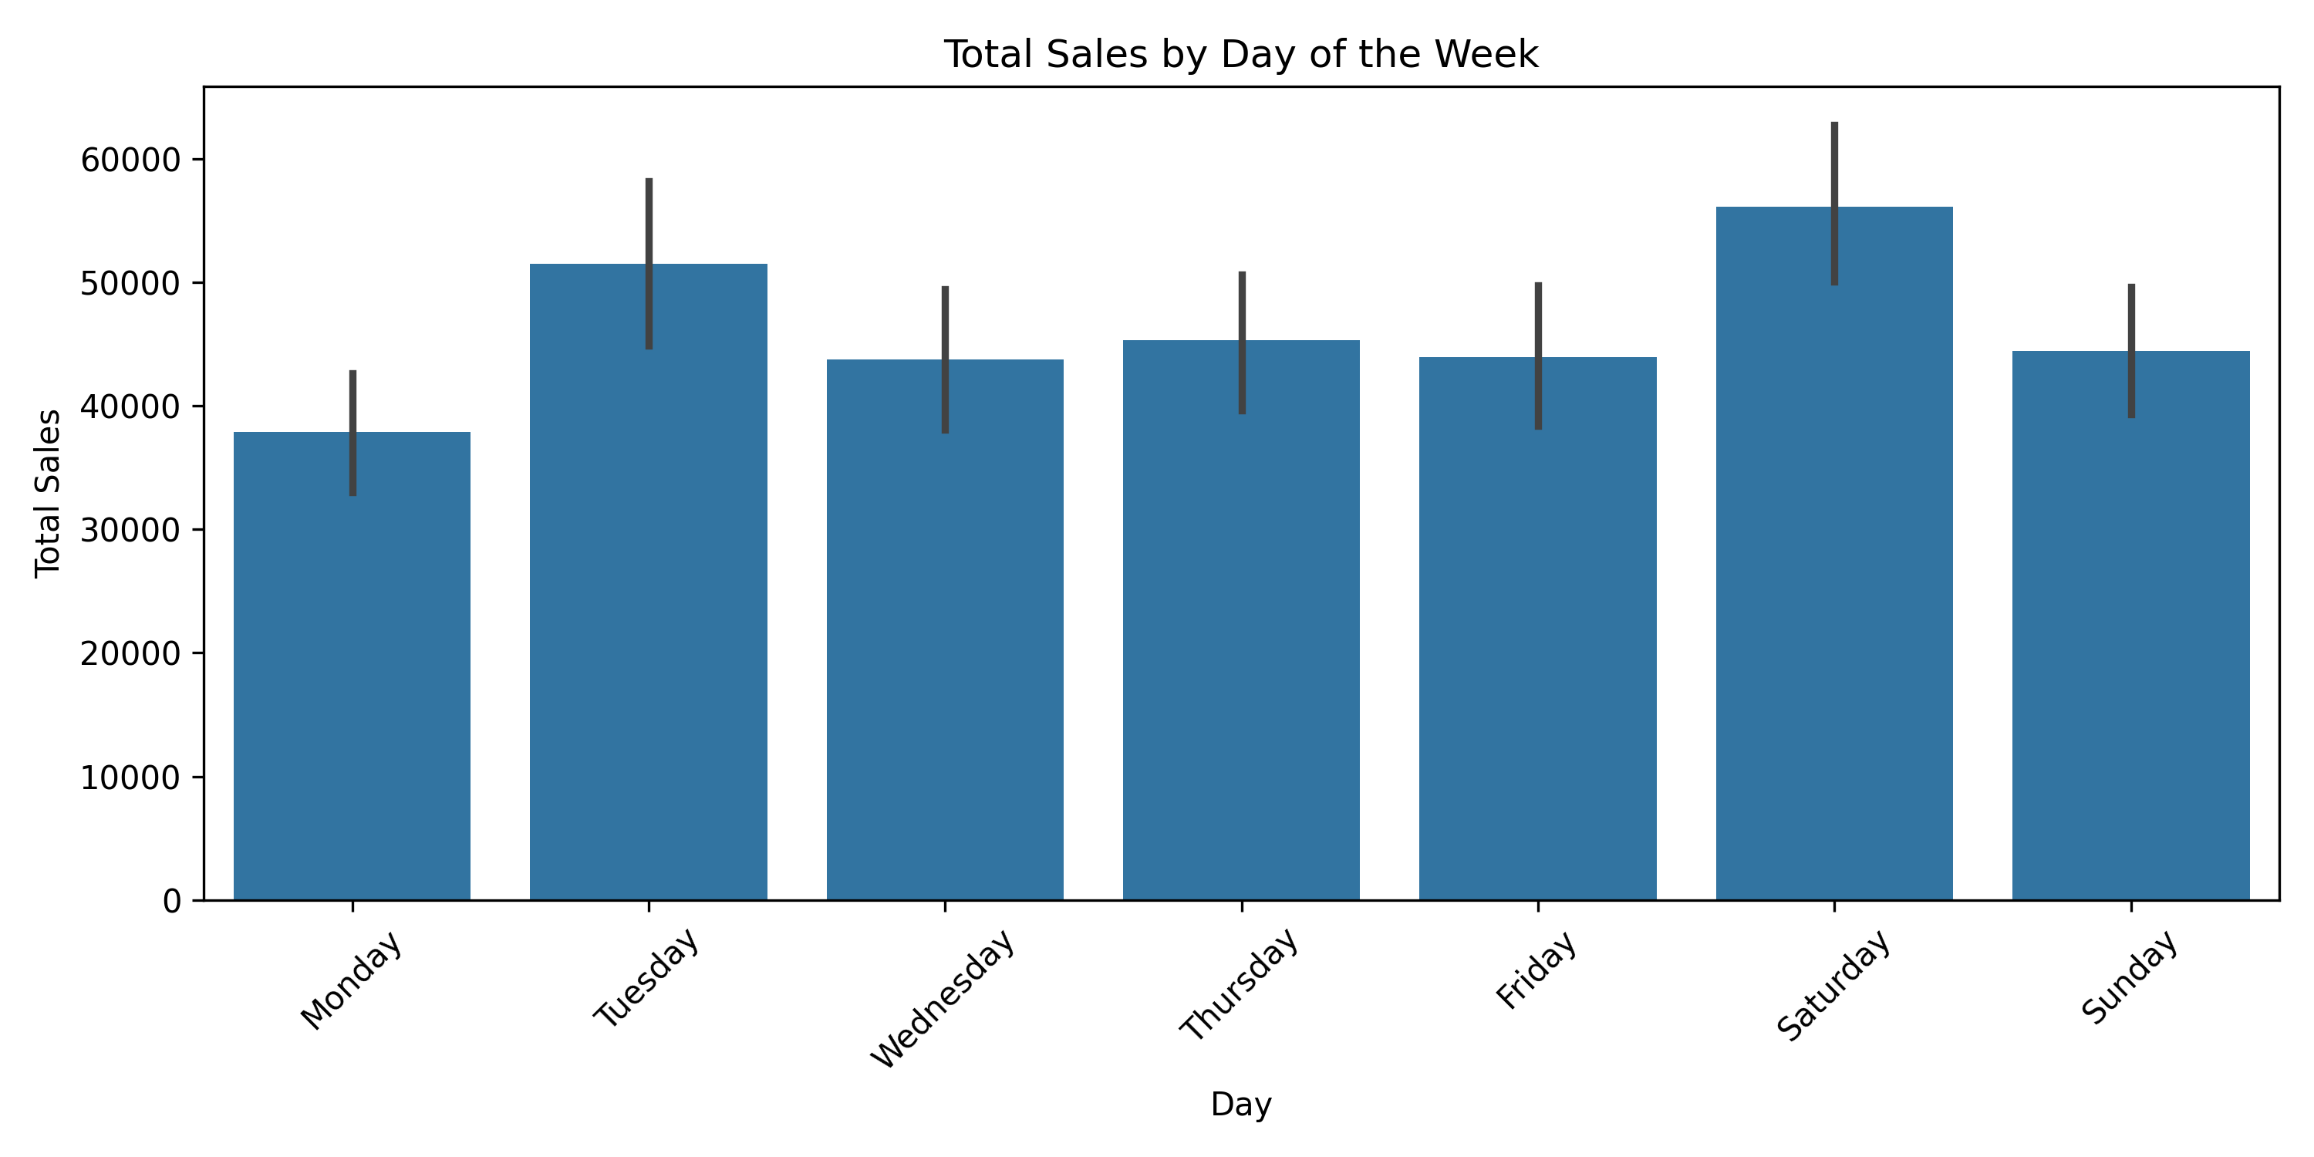
Interpretation: This visualization compares sales across different days of the week.

Distribution of Quantity Sold
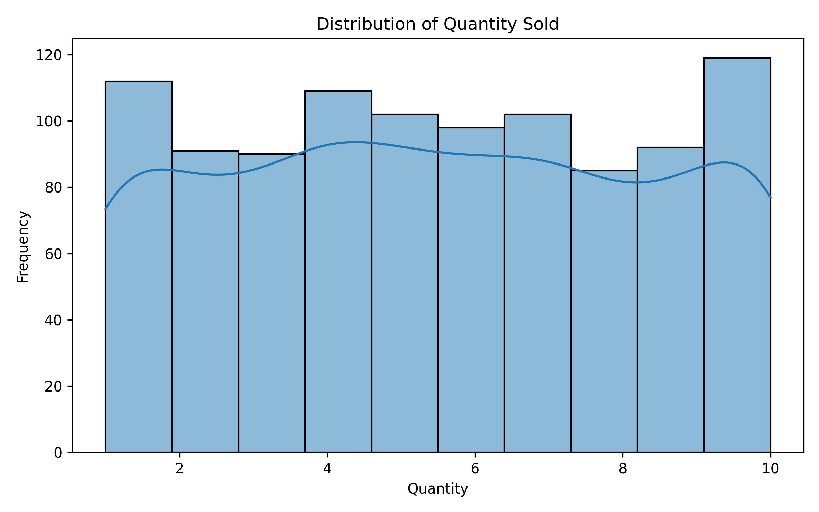
Interpretation: The histogram shows how frequently different quantities are purchased.

Total Quantity Sold by Product Line
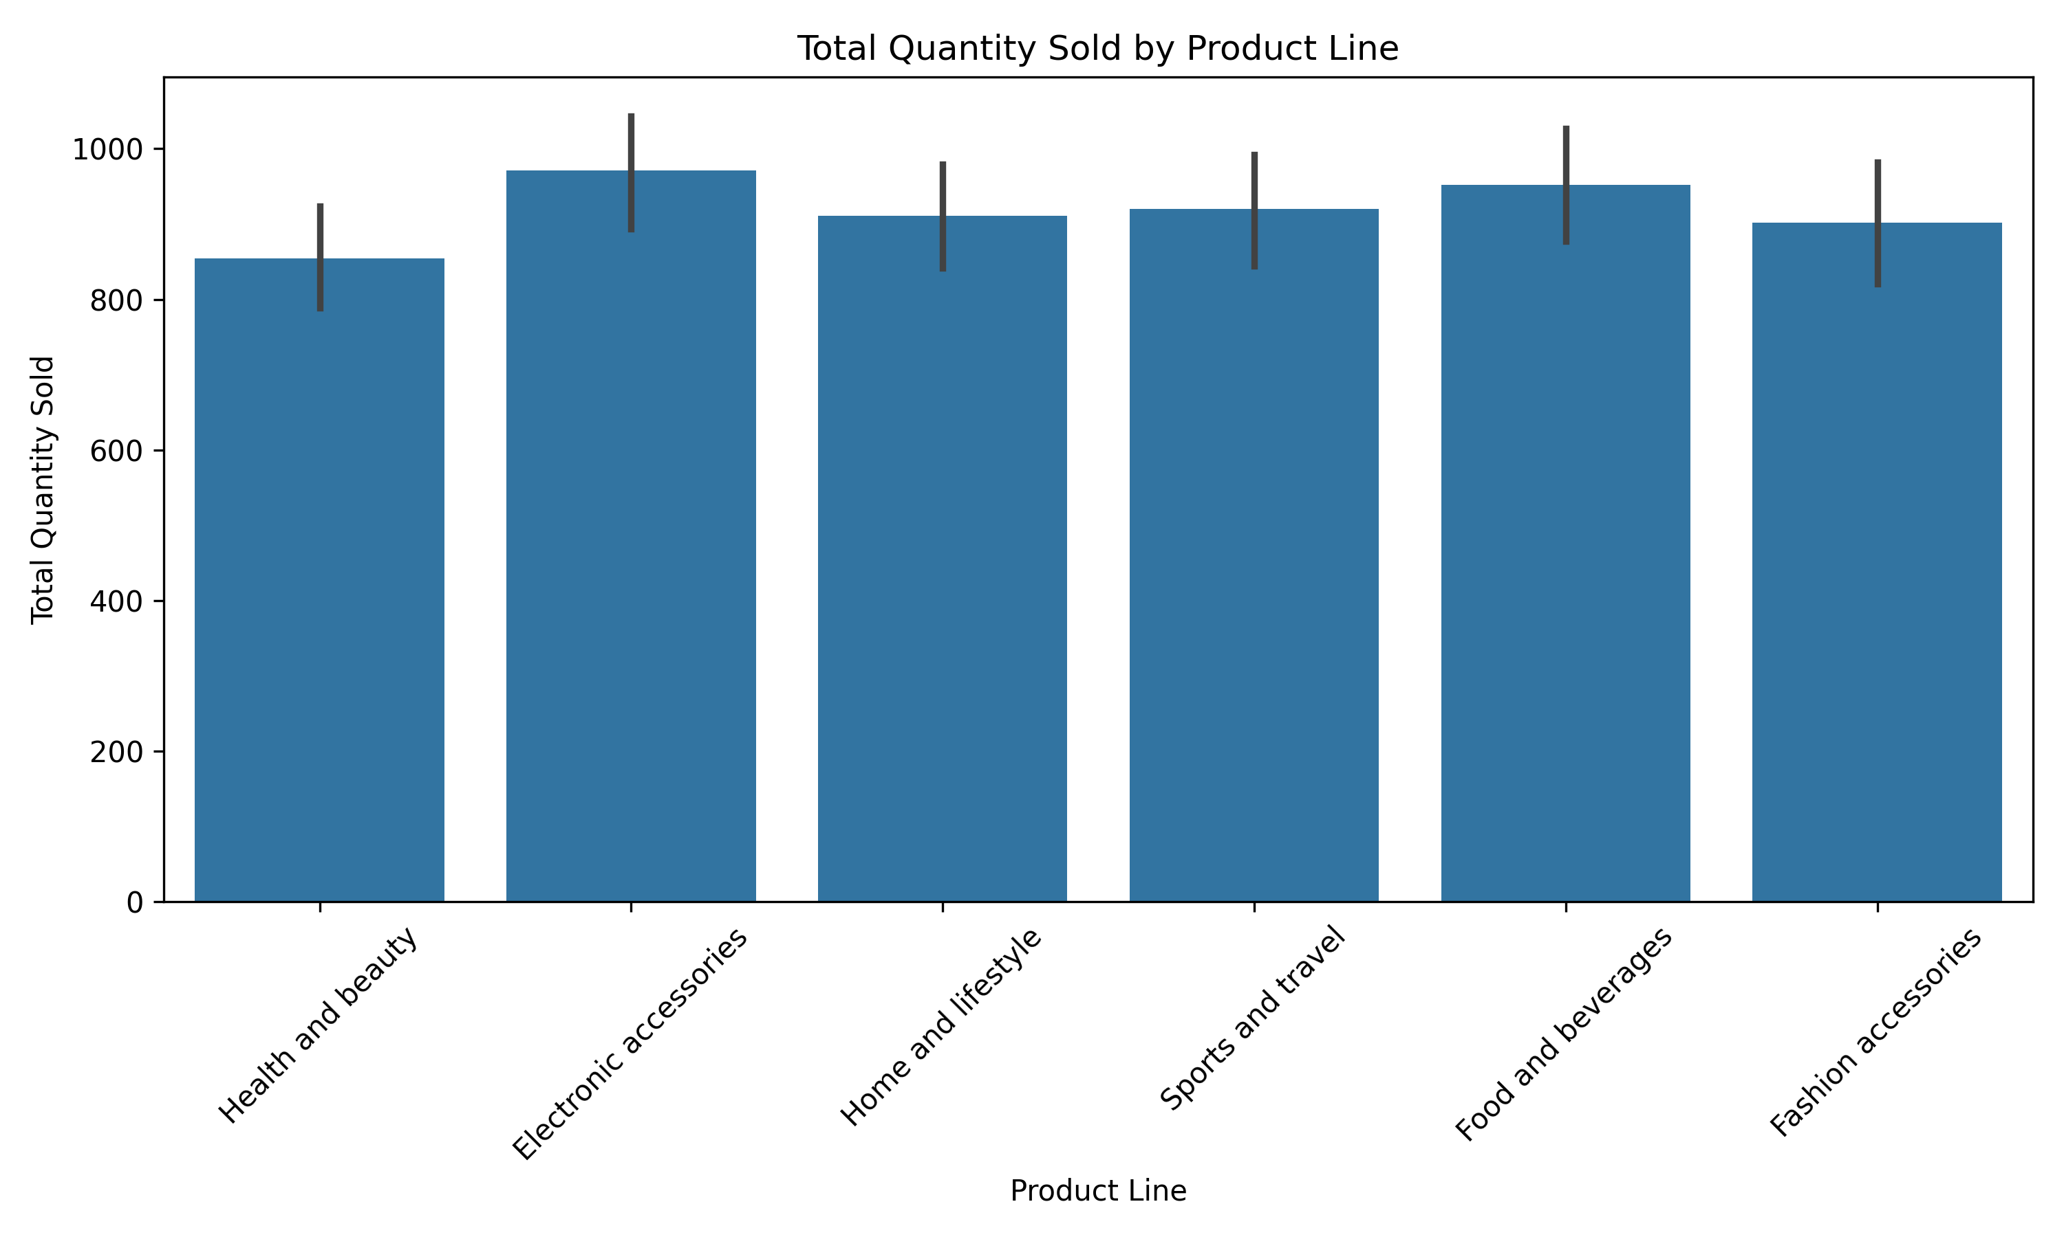
Interpretation: This chart compares the total quantity sold across product lines.

Average Unit Price by Product Line
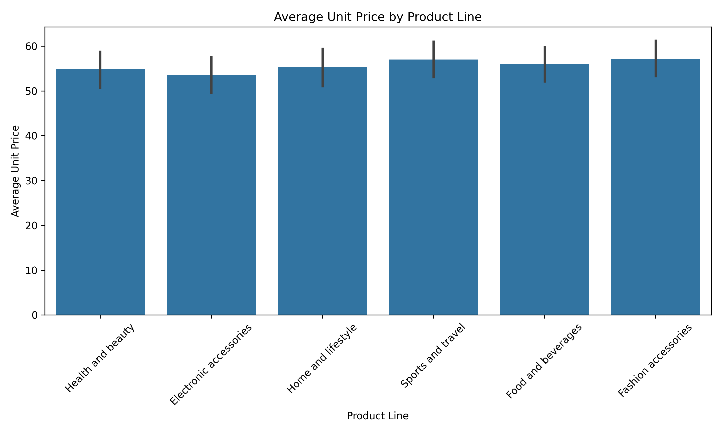
Interpretation: This visualization compares the average unit price of each product line.

Customer Type and Gender
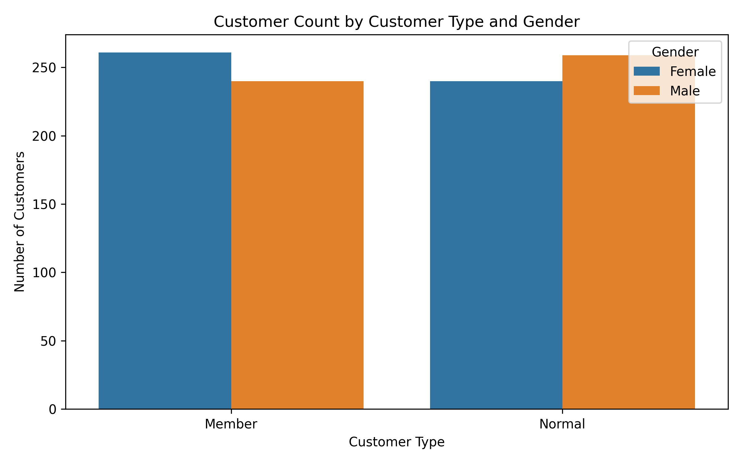
Interpretation: This count plot compares customer types across genders.

Total Gross Income by Product Line
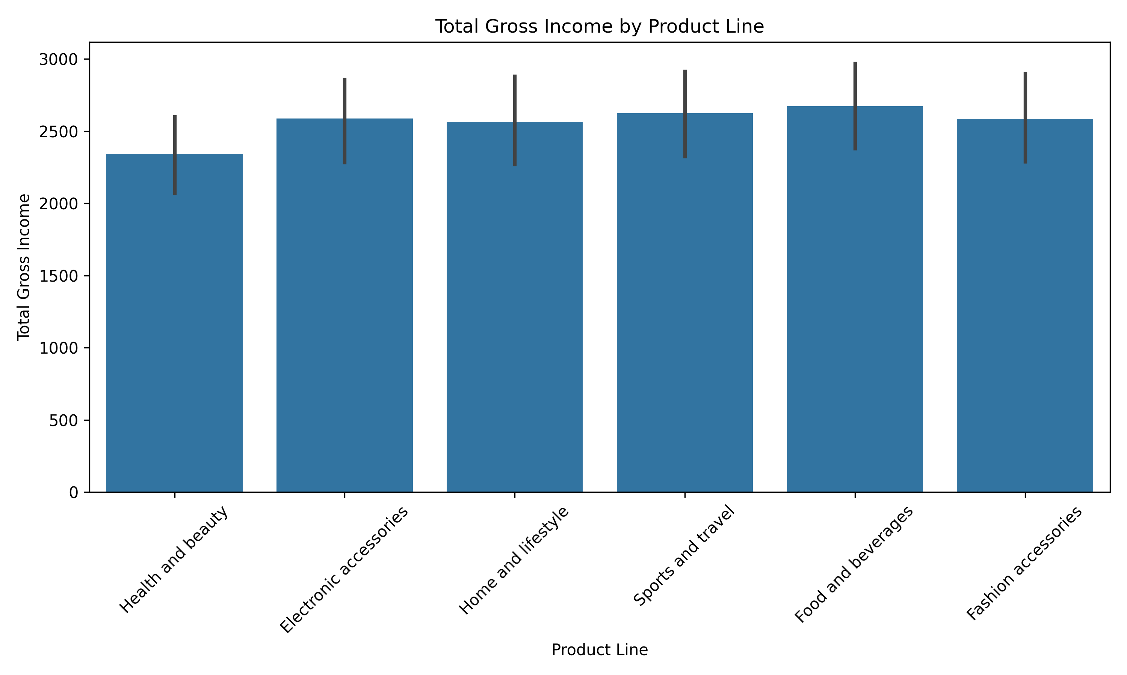
Interpretation: This chart compares gross income generated by different product lines.

Gross Income Distribution
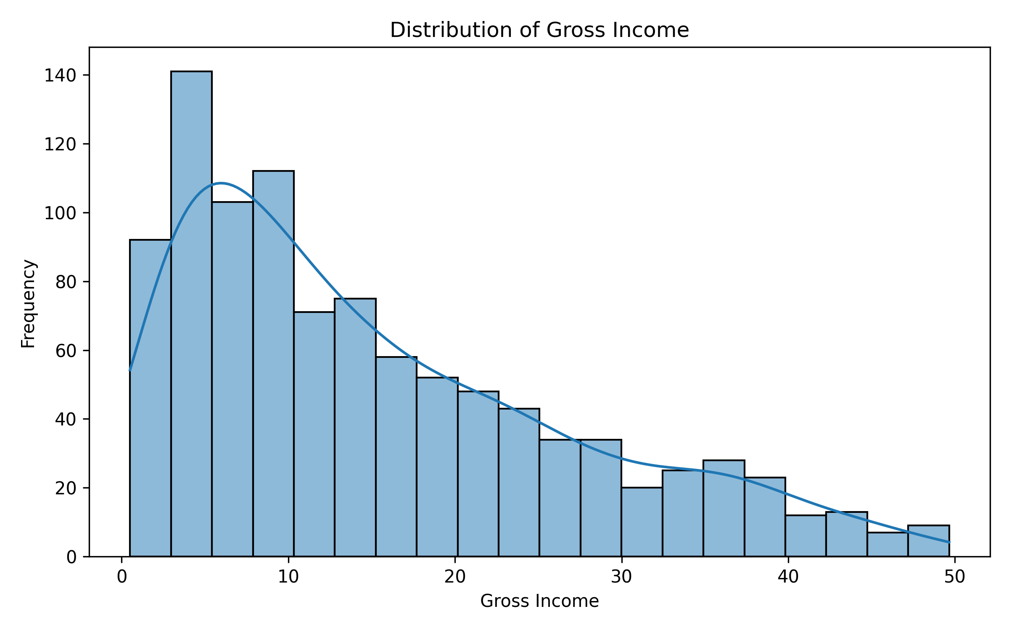
Interpretation: The histogram shows the distribution of gross income values.

Rating Distribution by Product Line
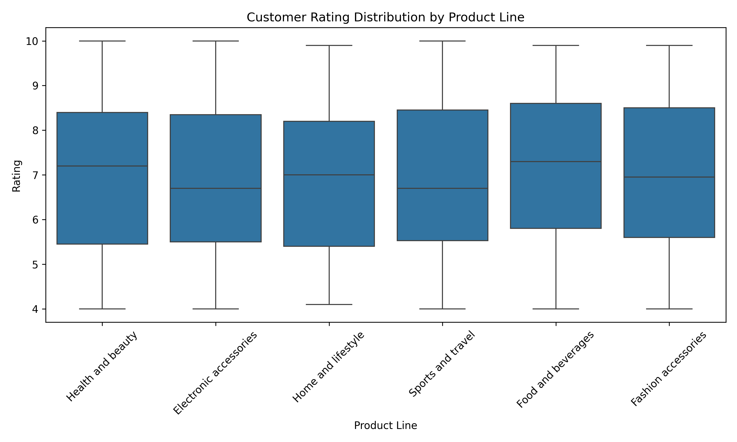
Interpretation: The box plot compares rating distributions and variation across product lines.

Unit Price vs Quantity
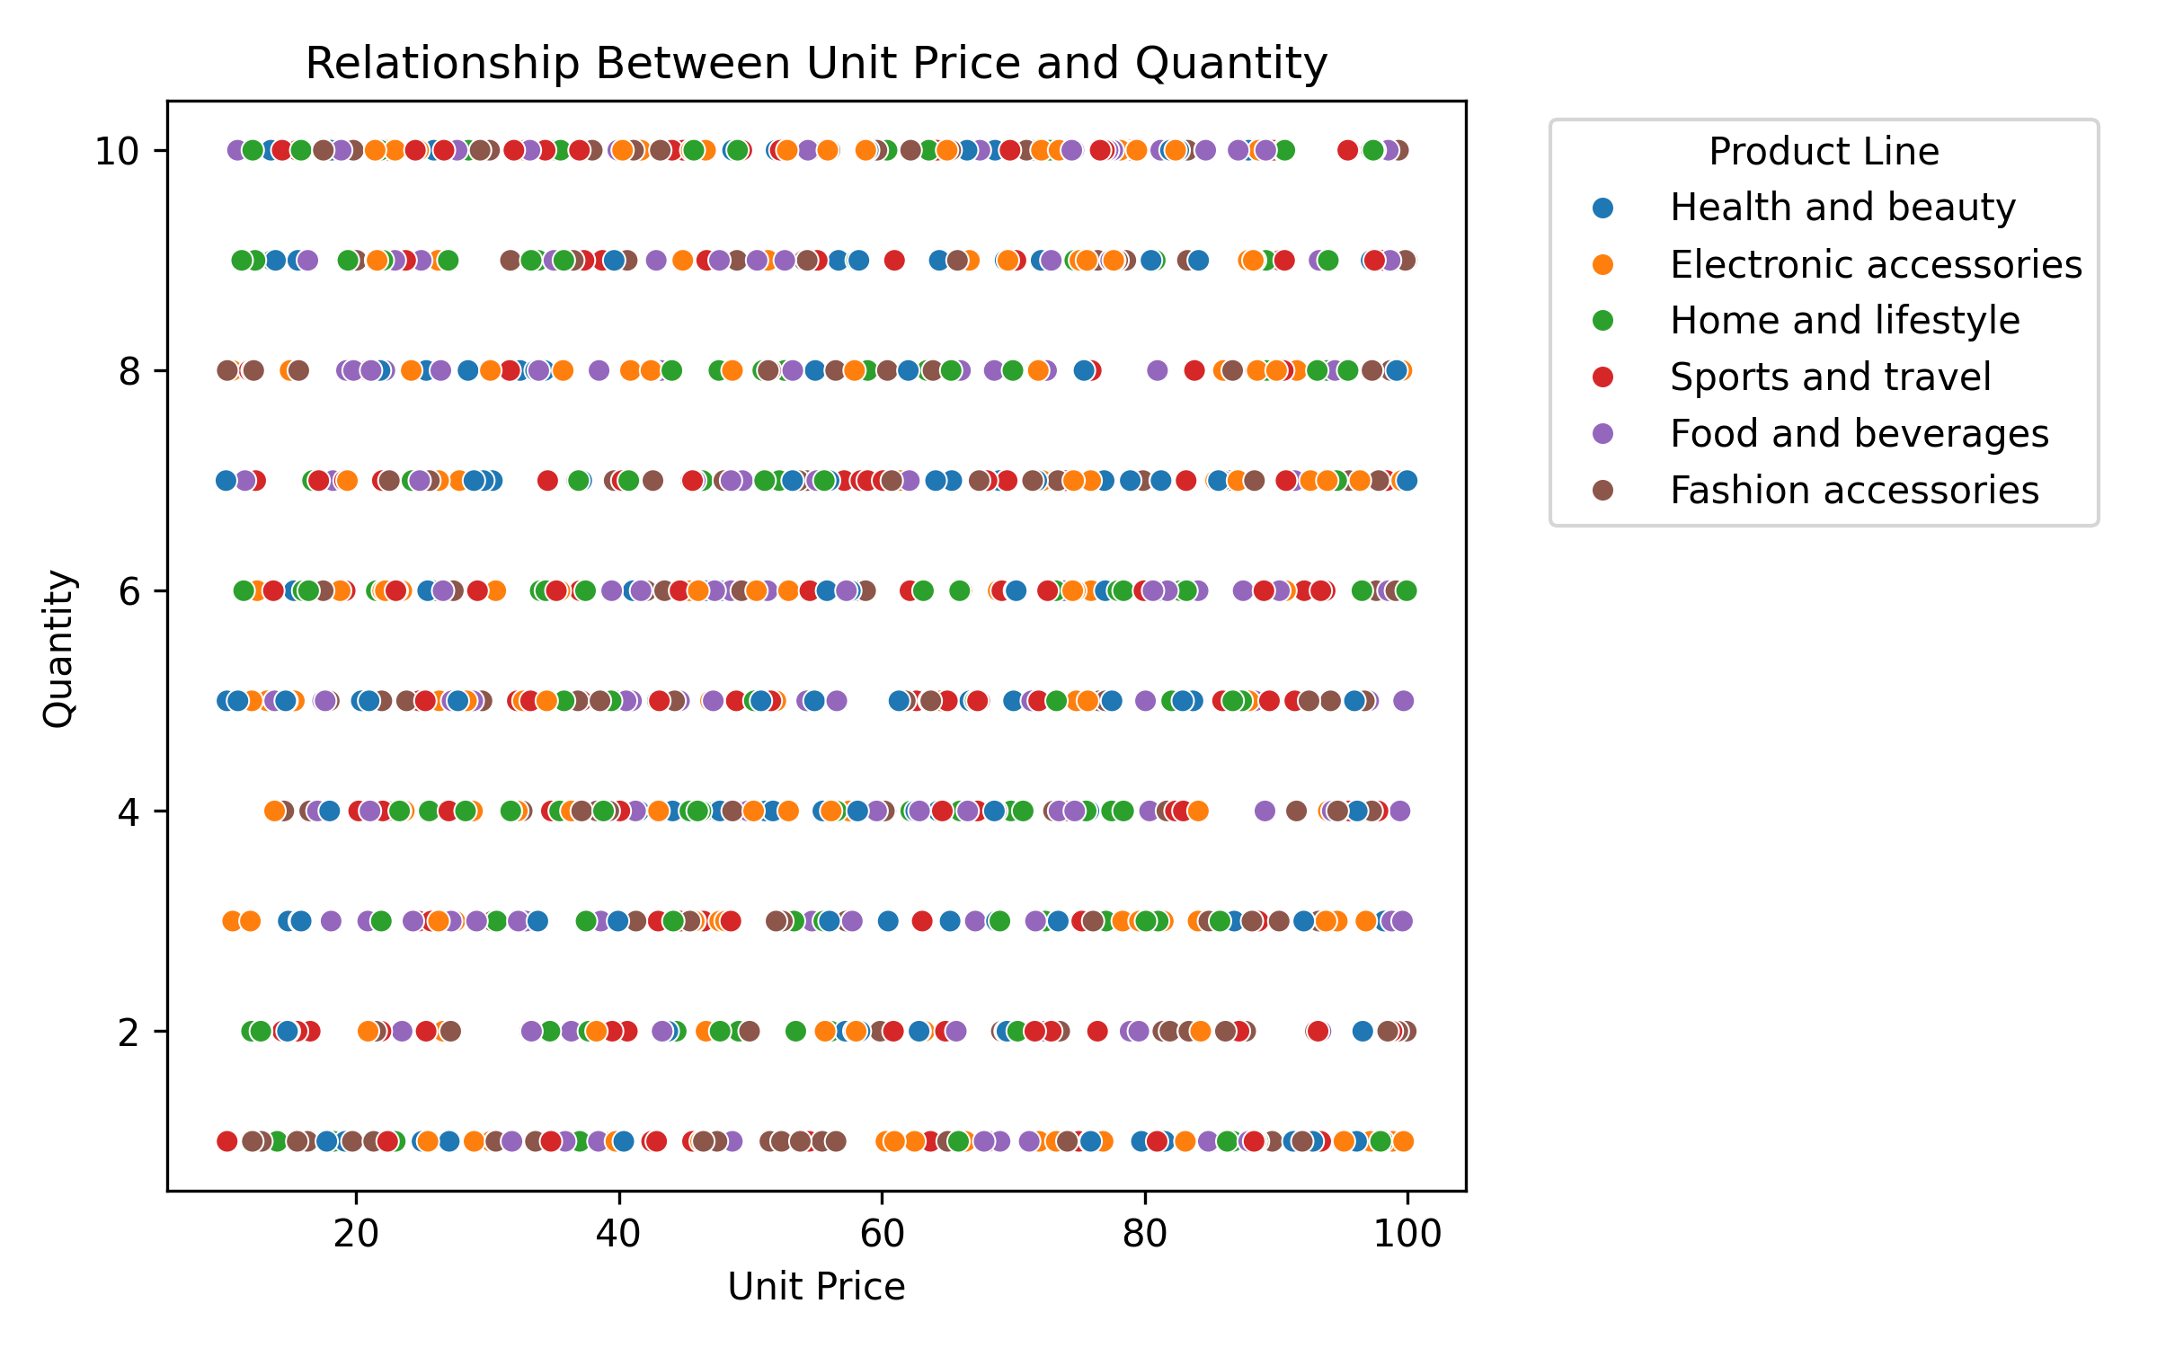
Interpretation: The scatter plot examines whether unit price and quantity show a visible relationship.

Customer Count by City
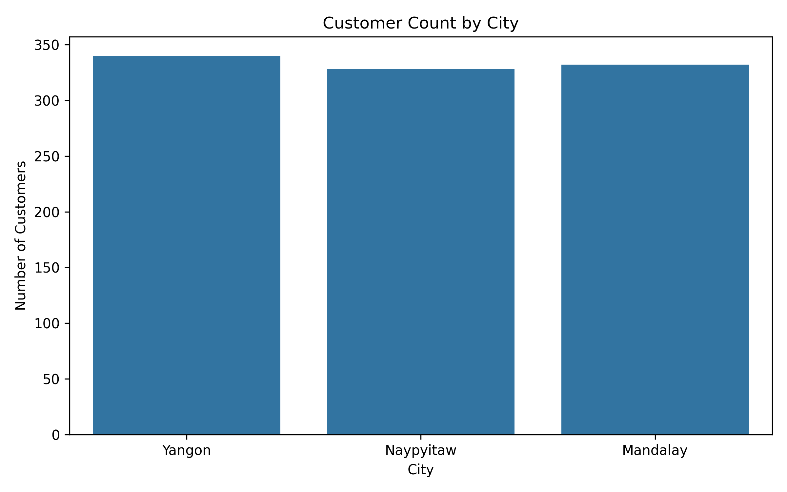
Interpretation: This chart compares the number of transactions/customers recorded in each city.

Average Rating by City
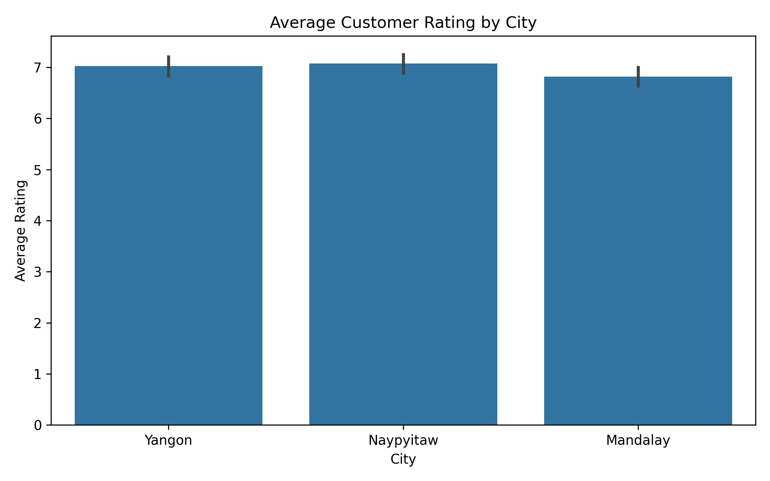
Interpretation: This visualization compares average customer ratings across cities.

16. Key Findings
- The dataset contains 1000 transaction records and 18 variables.
- There are 0 missing values in the dataset.
- There are 0 duplicate records.
- The product line with the highest total sales is Food and beverages.
- The city with the highest total sales is Naypyitaw.
- The customer type with the highest total sales is Member.
- The payment method with the highest total sales is Cash.
- The product line with the highest average rating is Food and beverages.
- The analysis identified 9 potential outlier transactions based on the IQR method.

17. Conclusion
The exploratory data analysis provided a detailed understanding of the supermarket sales dataset. Different aspects of the data were examined using descriptive statistics, aggregation, distribution analysis, correlation analysis, and multiple visualizations.
The analysis helped identify differences in sales performance across product lines, cities, customer types, payment methods, and time periods. Visualizations also helped identify distributions, relationships, and potential anomalies in the transaction data.
Overall, the EDA demonstrates how Python-based data analysis can be used to transform raw transaction data into meaningful business insights.

18. Tools and Technologies
- Google Colab
- Python
- Pandas
- Matplotlib
- Seaborn
- Microsoft Word / DOCX
- df = pd.read_csv('/content/supermarket_sales.csv')
df.isnull().sum()
- df.duplicated().sum()
- df.describe()
product_summary = df.groupby('Product line').agg({
- 'Total': 'sum',
- 'Quantity': 'sum',
- 'Rating': 'mean'
- }).round(2)
sns.barplot(data=df, x='Product line', y='Total', estimator='sum')
- plt.title('Total Sales by Product Line')
- plt.xlabel('Product Line')
- plt.ylabel('Total Sales')
- plt.show()
3. Improve the visualization interpretations
- Your current interpretations are mostly descriptions like “This chart compares…” rather than actual findings. For example, under Total Sales by Product Line, replace the current interpretation with:
- Interpretation: Food and beverages generated the highest total sales at 56,144.84, while Health and beauty generated the lowest total sales at 49,193.74. This shows that sales performance varies across product categories.
- For Total Sales by City:
- Interpretation: Naypyitaw recorded the highest total sales at 110,568.71, while Mandalay recorded 106,197.67. The difference suggests that sales performance varies slightly across cities.
- For Total Sales by Customer Type:
- Interpretation: Member customers generated higher total sales of 164,223.44 compared with Normal customers at 158,743.30.
- For Total Sales by Payment Method:
- Interpretation: Cash recorded the highest total sales at 112,206.57, followed by Ewallet at 109,993.11 and Credit card at 100,767.07.
- Your actual report already contains these underlying values in the aggregation tables.
4. Improve the correlation interpretation
- Under Correlation Analysis, add:
- Interpretation: Total Sales has a strong positive relationship with Quantity and a positive relationship with Unit Price. This is expected because purchasing more units or purchasing higher-priced products generally increases the total transaction value. Customer Rating has a very weak relationship with Total Sales, suggesting that rating does not have a strong linear relationship with transaction value.
- 5. Add “Data Transformation and Aggregation”
- This is specifically required by the assignment. Add this section:
- Data Transformation and Aggregation
- The Date column was converted into a datetime format to support time-based analysis. A Day column was created from the Date column to analyze sales by day of the week. GroupBy operations were used to calculate total sales, total quantity, and average ratings by product line, city, customer type, and payment method. A pivot table was also used to compare sales across product lines and cities. These transformations helped convert transaction-level data into meaningful summaries for analysis.

- Data Transformation and Aggregation
The Date column was converted into a datetime format to support time-based analysis. A Day column was created from the Date column to analyze sales by day of the week. GroupBy operations were used to calculate total sales, total quantity, and average ratings by product line, city, customer type, and payment method. A pivot table was also used to compare sales across product lines and cities. These transformations helped convert transaction-level data into meaningful summaries for analysis.
8. Exploratory Data Visualization
Multiple visualizations were created using Matplotlib and Seaborn to explore sales performance, customer behavior, product performance, distributions, relationships, and trends in the dataset. Bar charts, histograms, scatter plots, box plots, line charts, and heatmaps were used ty important patterns and anomalies.
- 9. Key Findings
• Highest Sales Product Line: Food and beverages
- • Highest Sales City: Naypyitaw
- • Highest Sales Customer Type: Member
- • Highest Sales Payment Method: Cash
- • Highest Average Rating Product Line: Food and beverages
- • Potential Outliers: 9 transactions were identified as potential outliers using the IQR method.
The EDA revealed differences in sales performance across product lines, cities, customer types, and payment methods. Food and beverages recorded the highest total sales among the product lines, while Naypyitaw recorded the highest city-wise sales. Member customers generated higher total sales than Normal customers, and Cash was the highest-selling payment method.
10. Conclusion
This exploratory data analysis provided useful insights into the Supermarket Sales dataset. The analysis examined data quality, descriptive statistics, product performance, customer behavior, payment methods, sales trends, correlations, distributions, and potential outliers. Different visualizations helped identify patterns and relationships within the data. Overall, the project demonstrates how Pandas, Matplotlib, and Seaborn can be used to explore raw transactional data and convert it into meaningful business insights.
11. Tools and Technologies Used
• Python
- • Pandas
- • Matplotlib
- • Seaborn
- • Google Colab
- • Microsoft Word
12. References
- Dataset Source: Kaggle – Supermarket Sales Dataset
Analysis Environment: Google Colab
Documentation: Python Pandas, Matplotlib and Seaborn libraries
