WEEK 2 REPORT
EXPLORATORY DATA ANALYSIS AND VISUALIZATION
Project: Supermarket Sales Analysis
Name: Nandita Manna
Internship: YuvaIntern
Tools Used: Python, Pandas, Matplotlib, Seaborn
Submitted as part of Week 2 Internship Task
1. Introduction
Exploratory Data Analysis (EDA) is an important process used to understand a dataset by examining its structure, characteristics, patterns, relationships, and possible anomalies. In this project, the Supermarket Sales dataset was analyzed using Python libraries such as Pandas, Matplotlib, and Seaborn. The analysis focuses on understanding sales performance, customer behaviour, product performance, payment methods, and relationships among numerical variables.
2. Objective
The main objective of this project is to perform detailed exploratory data analysis and visualization on the Supermarket Sales dataset. The analysis aims to identify meaningful patterns and trends, summarize important statistics, perform data transformation and aggregation, examine correlations, and generate useful insights through appropriate visualizations.
3. Dataset Description
The dataset used for this project is the Supermarket Sales dataset. It contains sales transactions from a supermarket and provides information about customers, products, sales amounts, payment methods, branches, and customer ratings. The dataset contains 1,000 transactions and 17 original variables. It is suitable for exploratory data analysis because it contains both categorical and numerical variables.
Variable | Description
Invoice ID | Unique identification number of each transaction
Branch | Supermarket branch where the transaction occurred
City | City where the branch is located
Customer type | Type of customer: Member or Normal
Gender | Gender of the customer
Product line | Category of the purchased product
Unit price | Price of one unit of the product
Quantity | Number of products purchased
Tax 5% | Tax amount charged on the transaction
Total | Total amount paid for the transaction
Date | Date of the transaction
Time | Time of the transaction
Payment | Payment method used by the customer
cogs | Cost of goods sold
gross margin percentage | Gross margin percentage of the transaction
gross income | Gross income generated from the transaction
Rating | Customer rating for the transaction

The dataset contains 1,000 transaction records and 17 original variables. It includes both numerical and categorical variables, making it suitable for exploratory data analysis and visualization.
4. Tools and Technologies
The analysis was performed using Google Colab and Python. Pandas was used for data loading, data cleaning, transformation, and aggregation. NumPy was used for numerical operations. Matplotlib and Seaborn were used to create different visualizations and analyze patterns and relationships in the dataset.
Tool / Library | Purpose
Google Colab | Environment for running Python code
Python | Programming language used for analysis
Pandas | Data loading, cleaning, transformation, and aggregation
NumPy | Numerical and mathematical operations
Matplotlib | Creating charts and visualizations
Seaborn | Statistical visualization and correlation analysis

5. Data Loading and Initial Analysis
The Supermarket Sales dataset was loaded into Google Colab using the Pandas library. After loading the dataset, the number of rows and columns was checked to understand its overall structure. The first few records were also displayed to examine the available variables and the format of the data.
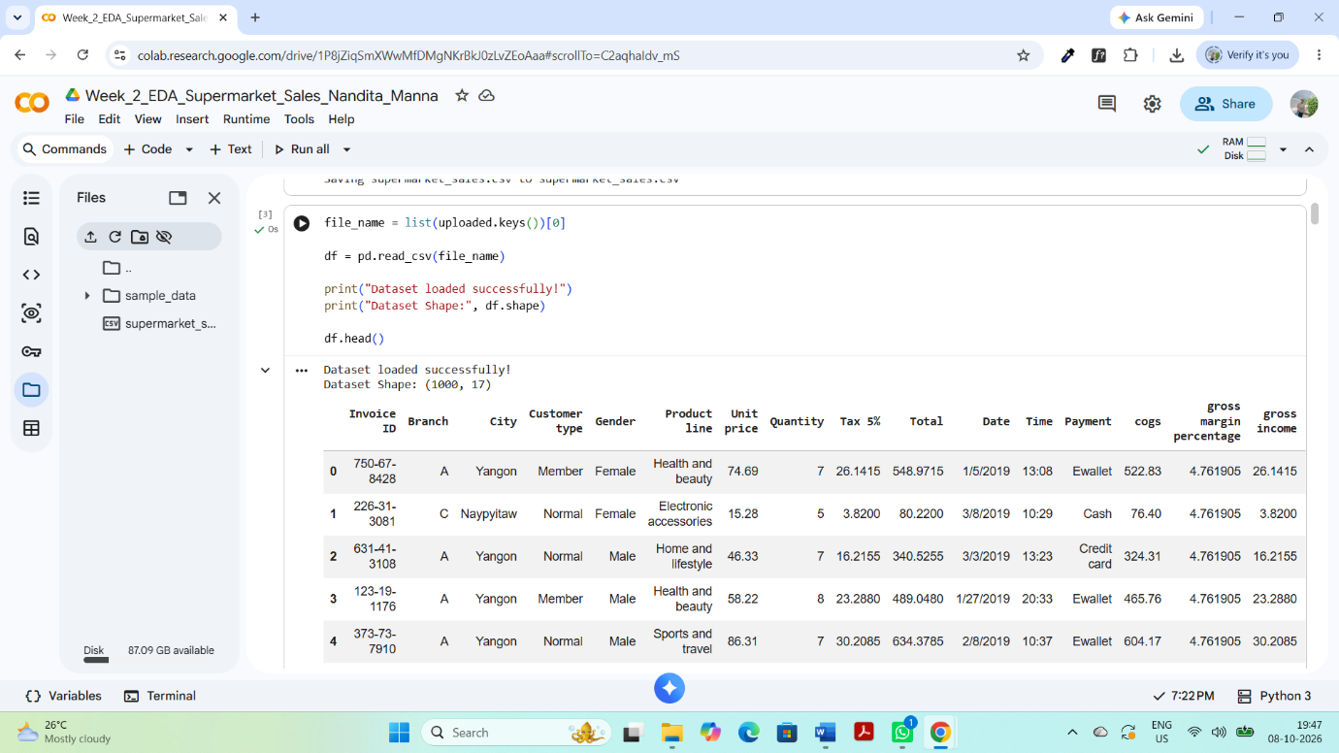
Figure 1: First five records and dataset dimensions
The dataset contains 1,000 transaction records and 17 original variables. The dataset includes information about branches, cities, customer types, gender, product lines, prices, quantities, sales totals, payment methods, and customer ratings.
5.1 Dataset Structure
The info() function was used to examine the data types and structure of the dataset. The dataset contains both numerical and categorical variables. Numerical variables include Unit price, Quantity, Tax 5%, Total, COGS, gross margin percentage, gross income, and Rating, while variables such as Branch, City, Customer type, Gender, Product line, and Payment are categorical.
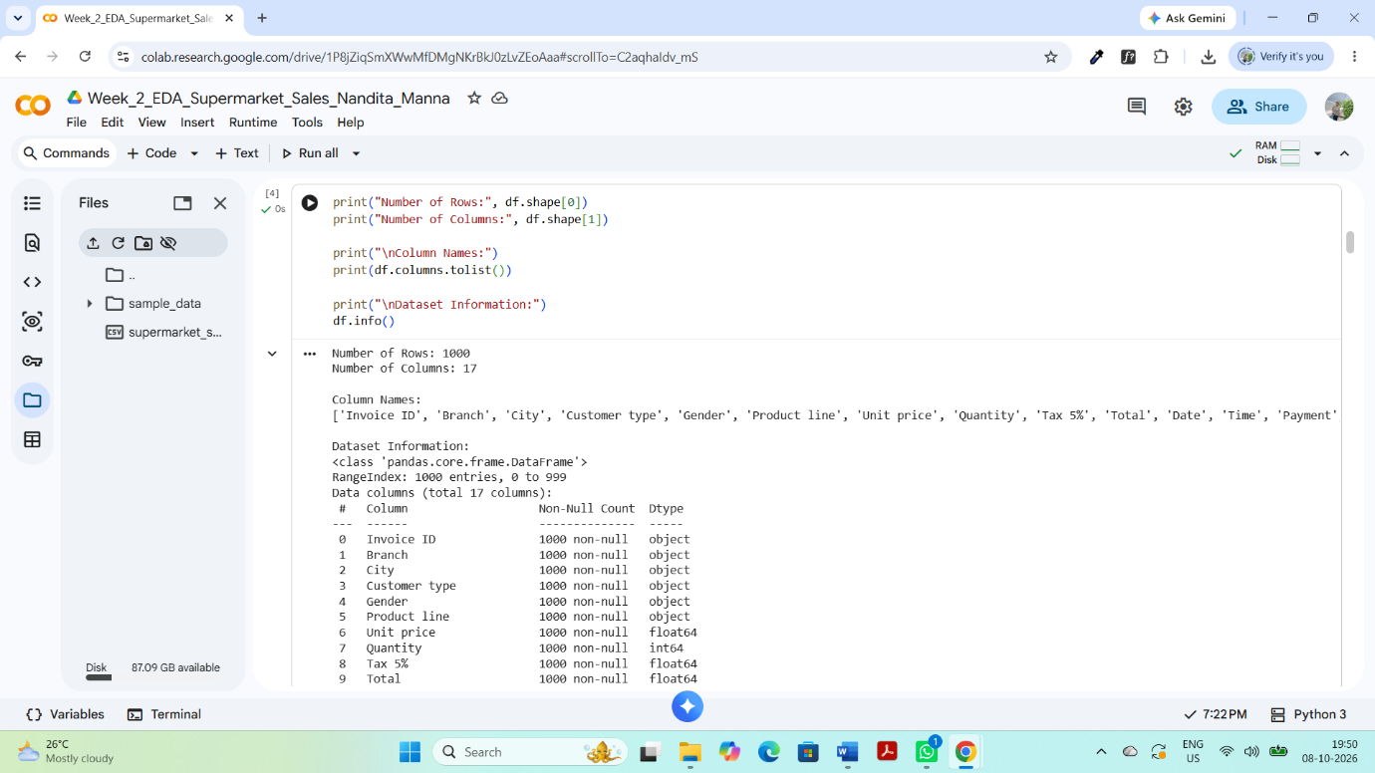
Figure 2: Dataset structure and data types
5.2 Missing Values and Duplicate Records
Missing values and duplicate records were checked to ensure the quality of the dataset. The isnull().sum() function was used to identify missing values, while duplicated().sum() was used to identify duplicate rows.
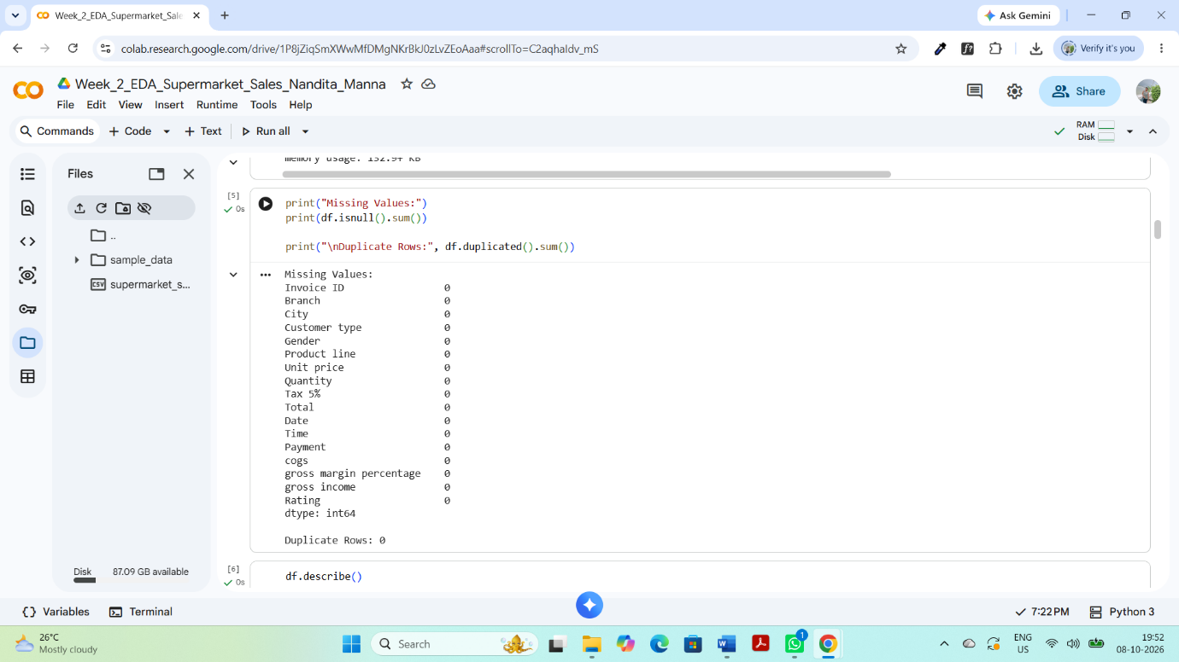
The analysis showed that there were no missing values and no duplicate records in the dataset. Therefore, no rows had to be removed because of missing or duplicate data.
6. Descriptive Statistics
Descriptive statistics were used to summarize the numerical variables in the Supermarket Sales dataset. The describe() function from Pandas was used to calculate important statistical measures such as count, mean, standard deviation, minimum, maximum, and quartile values. These measures help in understanding the distribution and range of the numerical variables.
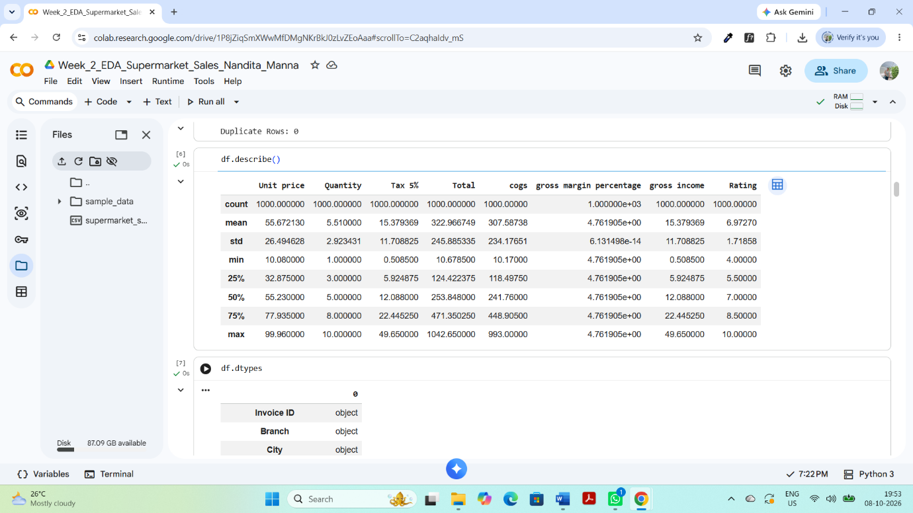
Figure 3: Descriptive statistics of numerical variables
The descriptive statistics provide an overview of the numerical variables. For example, the mean and standard deviation help understand the typical values and variation in the data, while the minimum and maximum values show the overall range. The statistics also help identify variables with relatively high or low values and provide an initial understanding of the dataset before performing further analysis.
6.1 Data Types
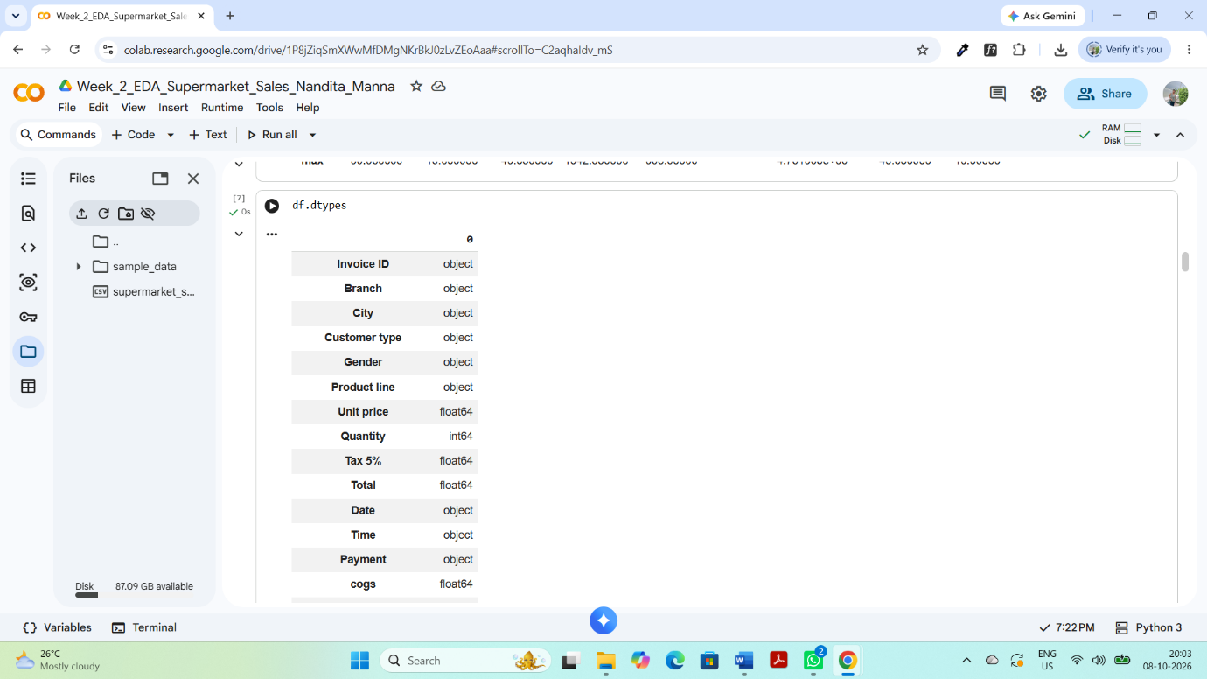
Figure 4: Data types of dataset variables
Checking the data types confirmed that the dataset contains a combination of numerical and categorical variables. Understanding the data types is important because different types of variables require different methods of analysis and visualization.
7. Data Transformation
Data transformation was performed to make the dataset more useful for exploratory analysis. The original Date column was converted into a proper datetime format. Additional variables such as Month, Day, and Day_Name were extracted from the Date column. A new Sales_Category variable was also created by grouping the Total sales values into different categories. These transformations helped in analyzing sales patterns from different perspectives.
7.1 Date Transformation
Heading:
7.1 Date Transformation
The Date column was converted from its original format into a datetime format using Pandas. After conversion, three new variables—Month, Day, and Day_Name—were extracted. These variables can be used to examine sales patterns according to month, day, and day of the week.
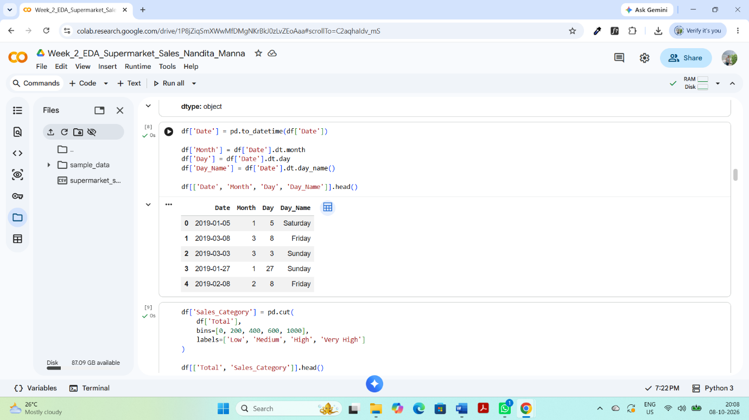
Figure 5: Date transformation and newly created date-related variables
df['Date'] = pd.to_datetime(df['Date'])

df['Month'] = df['Date'].dt.month
df['Day'] = df['Date'].dt.day
df['Day_Name'] = df['Date'].dt.day_name()
7.2 Sales Category Transformation
A new categorical variable named Sales_Category was created using the Total sales amount. The transactions were divided into four categories: Low, Medium, High, and Very High. This transformation makes it easier to classify transactions according to their sales value and helps in understanding the distribution of different sales levels.
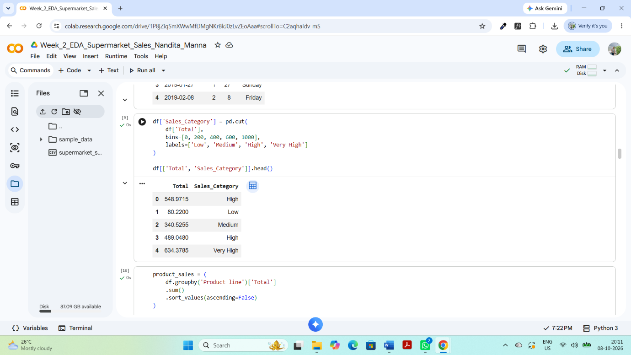
Figure 6: Sales category created from total sales
df['Sales_Category'] = pd.cut(
df['Total'],
bins=[0, 200, 400, 600, 1000],
labels=['Low', 'Medium', 'High', 'Very High']
)
7.3 Importance of Transformation
These transformations improved the usability of the dataset for further analysis. The date-based variables can help identify temporal patterns, while the Sales_Category variable provides a simple way to compare transactions across different sales levels.
8. Data Aggregation
Data aggregation was performed to summarize the sales data across different categories. The groupby() function in Pandas was used to calculate total sales for different product lines, branches, and payment methods. Aggregation helps compare different groups and identify which categories contribute more to the overall sales.
8.1 Product-wise Sales Aggregation
Heading:
8.1 Product-wise Sales Aggregation
The total sales were aggregated by Product line to identify which product categories generated the highest and lowest sales. The results provide a clear comparison of sales performance across different product categories.
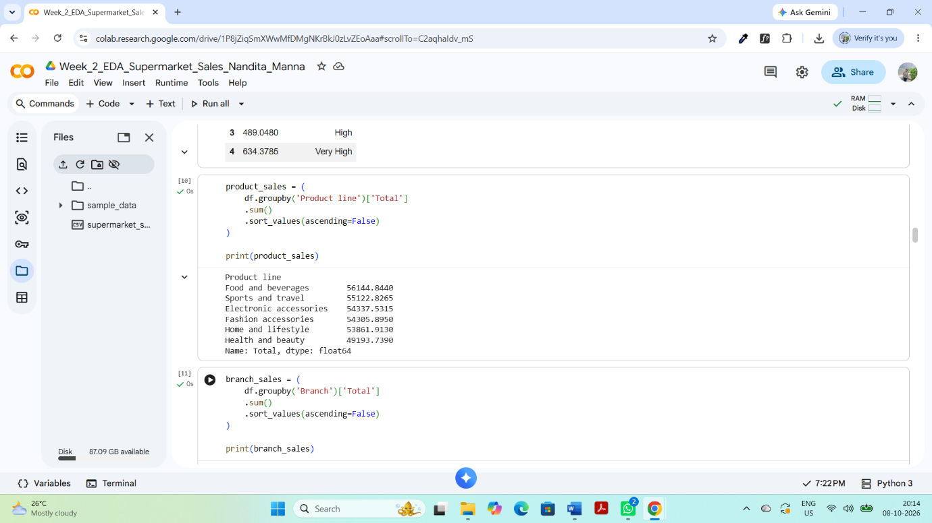

Figure 7: Total sales by product line
product_sales = (
df.groupby('Product line')['Total']
.sum()
.sort_values(ascending=False)
)
8.2 Branch-wise Sales Aggregation
The Total sales were also aggregated by Branch to compare the sales performance of different supermarket branches. This helps identify the branch with the highest and lowest contribution to total sales.
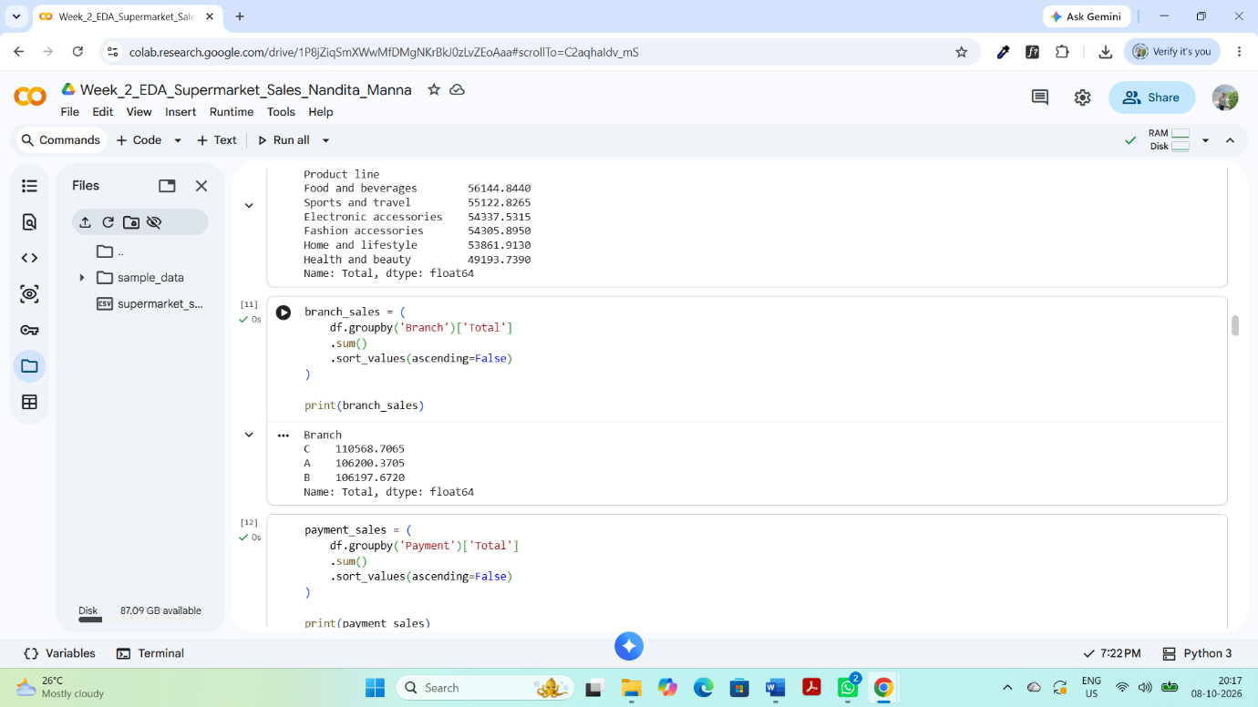
Figure 8: Total sales by branch
branch_sales = (
df.groupby('Branch')['Total']
.sum()
.sort_values(ascending=False)
)
8.3 Payment-wise Sales Aggregation
Sales were aggregated by Payment method to understand the total sales associated with different payment methods. This provides an overview of customer payment preferences and their contribution to sales.
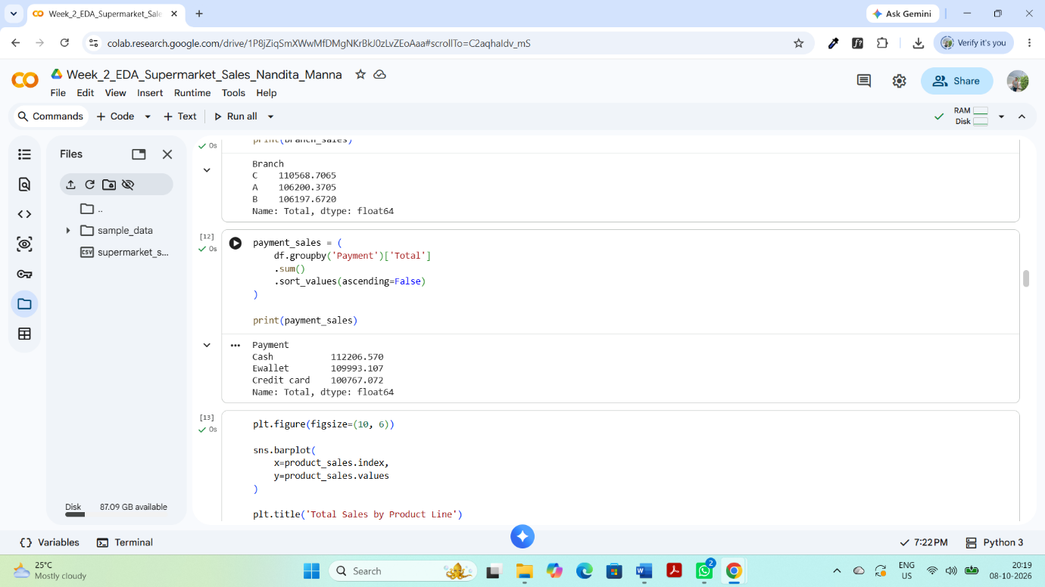
Figure 9: Total sales by payment method
payment_sales = (
df.groupby('Payment')['Total']
.sum()
.sort_values(ascending=False)
)
payment_sales = (
df.groupby('Payment')['Total']
.sum()
.sort_values(ascending=False)
)
8.4 Customer Type Aggregation

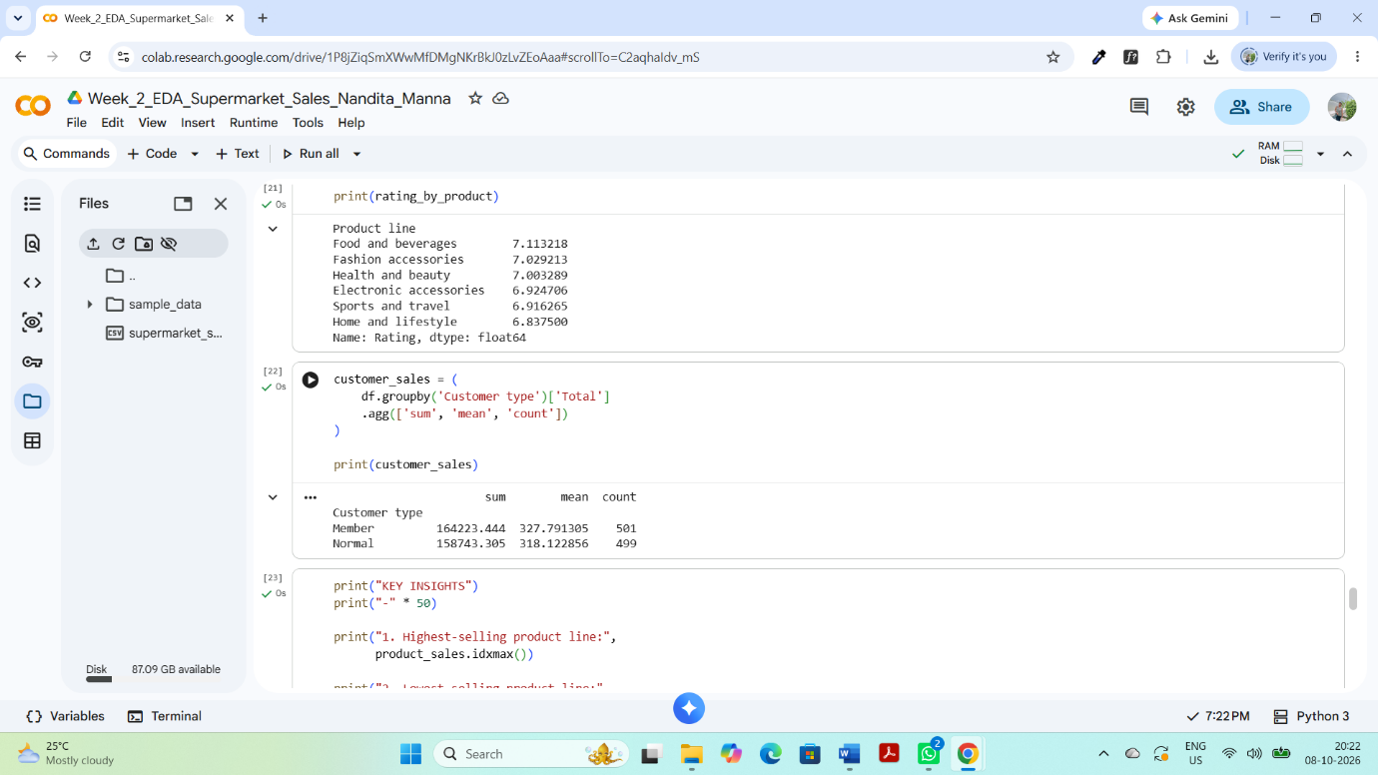
8.5 Aggregation Summary
The aggregation analysis provides a clearer understanding of sales performance across product categories, branches, payment methods, and customer types. These summarized results make it easier to identify high-performing categories and compare different customer and business segments.
9. Data Visualization and Interpretation
Data visualization was performed to identify trends, patterns, comparisons, and relationships within the Supermarket Sales dataset. Matplotlib and Seaborn were used to create different charts. Each visualization was analyzed to identify meaningful findings and possible reasons behind the observed patterns.
9.1 Total Sales by Product Line
Heading:
9.1 Total Sales by Product Line
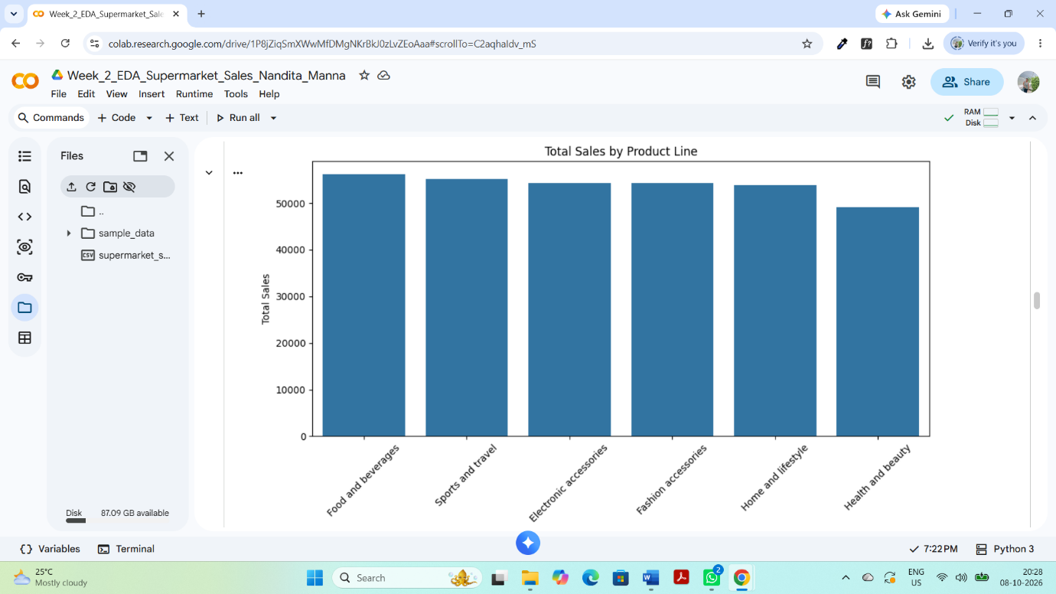
Figure 10: Total sales by product line
The bar chart compares the total sales generated by different product lines. It helps identify which product categories contribute more to overall supermarket sales and which categories have relatively lower sales.
Interpretation
Finding: The bar chart shows differences in total sales across the product lines. Some product categories generate higher sales than others.
Interpretation: The difference in sales may be influenced by product popularity, customer preferences, pricing, and purchasing frequency. Higher-selling product lines may indicate stronger customer demand.
.2 Total Sales by Branch
The branch-wise sales visualization compares the total sales generated by the different supermarket branches. It helps identify differences in sales performance among the branches and provides an overview of branch-level business performance.
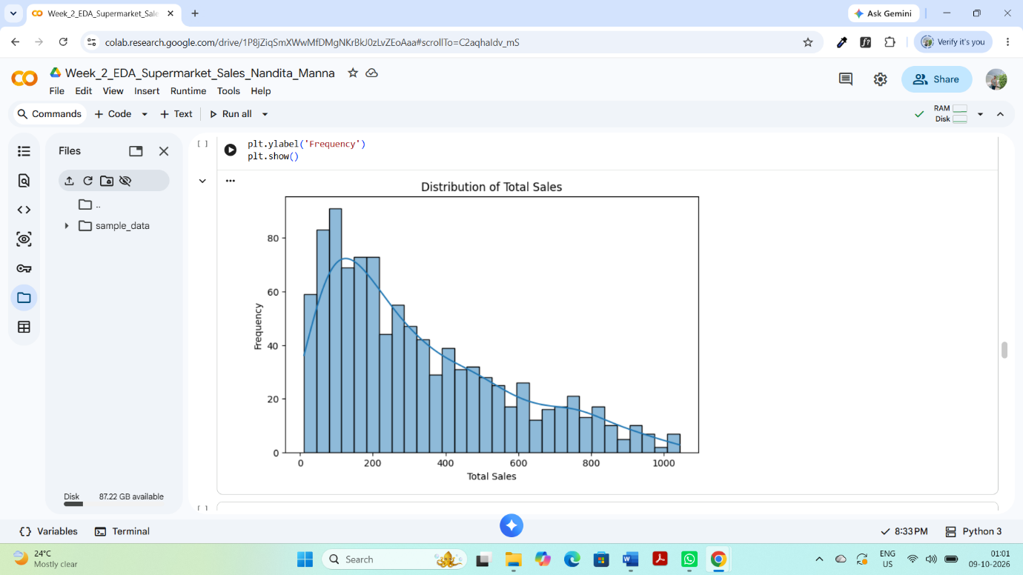
Figure 11: Total Sales by Branch
9.3 Payment Method
The chart shows the number of transactions made using different payment methods. It helps identify which payment method is most frequently preferred by customers.
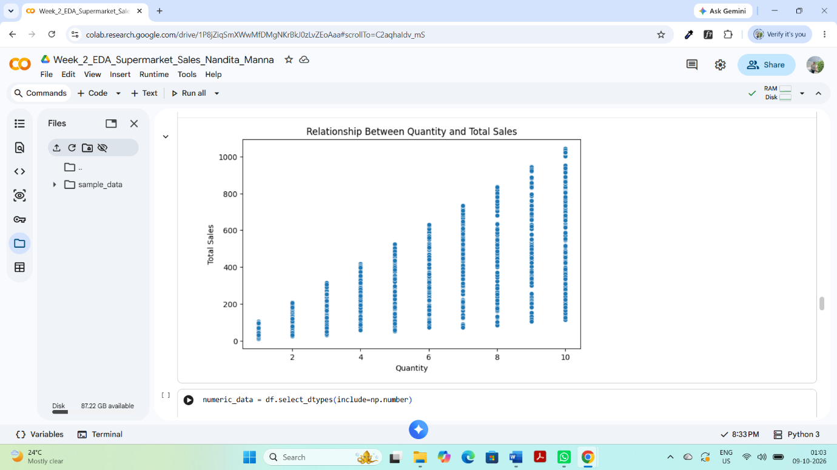
Figure 12: Number of Transactions by Payment Method
Interpretation
Finding: The chart shows differences in the number of transactions made through different payment methods.
Interpretation: Customers may prefer one payment method more than others because of convenience, accessibility, and familiarity. The transaction count provides an overview of customer payment prefere
9.4 Distribution of Total Sales
The histogram shows the distribution of total sales values across all transactions. It helps understand the common range of transaction values and shows how frequently different sales amounts occur.
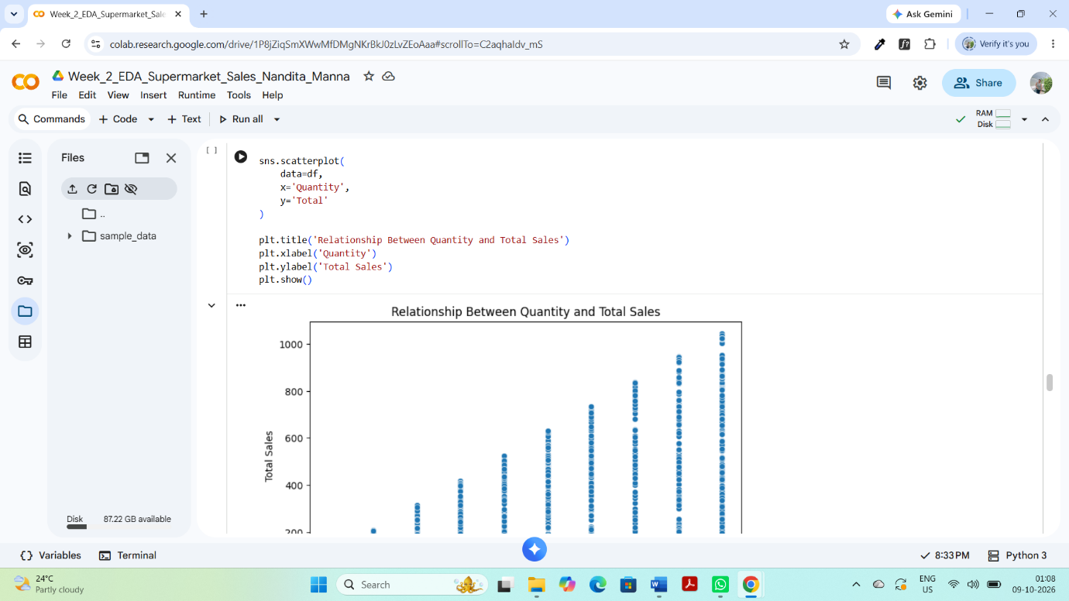
Figure 13: Distribution of Total Sales
Interpretation
Finding: The histogram shows that transaction values are spread across different sales ranges, with some values occurring more frequently than others.
Interpretation: The variation in transaction values may be due to differences in the quantity and prices of products purchased by customers. Higher transaction values represent purchases involving more products or relatively expensive products.
9.5 Quantity and Total Sales
The scatter plot examines the relationship between the quantity of products purchased and the total sales amount. It helps determine whether purchasing more products is generally associated with a higher transaction value.
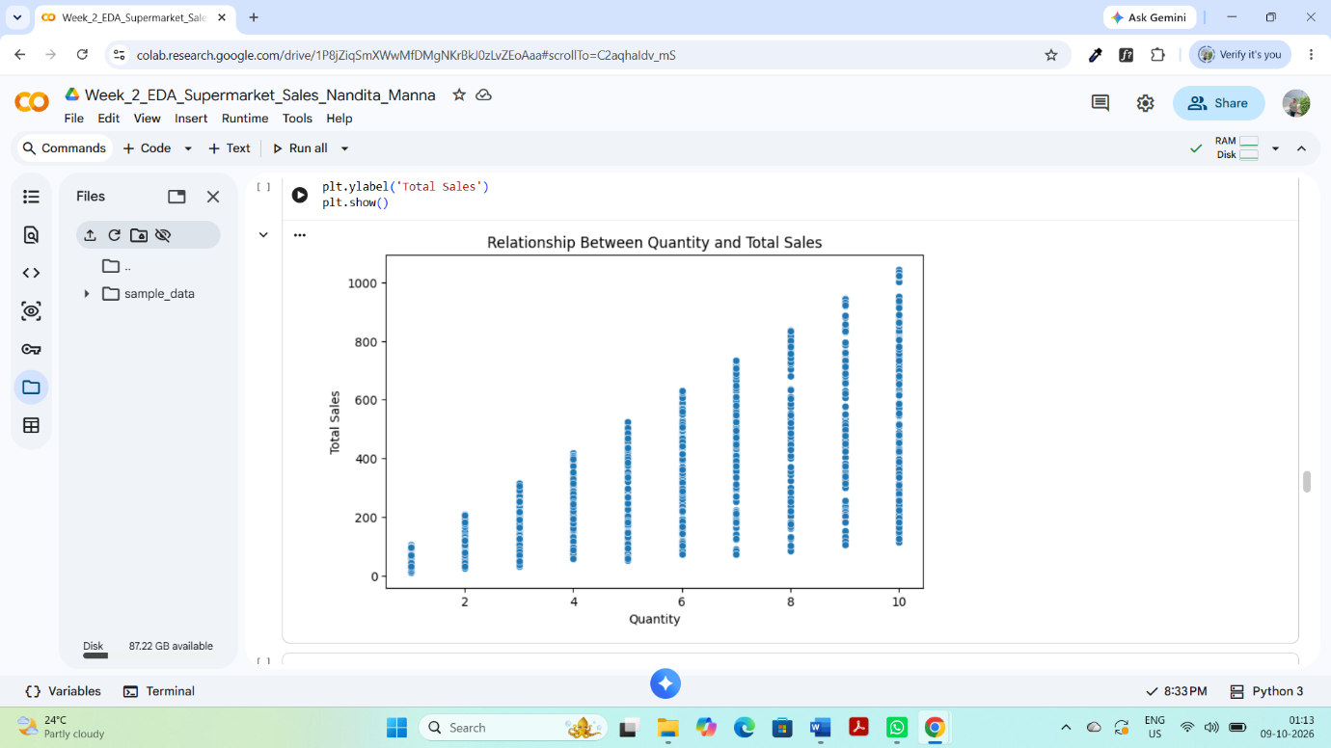
Figure 14: Relationship Between Quantity and Total Sales
Interpretation
Finding: The scatter plot generally shows a positive relationship between Quantity and Total Sales.
Interpretation: As the quantity of products purchased increases, the total transaction value generally tends to increase. However, the exact total sales amount also depends on the unit price of the products purchased.
9.6 Correlation Analysis
Correlation analysis was performed to examine the relationships between the numerical variables in the Supermarket Sales dataset. The correlation matrix was calculated using Pandas, and a heatmap was created using Seaborn to make the relationships easier to understand. Correlation values range from -1 to +1, where values closer to +1 indicate a strong positive relationship, values closer to -1 indicate a strong negative relationship, and values close to 0 indicate a weak or no linear relationship.
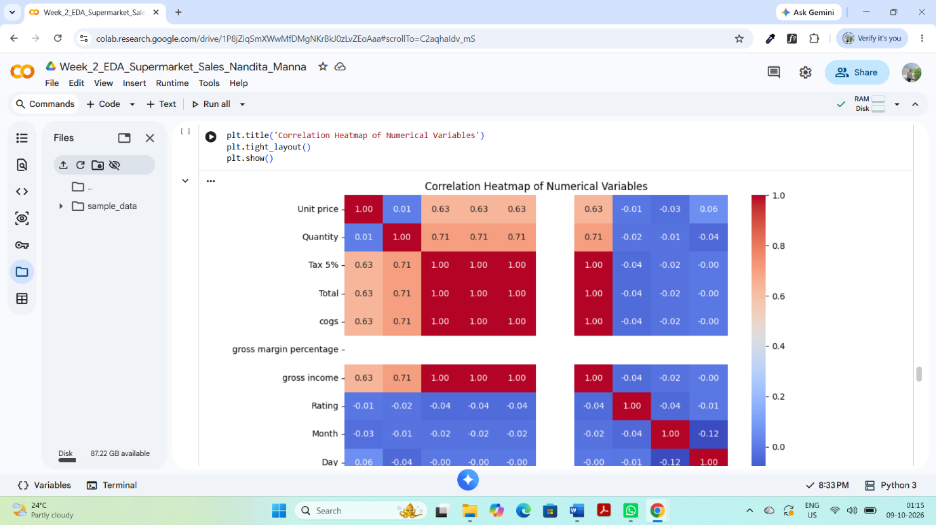
Figure 15: Correlation Heatmap of Numerical Variables
Interpretation
The correlation heatmap shows the strength and direction of relationships among the numerical variables. A strong positive correlation means that two variables tend to increase together, while a weak correlation indicates a limited linear relationship. The heatmap helps identify which variables are more closely associated with Total Sales and other numerical variables.
9.7 Correlation with Total Sales
To understand which numerical variables are more closely related to Total Sales, the correlation values with the Total variable were examined separately. This helps identify the variables that have a stronger relationship with the overall transaction amount.
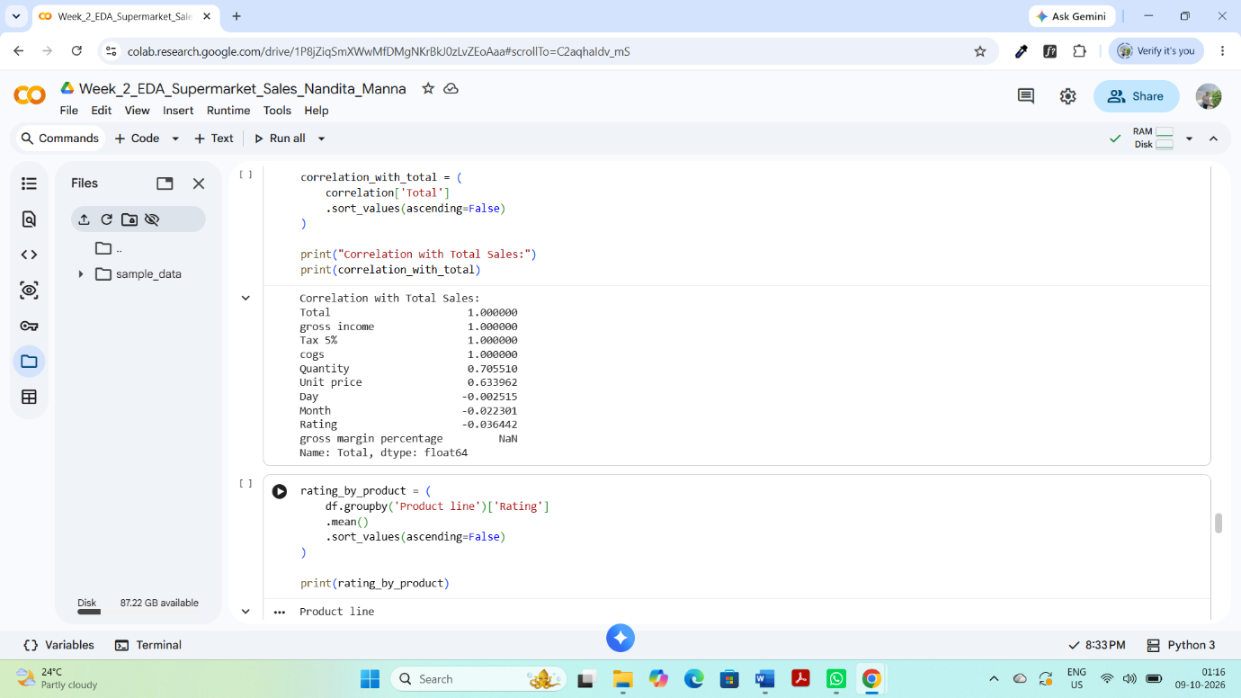
Figure 16: Correlation of Numerical Variables with Total Sales
Interpretation
The correlation results show that Total Sales has a strong positive relationship with variables that directly contribute to the transaction amount, particularly Quantity, Unit Price, Tax 5%, and COGS. This is expected because the total transaction value is influenced by the quantity purchased and product prices. Other variables may show weaker relationships with Total Sales, indicating that they have less direct influence on the transaction amount.
9.8 Overall EDA Findings
The overall EDA identified differences in product-line sales, branch performance, payment preferences, transaction values, and numerical relationships. Data transformation and aggregation helped summarize the dataset, while visualizations made the patterns easier to understand. The correlation analysis further explained the relationships among numerical variables. These findings provide useful information about customer purchasing behaviour and supermarket sales performance.
10. Key Findings
- Product Performance: Different product lines generated different levels of total sales, showing variation in customer demand across product categories.
- Branch Performance: The three supermarket branches showed differences in their total sales performance.
- Payment Preference: Customers used different payment methods, with some methods being more frequently used than others.
- Sales Distribution: Transaction values varied across the dataset, showing differences in customer spending.
- Quantity and Sales: Quantity generally showed a positive relationship with Total Sales. Customers purchasing more products generally generated higher transaction values.
- Correlation: Correlation analysis showed that variables directly related to transaction calculation had stronger relationships with Total Sales.
- Data Quality: The dataset contained no missing values and no duplicate records, so no rows needed to be removed during the initial data-cleaning stage.

10.1 Business Insights
The analysis provides useful insights into supermarket sales performance and customer purchasing behaviour. Understanding product demand, branch performance, payment preferences, and transaction values can help businesses make better decisions about product management, sales strategies, and customer services.
11. Conclusion
The Exploratory Data Analysis of the Supermarket Sales dataset provided a detailed understanding of sales performance, customer behaviour, product performance, payment methods, and numerical relationships. The analysis included data loading, data cleaning, descriptive statistics, data transformation, data aggregation, visualization, and correlation analysis. Different charts helped identify patterns and differences in the dataset, while correlation analysis helped understand relationships among numerical variables. Overall, the EDA process demonstrates how data analysis and visualization can be used to convert raw data into meaningful insights for better business decision-making.
11.1 Final Statement
This project improved my understanding of practical data analysis using Python, Pandas, Matplotlib, and Seaborn. It also helped me learn how to organize an EDA process, interpret visualizations, and communicate data-driven findings clearly.
12. Appendix – Important Python Code
1. Data Loading
df = pd.read_csv(file_name)
2. Date Transformation
df['Date'] = pd.to_datetime(df['Date'])df['Month'] = df['Date'].dt.monthdf['Day'] = df['Date'].dt.daydf['Day_Name'] = df['Date'].dt.day_name()
3. Sales Category
df['Sales_Category'] = pd.cut( df['Total'], bins=[0, 200, 400, 600, 1000], labels=['Low', 'Medium', 'High', 'Very High'])
4. Product-wise Aggregation
product_sales = ( df.groupby('Product line')['Total'] .sum() .sort_values(ascending=False))
5. Branch-wise Aggregation
branch_sales = ( df.groupby('Branch')['Total'] .sum() .sort_values(ascending=False))
6. Correlation Analysis
numeric_data = df.select_dtypes(include=np.number)correlation = numeric_data.corr()
7. Correlation Heatmap
sns.heatmap(correlation, annot=True, cmap='coolwarm', fmt='.2f')plt.title('Correlation Heatmap of Numerical Variables')plt.show()

