Week 3: Unsupervised Learning and Clustering Analysis
Submitted by: Nandita Manna
Internship: Virtual Data Science with Python
Dataset: Mall Customer Segmentation Data
Algorithm: K-Means Clustering
Tools: Python, Pandas, Matplotlib, Seaborn, Scikit-learn
1. Introduction
Unsupervised learning is a type of machine learning in which a model identifies patterns and structures in data without using predefined target labels. Clustering is an important unsupervised learning technique that groups similar data points together based on their characteristics.
In this project, K-Means clustering is applied to the Mall Customer Segmentation dataset. The dataset contains customer information such as age, annual income, and spending score. The analysis focuses on annual income and spending score to identify different customer groups.
The purpose of this project is to understand customer behaviour, identify meaningful customer segments, and explore how clustering can support business decision-making. The Elbow Method and Silhouette Score are used to help select and evaluate the number of clusters.
2. Objectives
The main objectives of this project are:
- To explore a publicly available Mall Customer Segmentation dataset.
- To inspect the dataset and identify missing values, duplicate records, and important features.
- To preprocess the selected features using StandardScaler.
- To apply the K-Means clustering algorithm to group customers with similar characteristics.
- To use the Elbow Method and Silhouette Score to help select a suitable number of clusters.
- To visualize the clusters and compare their characteristics.
- To interpret each cluster based on annual income and spending score.
- To discuss potential business applications of customer segmentation.
- To evaluate the clustering results and identify the limitations of the analysis.
3. Dataset Description
The dataset used in this project is the Mall Customer Segmentation dataset, publicly available on Kaggle.
Dataset source: https://www.kaggle.com/datasets/vjchoudhary7/customer-segmentation-tutorial-in-python
The dataset contains 200 customer records and 5 columns. It provides basic information about customers, including their customer ID, gender, age, annual income, and spending score.
Description of Features
- CustomerID: A unique identification number assigned to each customer.
- Gender: The gender category recorded for each customer.
- Age: The age of the customer in years.
- Annual Income (k$): The customer's annual income, expressed in thousands of dollars.
- Spending Score (1–100): A score representing the customer's spending behaviour, ranging from 1 to 100.
For clustering, Annual Income and Spending Score were selected as the main features. These two variables help identify customer groups with different income levels and spending patterns.
4. Tools and Technologies
The following tools and technologies were used to perform the clustering analysis.
- Python: The programming language used for data analysis and machine learning.
- Google Colab: The cloud-based environment used to write and execute Python code.
- Pandas: Used to load, inspect, clean, and summarize the dataset.
- NumPy: Used for numerical operations.
- Matplotlib: Used to create charts and visualize the analysis results.
- Seaborn: Used to create statistical visualizations.
- Scikit-learn: Used for feature scaling, K-Means clustering, and silhouette score evaluation.
Algorithm Used
K-Means clustering was selected because it is a widely used unsupervised learning algorithm that groups data points into a predefined number of clusters. It assigns each customer to the nearest cluster centre and updates the centres iteratively to reduce the within-cluster sum of squared distances.
Reason for Selecting K-Means
K-Means is suitable for this project because the selected features, Annual Income and Spending Score, are numerical. The algorithm makes it possible to identify customer segments and visualize their differences using a scatter plot. StandardScaler was used before clustering so that the selected features could be compared on a standardized scale.
5. Methodology and Data Preprocessing
The project was completed through a series of steps, starting with data loading and exploration and ending with clustering, visualization, and interpretation.
5.1 Loading the Dataset
The Mall Customer Segmentation dataset was loaded into Google Colab using the Pandas library. The dataset was examined to understand its structure, column names, data types, and number of records.
5.2 Data Exploration
The dataset was explored to understand the distribution of customer age, annual income, and spending score. The first few rows and basic statistical summaries were examined to understand the data before applying the clustering algorithm.
5.3 Data Quality Checking
The dataset was checked for missing values and duplicate records. These checks help identify possible data quality issues that could affect the analysis.
5.4 Feature Selection
Two numerical features were selected for clustering:
- Annual Income (k$)
- Spending Score (1–100)
These features were selected because they can help distinguish customers according to their income levels and spending behaviour.
5.5 Feature Scaling
StandardScaler from the Scikit-learn library was used to standardize the selected features before applying K-Means clustering. Standardization helps place the features on a comparable scale, reducing the influence of differences in their original scales.
5.6 Selecting the Number of Clusters
The Elbow Method and Silhouette Score were used to help determine a suitable number of clusters. The Elbow Method examines how the within-cluster sum of squared distances changes as the number of clusters increases. The Silhouette Score measures how well data points fit within their assigned clusters compared with other clusters.
5.7 Applying K-Means Clustering
The K-Means algorithm was applied to the standardized Annual Income and Spending Score features. The analysis used five clusters (K = 5) to group customers with similar characteristics.
5.8 Visualization and Interpretation
Scatter plots and comparison charts were used to visualize the resulting clusters. The number of customers and average characteristics of each cluster were examined to understand the different customer segments.
6. Determining the Optimal Number of Clusters
Before applying the final K-Means model, the Elbow Method and Silhouette Score were used to evaluate suitable cluster numbers.
6.1 Elbow Method
The Elbow Method helps identify a suitable number of clusters by examining the Within-Cluster Sum of Squares (WCSS), also known as inertia. The WCSS generally decreases as the number of clusters increases because data points become closer to their assigned cluster centres.
A graph is plotted with the number of clusters on the X-axis and WCSS on the Y-axis. The point where the decrease starts becoming less significant is known as the elbow point. This method helps select a reasonable number of clusters without creating too many groups.
Figure 1: Elbow Method plot generated in Google Colab.
6.2 Silhouette Score
The Silhouette Score evaluates how well each data point fits within its assigned cluster compared with other clusters. Its value ranges from -1 to 1.
- A score close to 1 indicates that data points are well matched to their own clusters.
- A score around 0 indicates that some clusters may overlap.
- A negative score may indicate that some data points have been assigned to an unsuitable cluster.
The Silhouette Score was calculated for different cluster numbers to support the selection of the final K-Means model.
Figure 2: Silhouette Score comparison generated in Google Colab.
6.3 Final Cluster Selection
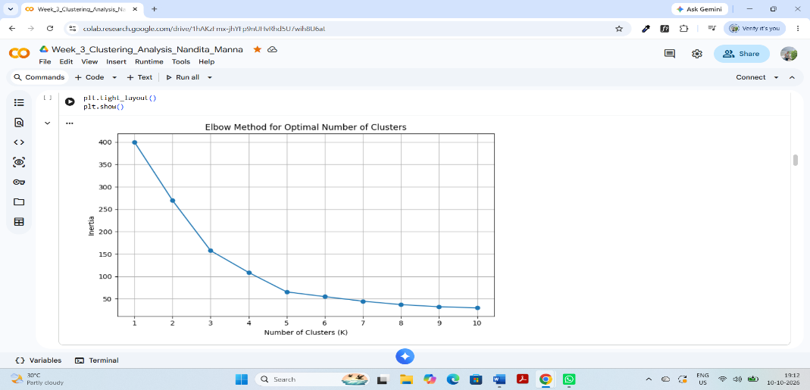
Based on the clustering experiments, five clusters (K = 5) were used for the final analysis. This choice allowed the customers to be divided into five groups with different combinations of annual income and spending score. The resulting clusters were then examined using visualizations and summary statistics.

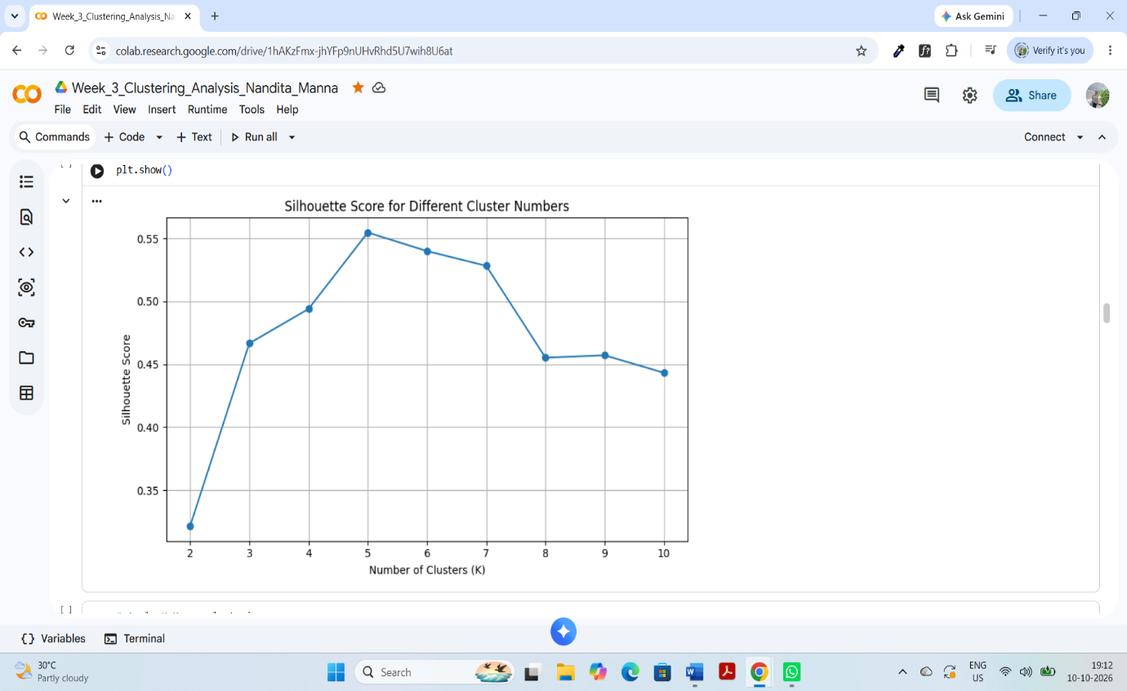
Figure 1: Elbow Method for Selecting the Number of Clusters

Figure 2: Silhouette Score Comparison
7. K-Means Clustering Results and Cluster Interpretation
The K-Means algorithm was applied to the selected features, Annual Income and Spending Score, using five clusters (K = 5). The model grouped customers according to similarities in their income and spending patterns.
7.1 Cluster Summary
The analysis produced the following cluster summary:
Cluster | Number of Customers | Average Age | Average Annual Income (k$) | Average Spending Score
0 | 81 | 42.72 | 55.30 | 49.52
1 | 39 | 32.69 | 86.54 | 82.13
2 | 22 | 25.27 | 25.73 | 79.36
3 | 35 | 41.11 | 88.20 | 17.11
4 | 23 | 45.22 | 26.30 | 20.91
The table shows that the customers are divided into five groups with different average income levels and spending scores. Cluster 0 contains the largest number of customers, with 81 records.
7.2 Interpretation of the Clusters
Cluster 0: Moderate-Income, Moderate-Spending Customers
This group contains 81 customers, with an average annual income of 55.30 thousand dollars and an average spending score of 49.52. These customers show moderate income and spending behaviour.
Cluster 1: High-Income, High-Spending Customers
This group contains 39 customers. Its average annual income is 86.54 thousand dollars, and its average spending score is 82.13. These customers have relatively high income and high spending scores, making them a potentially valuable segment for premium products and loyalty programmes.
Cluster 2: Low-Income, High-Spending Customers
This group contains 22 customers, with an average annual income of 25.73 thousand dollars and an average spending score of 79.36. Although their average income is relatively low, their spending scores are high. Affordable offers and targeted promotions may be relevant to this segment.
Cluster 3: High-Income, Low-Spending Customers
This group contains 35 customers. Its average annual income is 88.20 thousand dollars, while its average spending score is 17.11. These customers have relatively high income but low spending scores. Businesses could investigate their preferences and reasons for limited spending.
Cluster 4: Low-Income, Low-Spending Customers
This group contains 23 customers, with an average annual income of 26.30 thousand dollars and an average spending score of 20.91. These customers have relatively low income and low spending scores. Budget-friendly products and relevant discounts may be suitable options to explore.
7.3 Cluster Visualization
A scatter plot was created to display the five clusters using Annual Income on one axis and Spending Score on the other. Different colours were used to distinguish the clusters, and cluster centres were displayed to show the approximate central position of each group.
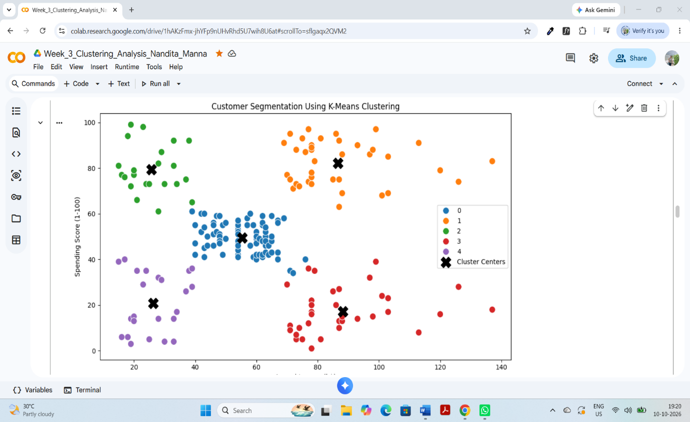

Figure 3: K-Means Customer Clusters based on Annual Income and Spending Score.
8. Model Evaluation and Silhouette Score
The quality of the K-Means clustering model was evaluated using the Silhouette Score. This metric helps assess how well the customers are grouped within their assigned clusters and how distinct the clusters are from one another.
8.1 Silhouette Score Result
The Silhouette Score obtained for the selected clustering model was 0.555.
A Silhouette Score of 0.555 suggests that the clustering has a reasonable separation between groups, although some overlap between customer segments may still exist. The result indicates that the five clusters provide a useful way to explore differences in annual income and spending behaviour in this dataset.
8.2 Evaluation of the Results
The clustering results show five customer groups with different income and spending patterns. The scatter plot indicates visible groupings, while the cluster summary provides numerical information about the average age, annual income, spending score, and number of customers in each group.
The model can help identify potentially valuable customer segments, such as high-income customers with high spending scores, as well as groups that may respond differently to promotions or product offers.
However, clustering is an exploratory technique. The results depend on the selected features, scaling method, and number of clusters. The identified groups should therefore be interpreted as patterns in this dataset rather than fixed categories that describe every customer perfectly.
8.3 Overall Assessment
Based on the Silhouette Score and visual inspection of the clusters, the K-Means model provides a useful initial segmentation of the mall's customers. Further analysis with additional features and real business data could help determine whether these segments are useful for practical marketing decisions.
9. Business Insights and Applications
Customer segmentation can help businesses understand different groups of customers and develop more suitable marketing strategies. The results of this project provide several potential business insights.
9.1 Personalized Marketing
The five customer segments have different income levels and spending patterns. Businesses could use these patterns to design targeted promotional campaigns instead of sending the same offers to every customer.
9.2 Premium Products and Loyalty Programmes
Cluster 1 represents customers with relatively high annual income and high spending scores. Businesses could explore premium product recommendations, exclusive offers, and loyalty programmes for this segment.
9.3 Affordable Offers and Promotions
Cluster 2 has a relatively low average annual income but a high spending score. Affordable products, suitable discounts, and value-for-money offers could be explored for this group.
9.4 Understanding Low-Spending Customers
Clusters 3 and 4 contain customers with relatively low spending scores. Businesses could investigate their product preferences, shopping frequency, and reasons for limited spending before designing appropriate marketing campaigns.
9.5 Improving Customer Retention
Customer segmentation can support customer relationship management by helping businesses develop different engagement strategies for different customer groups. The results could be combined with additional customer data to improve retention strategies.
9.6 Supporting Business Decisions
The analysis demonstrates how data analysis and machine learning can help organize customer information into understandable groups. These insights can support marketing planning and decision-making, but businesses should validate the findings using real customer behaviour and business outcomes before implementing major decisions.
Overall, K-Means clustering provides a useful starting point for understanding customer behaviour and exploring data-driven marketing strategies.
10. Limitations of the Study
Although the K-Means clustering analysis provides useful insights into customer segmentation, the study has some limitations.
- Limited Features: The clustering analysis uses only Annual Income and Spending Score. Other factors, such as purchase history, product preferences, and shopping frequency, were not included.
- Choice of Cluster Number: The final model uses five clusters. Although the Elbow Method and Silhouette Score help evaluate the choice, a different number of clusters could produce different customer groups.
- Sensitivity to Initialization: K-Means can produce different results depending on the initial placement of cluster centres. The results may therefore vary with different model settings or initializations.
- Assumption of Cluster Structure: K-Means works best when clusters can be represented reasonably well by their centres. It may not perform equally well for every possible data distribution.
- Limited Generalization: The dataset contains 200 customer records. The identified segments may not represent customers from every mall, location, or business.
- Exploratory Nature: The analysis identifies patterns in the available data but does not prove that a particular marketing strategy will increase sales or customer satisfaction.
Possible Improvements
Future work could include additional customer features, comparisons with other clustering algorithms, repeated model runs with different initializations, and validation using real business outcomes. These improvements could help assess the stability and practical usefulness of the identified customer segments.
11. Conclusion
This project applied K-Means clustering to the Mall Customer Segmentation dataset to identify groups of customers with similar annual income and spending patterns. The analysis used Python and libraries such as Pandas, Matplotlib, Seaborn, and Scikit-learn.
Annual Income and Spending Score were selected as the main features, and StandardScaler was used to standardize them before clustering. The Elbow Method and Silhouette Score were used to help evaluate the number of clusters. The final model used five clusters and achieved a Silhouette Score of 0.555.
The results identified five customer segments: moderate-income and moderate-spending customers, high-income and high-spending customers, low-income and high-spending customers, high-income and low-spending customers, and low-income and low-spending customers.
The project demonstrates how unsupervised learning can be used to explore patterns in customer data. These segments may help businesses understand customer behaviour and plan more targeted marketing strategies. However, the results are exploratory and should be validated with additional data before being used for important business decisions.
Overall, this project provided practical experience in data exploration, feature scaling, K-Means clustering, model evaluation, visualization, and interpretation of machine learning results.
12. References
- Dataset: Mall Customer Segmentation Data. Kaggle.
https://www.kaggle.com/datasets/vjchoudhary7/customer-segmentation-tutorial-in-python
- Pandas Documentation: https://pandas.pydata.org/docs/
- Matplotlib Documentation: https://matplotlib.org/stable/
- Seaborn Documentation: https://seaborn.pydata.org/
- Scikit-learn Documentation: https://scikit-learn.org/stable/
- Google Colab: https://colab.research.google.com/
These resources were used as references for the dataset, Python tools, data visualization, feature scaling, and clustering techniques used in this project.
16. Appendix: Important Python Code
The following code snippets illustrate the main stages of the analysis.
16.1 Feature Selection and Scaling
X = df[['Annual Income (k$)', 'Spending Score (1-100)']].copy()

scaler = StandardScaler()
X_scaled = scaler.fit_transform(X)
16.2 K-Means Clustering
kmeans = KMeans(
n_clusters=5,
random_state=42,
n_init=10
)

df['Cluster'] = kmeans.fit_predict(X_scaled)
16.3 Silhouette Score
final_silhouette = silhouette_score(
X_scaled,
df['Cluster']
)

print(round(final_silhouette, 3))
16.4 Cluster Summary
cluster_summary = df.groupby('Cluster').agg(
Customer_Count=('CustomerID', 'count'),
Average_Age=('Age', 'mean'),
Average_Annual_Income=('Annual Income (k$)', 'mean'),
Average_Spending_Score=('Spending Score (1-100)', 'mean')
).round(2)

display(cluster_summary)
16.5 Save the Results
df.to_csv('Week_3_Clustered_Customers.csv', index=False)
cluster_summary.to_csv('Week_3_Cluster_Summary.csv')
5.9 Python Code Snippet
The following code demonstrates how the selected features were standardized and how the K-Means clustering model was applied.
from sklearn.preprocessing import StandardScaler
from sklearn.cluster import KMeans
from sklearn.metrics import silhouette_score

features = df[['Annual Income (k$)',
'Spending Score (1-100)']]

scaler = StandardScaler()
scaled_features = scaler.fit_transform(features)

kmeans = KMeans(n_clusters=5, random_state=42, n_init=10)
df['Cluster'] = kmeans.fit_predict(scaled_features)

score = silhouette_score(scaled_features, df['Cluster'])
print("Silhouette Score:", score)
This code standardizes the selected features, applies K-Means with five clusters, assigns cluster labels, and calculates the Silhouette Score.

