WEEK 1 TASK
Data Acquisition, Cleaning, and Preprocessing
Dataset: Titanic Dataset
Source: Kaggle
Tools Used: Python, Pandas, NumPy, Matplotlib, Seaborn, Google Collab

Name: Nandita Manna
Internship: Yuva Intern(Virtual Data Science with Python Trainee)
Dataset: Titanic Dataset
Source: Kaggle
Tools Used: Python, Pandas, NumPy, Matplotlib, Seaborn, Google Collab
Date: 29 September 2026
1.Introduction
Data preprocessing is an important step in data analysis and machine learning. Raw datasets may contain missing values, duplicate records, inconsistent entries, and outliers. Therefore, it is necessary to examine and clean the data before using it for further analysis.
In this project, the Titanic dataset was selected as a publicly available dataset from Kaggle. The dataset was loaded and analysed using Python in Google Collab. Different data cleaning and preprocessing techniques were applied to improve the quality and consistency of the dataset.
The main purpose of this task was to understand the structure and quality of the dataset, identify missing and inconsistent data, check for duplicate records, detect potential outliers, and prepare a cleaned dataset for further analysis. The complete process, including data acquisition, exploration, cleaning, preprocessing, and final validation, is documented in this report.
2. Objective
To acquire a publicly available dataset from a reliable source.
To explore the structure and quality of the dataset.
To identify and handle missing values.
To check for duplicate and inconsistent records.
To detect potential outliers in numerical data.
To perform appropriate data preprocessing techniques.
To validate and save the final cleaned dataset.
To understand how preprocessing can affect further data analysis
3. Dataset Selection and Data Acquisition
For this project, the Titanic dataset was selected because it is a publicly available dataset that is widely used for learning data analysis and machine learning concepts. The dataset was obtained from Kaggle, a popular platform for publicly available datasets and data science projects.
The dataset was downloaded from Kaggle as a ZIP file. After downloading, the ZIP file was extracted to obtain the CSV files. The train.csv file was selected for the main data cleaning and preprocessing task. The dataset was then uploaded to Google Collab and loaded into Python using the Pandas library.
The following Python code was used to load the dataset:
df = pd.read_csv("train.csv")
After loading the dataset, its structure, columns, data types, missing values, and other quality issues were examined before performing the cleaning and preprocessing steps.
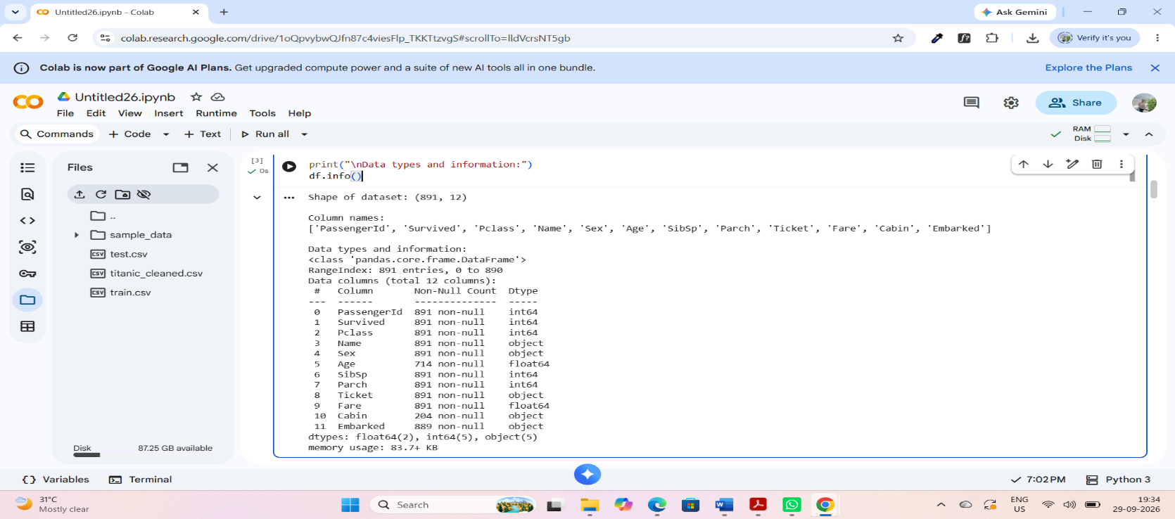
4. Initial Data Exploration
After acquiring the Titanic dataset, the first step was to examine its basic structure and quality. The dataset was loaded into Google Collab using Python and Pandas. The number of rows and columns, column names, and data types were checked. This initial exploration helped to understand the structure of the dataset and identify possible data quality issues before performing cleaning and preprocessing.
Python Code Used:
print("Shape of dataset:", df.shape)
print("\nColumn names:")
print(df.columns.tolist())
print("\nData types and information:")
df.info()

Figure 1: Initial exploration and structure of the Titanic dataset
The initial exploration showed that the dataset contains 891 rows and 12 columns. The dataset includes numerical and categorical variables. The information also showed missing values in columns such as Age, Cabin, and Embarked, which required further investigation and cleaning.
5. Missing Value Analysis
Missing values can affect the quality and reliability of data analysis. Therefore, the Titanic dataset was checked for missing values in each column. The number of missing values and their percentage were calculated using Python and Pandas.
missing = df.isnull().sum()
print("Missing values in each column:")
print(missing)
missing percentage = (df.isnull().sum() / len(df)) * 100
print("Missing values percentage:")
print(missing_percentage.sort_values(ascending=False))
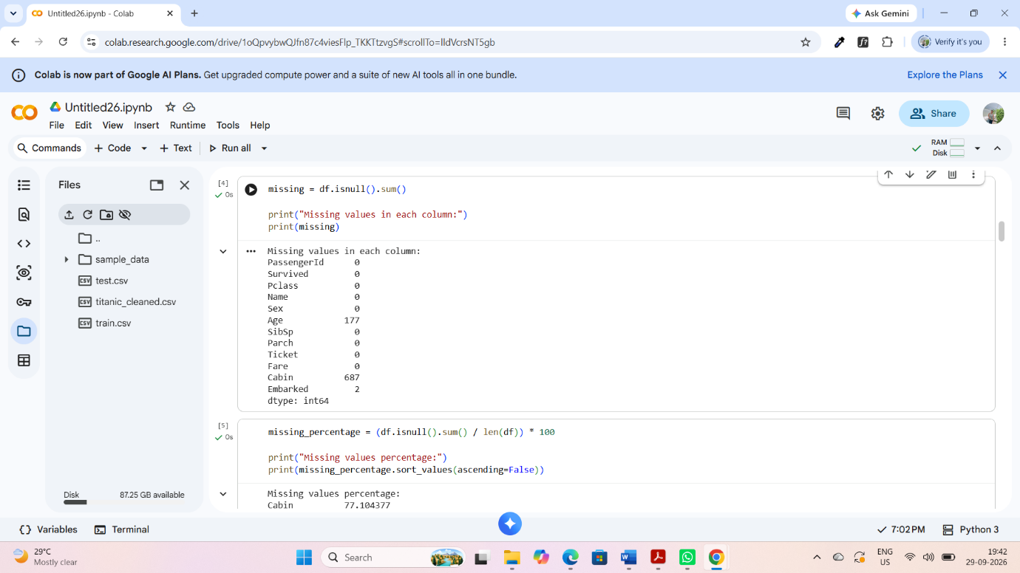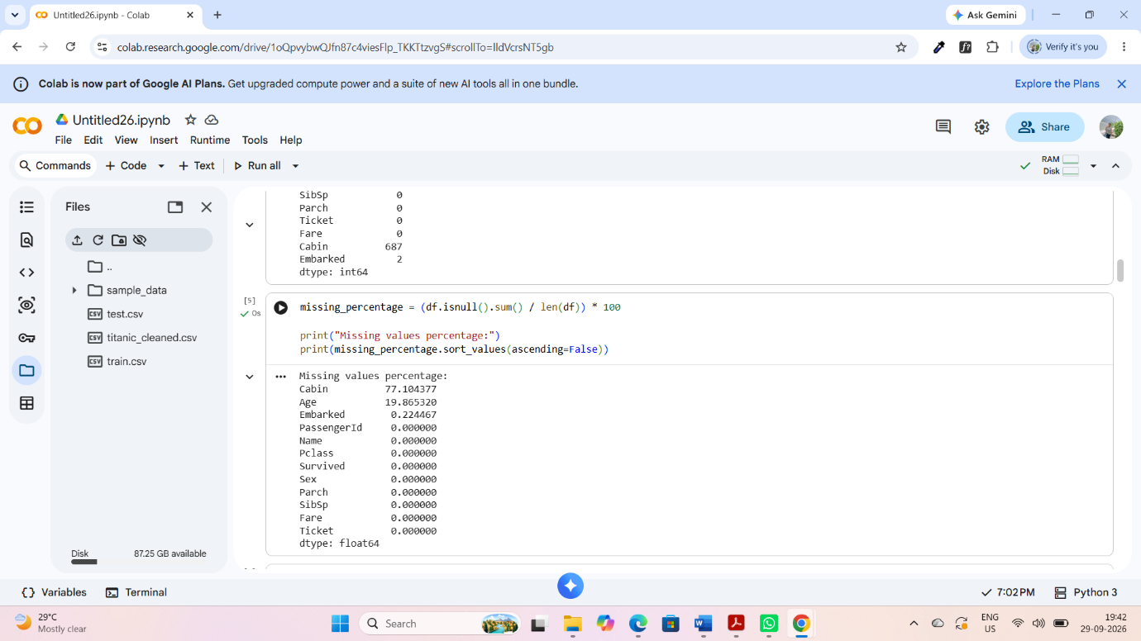
Figure 2: Missing value count and percentage in the dataset
6. Missing Value Treatment
After identifying the missing values, appropriate methods were selected to handle them. Different methods were used depending on the type and nature of each column. Missing values in the Age column were replaced with the median age. The Embarked column is categorical, so its missing value was replaced with the mode. The Cabin column contained many missing values, so it was removed from the dataset.
df['Age'] = df['Age'].fillna(df['Age'].median())
df['Embarked'] = df['Embarked'].fillna(df['Embarked'].mode()[0])
df.drop('Cabin', axis=1, inplace=True)

print("Missing values after cleaning:")
print(df.isnull().sum())
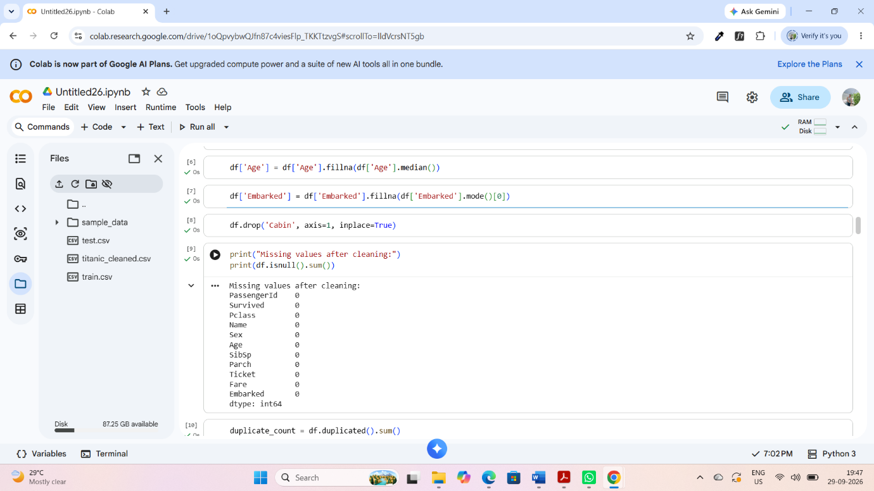
Figure 3: Missing values after treatment
Median imputation was used for Age because the median is less affected by extreme values. Mode imputation was used for Embarked because it is a categorical variable. The Cabin column was removed because a large proportion of its values were missing. After treatment, the remaining dataset was checked to ensure that the missing values had been properly handled.
7. Duplicate Data Analysis
Duplicate records can affect the accuracy of data analysis because the same observation may be counted more than once. Therefore, the dataset was checked for duplicate rows using the Pandas duplicated() function.
duplicate_count = df.duplicated().sum()
print("Number of duplicate rows:", duplicate count)
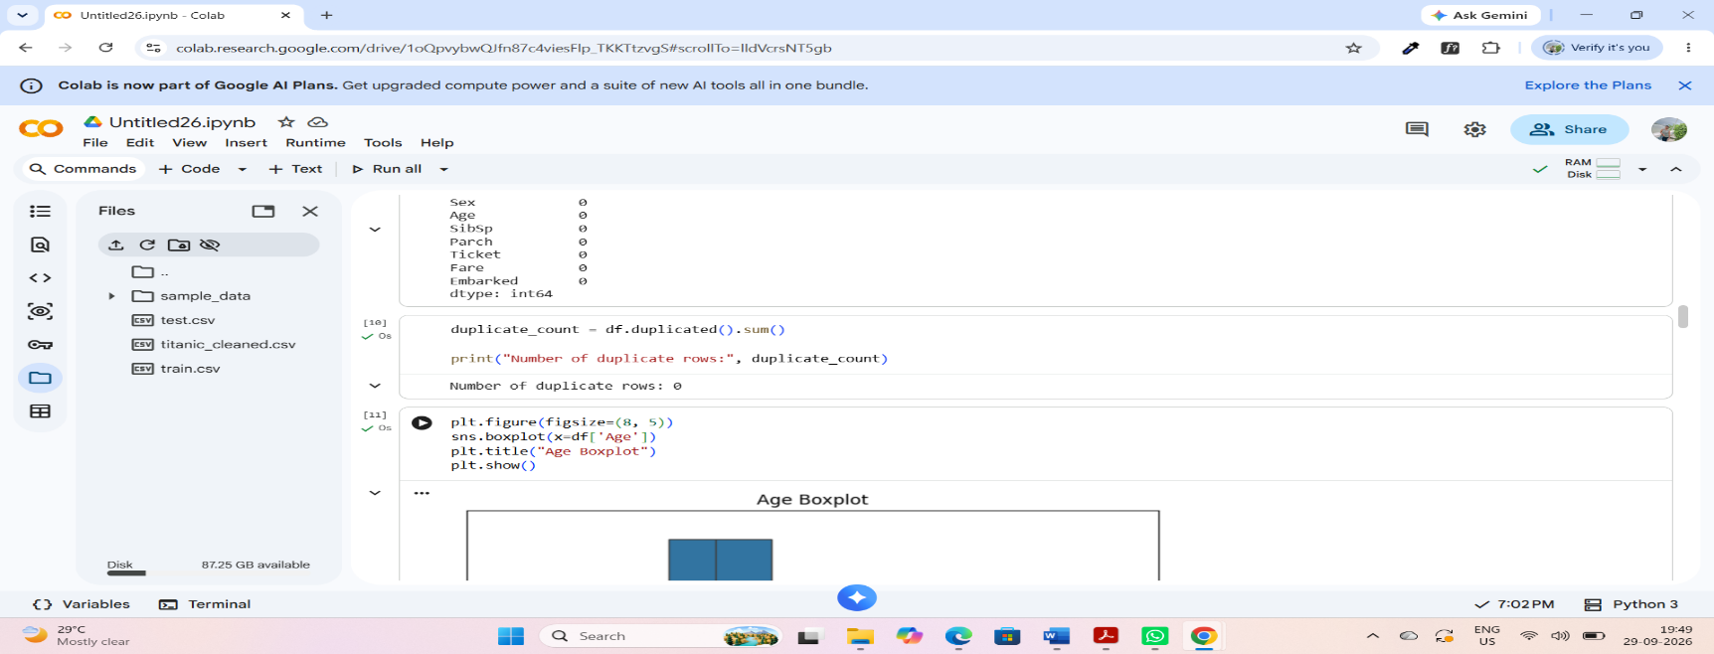

Figure 4: Duplicate rows check
The duplicate check returned zero duplicate rows. Therefore, no duplicate records were removed from the dataset.
8. Inconsistency and Error Checking
The categorical variables were examined to identify unexpected or inconsistent values. Unique values in the Sex, Embarked, and Pclass columns were checked using Python.
print("Unique values in Sex:")
print(df['Sex'].unique())
print("\nUnique values in Embarked:")
print(df['Embarked'].unique())
print("\nUnique values in Pclass:")
print(df['Pclass'].unique())
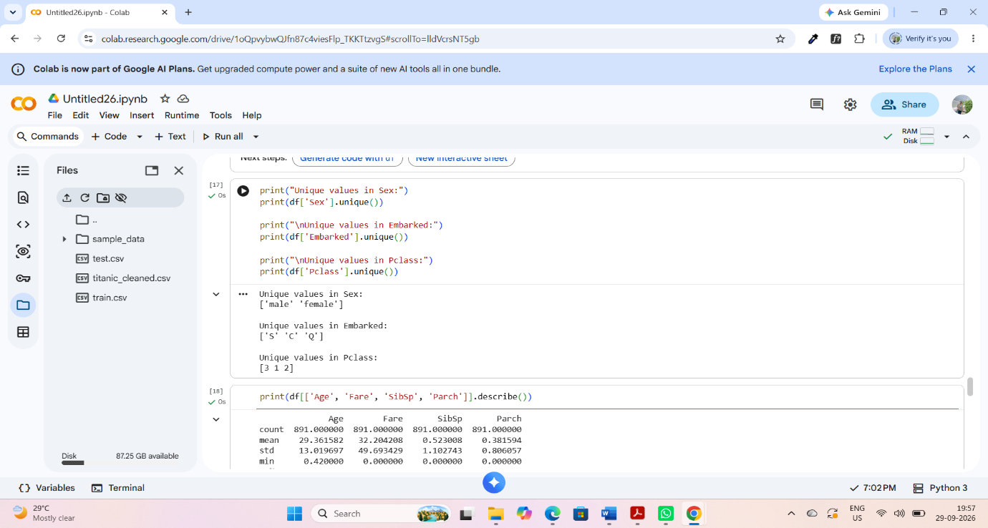
Figure 5: Checking unique values for categorical variables
The unique values were reviewed to identify any obvious inconsistencies. The values in these categorical columns were found to be reasonable and no additional correction was required.
9. Outlier Detection
Outliers are observations that are unusually high or low compared with the other values in a dataset. They can affect statistical analysis and machine learning models. In this project, boxplots were used to visually examine possible outliers in the numerical columns Age and Fare.
9.1 Age Outlier Analysis
A boxplot was created for the Age column to visually identify potential outliers.

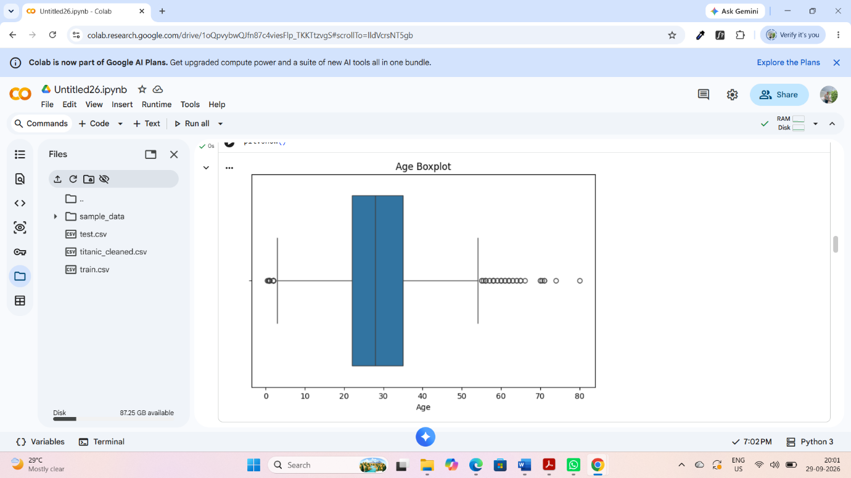
Figure 6: Boxplot of Age
9.2 Fare Outlier Analysis
A boxplot was also created for the Fare column. The boxplot showed several values that appeared to be higher than the usual range. Therefore, the IQR method was used to identify potential Fare outliers more systematically.
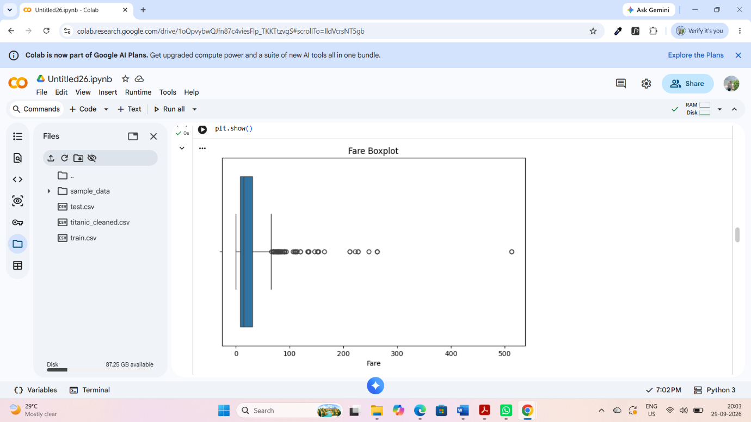
Figure 7: Boxplot of Fare
9.3 IQR Method for Fare
The Interquartile Range (IQR) method was used to identify potential outliers in the Fare column. The first quartile (Q1), third quartile (Q3), and IQR were calculated. Values below the lower bound or above the upper bound were considered potential outliers.
Q1 = df['Fare'].quantile(0.25)
Q3 = df['Fare'].quantile(0.75)

IQR = Q3 - Q1

lower_bound = Q1 - 1.5 * IQR
upper bound = Q3 + 1.5 * IQR

outliers = df[
(df['Fare'] < lower_bound) |
(df['Fare'] > upper_bound)
]
print("Q1:", Q1)
print("Q3:", Q3)
print("IQR:", IQR)
print("Lower Bound:", lower_bound)
print("Upper Bound:", upper_bound)
print("Number of Fare outliers:", len(outliers))
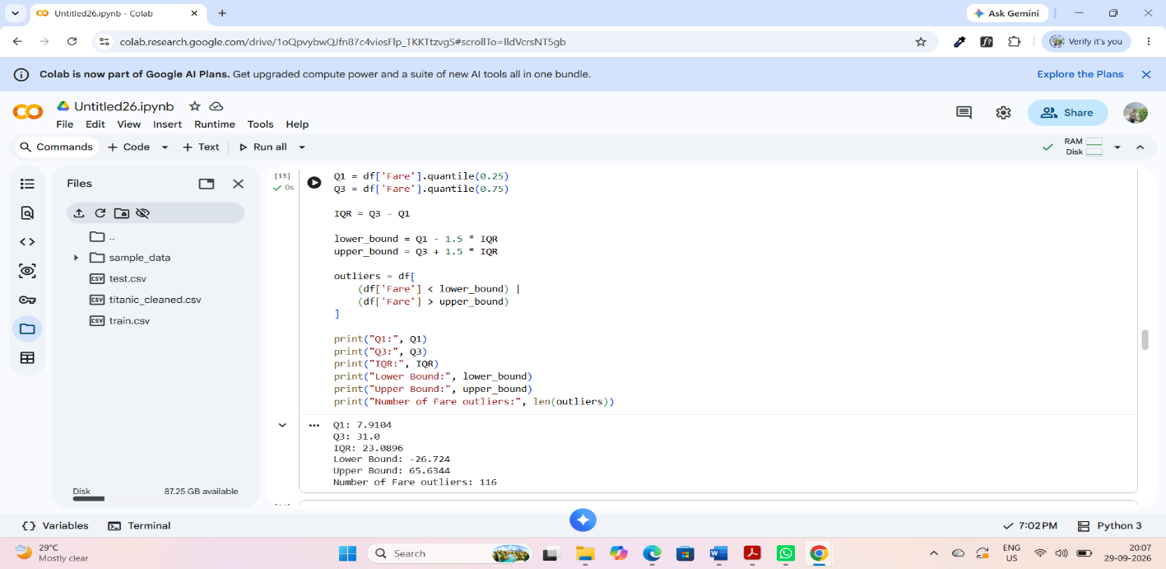
Figure 8: IQR-based identification of Fare outliers
The identified Fare outliers were not removed because an unusually high fare may represent a genuine passenger fare rather than a data-entry error. Retaining these observations helps preserve the original information in the dataset.

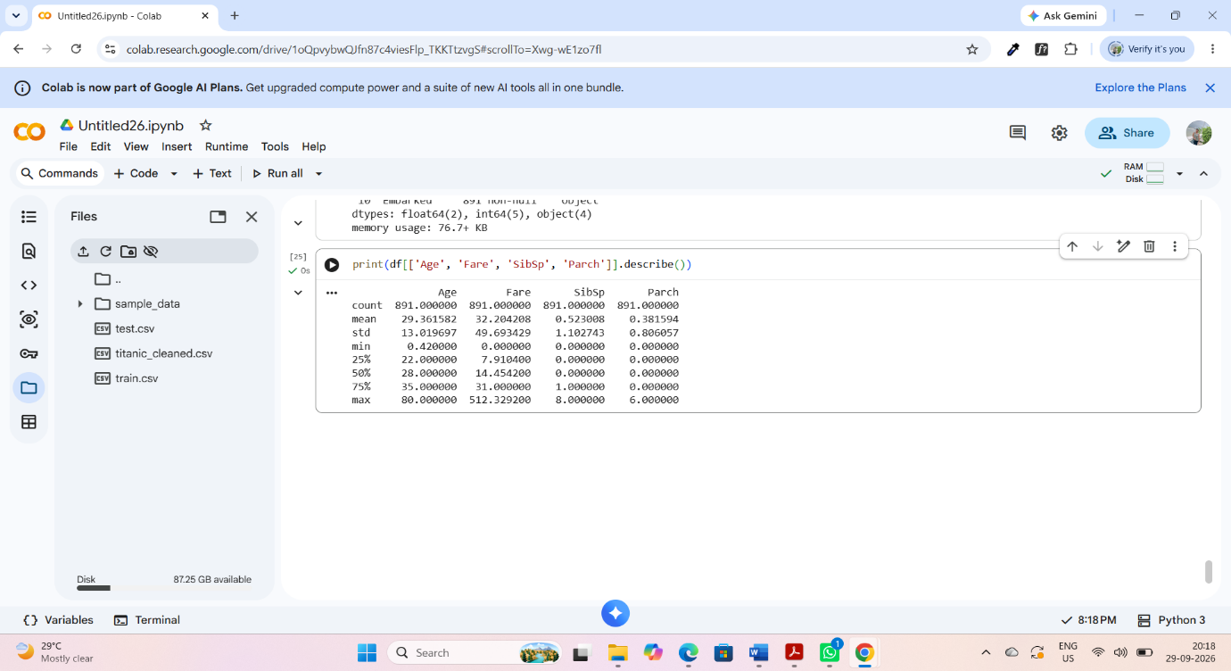
10. Data Preprocessing
After cleaning the dataset, the data was prepared for further analysis. The preprocessing steps included handling missing values, removing the Cabin column because of its high number of missing values, checking duplicate records, examining categorical values, and investigating potential outliers. These steps helped improve the quality and consistency of the dataset
10.1 Numerical and Categorical Data
The dataset contains both numerical and categorical variables. Numerical variables such as Age, Fare, SibSp, and Parch were examined using descriptive statistics. Categorical variables such as Sex and Embarked were checked for their unique values to identify possible inconsistencies.
print(df[['Age', 'Fare', 'SibSp', 'Parch']].describe())

Figure 9: Descriptive statistics of selected numerical variables
11. Final Dataset Validation
After completing the cleaning and preprocessing steps, the dataset was checked again to confirm that the cleaning process was successful. The final dataset shape, remaining missing values, duplicate rows, and data types were checked.
print("Final dataset shape:", df.shape)

print("\nRemaining missing values:")
print(df.isnull().sum())

print("\nDuplicate rows:")
print(df.duplicated().sum())

print("\nFinal data types:")
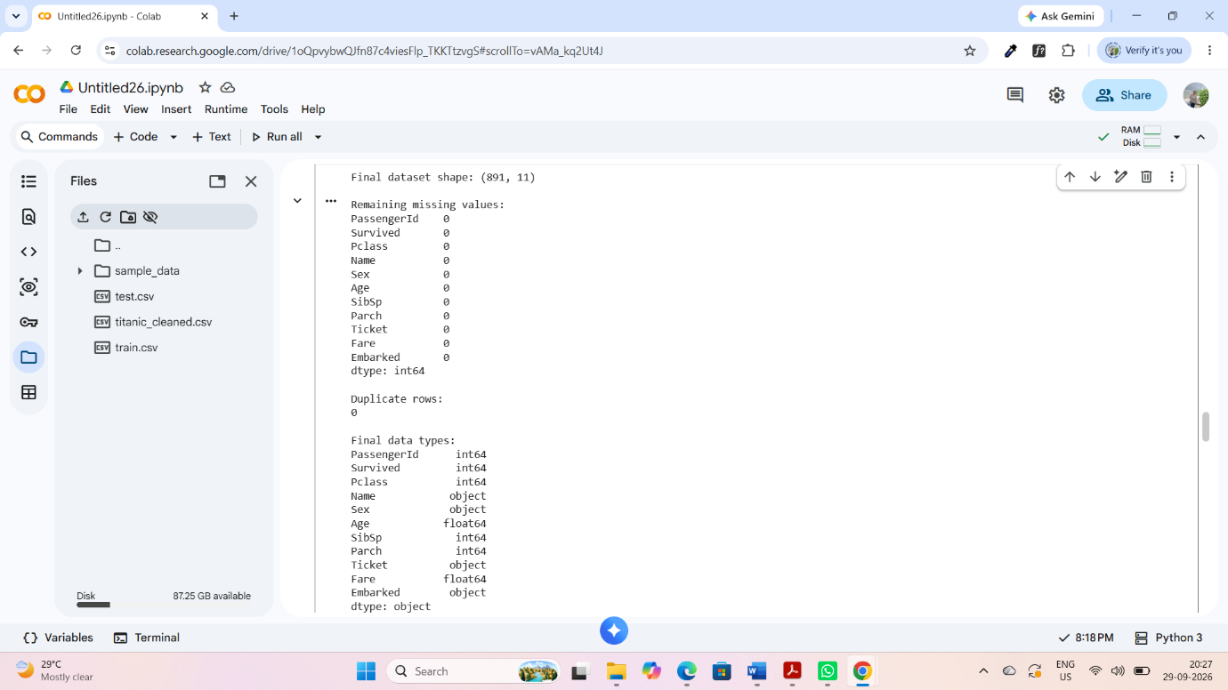
print(df.dtypes)

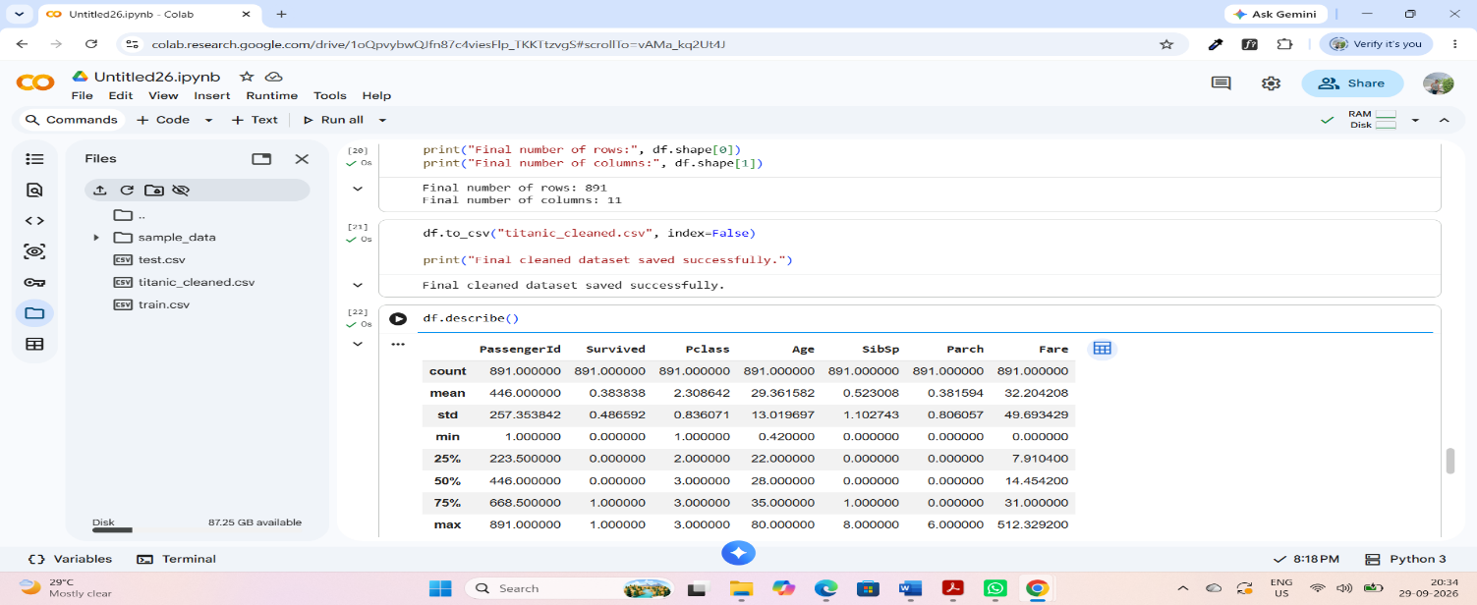
Figure 10: Final validation of the cleaned dataset
The final validation confirmed that the dataset was successfully cleaned and prepared. The remaining missing values and duplicate records were checked, and the data types were reviewed to ensure that the dataset was ready for further analysis.
12. Saving the Cleaned Dataset
After completing the cleaning and preprocessing steps, the final cleaned dataset was saved as a new CSV file. Saving the cleaned dataset allows it to be used later for further analysis or machine learning without repeating the cleaning process.
df.to_csv("titanic_cleaned.csv", index=False)
print("Final cleaned dataset saved successfully.")

Figure 11: Saving the final cleaned Titanic dataset
The cleaned dataset was saved with the filename titanic_cleaned.csv. The original dataset was kept unchanged, while the cleaned version was saved separately for future use.
13. Challenges Faced and Solutions
During the data cleaning and preprocessing process, several challenges were identified. One of the main challenges was handling missing values. Different columns required different treatment methods depending on their data type and the amount of missing information. The Age column was handled using median imputation, while the missing value in the Embarked column was replaced using the mode. The Cabin column was removed because it contained a large amount of missing data.
Another challenge was identifying potential outliers. The boxplot and IQR method were used to examine the Fare column. However, not every outlier represents an error. Some high fare values may be genuine observations, so the identified Fare outliers were retained.
Checking duplicate and inconsistent records was also necessary to ensure data quality. Pandas functions were used to check duplicate rows and unique values in categorical columns. These checks helped confirm that the dataset was suitable for further analysis.
14. Impact of Preprocessing on Further Analysis
Data preprocessing can have a significant impact on subsequent data analysis and machine learning. Handling missing values prevents incomplete records from causing problems during analysis. Removing the Cabin column reduces missing-data-related issues, although some information contained in that column is lost.
Using median imputation for Age helps maintain the dataset size while reducing the influence of extreme values. Replacing the missing Embarked value with the mode provides a simple and appropriate solution for the categorical variable.
The decision to retain potential Fare outliers preserves potentially genuine observations. However, these extreme values may influence statistical analysis or machine learning models, so their impact should be considered in future analysis.
15. Conclusion
In this project, the Titanic dataset was successfully acquired from Kaggle and processed using Python in Google Colab. The dataset was initially explored to understand its structure, data types, and quality. Missing values were identified and handled using appropriate methods. Duplicate records and categorical inconsistencies were also checked.
Potential outliers were examined using boxplots and the IQR method. The Fare outliers were retained because they could represent genuine observations. After completing the cleaning and preprocessing steps, the final dataset was validated and saved as titanic_cleaned.csv.
Overall, the preprocessing process improved the quality and consistency of the dataset and prepared it for further data analysis and machine learning applications.
16. Appendix – Python Code
The following Python code snippets were used for data acquisition, exploration, cleaning, preprocessing, outlier detection, and final validation of the Titanic dataset.
16.1 Importing Libraries
import pandas as pd
import numpy as np
import matplotlib.pyplot as plt
import seaborn as sns
16.2 Loading the Dataset
df = pd.read_csv("train.csv")
df.head()
16.3 Checking Missing Values
missing = df.isnull().sum()
print(missing)
16.4 Handling Missing Values
df['Age'] = df['Age'].fillna(df['Age'].median())
df['Embarked'] = df['Embarked'].fillna(df['Embarked'].mode()[0])
df.drop('Cabin', axis=1, inplace=True)
16.5 Checking Duplicates
duplicate_count = df.duplicated().sum()
print("Number of duplicate rows:", duplicate_count)
16.6 Outlier Detection
Q1 = df['Fare'].quantile(0.25)
Q3 = df['Fare'].quantile(0.75)
IQR = Q3 - Q1

lower_bound = Q1 - 1.5 * IQR
upper_bound = Q3 + 1.5 * IQR
16.7 Saving Cleaned Dataset
df.to_csv("titanic_cleaned.csv", index=False)

