WEEK 4: SUPERVISED LEARNING MODEL IMPLEMENTATION
Breast Cancer Classification Using Logistic Regression
Internship Project Report
Submitted by: Nandita Manna
Internship Domain: Data Science with Python
Organization: YuvaIntern
Dataset: Breast Cancer Wisconsin Dataset
Machine Learning Algorithm: Logistic Regression
Tools and Technologies: Python, Google Colab, Pandas, NumPy, Matplotlib, Seaborn, Scikit-learn
Submission: Week 4 – Supervised Learning Model Implementation
ABSTRACT
This project focuses on implementing a supervised machine learning model for breast cancer classification using Python. The main objective is to predict whether a breast tumour belongs to the benign or malignant class based on the features available in the Breast Cancer Wisconsin dataset.
The project uses Logistic Regression, a supervised classification algorithm, implemented with the Scikit-learn library. The dataset is loaded and prepared for analysis, and the selected features are standardized using StandardScaler. The data is divided into training and testing sets. Stratified 5-fold cross-validation is used to evaluate the consistency of the model during training.
The final model is evaluated using Accuracy, Precision, Recall, F1-score, and ROC-AUC. The model achieved a test accuracy of 95.00%, a mean cross-validation accuracy of 96.78%, and a ROC-AUC score of 0.9950. Confusion Matrix, ROC Curve, and feature correlation analysis are also used to understand the model's performance.
The results demonstrate that Logistic Regression can provide strong classification performance on this dataset. However, the model is intended for educational purposes and must not be considered a substitute for professional medical diagnosis.
1. INTRODUCTION
Machine learning is a branch of artificial intelligence that enables computer systems to learn patterns from data and make predictions. Supervised learning is a machine learning approach in which a model learns from labelled examples. It is commonly used for classification and regression problems.
Breast cancer classification is an important example of a classification problem. In this project, a supervised learning model is developed to classify tumour records into two categories: benign and malignant. The project uses the Breast Cancer Wisconsin dataset and applies Logistic Regression to learn the relationship between the input features and the target class.
Python is used for data preparation, model development, and evaluation. Libraries such as Pandas, NumPy, Matplotlib, Seaborn, and Scikit-learn support data handling, visualization, preprocessing, and machine learning.
The project follows a systematic workflow that includes dataset preparation, feature processing, model training, cross-validation, testing, and performance analysis. The findings are interpreted using multiple evaluation metrics rather than relying on accuracy alone.
2. PROBLEM STATEMENT
The problem addressed in this project is to develop a supervised classification model that predicts whether a tumour record is benign or malignant using the available input features in the Breast Cancer Wisconsin dataset.
The model is trained on labelled data and evaluated on a separate test set. The aim is to measure how effectively Logistic Regression distinguishes between the two classes and to identify the strengths and limitations of the approach.
3. OBJECTIVES
The main objectives of this project are:
- To select and understand a publicly available breast cancer dataset.
- To prepare the dataset for supervised learning.
- To identify the input features and the target variable.
- To apply appropriate feature preprocessing and scaling.
- To implement Logistic Regression using Scikit-learn.
- To evaluate model consistency using stratified 5-fold cross-validation.
- To measure test performance using Accuracy, Precision, Recall, F1-score, and ROC-AUC.
- To visualize and interpret the model's results.
- To discuss the strengths, limitations, and possible improvements of the model.

4. DATASET DESCRIPTION
4.1 Dataset Overview
This project uses the Breast Cancer Wisconsin dataset for a binary classification task. The dataset contains observations of breast tumour samples with associated numerical features and a class label. The objective is to use these features to predict whether a sample belongs to the benign or malignant category.
The dataset file used in the Google Colab environment is named breast-cancer-wisconsin.data. Before modelling, the data is loaded into Python and examined to understand its structure, feature types, target labels, and data quality.
4.2 Input Features and Target Variable
The input features represent measurements associated with the tumour samples. These features are used by the model to learn patterns that distinguish benign and malignant records.
The target variable represents the class label. In the project code, the two classes are encoded as:
- 0 — Benign
- 1 — Malignant
The input features are separated from the target variable before training. Identifier fields, where present, should not be used as predictive features because they identify records rather than describe tumour characteristics.
4.3 Dataset Preparation
The dataset is prepared for machine learning by checking its dimensions, column names, data types, missing or invalid values, and class distribution. Any preprocessing decisions are based on the actual structure of the loaded dataset.
The data is then divided into training and testing subsets. The training subset is used to build and validate the model, while the test subset is reserved for final evaluation.
4.4 Dataset Source
The dataset used in this project is the Breast Cancer Wisconsin dataset distributed in the UCI Machine Learning Repository.
Dataset reference:
https://archive.ics.uci.edu/dataset/15/breast+cancer+wisconsin+original
The dataset file used in the experiment is breast-cancer-wisconsin.data. The repository documentation should be consulted for the original feature descriptions, class labels, and dataset-specific information.
5. TOOLS AND TECHNOLOGIES
The following tools and libraries are used in this project:
Python: The programming language used to implement the supervised learning workflow.
Google Colab: A cloud-based notebook environment used to execute Python code.
Pandas: Used to load, organize, inspect, and manipulate tabular data.
NumPy: Used for numerical operations and data processing.
Matplotlib: Used to create plots and visualizations.
Seaborn: Used for statistical visualization and exploratory data analysis where applicable.
Scikit-learn: Used for data preprocessing, model development, cross-validation, predictions, and evaluation metrics.
StandardScaler: Used to standardize numerical features within the model pipeline.
Logistic Regression: The supervised classification algorithm selected to distinguish between benign and malignant classes.
StratifiedKFold: Used to create folds that preserve class proportions during cross-validation.
These tools provide a complete workflow for preparing the dataset, training the classifier, evaluating performance, and presenting the findings.
6. DATA PREPROCESSING AND FEATURE ENGINEERING
6.1 Data Inspection
The dataset was loaded into the Google Colab environment using Python. Initial inspection was performed to understand the number of rows and columns, column data types, missing values, duplicate records, and class distribution.
This step is important because data quality can directly affect the performance of a machine learning model. The dataset was inspected before applying preprocessing and model training.
6.2 Handling Missing and Invalid Values
The data was converted into a suitable numerical format for analysis. Missing values in the target variable were removed because the model requires a known class label during supervised training. Missing values in numerical input features were handled using the median of the corresponding feature.
The median is less sensitive to extreme values than the mean. The preprocessing process was followed by another check to confirm that the cleaned dataset could be used for modelling.
6.3 Removing the Identifier Column
The sample identifier was excluded from the input features. An identifier is generally used to distinguish records and does not necessarily contain meaningful information about the target class. Including such a column could introduce irrelevant information into the model.
6.4 Defining Features and Target
The input matrix, represented by X, contains the selected numerical features. The target vector, represented by y, contains the class labels.
The original class labels were mapped as follows:
- 0 — Benign
- 1 — Malignant
This binary encoding allows the classification algorithm to learn from the labelled examples and generate predictions for the two categories.
6.5 Train-Test Split
The dataset was divided into training and testing subsets using an 80:20 ratio. The training subset was used to train the model, while the testing subset was kept separate for final performance evaluation.
The train_test_split function was configured with random_state=42 to make the split reproducible. The stratify=y parameter was used to preserve the relative proportions of the classes in both subsets.
An 80:20 split provides the model with a substantial amount of training data while retaining an independent subset for evaluation.
6.6 Feature Scaling
Feature scaling was performed using StandardScaler. This technique transforms numerical features so that they have approximately zero mean and unit variance, based on the data used to fit the scaler.
Scaling is useful for Logistic Regression because numerical features may have different ranges. In this project, the scaler was included in a Scikit-learn pipeline with the classifier. This ensures that scaling is fitted within each training fold during cross-validation and helps prevent data leakage.
6.7 Preventing Data Leakage
Data leakage occurs when information from the validation or test data improperly influences the training process. To reduce this risk, the scaler and Logistic Regression classifier were combined in a pipeline.
Cross-validation was performed on the training subset, and the final evaluation was carried out on the held-out test subset. This separation provides a more reliable estimate of the model's performance on unseen records.

7. Model Selection and Implementation
7.1 Model Selection
Logistic Regression was selected as the classification algorithm for this project. It is a supervised machine learning algorithm commonly used for binary classification problems. In this project, the model predicts whether a breast cancer sample belongs to the benign or malignant class based on the given cell features.
7.2 Model Pipeline
A machine learning pipeline was created using Scikit-learn. The pipeline contains two main steps:
- StandardScaler: It standardizes the numerical features so that they are on a comparable scale.
- Logistic Regression: It learns patterns from the training data and predicts the target class.
The maximum number of iterations was set to 2000 to support model convergence.
7.3 Model Training
The model was trained using the training dataset, which contains 80% of the available samples. The remaining 20% was kept separate for testing the model's performance on unseen data.
The random state was set to 42 to make the train-test split reproducible.
7.4 Cross-Validation
Five-fold stratified cross-validation was performed on the training data. The training dataset was divided into five folds while maintaining the class proportions as closely as possible. In each round, four folds were used for training and one fold was used for validation.
The mean cross-validation accuracy was 96.78%, with a standard deviation of approximately 1.75 percentage points. This helps assess how consistently the model performs across different validation folds.
7.5 Prediction
After training, the model was used to predict the classes of samples in the test dataset. The predicted labels were compared with the actual labels to evaluate the model's performance.
The model also generated prediction probabilities, which were used to calculate the ROC-AUC score and plot the ROC curve.
8. Model Evaluation and Results
8.1 Evaluation Metrics
The performance of the Logistic Regression model was evaluated using several classification metrics. These metrics help measure the accuracy of predictions and the model's ability to identify the two classes.
The following results were obtained on the test dataset:
Evaluation Metric | Result
Accuracy | 95.00%
Precision | 93.62%
Recall | 91.67%
F1-Score | 92.63%
ROC-AUC Score | 99.50%
Mean 5-Fold Cross-Validation Accuracy | 96.78%
Cross-Validation Standard Deviation | 1.75 percentage points
8.2 Interpretation of Results
Accuracy: The model correctly classified 95% of the samples in the test dataset.
Precision: The precision score was 93.62%. This indicates that most samples predicted as malignant were actually malignant.
Recall: The recall score was 91.67%. This indicates that the model identified approximately 91.67% of the actual malignant samples in the test dataset.
F1-Score: The F1-score was 92.63%. It provides a balance between precision and recall.
ROC-AUC Score: The ROC-AUC score was 99.50%, indicating that the model showed strong ability to distinguish between the two classes on the test dataset.
Cross-Validation: The mean cross-validation accuracy was 96.78%, with a standard deviation of approximately 1.75 percentage points. These results suggest consistent performance across the five validation folds.
8.3 Confusion Matrix
A confusion matrix was generated to compare the actual class labels with the predicted class labels. It shows the number of correctly and incorrectly classified samples for each class.
The confusion matrix helps identify correct predictions as well as false positive and false negative predictions. These errors are important when evaluating a binary classification model.
Insert the confusion matrix image generated in Google Colab here.
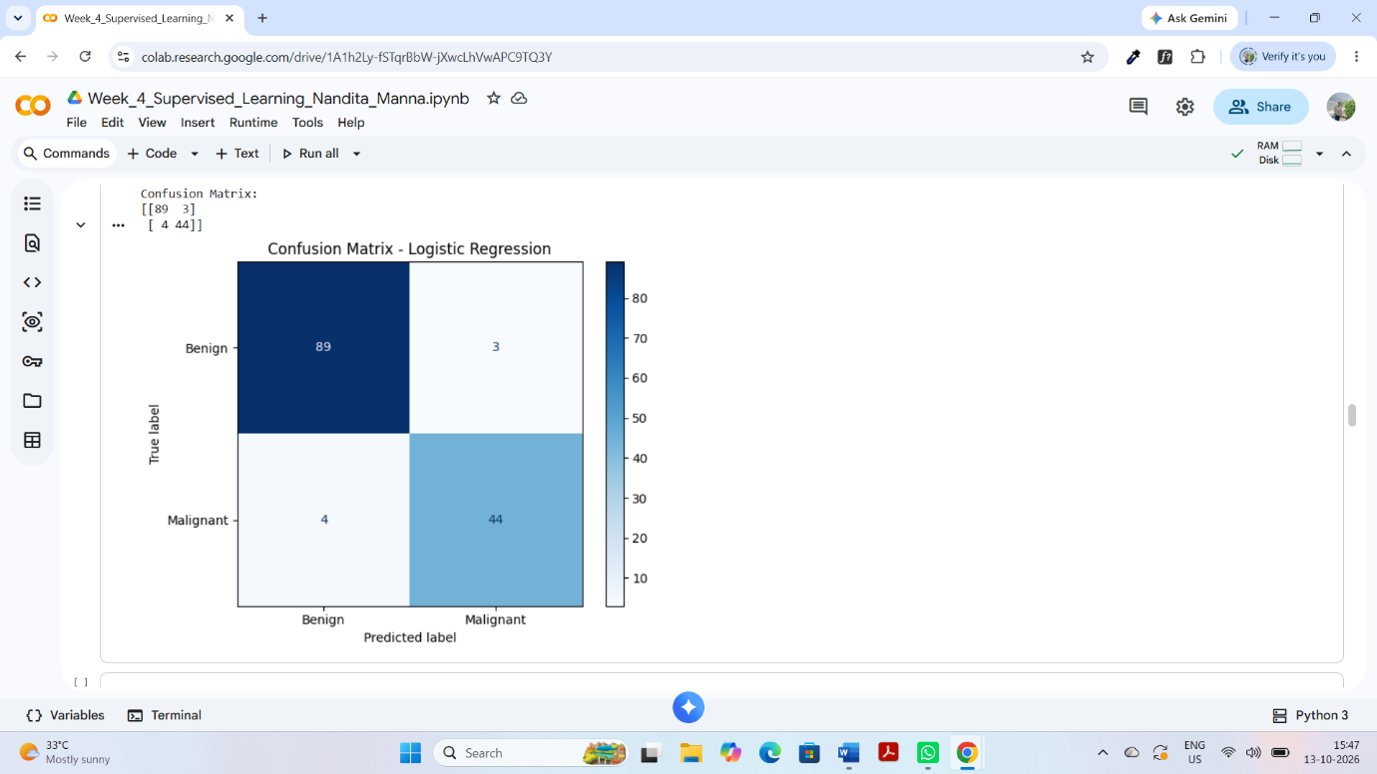
Figure 1: Confusion Matrix of the Logistic Regression Model
8.4 ROC Curve
The Receiver Operating Characteristic (ROC) curve illustrates the relationship between the true positive rate and the false positive rate at different classification thresholds. The area under this curve is represented by the ROC-AUC score.
The model achieved a ROC-AUC score of 0.9950, indicating excellent class-discrimination performance on the test dataset.
Insert the ROC curve image generated in Google Colab here.
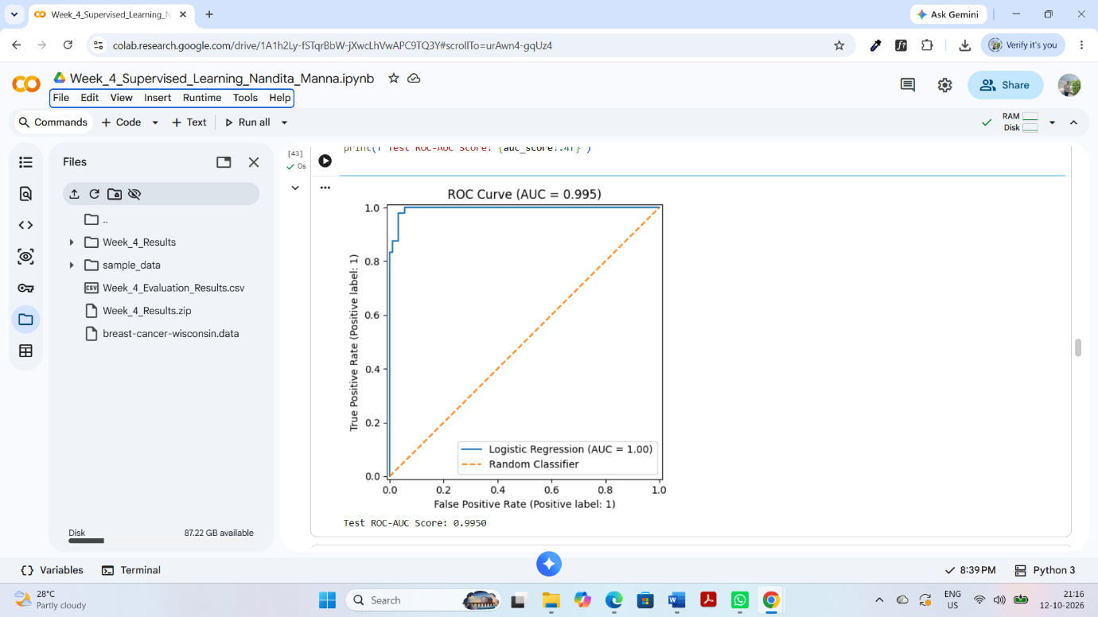
Figure 2: ROC Curve of the Logistic Regression Model
9. Data Visualization and Feature Analysis
9.1 Class Distribution
A class distribution chart was created to understand the number of benign and malignant samples in the dataset. This visualization helps identify the distribution of the target classes before model training.
The chart provides a simple overview of the two categories used in the classification task.
Insert the Class Distribution chart generated in Google Colab here.
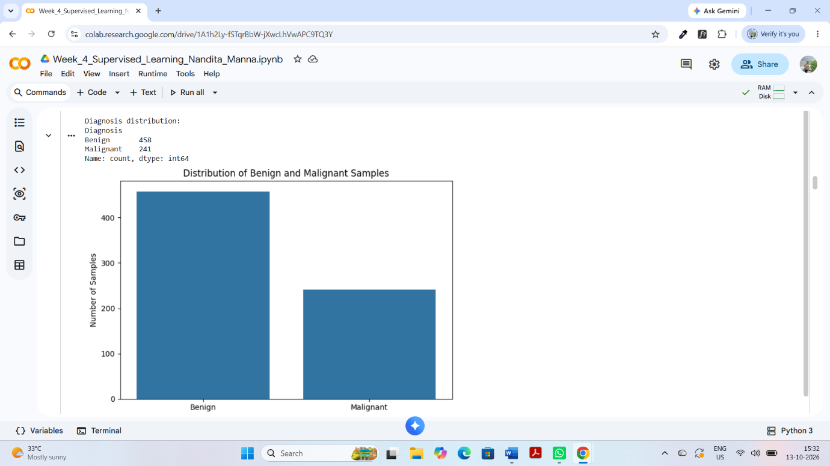
Figure 3: Distribution of Benign and Malignant Samples
9.2 Correlation Analysis
Correlation analysis was performed to examine the relationships between numerical features in the dataset. A correlation heatmap was created to represent these relationships visually.
The heatmap helps identify features that have stronger positive or negative correlations with other features. This information can support understanding of the dataset and the relationships among its variables.
Insert the correlation heatmap generated in Google Colab here.
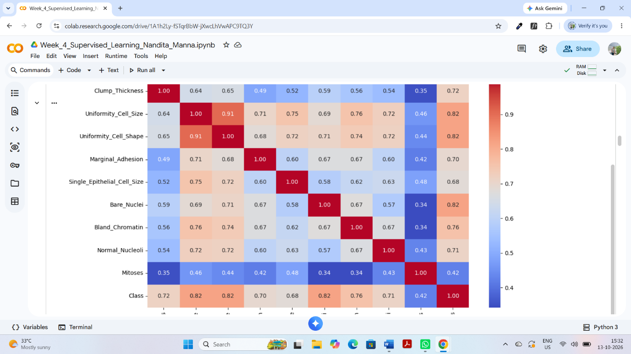
Figure 4: Correlation Heatmap of Dataset Features
9.3 Feature Importance and Interpretation
The numerical features describe characteristics of the cell samples, such as clump thickness, cell size uniformity, cell shape uniformity, marginal adhesion, bare nuclei, bland chromatin, normal nucleoli and mitoses.
These features were used as input variables for the Logistic Regression model. Their combined information helped the model classify samples into benign and malignant categories.
The correlation heatmap shows relationships between features; however, correlation alone does not establish causation or prove which feature is most important for prediction.
9.4 Sample Predictions
After model training, sample predictions were checked by comparing predicted classes with actual classes. This provided an additional way to inspect the model's output.
The predicted labels were interpreted as follows:
- 0: Benign
- 1: Malignant
The sample prediction check was used as an illustration of the model's classification output. The overall performance was evaluated using the test metrics described in the previous section.
10. Discussion
The Logistic Regression model achieved a test accuracy of 95.00% and a mean five-fold cross-validation accuracy of 96.78%. The ROC-AUC score was 0.9950, indicating strong class-discrimination performance on the test dataset.
The precision of 93.62%, recall of 91.67% and F1-score of 92.63% provide additional information about the model's classification performance. Together, these metrics suggest that the model performed well on this dataset.
However, machine learning results depend on the dataset, preprocessing methods, train-test split and evaluation procedure. Therefore, the results should be interpreted within the scope of this project.
11. Limitations
The project has the following limitations:
- Dataset limitation: The model was evaluated using one publicly available dataset. Its performance may differ on other datasets.
- Missing values: Missing feature values were replaced with their median values. This is a practical method, but it may not preserve all information in the original data.
- Model limitation: Only Logistic Regression was used as the main classification algorithm. Other algorithms may produce different results.
- Test data limitation: The test results represent performance on one held-out test set and may not reflect performance in every real-world situation.
- Medical limitation: This project is for educational purposes only. The model is not a medical diagnostic tool and must not be used to make clinical decisions.
12. Future Improvements
The project can be improved in several ways:
- Compare Logistic Regression with other classification algorithms, such as Decision Tree, Random Forest and Support Vector Machine.
- Use additional evaluation methods and examine precision, recall, F1-score and the confusion matrix carefully.
- Perform feature selection or feature engineering to investigate whether model performance can be improved.
- Test the model on additional suitable datasets to assess its ability to generalize.
- Tune model hyperparameters using an appropriate cross-validation procedure.
- Document the complete preprocessing and evaluation process to make the experiment reproducible.
These improvements may help provide a more comprehensive evaluation of the classification model.
13. Conclusion
This project successfully demonstrated the implementation of a supervised machine learning model for breast cancer classification using Python and Scikit-learn. The Breast Cancer Wisconsin dataset was cleaned and prepared before training the Logistic Regression model.
Missing feature values were handled using median imputation, and numerical features were standardized using StandardScaler. The dataset was divided into training and testing sets, and five-fold stratified cross-validation was used to assess model performance.
The model achieved 95.00% test accuracy, a precision of 93.62%, a recall of 91.67%, an F1-score of 92.63% and a ROC-AUC score of 0.9950. These results demonstrate the model's strong performance on the selected test dataset.
Through this project, practical knowledge was gained in data preprocessing, feature preparation, model training, cross-validation, performance evaluation and data visualization using Python.
The project fulfilled its educational objective of demonstrating a complete supervised learning workflow. The model is intended for academic learning and should not be used for actual medical diagnosis.
14. References
- UCI Machine Learning Repository. Breast Cancer Wisconsin (Original) Dataset. Available at: https://archive.ics.uci.edu/dataset/15/breast+cancer+wisconsin+original
- Scikit-learn Documentation. Logistic Regression. Available at: https://scikit-learn.org/stable/modules/linear_model.html#logistic-regression
- Scikit-learn Documentation. Model Evaluation. Available at: https://scikit-learn.org/stable/modules/model_evaluation.html
- Scikit-learn Documentation. StandardScaler. Available at: https://scikit-learn.org/stable/modules/generated/sklearn.preprocessing.StandardScaler.html
- Pandas Documentation. Available at: https://pandas.pydata.org/docs/
- Matplotlib Documentation. Available at: https://matplotlib.org/stable/
- Seaborn Documentation. Available at: https://seaborn.pydata.org/
15. Appendix
The following supporting files were generated during the project:
- Google Colab notebook containing the Python implementation.
- Evaluation results CSV file.
- Confusion matrix image.
- ROC curve image.
- Cross-validation results CSV file.
- ZIP file containing the generated result files.
- 16. Appendix: Important Python Code
- This appendix presents the main Python code segments used in the supervised learning project. The complete implementation was carried out in Google Colab using Pandas and Scikit-learn.
- 16.1 Data Preprocessing
- The dataset was converted into numerical format, missing target labels were removed, and the sample identifier was excluded from the input features. Missing numerical values were handled using median imputation within the model pipeline.
- import pandas as pd

- from sklearn.impute import SimpleImputer
- from sklearn.preprocessing import StandardScaler
- from sklearn.pipeline import Pipeline
- from sklearn.linear_model import LogisticRegression

- # Convert dataset columns to numeric values
- df = df.apply(pd.to_numeric, errors="coerce")

- # Remove rows with missing target labels
- df = df.dropna(subset=["Class"])

- # Define input features and target
- X = df.drop(columns=["Sample_Code", "Class"], errors="ignore")
- y = df["Class"].map({2: 0, 4: 1})

- # Remove rows with invalid target labels
- valid_rows = y.notna()
- X = X.loc[valid_rows]
- y = y.loc[valid_rows].astype(int)
- 16.2 Train-Test Split
- The dataset was divided into training and testing subsets using an 80:20 ratio. Stratification was used to maintain the class proportions.
- from sklearn.model_selection import train_test_split

- X_train, X_test, y_train, y_test = train_test_split(
- X,
- y,
- test_size=0.20,
- random_state=42,
- stratify=y
- )

- print("Training samples:", len(X_train))
- print("Testing samples:", len(X_test))
- 16.3 Logistic Regression Pipeline
- Logistic Regression was selected for binary classification. Median imputation and feature scaling were included in the pipeline so that these transformations are fitted using the training data.
- model = Pipeline([
- ("imputer", SimpleImputer(strategy="median")),
- ("scaler", StandardScaler()),
- ("classifier", LogisticRegression(
- max_iter=2000,
- random_state=42
- ))
- ])

- model.fit(X_train, y_train)

- y_pred = model.predict(X_test)
- y_prob = model.predict_proba(X_test)[:, 1]
- 16.4 Cross-Validation
- Stratified five-fold cross-validation was performed on the training data to evaluate the consistency of the model.
- from sklearn.model_selection import StratifiedKFold, cross_val_score

- cv = StratifiedKFold(
- n_splits=5,
- shuffle=True,
- random_state=42
- )

- cv_scores = cross_val_score(
- model,
- X_train,
- y_train,
- cv=cv,
- scoring="accuracy"
- )

- print("Cross-validation scores:", cv_scores)
- print("Mean CV accuracy:", cv_scores.mean())
- print("Standard deviation:", cv_scores.std())
- 16.5 Evaluation Metrics
- The model was evaluated on the held-out test dataset using Accuracy, Precision, Recall, F1-score, ROC-AUC, and the Confusion Matrix.
- from sklearn.metrics import (
- accuracy_score,
- precision_score,
- recall_score,
- f1_score,
- roc_auc_score,
- confusion_matrix
- )

- print("Accuracy:", accuracy_score(y_test, y_pred))
- print("Precision:", precision_score(y_test, y_pred, zero_division=0))
- print("Recall:", recall_score(y_test, y_pred, zero_division=0))
- print("F1-score:", f1_score(y_test, y_pred, zero_division=0))
- print("ROC-AUC:", roc_auc_score(y_test, y_prob))
- print("Confusion Matrix:")
- print(confusion_matrix(y_test, y_pred))
- 16.6 Summary
- These code segments demonstrate data preparation, train-test splitting, pipeline construction, cross-validation, and model evaluation. The reported performance values should be taken from the final successful execution of the complete Google Colab notebook.

