COVID-19 Global Data Analysis
Findings Report
Source: Our World in Data | Tool: SQL (SQLite) | Days 132-137

589,779  Rows Analysed | 7.79M  World Total Cases | 6.85M  World Total Deaths | 13.7B  Vaccine Doses Given | 262  Countries

1. Cases & Deaths Analysis

1.1 UK Profile
The United Kingdom recorded 25,117,472 confirmed cases against a population of 68,179,315 — meaning 36.84% of the entire UK population was infected at some point during the pandemic. Of those cases, 232,112 people died — a death rate of 0.92%, or roughly 1 in every 109 people who contracted COVID.

Metric | Value | Context
Total Cases | 25,117,472 | 36.84% of population
Total Deaths | 232,112 | 6th highest globally
Death Rate | 0.92% | 1 in 109 who got COVID died
Infection Rate | 36.84% | 1 in 3 of entire population

1.2 Highest Death Rates by Country
Countries with the highest death rates were predominantly conflict zones or nations with severely underfunded healthcare systems. For these countries, the high death rates reflect near-zero testing capacity rather than a more deadly virus strain — only the critically ill were ever tested, making fatality rates appear artificially high.

Country | Total Cases | Total Deaths | Death Rate
Sudan | 63,993 | 5,046 | 7.89%
Syria | 57,423 | 3,163 | 5.51%
Somalia | 27,334 | 1,361 | 4.98%
Peru | 4,533,808 | 221,071 | 4.88%
Egypt | 516,023 | 24,830 | 4.81%
Mexico | 7,630,026 | 335,106 | 4.39%

Key Insight: Sudan, Syria and Somalia top the list — all conflict zones with collapsed healthcare. Peru and Mexico are the more honest signal, showing the impact of overwhelmed hospitals during peak waves.

1.3 Total Deaths by Country & Continent
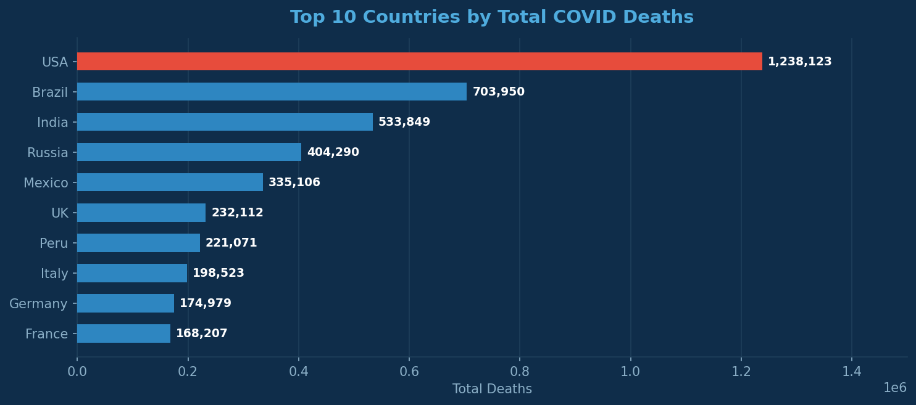

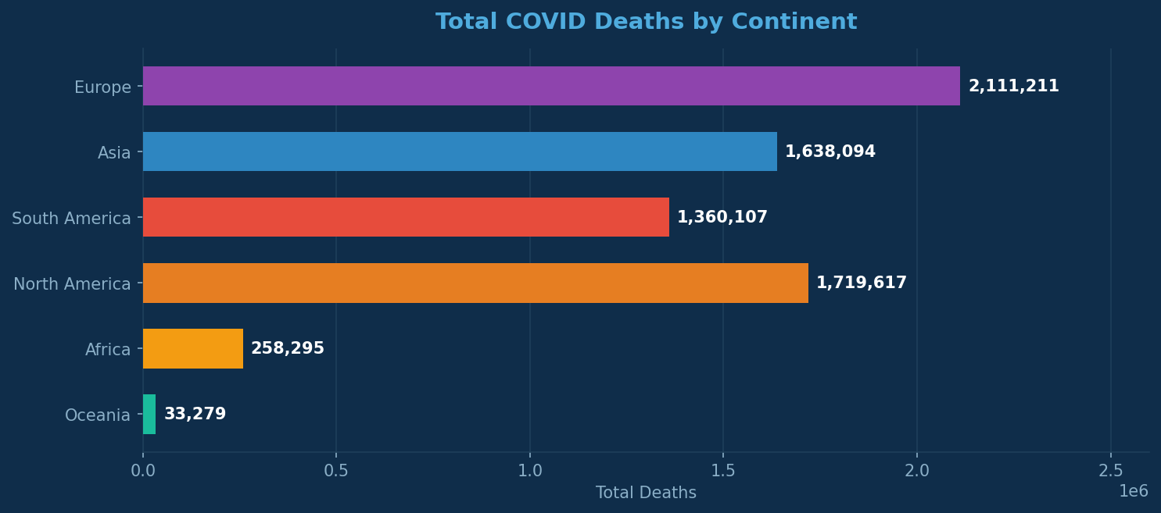

Continent | Total Deaths | Key Context
Europe | 2,111,211 | Hardest hit — older population, early wave before vaccines
North America | 1,719,617 | US alone = 1.24M deaths
Asia | 1,638,094 | Lower than expected — early SARS experience helped
South America | 1,360,107 | Brazil and Peru drove the numbers
Africa | 258,295 | Younger population + possible underreporting
Oceania | 33,279 | Island geography aided natural containment

2. Vaccination Analysis

2.1 Global Vaccination Scale
The global vaccination effort was unprecedented in scale. A total of 13.7 billion doses were administered worldwide, with nearly 1 billion people achieving full vaccination status. However the distribution was deeply unequal — wealthy nations with strong logistics infrastructure vaccinated far faster and at higher rates than low-income countries.

13.7B  Total Doses Given | ~1B  Fully Vaccinated | 95.61%  UAE Rate (Highest) | 0.03%  Lowest Death Rate (UAE)

2.2 Countries with Highest Vaccination Rates
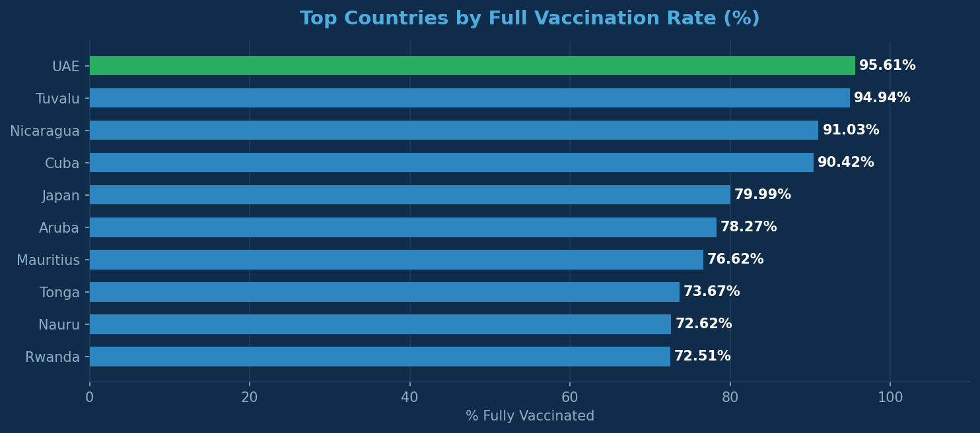

Country | Fully Vaccinated | Population | Vax Rate
UAE | 9,792,266 | 10,242,085 | 95.61%
Tuvalu | 9,505 | 10,012 | 94.94%
Cuba | 9,999,902 | 11,059,822 | 90.42%
Japan | 99,991,170 | 124,997,585 | 79.99%
Rwanda | 9,897,876 | 13,651,025 | 72.51%

Key Insight: Cuba reached 90% vaccination despite economic sanctions by developing its own vaccine. Rwanda at 72.5% stands out as the most impressive African performer — known for exceptional public health governance.

3. Government Response Analysis

3.1 R Number by Continent
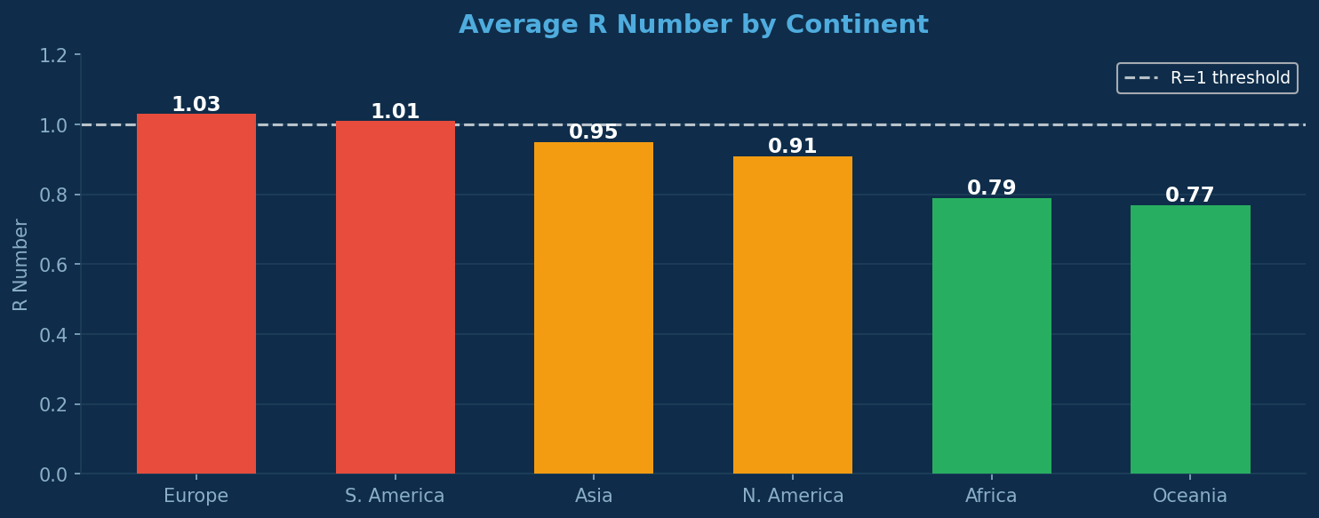

An R number above 1.0 means the virus was actively growing — every infected person was infecting more than one other. Europe (1.03) and South America (1.01) never brought their average R numbers below the critical threshold across the full pandemic period. Africa (0.79) and Oceania (0.77) achieved consistent suppression.

3.2 Stringency vs Death Rate
Analysis of government restriction stringency scores against death rates reveals that lockdown strictness alone does not determine outcomes. The critical factor is timing.

Country | Death Rate | Avg Stringency | Outcome
China | 0.12% | 73.31 | GOOD — early lockdown
Bhutan | 0.03% | 50.68 | GOOD — early & disciplined
Italy | 0.74% | 52.28 | DELAYED — first wave hit hard
Peru | 4.88% | 53.61 | POOR — too late, overwhelmed
Myanmar | 3.03% | 63.73 | POOR — military coup disrupted

Key Insight: Stringency alone does not save lives. Timing does. Countries that locked down before the virus took hold did well. Countries that locked down reactively paid the price regardless of restriction severity.

4. Testing Analysis
One of the clearest patterns in the entire dataset: countries that tested more aggressively consistently had lower death rates. Mass testing enabled early case identification, faster isolation and earlier treatment before patients became critical.

Country | Tests per 100 People | Death Rate | Pattern
Austria | 1,101 | 0.03% | HIGH test / LOW death
UAE | 973 | 0.01% | HIGH test / LOW death
Bahrain | 650 | 0.01% | HIGH test / LOW death
Norway | 183 | 0.68% | MED test / LOW death
Western Sahara | 0.69 | Unknown | ZERO test / INVISIBLE data

Key Insight: Countries with near-zero testing capacity did not just have worse outcomes — they had invisible outcomes. Deaths happened but were never counted. The true global toll is likely significantly higher than recorded figures.

5. Demographic Risk Factors
Analysis of country-level demographics reveals that no single factor fully explains COVID outcomes. The countries that survived best combined multiple advantages simultaneously.

Factor | Finding | Example
Median Age | Older populations at higher risk — but vaccination offsets it | Japan (age 48.5) had only 1% death rate due to 80% vaccination
GDP per Capita | Wealth helps but does not guarantee survival | Luxembourg ($128K GDP) had 10% death rate — early wave overwhelmed even rich nations
Hospital Beds | More beds help until a wave overwhelms them all at once | Germany (7.55 beds/1000) still saw high early death rates
Diabetes | High diabetes + poor healthcare = dangerous combination | Egypt (22.4% diabetes) had 10% death rate. Qatar (24.6% diabetes) had 0.1% — offset by wealth

6. Country Risk Scorecard
The following table presents the complete risk profile for the 15 countries with the highest death rates in the reliable dataset (minimum 100,000 cases, 1,000 deaths, cases exceeding deaths).

Country | Death Rate | Infection Rate | GDP/cap | Median Age | Hosp Beds | Continent
Sudan | 7.89% | 0.13% | $1,861 | 18.1 | 0.66 | Africa
Syria | 5.51% | 0.26% | $4,455 | 21.6 | 1.43 | Asia
Somalia | 4.98% | 0.15% | $1,409 | 15.4 | 0.87 | Africa
Peru | 4.88% | 13.54% | $15,662 | 29.1 | 1.56 | S. America
Egypt | 4.81% | 0.46% | $16,798 | 23.8 | 1.06 | Africa
Mexico | 4.39% | 5.93% | $22,040 | 28.5 | 1.01 | N. America
Bosnia | 4.06% | 12.62% | $20,528 | 44.6 | 2.35 | Europe
South Africa | 2.52% | 6.53% | $13,598 | 27.9 | — | Africa

7. Conclusions
The global COVID-19 pandemic exposed deep inequalities in healthcare capacity, government preparedness and economic resilience. The data from 262 countries and territories across 6 years tells a consistent story:

- No single factor predicts COVID outcomes. The best-performing countries combined early action, strong testing, fast vaccination and adequate healthcare capacity simultaneously.
- Timing beats strictness. A moderate lockdown implemented early outperforms a severe lockdown implemented after the wave has already hit.
- Testing saves lives. The inverse relationship between testing rates and death rates is the clearest pattern in the entire dataset.
- Vaccines work. The UAE, Cuba and Japan all achieved high vaccination rates and near-zero death rates despite different income levels and geographies.
- The true global toll is unknown. Countries with near-zero testing capacity had invisible outcomes. The 6.85 million recorded deaths is almost certainly a significant undercount.

Bottom Line: The pandemic was not won or lost by any single policy or demographic factor. It was decided by the speed, consistency and equity of the response — and the data shows exactly which countries got that right.

Days 132-137 | 365 Days of Data Analysis | Tool: SQL (SQLite) | Dataset: Our World in Data

